Supplementary Materials

Lab Visit
Experimenter Teaching Procedure. Warm-Up. The experimenter explained, “Sometimes it’s your turn, and sometimes it’s my turn!” She then allowed children to stack the four blocks while narrating the block stacking. The experimenter then stacked the blocks herself, after reminding children that they would take turns with the blocks. She narrated her own stacking (e.g., “The yellow one goes on top!”) and if children attempted to intervene, the experimenter reminded children that it was her turn. The procedure was repeated for one additional stacking turn for each child and experimenter (4 total turns: child, experimenter, child, experimenter). See Table 1 for scripted prompts offered during Warm-Up.
Table 1
Procedures for Warm-Up phase of Experimenter Teaching
Child’s Turn | Experimenter’s Turn
“Let’s stack these blocks! Sometimes it’s my turn, and sometimes it’s your turn. First it’s your turn!”  Respond to child actions: “Ooh, I like that!” “Do you want to put the yellow one on top?” etc.  “You did it! Yay!” | “Sometimes it’s your turn and sometimes it’s my turn. Now it’s my turn!”  Narrate own actions: “I’ll do the blue one first [place], then the green one on top [place], then the red one [place], then the yellow one [place].”  “Look, I did it! Yay!”

Active. First, children were given the base of the toy while the pieces were kept outside of children’s reach (though within view) until it was the child’s turn to place each piece. The experimenter told children, “You get to make the [toy name]!” Then, the experimenter provided instructions on each action. For example, the experimenter said, “Next, you do the eye. The eye goes right here [point]. Can you do that?” The experimenter handed the piece to the child for the child to place onto the base. This continued for each subsequent toy action in the same fixed order of Action Types for each toy. When all target actions were complete, the experimenter praised the child (“You did it! You made the [toy name]! Yay!”) but did not otherwise offer feedback or praise. The experimenter ensured children were accurate in their actions and attentive during instruction. If a child placed a piece incorrectly or had trouble placing a piece, the experimenter offered correction and guidance when necessary by repeating the prompt, pointing, adjusting the piece, or hovering the piece over its correct location. The experimenter ensured the child was looking towards the experimenter and the toy when she provided verbal and gestural instructions using attentional language (e.g., “Look!” “See?”) if the child was not attending.
Observed. First, the experimenter placed the base and manipulation pieces just outside of the child’s reach (though still clearly within the child’s view). Then, the experimenter told the child, “I’m going to make the [toy name]!” The experimenter narrated and instructed each action analogously to the Active session, but performed each target action herself after providing instructions. For example, she said, “Next, I’ll do the eye. The eye goes right here [point]. I’ll do that!” The experimenter then placed the piece. After performing all target actions, the experimenter praised her own performance (“I did it! I made the [toy name]! Yay!”). As with Active session, the experimenter ensured children were visually attentive. See Table 2 for details on the scripted prompts provided during Experimenter Instruction.
Table 2
Procedure for Active and Observed instruction sessions

 | Script for Cat/Dog  Active/Observed | Script for Snowman/Scarecrow  Active/Observed
Introduction | It’s your/my turn now. You’ll/I’ll make the [toy name].
Action 1 | First you/I’ll do the ear. The ear goes right here [point].  Can you do that? [hand piece]/I’ll do that. [place piece] | First you/I’ll do the bottom. The bottom goes right here [point].  Can you do that? [hand piece]/I’ll do that. [place piece]
Action 2 | Then you/I’ll do the other ear. The ear goes right here.  Can you do that? [hand piece]/I’ll do that. [place piece] | Next you/I’ll do the middle. The middle goes right here [point].  Can you do that? [hand piece]/I’ll do that. [place piece]
Action 3 | Next you/I’ll do the eye. The eye goes right here.  Can you do that? [hand piece]/I’ll do that. [place piece] | Next you/I’ll do the arm. The arm goes right here [point].  Can you do that? [hand piece]/I’ll do that. [place piece]
Action 4 | Next you/I’ll do the other eye. The eye goes right here.  Can you do that? [hand piece]/I’ll do that. [place piece] | Next you/I’ll do the other arm. The arm goes right here [point].  Can you do that? [hand piece]/I’ll do that. [place piece]
Action 5 | Next you/I’ll do the nose. The nose goes right here.  Can you do that? [hand piece]/I’ll do that. [place piece] | Next you/I’ll do the tie. The tie goes right here [point].  Can you do that? [hand piece]/I’ll do that. [place piece]
Action 6 | Last you/I’ll do the mouth. The mouth goes right here.  Can you do that? [hand piece]/I’ll do that. [place piece] | Last you/I’ll do the hat. The hat goes right here [point].  Can you do that? [hand piece]/I’ll do that. [place piece]
Conclusion | You/I did it! You/I made the [toy name]! Yay!

Test Procedure. First, children were tested on the caregiver-taught Rocket toy. Then, children were tested on the two Generalization Toys (untaught items matched to items taught in Active and Observed contexts). Finally, children were tested on the two Taught Toys learned in Experimenter Teaching. Presenting Generalization Toys before Taught Toys ensured that performance on Generalization Toys was not influenced by children’s Test performance on Taught Toys. In addition, piloting revealed that testing children on Generalization Toys before Taught Toys provided more variability in Test Scores. Toys were presented in the order they were taught: For example, if a child was taught the Cat and Snowman during Experimenter Teaching, she would be first tested on the Rocket, then matched Generalization Toys in the same order as Experimenter Teaching (Dog then Scarecrow), then the two Taught Toys (Cat then Snowman).
For each toy, the assistant asked the child, “What should we do with this one?” and did not correct or interfere with the child’s actions. The assistant offered neutral feedback after each action (e.g., “Hmm.” “Oh.”) and encouraged the child to continue performing actions by prompting neutrally (e.g., “What else should we do with this?”; “What should we do next?”). If a child struggled physically to place a piece, the assistant offered motoric help. See Figure 1 for toy details.
Figure 1
Toys in Caregiver and Experimenter Teaching and Test
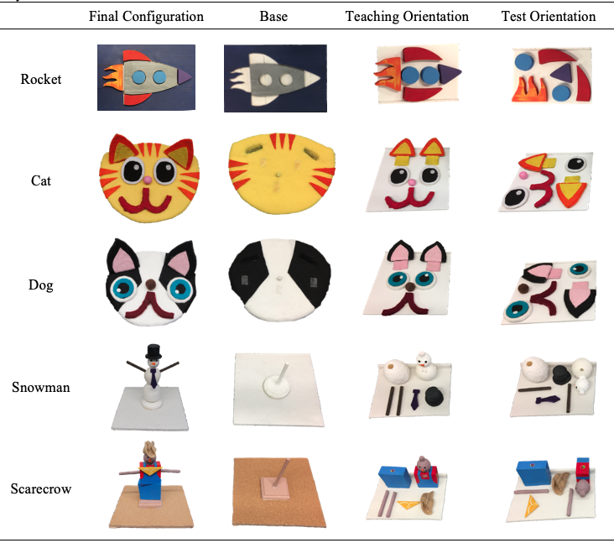
Note. Each toy in its final configuration, then separately showing the base onto which pieces were placed. Pieces were organized in relation to the base during Teaching, but were scrambled for Test.

Experiment Phase | Measure | Details | Mean (SD); Range; number of values missing or excluded
Experimenter Teaching | Active Time | Seconds | 95.7 (17.0); 66.1-156.9; 1 outlier
Experimenter Teaching | Observed Time | Seconds | 74.3 (6.1); 61.8-86.7; 0 missing
Experimenter Teaching | Observed Attention | Proportion of time looking out of Observed Time (out of 1) | .985 (.024); .900-1; 1 excluded
Experimenter Teaching | Active Instruction: Child Best Performance Score | Average score of best attempt of each Action Type (out of 1) | 37 of 46 children scored 1; 0 missing
Experimenter Teaching | Active Instruction: Experimenter Assistance | Number of instances of experimenter assistance during Active instruction | 10.1 (5.5); 2-27; 1 excluded
Problem-Solving | Bayley | Age-normed score on the Cognitive subscale | 61.5 (5.9); 48-74; 3 missing
Session Factors | Caregiver Teaching Time | Minutes | 3.0 (1.4); 1.0-5.9; 0 missing
Child Factors | MCDI | Number of words caregivers reported children said on the MCDI | 40 (17.9); 5-77; 0 missing
Descriptive Statistics

Table 3

Descriptive statistics for measures from lab visit

Note. Measures coded during the lab visit are listed with details about each measure and the Mean, Standard Deviation, range, and number of observations (out of the final sample of 46 children) that were missing or excluded because values were greater than 3 standard deviations from the mean.

Table 4

Reliability Statistics

Experiment Phase | Measure | ICC | p | F
Experimenter Teaching | Active Time | 0.999 | < .001 | 2846
Experimenter Teaching | Observed Time | 0.978 | < .001 | 110
Experimenter Teaching | Observed Attention | 0.835 | < .001 | 10.5
Experimenter Teaching | Action Engagement: Child Best Performance Score | N/A (9/10 scored identically)
Experimenter Teaching | Action Engagement: Experimenter Assistance | 0.936 | 0.001 | 53.9
Test | Active Taught Test Score | 0.979 | < .001 | 98.1
Test | Observed Taught Test Score | 0.814 | < .001 | 10.0
Test | Active Generalization Test Score | 0.857 | < .001 | 13.1
Test | Observed Generalization Test Score | 0.947 | < .001 | 37.4
Session Factors | Caregiver Teaching Time | 0.990 | < .001 | 223
Note. Videos of 10 children (21.7%) were double coded for reliability. Each measure was calculated for each child per coder and compared (e.g., Active Time was compared between coders for each of the 10 children). Intraclass correlation coefficients (ICCs) were calculated with corresponding p-values and F statistics.

Memory Task
Procedure. After completing the consent online and filling out the demographic survey to provide information about child ethnicity and maternal education, children and their primary caregiver joined a Zoom call with a trained assistant. The assistant greeted children and caregivers and helped caregivers set up their screen. Caregivers put Zoom into full-screen mode and used the “Hide self view” function to hide their own video view. The assistant reminded the caregivers not to intervene with the study. The assistant then administered two practice trials, showed the child images of their lab session, then proceeded with two additional practice trials. Then, the child saw the four Test Trials, followed by four additional trials to make the experiment more engaging (which were not analyzed). There was a blank screen presented between each set of trials. See Table 6 for details on the procedure.
Table 6
Memory Task Materials and Procedure
Trial | Stimuli | Prompt
Practice Trials |  | Let’s practice! Here’s a blue circle and an orange circle. Can you point to the blue circle? Can you point to the orange circle? Good work!
Practice Trials |  | What shape is this? [STAR] What shape is this? [HEART] Good work!
Pictures of Child | Caregiver/child  Experimenter/child  Assistant/child  Caregiver/child | A long time ago, you played with toys with your [mom/dad] and some friends!  - Caregiver/child: Here you are playing with your [mom/dad]!  - Experimenter/child: Here you are playing with my friend [experimenter name]!  - Assistant/child: Here you are playing with my friend [assistant name]!  - Caregiver/child: You had so much fun playing that day!  You played with lots of toys that day. I want to see if you remember which toys you played with.
Additional Practice |  | Did you make a tower or a castle?
Additional Practice |  | Did you make a submarine or a rocket?
Test Trials |  | Did you make a fox or a cat?
Test Trials | 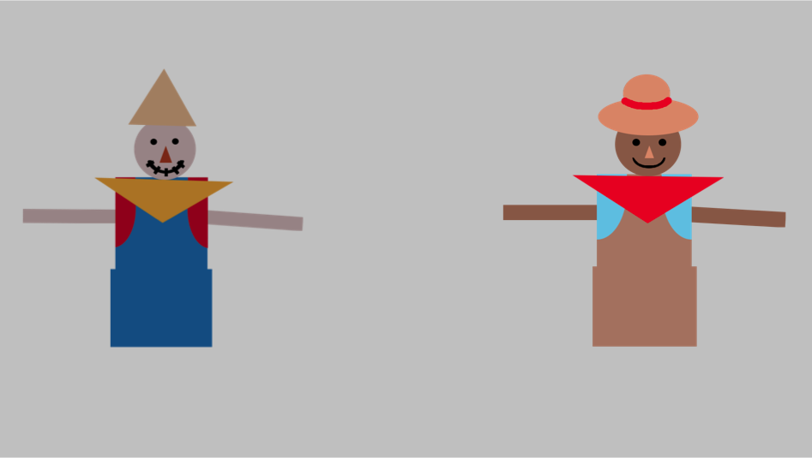 | Did you make a scarecrow or a cowboy?
Test Trials |  | Did you make a dog or a panda?
Test Trials | 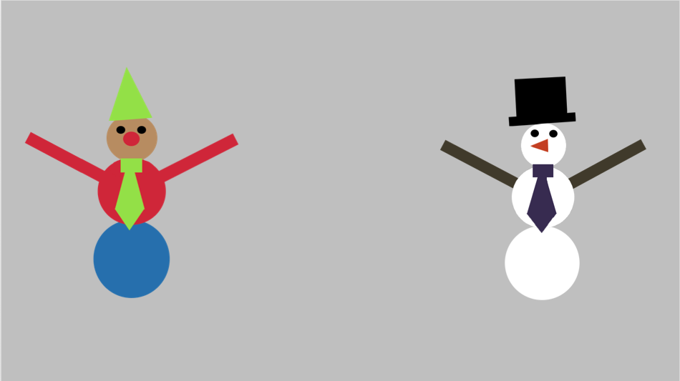 | Did you make a clown or a snowman?
Additional Trials | 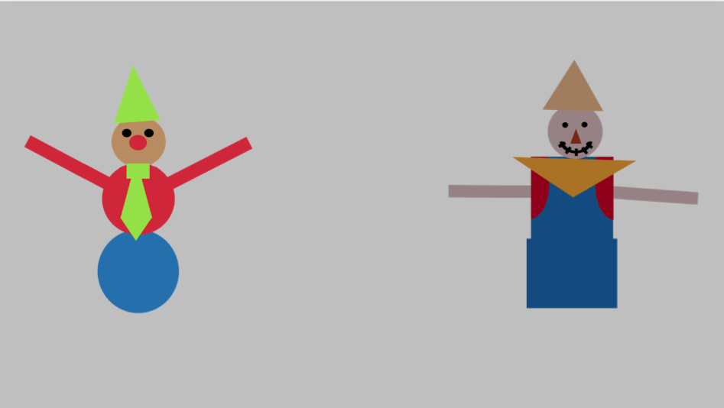 | Did you make a clown or a scarecrow?
Additional Trials | 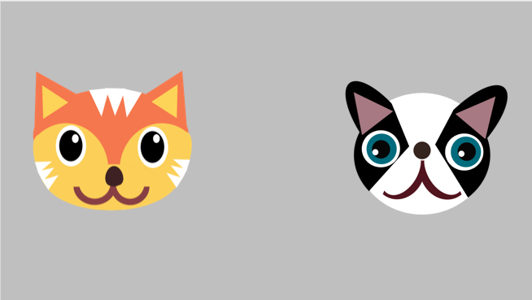 | Did you make a fox or a dog?
Additional Trials | 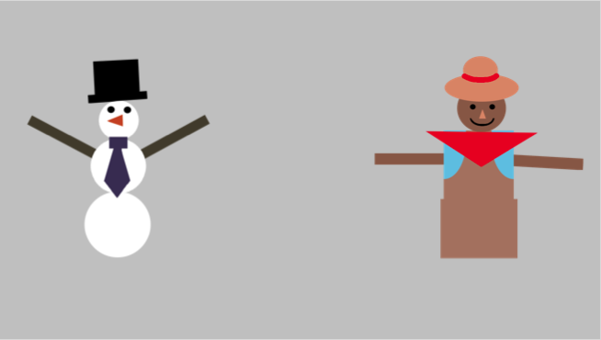 | Did you make a snowman or a cowboy?
Additional Trials |  | Did you make a cat or a panda?
Note. Stimuli: All images used in the memory task. Children first practiced pointing to or naming the practice items (blue circle and orange circle, then star and heart). Children then saw pictures from their prior lab session. Children were then presented with two additional practice trials: caregiver-taught Rocket and Warm-Up tower block configuration. Finally, children received four test trials (Cat, Scarecrow, Dog, and Snowman). Children also received four additional trials that were not analyzed because their responses on these trials could have been contaminated by their response to the Test Trials. Prompt: The assistant used these prompts when the images were displayed. Bolded words indicated where each image expanded slightly on the screen, then returned to its original size.

Exploratory Analysis
Since no difference between memory for Taught and Generalization measures emerged in the main preregistered analysis, we exploratorily computed average Active Memory Scores and Observed Memory Scores across Taught and Generalization items for each child and compared average memory scores to chance (.5). Children’s average Active Memory Score was greater than chance (t(25) = 2.848, p = .009, d = .557), while average Observed Memory Score was not significantly different from chance (t(25) = 0, p = 1; Figure 2). Children therefore remembered the toys they had learned through Active instruction, but did not recall those learned through Observed instruction. This was found despite the fact that all children had experienced both instruction conditions originally – yet, only instruction including active experience related to children’s memory. Of note, children’s learning from Active and Observed instructions did not relate to memory: Test Scores from Study 1the lab visit were not related to Memory Score (controlling for Bayley; β = -0.797, SE = 1.021, p = .435). In sum, children recalled toys learned actively, but not observationally, one year after receiving instructions in both conditions. Children’s cognitive maturity was not relevant for recall. Instead, active experience appeared pivotal for long-term memory.
Figure 2
Memory for Active and Observed toys compared to chance
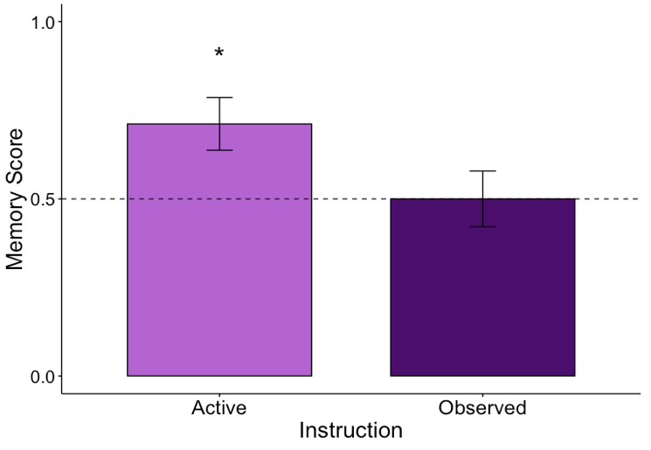
Note. Bar graph showing average Memory Score for Active toys (averaged across Taught and Generalization items) and Observed toys (averaged across Taught and Generalization items) compared to chance (0.5). Error bars: +/- 1 Standard Error. *p < .05.

In addition, we exploratory tested whether children’s memory for each item differed from chance (0.5): Active Taught, Active Generalization, Observational Taught, and Observational Generalization. Interestingly, the memory finding was driven by children’s memory for the Active Generalization item. Scores on Active Taught items trended greater than chance (t(25) = 1.62, p = .118), while scores on Active Generalization items was significantly greater than chance (t(25) = 3.20, p = .004). Scores on both observationally-learned items did not differ from chance (Taught: t(24) = 1, p = .327; Generalization: t(25) = -0.78, p = .444; Figure 3).
Figure 3
Memory for Active and Observed toys by test item compared to chance

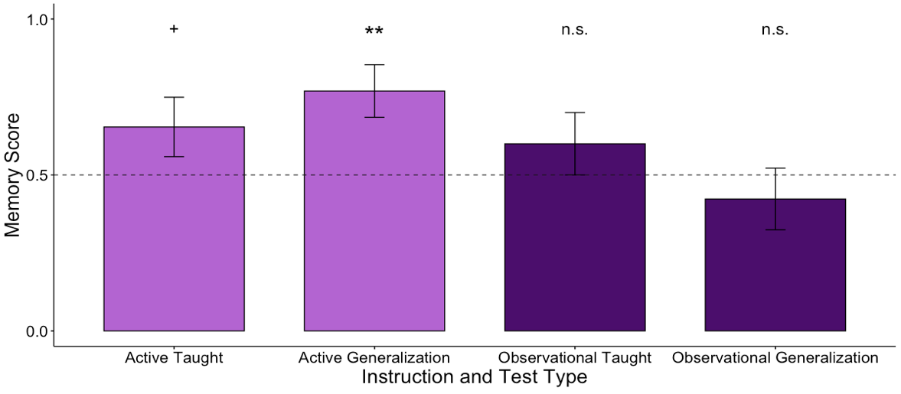
Note. Bar graph showing Memory Score for Active (separated by Taught and Generalization items) and Observed toys (separated by Taught and Generalization items) compared to chance (0.5). Error bars: +/- 1 Standard Error. **p < .01.

Caregiver Teaching

We had also hypothesized that the relative patterns of toddler and caregiver activity during everyday teaching could affect how well toddlers would learn from active or observational instruction. Alternatively, the patterns of toddler and caregiver activity could reflect variation in how well the dyad functions without contributing directly to children’s learning. For example, caregivers who expected their children to be more competent could have allowed them to be more active during teaching. Or, caregivers who engaged in child-active interactions could have been better teachers in other ways than those who did not.
As preregistered, in addition to testing whether active experience per se supported action learning, we also tested whether typical dyadic interaction patterns were relevant for learning. To assess whether dyadic patterns of engagement related to children’s ability to learn from instruction in the lab, caregivers taught their toddlers to perform novel actions to assemble a toy in whatever way caregivers chose, and we measured children’s and caregivers’ behavior. Behaviors included opportunities for children to learn by acting (naturalistic active experience) or by observing their caregivers’ actions (naturalistic observational experience). Children who tended to engage actively with caregivers might learn more from experimentally-manipulated active instruction.
Coding. Coding was performed to test whether children’s interaction patterns with caregivers relate to learning from Active and Observed instruction. Caregiver Teaching sessions were coded for dyadic interaction patterns; specifically, children’s naturalistic active experience (child actions) and opportunities for observational experience (caregiver actions) were coded. During Caregiver Teaching, toddlers’ and caregivers’ actions were coded to measure the patterns of activity that may be common in children’s everyday interactions with their caregivers. Children’s actions reflected opportunities for learning via active experience, and caregivers’ actions provided children opportunities to learn observationally.
Children’s and caregivers’ action attempts were coded and scored for accuracy analogously to the actions coded during Test. Then, the total number of actions performed by children and caregivers across Action Types was counted (Child Count of Target Actions, Caregiver Count of Target Actions). These measures were used to calculate the first measure of child active experience: Naturalistic Active Experience: Child Share of Target Actions. This measure reflected children’s activity relative to their caregiver, indicating the extent to which children “drove” the teaching session (Child Count of Target Actions/(Child Count of Target Actions + Caregiver Count of Target Actions)). The second measure of child active experience was calculated to reflect children’s accuracy in performing actions. Analogous to Test Scores, toddlers’ action accuracy was calculated by averaging their highest scoring attempt of each Action Type to generate Naturalistic Active Experience: Child Best Performance Score out of 1. To index observational experience, the number of actions performed by caregivers was used (Naturalistic Observational Experience: Caregiver Count of Target Actions; Table 5). Reliability was high for these measures: average ICC = .781, all p’s < .009 (Table 6).
Table 5
Descriptive statistics for measures from lab visit: Caregiver Teaching
Measure | Details | Mean (SD); Range; number of values missing or excluded
Naturalistic Observational Experience: Caregiver Count of Target Actions | Count of target actions | 4.7 (3.8); 0-18; 1 outlier
Naturalistic Active Experience: Child Share of Target Actions | Proportion of actions performed by child relative to caregiver (out of 1) | .79 (.14); .44-1; 1 outlier
Naturalistic Active Experience: Child Best Performance Score | Average score of best attempt of each Action Type (out of 1) | .87 (.15); .42-1; 0 missing
Note. Measures are listed with details about each measure and the Mean, Standard Deviation, range, and number of observations (out of the final sample of 46 children) that were missing or excluded because values were greater than 3 standard deviations from the mean.

Table 6
Reliability statistics for Caregiver Teaching
Measure | ICC | p | F
Naturalistic Observational Experience: Caregiver Count of Target Actions | 0.708 | 0.009 | 5.5
Naturalistic Active Experience: Child Share of Target Actions | 0.805 | 0.001 | 8.7
Naturalistic Active Experience: Child Best Performance Score | 0.829 | < .001 | 16.3
Note. Videos of 10 children (21.7%) were double coded for reliability. Each measure was calculated for each child per coder and compared. ICCs were calculated with corresponding p-values and F statistics.

Analysis. The analyses were run to test whether interaction patterns with caregivers related to children’s action learning from Active and Observed instructions. The following outliers were excluded: Naturalistic Observational Experience: Caregiver Count of Target Actions (1 value) and Naturalistic Active Experience: Child Share of Target Actions (1 value).
Results. As preregistered, we tested whether toddlers’ patterns of engagement with caregivers related to their learning from experimenter-administered Active or Observed instruction. More cognitively advanced children were more actively engaged with their caregivers (Naturalistic Active Experience: Child Share of Target Actions (mean = .79, SD = .14, range = .44-1) was correlated with Bayley: r = .37, p = .02; Naturalistic Active Experience: Child Best Performance Score (mean = .87. SD = .15, range = .42-1) was correlated with Bayley: r = .38, p = .01). We tested whether children’s active experience with caregivers related to Active Test Scores, and whether observational experience related to Observed Test Scores. Predictors were interacted with Bayley scores. This analysis strategy differed from the conceptually similar preregistered model. However, no evidence of positive relations emerged between active experience with caregivers and Active Test Scores, or observational experience with caregivers and Observed Test Scores (Naturalistic Active Experience: Child Share of Target Actions Performed: all p’s > .239; Naturalistic Active Experience: Child Best Performance Score: β = -0.096, SE = 0.035, p = .009; Naturalistic Observational Experience: Caregiver Count of Target Actions: all p’s > .711). Thus, we did not see evidence that children’s experience when learning from caregivers related to better learning from Active or Observed instruction.
Discussion. Surprisingly, we did not find evidence that children’s learning from Active or Observed instruction was related to the interaction patterns toddlers engage in with their caregivers. More developmentally advanced children were more active with their caregivers, but this activity was unrelated to children’s learning from the experimenter’s instructions. Specifically, we did not see a relation between children’s active experience with a caregiver and their ability to learn from experimenter-led active instruction, or between children’s observational experience with a caregiver and their ability to learn from experimenter-led observational instruction. However, the toy used in the caregiver-child interaction was fairly straightforward; the actions to be learned were relatively clear from the structure of the toy itself. Indeed, piloting revealed that caregivers did not need instructions to teach their children to perform the actions on the Rocket. Children’s test scores on the Rocket toy were also higher than scores in Brezack et al. (2021). A more challenging toy may have shown greater variability in dyadic interaction patterns, which could have better reflected children’s typical experiences when learning novel actions. In addition, it is possible that the in-lab caregiver-child interaction did not fully capture how children interact with their caregivers to learn at home. It remains an open question whether interaction patterns with caregivers relate to children’s learning from new teachers.

