Supplemental Materials

Table of Contents:
- Methods and Results for Study S1
- Example of stimuli for comparative questions in Study 1
- Example stimuli for the familiarization questions in Study 1 and Study 2
- Procedure and analyses of familiarization questions in Study 1 and Study 2
- Example of stimuli in Study 2
- Example of stimuli in Study 3
- Analyses and results for adult participants in Study 4

- Methods and Results for Study S1

Study S1
This initial study examined whether children recognize the elicitor of awe and how children emotionally react to awe-inspiring experiences. Much of the existing conceptualizations and findings on adults suggest that awe-inspiring experiences lead to perceivable shifts in one’s emotional state, often leading to enhanced or intensified positive emotions (Bonner & Friedman, 2011; Chirico & Yaden, 2018; Darbor et al., 2016) and sometimes leading to fearful feelings and chills (Gordon et al., 2017; Keltner & Haidt; 2003; Yaden et al., 2018). In this study, we took an exploratory look at changes in children’s basic emotions after they watched a video that has been used to elicit awe in adult studies.
Methods
Participants
We recruited 68 4-to-9-year-old children. Twelve participants were excluded due to inattention and distractions in the environment, leaving a final sample of 56 child participants (M age = 7.24 years, SD = 1.61 years, range = 4.04 to 9.92, male = 27, female = 29). According to G*Power (Faul et al., 2007), this sample size has at least 80% power to detect a moderate effect size of 0.36 for paired-sample Wilcoxon test. The majority of children in this study and in the following studies were from middle class families with diverse racial backgrounds, recruited from a database in the University of [masked for review].
We also recruited an adult sample of 101 participants (M age = 40.71 years, SD = 13.83 years, range = 18 to 75, male = 65, female = 34, other = 2) on Amazon Mechanical Turk (MTurk; Litman et al., 2017), who completed the study in exchange for a small participation fee. We tested adult participants in this and subsequent studies to get a general sense of the developmental endpoints, not for direct statistical comparisons to children’s data. We recruited more adults than children, in case some adults do not provide valid data in online studies (Chmielewski & Kucker, 2020).
Procedure
For all of our child studies, each child was tested individually in a quiet space at their home in a five to ten minute session over Zoom. All testing stimuli and questions were presented using a Qualtrics survey through Zoom. Before beginning the testing session, we asked the parents to check that the technical devices were working, minimize the background noise, and remove other distractions. Parents were allowed to remain in the same room as the child but were instructed not to talk to the child or comment on the study during the testing session. We also had practice trials to make sure children understood the online testing platform and how they would be directed (e.g., verbally respond to which of two stimuli the mouse was pointing at). Testing began once the child’s comprehension was confirmed.
Each child first provided a baseline emotion rating by selecting the word-picture pairs from a collection of basic emotion choices that described how they currently felt (Happy; Sad; Mad; Surprised; Disgusted; Scared; None), Figure S1. Children could select any one or multiple answers. A recent study showed that art stimuli could induce awe-inspired responses in children (Stamkou et al., 2023). We instead wanted to adopt the strongest and most reliable awe-inducing stimuli––vast scenes involving nature. Each child watched an awe-inspiring video montage from the BBC’s Planet Earth of sweeping, panoramic, natural landscape footage, which was previously validated in reliably eliciting awe experience among adults (e.g., Piff et al., 2015; Rivera et al., 2020; Valdesolo & Graham, 2014). The video excerpt we presented to children was approximately 1 minute in length.
Figure S1
Emotion stimuli in Study S1
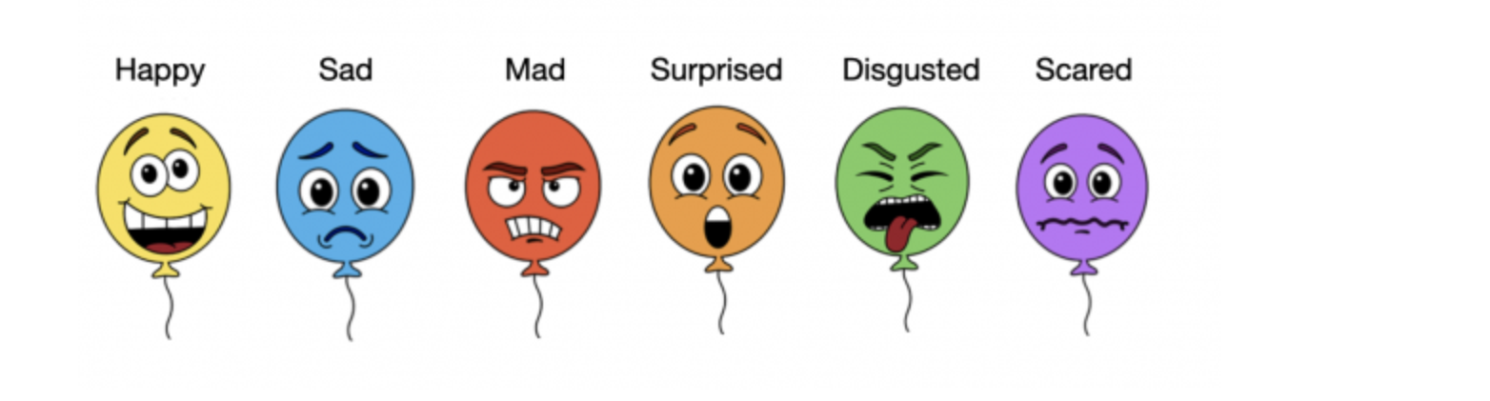
After watching the video, to understand how children’s emotions were moved by the awe-inspiring video, children were first asked to freely respond with a description in their own words of how watching the video made them feel. Next, children were asked to indicate their emotions by selecting from the same word-image pairs of basic emotions as we did for baseline. Finally, to see if children could recognize the facial expression of awe and its elicitors, children were presented with two child photos in a random order: one with a facial expression typical of a person in awe (with raised head, widened eyes and open mouth; Shiota et al., 2003; Awe emotion recognition) and the other with a happy facial expression (Happy emotion recognition), Figure S2. For each facial expression, children were asked to identify whether the experience depicted in each of three images (i.e., vast nature, playground, jack-in-the-box) could make the child in the photo feel the way they looked. We hypothesized that the three images may be perceived as most likely to elicit facial expressions of awe, happiness, and surprise respectively (see supplemental materials for testing stimuli in this study).
Figure S2
Images for Awe (left) and Happy (right) Recognition questions in Study S1


Adult participants watched the same awe-inspiring video and responded to the same questions through a Qualtrics survey on TurkPrime. To ensure data quality and check for attention in this and subsequent studies, after watching the video, adults were asked to identify from a list of items (i.e., a waterfall, the desert, a cat, outerspace) the particular item that was not in the video (i.e., a cat).
Results and Discussion
Open-Ended Response
Participants provided free responses about how the awe-inspiring experience made them feel. We were especially interested in if the participant mentioned any positive and non-positive emotions. The first author and a research assistant coded adult responses in terms of four non-exclusive thematic categories: positive affect; non-positive affect; small self or insignificance; other. Each response was coded in terms of whether it mentioned each category (coded as 1) or not (coded as 0). Any disagreement was resolved through discussions together with a third researcher. Positive affect responses included reports of positively-valenced states such as awe, inspiration and calmness, whereas responses that communicated neutral or negative emotional states like surprise and fear were coded as non-positive affect responses. Responses that included notions of expressing perceptions of small self size were coded as small self or insignificance. All responses that did not fall into one of these three categories were coded as other. Child responses were coded in the same way, except that the small-self or insignificance category was omitted due to no expressions of perceived small self size or relative insignificance among children.
For adult open-ended responses, a generalized linear mixed effect model indicated that there was a significant difference between the frequency of the four categories, χ²(3, N = 101) = 111.1, p < .001. Of the 101 adult responses provided, 69% mentioned positive affect (e.g., “The natural beauty of our planet is awe inspiring.”), 9% were categorized as non-positive affect (e.g., “Apart from the field of flowers, it somewhat scared me.”), 19% were categorized as small self or insignificance (e.g., “It makes me feel small and insignificant.”), and 15% of all responses were coded as other. The intercoder agreement was 96% for the positive affect category (Cohen’s K = 0.91, z = 9.09, p < .001) ; 87% for non-positive affect (Cohen’s K = 0.17, z = 1.65, p = .099); 100% for small-self or insignificance (Cohen’s K = 1, z = 10.0, p < .001), and 90% for other (Cohen’s K = 0.66, z = 6.7, p < .001) .
For children’s open-ended responses, a generalized linear mixed effect model indicated that there was also a significant difference between the frequency of the three categories, χ²(2, N = 55) = 45.16, p < .001. Of the 55 child responses (one child did not provide an response), 68% were coded as positive affect (e.g., “It made me feel excited.”), 38% were categorized as non-positive affect (e.g., “It makes me feel scared and surprised and worried.”), and the remaining 9% were categorized as other. The intercoder agreement was 100% for positive affect (Cohen’s K = 1, z = 7.42, p < .001); 93% for non-positive affect (Cohen’s K = 0.85, z = 6.31, p < .001), and 93% for other (Cohen’s K = 0.74, z = 5.5, p < .001). These provide initial evidence that children, similar to adults, experience awe as positive, with some emotions like surprise and fear.
Self-Reported Emotion Ratings
We compared adult ratings for basic emotions before and after watching the awe-inspiring video by conducting a generalized linear mixed effects model with the lme4 package (Bates et al., 2015) using emotion type, testing question (pretest vs. posttest), and their interaction to predict adult responses, with a random intercept for each participant. According to the “drop1” function in R (likelihood ratio test comparing the full model to a model without the interaction), we found a significant interaction between emotion and question in improving the model fit, χ²(6, N = 101) = 19.67, p = .003. We then looked at pretest and posttest differences for each individual emotion (Happiness, Sadess, Anger, Surprise, Disgust, and Fear) using paired-samples Wilcoxon test. We found a significantly higher level of surprise for posttest (M = 0.22) than for pretest (M = 0.03) (z = -3.78, p < .001), but not for other emotions (ps > .24 for all other comparisons).
We conducted a similar model with children’s data and found that the interaction between emotion and question also significantly improved the model fit, χ²(6, N = 56) = 36.00, p < .001. We also included age as a moderator in the model and did not find that age moderated the interaction effects, χ²(6, N = 56) = 8.84, p = .18. Paired-samples Wilcoxon tests indicated a significant difference between pretest and posttest emotions for happiness (pretest M = 0.95, posttest M = 0.73, z = -2.97, p = .003), surprise (pretest M = 0.14, posttest M = 0.45, z = -3.26, p = .001), fear (pretest M = 0.07, posttest M = 0.25, z = -2.33, p = .02), and sadness (pretest M = 0.04, posttest M = 0.18, z = -2.47, p = .013), but not for anger (pretest M = 0.05, posttest M = 0.05, z = -0.8, p = 0.423) or disgust (pretest M = 0.02, posttest M = 0.00, z = 0, p = 1). These results show that adults and children both report an increase in feelings of surprise after the awe experience, relative to the neutral experience, and that children also feel greater sadness and fear after the awe experience.
Emotion Recognition
We conducted a chi-square test of independence to examine adult responses to each emotion recognition question. For Awe recognition, the difference between people’s choices for the three elicitors was significant, χ²(2, N = 101) = 39.98, p < .001. We then performed a binomial test to compare their choice for each option to chance level (0.33). We found that adults chose the vast nature image most often and at a significantly higher rate than chance level (M = 0.63, p < .001, d = 0.63), and they chose the playground (M = 0.16, p < .001, d = 0.47) and jack-in-the-box images (M = 0.21, p = .008, d = 0.30) significantly lower than chance level. For Happy recognition, adults also significantly distinguished the three possible options, χ²(2, N = 101) = 42.14, p < .001. Only a very small percentage of adults chose the vast nature image as eliciting the happy expression (M = 0.03, p < .001, d = 1.76), and they selected the jack-in-the-box image (M = 0.52, p < .001, d = 0.39 ) and the playground image (M = 0.45, p = .020, d = 0.23) significantly higher than chance. The findings suggest that adults expect the vast nature experience to elicit awe expressions but not happiness expressions.
We also conducted a similar chi-square test of independence to analyze children’s responses to each emotion recognition question. Similar to adults, children also distinguished the three elicitors for the Awe emotion recognition question, χ²(2, N = 56) = 39.98, p < .001. A subsequent binomial test showed that children chose the vast nature image most often and significantly higher than chance level (0.33; M = 0.64, p < .001, d = 0.65), and they chose the playground (M = 0.14, p = .002, d = 0.53) and jack-in-the-box images (M = 0.21, p = .065, d = 0.28) lower than chance level, suggesting that children perceive the typical awe expression as a response to awe-inspiring scenes. For Happy emotion recognition, children’s selections of the three possible options were significantly different, χ²(2, N = 56) = 32.40, p < .001. Binomial tests indicated that children chose the playground image (M = 0.59, p < .001, d = 0.52), but not the vast nature (M = 0.13, p < .001, d = 0.61) and jack-in-the-box images (M = 0.29, p = 0.48, d = 0.10) images significantly higher than chance level (0.33), showing that children did not perceive awe-inspiring scenes as a primary elicitor for happiness expressions. To examine potential age changes, we conducted generalized linear models using age to predict children’s responses. We found that children become more likely to select the vast nature image as an elicitor for the awe expression with age (p = .04), and there are no age effects on other responses (ps > .08).
The results from this study suggest that consistent with the theorizing in the literature (Keltner & Haidt, 2003), children perceive a mixed composition of relevant basic emotions after an awe-inspiring experience, which involves some levels of surprise, fear, and sadness but not anger or disgust. In particular, our findings show that an awe experience led to a much higher level of surprise in both children and adults compared to their baseline feelings, which is consistent with the view that awe experiences involve an element of surprise and sense of accommodation (Keltner & Haidt, 2003). The results also show that children and adults are generally accurate at identifying the facial expression of awe and recognizing vast nature as its elicitor, which is distinct from the expression and elicitor of happiness. Together, these initial findings suggest that basic perceptions and understanding of awe-inspiring experiences are present in childhood, which inspire questions about whether children are also able to appreciate awe-inspiring experiences differentially from other kinds of experiences in terms of social, cognitive and motivational dimensions, the focus of our next three studies.
- Example of stimuli for comparative questions in Study 1
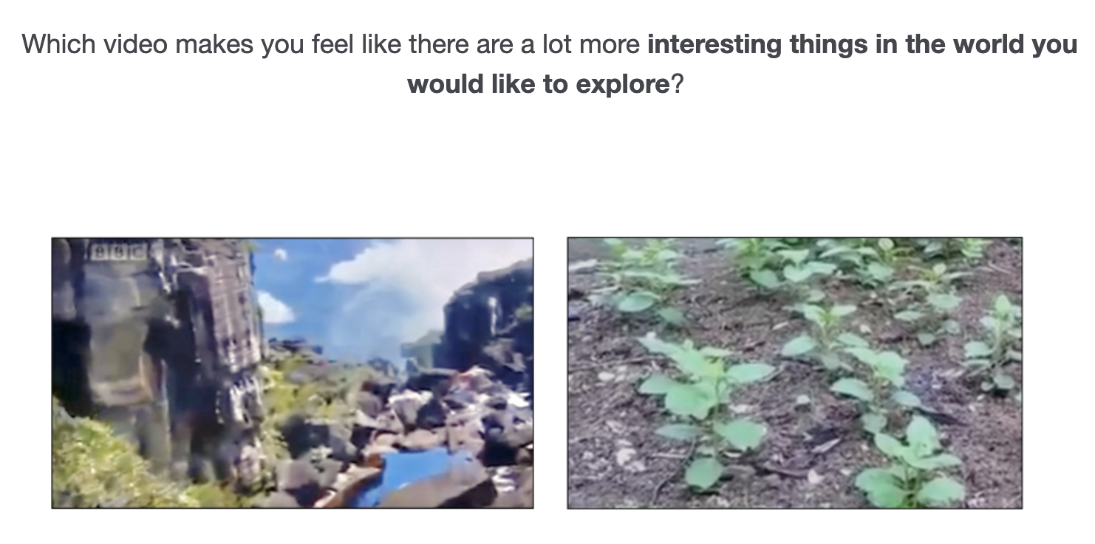

- Example stimuli for familiarization questions in Study 1 and Study 2.
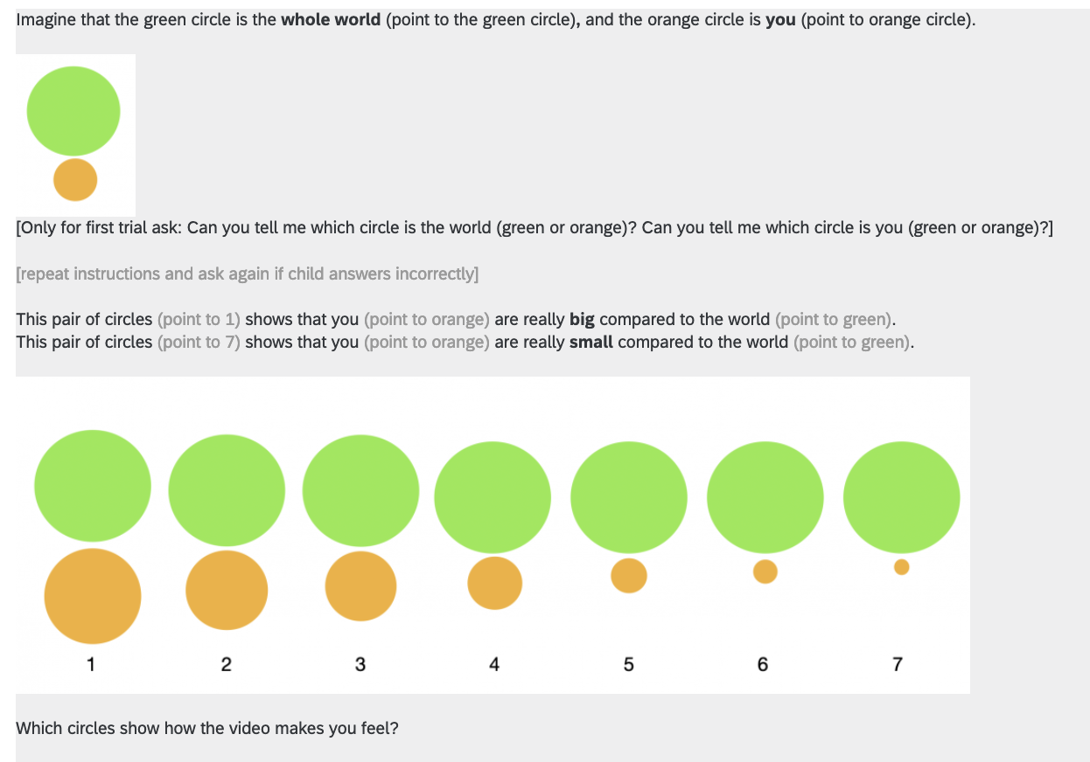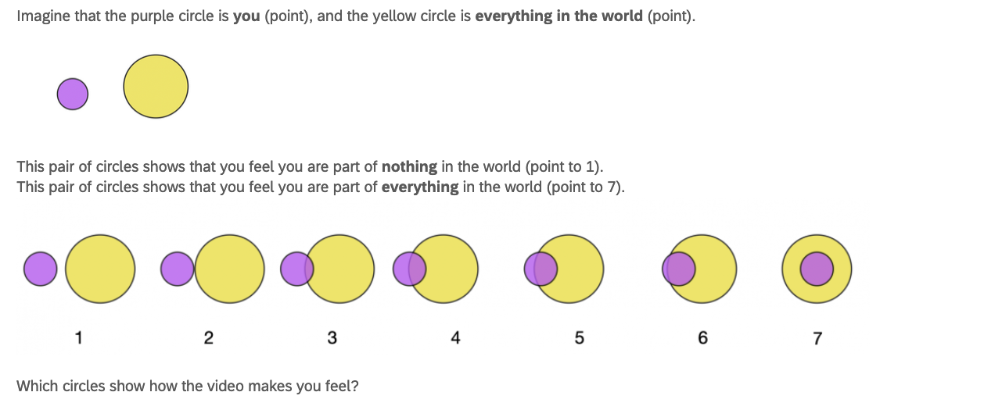
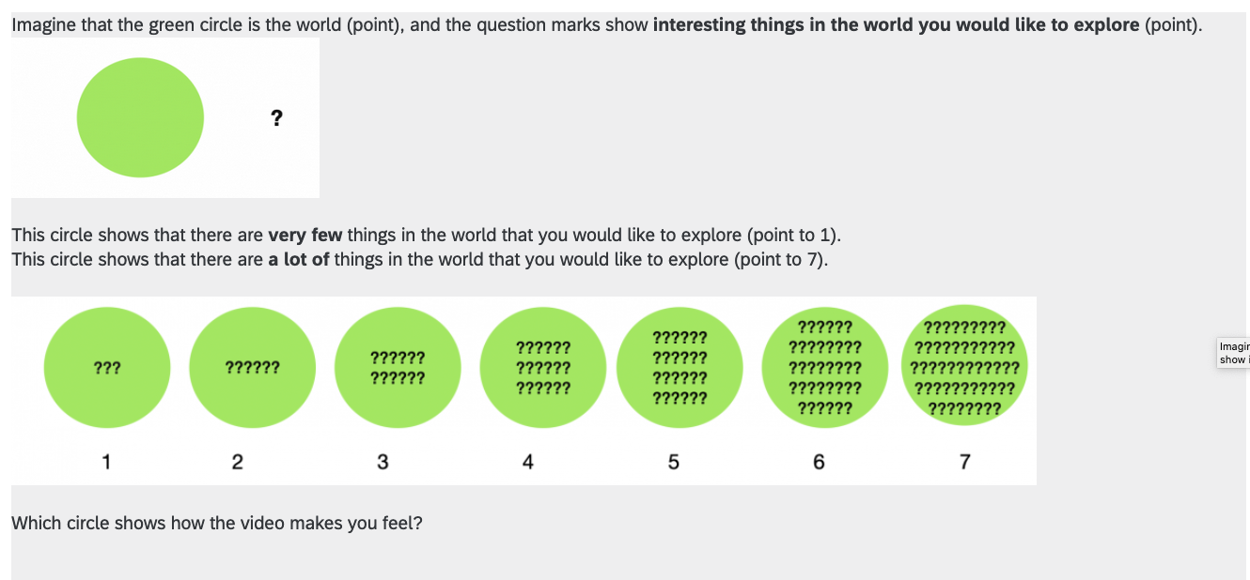
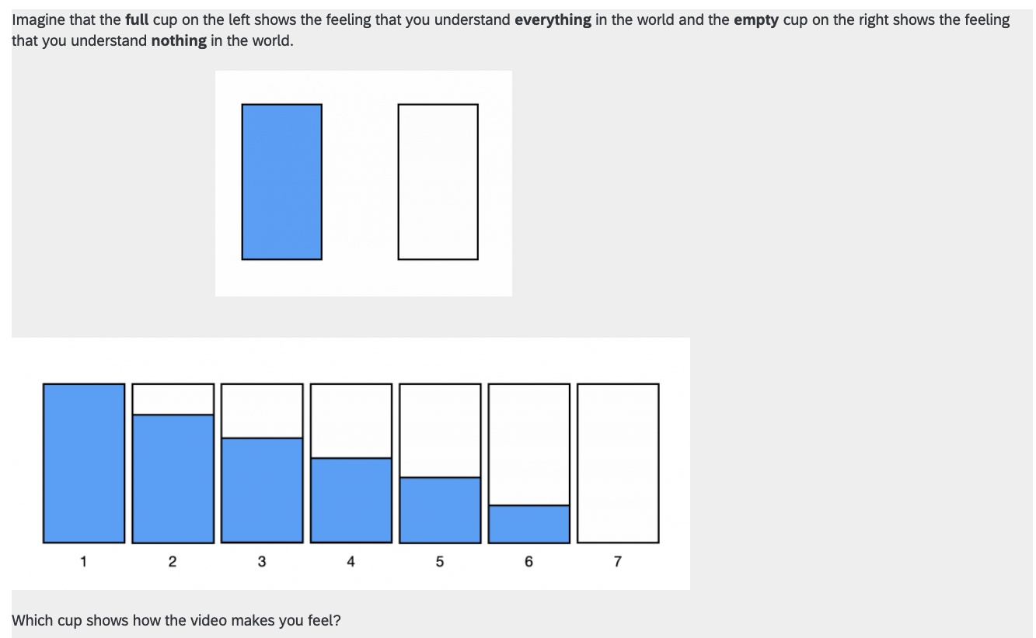
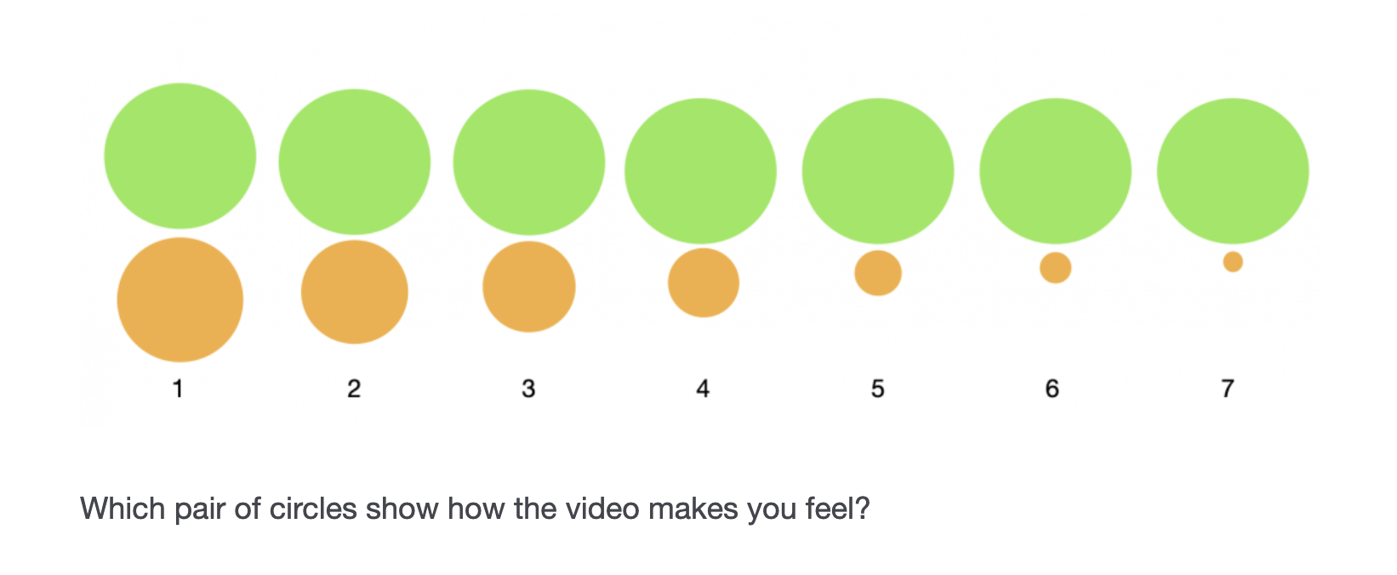
- Procedure and analyses of familiarization questions in Study 1 and Study 2
In Studies 1 and 2, after watching each video, participants answered questions about the way the videos made them feel. The questions were mainly used to familiarize children with the measures, and we did not expect them to be sensitive enough to detect children’s capacity to differentiate the experiences of the two videos. Based on modified procedure in Colantonio & Bonawitz (2018), participants were shown graphical depictions of the measures and then rated how the video made them feel in the following order: Perceived Vastness: Participants were shown circles representing themselves and the world with different ratios (i.e., 1 = they are really big in relation to the world, 7 = they are really small in relation to the world) and rated their perceived self-size in comparison to the world; Sense of Connectedness: Participants viewed overlapping circles representing themselves and the world and rated how the video made them feel (i.e., 1 = they are part of nothing in the world, 7 = they are part of everything in the world) and rated which pair of circles depicted themself and the world; Motivation to Explore: Participants rated how many interesting things in the world they felt like they would like to explore on a scale from (1 = few, 7 = many); Awareness of Unknown: Participants rated how much they felt they knew about everything in the world on a scale from 1 to 7 (see Figure A1 for an example of the stimuli).
In both studies, to see if children’s responses to the videos were significantly predicted by an interaction of condition and measure, we conducted an overall, linear model and used the drop1 function in R to see if the interaction term significantly improved the model fit. In Study 1, the interaction of condition and measure on child response was not significant, χ2(3, N = 62) = 1.38, p = 0.25. We found that “measure” improved the model fit, χ2(3, N = 62) = 32.09, p < 0.001, but condition did not, χ2(1, N = 62) = 2.13, p = 0.15.
In Study 2, we found a significant interaction of condition and measure on child response, χ2(3, N = 72) = 6.74, p < 0.001. We then conducted separate linear mixed models for each of the four dependent variables in Study 3 to see if condition significantly affected participant responses. We did not find a significant effect of condition in terms of Motivation to Explore χ2(1, N = 72) = 3.09, p = 0.082. But we found that the threatening awe experience (M = 5.01) was more likely than the neutral experience (M = 3.92) to led children feel the world as bigger (Perceived Vastness; χ2(1, N = 72) = 10.72, p = .002), and the threatening awe experience (M = 3.86) was also more likely than the neutral experience (M = 3.03) to motivate children to understand more things in the world (Awareness of Unknown; χ2(1, N = 72) = 10.89, p = .002). In contrast, compared to the neutral experience (M = 5.39), the threatening awe experience (M = 4.64) led to a lower sense of connection to everything in the world (Sense of Connection; χ2(1, N = 72) = 5.39, p = .023).
- Example of stimuli in Study 2
Footage images from the natural disaster video:

Image for testing questions in Study 2
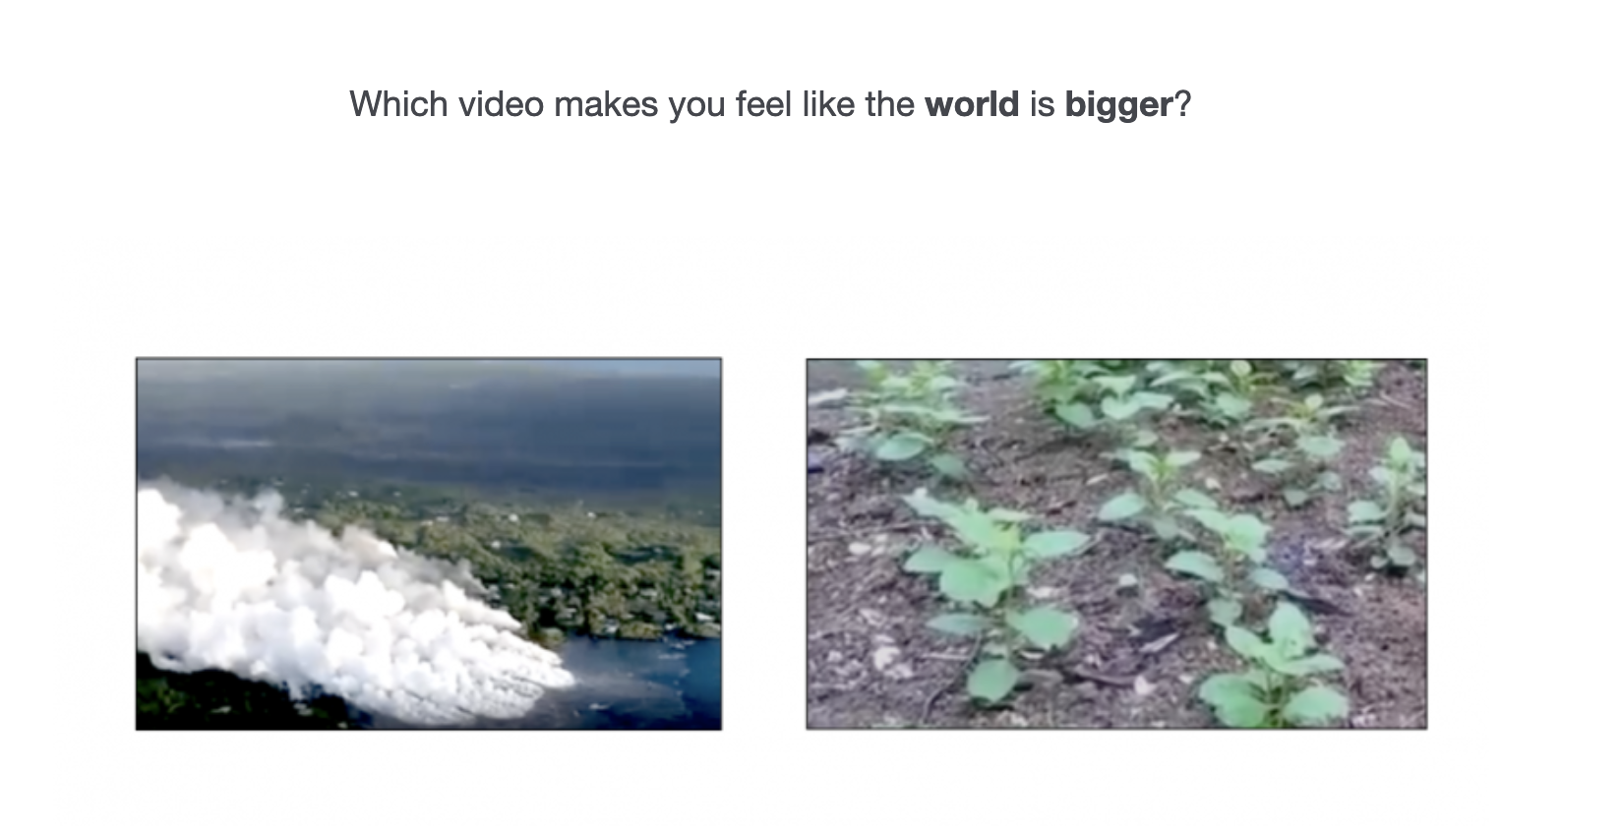
- Example of stimuli for comparative questions in Study 3.
Images from the crowd video in Study 3:

Image for testing questions in Study 3:
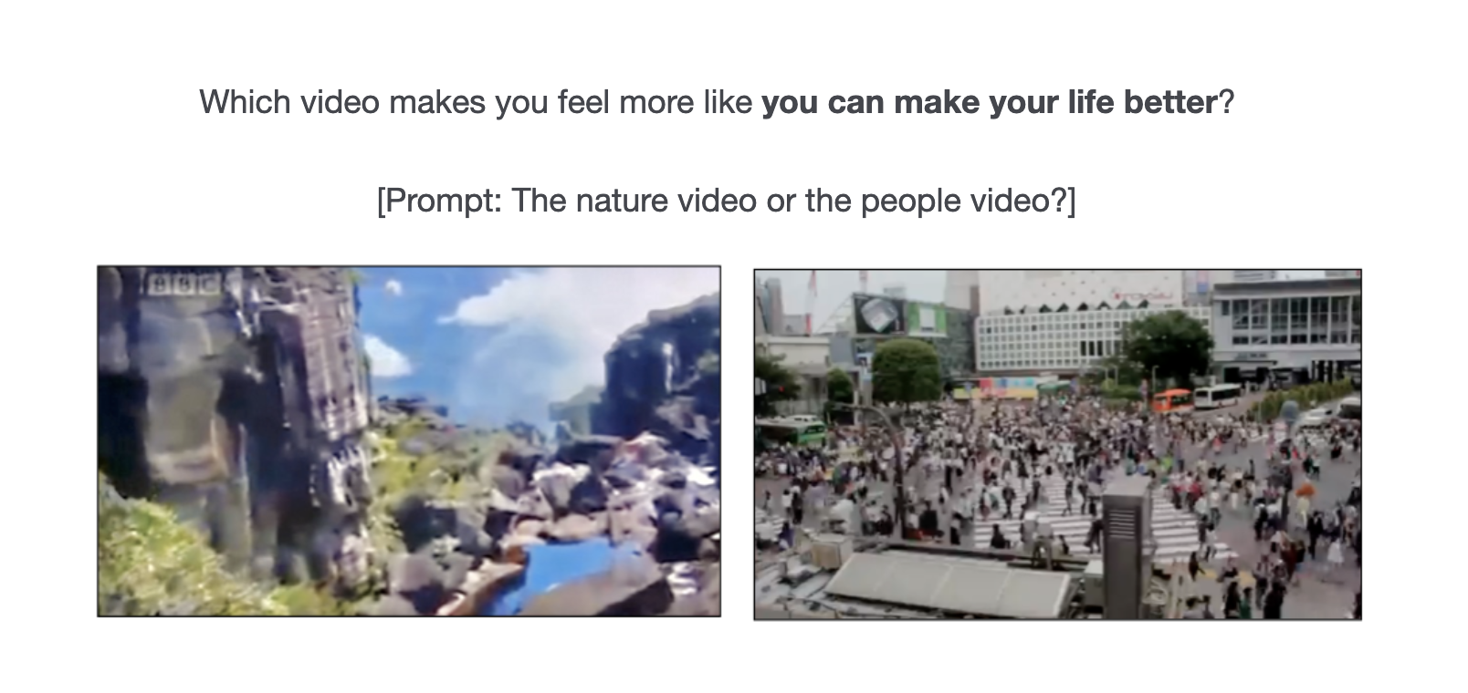
- Analyses and results for adult participants in Study 4
To get a sense of how viewing the images made adults feel, we conducted an overall generalized linear mixed effects model using condition (nature, disaster, motion), measure, and their interaction to predict their responses, with a random intercept for each participant. We found that the interaction term significantly improved model fit, χ²(14, N = 194) = 242.84, p < .001. To understand the interaction, we then conducted separate generalized linear mixed effects models for each condition using “measure” to predict their responses. We found that measure significantly improved the model fit in the nature condition, χ²(7, N = 64) = 216.02, p < .001, the disaster condition, χ²(7, N = 64) = 366.14, p < .001, and the motion condition, χ²(7, N = 66) = 211.63, p < .001.
Nature condition. Binomial tests indicated that the nature images (coded as 1), in comparison to the everyday images (coded as 0), led adults to feel a greater sense of awe (M = 0.97, SD = 0.18, p < .001, d = 2.67), joy (M = 0.89, SD = 0.31, p < .001, d =1.24) and fear (M = 0.77, SD = 0.47, p = .008, d = 0.36), to perceive themselves as smaller in comparison to the world (M = 0.88, SD = 0.33, p < .001, d = 1.13), to feel an overall increased motivation to explore things (M = 0.91, SD = 0.29, p < .001, d = 1.38) and to perceive themselves as part of a world much bigger than themselves (M = 0.91, SD = 0.29, p < .001, d = 1.38). In addition, the nature images were less familiar to adults (M = 0.09, SD = 0.29, p < .001, d = 1.38), but significantly more liked (M = 0.94, SD = 0.24, p < .001, d = 1.79) than the everyday images.
Disaster condition. Binomial tests indicated that the natural disaster images, in comparison to the everyday images, led adults to feel a greater sense of awe (M = 0.92, SD = 0.27, p < .001, d = 1.56) and fear (M = 0.97, SD = 0.18, p < .001, d = 2.67), to perceive themselves as smaller in comparison to the world (M = 0.95, SD = 0.21, p < .001, d = 2.13), to feel an overall increased motivation to explore things (M = 0.80, SD = 0.41, p < .001, d = 0.73), and to perceive themselves as part of a world much bigger than themselves (M = 0.86, SD = 0.35, p < .001, d = 1.03). The disaster images were less familiar to adults (M = 0.03, SD = 0.18, p < .001, d = 2.67). Unlike the Nature condition, the disaster images were not preferred (M = 0.30, SD = 0.46, p = .002, d = 0.44) than the everyday images and also did not lead adults to feel a greater sense of joy (M = 0.11, SD = 0.31, p < .001, d = 1.24).
Slow Motion condition. Binomial tests indicated that the slow motion images, in comparison to the everyday images, led adults to feel a greater sense of awe (M = 0.97, SD = 0.17, p < .001, d = 2.72) and fear (M = 0.67, SD = 0.48, p = .009, d = 0.35), to feel an overall increased motivation to explore things (M = 0.80, SD = 0.40, p < .001, d = 0.76). As in the other two conditions, the nature images were less familiar to adults (M = 0.03, SD = 0.17, p < .001, d = 2.72). Unlike the Nature and Disaster conditions, compared to the slow motion images, the everyday images led people perceive themselves as smaller in comparison to the world (M = 0.33, SD = 0.48, p = .009, d = 0.35) and to perceive themselves as part of a world much bigger than themselves (M = 0.24, SD = 0.43, p < .001, d = 0.60). Similar to the Disaster condition, the slow motion images were not significantly more liked (M = 0.56, SD = 0.50, p = .389, d = 0.12) than the everyday images, and they did not lead adults to feel a greater sense of joy (M = 0.44, SD = 0.50, p = .009, d = 0.35).

