Supporting Information
Elucidating Dynamic Conductive State Changes in Amorphous Lithium Lanthanum Titanate for Resistive Switching Devices
Ryosuke Shimizu¹, Diyi Cheng², Guomin Zhu¹, Bing Han¹, Thomas S. Marchese³, Randall Burger¹, Mingjie Xu⁴, Xiaoqing Pan⁴, Minghao Zhang^{1,*}, and Ying Shirley Meng^{1,3,*}

¹Department of NanoEngineering, University of California San Diego, La Jolla, CA, USA.
²Materials Science and Engineering Program, University of California San Diego, La Jolla, CA, USA.
³Pritzker school of Molecular Engineering, University of Chicago, Chicago, IL, 60637, USA ⁴Irvine Materials Research Institute, University of California Irvine, Irvine, California 92697, USA

* Co-correspondence: miz016@eng.ucsd.edu, shirleymeng@uchicago.edu

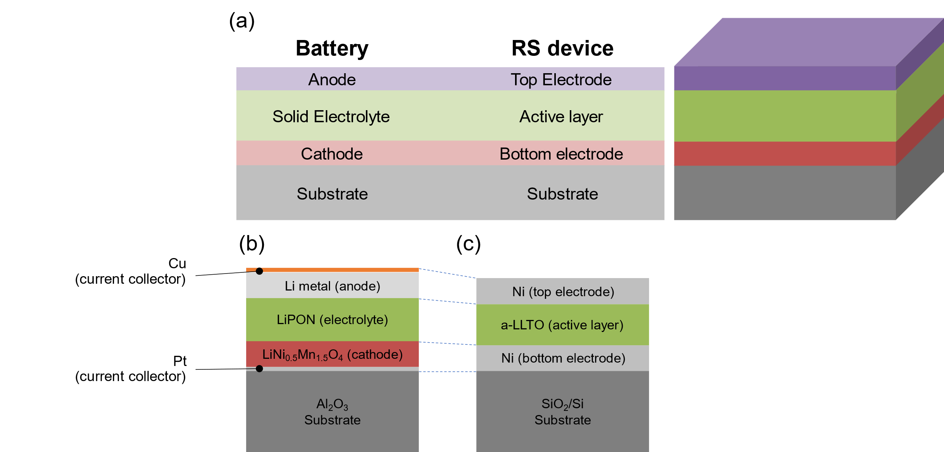
Figure S1. Structural similarities of all solid-state thin-film battery and resistive switching (RS) device. (a) Configuration comparison of two devices. Example of (b) LiNi_{0.5}Mn_{1.5}O₄/LiPON/Li-metal battery (our past work¹) and (c) Ni/a-LLTO/Ni resistive switching device (this work)
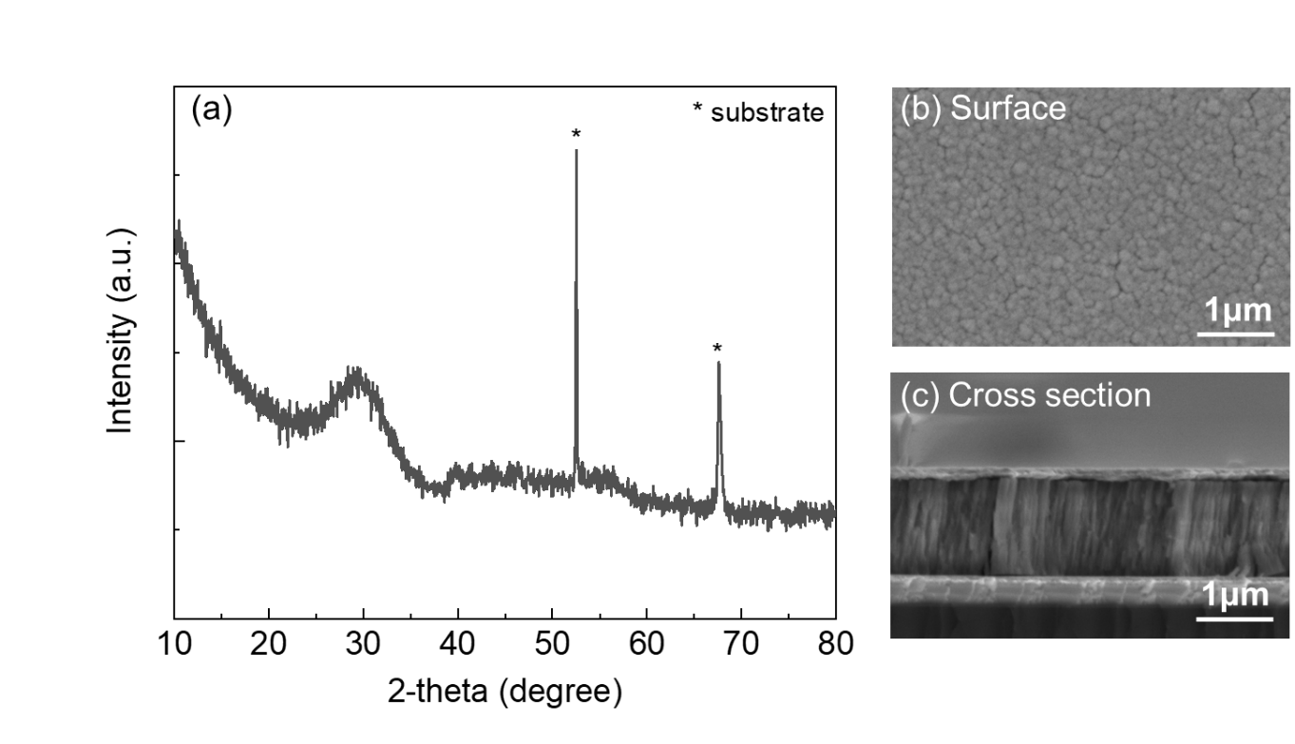
Figure S2. Basic structural and morphological characterization of a-LLTO thin film. (a) XRD pattern of a-LLTO deposited on Pt-coated SiO₂/Si substrate. (b) Surface and (c) cross-sectional SEM images of a-LLTO thin film. Cross-sectional image of LLTO film was taken by cleaving the substrate.

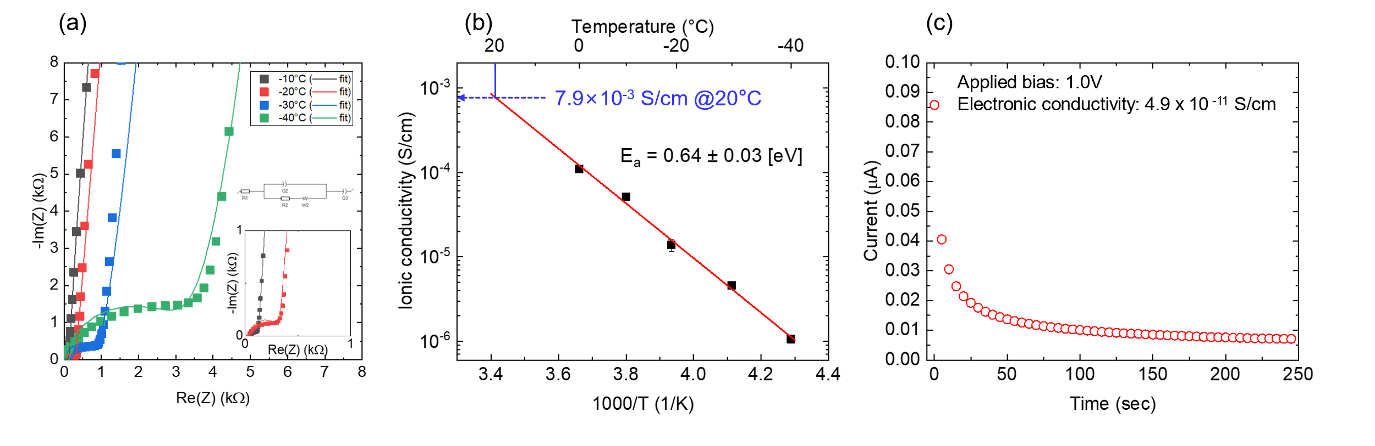
Figure S3. Basic electrochemical characterization of a-LLTO thin film. (a) Electrochemical impedance spectroscopy of a-LLTO deposited on Pt-coated SiO₂/Si substrate at different temperatures. (b) Arrhenius plot of a-LLTO ionic conductivity at various temperatures. Fitting was conducted for the data acquired at -10°C or less since semicircle feature is less obvious for those acquired at higher temperatures. Ionic conductivity of a-LLTO at room temperature is estimated through the extrapolation of least square fit of Arrhenius plot. (c) I-t plot of DC polarization measurement, where 1.0 V was applied to a-LLTO.
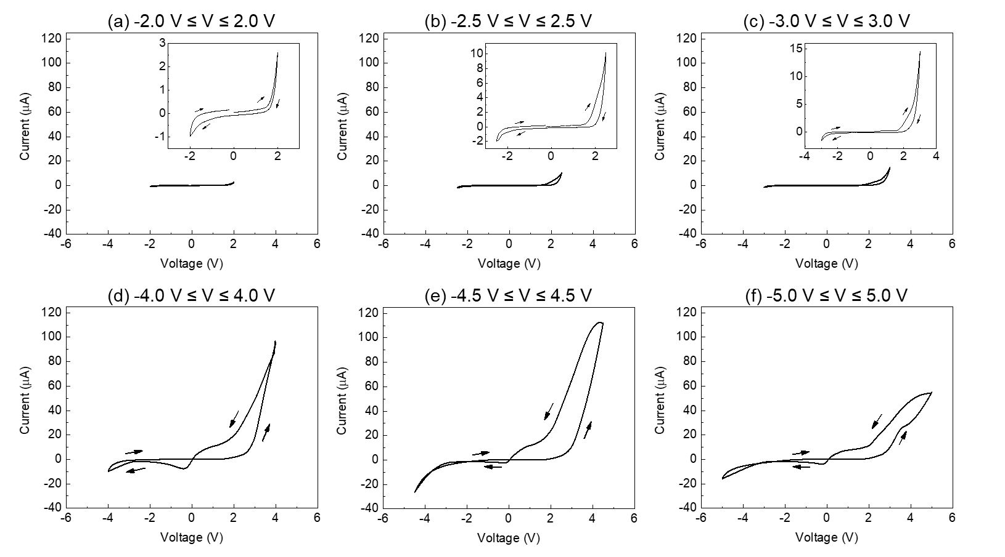
Figure S4. Linear I-V plot in different voltage range. (a) -2.0 V ≤ V ≤ 2.0 V, (b) -2.5 V ≤ V ≤ 2.5 V, (c) -3.0 V ≤ V ≤ 3.0 V, (d) -4.0 V ≤ V ≤ 4.0 V, (e) -4.5 V ≤ V ≤ 4.5 V, and (f) -5.0 V ≤ V ≤ 5.0 V. Inset figures in (a), (b), and (c) are magnified images of respective plots.

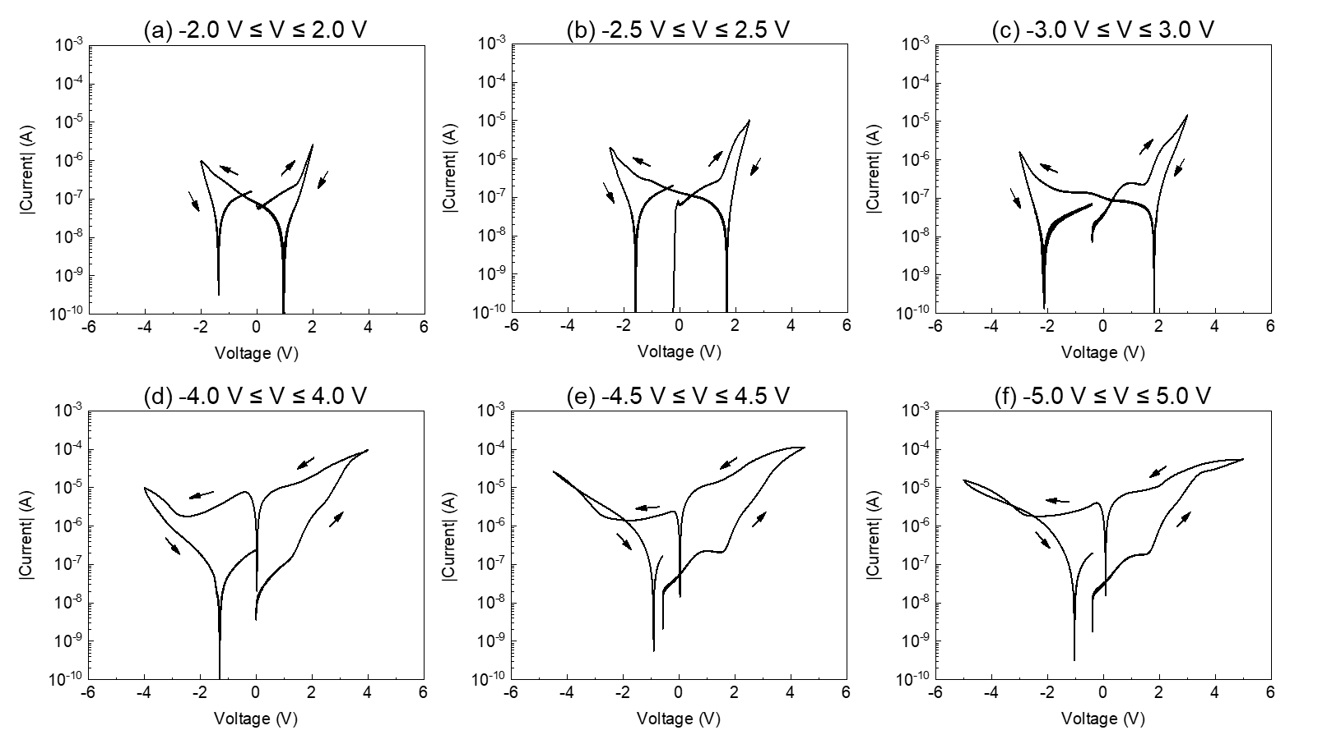
Figure S5. Log |I|-V plot in different voltage range. (a) -2.0 V ≤ V ≤ 2.0 V, (b) -2.5 V ≤ V ≤ 2.5 V, (c) -3.0 V ≤ V ≤ 3.0 V, (d) -4.0 V ≤ V ≤ 4.0 V, (e) -4.5 V ≤ V ≤ 4.5 V, and (f) -5.0 V ≤ V ≤ 5.0 V. These are log |I| plot from Figure S2. The absolute value of the current in Figure S2 are used to make these plots.

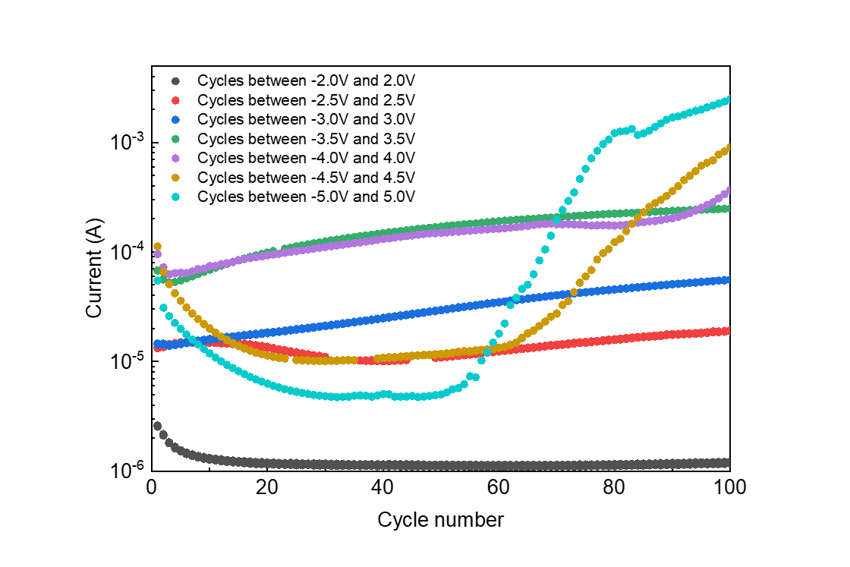
Figure S6. Cycling stability of Ni/LLTO/Ni system. End point current vs. cycle number. For example, current at 3.5 V when voltage is swept between -3.5 and 3.5 V (= end-point current) is used as a current value in the plot.

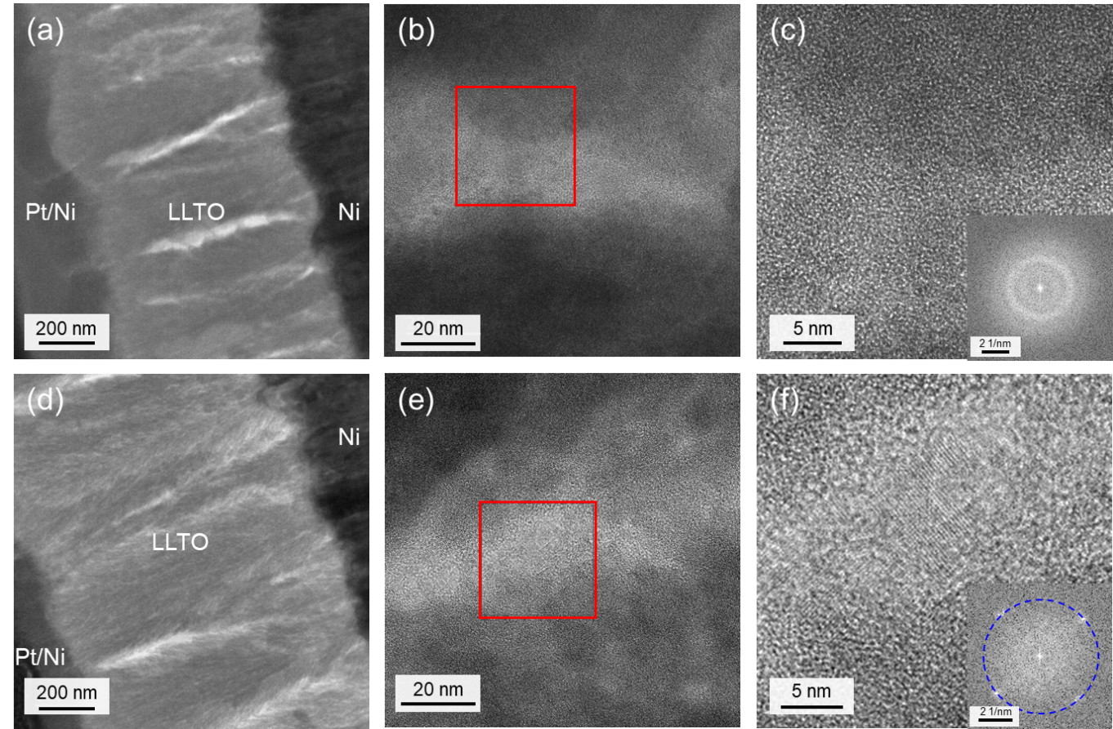
Figure S7. TEM images of pristine and after-biasing state of LLTO. (a) Zoom-out and (b) magnified TEM images of pristine LLTO. (c) Further magnified images of the area surrounded by red square in (b) with (inset) FFT image. (d) Zoom-out and (e) magnified TEM images of LLTO after biasing up to 5 V. (c) Further magnified images of the area surrounded by red square in (e) with (inset) FFT image. Periodic pattern is found in its FFT image, which is equivalent to the structure with d-spacing at 2.98 Å.

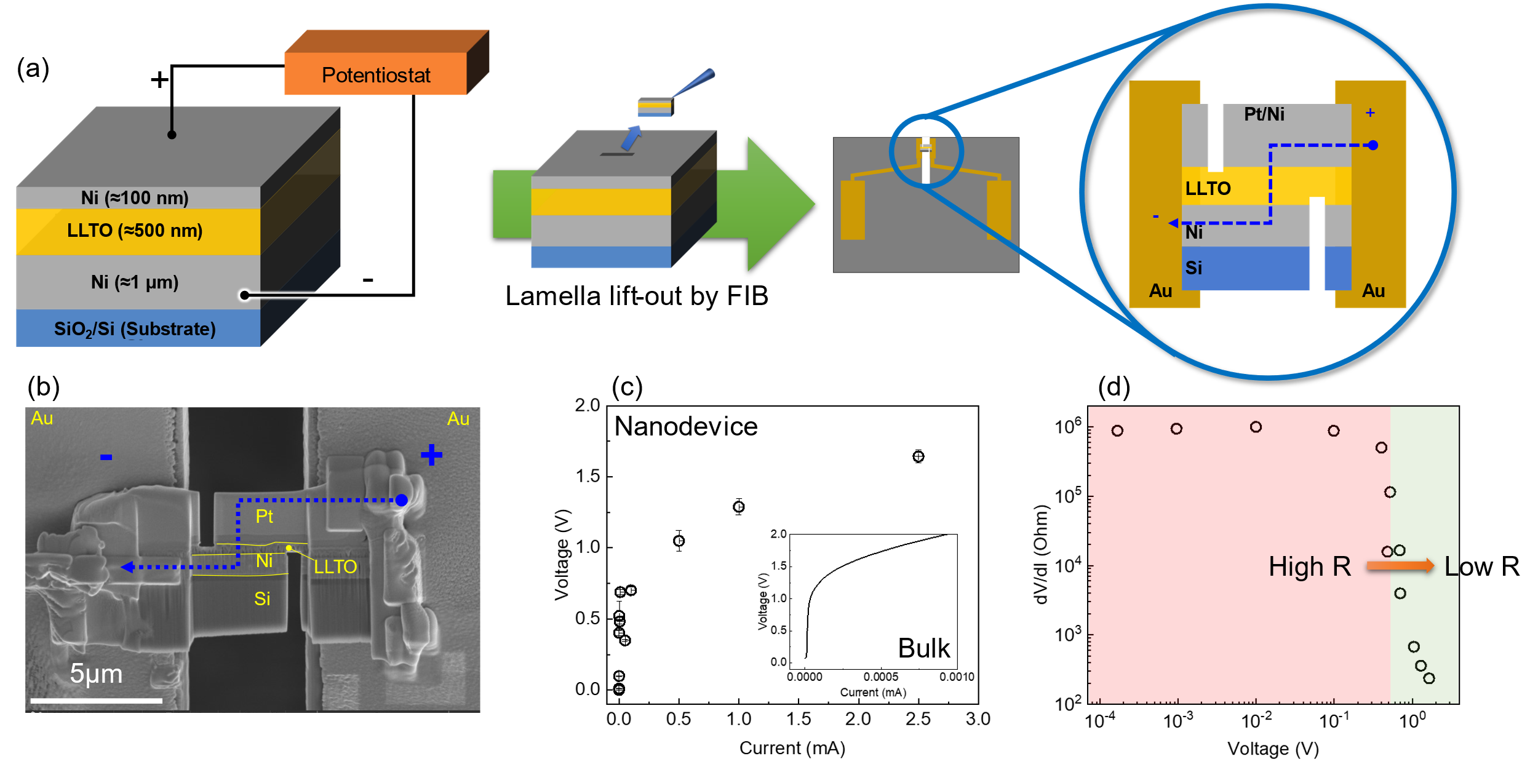
Figure S8. Fabrication and testing results of LLTO nanodevice in FIB-SEM. (a) Experimental configuration of bulk Ni/LLTO/Ni device and nanodevice fabrication inside FIB-SEM on a biasing chip. (b) SEM image of the fabricated nanodevice, where Pt is deposited in FIB as an additional conductive layer and bond for lamella to chip. (c) V-I plot of constant current bias testing with comparison to the bulk device result (inset, replot from Figure 1 (a)). (d) Differential resistance, dV/dI, vs. measured voltage, calculated from (c).

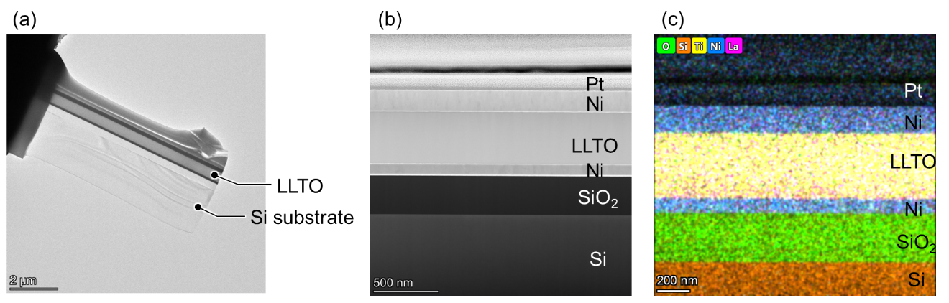
Figure S9. Structural and chemical analysis of O-vacant LLTO by STEM-EDS. STEM images of Ni/LLTO/Ni device at (a) zoom-out and (b) zoom-in. EDS mapping image of Ni/LLTO/Ni. Top layer is covered with Pt to protect the surface during milling procedure. EDS elemental analysis shows O/Ti ratio of O-vacant LLTO that was deposited at vacuum state without O₂ feed is 2.25, while that of pristine LLTO (0.26 mbar) is around 2.99.

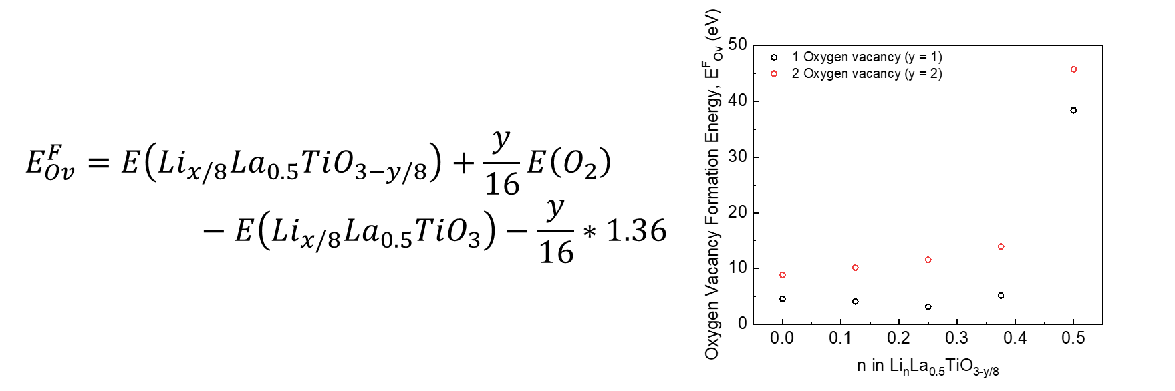
Figure S10. Oxygen vacancy formation energy. (a) Formula to calculate oxygen vacancy formation energy per unit formula². Here $x$ and $y$ represents number of lithium and oxygen atoms in supercells, respectively, that are used in DFT calculation. (b) Oxygen vacancy formation energy as a function of lithium composition n in Li_{n}La_{0.5}TiO_{3-y/8}, where n = x/8.

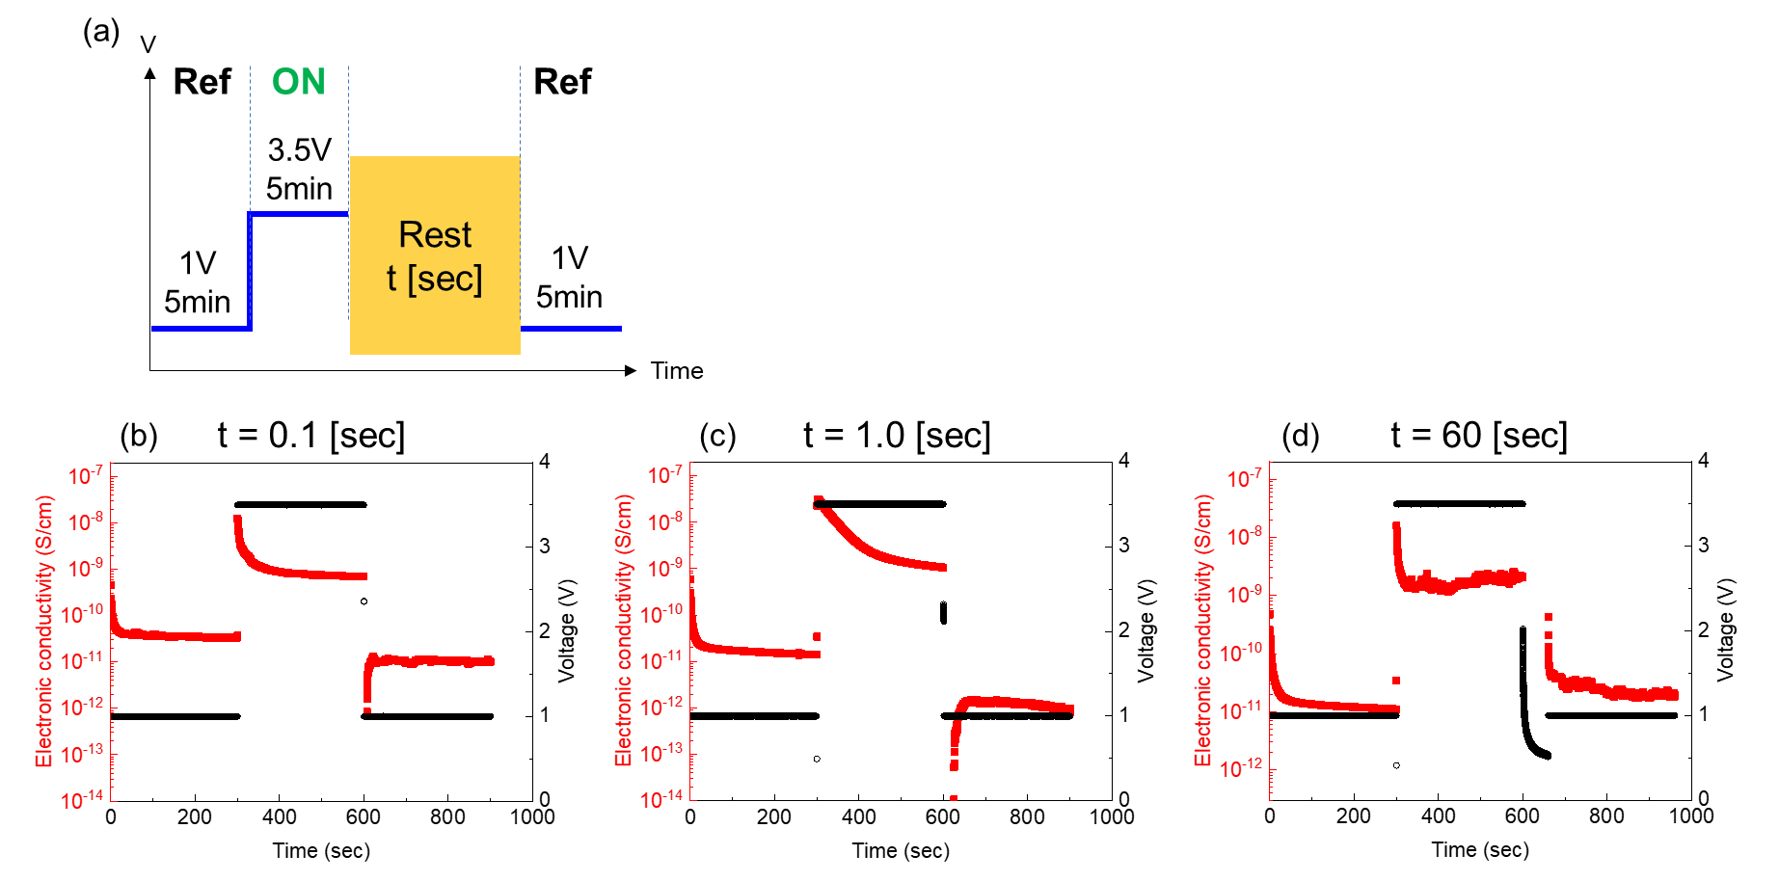
Figure S11. DC polarization test of Ni/LLTO/Ni. (a) Testing protocol of the device. DC polarization results with variable rest time: (b) t = 0.1 [sec], (b) t = 1.0 [sec], and (c) t = 60 [sec]. Here cross-section area and thickness are ≈ 0.01 cm². Thickness of samples used in (b), (c), and (d) are measured as 355, 309, and 426 nm, respectively.

References
(1) Shimizu, R.; Cheng, D.; Weaver, J. L.; Zhang, M.; Lu, B.; Wynn, T. A.; Burger, R.; Kim, M.; Zhu, G.; Meng, Y. S. Unraveling the Stable Cathode Electrolyte Interface in All Solid-State Thin-Film Battery Operating at 5 V. Advanced Energy Materials 2022, 2201119. https://doi.org/10.1002/aenm.202201119.
(2) Wang, L.; Maxisch, T.; Ceder, G. Oxidation Energies of Transition Metal Oxides within the GGA+U Framework. Phys. Rev. B 2006, 73 (19), 195107. https://doi.org/10.1103/PhysRevB.73.195107.

