SUPPLEMENTARY TEXT
Table of Contents
Part A. CT Scan Parameters
Part B. Theoretical Modelling of Hyoid Position Change Across IHP Change
Part C. Supplementary Tables and Figures

Part A: CT Scan Parameters
Table S1. Scan parameters
Parameter | Static hyoid position measurement across different posture-gape combinations |  |  |  |  |  | DiceCT on suprahyoid muscle length
Parameter | Opossum AI | Opossum H | Opossum K | Opossum L | Opossum M | Opossum W | OBA Didelphis (unstained) | OBA Didelphis (stained)
Scanner | Vimago veterinary CT scanner | Vimago veterinary CT scanner | Vimago veterinary CT scanner | Vimago veterinary CT scanner | Vimago veterinary CT scanner | Vimago veterinary CT scanner | GE phoenix v|tome|x | GE phoenix v|tome|x
kV | 80 | 80 | 80 | 80 | 80 | 80 | 170 | 190
mA | 60 | 60 | 60 | 60 | 60 | 60 | 290 | 310
Exposure (ms) | 6 | 6 | 6 | 6 | 6 | 6 | 333 | 333
Voxel width (μm) | 300 | 300 | 300 | 300 | 300 | 300 | 75.3460 | 77.5480
Filter | none | none | none | none | none | none | none | 0.5 mm Cu

Part B: Theoretical Modelling of Hyoid Position Change Across IHP Change
The following paragraphs describe the trigonometric model used to calculate expected changes in hyoid X and Y coordinates if the hyoid is perfectly coupled to vertebral column during head flexion/extension. We repeated the following steps for small gape, medium gape and large gape.

The input parameters of the model include species mean hyoid X and Y coordinates at small gape, flexed posture; the minimum and maximum observed head-neck angles in the dataset; species mean distance from the hyoid to the foramen magnum (FM), and species mean distance from PNS to FM.

First, the angle θ between the PNS_FM line and the hyoid_PNS line is calculated using the equation following the cosine law:

∠θ = arccos((PNS_FM² + Hyoid_PNS² - Hyoid_FM²)/(2 x PNS_FM x Hyoid_PNS)) (1)
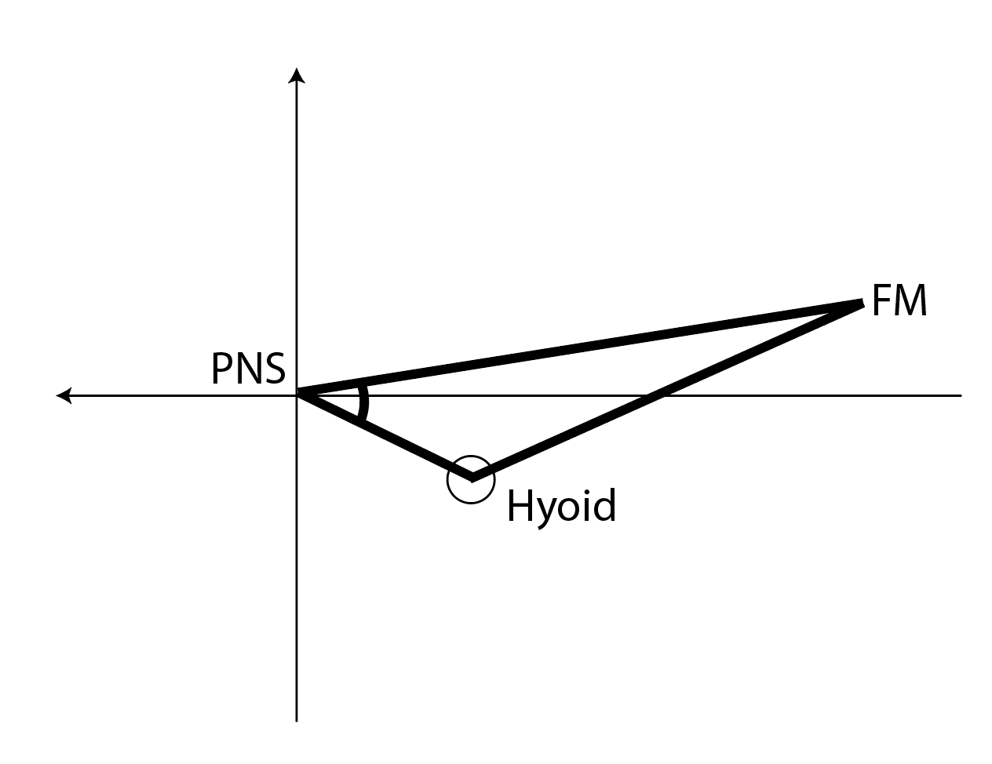
The angle between hyoid_PNS line and the x axis is the arctangent of the hyoid Y coordinates over X coordinates. By subtracting this angle from θ we get the angle between PNS_FM line and the x axis, and thereby getting the X and Y coordinates of FM in this cranial coordinate system.

Next, for every head-neck angle between the minimum and maximum observed head-neck angles, α, the linear distance I between the initial PNS position (0, 0) and the PNS position after head rotation (PNS’) is calculated as

l = 2 x PNS_FM x sin(α/2)
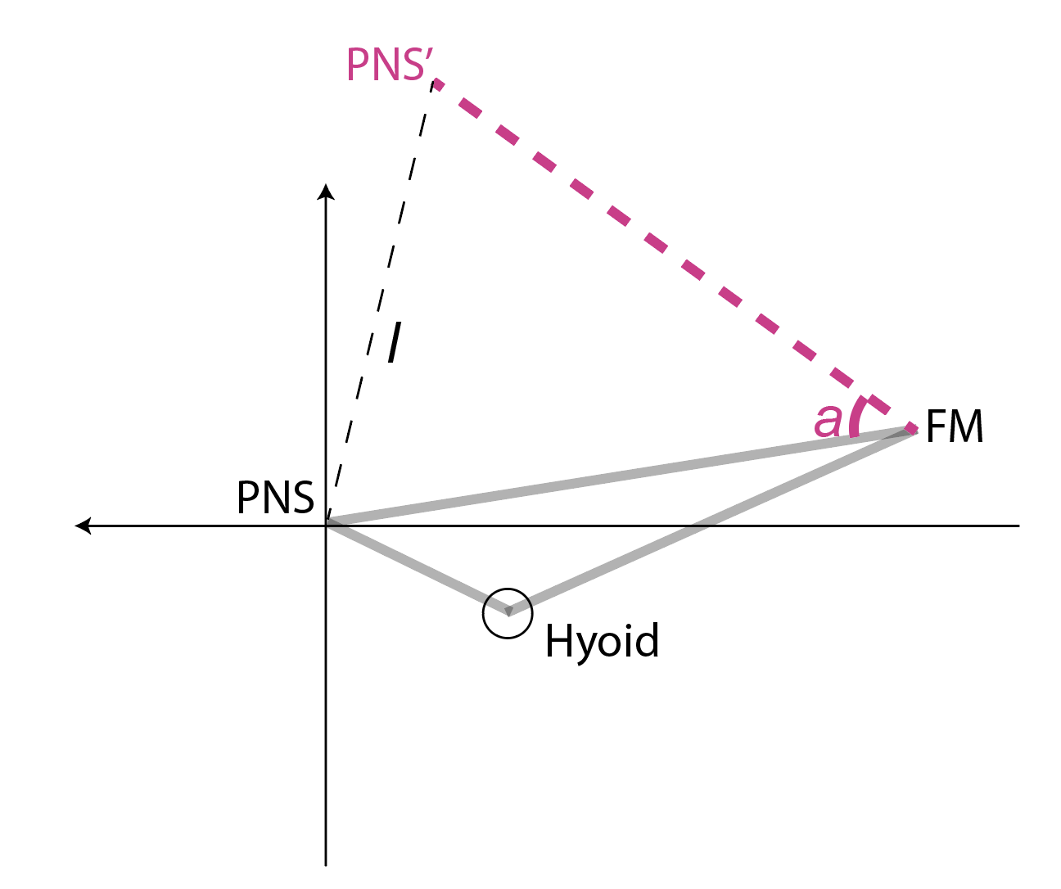

The angle β between PNS’, PNS and FM is calculated as (180- α)/2, and this also has the same magnitude as the angle between PNS, PNS’ and FM. The angle between PNS’, PNS and the X axis equals to β + the angle between PNS_FM line and the x axis. From this combined angle, we can get the X and Y coordinates of PNS’, and the hyoid_PNS’ distance.
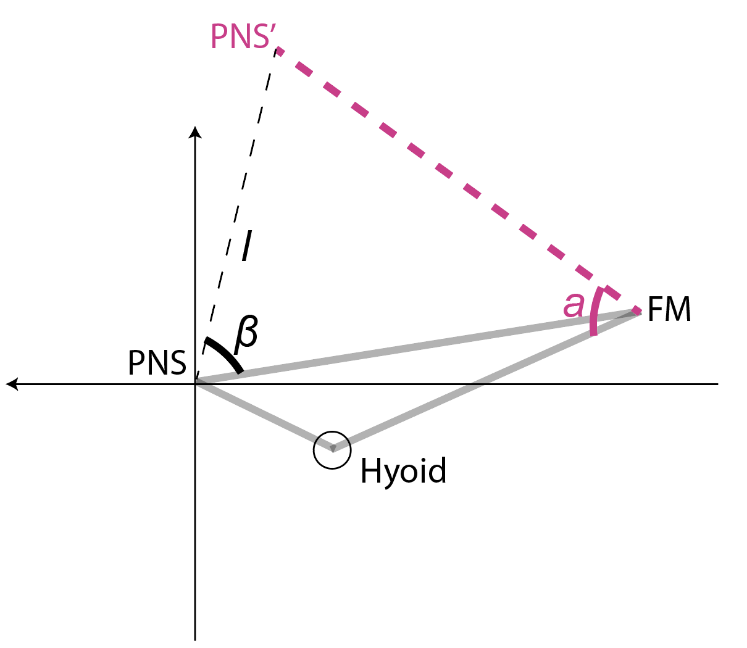

we can calculate the angle γ using the same equation used above following the law of cosine:
∠γ = arccos((l² + Hyoid_PNS’² - Hyoid_PNS ²)/(2 x l x Hyoid_PNS))
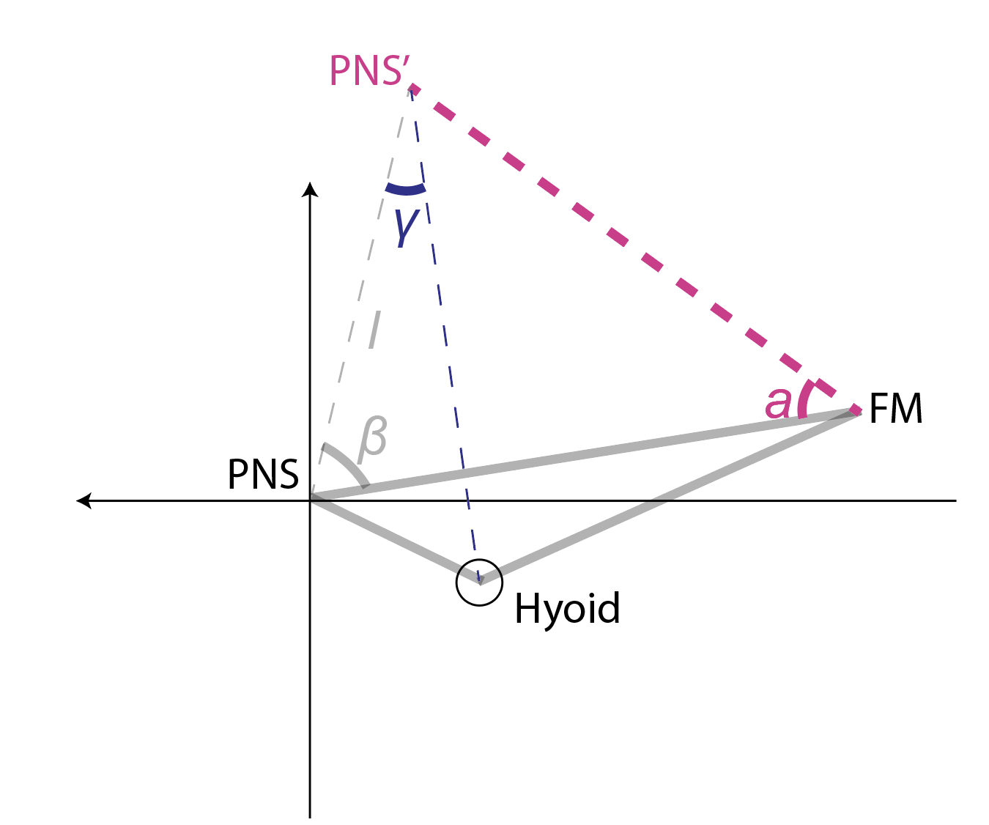
Subtracting γ from β we get the angle z between the Hyoid_PNS’ line and the FM_PNS’ line. The new hyoid X coordinates relative to PNS’ is Hyoid_PNS’ x cos(z), while the new hyoid Y coordinates relative to PNS’ is Hyoid_PNS’ x sin(z).
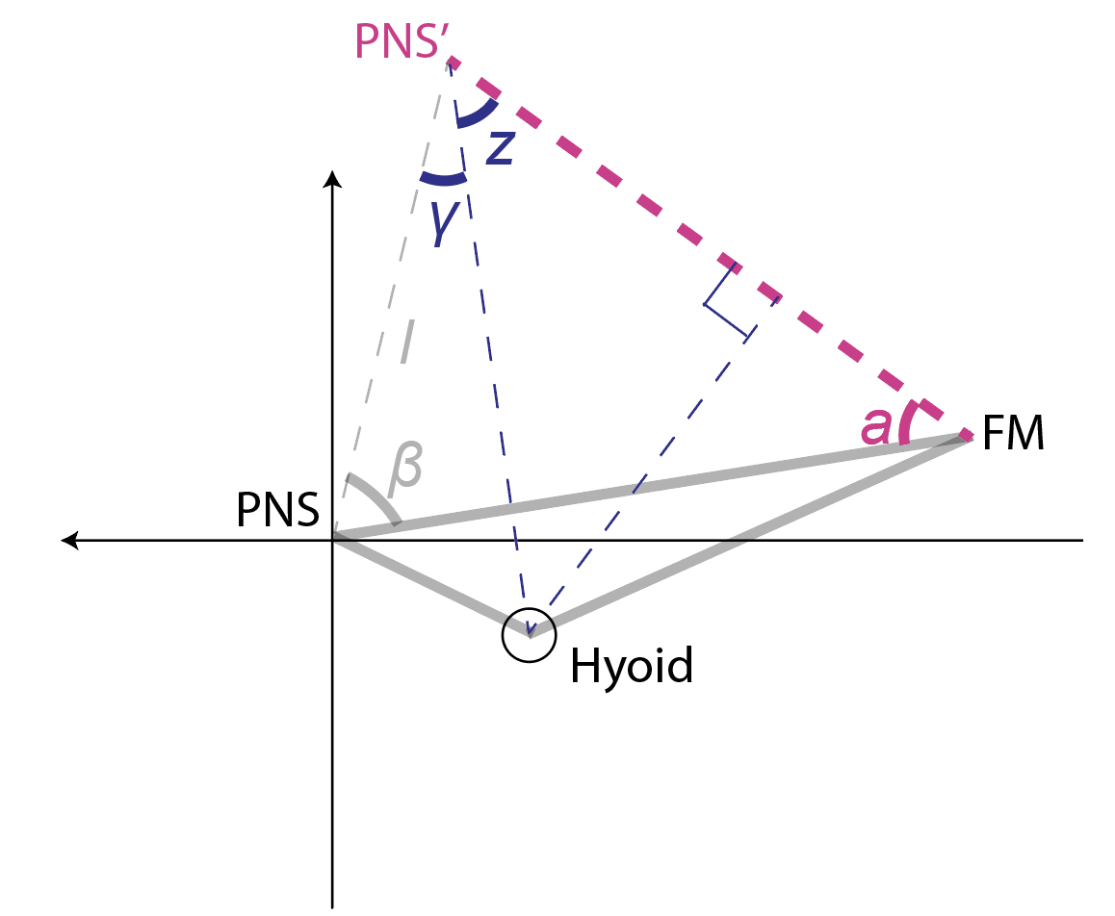

Part C. Supplementary Figures
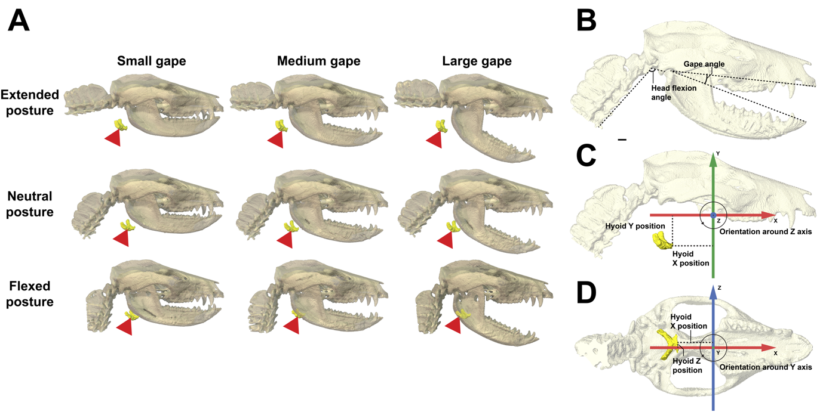
Figure S1: Head posture and gape combinations and measurement scheme of hyoid position. (A) 3D visualization of static hyoid position across different posture-gape combinations of Didelphis virginiana. (B) Measurement scheme of head flexion angle, gape, and hyoid position in a cranial coordinate system, with head positioned at neutral posture with medium gape. Scale bar = 5mm

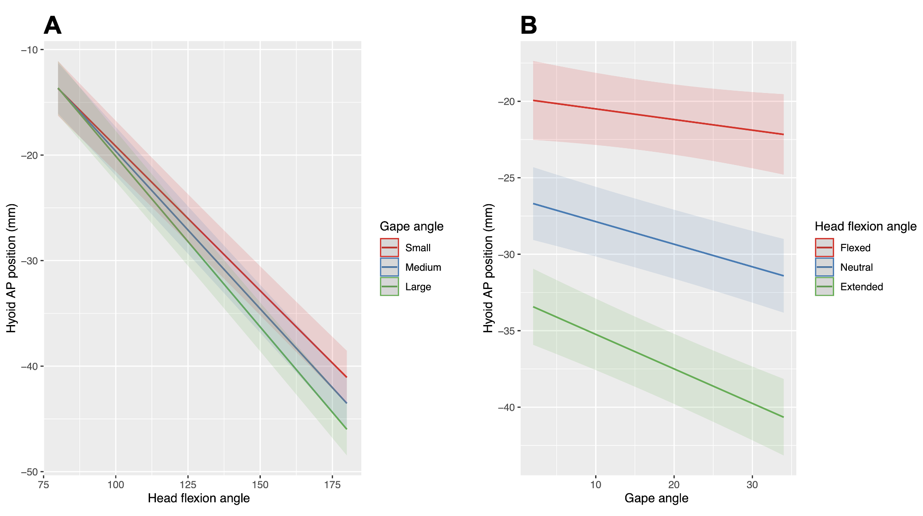
Figure S2: visualization of the interaction effect between head posture (A) and gape (B) on hyoid AP position. (A) with increasing gape, increasing head extension has a more negative marginal effect on hyoid AP position. Likewise, (B) at neutral and extended posture, increasing gape has a negative marginal effect on hyoid AP position.

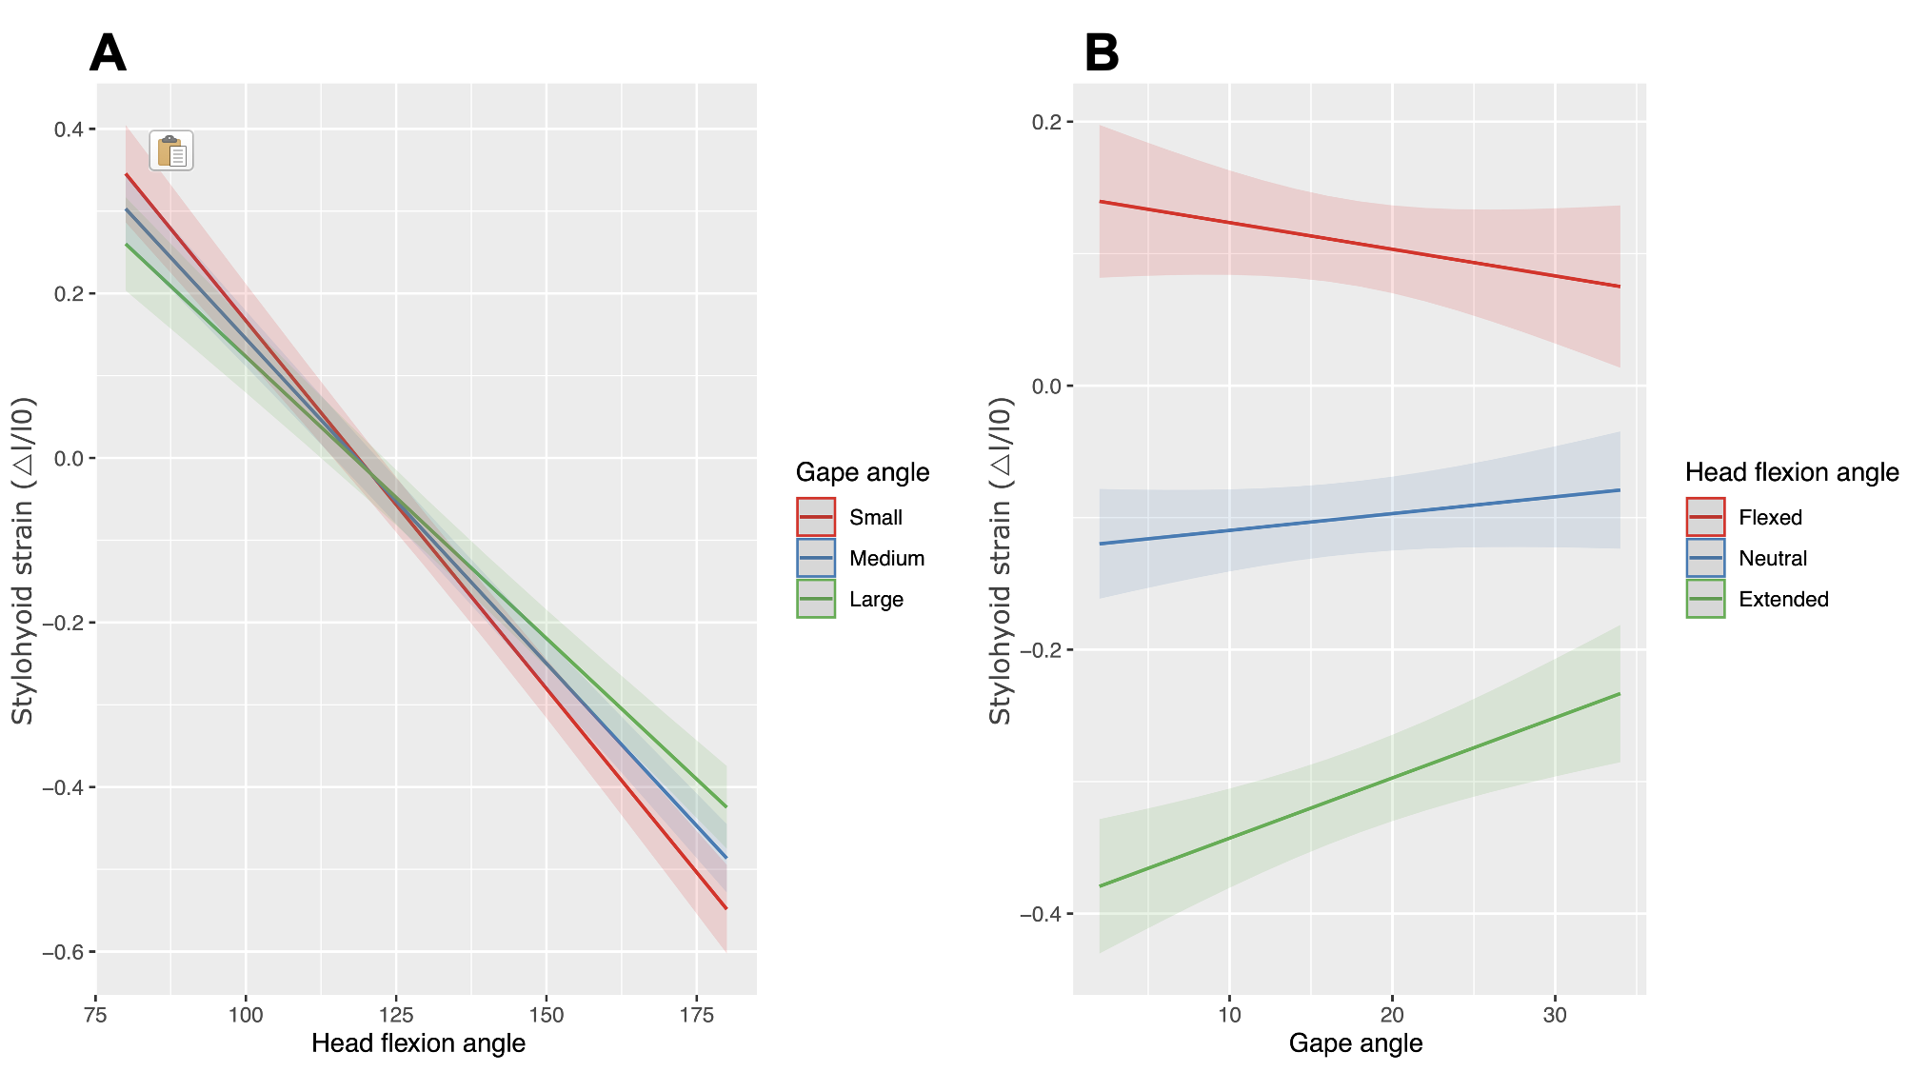
Figure S3: visualization of the interaction effect between head posture (A) and gape (B) on resting stylohyoid length. (A) with increasing gape, increasing head extension has a less negative marginal effect on stylohyoid length. Likewise, (B) the marginal effect of gape change on stylohyoid length is different across different head posture

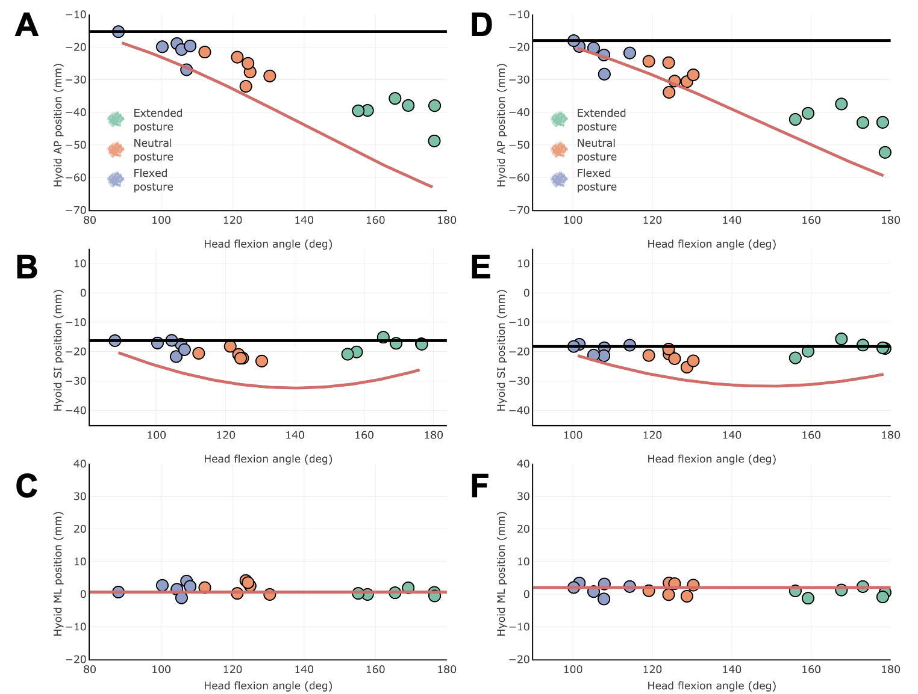
Figure S4: Coupling between static hyoid position and head posture varies across anatomical axes. Observed hyoid position across head posture change at medium gape is plotted along AP (A), SI (B), and ML (C) axes against theoretical expectations of hyoid position. Observed hyoid position across head posture change at large gape is plotted along AP (D), SI (E) and ML (F) axes. Horizontal lines (black in A and B, red in C) show theoretical hyoid position if it is perfectly coupled to the cranium, while red curves in A and B represents theoretical hyoid position if it is perfectly coupled to the vertebral column.

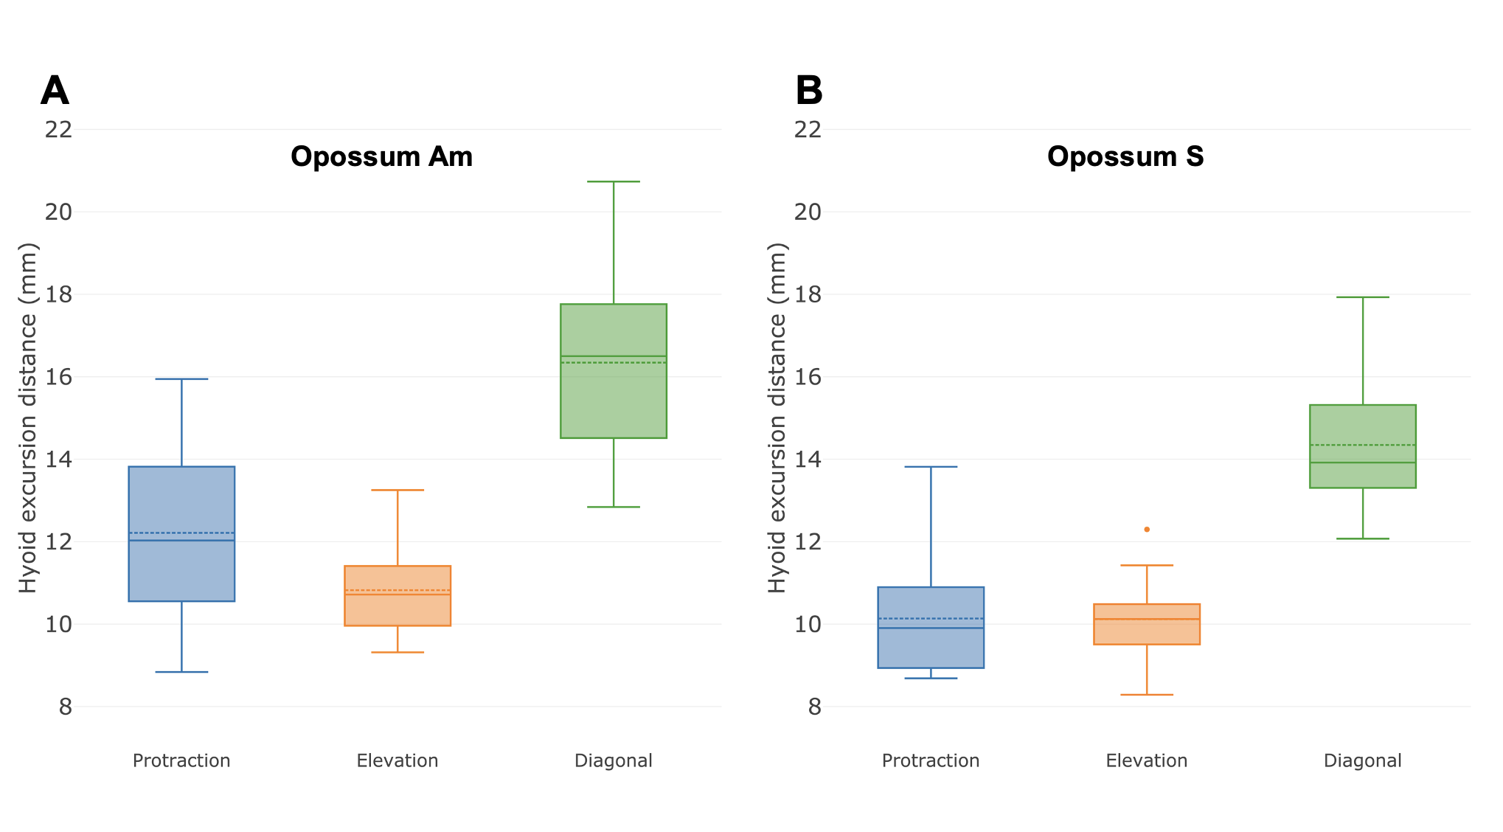
Figure S5: Maximum hyoid excursion in AP (blue), SI (orange) and diagonal direction (green) for opossum Am (A) and opossum S (B). Dashed line in each boxplot denotes mean values while solid line denotes median.

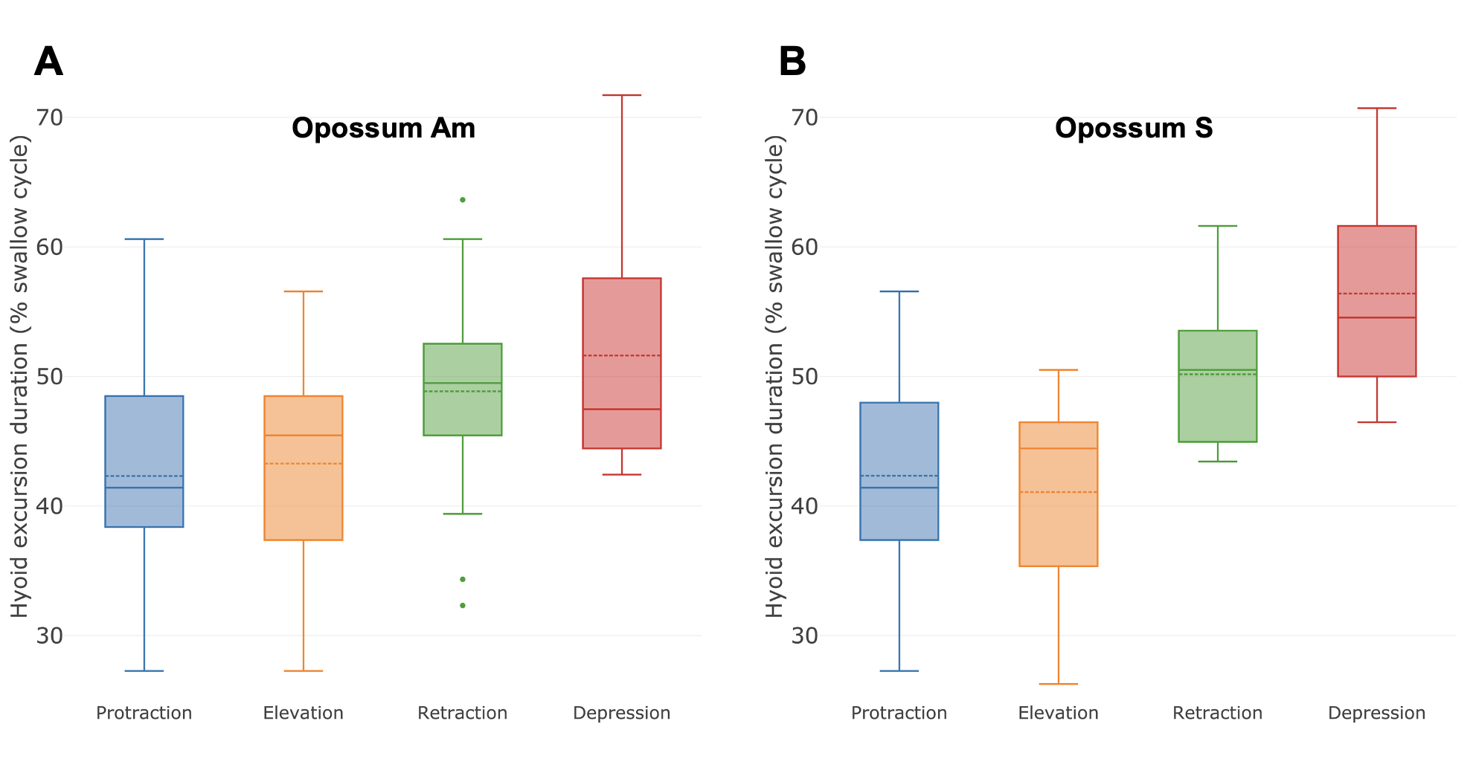
Figure S6: Duration of hyoid protraction (blue), elevation (orange), retraction (green) and depression (red) as percentage of swallow cycle for opossum Am (A) and opossum S (B). Dashed line in each boxplot denotes mean values while solid line denotes median.

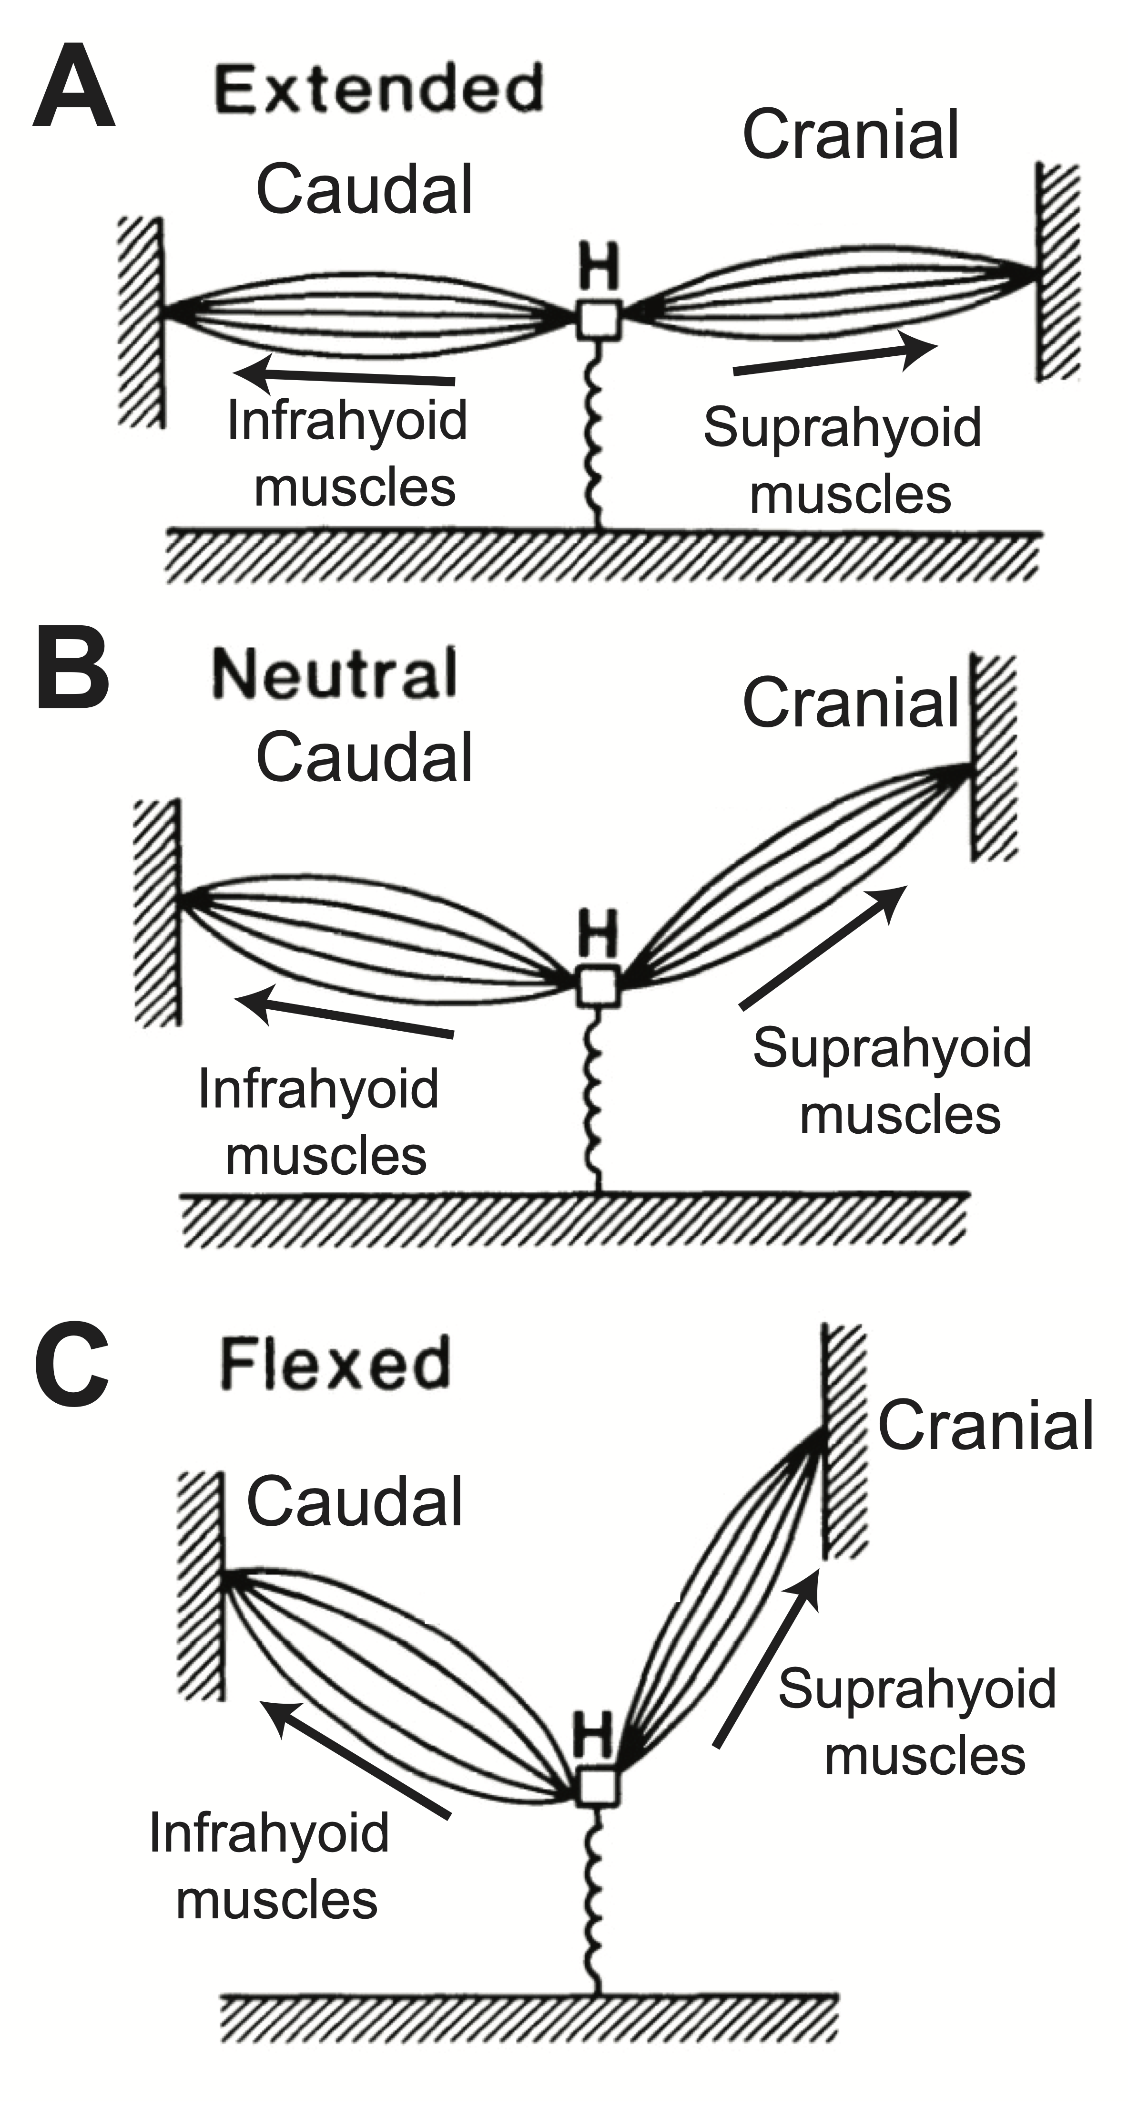
Figure S7: The force vectors of supra- and infrahyoid muscles are oriented at different directions depending on head posture. Hyoid is denoted as “H”. Figure modified from [35].

Table S2: Mean hyoid excursion distance (mm) and timing (% of gape cycle) during swallowing for individual animals and species average. Standard deviation shown in parentheses.

 | Opossum Am | Opossum S | Combined
Mean hyoid AP excursion | 12.21  (1.94) | 10.14  (1.46) | 11.41  (2.02)
Mean hyoid SI excursion | 10.82  (1.11) | 10.12  (1.05) | 10.55  (1.13)
Mean hyoid diagonal excursion | 16.34  (2.04) | 14.34  (1.61) | 15.57  (2.10)
Mean hyoid protraction duration | 0.42  (0.08) | 0.42  (0.08) | 0.42  (0.08)
Mean hyoid elevation duration | 0.43  (0.08) | 0.41  (0.08) | 0.42  (0.08)
Mean hyoid retraction duration | 0.49  (0.08) | 0.50  (0.05) | 0.49  (0.07)
Mean hyoid depression duration | 0.52  (0.09) | 0.56  (0.08) | 0.53  (0.09)

Table S3: Coefficients of variation (CV*) for hyoid excursion distance and timing during swallow cycles

Parameter | Opossum Am | Opossum S | Combined
Hyoid protraction distance | 16.08 | 14.74 | 17.89
Hyoid elevation distance | 10.41 | 10.60 | 10.76
Hyoid diagonal distance | 12.63 | 11.43 | 13.60
Hyoid protraction duration | 20.10 | 19.33 | 19.33
Hyoid elevation duration | 19.76 | 19.24 | 19.29
Hyoid retraction duration | 16.69 | 10.99 | 14.44
Hyoid depression duration | 17.87 | 13.77 | 16.49
CV* = (1 + 1/4n)CV

