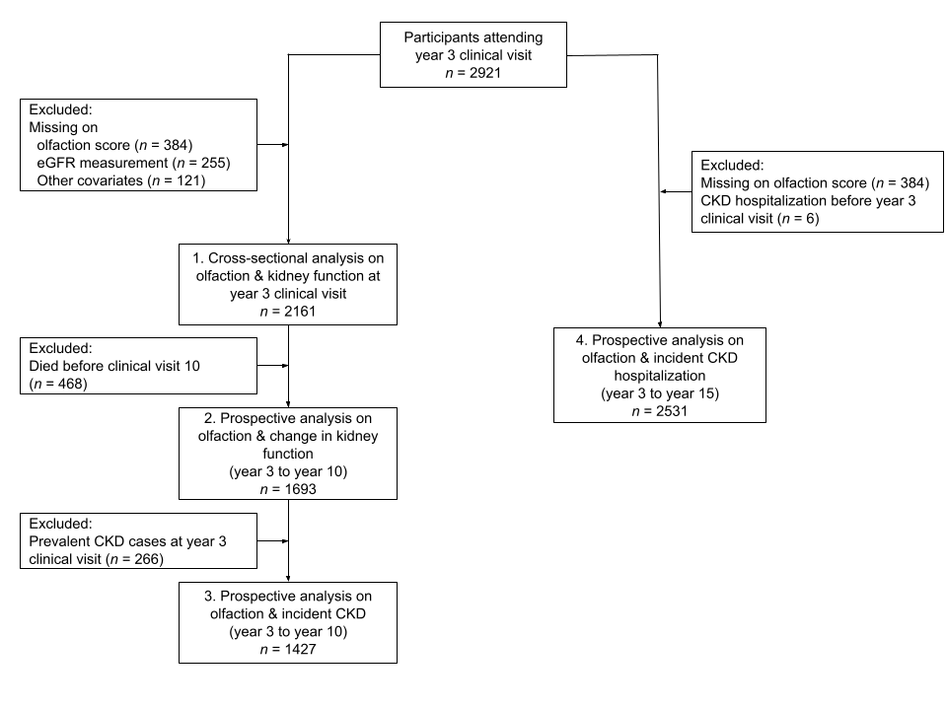
S1 Fig. Analytic samples sizes for various analyses

