Supplement to: Ba/Ca of stylasterid coral skeletons records dissolved seawater barium concentrations
James Kershaw ^{a*}, Joseph A. Stewart ^{a,b}, Ivo Strawson ^{a,c}, Maria Luiza de Carvalho Ferreira ^{a,d}, Laura F. Robinson ª, Katharine R. Hendry ^{a,e}, Ana Samperiz ^{a,f}, Andrea Burke ^{g}, James W. B. Rae ^{g}, Rusty D. Day ^{b,h}, Peter J. Etnoyer ^{i}, Branwen Williams ^{j}, Vreni Häussermann ^{k}

ª School of Earth Sciences, University of Bristol, Queens Road, Bristol, BS8 1RJ, UK
^{b} National Institute of Standards and Technology, Chemical Science Division, Hollings Marine Laboratory, Charleston, SC, USA
^{c} Department of Earth Sciences, University of Cambridge, Downing Street, Cambridge, CB2 3EQ, UK
^{d} Department of the Geophysical Sciences, University of Chicago, 5734 S. Ellis Avenue, Chicago, IL 60637, USA
^{e} British Antarctic Survey, Cambridge, CB3 0ET, UK
^{f} School of Earth and Environmental Sciences, Cardiff University, Cardiff, CF10 3AT, UK
^{g} School of Earth & Environmental Sci., Univ. of St Andrews, St Andrews, Bute Building, KY16 9TS, UK
^{h} Marine Science and Nautical Training Academy (MANTA), 417 Planters Trace Dr, Charleston, SC 29412, USA
^{i} NOAA National Centers for Coastal Ocean Science, Charleston SC 29412, USA
^{j} Keck Science Department, Claremont McKenna-Pitzer-Scripps Colleges, Claremont, CA 91711, USA
^{k} Pontificia Universidad Católica de Valparaíso, Escuela de Ciencias del Mar, Facultad de Recursos Naturales, Valparaíso , Chile

*correspondence james.kershaw@bristol.ac.uk

Supplement contents

1. Coral sampling strategy
2. Fe/Ca and Mn/Ca ratios: contamination screening
3. Scleractinian compilation; analytical offsets and uncertainties
4. Sr/Ca vs temperature correlations
5. Origin of elevated Ba/Ca in mixed mineralogy stylasterids
6. Bamboo coral Ba/Ca
7. Additional controls on stylasterid and scleractinian Ba-incorporation

- Coral sampling strategy

As outlined in the main text, large chunks of coral samples were taken and, where possible, two samples were taken from each coral. Visually pristine areas of material were targeted, and any remaining discoloured or altered material was removed using a hand-held Dremel tool. For stylasterid corals, the apical tips of branches were avoided, since it has been shown their oxygen and carbon stable isotopic composition is further from equilibrium than bulk skeletal samples (Samperiz et al. [2020]). Examples of sampling of three stylasterid specimens used in this study is shown below (Figure 1).
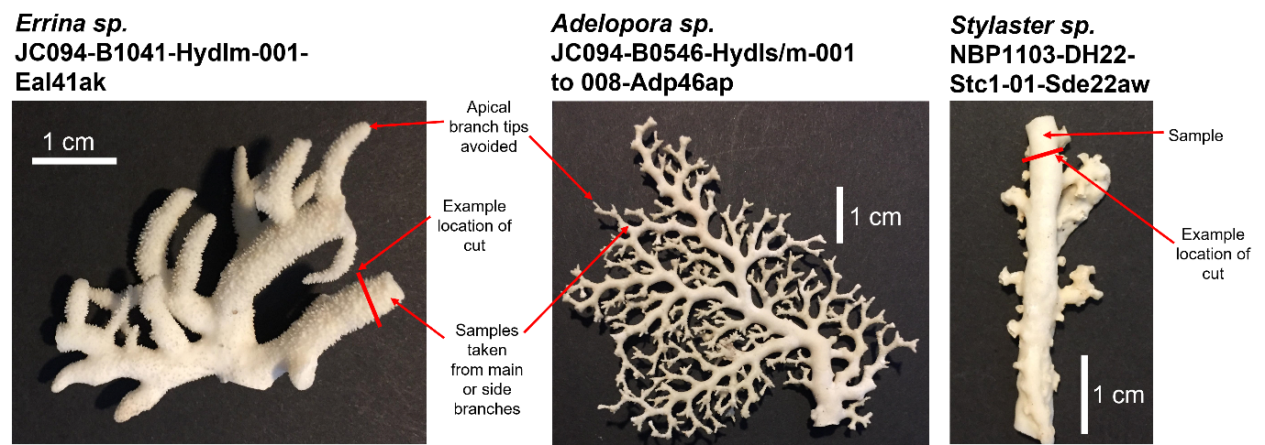
Figure 1. Photos of three stylasterid specimens used in this study. Red lines show examples of where specimens were cut to obtain samples.

- Fe/Ca and Mn/Ca ratios: contamination screening

Iron oxyhydroxides are common contaminant phases which can impact element/Ca ratios in marine biogenic carbonates (e.g. Boyle [1981]). Here, we test for their influence in our dataset by measuring the Fe/Ca and Mn/Ca of sample replicates, and reporting correlations with both coral Ba/Ca and residuals of the Ba/Ca vs [Ba]_{SW} relationships (Ba/Ca_{residual} = Ba/Ca_{coral} – Ba/Ca_{calibration}) (Figure 2; Figure 3).

No significant correlation is found between Ba/Ca and either Fe/Ca or Mn/Ca values for aragonitic stylasterids, or between scleractinian Ba/Ca and Fe/Ca (p > 0.05). However, high-Mg calcitic stylasterids show a significant (p < 0.05) positive correlation between these variables (r_{Fe-Ba} = 0.69; r_{Mn-Ba} = 0.69), while scleractinian Ba/Ca ratios also correlate significantly with Mn/Ca (p < 0.05, r = 0.21). Furthermore, both Fe/Ca and Mn/Ca correlate significantly and positively with residuals of the Ba/Ca vs [Ba]_{SW} relationships for both high-Mg calcitic stylasterids (r_{Fe-resid} = 0.90; r_{Mn-resid} = 0.89) and Scleractinia (r_{Fe-resid} = 0.40; r_{Mn-resid} = 0.40) (Figure 2; Figure 3).

We therefore exclude sample replicates which have Fe/Ca > 40 mmol/mol, following Spooner et al. [2018]. This results in 12 measurements from eight corals being removed from our dataset, with four corals having both of their replicate analyses removed (Table 1). When these replicates are excluded, the correlations between scleractinian Ba/Ca and Mn/Ca, and scleractinian calibration residuals and Fe/Ca and Mn/Ca, become insignificant (p > 0.05, - 0.20 < r < 0.20; Figure 2; Figure 3). For high-Mg calcitic stylasterids, correlations are reduced by this screening, but not removed (r_{Fe-Ba} = 0.56; r_{Mn-Ba} = 0.63; r_{Fe-resid} = 0.77; r_{Mn-resid} = 0.82; Figure 2; Figure 3). These correlations are driven almost entirely by two replicates of one Errina sp. sample which both have relatively high Ba/Ca residuals and slightly elevated Fe/Ca and Mn/Ca. Owing to the small magnitude of Fe/Ca and Mn/Ca enrichment in this sample, we choose to retain it in our calibration.

Sample ID | No. reps excluded | Type | Taxon | Location
NBP1103-DH07-Bp-0 | 2 | Scleractinia | Balanophyllia sp. | Drake Passage
NBP1103-DH14-Fpalive-8 | 2 | Scleractinia | Flabellum sp. | Drake Passage
NBP1103-DH14-Fpalive-1 | 2 | Scleractinia | Flabellum sp. | Drake Passage
DY081-008-ROV329-Ev024-453Flab | 1 | Scleractinia | Flabellum sp. | Labrador Sea
JC094-21-EBB-ROV228-SLP44-B1584-Carls-001 | 1 | Scleractinia | Caryophyllia sp. | Equatorial Atlantic
DY081-031-ROV333-Ev037-201-590-Loph | 1 | Scleractinia | Lophelia sp. | Labrador Sea
JR15005-40-832-Egr832 | 1 | Stylasterid, mixed | Errina sp., mixed (arag.) | S. Orkney
JR15005-44-907-mn-1-Ela907 | 2 | Stylasterid, high-Mg calc. | Errina sp., calc. | S. Orkney
Table 1. Samples measured in this study which are excluded from calibrations due to contamination inferred from Fe/Ca ratios. Where only one replicate was removed, the remaining replicate was retained in the calibration.
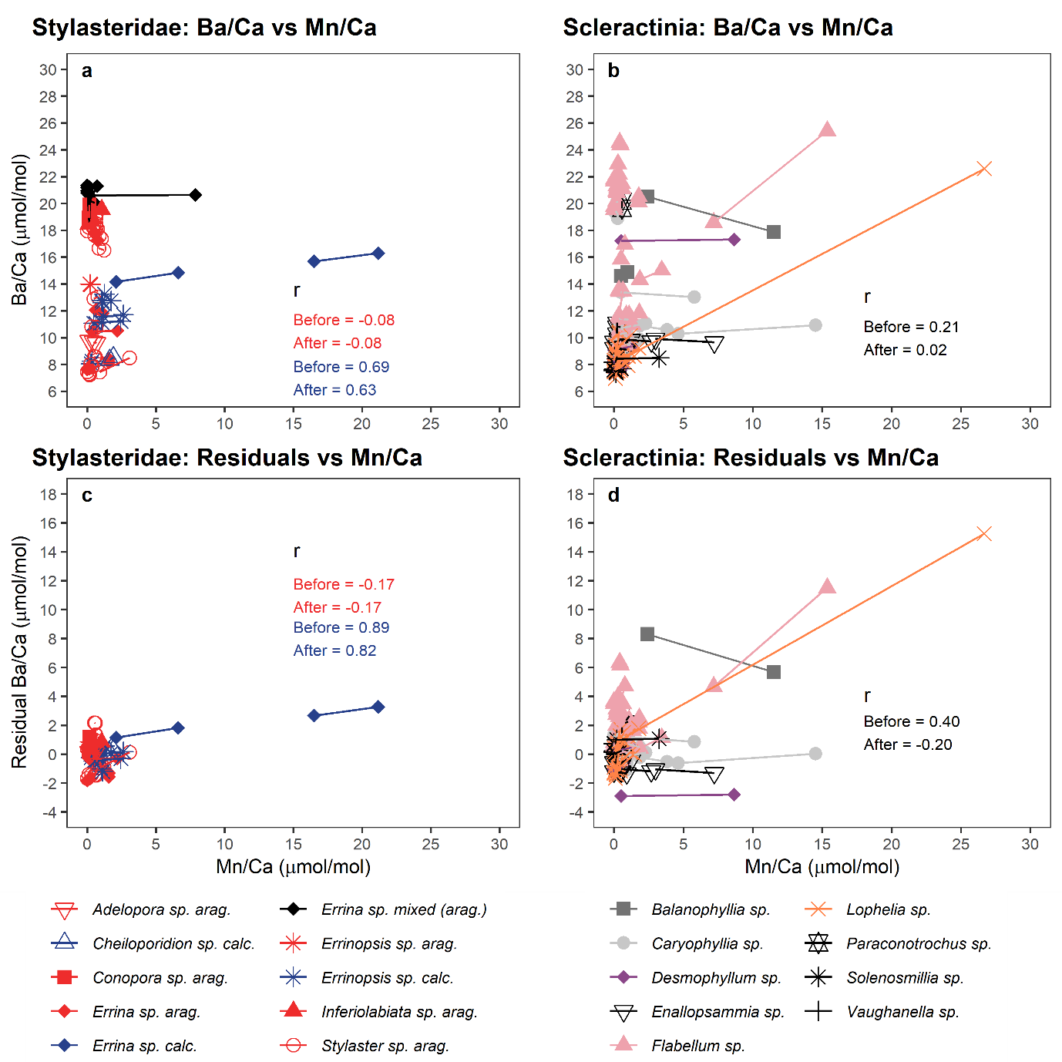
Figure 2. Correlations between Ba/Ca and Mn/Ca (a and b) and residual Ba/Ca and Mn/Ca (c and d) for corals measured in this study. Straight lines join replicates of the same coral. Pearson r values before and after screening are shown. All r values calculated using average values for each coral to avoid pseudoreplication. All Lophelia sp. replicates used to calculate sample averages at this stage (i.e. both bulk calyx and theca wall replicates; see main text section 4.4). Mixed mineralogy corals not included in goodness-of-fit calculations. Where Mn/Ca values were less than detection limits, values were set to 0 μmol/mol.

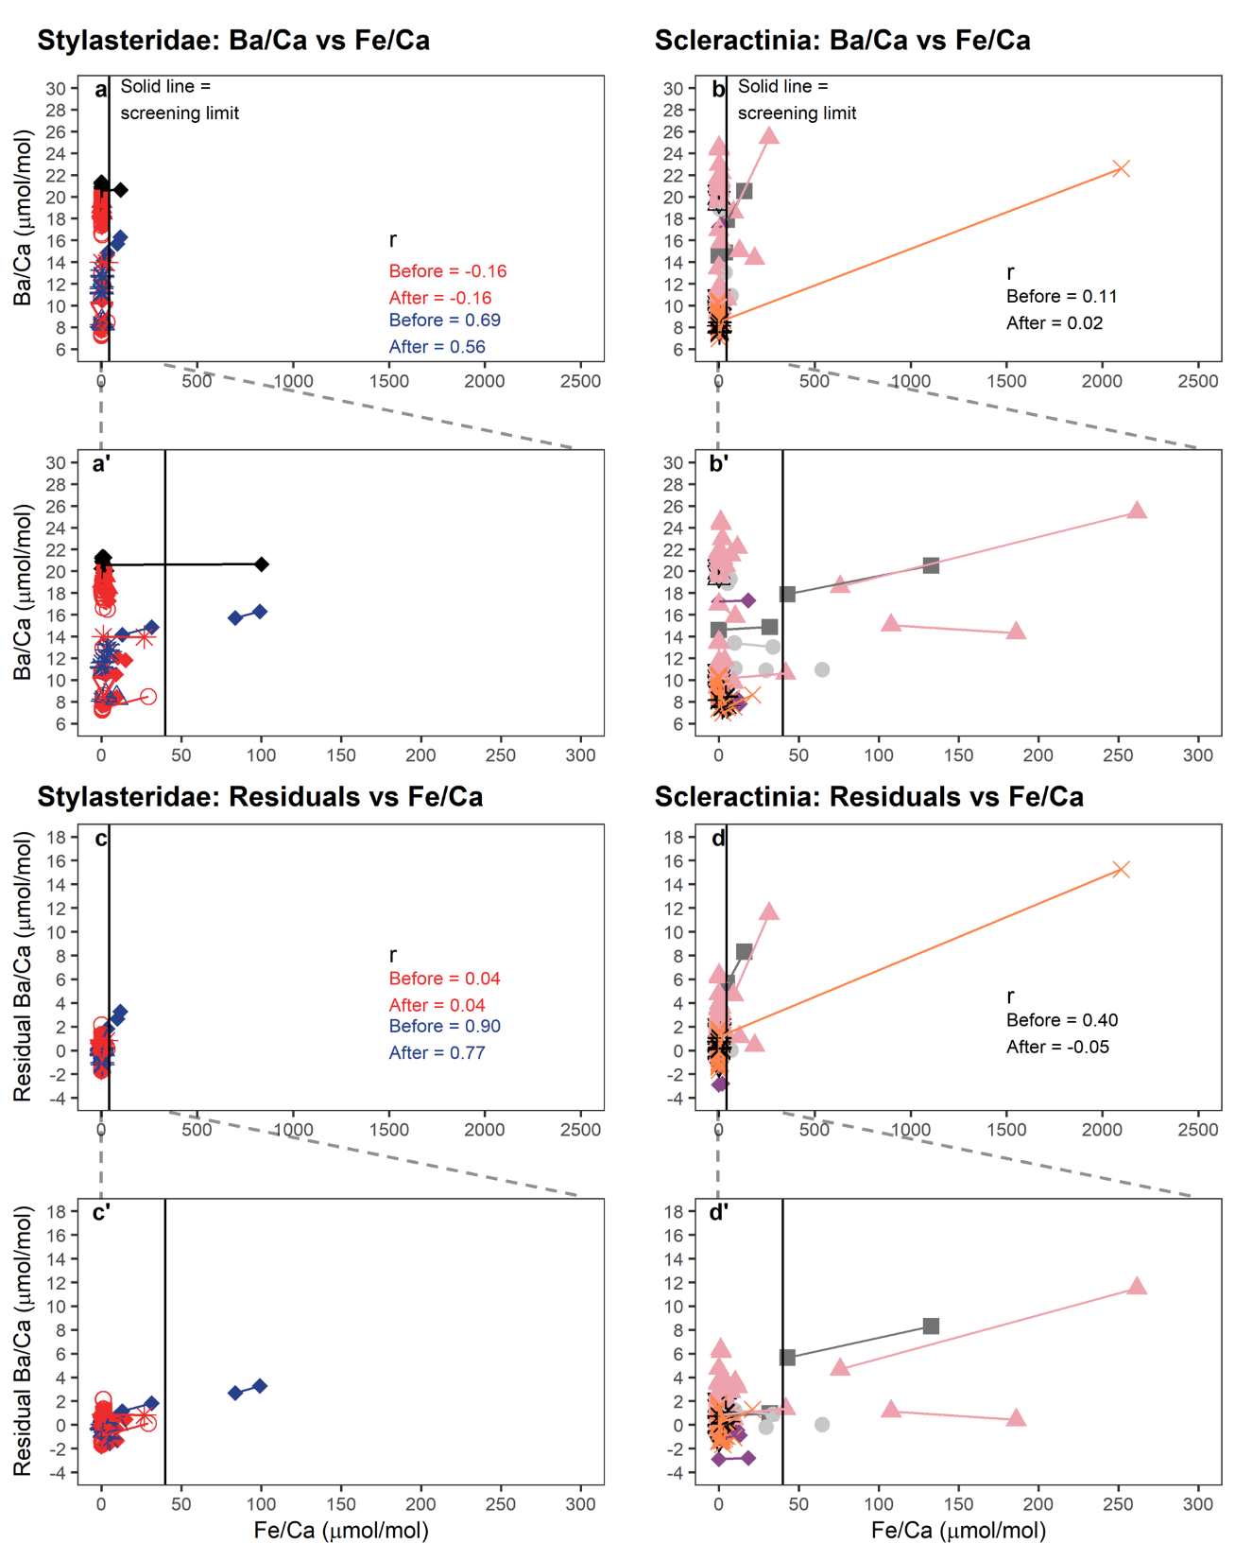
Figure 3. As Figure 2, with Mn/Ca replaced with Fe/Ca. For clarity, panels a’, b’, c’ and d’ show data from panels a, b, c and d in the Fe/Ca range 0 to 300 μmol/mol. When Fe/Ca values were less than detection limits, values were set to 0 μmol/mol. Symbols and colours follow Figure 2.

- Scleractinian compilation: analytical offsets and uncertainties

Ba/Ca data require correction for analytical offsets which can occur between laboratories (e.g. Stewart et al. [2020]a). For data measured in our study, we normalised Ba/Ca values measured in Bristol, NIST and St Andrews to the relatively homogenous NIST RM 8301 (Coral) solution (interlaboratory reproducibility for Ba/Ca 2.7 % (RSD; 1s) (Stewart et al. [2020]a)).

Our new scleractinian Ba/Ca data were combined with those published in previous studies (Hemsing et al. [2018]; Spooner et al. [2018]) to create a compiled dataset. Laser ablation data (Anagnostou et al. [2011]) were not used due to apparent analytical differences between solution and laser-ablation techniques (see Spooner et al. [2018]).

NIST RM 8301 (Coral) was not available for previous studies, and instead, Ba/Ca data from these two studies was previously normalised based on measurements of the coral reference material JCp-1 (see Spooner et al. [2018]). We use these JCp-1 corrected ratios in our compilation. JCp-1 Ba/Ca ratios are known to be significantly more heterogenous than NIST RM 8301 (Coral), with an interlaboratory reproducibility of ~ 9 % (RSD; 1s) (Hathorne et al. [2013]). Therefore, while we did measure JCp-1 as part of our study, we chose not to use this reference material for normalisation. By instead normalising our data to NIST RM 8301 (Coral), we ensure that our dataset is compatible with future projects which may use this more homogenous reference material (Stewart et al. [2020]a).

Use of different reference materials to correct for interlaboratory offsets raises the possibility of analytical differences between our data and previous work. To test for this, we measured additional replicates of 7 corals which were also measured by Spooner et al. [2018] and/or Hemsing et al. [2018]. We find good agreement between coral subsamples measured in each study, and importantly find no systematic offset between data measured in our study and these studies (Figure 4). Furthermore, our long-term laboratory average values for JCp-1 – once corrected to NIST RM 8301 (Coral) - differed from the published interlaboratory value by < 4 %, meaning any additional correction would have a minor impact on our results. Therefore, direct comparison of ours and previously published datasets is justified, and in practise, any remaining analytical offsets between laboratories are unlikely to influence our findings.

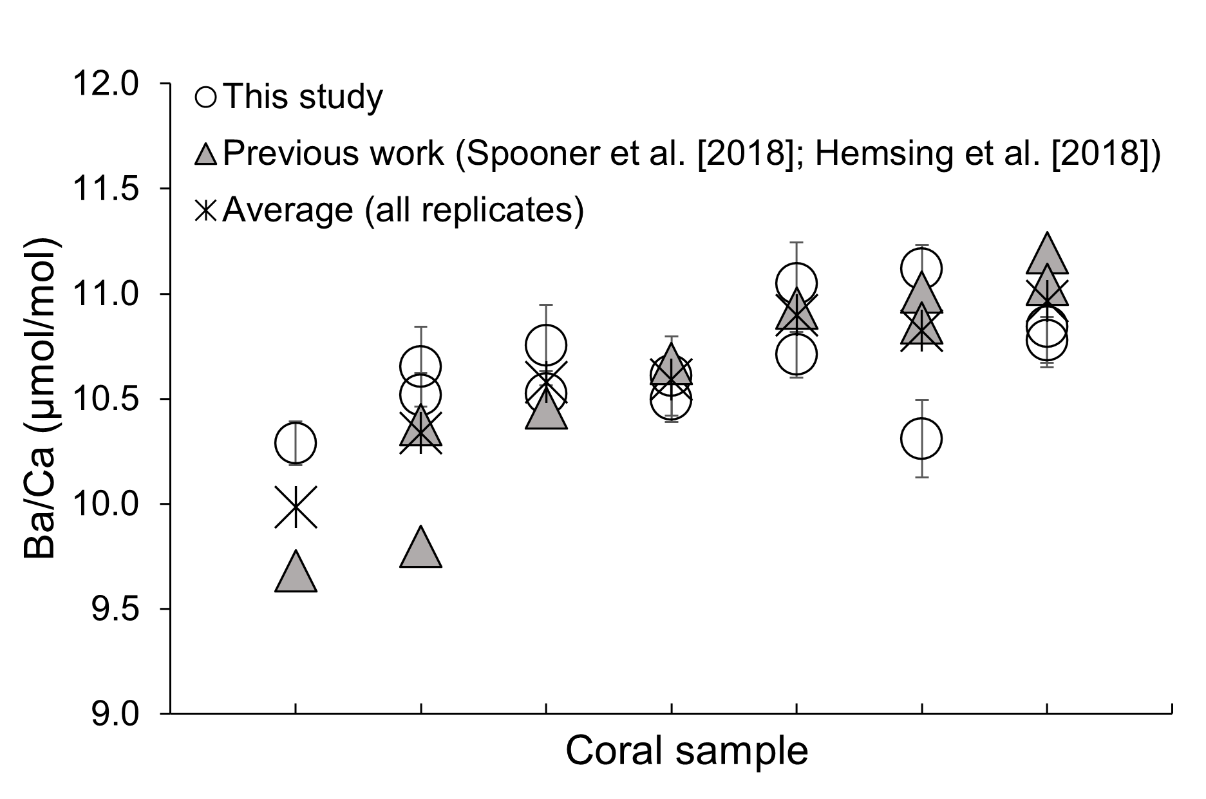

Figure 4. Replicate subsamples of corals measured in this study and by previous authors show good agreement, after correction for analytical offsets. Analytical error bars (RSD; 2s) on individual replicates from this study are shown.

- Sr/Ca vs temperature correlations

Sr/Ca values for most samples used here were reported and analysed previously (Stewart et al. [2020]b), and the reader is directed to this work for a detailed discussion of Sr-incorporation into azooxanthellate stylasterids and Scleractinia. These authors found a strong correlation between aragonitic stylasterid Sr/Ca and seawater temperature, and a weaker relationship for Scleractinia. Addition of new samples reported here (20 stylasterid and 17 scleractinian samples) results in relationships between coral Sr/Ca and temperature which have intercepts and gradients within error of those reported previously (Figure 5; Table 2; Stewart et al. [2020]b). Compared to this previous work, the r² of the aragonitic stylasterid calibration is reduced slightly, and the prediction interval made wider. However, the observation that aragonitic stylasterid Sr/Ca more reliably records seawater temperature than scleractinian Sr/Ca remains robust (compare r² and prediction intervals in Table 2), consistent with biologically-mediated “vital effects” impacting scleractinian Sr/Ca more than stylasterid Sr/Ca (Stewart et al. [2020]b).

Sr/Ca values of a number of high-Mg calcitic stylasterids were also measured in this study. However, these samples span a small temperature range, precluding assessment of whether their Sr/Ca values also correlate with seawater temperature.

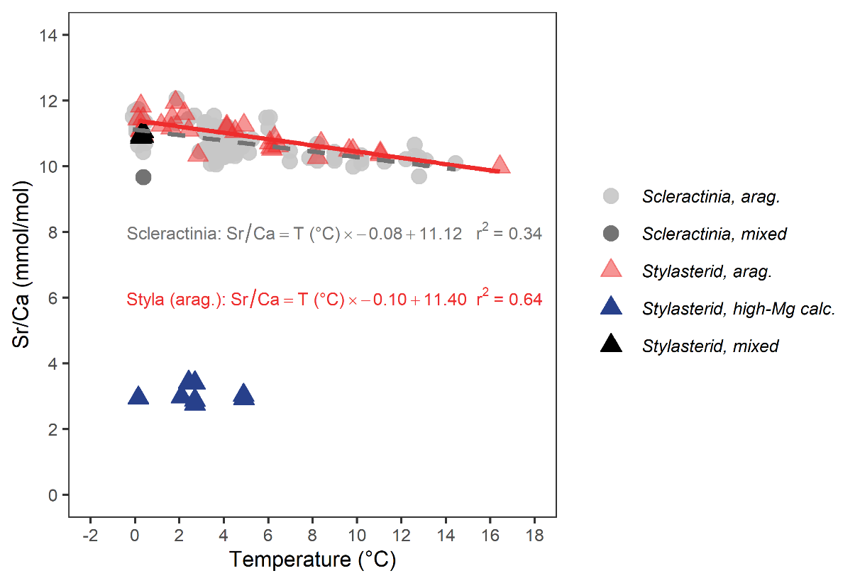
Figure 5. Relationships between Sr/Ca and seawater temperature for corals used in this study. Data are measured here, or are from Stewart et al. [2020]b. Lines of best fit (Ordinary Least Squares) shown for aragonitic stylasterids (solid, red) and Scleractinia (dashed, grey).

Taxon | Source | r | p | Regression type | Gradient, m | (± 2SE) | Intercept, c | (± 2SE) | r² | Prediction Interval (⁰C)
Stylasterid, arag. | Stewart et al. [2020]b |  | < 0.05 | OLS | - 0.11 |  | 11.61 |  | 0.79 | ± 5.3
Stylasterid, arag. | Stewart et al. [2020]b & this study | - 0.80 | < 0.05 | OLS | - 0.10 | 0.03 | 11.40 | 0.17 | 0.64 | ± 6.7
 |  |  |  | Deming (unweighted, orthogonal) | - 0.10 | 0.02 | 11.40 | 0.20
Scleractinia | Stewart et al. [2020]b |  | < 0.05 | OLS | - 0.08 |  | 11.06 |  | 0.31 | > ± 7.7
Scleractinia | Stewart et al. [2020]b & this study | - 0.59 | < 0.05 | OLS | - 0.08 | 0.02 | 11.12 | 0.14 | 0.34 | ± 9.2
 |  |  |  | Deming (unweighted, orthogonal) | - 0.08 | 0.02 | 11.11 | 0.16

Table 2. Summary of relationships between Sr/Ca and seawater temperature. Results of Ordinary Least Squares (OLS) and Deming (unweighted, i.e. orthogonal) regressions shown, for simplicity we recommend use of OLS regressions in palaeoceanographic contexts. 95 % prediction intervals calculated at the mean aragonite Sr/Ca value (~ 11 mmol/mol).

Subsample Sr/Ca and Ba/Ca ratios of mixed mineralogy corals are positively correlated in three out of four cases, indicating a shared mineralogical control on the incorporation of each element (Figure 6).

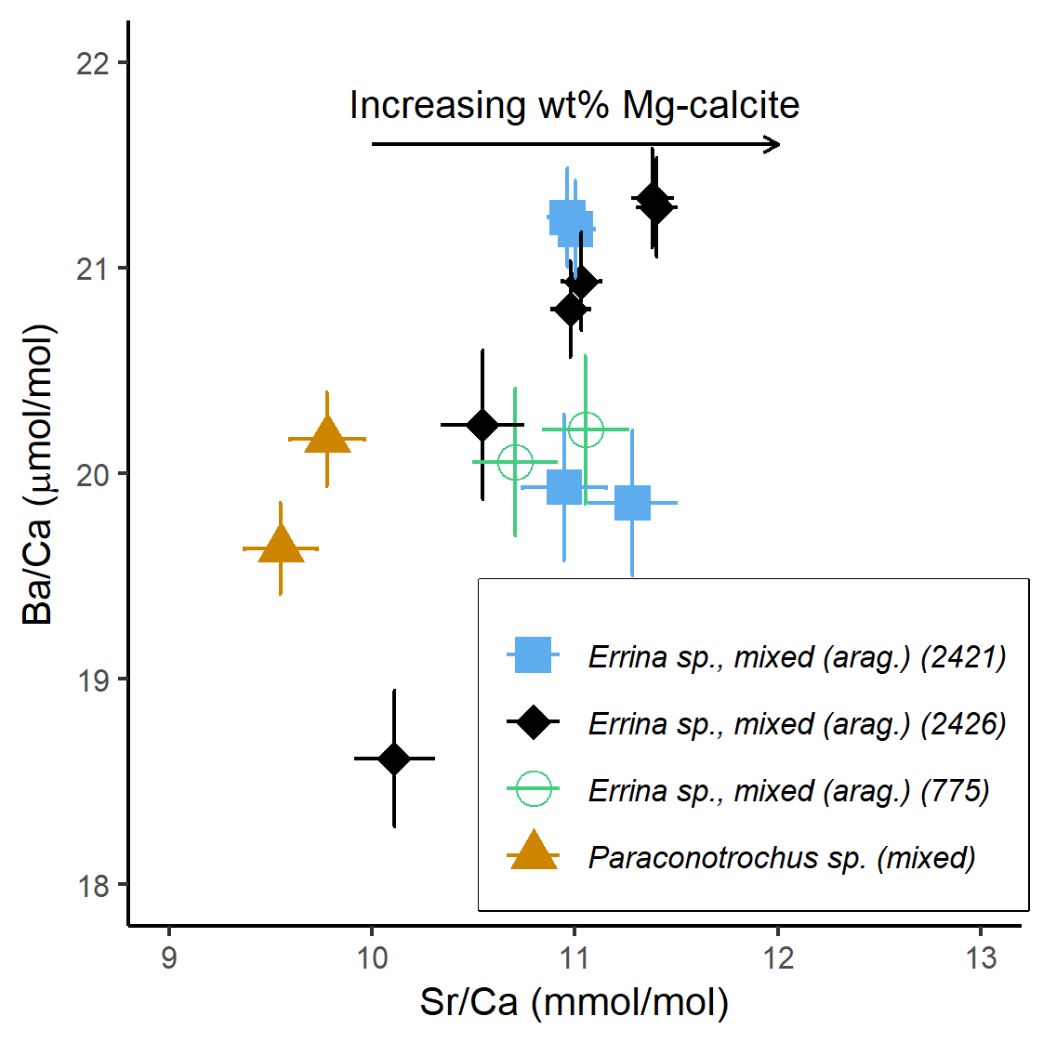
Figure 6. Ba/Ca vs Sr/Ca of mixed mineralogy coral subsamples. Colours and symbols represent different corals. One Errina sp. sample had only one replicate after filtering for contaminant phases, and so is not included in this plot. Errina sp. samples are identified by the final numbers in their sample codes. Error bars represent analytical errors (RSD; 2s).

- Origin of elevated Ba/Ca in mixed mineralogy stylasterids

The four mixed mineralogy stylasterids (genus: Errina sp., mixed (arag.); species: Errina gracilis) measured in this study have higher Ba/Ca than co-located entirely aragonitic stylasterids, despite the robust mineralogical control on stylasterid Ba/Ca outlined in section 4.1 of the main text. This elevated Ba/Ca signature is apparently specific to Ba; Sr/Ca, Li/Ca and Mg/Ca ratios measured in the same samples (same dissolved solutions) fall between entirely aragonitic and high-Mg calcitic stylasterids (Stewart et al. [2020]b).

This Ba-specific signature could be caused by contamination by barite (BaSO₄) crystals, which are a common Ba-bearing particulate phase at mesopelagic depths (Dehairs et al. [1980]). However, treatment with DTPA – a cleaning procedure designed to remove barite from marine carbonates - had no distinguishable effect on Errina gracilis Ba/Ca ratios, compared to standard oxidative cleaning procedures (Figure 7). Secondly, any effect of regional hydrographic conditions (e.g. temperature, see main text section 4.3) cannot explain our observations, because this should also impact on co-located aragonitic samples.

Instead, we suggest two possible alternatives. Firstly, the mixed mineralogy of this species suggests it calcifies in a different manner to other, mono-mineralic stylasterids. Variations in growth rates and/or modification of the coral calcifying fluid could lead to high and variable Ba/Ca ratios via Rayleigh fractionation processes (e.g. Gaetani and Cohen [2006]; main text section 4.5). Alternatively, other phases such as witherite (BaCO₃) may be present in the coral skeleton, leading to Ba-enrichment (e.g. Mavromatis et al. [2018]; main text section 4.5). As noted above, Ba-incorporation in Errina gracilis is the exception to mineralogical rule, and the skeletal δ¹⁸O and δ¹³C of these samples are close to equilibrium with seawater (Samperiz et al. [2020]; Stewart et al. [2020]b). This could indicate that calcification-related effects are unlikely the cause of Ba-enrichment. However, the (relatively) similar partition coefficients of Ba into aragonite and high-Mg calcite mean that calcification-related effects discernible in Ba/Ca data could be overprinted by more extreme mineralogical controls on other elements (e.g. Mg, Li and Sr).

Alternatively, anomalously high Ba/Ca ratios may be caused by small-scale spatial and/or temporal variability in [Ba]_{SW}. All Errina gracilis samples were collected from the South Orkney region, where seasonal fluctuations in primary productivity (e.g. Jennings et al. [1984]; Clarke and Leakey [1996]), phytoplankton community structure (Kang et al. [2002]), sea ice extent (e.g. Murphy et al. [1995]) and upwelling of Ba-rich deep waters all influence Ba cycling (Hoppema et al. [2010]; Pyle et al. [2017]; [2018]) and could plausibly generate spatial and temporal heterogeneity in [Ba]_{SW}. Whether Errina gracilis calcifies at a different time of year to other stylasterid species is unknown, meaning we cannot assess whether temporal variations in [Ba]_{SW} are responsible for their elevated Ba/Ca. However Errina gracilis does form part of a group of four “field-forming” stylasterid species which are commonly found together in dense aggregations, sustained by waters rich in organic carbon, focused by local bathymetry (Post et al. [2010]; Bax and Cairns [2014]). The remineralisation of barite associated with this organic carbon may result in Errina gracilis experiencing systematically higher [Ba]_{SW} than other stylasterid species, although one sample of the entirely aragonitic species Inferiolabiata labiata has lower Ba/Ca than Errina gracilis, despite being collected from the same locality and also being a member of this “field-forming” group (Bax and Cairns [2014]).

Whether the elevated and variable Ba/Ca of Errina gracilis results from a calcification-related effect or is due to its specific habitat is unknown. However, the uncertainty regarding Ba-incorporation into this species, combined with its mixed mineralogy, means it is unsuitable for use in palaeoceanographic contexts.

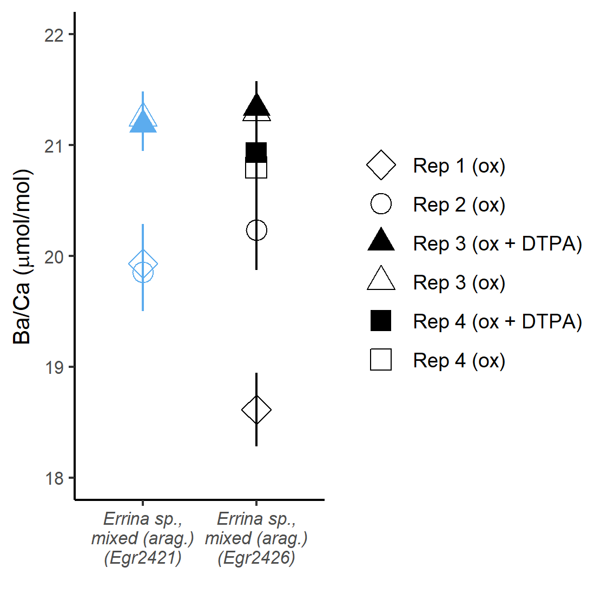
Figure 7. Cleaning experiments carried out on two mixed mineralogy Errina sp. corals. Symbols represent different replicates of the same powders. The two corals used were JR15005-113-2421-Egr2421 (Egr2421) and JR15005-113-2426-Egr2426 (Egr2426). Open symbols were cleaned by standard oxidative techniques (ox), filled symbols were additionally treated with DTPA (ox + DTPA). Error bars represent analytical errors (RSD; 2s).

- Bamboo coral Ba/Ca

Bamboo coral Ba/Ca has previously been shown to correlate with [Ba]_{SW} (LaVigne et al. [2011]). Our high-Mg calcitic stylasterid Ba/Ca vs [Ba]_{SW} relationship is steeper than that found for bamboo corals (LaVigne et al. [2011]; red line in Figure 8). However, closer inspection of the bamboo coral data reveals a reduction in Ba-incorporation at high [Ba]_{SW} (compare grey and red lines in Figure 8), likely driven by decreasing bamboo coral D_{Ba} with increasing water depth (Geyman et al. [2019]). When bamboo coral samples from the range of [Ba]_{SW} represented in our stylasterid study (i.e. [Ba]_{SW} < 105 nmol/kg) are considered, the bamboo coral Ba/Ca vs [Ba]_{SW} relationship is steeper (compare grey and red lines in Figure 8) and agrees well with our high-Mg calcitic stylasterid relationship (main text, Figure 4). However, we note that the lack of a comparable interlaboratory standard may complicate direct comparison of these datasets. Finally, we also note that one bamboo coral sample is plotted differently here to Figure 2 in LaVigne et al. [2011]. Here, we are plotting this data point as it is provided in their Table 1 and supplement. In practise, the position of this sample does not change our conclusions.

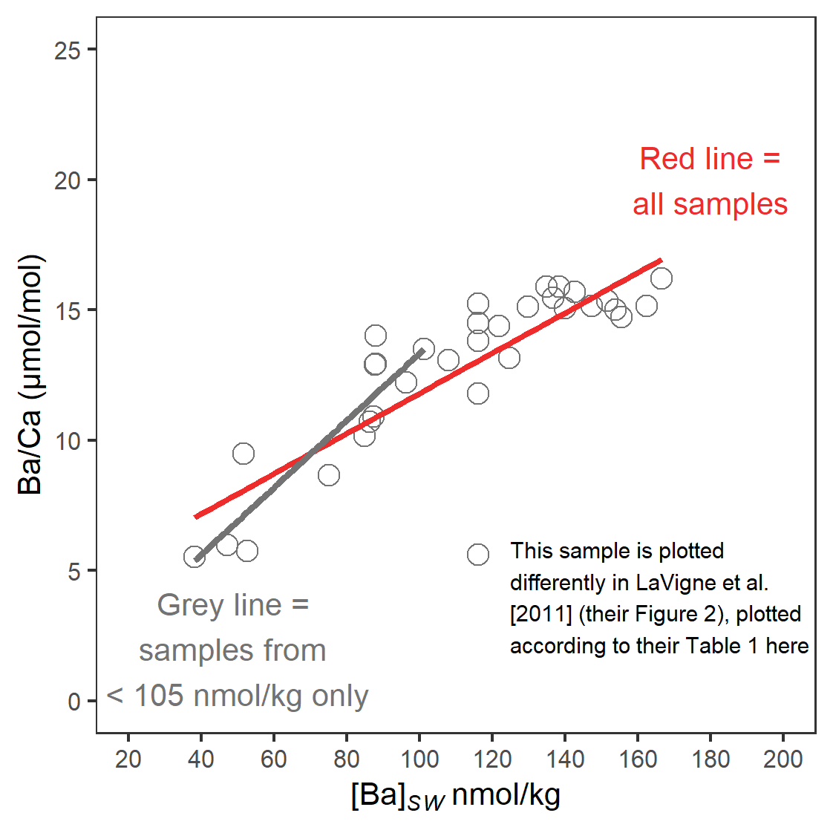
Figure 8. Bamboo coral Ba/Ca vs [Ba]_{SW} from LaVigne et al. [2011]. Note the reduction in gradient when including samples from higher [Ba]_{SW}, shown by comparison of grey and red lines. For comparability with our data set, samples from [Ba]_{SW} > 105 nmol/kg are not used in Figures 3a and 4 in the main text.
- Additional controls on stylasterid and scleractinian Ba-incorporation

Correlations between hydrographic variables and stylasterid and scleractinian D_{Ba} and Ba/Ca vs [Ba]_{SW} residuals are summarised in Table 3. As outlined in the main text (main text, sections 4.3 and 4.4), the strongest observed correlations are found for stylasterids, with both temperature and dissolved silica concentrations. We find no significant correlations between scleractinian D_{Ba} values and any hydrographic parameter (Figure 9).

 | Aragonitic Stylasteridae |  | High-Mg calcitic Stylasteridae |  | Scleractinia (compiled dataset)
 | D_{Ba} | Ba/Ca vs [Ba]_{SW} residuals | D_{Ba} | Ba/Ca vs [Ba]_{SW} residuals | D_{Ba} | Ba/Ca vs [Ba]_{SW} residuals
Temperature (⁰C) | r = - 0.54  p < 0.05 | r = - 0.16  p > 0.05 | r = - 0.55  p > 0.05 | r = - 0.45  p > 0.05 | r = - 0.15  p > 0.05 | r = - 0.17  p < 0.05
Dissolved silica (µmol/kg) | r = 0.47  p < 0.05 | r = 0.14  p > 0.05 | r = 0.45  p > 0.05 | r = 0.33  p > 0.05 | r = - 0.01  p > 0.05 | r = 0.07  p > 0.05
Depth (m) | r = - 0.18  p > 0.05 | r = - 0.45  p < 0.05 | r = - 0.18  p > 0.05 | r = - 0.31  p > 0.05 | r = - 0.06  p > 0.05 | r = - 0.11  p > 0.05
pH (total scale) | r = 0.33  p > 0.05 | r = 0.24  p > 0.05 | r = 0.15  p > 0.05 | r = 0.27  p > 0.05 | r = 0.01  p > 0.05 | r = 0.03  p > 0.05
Salinity (psu) | r = - 0.28  p > 0.05 | r = - 0.06  p > 0.05 | r = 0.34  p > 0.05 | r = 0.21  p > 0.05 | r = 0.03  p > 0.05 | r = 0.00  p > 0.05
Oxygen (µmol/kg) | r = 0.39  p < 0.05 | r = 0.27  p > 0.05 | r = 0.08  p > 0.05 | r = 0.20  p > 0.05 | r = 0.07  p > 0.05 | r = 0.09  p > 0.05
Phosphate (µmol/kg) | r = 0.10  p > 0.05 | r = - 0.11  p > 0.05 | r = 0.12  p > 0.05 | r = 0.00  p > 0.05 | r = 0.01  p > 0.05 | r = 0.09  p > 0.05
Ω_{arag.} | r = 0.02  p > 0.05 | r = 0.23  p > 0.05 | r = 0.00  p > 0.05 | r = 0.13  p > 0.05 | r = 0.19  p > 0.05 | r = 0.13  p > 0.05
Table 3. Correlations between coral D_{Ba}, and Ba/Ca vs [Ba]_{SW} residuals, with various hydrographic parameters. Relationships with p values < 0.05 and/or r values > 0.4 are shown in bold. For Scleractinia, the entire compiled dataset (this study, Spooner et al. [2018] and Hemsing et al. [2018]) is included in this analysis, where relevant hydrographic data were previously published. Note that some samples from Hemsing et al. [2018] were not published with associated concentrations of dissolved oxygen, phosphate or silica. Samples from Spooner et al. [2018] and Hemsing et al. [2018] were not published with associated Ω_{arag.}, or carbonate system parameters to facilitate Ω_{arag.} calculation.

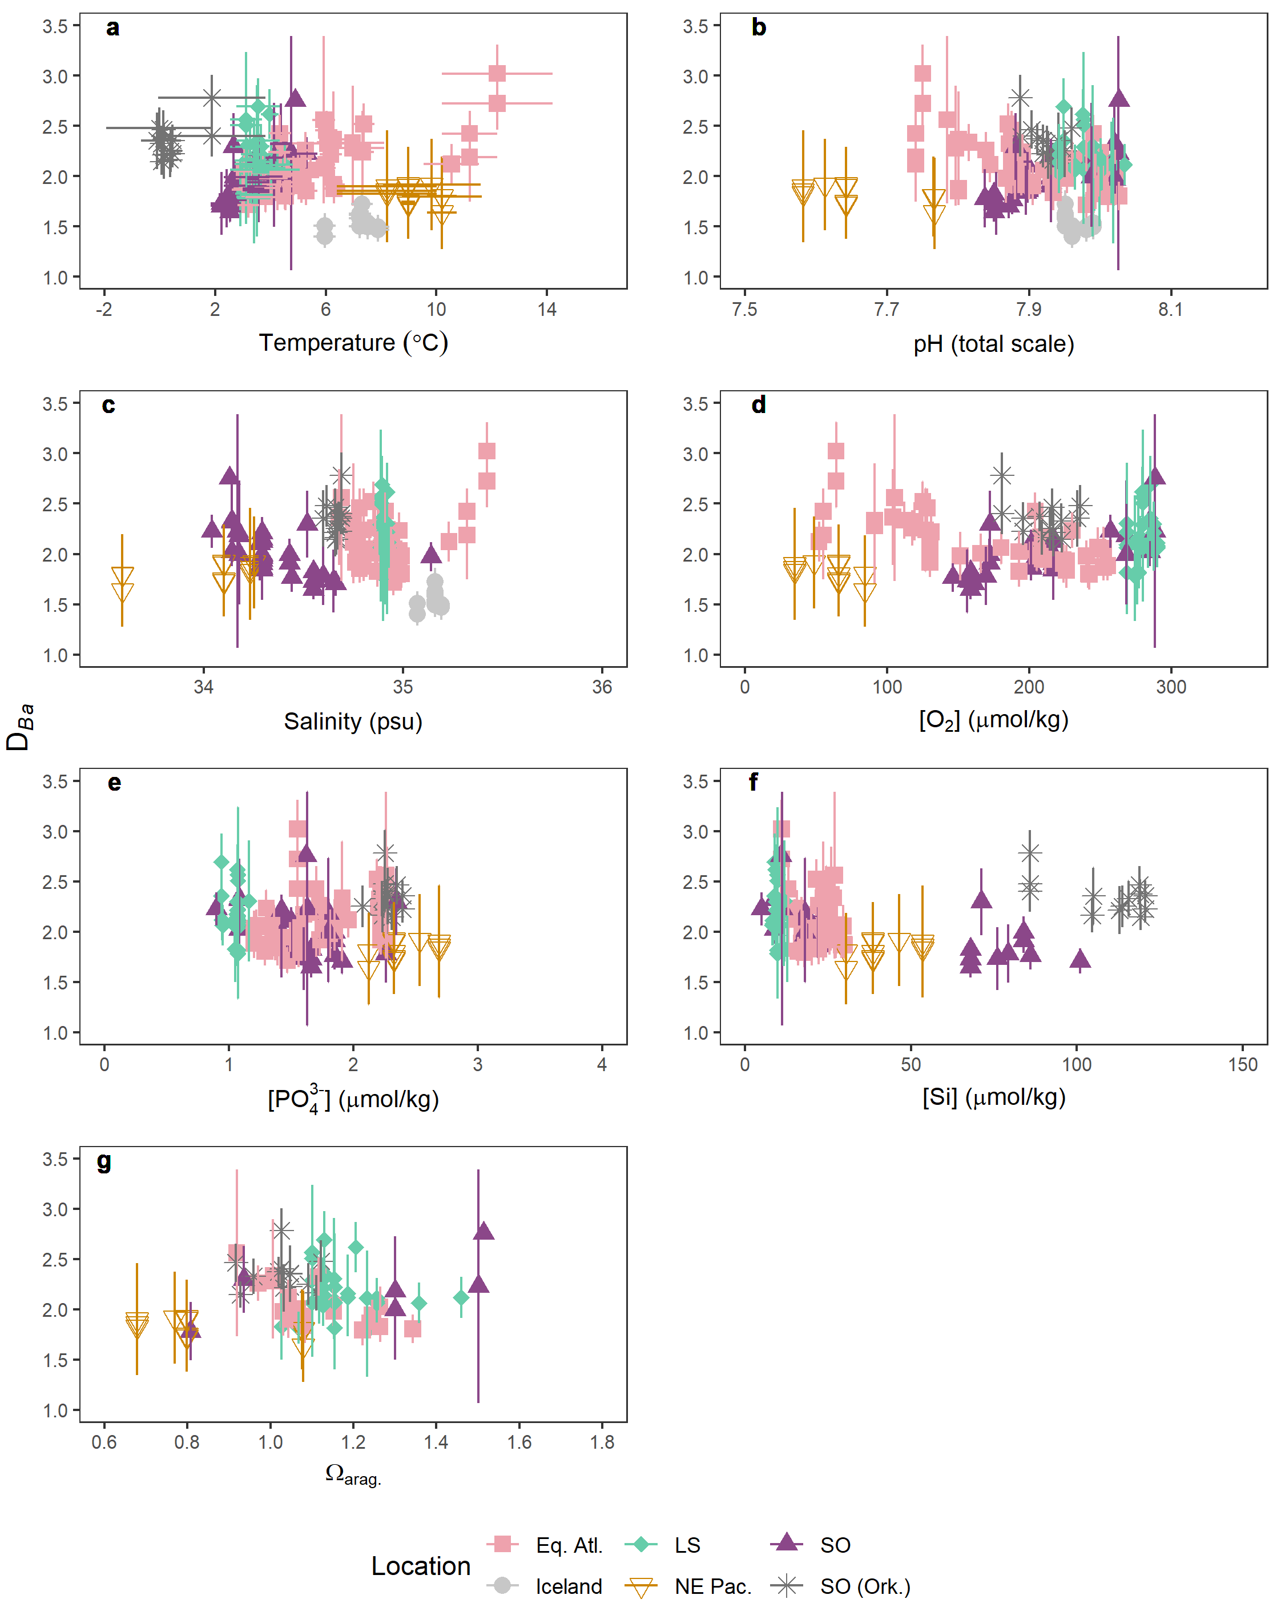
Figure 9. Scleractinian D_{Ba} values as a function of various seawater parameters. Colours and symbols represent locations. Icelandic samples from Hemsing et al. [2018] were not published with associated concentrations of dissolved oxygen, phosphate or silica. Samples from Spooner et al. [2018] and Hemsing et al. [2018] were not published with associated Ω_{arag.}, or carbonate system parameters to facilitate Ω_{arag.} calculation.
Finally, while genus-specific effects on Ba-incorporation into stylasterid and scleractinian corals appear to be minimal, we find that sampling approach is an important consideration when analysing Ba/Ca ratios of the scleractinian coral Lophelia sp., owing to the systematic offset between Ba/Ca of bulk calyx and theca only subsamples (Figure 10; main text section 4.4).
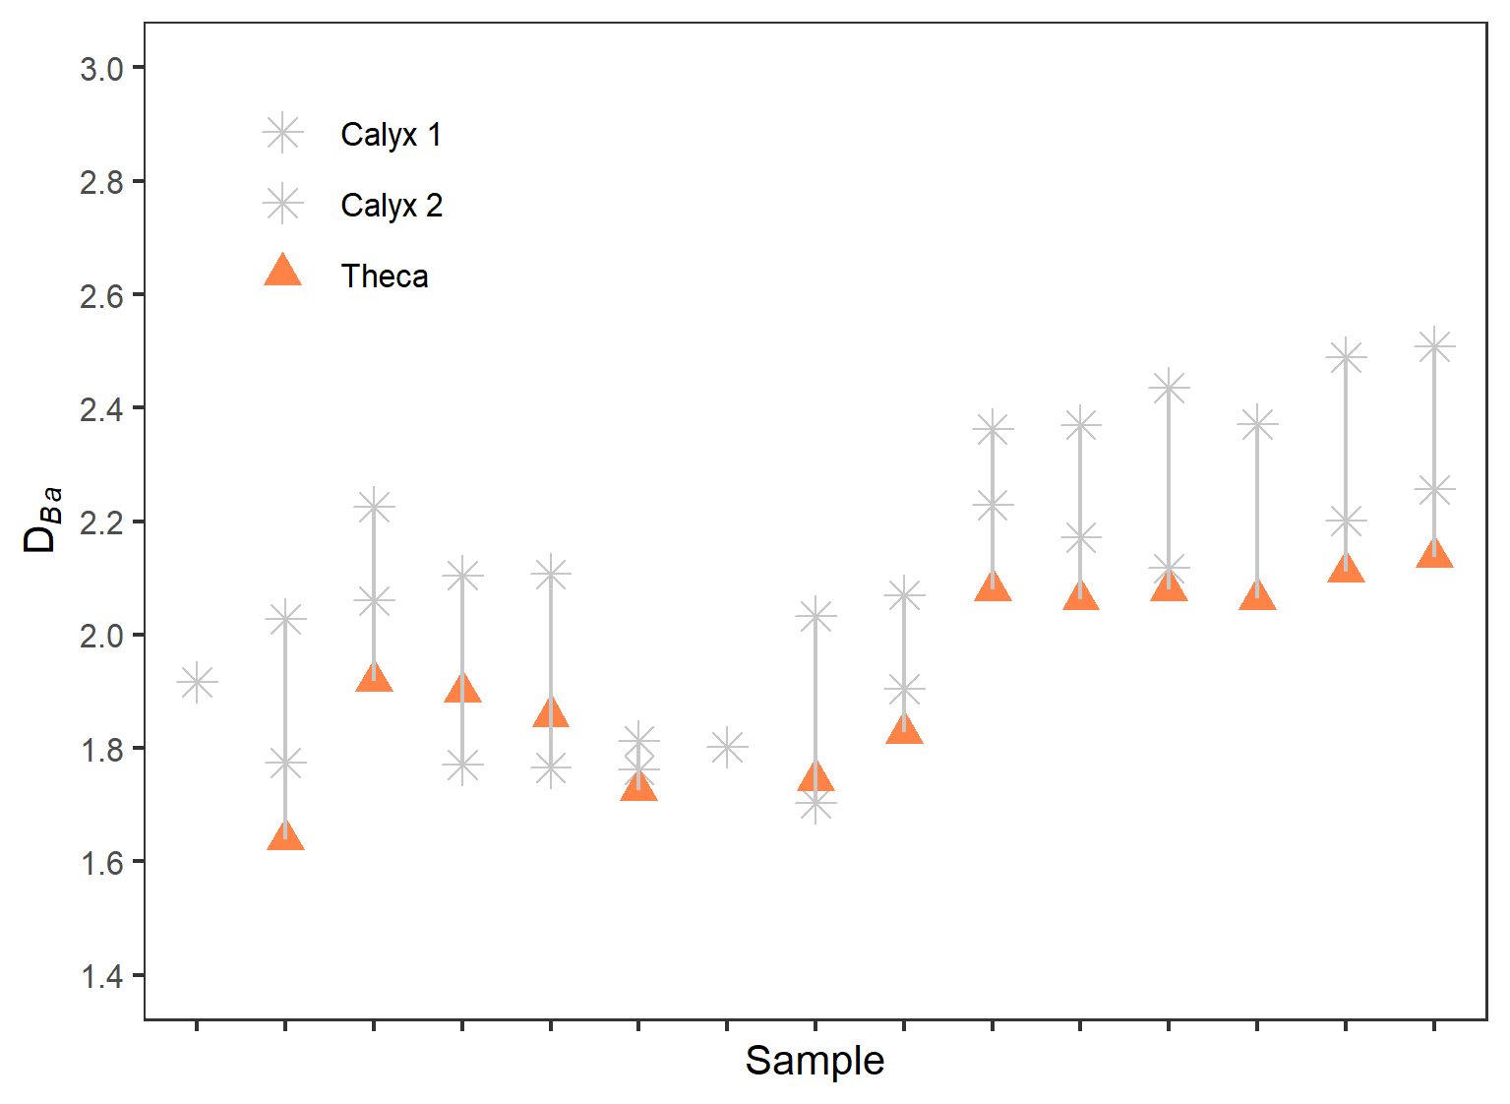
Figure 10. Effect of sampling on Lophelia D_{Ba}. Whole calyx samples are thought to incorporate centres of calcification (COCs), which results in increased Ba-incorporation compared to theca samples. For description of sampling, see Stewart et al. [2020]b.

References

- Anagnostou, E., Sherrell, R.M., Gagnon, A., LaVigne, M., Field, M.P., McDonough, W.F., 2011. Seawater nutrient and carbonate ion concentrations recorded as P/Ca, Ba/Ca, and U/Ca in the deep-sea coral Desmophyllum dianthus. Geochimica et Cosmochimica Acta 75, 2529–2543. https://doi.org/10.1016/j.gca.2011.02.019
- Bax, N., Cairns, S.D., 2014. Chapter 5.7. Stylasteridae (Cnidaria: Hydrozoa). In: De Broyer C., Koubbi P., Griffiths H.J., Raymond B., Udekem d’Acoz C. d’, et al. (eds.). Biogeographic Atlas of the Southern Ocean. Scientific Committee on Antarctic Research, Cambridge, pp. 107-112.
- Boyle, E.A., 1981. Cadmium, zinc, copper, and barium in foraminifera tests. Earth and Planetary Science Letters 53, 11–35. https://doi.org/10.1016/0012-821X(81)90022-4
- Clarke, A., Leakey, R.J.G., 1996. The seasonal cycle of phytoplankton, macronutrients, and the microbial community in a nearshore antarctic marine ecosystem. Limnology and Oceanography 41, 1281–1294. https://doi.org/10.4319/lo.1996.41.6.1281
- Dehairs, F., Chesselet, R., Jedwab, J., 1980. Discrete suspended particles of barite and the barium cycle in the open ocean. Earth and Planetary Science Letters 49, 528–550. https://doi.org/10.1016/0012-821X(80)90094-1
- Evans, D., Gray, W.R., Rae, J.W.B., Greenop, R., Webb, P.B., Penkman, K., Kröger, R., Allison, N., 2020. Trace and major element incorporation into amorphous calcium carbonate (ACC) precipitated from seawater. Geochimica et Cosmochimica Acta 290, 293–311. https://doi.org/10.1016/j.gca.2020.08.034
- Gaetani, G.A., Cohen, A.L., 2006. Element partitioning during precipitation of aragonite from seawater: A framework for understanding paleoproxies. Geochimica et Cosmochimica Acta 70, 4617–4634. https://doi.org/10.1016/j.gca.2006.07.008
- Geyman, B.M., Ptacek, J.L., LaVigne, M., Horner, T.J., 2019. Barium in deep-sea bamboo corals: phase associations, barium stable isotopes, & prospects for paleoceanography. Earth and Planetary Science Letters 525, 115751. https://doi.org/10.1016/j.epsl.2019.115751
- Hathorne, E.C., Gagnon, A., Felis, T., Adkins, J., Asami, R., Boer, W., Caillon, N., Case, D., Cobb, K.M., Douville, E., deMenocal, P., Eisenhauer, A., Garbe-Schönberg, D., Geibert, W., Goldstein, S., Hughen, K., Inoue, M., Kawahata, H., Kölling, M., Cornec, F.L., Linsley, B.K., McGregor, H.V., Montagna, P., Nurhati, I.S., Quinn, T.M., Raddatz, J., Rebaubier, H., Robinson, L., Sadekov, A., Sherrell, R., Sinclair, D., Tudhope, A.W., Wei, G., Wong, H., Wu, H.C., You, C.-F., 2013. Interlaboratory study for coral Sr/Ca and other element/Ca ratio measurements. Geochemistry, Geophysics, Geosystems 14, 3730–3750. https://doi.org/10.1002/ggge.20230
- Hemsing, F., Hsieh, Y.-T., Bridgestock, L., Spooner, P.T., Robinson, L.F., Frank, N., Henderson, G.M., 2018. Barium isotopes in cold-water corals. Earth and Planetary Science Letters 491, 183–192. https://doi.org/10.1016/j.epsl.2018.03.040
- Hoppema, M., Dehairs, F., Navez, J., Monnin, C., Jeandel, C., Fahrbach, E., de Baar, H.J.W., 2010. Distribution of barium in the Weddell Gyre: Impact of circulation and biogeochemical processes. Marine Chemistry 122, 118–129. https://doi.org/10.1016/j.marchem.2010.07.005
- Jennings, J.C., Gordon, L.I., Nelson, D.M., 1984. Nutrient depletion indicates high primary productivity in the Weddell Sea. Nature 309, 51–54. https://doi.org/10.1038/309051a0
- Kang, J., Kang, S., Lee, J., Lee, S., 2002. Seasonal variation of microalgal assemblages at a fixed station in King George Island, Antarctica, 1996. Marine Ecology Progress Series 229, 19–32. https://doi.org/10.3354/meps229019
- LaVigne, M., Hill, T.M., Spero, H.J., Guilderson, T.P., 2011. Bamboo coral Ba/Ca: Calibration of a new deep ocean refractory nutrient proxy. Earth and Planetary Science Letters 312, 506–515. https://doi.org/10.1016/j.epsl.2011.10.013
- Mavromatis, V., Goetschl, K.E., Grengg, C., Konrad, F., Purgstaller, B., Dietzel, M., 2018. Barium partitioning in calcite and aragonite as a function of growth rate. Geochimica et Cosmochimica Acta 237, 65–78. https://doi.org/10.1016/j.gca.2018.06.018
- Murphy, E.J., Clarke, A., Symon, C., Priddle, J., 1995. Temporal variation in Antarctic sea-ice: analysis of a long term fast-ice record from the South Orkney Islands. Deep Sea Research Part I: Oceanographic Research Papers 42, 1045–1062. https://doi.org/10.1016/0967-0637(95)00057-D
- Post, A.L., O’Brien, P.E., Beaman, R.J., Riddle, M.J., De Santis, L., 2010. Physical controls on deep water coral communities on the George V Land slope, East Antarctica. Antarctic Science 22, 371–378. https://doi.org/10.1017/S0954102010000180
- Pyle, K.M., Hendry, K.R., Sherrell, R.M., Meredith, M.P., Venables, H., Lagerström, M., Morte-Ródenas, A., 2017. Coastal barium cycling at the West Antarctic Peninsula. Deep Sea Research Part II: Topical Studies in Oceanography 139, 120–131. https://doi.org/10.1016/j.dsr2.2016.11.010
- Pyle, K.M., Hendry, K.R., Sherrell, R.M., Legge, O., Hind, A.J., Bakker, D., Venables, H., Meredith, M.P., 2018. Oceanic fronts control the distribution of dissolved barium in the Southern Ocean. Marine Chemistry 204, 95–106. https://doi.org/10.1016/j.marchem.2018.07.002
- Samperiz, A., Robinson, L.F., Stewart, J.A., Strawson, I., Leng, M.J., Rosenheim, B.E., Ciscato, E.R., Hendry, K.R., Santodomingo, N., 2020. Stylasterid corals: A new paleotemperature archive. Earth and Planetary Science Letters 545, 116407. https://doi.org/10.1016/j.epsl.2020.116407
- Spooner, P.T., Robinson, L.F., Hemsing, F., Morris, P., Stewart, J.A., 2018. Extended calibration of cold-water coral Ba/Ca using multiple genera and co-located measurements of dissolved barium concentration. Chemical Geology 499, 100–110. https://doi.org/10.1016/j.chemgeo.2018.09.012
- Stewart, J.A., Christopher, S.J., Kucklick, J.R., Bordier, L., Chalk, T.B., Dapoigny, A., Douville, E., Foster, G.L., Gray, W.R., Greenop, R., Gutjahr, M., Hemsing, F., Henehan, M.J., Holdship, P., Hsieh, Y., Kolevica, A., Lin, Y., Mawbey, E.M., Rae, J.W.B., Robinson, L.F., Shuttleworth, R., You, C., Zhang, S., Day, R.D., 2020a. NIST RM 8301 Boron Isotopes in Marine Carbonate (Simulated Coral and Foraminifera Solutions): Inter‐laboratory δ¹¹B and Trace Element Ratio Value Assignment. Geostandards and Geoanalytical Research 45, 77–96. https://doi.org/10.1111/ggr.12363
- Stewart, J.A., Robinson, L.F., Day, R.D., Strawson, I., Burke, A., Rae, J.W.B., Spooner, P.T., Samperiz, A., Etnoyer, P.J., Williams, B., Paytan, A., Leng, M.J., Häussermann, V., Wickes, L.N., Bratt, R., Pryer, H., 2020b. Refining trace metal temperature proxies in cold-water scleractinian and stylasterid corals. Earth and Planetary Science Letters 545, 116412. https://doi.org/10.1016/j.epsl.2020.116412

