Supporting Information

Melt-Functionalization of Cellulose Nanocrystals using Dynamic Hindered Ureas

Zehra Oluz, Nicholas Macke, Sarah Candelaria, Abrianna Ambus, Aurora Zemborain, Chinwe S. Udemgba, Adam M. Weiss, Céline Calvino*, Stuart J. Rowan*

- Materials, Methods, and Instrumentation
  - Materials
If not specified otherwise, all compounds and solvents were used as received, without further purification. Hydrochloric acid (HCl), sodium bromide (NaBr), sodium hypochlorite (NaOCl), D-(+)-galactose, sulfuric acid, dodecyl isocyanate, N-tert-butylmethylamine, methoxy-poly(ethylene glycol) (2,000 g/mol and 10,000 g/mol, PEG_{2k}-OH and PEG_{10k}-OH), hexamethylene diisocyanate, dibutyltin dilaurate (DBTDL), disperse orange 3 (DO3), benzyl alcohol, 1,5,7-Triazabicyclo[4.4.0]dec-5-ene, ε-caprolactone, ethyl α-bromoisobutyrate (EBiB), butyl acrylate, tris[2-(dimethylamino)ethyl]amine (Me₆TREN), copper (II) bromide (CuBr₂), allyl isocyanate, 2,2-dimethoxy-2-phenylacetophenone (DMPA), triethylamine (TEA) and chloroform-d (CDCl₃) were all purchased from Sigma-Aldrich. Whatman filter paper, sodium hydroxide (NaOH), sodium carbonate, copper (0) wire, basic alumina, neutral alumina, and all solvents, acetone, toluene, hexanes, dimethyl sulfoxide (DMSO), diethyl ether, chloroform, tetrahydrofuran (THF), dichloromethane (DCM), ethyl acetate, and N,N-dimethylformamide (DMF), were purchased from Fisher Scientific. (2,2,6,6-tetramethylpiperidin-1-yl)oxyl (TEMPO) was purchased from Ambeed, poly-(L)-lysine was purchased from Ted Pella, 1,6,-hexanedithiol was purchased from Oakwood Chemical, and PLA 4060D was kindly provided by NatureWorks.
  - Methods
    - Preparation of c-CNC-OSO₃
10 g of Whatman Number 1 Grade Filter Paper were cut into small pieces, poured into 500 mL deionized water, and blended until formation of a pulp. The CNC-pulp solution was then placed into an ice bath and 280 mL of concentrated sulfuric acid (98 %) was slowly added under stirring. During the addition, the temperature of the reaction was maintained below 35°C. After complete addition, the mixture was heated to 45 °C and stirred for 5 h. The mixture was then cooled to room temperature and filtered through a fine-fritted glass filter. The CNCs were centrifuged at 8000 rpm and resuspended in water ~5 times until the supernatant reached a neutral pH. Finally, the thoroughly washed material was suspended in DI and freeze-dried to yield c-CNC-OSO₃⁻ in fluffy powder form (7.6 g).
    - Preparation of c-CNC-OH
10 g of Whatman Number 1 Grade Filter Paper were cut into small pieces, mixed with 500 mL deionized water, and blended into a uniform pulp. In a 2 L round bottom flask, 75 mL of concentrated HCl was combined with 225 mL of DI water and heated to 100 °C. Once at temperature, the CNC-pulp solution was added to the HCl solution and stirred for 90 minutes. The mixture was then filtered through fine-fritted glass filter before resuspending the c-CNC-OH in DI water. The CNCs were centrifuged at 8000 rpm and resuspended in water ~5 times until the supernatant reached neutral pH. Finally, the thoroughly washed material was suspended in DI water and freeze-dried to yield c-CNC-OH in fluffy powder form (7 g).
    - Preparation of c-CNC-COOH via TEMPO Oxidation
TEMPO oxidation of c-CNC-OH was conducted based on a prior literature report.^{[51]} In brief, 7 g of c-CNC-OH were dispersed in 700 mL of DI water and dispersed with probe sonication. To the dispersed CNCs, pre-dissolved TEMPO (0.109 g, 0.7 mmol), NaBr (0.306 g, 3.5 mmol), and NaOCl (14.08 mL, 210 mmol) were added. The pH was adjusted to 10-10.5 and maintained in that range using 1 M NaOH for 2 hours, or until the pH stopped decreasing. Once the reaction was complete, the solution was filtered through fine-fritted glass filter before resuspending the c-CNC-COOH in DI water. The CNCs were centrifuged at 8000 rpm and resuspended in water ~5 times. Finally, the thoroughly washed material was suspended in DI water and freeze-dried to yield c-CNC-COOH as a fluffy white powder (6 g).
    - Determination of Surface Carboxylate Concentration
To determine the carboxylate content of the isolated and oxidized c-CNC-COOH, conductivity titration was performed with a pH probe by recording conductivity and pH following dropwise addition of 0.01M NaOH. The resulting conductivity data was plotted against the volume of added NaOH and the weak acid plateau was used to determine the concentration of carboxylates on the surface of the CNCs. The functional group density was determined using the following equation:
$$Carboxylate Density \left(\frac{mol}{kg}\right)=\frac{Concentration × {Volume}_{plateau}}{Mass (kg)}$$
To convert from surface concentration (mol/kg) to surface density (groups/nm²), the calculated value is multiplied by 3.21, which was calculated based on the crystal structure of cellulose Iβ as well as the CNC dimensions measured via AFM.^{[15]} For example, a measured surface concentration of 0.37 mol/kg equates to 1.2 groups/nm².
    - Synthesis of the Isopropylidene-Protected D-galactose (PG)
The isopropylidene protection of D-(+)-galactose was prepared following a previously reported procedure.^{[37]} D-(+)-galactose (5 g, 27.7 mmol, 1 eq.) was dissolved in acetone (185 mL) and the solution was put in an ice bath. Concentrated sulfuric acid (98%) was added dropwise into the mixture (5.5 mL, 1.1 mL/g). The reaction mixture was then stirred at room temperature for 5 h and neutralized with a solution of sodium carbonate until reaching a pH of 7. The resulting white precipitate was filtered and washed with acetone. The filtrate was collected and dried under high vacuum to remove residual solvent and yield the protected galactose (PG) as a light-yellow oil. ¹H NMR (400 MHz, CDCl₃) δ 5.56 (d, J = 5.0 Hz, 1H), 4.61 (dd, J = 8.0, 2.5 Hz, 1H), 4.33 (dd, J = 4.92, 2.63 Hz, 1H), 4.27 (dd, J = 8.1, 1.7 Hz, 1H), 3.90 – 3.80 (m, 2H), 3.72 (dd, J = 10.8, 3.5 Hz, 1H), 1.52 (s, 3H), 1.45 (s, 3H), 1.33 (s, 6H).
    - Synthesis of alkyl end-functionalized hindered urea (Dodecyl-HU)
Dodecyl isocyanate (1.14 mL, 5.3 mmol, 1 eq.) and N-tert-butylmethylamine (0.65 mL, 5.5 mmol, 1.02 eq.) were solubilized in dry toluene (100 mL). The mixture was stirred at room temperature for 6 h. The resulting precipitate was filtered, thoroughly washed with hexanes, and dried under high vacuum to yield dodecyl-HU as a white powder. ¹H NMR (400 MHz, CDCl₃) δ 4.22 (br, 1H), 3.17 (dt, J = 7.5, 5.6 Hz, 2H), 2.81 (s, 3H), 1.48 (t, J = 7.3 Hz, 3H), 1.39 (s, 9H), 1.34 – 1.20 (m, 18H), 0.87 (t, J = 6.8 Hz, 3H).
    - Procedure for PG and Docedyl-HU model reaction in melt
In a desired ratio, PG and dodecyl-HU compounds were dissolved in a small vial using a minimal amount of acetone (ca. 1-2 mL). A final weight of 200 mg of compound was targeted, to ensure enough material for analysis. The solvent was removed under high pressure vacuum overnight to yield a dried solid powder. The powder was then heated to 120 °C and stirred in ambient atmosphere for 8 h. The experiment was tracked with in-situ FTIR, focusing on the urea and urethane peaks at 1645 and 1722 cm⁻¹, respectively. The resulting compound was precipitated in cold hexanes and dried under high vacuum to obtain a white powder before being characterized with ¹H NMR. ¹H NMR (400 MHz, CDCl₃): δ = 5.54 (d, 1H), 4.77 (br, 1H), 4.60 (d, 1H), 4.31 (dd, 2H), 4.25 (d, 1H), 4.12 (t, 1H), 4.03 (br, 1H), 3.14 (dd, 2H), 1.60-1.20 (m, 32H), 0.88 (t, 3H).
    - Synthesis of Isocyanate-terminated PEG (PEG-NCO)
Poly (ethylene glycol) methyl ether (2 g, 1 mmol), previously azeotropically dried from toluene under high vacuum, was dissolved in dry toluene (20 mL) under inert atmosphere. Hexamethylene diisocyanate (1.6 ml, 10 mmol) and a trace amount of DBTDL were added into the solution. The mixture was heated at 40 °C under stirring and nitrogen atmosphere for 2 h. The polymer was precipitated in cold hexanes (200 mL) twice from a concentrated toluene solution, taking extreme care to keep the polymer under inert atmosphere as much as possible. The resulting PEG-NCO was dried under high vacuum to yield a solid white material for characterization. ¹H NMR (400 MHz, CDCl₃) δ 4.83 (br, 1H), 4.21 (t, J = 4.8 Hz, 2H), 3.83 – 3.42 (backbone), 3.37 (s, 3H), 3.30 (t, J = 6.6 Hz, 2H), 3.16 (q, J = 6.7 Hz, 2H), 1.67 – 1.20 (m, 8H). SEC (THF) M_{n, 2k} = 4,730 g/mol, Ð_{2k} = 1.10; M_{n, 10k} = 10,600 g/mol, Ð_{10k} = 1.008.
    - Synthesis of Hindered-urea Terminated PEG (PEG-HU)
Dried PEG-NCO (1.75 g, 0.8 mmol) and N-tert-butylmethylamine (0.945 mL, 8 mmol) were dissolved in dry toluene (35 mL) under inert atmosphere. The mixture was stirred at room temperature for 2 h. The product was then precipitated 4 times in cold hexane (350 mL) from a concentrated toluene solution and dried to yield PEG-HU as a solid white material. ¹H NMR (400 MHz, CDCl₃) δ 4.86 (br, 1H), 4.28 (br, 1H), 4.20 (t, J = 4.7 Hz, 2H), 3.83 – 3.42 (backbone), 3.37 (s, 3H), 3.16 (m, 4H), 2.81 (s, 3H), 1.48 (m, 4H), 1.38 (s, 9H), 1.33 (m, 4H). SEC (THF) M_{n, 2k} = 3,130 g/mol, Ð_{2k} = 1.10, M_{n, 10k} = 13,000 g/mol, Ð_{10k} = 1.07.
    - Synthesis of Disperse Orange 3-terminated PEG (PEG-DO3)
PEG-HU (1 g, 0.5 mmol) was dissolved in dry DMSO along with DO3 (1.21 g, 5 mmol). The solution was heated to 120°C under vacuum (200 mbar) for 2 hours to remove the urea blocking group without evaporating the solvent. The DMSO was removed via liquid-liquid extraction with water and chloroform, where the DMSO went into the aqueous layer and the product remained in the organic layer. After concentrating, the organic layer was precipitated in diethyl ether 3 times before drying and characterizing the resulting PEG-DO3. ¹H NMR (400 MHz, CDCl₃) δ 8.41 – 7.55 (ar, 8H), 5.70 (br, 1H), 5.10 (br, 1H), 4.20 (t, J = 4.7 Hz, 2H), 3.83 – 3.42 (backbone), 3.37 (s, 3H), 3.22 (m, 4H), 1.48 (m, 4H), 1.33 (m, 4H).
    - Synthesis of Polycaprolactone (PCL)
Benzyl alcohol (0.24 mL, 23.1 mmol), 1,5,7-triazabicyclo[4.4.0]dec-5-ene (6.4 mg, 0.05 mmol, 0.1 mol.%), and ε-caprolactone (5 mL, 462.4 mmol) were mixed under inert atmosphere. The mixture was heated at 60 °C for 4 hours, then quenched with benzyl alcohol (2.5 mL). The polymer was precipitated 5 times in cold diethyl ether (200 mL) from concentrated solution of THF and dried to yield PCL as a white solid material. ¹H NMR (400 MHz, CDCl₃) δ 7.35 (ar, 5H), 4.05 (m, 2H), 2.30 (m, 2H), 1.64 (m, 4H), 1.38 (m, 2H). SEC (THF) M_{n} = 9,070 g/mol, Ð = 1.23.
    - Synthesis of PCL end-functionalize isocyanate (PCL-NCO)
PCL (2.051 g, 1.26 mmol), previously azeotropically dried from toluene under high vacuum, was dissolved in dry THF (100 mL) under inert conditions. Hexamethylene diisocyanate (3 mL, 25 mmol) and a tiny amount of DBTDL were added into the solution. The mixture was heated at 40 °C under stirring and nitrogen atmosphere for 2 h. The polymer was precipitated 4 times in cold diethyl ether (100 mL) from a concentrated THF solution and dried to yield PCL-NCO as a white solid material. ¹H NMR (400 MHz, CDCl₃) δ 7.35 (ar, 5H), 4.68 (br, 1H), 4.06 (m, backbone), 3.30 (m, 2H), 3.16 (m, 2H), 2.30 (m, backbone), 1.64 (m, backbone), 1.51 (m, 4H), 1.38 (m, backbone), 1.28 (m, 4H). SEC (THF) M_{n} = 14,300 g/mol, Ð = 1.43.
    - Synthesis of PCL end-functionalize hindered urea (PCL-HU)
Dried PCL-NCO (1.72 g) and N-tert-butylmethylamine (2 mL, 16.68 mmol) were dissolved in dry THF (60 mL) under inert atmosphere. The mixture was stirred at room temperature for 2 h. The product was then precipitated 4 times in cold ether (100 mL) from a concentrated THF solution and dried to yield PCL-HU as a solid white material. ¹H NMR (400 MHz, CDCl₃) δ 7.35 (ar, 5H), 4.74 (br, 1H), 4.29 (br, 1H), 4.06 (m, backbone), 3.16 (m, 4H), 2.81 (s, 3H), 2.30 (m, backbone), 1.64 (m, backbone), 1.50 (m, 4H), 1.38 (m, backbone + 9H), 1.25 (m, 4H). SEC (THF) M_{n} = 11,100 g/mol, Ð = 1.34.
    - Synthesis of Poly(Butyl Acrylate) (PBA-Br)
PBA-Br was synthesized via Cu(0)-mediated living radical polymerization, following a published procedure.^{[52]} In brief, butyl acrylate was filtered through basic alumina to remove any inhibitor, then the initiator (EBiB) (1 eq.), monomer (targeting 10,000 g/mol at 50% conversion), CuBr₂ (0.05 eq.), and DMF (targeting 75 vol.% relative to all other reactants) were all added to a round-bottom flask. The flask was sparged with inert gas for 15 minutes before adding the Me6TREN ligand (0.12 eq.). A stir bar was wrapped in 10 cm of copper wire and cleaned with concentrated HCl, then rinsed with acetone and DMF before dropping it into the flask to begin the reaction. NMR aliquots were taken every 30 minutes to track conversion and the reaction was quenched by opening it to air and removing the stir bar once it reached 50% conversion. The polymer was purified by rotary evaporation of any remaining monomer, redissolving in DCM, running it through a neutral alumina plug to remove the copper and ligand, then drying on high vacuum overnight before characterizing. The pure polymer was characterized with ¹H NMR and SEC to confirm the product. ¹H NMR (400 MHz, CDCl₃) δ 4.03 (m, 2H), 2.28 (m, 1H), 1.90 (m, 1H), 1.60 (m, 3H), 1.37 (m, 2H), 0.93 (m, 3H). SEC (THF) M_{n} = 13,000 g/mol, Ð = 1.21.
    - Preparation of Thio-HU for End Group Functionalization
Thio-HU was synthesized in a two-step process before being added to the polymer chain end. First, an allyl-hindered urea was synthesized by mixing allyl isocyanate (1 eq.) with N-tert-butylmethylamine (1.1 eq.) at 1M concentration in DCM. The resulting allyl-HU was purified with high vacuum to remove all solvent and remaining reactants, resulting in a white solid, before characterizing with ¹H NMR, ¹³C NMR, and high-resolution mass spectrometry. ¹H NMR (400 MHz, CDCl₃) δ 5.87 (ddt, J = 17.2, 10.2, 5.6 Hz, 1H), 5.14 (dq, J = 17.2, 1.7 Hz, 1H), 5.06 (dq, J = 10.2, 1.5 Hz, 1H), 4.33 (br, 1H), 3.80 (tt, J = 5.6, 1.6 Hz, 2H), 2.82 (s, 3H), 1.37 (s, 9H). ¹³C NMR (101 MHz, CDCl₃) δ 159.09 (C = O), 136.13 (C = C – C), 115.40 (C = C), 55.71 (C), 43.31 (C = C – C), 31.84 (CH₃), 29.05 (3CH₃). HRMS (ESI) m/z: [M + H]⁺ calcd for C₉H₁₈N₂O, 171.1453; found, 171.1497.
A thiol group was added to the allyl-HU by dissolving 1 eq. of allyl-HU in 15 eq. of 1,6-hexanedithiol along with 0.5 eq. DMPA photoinitiator. Once dissolved, the solution was placed on a low-power UV source (bug zapper) for 30 minutes. The resulting thio-HU molecule was purified by loading the crude mixture onto a silica column with 9:1 hexanes:ethyl acetate. This 9:1 mixture pushed the excess dithiol and initiator fragments through, while retaining the product in the column. The product was then flushed from the column using pure ethyl acetate. Thio-HU was then dried as a yellow oil before characterization with ¹H NMR, ¹³C NMR, and high resolution mass spectrometry. ¹H NMR (400 MHz, CDCl₃) δ 4.51 (br, 1H), 3.27 (td, J = 6.7, 5.6 Hz, 2H), 2.80 (s, 3H), 2.57 – 2.44 (m, 6H), 1.78 (qi, J = 6.9 Hz, 2H), 1.65 – 1.50 (m, 4H), 1.37 (m, 13H), 1.31 (t, J = 7.8 Hz, 1H). ¹³C NMR (101 MHz, CDCl₃) δ 159.36 (C = O), 55.62 (C), 40.08 (C – N), 33.94 (CH₂), 32.16 (S – C), 31.88 (CH₃), 30.01 (CH₂), 29.96 (CH₂), 29.51 (CH₂), 29.08 (3CH₃), 28.39 (CH₂), 28.02 (CH₂), 24.64 (CH₂). HRMS (ESI) m/z: [M + H]⁺ calcd for C₁₅H₃₂N₂OS₂, 321.1990; found, 321.2041.
    - Synthesis of Hindered Urea-Terminated PBA (PBA-HU)
Thio-HU was added to PBA-Br chain ends via nucleophilic substitution. The bromine-terminated polymer (1 eq.) was dissolved in acetone at 500 mg/mL along with TEA (10 eq.). The solution was then purged with inert gas for 5 minutes before adding thio-HU (2 eq.). The reaction was allowed to proceed for 24 hours before another 2 eq. of thio-HU were added under inert atmosphere. This process was repeated until 5 total additions were made, totaling 10 eq. of thio-HU. The resulting HU-terminated PBA-HU was purified by running the crude solution through a silica plug with 65:35 hexanes:ethyl acetate, where the PBA-HU eluted first, followed by the other reagents. The products were then dried before characterization with ¹H NMR and SEC. ¹H NMR (400 MHz, CDCl₃) δ 4.51 (br, 1H), 4.03 (m, backbone), 3.29 (m, 2H), 2.81 (s, 3H), 2.52 (m, 6H), 2.27 (m, backbone), 1.90 (m, backbone), 1.80 (m, 4H), 1.60 (m, backbone), 1.39 (s, 9H), 1.37 (m, backbone), 0.93 (m, backbone). SEC (THF) M_{n} = 11,900 g/mol, Ð = 1.04.
    - Functionalization of c-CNC-g-Polymer in Melt
The c-CNC-COOH (30 to 200 mg) were dispersed in 25 mL of deionized water by ultrasonication for 15 min, then solvent exchanged into acetone (see below). Relative to the CNC mass, hindered-urea-terminated polymer of the desired molar ratio was added to the CNC suspension and placed in a sonic bath until completely dissolved. The solvent was removed under high vacuum overnight to yield a dried powder. Once dry, the mixture was placed in an oil bath at 130°C and 120 mbar vacuum was applied to pull off the released volatile amine. After 2 hours, heat was removed and a mixture of water/acetone in a 1:1 ratio (50 mL) was added to the PEG grafting reactions, or THF for PCL and PBA reactions. The mixture was centrifuged and resuspended in the same solvent 10 times to remove non-attached polymer. The resulting c-CNC-g-Polymer were suspended in water and freeze-dried to obtain a fluffy powder.
    - Measuring Non-Grafted Polymer Chains
A UV-Vis calibration curve was created for PEG-DO3 in 1:1 water/acetone mixture from 100 mM to 10 nM. The functionalization of c-CNC-g-PEG was carried out as described before. After the grafting reaction was completed, a mixture of water/acetone in a 1:1 ratio (50 mL) containing 1 eq. of PEG-DO3 (relative to the PEG-HU added to the original reaction) was added to the medium. The mixture was centrifuged and resuspended in the same solvent couple, and the supernatants were analyzed with UV-Vis spectroscopy to track the removal of non-grafted polymer.
    - Solvent Exchange of CNCs
To disperse CNCs in non-aqueous solvents such as acetone, solvent exchange can be done to improve the quality of the suspension. In essence, 100 mg of CNCs are dispersed in 20 mL of DI water in a centrifuge tube using an ultrasonic bath before adding 20 mL of acetone. After mixing, the acetone/water suspension is centrifuged (10,000 g for 10 minutes) and the supernatant is poured off and replace by another 1:1 mixture of acetone:water. The precipitate is resuspended using a sonic bath and vortexer before centrifuging once again. The supernatant is then poured off and replace by pure acetone. Once the precipitate is resuspended, the CNCs form a more stable dispersion in acetone.
    - CNC + PCL and CNC + PBA FTIR Calibration Curves
To measure the polymer content of grafted CNCs, FTIR calibration curves were generated for PCL and PBA. In a small vial, 5-10 mg of c-CNC-COOH were mixed with the desired amount of polymer using a 20 mg/mL stock solution in MeOH to target samples with 5, 10, 15, 20, and 25 wt.% polymer. Minimal additional MeOH was added, and a spatula was used to ensure thorough mixing. The vials were immediately placed under high vacuum to remove the methanol and ensure a uniform distribution of polymer within the CNCs. Once dry, the samples were analyzed using FTIR and a calibration curve was developed based the representative carbonyl peak of each polymer (1724 cm⁻¹ for PCL, and 1730 cm⁻¹ for PBA).
    - Preparation of PLA + CNC composites
A 10 wt.% PLA stock solution was prepared by dissolving 30 g of PLA in 270 g of CHCl₃. Films with 5 wt.% c-CNC-g-PEG_{2k} and c-CNC-g-PEG_{10k} were prepared. The desired CNCs (e.g. 50 mg) were directly suspended in 20 ml of CHCl₃ using a sonic bath and vigorous shaking. The 10 wt.% PLA stock solution (10.0 g) was then added to the CNC suspension and thoroughly mixed. The resulting solution was allowed to mix in a sonic bath for a few hours and then cast into a Teflon petri dish to dry overnight. After removing the films from the petri dish, they were further dried in a vacuum oven at 60 °C for 48h before melt-pressing at 120 °C to obtain films of uniform thickness.
    - Tensile testing of composites
Tensile testing of composite materials was conducted following the ASTM D1708 standard. The video extensometer was used to monitor the elongation before yielding, while the crosshead distance was used to monitor the elongation after yielding, providing more accurate elongation measurements in the elastic regime and accounting for uneven plastic deformation after yielding. All samples were tested in triplicate and the average tensile strength and elongation at break were extracted for each sample.

  - Instrumentation
Atomic Force Microscopy (AFM) was done with a Cypher ES Environmental equipped with FS-1500 probes (Asylum Research) to determine the dimensions of CNCs. Crystals were dispersed in water by ultrasonication (10 min, 25% power, 3 s on/off cycle) at a concentration of 0.01% (w/w). A mica surface was mechanically exfoliated, treated with 50 μL poly(L-lysine), gently rinsed with DI water, then 50 μL of the freshly prepared CNC dispersion was drop-cast onto the surface. The dispersions were gently rinsed with DI water after 3 minutes and substrates were air-dried overnight prior to imaging. The images were recorded using tapping mode and the data was analyzed with Gwyddion software (Czech Metrology Institute).
Conductometric titrations of carboxylate and sulfate functional groups on the surface of the CNCs were performed using an Accumet XLbenchtop pH/conductivity meter on aqueous solutions. In brief, 30 mg of the desired CNCs were dispersed in 80 mL of DI water using probe sonication. For c-CNC-COOH the solution was acidified to a pH of 2-3 using concentrated HCl, then 0.01 M NaOH was titrated in using a syringe pump. For c-CNC-OSO₃, 0.01 M NaOH was directly titrated without acidification. Data was recorded at regular intervals and plotted as Conductivity vs. Volume added to determine the functional group content of the nanoparticles.
Fourier transform infrared (FTIR) spectroscopy of solid samples was carried out using a Shimadzu IRTracer-100 Fourier transform infrared spectrometer in the attenuated total reflection (ATR) geometry with a monolithic diamond ATR crystal. The sample temperature was controlled under a vacuum using the PIKE GladiATR accessory. Data was collected in the range of 4000–400 cm⁻¹, averaging over 45 scans, and treated with Shimadzu LabSolutions IR software.
High resolution mass spectrometry (HRMS) was performed on an Agilent 6224 ToF-MS using electrospray ionization (ESI).
Nuclear magnetic resonance (NMR) was carried out at ambient temperature on a Bruker Avance II+ 400 spectrometer at frequencies 400 MHz for ¹H nuclei and 101 MHz for ¹³C nuclei. Spectra were calibrated to the residual solvent peak of CDCl₃ (7.26 ppm ¹H NMR, 77.16 ppm for ¹³C NMR) and processed with MestReNova software. All chemical shifts, δ, are reported in parts per million (ppm) with coupling constant in Hz (multiplicity: s = singlet, d = doublet, dd = double doublet, td = triple doublet, t = triplet, dt = double triplet, tt = triple triplet, ddt = double double triplet, q = quadruplet, dq = double quadruplet, qi = quintuplet, m = multiplet, br = broad signal, ar = aromatic signal).
Size exclusion chromatography (SEC) of the polymers was performed on a Shimadzu Prominence High Performance Liquid Chromatography system using an eluent mobile phase of THF at a flow rate of 1 mL/min. Separation was achieved using two PLgel mixed-D columns (Agilent) maintained at ambient temperature with pore sizes suitable for materials with effective molecular weights from ~200 to 400,000 g/mol. The differential refractive index signal was collected using a Wyatt Optilab T-rEX differential refractometer (λ = 658 nm), and on-line multi-angle light scattering (MALS) measurement was performed using a Wyatt Dawn Heleos II light scattering detector. Data analysis was carried out using Wyatt Astra VII software. Weight-averaged molecular weights (M_{w}) were determined by MALS, and number-average molecular weights (M_{n}) were determined in comparison to narrow dispersity polystyrene calibration standards (from 1,800 to 400,000 g mol^{–1}).
Thermogravimetric analysis (TGA) was performed using a TA Instruments Discovery thermogravimetric analyzer. Samples (~5mg) were loaded in Pt crucibles and heated under a N₂ atmosphere. High resolution dynamic procedure with default settings (sensitivity=1, ramp=10 to 700 °C, resolution=5) were applied. Data was processed in TA Instruments Trios software.
Wide-angle X-ray scattering (WAXS) patterns were recorded using a SAXSLAB GANESHA 300XL system with Cu Kα source (λ= 0.154 nm) at a voltage of 40 kV and 40 mA power. Powder samples were tightly packed inside plastic washers and were held in place between two pieces of Kapton tape. The data were collected in the 2-theta angle range of 1-32° for 20 minutes. The crystallinity index was calculated using MATLAB R2018a by modelling the (1,-1,0), (1,1,0), (1,0,2), and (2,0,0) cellulose-1β peaks and the residual amorphous component to Gaussian distribution functions as described previously.^{[53,54]}
Probe Ultrasonication was carried out on a Branson SFX 550 instrument equipped with a 13 mm probe. Sonication was conducted at 20% amplitude with 5 seconds on and 5 seconds off per cycle while the sample vial was submerged in ice water to prevent significant heating.
Ultraviolet-Visible Light (UV-Vis) Spectroscopy was conducted on a Shimadzu UV-3600 Plus UV-Vis-NIR spectrophotometer from 350-800 nm wavelengths. Samples were run at 1 nm resolution in quartz cuvettes.
Melt Pressing was done on a Carver AccuStamp Model 3693 melt press at 120 °C at 2 tons of pressure for 3 minutes.
Tensile testing was conducted with a Zwick-Roell zwickiLine Z0.5 instrument. Dogbones in accordance with ASTM D1708 were measured up to the yield point with a VideoXtens extensometer, then by crosshead tracking after yielding.
Dynamic mechanical analysis (DMA) was performed on a TA Instruments RSA-G2 DMA on films of each sample (~ 3 mm x 1 mm x 20 mm). Temperature ramps were run from 25 to 100 °C at 3 °C per min at a frequency of 1 Hz.

- Supporting Figures

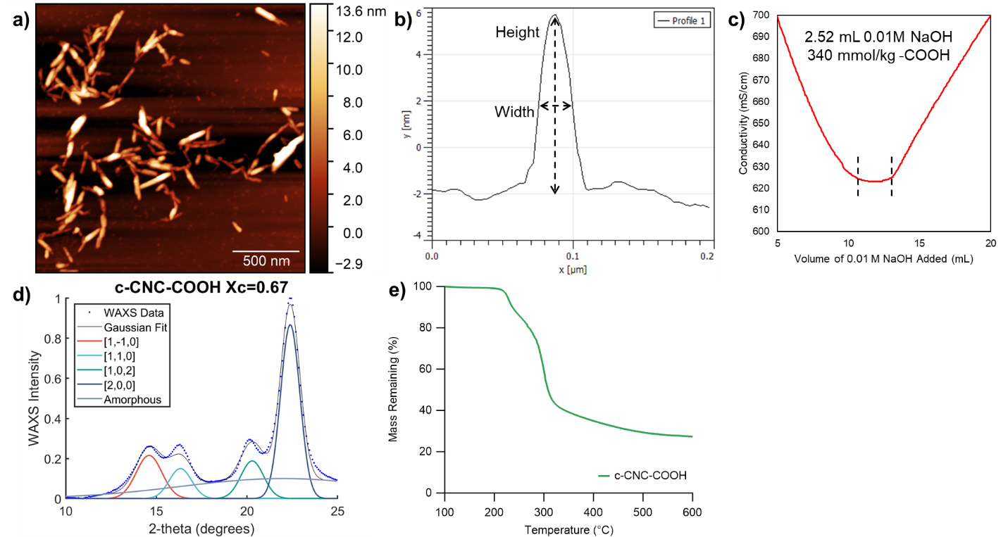

Figure S1. a) AFM height image of c-CNC-COOH, b) a height profile extracted from the AFM image showing how height and width of the nanoparticles are measured, c) a representative conductivity titration curve of c-CNC-COOH showing the weak acid plateau corresponding to -COOH neutralization, d) WAXS of c-CNC-COOH showing the crystallinity index, and e) the TGA degradation trace of the c-CNC-COOH.

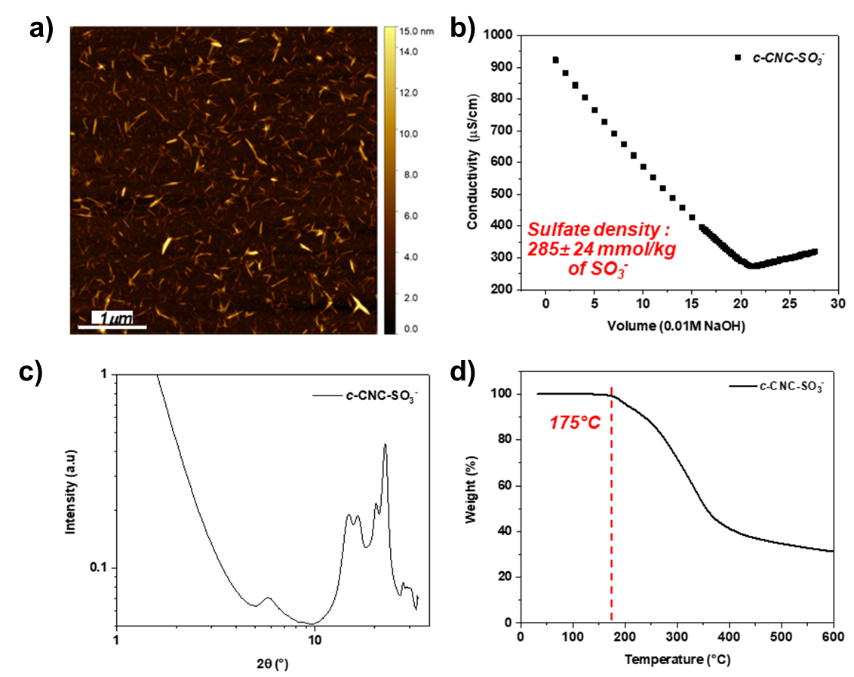

Figure S2. a) AFM height image of c-CNC-OSO₃, b) a representative conductivity titration curve of c-CNC-OSO₃, c) WAXS of c-CNC-OSO₃ showing the crystallinity index, and d) the TGA degradation trace of the c-CNC-OSO₃.

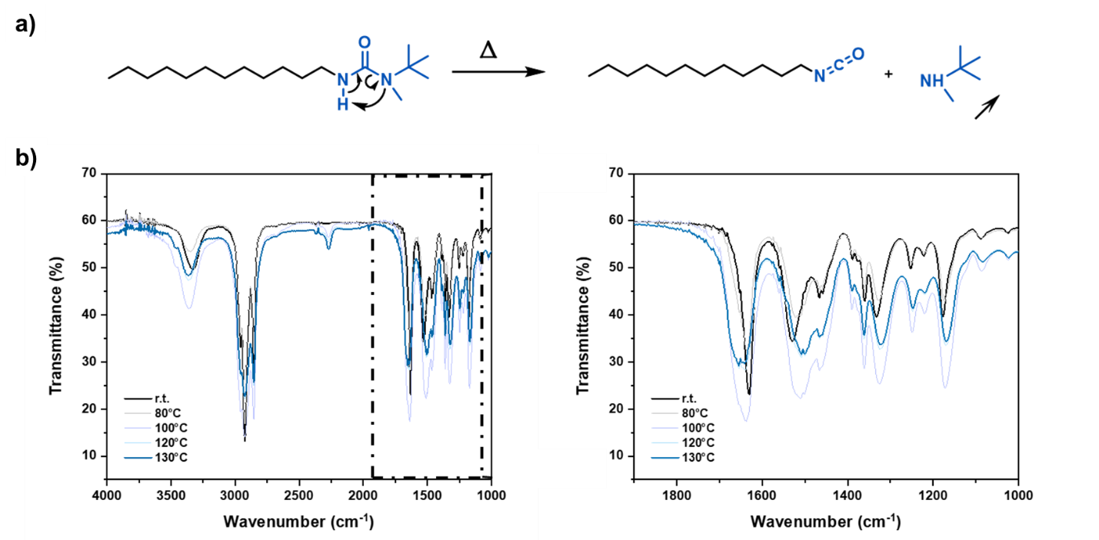

Figure S3. a) Scheme of hindered urea (dodecyl-HU) dissociation upon heating and b) FTIR spectra of the dodecyl-HU component at temperatures ranging from 80°C to 130°C, focusing on the signals at 1900-1000 cm⁻¹.

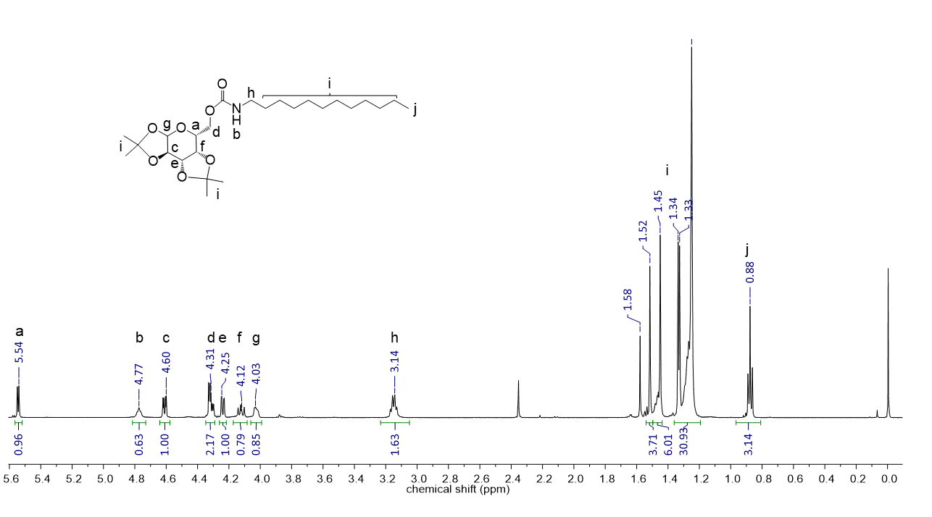
Figure S4. The ¹H NMR spectrum of the product resulting from the reaction of dodecyl-HU with PG with key peaks labeled.

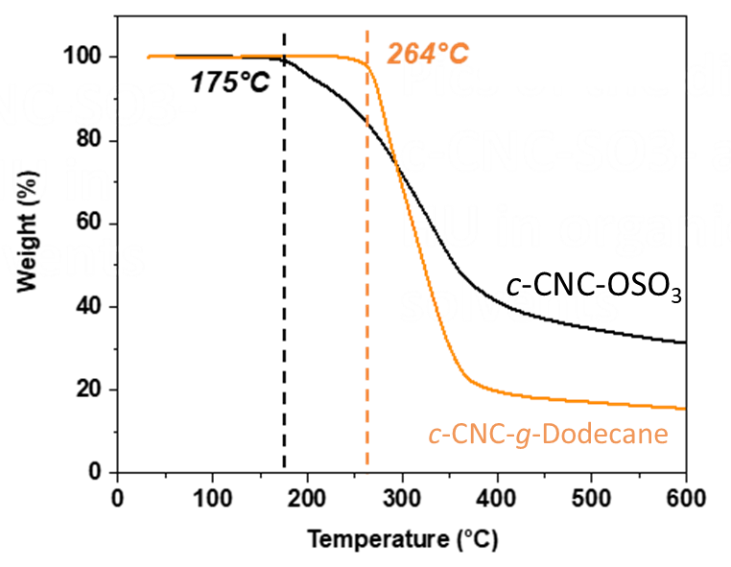
Figure S5. TGA of c-CNC-OSO₃ and c-CNC-g-dodecane showing increased thermal stability in the grafted CNCs.
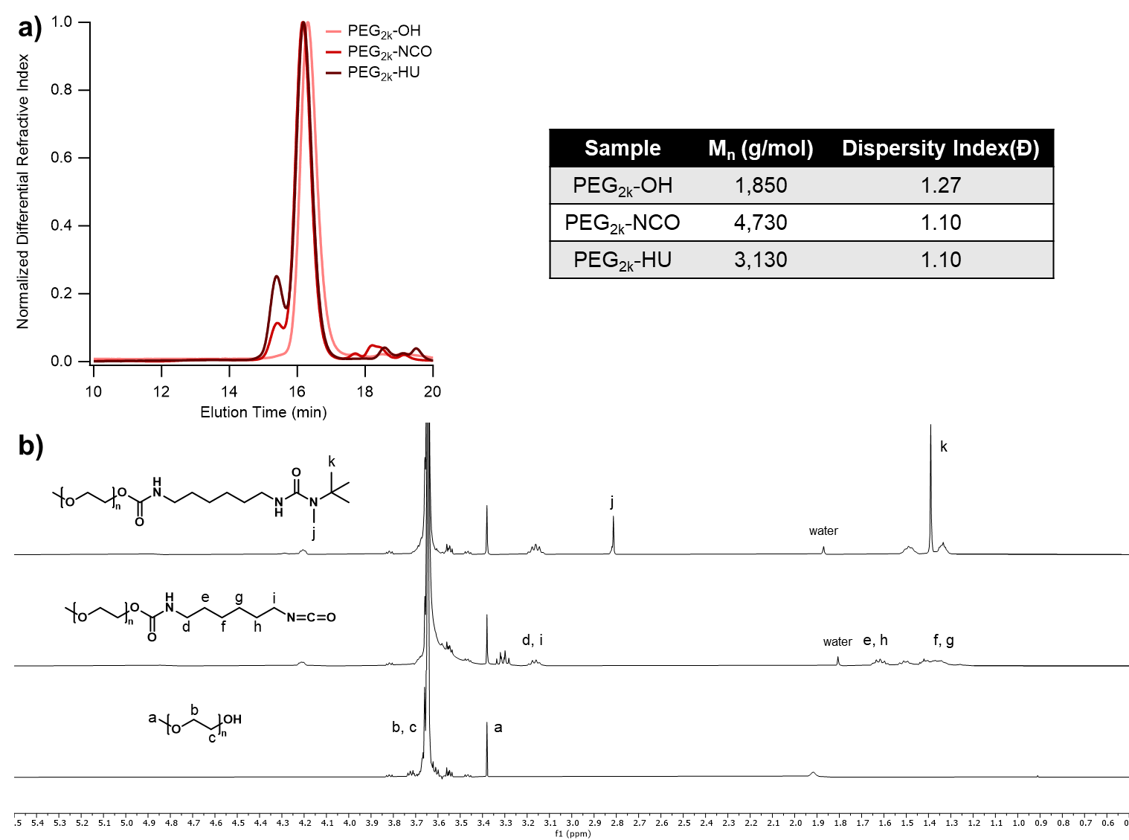

Figure S6. a) SEC traces and corresponding molecular weight and dispersity for PEG_{2k}-OH, PEG_{2k}-NCO, and PEG_{2k}-HU, and b) ¹H NMR spectra of PEG_{2k}-OH, PEG_{2k}-NCO, and PEG_{2k}-HU with key peaks labeled.

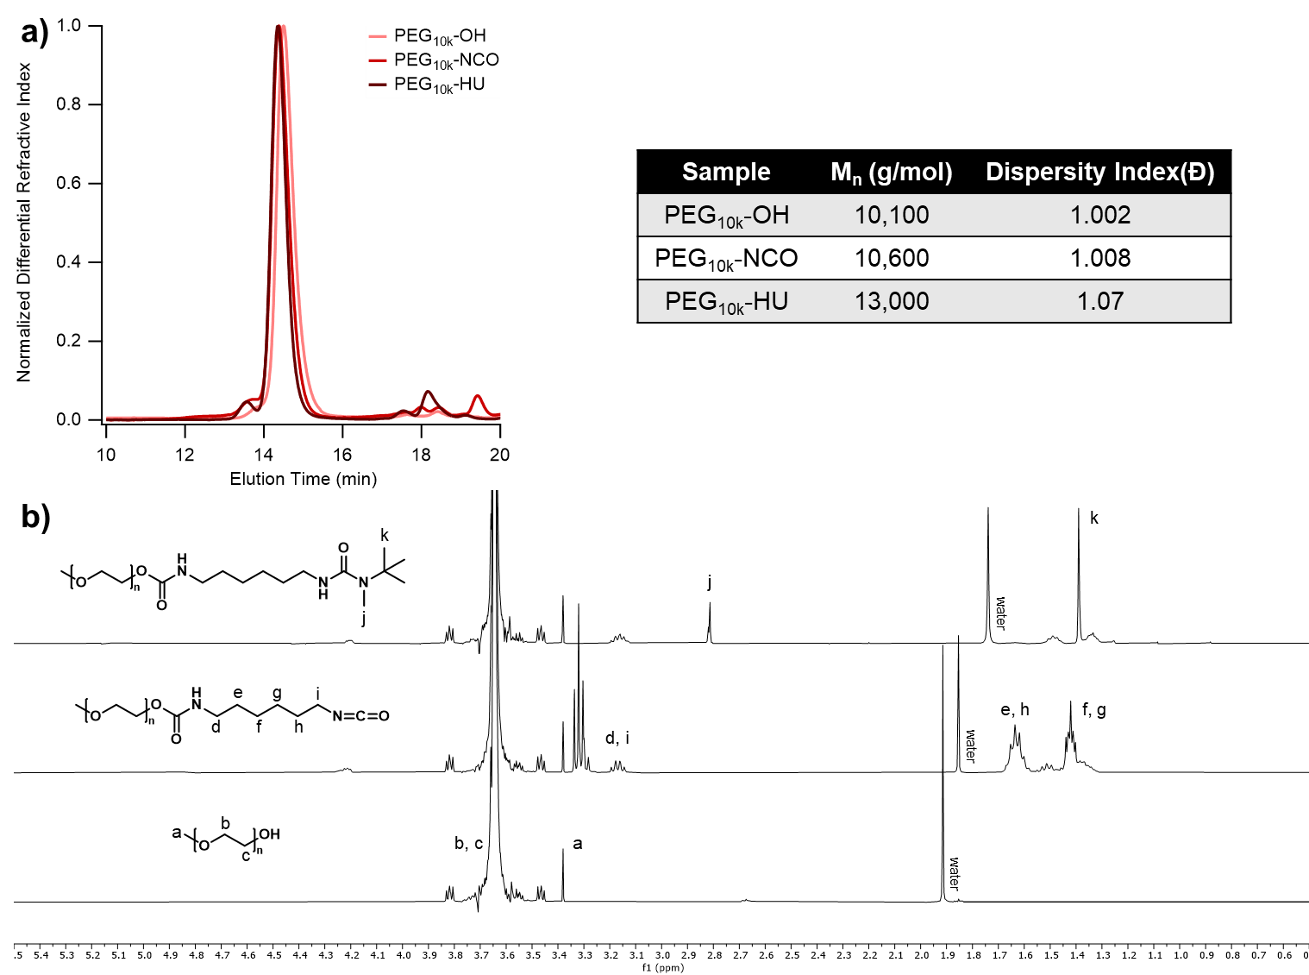

Figure S7. a) SEC traces and corresponding molecular weight and dispersity for PEG_{10k}-OH, PEG_{10k}-NCO, and PEG_{10k}-HU, and b) ¹H NMR spectra of PEG_{10k}-OH, PEG_{10k}-NCO, and PEG_{10k}-HU with key peaks labeled.

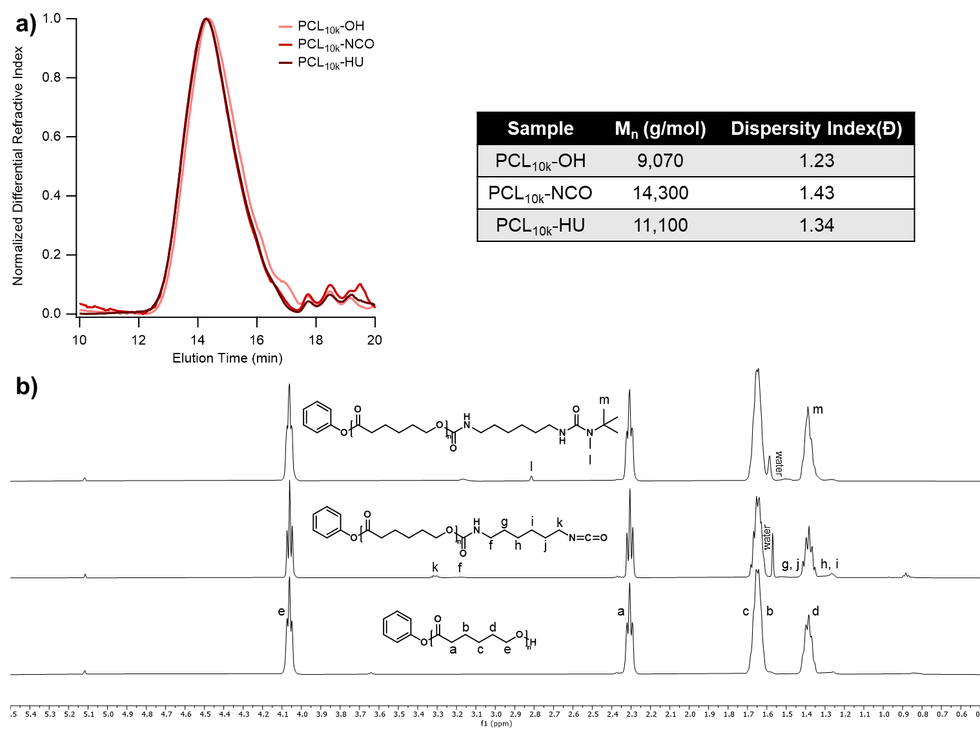

Figure S8. a) SEC traces and corresponding molecular weight and dispersity for PCL_{10k}-OH, PCL_{10k}-NCO, and PCL_{10k}-HU, and b) ¹H NMR spectra of PCL_{10k}-OH, PCL_{10k}-NCO, and PCL_{10k}-HU with key peaks labeled.

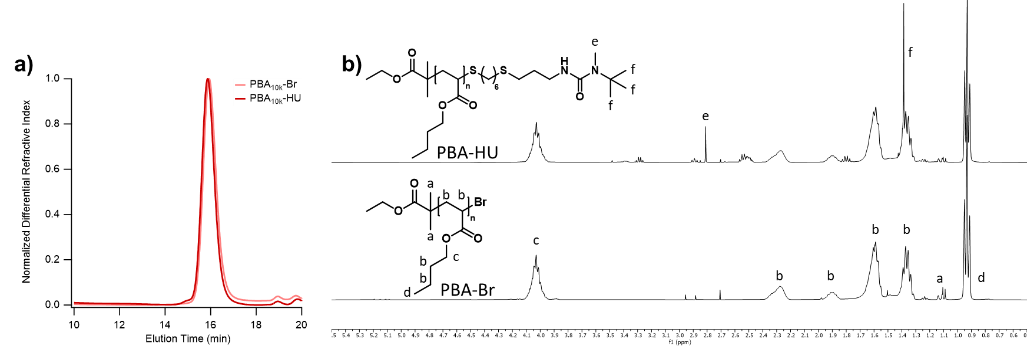

Figure S9. a) SEC traces for PBA_{10k}-Br and PBA_{10k}-HU and b) ¹H NMR spectra of PBA_{10k}-Br and PBA_{10k}-HU with key peaks labeled.

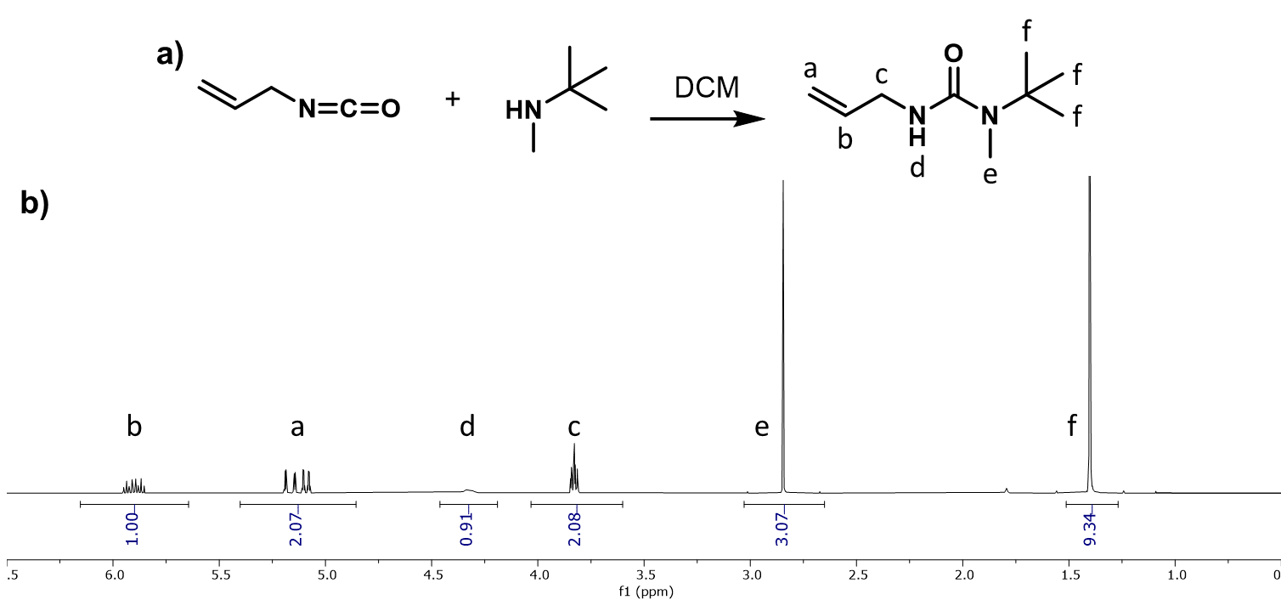

Figure S10. a) Schematic for the synthesis of allyl-HU from allyl isocyanate and N-tert-butylmethylamine and b) the resulting ¹H NMR spectrum.

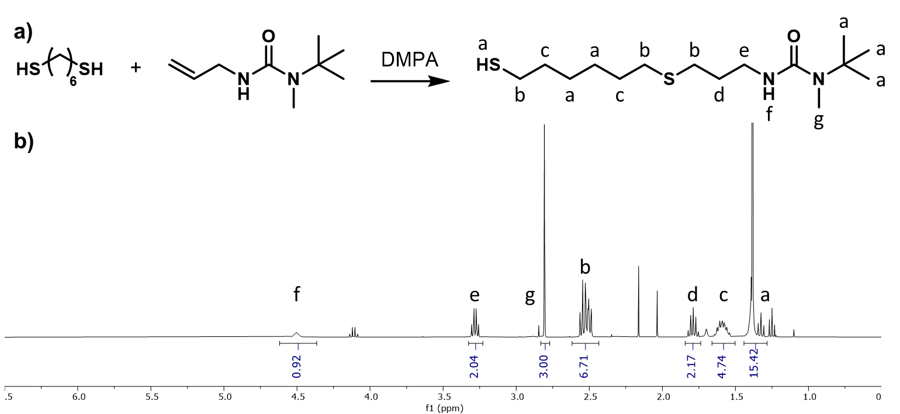

Figure S11. a) Schematic for the synthesis of thio-HU from allyl-HU and 1,6-hexanedithiol and b) the resulting ¹H NMR spectrum.

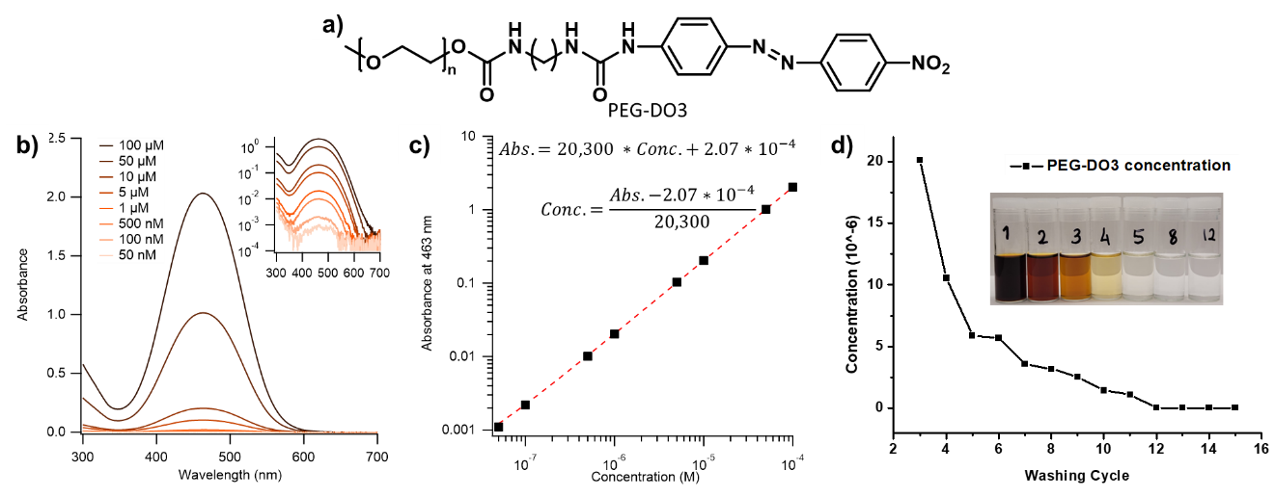

Figure S12. a) The chemical structure of PEG-DO3, b) UV-Vis traces of PEG-DO3 in 1:1 acetone:water with concentrations ranging from 50 nM to 100 μM, c) the resulting calibration curve generated from the maximum of the 463 nm absorbance peak, and d) the height of the 463 nm absorbance peak measured from supernatants generated during washing of c-CNC-PEG_{2k} plotted against wash number, showing that all removable polymer is gone at wash 12.

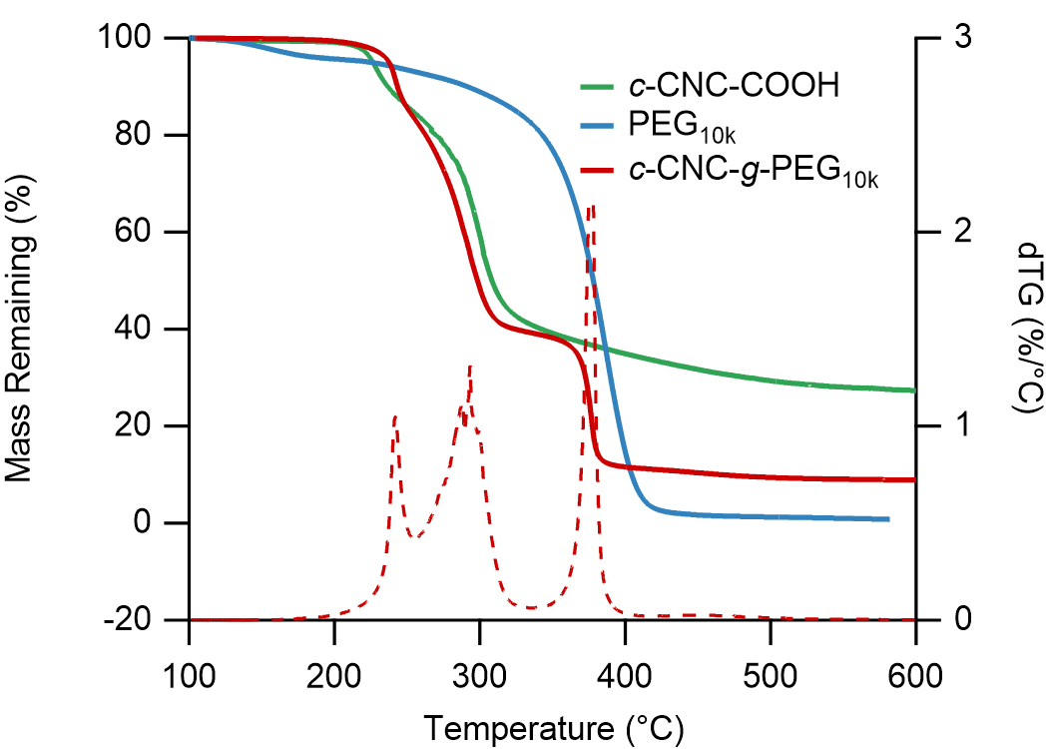

Figure S13. TGA traces of c-CNC-COOH, PEG_{10k}-Br, and c-CNC-g-PEG_{10k} along with the dTG curve for c-CNC-g-PEG_{10k}.

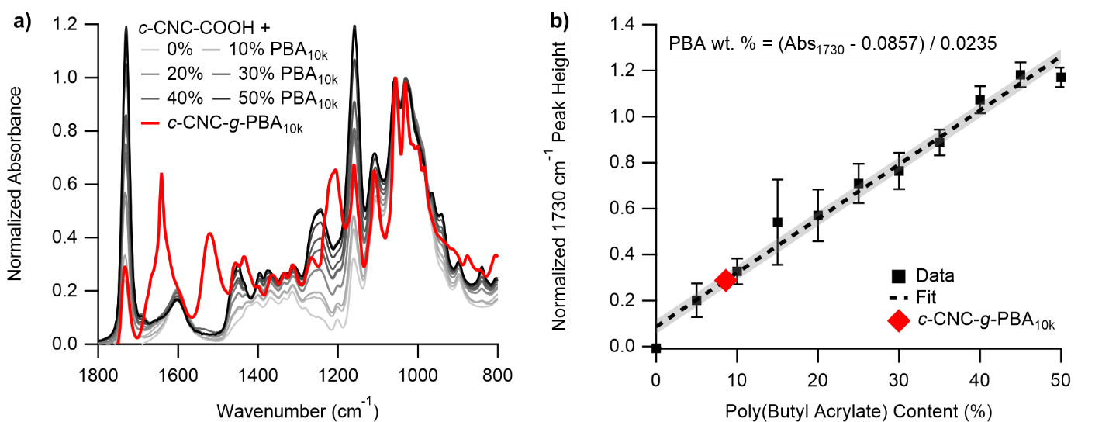

Figure S14. a) FTIR spectra for c-CNC-COOH mixed with various ratios of PBA_{10k}-Br and b) the resulting calibration curve to measure PBA content on grafted CNCs with the measured c-CNC-g-PBA_{10k} data placed on the curve.

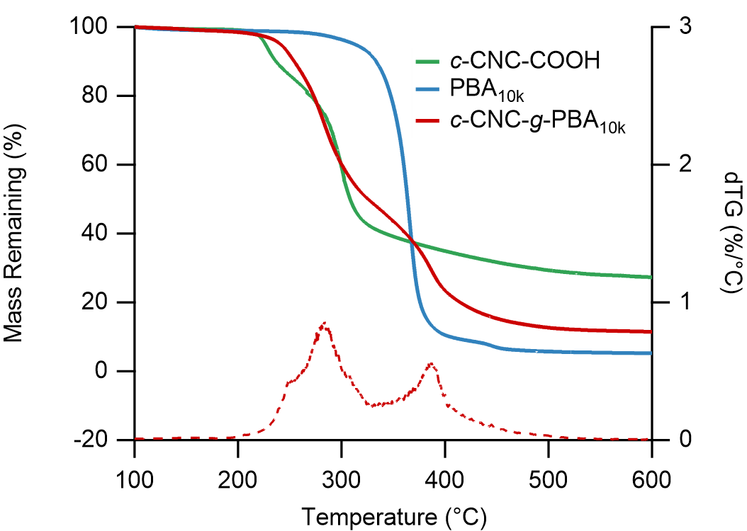

Figure S15. TGA traces of c-CNC-COOH, PBA_{10k}-Br, and c-CNC-g-PBA_{10k} along with the dTG curve for c-CNC-g-PBA_{10k}.

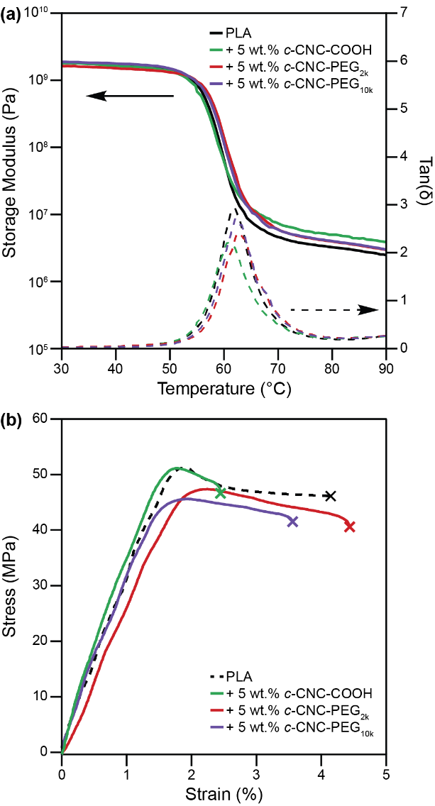
Figure S16: (a) Dynamic mechanical analysis data of PLA composites with 5 wt.% c-CNC-COOH, 5 wt.% c-CNC-g-PEG_{2k}, and 5 wt.% c-CNC-g-PEG_{10k} compared to unmodified PLA, and (b) tensile testing data of neat PLA and composites with 5 wt.% c-CNC-COOH, 5 wt.% c-CNC-g-PEG_{2k}, and 5 wt.% c-CNC-g-PEG_{10k}.

3. References
[1] Fraschini, C., Chauve, G. & Bouchard, J. TEMPO-mediated surface oxidation of cellulose nanocrystals (CNCs). Cellulose 24, 2775–2790 (2017).
[2] Macke, N., Hemmingsen, C. M. & Rowan, S. J. The effect of polymer grafting on the mechanical properties of PEG-grafted cellulose nanocrystals in poly(lactic acid). J. Polym. Sci. 60, 3318–3330 (2022).
[3] Gille, A. & Hiersemann, M. (−)-Lytophilippine A: Synthesis of a C1− C18 Building Block. Org. Lett. 12, 5258–5261 (2010).
[4] Anastasaki, A. et al. Cu(0)-Mediated Living Radical Polymerization: A Versatile Tool for Materials Synthesis. Chem. Rev. 116, 835–877 (2016).
[5] French, A. D. Idealized powder diffraction patterns for cellulose polymorphs. Cellulose 21, 885–896 (2014).
[6] Park, S., Baker, J. O., Himmel, M. E., Parilla, P. A. & Johnson, D. K. Cellulose crystallinity index: measurement techniques and their impact on interpreting cellulase performance. Biotechnol. Biofuels 3, 1–10 (2010).

