Identifying the critical windows and interactions of temperature and PM_{2.5} exposure on small for gestational age
Supplementary tables and figures

Table S1. Distribution of the daily mean temperature (℃) in each gestational week

Table S2. Distribution of the daily mean PM_{2.5} (μg/m³) in each gestational week

Table S3. Adjusted OR and 95% CI between weekly-specific temperature (compared to 41st -50th reference centile) and SGA

Table S4. Table S4. Adjusted OR and 95% CI between weekly-specific extreme temperature (cold (<=5th ,<=10th ) and heat (>90th , >95th ) compared to 41st -50th reference centile) and SGA

Table S5. Adjusted OR and 95% CI between weekly-specific PM_{2.5} and SGA

Table S6. Adjusted OR and 95% CI between weekly-specific PM_{2.5} and SGA using two-pollutant model

Table S7. Adjusted OR and 95% CI between weekly-specific extreme temperature (cold (<=5th ,<=10th ) and heat (>90th , >95th ) compared to 41st -50th reference centile) PM_{2.5} and SGA using the method of multiple imputation

Table S8. Adjusted OR and 95% CI between weekly-specific extreme temperature (cold (<=5th ,<=10th ) and heat (>90th , >95th ) compared to 41st -50th reference centile) PM_{2.5} and SGA for all live birth

Table S9. Adjusted OR and 95% CI between weekly-specific extreme temperature (cold (<=5th) and heat (>95th ) compared to 41-50th reference centile) PM_{2.5} and SGA establishing two cross-basis

Table S10. Adjusted OR and 95% CI between weekly-specific extreme temperature (cold (<=10th) and heat (>90th )compared to 41st -50th reference centile) PM_{2.5} and SGA establishing two cross-basis

Table S11. Interactive analysis in DLNMs between heat (>90th) and PM_{2.5} (>75th) on the risk of SGA

Table S12. Interactive analysis in DLNMs between heat (>95th) and PM_{2.5} (>75th) on the risk of SGA

Table S13. Interactive analysis in DLNMs between cold (<=10th) and PM_{2.5} (>75th) on the risk of SGA

Table S14. Interactive analysis in DLNMs between cold (<=5th) and PM_{2.5} (>75th) on the risk of SGA

Figure S1. Spatial distribution of study sites

Figure S2. Spatial distribution of study participants and monitoring stations

Figure S3. Flowchart of the study population

Figure S4. Illustration of potential confounding variables and possible selection bias in the association between PM_{2.5} exposure and SGA and the minimal adjustment set to block all biasing paths

Table S1. Distribution of the daily mean temperature (℃) in each gestational week
Gestational week | Mean | Min | P.10 | P.20 | P.30 | P.40 | P.50 | P.60 | P.70 | P.80 | P.90 | Max
1w | 17.53 | -17.23 | 5.57 | 9.75 | 13.26 | 16.26 | 19.39 | 21.40 | 23.52 | 25.59 | 27.54 | 33.33
2w | 17.53 | -17.18 | 5.55 | 9.73 | 13.22 | 16.18 | 19.38 | 21.40 | 23.57 | 25.65 | 27.59 | 33.38
3w | 17.51 | -17.00 | 5.52 | 9.69 | 13.12 | 16.09 | 19.32 | 21.41 | 23.60 | 25.68 | 27.63 | 33.38
4w | 17.50 | -17.18 | 5.46 | 9.67 | 13.04 | 15.98 | 19.31 | 21.42 | 23.67 | 25.74 | 27.67 | 33.33
5w | 17.48 | -17.11 | 5.41 | 9.59 | 13.00 | 15.89 | 19.25 | 21.44 | 23.70 | 25.79 | 27.68 | 33.35
6w | 17.46 | -17.00 | 5.35 | 9.61 | 12.93 | 15.81 | 19.22 | 21.45 | 23.77 | 25.87 | 27.70 | 33.33
7w | 17.43 | -17.12 | 5.29 | 9.57 | 12.87 | 15.77 | 19.22 | 21.46 | 23.78 | 25.91 | 27.71 | 33.35
8w | 17.41 | -17.18 | 5.13 | 9.55 | 12.84 | 15.75 | 19.18 | 21.41 | 23.77 | 25.96 | 27.74 | 33.33
9w | 17.37 | -17.00 | 5.04 | 9.52 | 12.82 | 15.76 | 19.13 | 21.33 | 23.75 | 25.96 | 27.76 | 33.33
10w | 17.32 | -17.23 | 4.91 | 9.46 | 12.82 | 15.77 | 19.10 | 21.27 | 23.66 | 25.96 | 27.75 | 33.33
11w | 17.29 | -17.00 | 4.78 | 9.44 | 12.83 | 15.80 | 19.09 | 21.19 | 23.58 | 25.93 | 27.75 | 33.34
12w | 17.25 | -17.11 | 4.64 | 9.39 | 12.82 | 15.79 | 19.08 | 21.17 | 23.52 | 25.85 | 27.72 | 33.35
13w | 17.21 | -17.12 | 4.55 | 9.33 | 12.82 | 15.77 | 19.07 | 21.12 | 23.45 | 25.78 | 27.67 | 33.38
14w | 17.17 | -17.00 | 4.51 | 9.30 | 12.78 | 15.75 | 19.05 | 21.06 | 23.39 | 25.71 | 27.61 | 33.38
15w | 17.14 | -17.18 | 4.44 | 9.28 | 12.80 | 15.74 | 19.06 | 21.03 | 23.32 | 25.62 | 27.54 | 33.35
16w | 17.10 | -17.00 | 4.45 | 9.26 | 12.74 | 15.69 | 19.04 | 20.99 | 23.23 | 25.52 | 27.48 | 33.38
17w | 17.07 | -17.00 | 4.49 | 9.26 | 12.77 | 15.65 | 18.99 | 20.96 | 23.15 | 25.44 | 27.42 | 33.35
18w | 17.04 | -17.18 | 4.54 | 9.30 | 12.78 | 15.60 | 18.94 | 20.94 | 23.11 | 25.36 | 27.33 | 33.38
19w | 17.02 | -17.00 | 4.58 | 9.36 | 12.82 | 15.60 | 18.85 | 20.89 | 23.05 | 25.28 | 27.23 | 33.38
20w | 16.99 | -17.00 | 4.68 | 9.42 | 12.82 | 15.56 | 18.74 | 20.84 | 22.97 | 25.2 | 27.18 | 33.35
21w | 16.98 | -17.23 | 4.76 | 9.47 | 12.84 | 15.54 | 18.65 | 20.76 | 22.90 | 25.17 | 27.16 | 33.38
22w | 16.96 | -17.18 | 4.90 | 9.48 | 12.87 | 15.50 | 18.56 | 20.69 | 22.83 | 25.11 | 27.13 | 33.34
23w | 16.95 | -17.00 | 4.95 | 9.51 | 12.85 | 15.49 | 18.49 | 20.64 | 22.78 | 25.12 | 27.13 | 33.35
24w | 16.94 | -17.23 | 5.02 | 9.50 | 12.86 | 15.46 | 18.38 | 20.55 | 22.68 | 25.11 | 27.19 | 33.33
25w | 16.93 | -17.57 | 5.10 | 9.51 | 12.86 | 15.42 | 18.32 | 20.52 | 22.65 | 25.10 | 27.20 | 33.38
26w | 16.92 | -17.37 | 5.10 | 9.48 | 12.82 | 15.37 | 18.25 | 20.48 | 22.65 | 25.10 | 27.27 | 33.38
27w | 16.93 | -17.57 | 5.06 | 9.52 | 12.85 | 15.33 | 18.21 | 20.47 | 22.65 | 25.12 | 27.33 | 33.33
28w | 16.91 | -17.57 | 5.10 | 9.46 | 12.82 | 15.28 | 18.18 | 20.48 | 22.67 | 25.08 | 27.33 | 33.35
29w | 16.91 | -17.23 | 5.08 | 9.44 | 12.80 | 15.28 | 18.19 | 20.48 | 22.71 | 25.15 | 27.36 | 33.38
30w | 16.91 | -17.18 | 4.98 | 9.42 | 12.79 | 15.26 | 18.17 | 20.49 | 22.72 | 25.20 | 27.39 | 33.35
31w | 16.91 | -17.18 | 4.96 | 9.43 | 12.74 | 15.27 | 18.25 | 20.52 | 22.75 | 25.21 | 27.35 | 33.33
32w | 16.91 | -17.20 | 4.87 | 9.34 | 12.74 | 15.32 | 18.27 | 20.54 | 22.81 | 25.24 | 27.35 | 33.34
33w | 16.91 | -17.23 | 4.82 | 9.35 | 12.75 | 15.31 | 18.30 | 20.57 | 22.86 | 25.24 | 27.36 | 33.34
34w | 16.94 | -17.43 | 4.85 | 9.40 | 12.80 | 15.36 | 18.30 | 20.61 | 22.88 | 25.27 | 27.39 | 33.35
35w | 16.96 | -17.00 | 4.75 | 9.38 | 12.85 | 15.42 | 18.36 | 20.64 | 22.93 | 25.31 | 27.43 | 33.33
36w | 17.00 | -17.04 | 4.78 | 9.36 | 12.88 | 15.49 | 18.41 | 20.70 | 22.96 | 25.34 | 27.46 | 33.33
37w | 17.04 | -16.97 | 4.85 | 9.46 | 12.91 | 15.51 | 18.49 | 20.73 | 22.99 | 25.42 | 27.46 | 33.33
38w | 17.08 | -17.57 | 4.86 | 9.50 | 12.98 | 15.58 | 18.57 | 20.75 | 23.03 | 25.47 | 27.48 | 33.35
39w | 17.10 | -17.31 | 4.97 | 9.49 | 12.95 | 15.56 | 18.61 | 20.78 | 23.06 | 25.47 | 27.50 | 33.35
40w | 17.09 | -17.05 | 4.95 | 9.43 | 12.92 | 15.59 | 18.69 | 20.81 | 23.04 | 25.45 | 27.48 | 33.33
41w | 16.85 | -16.94 | 4.34 | 8.94 | 12.44 | 15.40 | 18.49 | 20.73 | 22.94 | 25.35 | 27.44 | 33.32
42w | 16.01 | -10.72 | 4.11 | 7.85 | 10.61 | 13.76 | 16.93 | 19.93 | 22.37 | 24.91 | 27.24 | 32.88
43w | 15.92 | -10.14 | 4.31 | 7.44 | 10.65 | 13.68 | 16.80 | 19.76 | 21.70 | 25.31 | 27.46 | 32.92
44w | 15.65 | -15.96 | 2.88 | 6.97 | 10.40 | 13.04 | 16.58 | 19.93 | 22.44 | 24.81 | 27.50 | 32.82

Table S2. Distribution of the daily mean PM_{2.5} (μg/m³) in each gestational week
Gestational week | Mean | Min | P.10 | P.20 | P.30 | P.40 | P.50 | P.60 | P.70 | P.80 | P.90 | Max
1w | 52.88 | 8.32 | 20.40 | 25.88 | 31.07 | 36.49 | 42.69 | 49.63 | 58.77 | 72.97 | 95.05 | 445.90
2w | 52.92 | 8.32 | 20.27 | 25.84 | 31.07 | 36.52 | 42.79 | 49.62 | 58.76 | 72.97 | 95.33 | 445.90
3w | 52.94 | 8.32 | 20.23 | 25.81 | 31.00 | 36.46 | 42.76 | 49.62 | 58.77 | 72.85 | 94.97 | 453.17
4w | 52.84 | 8.32 | 20.26 | 25.82 | 31.01 | 36.38 | 42.67 | 49.56 | 58.63 | 72.59 | 94.61 | 461.61
5w | 53.01 | 7.40 | 20.31 | 25.86 | 31.01 | 36.56 | 42.83 | 49.68 | 58.76 | 72.80 | 94.94 | 446.75
6w | 53.17 | 7.75 | 20.29 | 25.85 | 31.06 | 36.58 | 42.83 | 49.69 | 58.72 | 72.82 | 95.53 | 461.69
7w | 53.17 | 8.32 | 20.34 | 25.87 | 31.07 | 36.48 | 42.63 | 49.62 | 58.77 | 72.65 | 95.96 | 445.90
8w | 53.23 | 8.32 | 20.31 | 25.86 | 31.10 | 36.52 | 42.68 | 49.52 | 58.55 | 72.63 | 96.04 | 445.90
9w | 53.24 | 8.32 | 20.32 | 25.92 | 31.15 | 36.49 | 42.56 | 49.45 | 58.54 | 72.76 | 96.12 | 446.17
10w | 53.15 | 8.32 | 20.43 | 25.98 | 31.06 | 36.39 | 42.38 | 49.21 | 58.13 | 72.16 | 96.35 | 450.58
11w | 53.07 | 8.32 | 20.52 | 25.99 | 31.13 | 36.42 | 42.39 | 49.15 | 57.92 | 71.99 | 95.80 | 460.72
12w | 52.91 | 7.75 | 20.67 | 26.03 | 31.06 | 36.21 | 42.07 | 48.85 | 57.66 | 71.73 | 95.31 | 445.90
13w | 52.76 | 8.32 | 20.75 | 26.08 | 31.08 | 36.16 | 41.97 | 48.71 | 57.37 | 71.42 | 95.26 | 444.32
14w | 52.95 | 8.13 | 20.92 | 26.23 | 31.08 | 36.24 | 42.07 | 48.77 | 57.43 | 71.49 | 95.53 | 447.00
15w | 52.89 | 8.32 | 21.01 | 26.29 | 31.11 | 36.15 | 41.97 | 48.70 | 57.41 | 71.43 | 95.81 | 447.86
16w | 52.93 | 7.75 | 21.11 | 26.30 | 31.17 | 36.21 | 42.02 | 48.78 | 57.40 | 71.29 | 95.08 | 461.61
17w | 52.99 | 6.96 | 21.18 | 26.39 | 31.24 | 36.20 | 41.95 | 48.66 | 57.40 | 71.41 | 95.34 | 445.90
18w | 52.96 | 7.22 | 21.23 | 26.41 | 31.14 | 36.13 | 41.92 | 48.66 | 57.35 | 71.26 | 95.59 | 445.90
19w | 52.81 | 8.64 | 21.14 | 26.37 | 31.12 | 36.05 | 41.77 | 48.57 | 57.18 | 71.16 | 95.07 | 460.72
20w | 52.76 | 8.68 | 21.07 | 26.25 | 30.98 | 35.93 | 41.56 | 48.36 | 57.10 | 71.27 | 94.64 | 445.90
21w | 52.64 | 8.45 | 21.19 | 26.20 | 30.92 | 35.95 | 41.51 | 48.18 | 56.94 | 71.19 | 94.73 | 445.90
22w | 52.64 | 7.75 | 21.11 | 26.14 | 30.83 | 35.85 | 41.51 | 48.23 | 56.93 | 71.20 | 95.04 | 445.90
23w | 52.47 | 8.65 | 21.06 | 26.13 | 30.84 | 35.91 | 41.48 | 48.22 | 57.04 | 71.22 | 94.29 | 446.75
24w | 52.50 | 8.65 | 21.02 | 26.07 | 30.75 | 35.8 | 41.47 | 48.06 | 56.85 | 71.12 | 94.47 | 461.61
25w | 52.47 | 8.64 | 20.96 | 26.06 | 30.79 | 35.84 | 41.49 | 48.22 | 57.13 | 71.31 | 94.72 | 461.61
26w | 52.43 | 8.32 | 20.94 | 26.04 | 30.75 | 35.80 | 41.42 | 48.14 | 56.88 | 71.15 | 94.65 | 447.00
27w | 52.44 | 8.27 | 20.93 | 26.12 | 30.76 | 35.77 | 41.44 | 48.03 | 56.89 | 70.92 | 95.03 | 445.90
28w | 52.43 | 8.32 | 20.91 | 26.14 | 30.72 | 35.67 | 41.33 | 47.92 | 56.71 | 70.86 | 95.12 | 445.90
29w | 52.35 | 8.32 | 20.93 | 26.07 | 30.66 | 35.60 | 41.23 | 47.79 | 56.33 | 70.44 | 94.74 | 461.69
30w | 52.31 | 8.29 | 20.92 | 26.11 | 30.62 | 35.60 | 41.19 | 47.57 | 56.03 | 70.17 | 94.70 | 445.90
31w | 52.21 | 8.32 | 20.93 | 26.06 | 30.60 | 35.57 | 41.26 | 47.57 | 55.87 | 69.91 | 94.18 | 460.72
32w | 52.02 | 8.32 | 20.85 | 25.97 | 30.50 | 35.38 | 41.09 | 47.41 | 55.63 | 69.68 | 94.04 | 446.75
33w | 52.13 | 8.32 | 20.82 | 25.96 | 30.51 | 35.37 | 40.97 | 47.35 | 55.63 | 69.63 | 94.32 | 446.28
34w | 52.14 | 7.47 | 20.79 | 26.06 | 30.58 | 35.38 | 40.91 | 47.20 | 55.45 | 69.71 | 94.72 | 461.61
35w | 52.18 | 8.32 | 20.84 | 26.06 | 30.52 | 35.32 | 40.81 | 47.15 | 55.43 | 69.60 | 94.63 | 444.32
36w | 52.10 | 8.32 | 20.85 | 26.05 | 30.58 | 35.31 | 40.76 | 47.04 | 55.31 | 69.72 | 94.33 | 445.90
37w | 52.10 | 8.32 | 20.79 | 25.99 | 30.45 | 35.13 | 40.54 | 46.92 | 55.16 | 69.59 | 94.22 | 445.90
38w | 51.95 | 7.75 | 20.70 | 25.89 | 30.36 | 34.99 | 40.56 | 46.93 | 55.06 | 69.53 | 93.34 | 445.90
39w | 51.91 | 7.75 | 20.67 | 25.92 | 30.30 | 35.00 | 40.52 | 46.96 | 54.95 | 69.37 | 93.20 | 460.72
40w | 51.93 | 8.51 | 20.82 | 25.89 | 30.4 | 35.35 | 40.94 | 47.56 | 55.75 | 69.66 | 92.53 | 444.32
41w | 53.15 | 8.52 | 21.19 | 26.27 | 30.92 | 36 | 42.01 | 48.54 | 57.24 | 71.55 | 95.19 | 445.90
42w | 54.46 | 9.09 | 23.64 | 29.79 | 34.79 | 40.25 | 45.71 | 52.17 | 61.52 | 74.18 | 94.29 | 434.35
43w | 53.74 | 10.61 | 23.49 | 28.86 | 33.51 | 38.69 | 44.7 | 51.64 | 60.20 | 72.56 | 88.74 | 374.38
44w | 50.54 | 9.43 | 22.75 | 28.21 | 31.81 | 37.41 | 42.37 | 47.98 | 55.22 | 65.82 | 86.89 | 346.90

Table S3. Adjusted OR and 95% CI between weekly-specific temperature (compared to 41-50th reference centile) and SGA
Gestational week | <=10th | 11-20th | 21-30th | 31-40th | 51-60th | 61-70th | 71-80th | 81-90th | >90th
1w | 0.963 (0.934,0.994) | 0.997 (0.966,1.029) | 0.965 (0.933,0.998) | 0.997 (0.964,1.032) | 0.993 (0.96,1.028) | 0.962 (0.929,0.995) | 1.000 (0.967,1.034) | 1.003 (0.969,1.038) | 0.991 (0.959,1.025)
2w | 0.966 (0.938,0.994) | 0.998 (0.969,1.027) | 0.969 (0.94,1) | 0.999 (0.968,1.031) | 0.995 (0.964,1.026) | 0.965 (0.935,0.996) | 1.001 (0.971,1.032) | 1.004 (0.973,1.036) | 0.994 (0.964,1.025)
3w | 0.969 (0.943,0.995) | 0.998 (0.971,1.026) | 0.973 (0.946,1.001) | 1.000 (0.972,1.029) | 0.996 (0.968,1.024) | 0.968 (0.94,0.996) | 1.003 (0.975,1.031) | 1.005 (0.977,1.034) | 0.996 (0.969,1.025)
4w | 0.971 (0.947,0.996) | 0.999 (0.974,1.024) | 0.977 (0.952,1.003) | 1.002 (0.976,1.028) | 0.997 (0.971,1.023) | 0.971 (0.945,0.997) | 1.004 (0.979,1.03) | 1.006 (0.98,1.032) | 0.999 (0.974,1.025)
5w | 0.974 (0.951,0.996) | 0.999 (0.976,1.023) | 0.981 (0.957,1.005) | 1.003 (0.979,1.027) | 0.998 (0.974,1.022) | 0.974 (0.95,0.998) | 1.006 (0.983,1.029) | 1.007 (0.983,1.031) | 1.001 (0.978,1.025)
6w | 0.976 (0.955,0.997) | 1.000 (0.978,1.022) | 0.985 (0.962,1.008) | 1.004 (0.983,1.027) | 0.999 (0.977,1.021) | 0.976 (0.955,0.998) | 1.007 (0.986,1.028) | 1.008 (0.986,1.03) | 1.004 (0.982,1.026)
7w | 0.978 (0.959,0.998) | 1.000  (0.98,1.021) | 0.989 (0.967,1.01) | 1.006 (0.986,1.026) | 1.000 (0.98,1.021) | 0.979 (0.959,1) | 1.008 (0.989,1.028) | 1.009 (0.989,1.029) | 1.006 (0.986,1.026)
8w | 0.981 (0.962,1) | 1.001 (0.981,1.021) | 0.992 (0.972,1.013) | 1.007 (0.988,1.026) | 1.001 (0.982,1.021) | 0.982 (0.963,1.001) | 1.01 (0.992,1.028) | 1.01 (0.991,1.029) | 1.008 (0.99,1.028)
9w | 0.983 (0.965,1.001) | 1.001 (0.983,1.021) | 0.996 (0.976,1.016) | 1.008 (0.99,1.027) | 1.002 (0.984,1.021) | 0.984 (0.966,1.003) | 1.011 (0.994,1.028) | 1.011 (0.993,1.029) | 1.011 (0.993,1.029)
10w | 0.985 (0.967,1.003) | 1.002 (0.983,1.021) | 0.999 (0.979,1.019) | 1.009 (0.991,1.027) | 1.003 (0.986,1.022) | 0.987 (0.969,1.005) | 1.012 (0.995,1.029) | 1.012 (0.994,1.029) | 1.013 (0.995,1.03)
11w | 0.987 (0.969,1.005) | 1.002 (0.984,1.021) | 1.002 (0.982,1.022) | 1.01 (0.992,1.028) | 1.004 (0.987,1.023) | 0.989 (0.972,1.007) | 1.013 (0.996,1.03) | 1.013 (0.995,1.03) | 1.015 (0.998,1.032)
12w | 0.989 (0.971,1.006) | 1.003 (0.984,1.022) | 1.005 (0.985,1.025) | 1.011 (0.993,1.029) | 1.005 (0.987,1.024) | 0.991 (0.973,1.009) | 1.014 (0.997,1.031) | 1.013 (0.996,1.031) | 1.017 (0.999,1.034)
13w | 0.99 (0.972,1.008) | 1.003 (0.984,1.022) | 1.008 (0.987,1.029) | 1.012 (0.993,1.03) | 1.006 (0.988,1.025) | 0.993 (0.975,1.012) | 1.015 (0.997,1.032) | 1.014 (0.996,1.032) | 1.018 (1.001,1.036)
14w | 0.992 (0.974,1.01) | 1.003 (0.984,1.023) | 1.01 (0.989,1.032) | 1.012 (0.993,1.031) | 1.007 (0.988,1.027) | 0.995 (0.976,1.014) | 1.015 (0.997,1.034) | 1.015 (0.997,1.033) | 1.02 (1.002,1.038)
15w | 0.993 (0.975,1.012) | 1.004 (0.984,1.024) | 1.012 (0.991,1.034) | 1.012 (0.993,1.032) | 1.008 (0.988,1.028) | 0.996 (0.977,1.016) | 1.016 (0.997,1.035) | 1.016 (0.997,1.035) | 1.021 (1.003,1.04)
16w | 0.994 (0.975,1.013) | 1.004 (0.984,1.024) | 1.014 (0.993,1.037) | 1.013 (0.993,1.033) | 1.009 (0.989,1.03) | 0.998 (0.978,1.017) | 1.016 (0.997,1.036) | 1.016 (0.997,1.036) | 1.023 (1.004,1.042)
17w | 0.995 (0.976,1.015) | 1.004 (0.984,1.025) | 1.016 (0.994,1.039) | 1.013 (0.992,1.034) | 1.01 (0.989,1.031) | 0.999 (0.979,1.019) | 1.017 (0.997,1.037) | 1.017 (0.997,1.037) | 1.024 (1.005,1.043)
18w | 0.996 (0.976,1.016) | 1.004 (0.984,1.025) | 1.018 (0.995,1.04) | 1.013 (0.992,1.034) | 1.01 (0.989,1.032) | 0.999 (0.979,1.02) | 1.017 (0.997,1.037) | 1.017 (0.997,1.038) | 1.025 (1.005,1.044)
19w | 0.996 (0.977,1.016) | 1.004 (0.984,1.025) | 1.018 (0.996,1.042) | 1.012 (0.992,1.033) | 1.011 (0.99,1.033) | 1.000 (0.98,1.02) | 1.017 (0.997,1.037) | 1.018 (0.998,1.038) | 1.025 (1.006,1.045)
20w | 0.996 (0.977,1.016) | 1.004 (0.984,1.025) | 1.019 (0.997,1.042) | 1.012 (0.991,1.033) | 1.011 (0.99,1.033) | 1.000 (0.98,1.02) | 1.016 (0.996,1.037) | 1.018 (0.998,1.038) | 1.026 (1.007,1.045)
21w | 0.996 (0.977,1.016) | 1.004 (0.984,1.024) | 1.019 (0.997,1.042) | 1.011 (0.991,1.032) | 1.012 (0.991,1.033) | 1.000 (0.98,1.02) | 1.016 (0.996,1.036) | 1.018 (0.999,1.038) | 1.026 (1.007,1.045)
22w | 0.996 (0.977,1.015) | 1.004 (0.984,1.024) | 1.019 (0.997,1.042) | 1.01 (0.99,1.03) | 1.012 (0.992,1.033) | 0.999 (0.98,1.019) | 1.015 (0.996,1.035) | 1.019 (0.999,1.038) | 1.026 (1.007,1.045)
23w | 0.995 (0.977,1.014) | 1.003 (0.984,1.023) | 1.019 (0.998,1.04) | 1.009 (0.989,1.028) | 1.013 (0.993,1.033) | 0.999 (0.98,1.018) | 1.015 (0.996,1.034) | 1.019 (1,1.038) | 1.026 (1.008,1.044)
24w | 0.995 (0.977,1.013) | 1.003 (0.985,1.022) | 1.018 (0.997,1.039) | 1.007 (0.989,1.026) | 1.013 (0.993,1.033) | 0.998 (0.979,1.016) | 1.014 (0.995,1.033) | 1.019 (1,1.038) | 1.025 (1.008,1.043)
25w | 0.994 (0.976,1.012) | 1.003 (0.985,1.021) | 1.017 (0.997,1.038) | 1.006 (0.988,1.024) | 1.013 (0.994,1.033) | 0.996 (0.978,1.015) | 1.013 (0.995,1.031) | 1.019 (1,1.038) | 1.025 (1.007,1.042)
26w | 0.993 (0.975,1.01) | 1.002 (0.985,1.02) | 1.016 (0.996,1.036) | 1.004 (0.987,1.022) | 1.013 (0.995,1.032) | 0.995 (0.977,1.013) | 1.012 (0.994,1.03) | 1.019 (1.001,1.038) | 1.024 (1.007,1.042)
27w | 0.992 (0.974,1.009) | 1.002 (0.985,1.02) | 1.014 (0.995,1.034) | 1.002 (0.985,1.02) | 1.014 (0.995,1.032) | 0.993 (0.976,1.012) | 1.01 (0.992,1.029) | 1.019 (1,1.038) | 1.023 (1.006,1.041)
28w | 0.99 (0.973,1.008) | 1.001 (0.984,1.019) | 1.013 (0.994,1.032) | 1.001 (0.983,1.018) | 1.014 (0.995,1.032) | 0.992 (0.974,1.01) | 1.009 (0.99,1.028) | 1.019 (1,1.038) | 1.022 (1.004,1.041)
29w | 0.989 (0.971,1.006) | 1.001 (0.983,1.019) | 1.011 (0.992,1.03) | 0.999 (0.981,1.016) | 1.014 (0.995,1.033) | 0.99 (0.971,1.009) | 1.008 (0.988,1.027) | 1.019 (0.999,1.039) | 1.021 (1.002,1.041)
30w | 0.987 (0.969,1.005) | 1.000 (0.982,1.019) | 1.009 (0.99,1.029) | 0.997 (0.978,1.015) | 1.014 (0.995,1.033) | 0.988 (0.968,1.008) | 1.006 (0.986,1.027) | 1.019 (0.997,1.04) | 1.02 (1,1.041)
31w | 0.985 (0.967,1.004) | 1.000 (0.981,1.019) | 1.007 (0.987,1.027) | 0.994 (0.975,1.014) | 1.014 (0.994,1.034) | 0.986 (0.965,1.007) | 1.004 (0.982,1.027) | 1.018 (0.996,1.042) | 1.019 (0.997,1.042)
32w | 0.984 (0.964,1.004) | 0.999 (0.979,1.02) | 1.005 (0.984,1.026) | 0.992 (0.971,1.013) | 1.014 (0.992,1.036) | 0.984 (0.961,1.006) | 1.003 (0.979,1.027) | 1.018 (0.993,1.044) | 1.018 (0.993,1.043)
33w | 0.982 (0.961,1.003) | 0.999 (0.977,1.02) | 1.002 (0.98,1.025) | 0.99 (0.967,1.013) | 1.014 (0.991,1.038) | 0.981 (0.957,1.006) | 1.001 (0.975,1.028) | 1.018 (0.991,1.046) | 1.016 (0.99,1.044)
34w | 0.98 (0.957,1.003) | 0.998 (0.975,1.022) | 1.000 (0.976,1.025) | 0.988 (0.963,1.013) | 1.014 (0.989,1.04) | 0.979 (0.952,1.006) | 0.999 (0.971,1.029) | 1.018 (0.988,1.049) | 1.015 (0.986,1.045)
35w | 0.978 (0.954,1.002) | 0.997 (0.972,1.023) | 0.997 (0.971,1.024) | 0.985 (0.958,1.013) | 1.014 (0.986,1.042) | 0.976 (0.948,1.006) | 0.998 (0.967,1.03) | 1.018 (0.985,1.051) | 1.014 (0.982,1.046)
36w | 0.976 (0.95,1.002) | 0.997 (0.969,1.024) | 0.995 (0.967,1.024) | 0.983 (0.954,1.013) | 1.014 (0.984,1.045) | 0.974 (0.943,1.006) | 0.996 (0.962,1.031) | 1.017 (0.982,1.054) | 1.012 (0.977,1.048)
37w | 0.974 (0.946,1.002) | 0.996 (0.967,1.026) | 0.992 (0.962,1.024) | 0.981 (0.949,1.014) | 1.014 (0.981,1.047) | 0.972 (0.938,1.006) | 0.994 (0.958,1.032) | 1.017 (0.979,1.057) | 1.01 (0.973,1.05)

Table S4. Adjusted OR and 95% CI between weekly-specific extreme temperature (cold (<=5th ,<=10th ) and heat (>90th , >95th ) compared to 41-50th reference centile) and SGA

Gestational week | <=5th | <=10th | >90th | >95th
1w | 0.945 (0.907,0.985) | 0.963 (0.934,0.994) | 0.991 (0.959,1.025) | 0.964 (0.925,1.005)
2w | 0.948 (0.913,0.985) | 0.966 (0.938,0.994) | 0.994 (0.964,1.025) | 0.969 (0.932,1.007)
3w | 0.952 (0.919,0.986) | 0.969 (0.943,0.995) | 0.996 (0.969,1.025) | 0.973 (0.94,1.008)
4w | 0.955 (0.924,0.987) | 0.971 (0.947,0.996) | 0.999 (0.974,1.025) | 0.978 (0.947,1.01)
5w | 0.959 (0.93,0.988) | 0.974 (0.951,0.996) | 1.001 (0.978,1.025) | 0.982 (0.953,1.012)
6w | 0.962 (0.935,0.989) | 0.976 (0.955,0.997) | 1.004 (0.982,1.026) | 0.987 (0.96,1.014)
7w | 0.965 (0.94,0.991) | 0.978 (0.959,0.998) | 1.006 (0.986,1.026) | 0.991 (0.966,1.016)
8w | 0.968 (0.944,0.992) | 0.981 (0.962,1.000) | 1.008 (0.99,1.028) | 0.995 (0.972,1.019)
9w | 0.971 (0.948,0.994) | 0.983 (0.965,1.001) | 1.011 (0.993,1.029) | 0.999 (0.977,1.022)
10w | 0.974 (0.952,0.997) | 0.985 (0.967,1.003) | 1.013 (0.995,1.03) | 1.003 (0.981,1.025)
11w | 0.977 (0.955,0.999) | 0.987 (0.969,1.005) | 1.015 (0.998,1.032) | 1.007 (0.985,1.029)
12w | 0.98 (0.958,1.002) | 0.989 (0.971,1.006) | 1.017 (0.999,1.034) | 1.01 (0.989,1.032)
13w | 0.982 (0.96,1.005) | 0.99 (0.972,1.008) | 1.018 (1.001,1.036) | 1.014 (0.991,1.036)
14w | 0.984 (0.962,1.007) | 0.992 (0.974,1.01) | 1.02 (1.002,1.038) | 1.016 (0.994,1.04)
15w | 0.986 (0.963,1.01) | 0.993 (0.975,1.012) | 1.021 (1.003,1.04) | 1.019 (0.996,1.043)
16w | 0.988 (0.965,1.012) | 0.994 (0.975,1.013) | 1.023 (1.004,1.042) | 1.022 (0.998,1.046)
17w | 0.99 (0.966,1.014) | 0.995 (0.976,1.015) | 1.024 (1.005,1.043) | 1.024 (1.000,1.048)
18w | 0.991 (0.967,1.016) | 0.996 (0.976,1.016) | 1.025 (1.005,1.044) | 1.026 (1.001,1.05)
19w | 0.992 (0.968,1.017) | 0.996 (0.977,1.016) | 1.025 (1.006,1.045) | 1.027 (1.003,1.052)
20w | 0.993 (0.969,1.018) | 0.996 (0.977,1.016) | 1.026 (1.007,1.045) | 1.028 (1.004,1.053)
21w | 0.993 (0.969,1.018) | 0.996 (0.977,1.016) | 1.026 (1.007,1.045) | 1.028 (1.005,1.053)
22w | 0.994 (0.97,1.018) | 0.996 (0.977,1.015) | 1.026 (1.007,1.045) | 1.029 (1.005,1.053)
23w | 0.994 (0.97,1.018) | 0.995 (0.977,1.014) | 1.026 (1.008,1.044) | 1.029 (1.006,1.052)
24w | 0.993 (0.971,1.017) | 0.995 (0.977,1.013) | 1.025 (1.008,1.043) | 1.028 (1.006,1.051)
25w | 0.993 (0.971,1.016) | 0.994 (0.976,1.012) | 1.025 (1.007,1.042) | 1.028 (1.006,1.05)
26w | 0.992 (0.97,1.015) | 0.993 (0.975,1.01) | 1.024 (1.007,1.042) | 1.026 (1.005,1.049)
27w | 0.992 (0.97,1.014) | 0.992 (0.974,1.009) | 1.023 (1.006,1.041) | 1.025 (1.004,1.048)
28w | 0.991 (0.969,1.013) | 0.99 (0.973,1.008) | 1.022 (1.004,1.041) | 1.024 (1.002,1.046)
29w | 0.989 (0.968,1.012) | 0.989 (0.971,1.006) | 1.021 (1.002,1.041) | 1.022 (0.999,1.046)
30w | 0.988 (0.966,1.011) | 0.987 (0.969,1.005) | 1.02 (1.000,1.041) | 1.02 (0.996,1.045)
31w | 0.987 (0.963,1.011) | 0.985 (0.967,1.004) | 1.019 (0.997,1.042) | 1.018 (0.992,1.045)
32w | 0.985 (0.961,1.011) | 0.984 (0.964,1.004) | 1.018 (0.993,1.043) | 1.016 (0.988,1.046)
33w | 0.984 (0.957,1.011) | 0.982 (0.961,1.003) | 1.016 (0.99,1.044) | 1.014 (0.983,1.046)
34w | 0.982 (0.954,1.011) | 0.98 (0.957,1.003) | 1.015 (0.986,1.045) | 1.012 (0.978,1.047)
35w | 0.981 (0.95,1.012) | 0.978 (0.954,1.002) | 1.014 (0.982,1.046) | 1.01 (0.973,1.048)
36w | 0.979 (0.946,1.013) | 0.976 (0.95,1.002) | 1.012 (0.977,1.048) | 1.007 (0.967,1.049)
37w | 0.977 (0.942,1.014) | 0.974 (0.946,1.002) | 1.01 (0.973,1.05) | 1.005 (0.962,1.05)

Table S5. Adjusted OR and 95% CI between weekly-specific PM_{2.5} and SGA
Gestational week | OR | 95%CI
1w | 1.002 | 1.0000,1.0039
2w | 1.0017 | 1.0001,1.0034
3w | 1.0015 | 1.0001,1.0028
4w | 1.0012 | 1.0001,1.0023
5w | 1.001 | 1.0001,1.0018
6w | 1.0007 | 1.0000,1.0015
7w | 1.0005 | 0.9999,1.0012
8w | 1.0004 | 0.9997,1.0011
9w | 1.0002 | 0.9995,1.001
10w | 1.0001 | 0.9992,1.001
11w | 1.0000 | 0.9991,1.0009
12w | 1.0000 | 0.999,1.001
13w | 1.0000 | 0.999,1.001
14w | 1.0000 | 0.9991,1.001
15w | 1.0001 | 0.9993,1.001
16w | 1.0003 | 0.9995,1.0011
17w | 1.0004 | 0.9997,1.0012
18w | 1.0006 | 0.9999,1.0013
19w | 1.0007 | 1.0001,1.0014
20w | 1.0009 | 1.0002,1.0016
21w | 1.001 | 1.0002,1.0018
22w | 1.0012 | 1.0003,1.0021
23w | 1.0013 | 1.0003,1.0022
24w | 1.0013 | 1.0003,1.0023
25w | 1.0013 | 1.0002,1.0023
26w | 1.0012 | 1.0002,1.0023
27w | 1.0011 | 1.0001,1.0021
28w | 1.0009 | 1.0000,1.0018
29w | 1.0007 | 0.9999,1.0015
30w | 1.0005 | 0.9997,1.0012
31w | 1.0002 | 0.9994,1.001
32w | 0.9998 | 0.9989,1.0008
33w | 0.9995 | 0.9983,1.0007
34w | 0.9991 | 0.9977,1.0006
35w | 0.9987 | 0.997,1.0005
36w | 0.9984 | 0.9963,1.0004
37w | 0.998 | 0.9955,1.0004

Table S6. Adjusted OR and 95% CI between weekly-specific PM_{2.5} and SGA using two-pollutant model
Gestational week | Co | No₂ | O₃ | So₂
1w | 1.002 (1.0000, 1.0039) | 1.0023 (1.0004, 1.0043) | 1.0022 (1.0003, 1.0042) | 1.0029 (1.0008, 1.005)
2w | 1.0017 (1.0001, 1.0034) | 1.0021 (1.0004, 1.0037) | 1.0019 (1.0003, 1.0036) | 1.0025 (1.0007, 1.0043)
3w | 1.0015 (1.0001, 1.0029) | 1.0018 (1.0005, 1.0032) | 1.0017 (1.0003, 1.003) | 1.0021 (1.0006, 1.0036)
4w | 1.0013 (1.0002, 1.0024) | 1.0016 (1.0005, 1.0027) | 1.0014 (1.0003, 1.0025) | 1.0017 (1.0005, 1.0029)
5w | 1.0011 (1.0002, 1.002) | 1.0014 (1.0004, 1.0023) | 1.0011 (1.0002, 1.002) | 1.0013 (1.0004, 1.0023)
6w | 1.0009 (1.0001, 1.0016) | 1.0011 (1.0004, 1.0019) | 1.0009 (1.0001, 1.0016) | 1.001 (1.0002, 1.0018)
7w | 1.0007 (1.0000, 1.0014) | 1.001 (1.0002, 1.0017) | 1.0007 (1.0000, 1.0013) | 1.0007 (1.0000, 1.0014)
8w | 1.0005 (0.9998, 1.0012) | 1.0008 (1.0000, 1.0015) | 1.0005 (0.9998, 1.0012) | 1.0004 (0.9997, 1.0012)
9w | 1.0004 (0.9996, 1.0012) | 1.0006 (0.9998, 1.0015) | 1.0003 (0.9995, 1.0011) | 1.0002 (0.9994, 1.001)
10w | 1.0003 (0.9994, 1.0012) | 1.0005 (0.9996, 1.0014) | 1.0002 (0.9993, 1.001) | 1.0000 (0.9991, 1.0009)
11w | 1.0002 (0.9993, 1.0012) | 1.0005 (0.9995, 1.0014) | 1.0001 (0.9992, 1.001) | 0.9999 (0.9989, 1.0009)
12w | 1.0002 (0.9992, 1.0012) | 1.0004 (0.9994, 1.0014) | 1.0000 (0.9991, 1.001) | 0.9999 (0.9988, 1.0009)
13w | 1.0002 (0.9992, 1.0012) | 1.0004 (0.9994, 1.0015) | 1.0000 (0.9991, 1.001) | 0.9999 (0.9988, 1.0009)
14w | 1.0003 (0.9993, 1.0012) | 1.0005 (0.9995, 1.0015) | 1.0001 (0.9991, 1.001) | 0.9999 (0.9989, 1.001)
15w | 1.0004 (0.9995, 1.0013) | 1.0006 (0.9996, 1.0015) | 1.0002 (0.9993, 1.001) | 1.0001 (0.9991, 1.0011)
16w | 1.0005 (0.9997, 1.0013) | 1.0007 (0.9998, 1.0016) | 1.0003 (0.9995, 1.0011) | 1.0003 (0.9994, 1.0012)
17w | 1.0006 (0.9999, 1.0014) | 1.0008 (1.0000, 1.0016) | 1.0004 (0.9997, 1.0012) | 1.0005 (0.9997, 1.0013)
18w | 1.0008 (1.0001, 1.0015) | 1.001 (1.0002, 1.0017) | 1.0006 (0.9999, 1.0013) | 1.0007 (1.0000, 1.0015)
19w | 1.0009 (1.0002, 1.0016) | 1.0011 (1.0004, 1.0019) | 1.0007 (1.0001, 1.0014) | 1.001 (1.0002, 1.0017)
20w | 1.0011 (1.0003, 1.0018) | 1.0013 (1.0005, 1.0021) | 1.0009 (1.0002, 1.0016) | 1.0012 (1.0004, 1.002)
21w | 1.0012 (1.0004, 1.002) | 1.0014 (1.0006, 1.0023) | 1.001 (1.0002, 1.0018) | 1.0015 (1.0006, 1.0023)
22w | 1.0013 (1.0004, 1.0022) | 1.0015 (1.0006, 1.0025) | 1.0012 (1.0003, 1.002) | 1.0017 (1.0007, 1.0026)
23w | 1.0014 (1.0004, 1.0023) | 1.0016 (1.0006, 1.0026) | 1.0012 (1.0003, 1.0022) | 1.0018 (1.0008, 1.0028)
24w | 1.0014 (1.0004, 1.0024) | 1.0017 (1.0006, 1.0027) | 1.0013 (1.0003, 1.0023) | 1.0019 (1.0008, 1.003)
25w | 1.0014 (1.0003, 1.0025) | 1.0016 (1.0006, 1.0027) | 1.0013 (1.0002, 1.0023) | 1.0019 (1.0008, 1.003)
26w | 1.0013 (1.0003, 1.0024) | 1.0016 (1.0005, 1.0026) | 1.0012 (1.0002, 1.0023) | 1.0018 (1.0007, 1.0029)
27w | 1.0012 (1.0002, 1.0022) | 1.0014 (1.0004, 1.0025) | 1.0011 (1.0001, 1.0021) | 1.0017 (1.0006, 1.0027)
28w | 1.0011 (1.0002, 1.002) | 1.0013 (1.0003, 1.0022) | 1.0009 (1.0000, 1.0018) | 1.0015 (1.0005, 1.0024)
29w | 1.0009 (1.0000, 1.0017) | 1.0011 (1.0002, 1.0019) | 1.0007 (0.9999, 1.0015) | 1.0012 (1.0003, 1.0021)
30w | 1.0006 (0.9998, 1.0014) | 1.0008 (1.0000, 1.0016) | 1.0005 (0.9997, 1.0013) | 1.0008 (1.0000, 1.0017)
31w | 1.0004 (0.9995, 1.0012) | 1.0005 (0.9997, 1.0014) | 1.0002 (0.9994, 1.001) | 1.0005 (0.9996, 1.0013)
32w | 1.0001 (0.9991, 1.001) | 1.0002 (0.9992, 1.0012) | 0.9999 (0.9989, 1.0008) | 1.0000 (0.999, 1.001)
33w | 0.9998 (0.9986, 1.0009) | 0.9998 (0.9987, 1.001) | 0.9995 (0.9984, 1.0007) | 0.9996 (0.9983, 1.0008)
34w | 0.9994 (0.998, 1.0009) | 0.9995 (0.998, 1.0009) | 0.9992 (0.9977, 1.0006) | 0.9991 (0.9975, 1.0006)
35w | 0.9991 (0.9973, 1.0008) | 0.9991 (0.9973, 1.0008) | 0.9988 (0.997, 1.0005) | 0.9985 (0.9967, 1.0004)
36w | 0.9987 (0.9966, 1.0008) | 0.9987 (0.9966, 1.0008) | 0.9984 (0.9963, 1.0005) | 0.998 (0.9958, 1.0002)
37w | 0.9983 (0.9959, 1.0008) | 0.9983 (0.9959, 1.0007) | 0.998 (0.9956, 1.0004) | 0.9975 (0.9949, 1.0001)

Table S7. Adjusted OR and 95% CI between weekly-specific extreme temperature (cold (<=5th ,<=10th ) and heat (>90th , >95th ) compared to 41-50th reference centile) PM_{2.5} and SGA using the method of multiple imputation
Gestational week | PM_{2.5} | <=5th | <=10th | >90th | >95th
1w | 1.0020 (1.0000,1.0039) | 0.9454 (0.9042,0.9866) | 0.9641 (0.9328,0.9954) | 0.9912 (0.9578,1.0246) | 0.9640 (0.9223,1.0057)
2w | 1.0017 (1.0001,1.0034) | 0.9488 (0.9106,0.9870) | 0.9667 (0.9377,0.9957) | 0.9937 (0.9630,1.0244) | 0.9685 (0.9301,1.0069)
3w | 1.0015 (1.0001,1.0028) | 0.9522 (0.9169,0.9875) | 0.9692 (0.9423,0.9961) | 0.9962 (0.9680,1.0244) | 0.9730 (0.9377,1.0083)
4w | 1.0012 (1.0001,1.0023) | 0.9555 (0.9229,0.9881) | 0.9717 (0.9468,0.9966) | 0.9987 (0.9729,1.0245) | 0.9776 (0.9453,1.0099)
5w | 1.0010 (1.0001,1.0018) | 0.9589 (0.9287,0.9891) | 0.9742 (0.9511,0.9973) | 1.0012 (0.9776,1.0248) | 0.9820 (0.9523,1.0117)
6w | 1.0007 (1.0000,1.0015) | 0.9622 (0.9342,0.9902) | 0.9766 (0.9551,0.9981) | 1.0036 (0.9819,1.0253) | 0.9864 (0.9591,1.0137)
7w | 1.0005 (0.9999,1.0012) | 0.9654 (0.9392,0.9916) | 0.9789 (0.9587,0.9991) | 1.0060 (0.9860,1.0260) | 0.9908 (0.9655,1.0161)
8w | 1.0004 (0.9997,1.0011) | 0.9685 (0.9438,0.9932) | 0.9812 (0.9620,1.0004) | 1.0083 (0.9895,1.0271) | 0.9950 (0.9712,1.0188)
9w | 1.0002 (0.9994,1.0010) | 0.9716 (0.9480,0.9952) | 0.9834 (0.9649,1.0019) | 1.0106 (0.9928,1.0284) | 0.9990 (0.9764,1.0216)
10w | 1.0001 (0.9992,1.0009) | 0.9745 (0.9515,0.9975) | 0.9855 (0.9675,1.0035) | 1.0127 (0.9954,1.0300) | 1.0030 (0.9811,1.0249)
11w | 1.0000 (0.9991,1.0009) | 0.9773 (0.9546,1.0000) | 0.9874 (0.9695,1.0053) | 1.0147 (0.9977,1.0317) | 1.0067 (0.9850,1.0284)
12w | 1.0000 (0.9990,1.0010) | 0.9799 (0.9573,1.0025) | 0.9892 (0.9713,1.0071) | 1.0166 (0.9995,1.0337) | 1.0102 (0.9885,1.0319)
13w | 1.0000 (0.9990,1.0010) | 0.9824 (0.9595,1.0053) | 0.9909 (0.9728,1.0090) | 1.0184 (1.0011,1.0357) | 1.0135 (0.9915,1.0355)
14w | 1.0000 (0.9991,1.0010) | 0.9846 (0.9614,1.0078) | 0.9924 (0.9740,1.0108) | 1.0200 (1.0023,1.0377) | 1.0165 (0.9941,1.0389)
15w | 1.0001 (0.9992,1.0010) | 0.9867 (0.9631,1.0103) | 0.9937 (0.9749,1.0125) | 1.0214 (1.0034,1.0394) | 1.0193 (0.9964,1.0422)
16w | 1.0003 (0.9995,1.0011) | 0.9886 (0.9645,1.0127) | 0.9948 (0.9757,1.0139) | 1.0227 (1.0043,1.0411) | 1.0217 (0.9984,1.0450)
17w | 1.0004 (0.9997,1.0011) | 0.9902 (0.9658,1.0146) | 0.9957 (0.9763,1.0151) | 1.0237 (1.0050,1.0424) | 1.0238 (1.0001,1.0475)
18w | 1.0006 (0.9999,1.0013) | 0.9915 (0.9668,1.0162) | 0.9963 (0.9767,1.0159) | 1.0246 (1.0058,1.0434) | 1.0256 (1.0017,1.0495)
19w | 1.0007 (1.0001,1.0014) | 0.9926 (0.9678,1.0174) | 0.9967 (0.9770,1.0164) | 1.0253 (1.0064,1.0442) | 1.0269 (1.0030,1.0508)
20w | 1.0009 (1.0002,1.0016) | 0.9934 (0.9686,1.0182) | 0.9969 (0.9773,1.0165) | 1.0257 (1.0070,1.0444) | 1.0279 (1.0041,1.0517)
21w | 1.0010 (1.0002,1.0018) | 0.9939 (0.9694,1.0184) | 0.9968 (0.9774,1.0162) | 1.0259 (1.0075,1.0443) | 1.0285 (1.0050,1.0520)
22w | 1.0012 (1.0003,1.0020) | 0.9941 (0.9699,1.0183) | 0.9965 (0.9774,1.0156) | 1.0259 (1.0078,1.0440) | 1.0287 (1.0057,1.0517)
23w | 1.0012 (1.0003,1.0022) | 0.9941 (0.9704,1.0178) | 0.9960 (0.9772,1.0148) | 1.0257 (1.0080,1.0434) | 1.0286 (1.0061,1.0511)
24w | 1.0013 (1.0003,1.0023) | 0.9939 (0.9706,1.0172) | 0.9952 (0.9768,1.0136) | 1.0253 (1.0080,1.0426) | 1.0281 (1.0061,1.0501)
25w | 1.0013 (1.0002,1.0023) | 0.9935 (0.9707,1.0163) | 0.9943 (0.9763,1.0123) | 1.0248 (1.0077,1.0419) | 1.0274 (1.0058,1.0490)
26w | 1.0012 (1.0002,1.0022) | 0.9928 (0.9704,1.0152) | 0.9933 (0.9756,1.0110) | 1.0241 (1.0071,1.0411) | 1.0264 (1.0051,1.0477)
27w | 1.0011 (1.0001,1.0021) | 0.9920 (0.9699,1.0141) | 0.9920 (0.9745,1.0095) | 1.0233 (1.0060,1.0406) | 1.0252 (1.0038,1.0466)
28w | 1.0009 (1.0000,1.0018) | 0.9911 (0.9690,1.0132) | 0.9906 (0.9731,1.0081) | 1.0223 (1.0044,1.0402) | 1.0237 (1.0018,1.0456)
29w | 1.0007 (0.9999,1.0015) | 0.9900 (0.9676,1.0124) | 0.9891 (0.9713,1.0069) | 1.0213 (1.0024,1.0402) | 1.0220 (0.9992,1.0448)
30w | 1.0005 (0.9997,1.0012) | 0.9887 (0.9657,1.0117) | 0.9875 (0.9692,1.0058) | 1.0201 (0.9998,1.0404) | 1.0202 (0.9960,1.0444)
31w | 1.0002 (0.9993,1.0010) | 0.9874 (0.9634,1.0114) | 0.9858 (0.9667,1.0049) | 1.0188 (0.9967,1.0409) | 1.0182 (0.9921,1.0443)
32w | 0.9998 (0.9989,1.0008) | 0.9859 (0.9605,1.0113) | 0.9840 (0.9639,1.0041) | 1.0175 (0.9933,1.0417) | 1.0161 (0.9877,1.0445)
33w | 0.9995 (0.9983,1.0006) | 0.9844 (0.9573,1.0115) | 0.9821 (0.9606,1.0036) | 1.0161 (0.9895,1.0427) | 1.0138 (0.9828,1.0448)
34w | 0.9991 (0.9977,1.0005) | 0.9828 (0.9536,1.0120) | 0.9802 (0.9571,1.0033) | 1.0146 (0.9854,1.0438) | 1.0115 (0.9776,1.0454)
35w | 0.9987 (0.9970,1.0005) | 0.9811 (0.9496,1.0126) | 0.9783 (0.9534,1.0032) | 1.0132 (0.9812,1.0452) | 1.0091 (0.9720,1.0462)
36w | 0.9983 (0.9963,1.0004) | 0.9795 (0.9455,1.0135) | 0.9763 (0.9495,1.0031) | 1.0117 (0.9768,1.0466) | 1.0067 (0.9662,1.0472)
37w | 0.9979 (0.9955,1.0004) | 0.9778 (0.9411,1.0145) | 0.9743 (0.9454,1.0032) | 1.0101 (0.9721,1.0481) | 1.0043 (0.9603,1.0483)

Table S8. Adjusted OR and 95% CI between weekly-specific extreme temperature (cold (<=5th ,<=10th ) and heat (>90th , >95th )compared to 41-50th reference centile) PM_{2.5} and SGA for all live birth
Gestational week | PM_{2.5} | <=5th | <=10th | >90th | >95th
1w | 1.0019 (0.9999, 1.0039) | 0.948 (0.9092, 0.9884) | 0.9647 (0.9346, 0.9958) | 0.9962 (0.9632, 1.0303) | 0.9671 (0.9273, 1.0086)
2w | 1.0016 (1.0000, 1.0033) | 0.9509 (0.9149, 0.9884) | 0.967 (0.939, 0.9959) | 0.9981 (0.9677, 1.0295) | 0.9711 (0.9342, 1.0095)
3w | 1.0014 (1.0000, 1.0028) | 0.9539 (0.9204, 0.9886) | 0.9693 (0.9433, 0.9961) | 1.0000 (0.9721, 1.0288) | 0.9751 (0.941, 1.0104)
4w | 1.0012 (1.0001, 1.0022) | 0.9568 (0.9258, 0.9889) | 0.9716 (0.9475, 0.9964) | 1.0019 (0.9763, 1.0283) | 0.979 (0.9476, 1.0115)
5w | 1.0009 (1.0001, 1.0018) | 0.9597 (0.9309, 0.9895) | 0.9739 (0.9514, 0.9969) | 1.0038 (0.9803, 1.028) | 0.983 (0.954, 1.0129)
6w | 1.0007 (1.0000, 1.0014) | 0.9626 (0.9357, 0.9903) | 0.9761 (0.9551, 0.9976) | 1.0057 (0.984, 1.0279) | 0.9869 (0.96, 1.0144)
7w | 1.0005 (0.9999, 1.0012) | 0.9654 (0.9402, 0.9913) | 0.9783 (0.9585, 0.9985) | 1.0075 (0.9874, 1.028) | 0.9907 (0.9657, 1.0163)
8w | 1.0004 (0.9997, 1.001) | 0.9682 (0.9442, 0.9927) | 0.9804 (0.9615, 0.9996) | 1.0093 (0.9904, 1.0285) | 0.9944 (0.9708, 1.0185)
9w | 1.0002 (0.9994, 1.001) | 0.9708 (0.9478, 0.9944) | 0.9824 (0.9642, 1.0009) | 1.011 (0.993, 1.0293) | 0.998 (0.9755, 1.021)
10w | 1.0001 (0.9992, 1.001) | 0.9734 (0.951, 0.9963) | 0.9842 (0.9665, 1.0024) | 1.0126 (0.9952, 1.0304) | 1.0015 (0.9796, 1.0239)
11w | 1.0000 (0.9991, 1.001) | 0.9758 (0.9536, 0.9985) | 0.986 (0.9684, 1.004) | 1.0142 (0.9969, 1.0317) | 1.0048 (0.9831, 1.0269)
12w | 1.0000 (0.999, 1.001) | 0.9781 (0.9559, 1.0008) | 0.9877 (0.97, 1.0057) | 1.0157 (0.9984, 1.0332) | 1.008 (0.9862, 1.0302)
13w | 1.0000 (0.999, 1.001) | 0.9803 (0.9578, 1.0032) | 0.9892 (0.9712, 1.0075) | 1.017 (0.9995, 1.0349) | 1.0109 (0.9888, 1.0335)
14w | 1.0001 (0.9991, 1.001) | 0.9823 (0.9594, 1.0056) | 0.9906 (0.9723, 1.0092) | 1.0183 (1.0004, 1.0366) | 1.0137 (0.9911, 1.0368)
15w | 1.0002 (0.9993, 1.001) | 0.9841 (0.9608, 1.0079) | 0.9917 (0.9731, 1.0107) | 1.0195 (1.0012, 1.0381) | 1.0162 (0.9931, 1.0399)
16w | 1.0003 (0.9995, 1.0011) | 0.9857 (0.962, 1.0101) | 0.9927 (0.9737, 1.0121) | 1.0205 (1.0018, 1.0396) | 1.0185 (0.9949, 1.0427)
17w | 1.0004 (0.9997, 1.0012) | 0.9872 (0.963, 1.0119) | 0.9935 (0.9743, 1.0132) | 1.0214 (1.0024, 1.0408) | 1.0205 (0.9965, 1.0451)
18w | 1.0006 (0.9999, 1.0013) | 0.9884 (0.964, 1.0134) | 0.9941 (0.9747, 1.014) | 1.0222 (1.003, 1.0417) | 1.0223 (0.998, 1.0471)
19w | 1.0007 (1.0001, 1.0014) | 0.9894 (0.9648, 1.0145) | 0.9945 (0.9749, 1.0145) | 1.0228 (1.0036, 1.0424) | 1.0237 (0.9993, 1.0487)
20w | 1.0009 (1.0002, 1.0016) | 0.9901 (0.9656, 1.0152) | 0.9946 (0.9751, 1.0145) | 1.0233 (1.0042, 1.0427) | 1.0248 (1.0006, 1.0496)
21w | 1.001 (1.0002, 1.0018) | 0.9906 (0.9663, 1.0155) | 0.9946 (0.9752, 1.0143) | 1.0236 (1.0048, 1.0427) | 1.0256 (1.0017, 1.0501)
22w | 1.0012 (1.0003, 1.002) | 0.9909 (0.967, 1.0155) | 0.9943 (0.9752, 1.0137) | 1.0238 (1.0053, 1.0425) | 1.0261 (1.0026, 1.0502)
23w | 1.0012 (1.0003, 1.0022) | 0.991 (0.9675, 1.0151) | 0.9938 (0.9751, 1.0128) | 1.0238 (1.0058, 1.0421) | 1.0264 (1.0034, 1.0499)
24w | 1.0013 (1.0003, 1.0023) | 0.9909 (0.9679, 1.0145) | 0.9931 (0.9748, 1.0117) | 1.0237 (1.0061, 1.0417) | 1.0263 (1.0039, 1.0493)
25w | 1.0013 (1.0002, 1.0023) | 0.9906 (0.9681, 1.0137) | 0.9922 (0.9743, 1.0104) | 1.0235 (1.0061, 1.0412) | 1.0261 (1.004, 1.0486)
26w | 1.0012 (1.0002, 1.0023) | 0.9902 (0.968, 1.0128) | 0.9912 (0.9736, 1.0091) | 1.0232 (1.0058, 1.0408) | 1.0256 (1.0038, 1.0479)
27w | 1.0011 (1.0001, 1.0021) | 0.9896 (0.9677, 1.012) | 0.99 (0.9727, 1.0077) | 1.0228 (1.0052, 1.0407) | 1.0249 (1.003, 1.0473)
28w | 1.001 (1.0001, 1.0019) | 0.9888 (0.967, 1.0112) | 0.9888 (0.9714, 1.0064) | 1.0223 (1.004, 1.0408) | 1.0241 (1.0017, 1.0469)
29w | 1.0007 (0.9999, 1.0016) | 0.988 (0.9659, 1.0106) | 0.9874 (0.9698, 1.0052) | 1.0217 (1.0025, 1.0413) | 1.0231 (0.9998, 1.0469)
30w | 1.0005 (0.9997, 1.0013) | 0.987 (0.9643, 1.0103) | 0.9858 (0.9679, 1.0042) | 1.021 (1.0004, 1.0421) | 1.0219 (0.9972, 1.0472)
31w | 1.0002 (0.9994, 1.001) | 0.986 (0.9623, 1.0102) | 0.9842 (0.9655, 1.0033) | 1.0203 (0.9979, 1.0433) | 1.0206 (0.9941, 1.0478)
32w | 0.9999 (0.999, 1.0009) | 0.9848 (0.9598, 1.0104) | 0.9826 (0.9629, 1.0027) | 1.0196 (0.995, 1.0447) | 1.0192 (0.9905, 1.0488)
33w | 0.9996 (0.9984, 1.0007) | 0.9836 (0.957, 1.011) | 0.9808 (0.9598, 1.0023) | 1.0188 (0.9918, 1.0464) | 1.0177 (0.9864, 1.05)
34w | 0.9992 (0.9978, 1.0007) | 0.9823 (0.9538, 1.0117) | 0.9791 (0.9566, 1.0021) | 1.0179 (0.9884, 1.0483) | 1.0162 (0.982, 1.0515)
35w | 0.9989 (0.9971, 1.0006) | 0.981 (0.9503, 1.0128) | 0.9772 (0.9531, 1.002) | 1.0171 (0.9847, 1.0504) | 1.0146 (0.9773, 1.0532)
36w | 0.9985 (0.9964, 1.0006) | 0.9797 (0.9466, 1.014) | 0.9754 (0.9494, 1.0021) | 1.0162 (0.981, 1.0526) | 1.0129 (0.9724, 1.0551)
37w | 0.9981 (0.9957, 1.0006) | 0.9784 (0.9427, 1.0154) | 0.9735 (0.9456, 1.0024) | 1.0153 (0.9771, 1.055) | 1.0113 (0.9674, 1.0571)

Table S9. Adjusted OR and 95% CI between weekly-specific extreme temperature (cold (<=5th ) and heat (>95th ) compared to 41-50th reference centile) PM_{2.5} and SGA establishing two cross-basis
Gestational week | PM_{2.5} | <=5th | >95th
1w | 1.0032 (1.001, 1.0055) | 0.9498 (0.9112, 0.9902) | 0.9582 (0.9175, 1.0006)
2w | 1.0028 (1.0009, 1.0048) | 0.9529 (0.9169, 0.9903) | 0.9635 (0.9257, 1.0027)
3w | 1.0024 (1.0008, 1.004) | 0.9559 (0.9225, 0.9905) | 0.9688 (0.9338, 1.005)
4w | 1.002 (1.0006, 1.0033) | 0.9589 (0.9279, 0.9909) | 0.974 (0.9417, 1.0074)
5w | 1.0016 (1.0005, 1.0027) | 0.9619 (0.9331, 0.9916) | 0.9792 (0.9494, 1.01)
6w | 1.0012 (1.0002, 1.0021) | 0.9648 (0.9379, 0.9924) | 0.9843 (0.9567, 1.0128)
7w | 1.0008 (1.0000, 1.0017) | 0.9676 (0.9424, 0.9936) | 0.9894 (0.9635, 1.0159)
8w | 1.0005 (0.9997, 1.0013) | 0.9704 (0.9464, 0.995) | 0.9942 (0.9697, 1.0193)
9w | 1.0002 (0.9993, 1.0011) | 0.9731 (0.95, 0.9968) | 0.9989 (0.9754, 1.023)
10w | 1.0000 (0.999, 1.0009) | 0.9757 (0.9532, 0.9988) | 1.0034 (0.9805, 1.0269)
11w | 0.9998 (0.9987, 1.0008) | 0.9782 (0.9558, 1.0011) | 1.0077 (0.9849, 1.031)
12w | 0.9996 (0.9986, 1.0007) | 0.9805 (0.958, 1.0035) | 1.0117 (0.9887, 1.0352)
13w | 0.9995 (0.9985, 1.0006) | 0.9827 (0.9599, 1.0061) | 1.0154 (0.992, 1.0393)
14w | 0.9995 (0.9985, 1.0005) | 0.9847 (0.9615, 1.0085) | 1.0187 (0.9948, 1.0433)
15w | 0.9995 (0.9986, 1.0005) | 0.9866 (0.9628, 1.0109) | 1.0217 (0.9972, 1.0469)
16w | 0.9996 (0.9987, 1.0005) | 0.9882 (0.964, 1.0131) | 1.0244 (0.9993, 1.0501)
17w | 0.9997 (0.9989, 1.0005) | 0.9897 (0.965, 1.015) | 1.0265 (1.001, 1.0527)
18w | 0.9999 (0.9991, 1.0006) | 0.9909 (0.9659, 1.0165) | 1.0283 (1.0024, 1.0548)
19w | 1.0000 (0.9993, 1.0008) | 0.9918 (0.9667, 1.0176) | 1.0295 (1.0036, 1.0561)
20w | 1.0002 (0.9994, 1.001) | 0.9926 (0.9675, 1.0183) | 1.0302 (1.0045, 1.0567)
21w | 1.0003 (0.9994, 1.0012) | 0.993 (0.9681, 1.0186) | 1.0305 (1.005, 1.0566)
22w | 1.0005 (0.9995, 1.0015) | 0.9933 (0.9687, 1.0185) | 1.0303 (1.0053, 1.0558)
23w | 1.0006 (0.9995, 1.0017) | 0.9933 (0.9691, 1.0181) | 1.0296 (1.0052, 1.0546)
24w | 1.0007 (0.9995, 1.0018) | 0.9932 (0.9694, 1.0174) | 1.0285 (1.0048, 1.0529)
25w | 1.0007 (0.9996, 1.0019) | 0.9928 (0.9695, 1.0166) | 1.0271 (1.0039, 1.0509)
26w | 1.0007 (0.9996, 1.0019) | 0.9923 (0.9694, 1.0157) | 1.0253 (1.0024, 1.0487)
27w | 1.0007 (0.9996, 1.0018) | 0.9916 (0.9689, 1.0148) | 1.0232 (1.0004, 1.0466)
28w | 1.0006 (0.9996, 1.0017) | 0.9908 (0.9681, 1.014) | 1.0209 (0.9977, 1.0445)
29w | 1.0005 (0.9995, 1.0015) | 0.9898 (0.9668, 1.0134) | 1.0182 (0.9943, 1.0427)
30w | 1.0003 (0.9994, 1.0013) | 0.9888 (0.9651, 1.013) | 1.0154 (0.9903, 1.0412)
31w | 1.0002 (0.9992, 1.0012) | 0.9876 (0.963, 1.0129) | 1.0124 (0.9855, 1.0399)
32w | 1.0000 (0.9988, 1.0011) | 0.9864 (0.9604, 1.0131) | 1.0092 (0.9802, 1.039)
33w | 0.9997 (0.9984, 1.0011) | 0.985 (0.9574, 1.0135) | 1.0058 (0.9744, 1.0383)
34w | 0.9995 (0.9978, 1.0011) | 0.9837 (0.954, 1.0143) | 1.0024 (0.9682, 1.0378)
35w | 0.9992 (0.9973, 1.0012) | 0.9823 (0.9504, 1.0152) | 0.9989 (0.9617, 1.0375)
36w | 0.999 (0.9966, 1.0013) | 0.9808 (0.9465, 1.0164) | 0.9954 (0.955, 1.0374)
37w | 0.9987 (0.996, 1.0014) | 0.9794 (0.9425, 1.0178) | 0.9918 (0.9482, 1.0374)

Table S10. Adjusted OR and 95% CI between weekly-specific extreme temperature (cold (<=10th) and heat (>90th ) compared to 41-50th reference centile) PM_{2.5} and SGA establishing two cross-basis
Gestational week | PM_{2.5} | <=10th | >90th
1w | 1.0033 (1.0011, 1.0056) | 0.9645 (0.9344, 0.9955) | 0.9852 (0.9511, 1.0206)
2w | 1.0029 (1.001, 1.0048) | 0.9669 (0.9389, 0.9957) | 0.9882 (0.9567, 1.0209)
3w | 1.0024 (1.0008, 1.0041) | 0.9693 (0.9433, 0.996) | 0.9912 (0.9622, 1.0212)
4w | 1.002 (1.0007, 1.0034) | 0.9717 (0.9476, 0.9965) | 0.9942 (0.9675, 1.0217)
5w | 1.0016 (1.0005, 1.0027) | 0.9741 (0.9516, 0.9971) | 0.9972 (0.9726, 1.0224)
6w | 1.0012 (1.0003, 1.0021) | 0.9764 (0.9554, 0.9979) | 1.0000 (0.9774, 1.0232)
7w | 1.0009 (1.0000, 1.0017) | 0.9787 (0.9588, 0.9989) | 1.0029 (0.9818, 1.0244)
8w | 1.0005 (0.9997, 1.0014) | 0.9809 (0.962, 1.0001) | 1.0056 (0.9858, 1.0257)
9w | 1.0002 (0.9994, 1.0011) | 0.983 (0.9647, 1.0016) | 1.0082 (0.9893, 1.0274)
10w | 1.0000 (0.999, 1.0009) | 0.985 (0.967, 1.0032) | 1.0107 (0.9924, 1.0293)
11w | 0.9998 (0.9988, 1.0008) | 0.9868 (0.969, 1.005) | 1.013 (0.9949, 1.0314)
12w | 0.9996 (0.9986, 1.0007) | 0.9886 (0.9706, 1.0069) | 1.0152 (0.997, 1.0337)
13w | 0.9995 (0.9985, 1.0006) | 0.9902 (0.9719, 1.0088) | 1.0172 (0.9987, 1.036)
14w | 0.9995 (0.9985, 1.0005) | 0.9916 (0.973, 1.0106) | 1.019 (1.0002, 1.0382)
15w | 0.9995 (0.9986, 1.0005) | 0.9929 (0.9739, 1.0123) | 1.0206 (1.0013, 1.0403)
16w | 0.9996 (0.9987, 1.0005) | 0.994 (0.9746, 1.0137) | 1.022 (1.0022, 1.0421)
17w | 0.9997 (0.9989, 1.0005) | 0.9948 (0.9752, 1.0149) | 1.0231 (1.003, 1.0435)
18w | 0.9998 (0.9991, 1.0006) | 0.9955 (0.9756, 1.0158) | 1.0239 (1.0037, 1.0446)
19w | 1.0000 (0.9992, 1.0007) | 0.9959 (0.9759, 1.0164) | 1.0245 (1.0042, 1.0452)
20w | 1.0001 (0.9993, 1.0009) | 0.9961 (0.9762, 1.0165) | 1.0247 (1.0046, 1.0453)
21w | 1.0003 (0.9994, 1.0012) | 0.9961 (0.9763, 1.0163) | 1.0247 (1.0049, 1.045)
22w | 1.0004 (0.9994, 1.0014) | 0.9958 (0.9763, 1.0157) | 1.0244 (1.005, 1.0443)
23w | 1.0005 (0.9995, 1.0016) | 0.9954 (0.9762, 1.0149) | 1.0239 (1.0049, 1.0433)
24w | 1.0006 (0.9995, 1.0018) | 0.9947 (0.9759, 1.0139) | 1.0231 (1.0045, 1.0421)
25w | 1.0007 (0.9995, 1.0019) | 0.9939 (0.9755, 1.0127) | 1.0221 (1.0038, 1.0408)
26w | 1.0007 (0.9995, 1.0018) | 0.9929 (0.9748, 1.0114) | 1.021 (1.0028, 1.0395)
27w | 1.0007 (0.9995, 1.0018) | 0.9918 (0.9738, 1.0101) | 1.0196 (1.0013, 1.0382)
28w | 1.0006 (0.9995, 1.0016) | 0.9905 (0.9725, 1.0088) | 1.0181 (0.9992, 1.0372)
29w | 1.0005 (0.9995, 1.0014) | 0.9891 (0.9709, 1.0077) | 1.0164 (0.9966, 1.0365)
30w | 1.0003 (0.9994, 1.0013) | 0.9876 (0.9689, 1.0067) | 1.0146 (0.9935, 1.0361)
31w | 1.0001 (0.9991, 1.0011) | 0.986 (0.9665, 1.006) | 1.0126 (0.9899, 1.0359)
32w | 1.0000 (0.9988, 1.0011) | 0.9844 (0.9637, 1.0054) | 1.0106 (0.9859, 1.036)
33w | 0.9997 (0.9984, 1.0011) | 0.9826 (0.9607, 1.0051) | 1.0085 (0.9815, 1.0363)
34w | 0.9995 (0.9979, 1.0011) | 0.9809 (0.9573, 1.005) | 1.0064 (0.9768, 1.0369)
35w | 0.9993 (0.9973, 1.0012) | 0.979 (0.9538, 1.005) | 1.0042 (0.9719, 1.0375)
36w | 0.999 (0.9967, 1.0013) | 0.9772 (0.95, 1.0052) | 1.0019 (0.9668, 1.0383)
37w | 0.9988 (0.9961, 1.0015) | 0.9754 (0.9461, 1.0055) | 0.9997 (0.9616, 1.0393)

Table S11. Interactive analysis in DLNMs between heat (>90th) and PM_{2.5} (>75th) on the risk of SGA
Gestational week | OR_{H1P0} | OR_{H0P1} | OR_{H1P1} | RERI | AP
1w | 1.0019 (0.9957, 1.0082) | 1.0038 (0.9913, 1.0164) | 1.0057 (0.9871, 1.0248) | 0.000007 | 0.000007
2w | 1.002 (0.9963, 1.0077) | 1.004 (0.9926, 1.0155) | 1.006 (0.9889, 1.0234) | 0.000008 | 0.000008
3w | 1.0021 (0.9969, 1.0073) | 1.0041 (0.9938, 1.0146) | 1.0062 (0.9907, 1.022) | 0.000009 | 0.000009
4w | 1.0022 (0.9975, 1.0069) | 1.0043 (0.9949, 1.0138) | 1.0065 (0.9924, 1.0207) | 0.000009 | 0.000009
5w | 1.0022 (0.998, 1.0065) | 1.0045 (0.996, 1.013) | 1.0067 (0.994, 1.0196) | 0.000010 | 0.000010
6w | 1.0023 (0.9985, 1.0061) | 1.0046 (0.997, 1.0123) | 1.0069 (0.9954, 1.0185) | 0.000011 | 0.000010
7w | 1.0024 (0.9989, 1.0058) | 1.0047 (0.9978, 1.0117) | 1.0071 (0.9967, 1.0176) | 0.000011 | 0.000011
8w | 1.0024 (0.9993, 1.0056) | 1.0048 (0.9985, 1.0112) | 1.0073 (0.9978, 1.0169) | 0.000012 | 0.000012
9w | 1.0025 (0.9995, 1.0054) | 1.005 (0.9991, 1.0109) | 1.0074 (0.9986, 1.0163) | 0.000012 | 0.000012
10w | 1.0025 (0.9997, 1.0053) | 1.005 (0.9995, 1.0106) | 1.0076 (0.9992, 1.016) | 0.000013 | 0.000013
11w | 1.0025 (0.9998, 1.0053) | 1.0051 (0.9997, 1.0106) | 1.0077 (0.9995, 1.0159) | 0.000013 | 0.000013
12w | 1.0026 (0.9999, 1.0053) | 1.0051 (0.9997, 1.0106) | 1.0077 (0.9996, 1.0159) | 0.000013 | 0.000013
13w | 1.0026 (0.9998, 1.0053) | 1.0052 (0.9997, 1.0107) | 1.0077 (0.9995, 1.016) | 0.000013 | 0.000013
14w | 1.0026 (0.9998, 1.0054) | 1.0051 (0.9995, 1.0108) | 1.0077 (0.9993, 1.0162) | 0.000013 | 0.000013
15w | 1.0025 (0.9997, 1.0054) | 1.0051 (0.9993, 1.0109) | 1.0077 (0.999, 1.0164) | 0.000013 | 0.000013
16w | 1.0025 (0.9995, 1.0055) | 1.005 (0.9991, 1.011) | 1.0075 (0.9986, 1.0165) | 0.000013 | 0.000013
17w | 1.0025 (0.9994, 1.0055) | 1.0049 (0.9989, 1.011) | 1.0074 (0.9983, 1.0166) | 0.000012 | 0.000012
18w | 1.0024 (0.9993, 1.0055) | 1.0048 (0.9986, 1.0109) | 1.0072 (0.998, 1.0165) | 0.000011 | 0.000011
19w | 1.0023 (0.9992, 1.0054) | 1.0046 (0.9985, 1.0108) | 1.0069 (0.9977, 1.0162) | 0.000011 | 0.000010
20w | 1.0022 (0.9991, 1.0052) | 1.0044 (0.9983, 1.0105) | 1.0066 (0.9974, 1.0158) | 0.000010 | 0.000009
21w | 1.0021 (0.9991, 1.005) | 1.0041 (0.9982, 1.0101) | 1.0062 (0.9972, 1.0152) | 0.000008 | 0.000008
22w | 1.0019 (0.999, 1.0048) | 1.0038 (0.998, 1.0096) | 1.0057 (0.997, 1.0145) | 0.000007 | 0.000007
23w | 1.0017 (0.9989, 1.0045) | 1.0035 (0.9979, 1.0091) | 1.0052 (0.9968, 1.0137) | 0.000006 | 0.000006
24w | 1.0016 (0.9989, 1.0043) | 1.0031 (0.9977, 1.0085) | 1.0047 (0.9966, 1.0128) | 0.000005 | 0.000005
25w | 1.0014 (0.9987, 1.004) | 1.0027 (0.9975, 1.008) | 1.0041 (0.9962, 1.012) | 0.000004 | 0.000004
26w | 1.0012 (0.9986, 1.0037) | 1.0023 (0.9971, 1.0075) | 1.0035 (0.9957, 1.0113) | 0.000003 | 0.000003
27w | 1.0009 (0.9983, 1.0035) | 1.0019 (0.9967, 1.0071) | 1.0028 (0.995, 1.0107) | 0.000002 | 0.000002
28w | 1.0007 (0.998, 1.0034) | 1.0014 (0.996, 1.0068) | 1.0021 (0.994, 1.0102) | 0.000001 | 0.000001
29w | 1.0005 (0.9976, 1.0033) | 1.0009 (0.9952, 1.0067) | 1.0014 (0.9927, 1.0101) | 0.000000 | 0.000000
30w | 1.0002 (0.9971, 1.0033) | 1.0004 (0.9941, 1.0067) | 1.0006 (0.9912, 1.0101) | 0.000000 | 0.000000
31w | 0.9999 (0.9965, 1.0034) | 0.9999 (0.9929, 1.0069) | 0.9998 (0.9894, 1.0103) | 0.000000 | 0.000000
32w | 0.9997 (0.9958, 1.0036) | 0.9993 (0.9916, 1.0071) | 0.999 (0.9874, 1.0107) | 0.000000 | 0.000000
33w | 0.9994 (0.9951, 1.0037) | 0.9988 (0.9902, 1.0075) | 0.9982 (0.9853, 1.0113) | 0.000001 | 0.000001
34w | 0.9991 (0.9943, 1.004) | 0.9982 (0.9886, 1.0079) | 0.9974 (0.983, 1.0119) | 0.000002 | 0.000002
35w | 0.9988 (0.9935, 1.0042) | 0.9977 (0.987, 1.0084) | 0.9965 (0.9806, 1.0127) | 0.000003 | 0.000003
36w | 0.9986 (0.9927, 1.0045) | 0.9971 (0.9854, 1.009) | 0.9957 (0.9782, 1.0135) | 0.000004 | 0.000004
37w | 0.9983 (0.9918, 1.0048) | 0.9966 (0.9837, 1.0096) | 0.9948 (0.9757, 1.0144) | 0.000006 | 0.000006

Table S12. Interactive analysis in DLNMs between heat (>95th) and PM_{2.5} (>75th) on the risk of SGA
Gestational week | OR_{H1P0} | OR_{H0P1} | OR_{H1P1} | RERI | AP
1w | 1.0026 (0.9964, 1.0089) | 1.0052 (0.9928, 1.0178) | 1.0078 (0.9892, 1.0268) | 0.000014 | 0.000013
2w | 1.0025 (0.9969, 1.0082) | 1.0051 (0.9938, 1.0166) | 1.0077 (0.9907, 1.0249) | 0.000013 | 0.000013
3w | 1.0025 (0.9973, 1.0077) | 1.005 (0.9947, 1.0154) | 1.0075 (0.9921, 1.0231) | 0.000012 | 0.000012
4w | 1.0024 (0.9978, 1.0071) | 1.0049 (0.9956, 1.0142) | 1.0073 (0.9934, 1.0214) | 0.000012 | 0.000012
5w | 1.0024 (0.9982, 1.0066) | 1.0047 (0.9964, 1.0132) | 1.0071 (0.9946, 1.0198) | 0.000011 | 0.000011
6w | 1.0023 (0.9985, 1.0061) | 1.0046 (0.9971, 1.0122) | 1.0069 (0.9956, 1.0184) | 0.000011 | 0.000011
7w | 1.0022 (0.9988, 1.0057) | 1.0045 (0.9977, 1.0114) | 1.0068 (0.9965, 1.0171) | 0.000010 | 0.000010
8w | 1.0022 (0.9991, 1.0053) | 1.0044 (0.9981, 1.0107) | 1.0066 (0.9972, 1.0161) | 0.000010 | 0.000009
9w | 1.0021 (0.9992, 1.005) | 1.0042 (0.9984, 1.0101) | 1.0064 (0.9976, 1.0152) | 0.000009 | 0.000009
10w | 1.0021 (0.9993, 1.0049) | 1.0041 (0.9985, 1.0097) | 1.0062 (0.9978, 1.0146) | 0.000008 | 0.000008
11w | 1.002 (0.9992, 1.0047) | 1.004 (0.9985, 1.0095) | 1.006 (0.9977, 1.0143) | 0.000008 | 0.000008
12w | 1.0019 (0.9992, 1.0047) | 1.0038 (0.9983, 1.0094) | 1.0058 (0.9975, 1.0141) | 0.000007 | 0.000007
13w | 1.0018 (0.999, 1.0047) | 1.0037 (0.9981, 1.0093) | 1.0055 (0.9971, 1.014) | 0.000007 | 0.000007
14w | 1.0018 (0.9989, 1.0047) | 1.0035 (0.9978, 1.0093) | 1.0053 (0.9967, 1.014) | 0.000006 | 0.000006
15w | 1.0017 (0.9987, 1.0047) | 1.0034 (0.9975, 1.0094) | 1.0051 (0.9962, 1.0141) | 0.000006 | 0.000006
16w | 1.0016 (0.9986, 1.0047) | 1.0032 (0.9971, 1.0094) | 1.0049 (0.9957, 1.0141) | 0.000005 | 0.000005
17w | 1.0015 (0.9984, 1.0046) | 1.0031 (0.9969, 1.0093) | 1.0046 (0.9953, 1.014) | 0.000005 | 0.000005
18w | 1.0014 (0.9983, 1.0046) | 1.0029 (0.9966, 1.0092) | 1.0044 (0.995, 1.0138) | 0.000004 | 0.000004
19w | 1.0014 (0.9982, 1.0045) | 1.0027 (0.9965, 1.009) | 1.0041 (0.9947, 1.0135) | 0.000004 | 0.000004
20w | 1.0013 (0.9982, 1.0044) | 1.0025 (0.9964, 1.0087) | 1.0038 (0.9946, 1.0131) | 0.000003 | 0.000003
21w | 1.0012 (0.9982, 1.0042) | 1.0023 (0.9964, 1.0084) | 1.0035 (0.9945, 1.0126) | 0.000003 | 0.000003
22w | 1.0011 (0.9982, 1.004) | 1.0022 (0.9964, 1.008) | 1.0032 (0.9946, 1.012) | 0.000002 | 0.000002
23w | 1.001 (0.9982, 1.0037) | 1.0019 (0.9964, 1.0075) | 1.0029 (0.9946, 1.0113) | 0.000002 | 0.000002
24w | 1.0009 (0.9982, 1.0035) | 1.0017 (0.9965, 1.007) | 1.0026 (0.9947, 1.0106) | 0.000002 | 0.000002
25w | 1.0008 (0.9982, 1.0033) | 1.0015 (0.9965, 1.0066) | 1.0023 (0.9947, 1.01) | 0.000001 | 0.000001
26w | 1.0007 (0.9982, 1.0031) | 1.0013 (0.9964, 1.0063) | 1.002 (0.9945, 1.0094) | 0.000001 | 0.000001
27w | 1.0005 (0.9981, 1.003) | 1.0011 (0.9961, 1.0061) | 1.0016 (0.9942, 1.0091) | 0.000001 | 0.000001
28w | 1.0004 (0.9978, 1.003) | 1.0009 (0.9957, 1.0061) | 1.0013 (0.9935, 1.0091) | 0.000000 | 0.000000
29w | 1.0003 (0.9975, 1.0031) | 1.0006 (0.9951, 1.0062) | 1.0009 (0.9926, 1.0093) | 0.000000 | 0.000000
30w | 1.0002 (0.9971, 1.0033) | 1.0004 (0.9943, 1.0066) | 1.0006 (0.9914, 1.0099) | 0.000000 | 0.000000
31w | 1.0001 (0.9966, 1.0035) | 1.0002 (0.9933, 1.0071) | 1.0002 (0.99, 1.0106) | 0.000000 | 0.000000
32w | 1.0000 (0.9961, 1.0039) | 0.9999 (0.9922, 1.0077) | 0.9999 (0.9883, 1.0116) | 0.000000 | 0.000000
33w | 0.9998 (0.9955, 1.0042) | 0.9997 (0.991, 1.0085) | 0.9995 (0.9865, 1.0128) | 0.000000 | 0.000000
34w | 0.9997 (0.9948, 1.0047) | 0.9994 (0.9897, 1.0093) | 0.9992 (0.9845, 1.014) | 0.000000 | 0.000000
35w | 0.9996 (0.9941, 1.0051) | 0.9992 (0.9883, 1.0102) | 0.9988 (0.9825, 1.0154) | 0.000000 | 0.000000
36w | 0.9995 (0.9934, 1.0056) | 0.999 (0.9869, 1.0112) | 0.9984 (0.9804, 1.0168) | 0.000001 | 0.000001
37w | 0.9994 (0.9927, 1.0061) | 0.9987 (0.9854, 1.0122) | 0.9981 (0.9782, 1.0183) | 0.000001 | 0.000001

Table S13. Interactive analysis in DLNMs between cold (<=10th) and PM_{2.5} (>75th) on the risk of SGA
Gestational week | OR_{C1P0} | OR_{C0P1} | OR_{C1P1} | RERI | AP
1w | 1.0031 (0.9979, 1.0083) | 1.0062 (0.9959, 1.0167) | 1.0094 (0.9938, 1.0252) | 0.000019 | 0.000019
2w | 1.0029 (0.9982, 1.0077) | 1.0059 (0.9964, 1.0155) | 1.0089 (0.9946, 1.0233) | 0.000017 | 0.000017
3w | 1.0028 (0.9985, 1.0071) | 1.0056 (0.9969, 1.0143) | 1.0084 (0.9954, 1.0215) | 0.000016 | 0.000015
4w | 1.0026 (0.9987, 1.0066) | 1.0053 (0.9974, 1.0132) | 1.0079 (0.9961, 1.0198) | 0.000014 | 0.000014
5w | 1.0025 (0.9989, 1.006) | 1.0049 (0.9978, 1.0121) | 1.0074 (0.9967, 1.0182) | 0.000012 | 0.000012
6w | 1.0023 (0.9991, 1.0056) | 1.0046 (0.9981, 1.0112) | 1.0069 (0.9972, 1.0168) | 0.000011 | 0.000011
7w | 1.0022 (0.9992, 1.0051) | 1.0043 (0.9984, 1.0103) | 1.0065 (0.9976, 1.0155) | 0.000009 | 0.000009
8w | 1.002 (0.9992, 1.0048) | 1.004 (0.9985, 1.0095) | 1.006 (0.9977, 1.0143) | 0.000008 | 0.000008
9w | 1.0018 (0.9993, 1.0044) | 1.0037 (0.9985, 1.0089) | 1.0055 (0.9978, 1.0134) | 0.000007 | 0.000007
10w | 1.0017 (0.9992, 1.0042) | 1.0034 (0.9984, 1.0084) | 1.0051 (0.9976, 1.0127) | 0.000006 | 0.000006
11w | 1.0015 (0.9991, 1.004) | 1.0031 (0.9982, 1.008) | 1.0046 (0.9973, 1.0121) | 0.000005 | 0.000005
12w | 1.0014 (0.9989, 1.0039) | 1.0028 (0.9979, 1.0078) | 1.0042 (0.9968, 1.0117) | 0.000004 | 0.000004
13w | 1.0013 (0.9988, 1.0038) | 1.0025 (0.9975, 1.0076) | 1.0038 (0.9963, 1.0114) | 0.000003 | 0.000003
14w | 1.0011 (0.9986, 1.0037) | 1.0022 (0.9971, 1.0074) | 1.0034 (0.9957, 1.0111) | 0.000003 | 0.000003
15w | 1.001 (0.9984, 1.0036) | 1.002 (0.9967, 1.0072) | 1.003 (0.9951, 1.0109) | 0.000002 | 0.000002
16w | 1.0009 (0.9982, 1.0035) | 1.0017 (0.9964, 1.0071) | 1.0026 (0.9946, 1.0106) | 0.000001 | 0.000001
17w | 1.0007 (0.998, 1.0034) | 1.0015 (0.9961, 1.0069) | 1.0022 (0.9941, 1.0104) | 0.000001 | 0.000001
18w | 1.0006 (0.9979, 1.0033) | 1.0012 (0.9958, 1.0067) | 1.0018 (0.9937, 1.01) | 0.000001 | 0.000001
19w | 1.0005 (0.9978, 1.0032) | 1.001 (0.9956, 1.0064) | 1.0015 (0.9934, 1.0096) | 0.000000 | 0.000000
20w | 1.0004 (0.9978, 1.003) | 1.0008 (0.9955, 1.0061) | 1.0012 (0.9933, 1.0091) | 0.000000 | 0.000000
21w | 1.0003 (0.9977, 1.0028) | 1.0006 (0.9955, 1.0057) | 1.0008 (0.9932, 1.0085) | 0.000000 | 0.000000
22w | 1.0002 (0.9977, 1.0026) | 1.0004 (0.9955, 1.0053) | 1.0005 (0.9932, 1.0079) | 0.000000 | 0.000000
23w | 1.0001 (0.9978, 1.0024) | 1.0002 (0.9955, 1.0048) | 1.0002 (0.9933, 1.0072) | 0.000000 | 0.000000
24w | 1.0000 (0.9978, 1.0022) | 1.0000 (0.9956, 1.0044) | 1.0000 (0.9934, 1.0066) | 0.000000 | 0.000000
25w | 0.9999 (0.9978, 1.002) | 0.9998 (0.9956, 1.004) | 0.9997 (0.9934, 1.006) | 0.000000 | 0.000000
26w | 0.9998 (0.9978, 1.0019) | 0.9996 (0.9956, 1.0037) | 0.9995 (0.9934, 1.0056) | 0.000000 | 0.000000
27w | 0.9997 (0.9977, 1.0018) | 0.9995 (0.9954, 1.0036) | 0.9992 (0.9931, 1.0053) | 0.000000 | 0.000000
28w | 0.9997 (0.9975, 1.0018) | 0.9993 (0.9951, 1.0036) | 0.999 (0.9926, 1.0054) | 0.000000 | 0.000000
29w | 0.9996 (0.9973, 1.0019) | 0.9992 (0.9946, 1.0038) | 0.9987 (0.9919, 1.0056) | 0.000000 | 0.000000
30w | 0.9995 (0.997, 1.0021) | 0.999 (0.9939, 1.0041) | 0.9985 (0.9909, 1.0062) | 0.000000 | 0.000000
31w | 0.9994 (0.9966, 1.0023) | 0.9989 (0.9931, 1.0046) | 0.9983 (0.9897, 1.007) | 0.000001 | 0.000001
32w | 0.9994 (0.9961, 1.0026) | 0.9987 (0.9922, 1.0053) | 0.9981 (0.9884, 1.0079) | 0.000001 | 0.000001
33w | 0.9993 (0.9956, 1.003) | 0.9986 (0.9912, 1.006) | 0.9979 (0.9869, 1.009) | 0.000001 | 0.000001
34w | 0.9992 (0.9951, 1.0034) | 0.9985 (0.9902, 1.0068) | 0.9977 (0.9853, 1.0102) | 0.000001 | 0.000001
35w | 0.9992 (0.9945, 1.0038) | 0.9983 (0.9891, 1.0077) | 0.9975 (0.9837, 1.0115) | 0.000001 | 0.000001
36w | 0.9991 (0.994, 1.0043) | 0.9982 (0.9879, 1.0086) | 0.9973 (0.982, 1.0129) | 0.000002 | 0.000002
37w | 0.999 (0.9934, 1.0047) | 0.9981 (0.9868, 1.0095) | 0.9971 (0.9802, 1.0143) | 0.000002 | 0.000002

Table S14. Interactive analysis in DLNMs between cold (<=5th) and PM_{2.5} (>75th) on the risk of SGA
Gestational week | OR_{C1P0} | OR_{C0P1} | OR_{C1P1} | RERI | AP
1w | 1.0038 (0.9981, 1.0095) | 1.0075 (0.9961, 1.0191) | 1.0113 (0.9942, 1.0288) | 0.000028 | 0.000028
2w | 1.0036 (0.9984, 1.0088) | 1.0071 (0.9967, 1.0177) | 1.0107 (0.9951, 1.0266) | 0.000025 | 0.000025
3w | 1.0034 (0.9986, 1.0081) | 1.0067 (0.9973, 1.0163) | 1.0101 (0.9959, 1.0245) | 0.000023 | 0.000022
4w | 1.0032 (0.9989, 1.0075) | 1.0063 (0.9978, 1.015) | 1.0095 (0.9967, 1.0225) | 0.000020 | 0.000020
5w | 1.003 (0.9991, 1.0068) | 1.006 (0.9982, 1.0137) | 1.0089 (0.9973, 1.0207) | 0.000018 | 0.000018
6w | 1.0028 (0.9993, 1.0063) | 1.0056 (0.9986, 1.0126) | 1.0084 (0.9979, 1.019) | 0.000015 | 0.000015
7w | 1.0026 (0.9994, 1.0058) | 1.0052 (0.9988, 1.0116) | 1.0078 (0.9982, 1.0174) | 0.000013 | 0.000013
8w | 1.0024 (0.9995, 1.0053) | 1.0048 (0.9989, 1.0107) | 1.0072 (0.9984, 1.0161) | 0.000012 | 0.000011
9w | 1.0022 (0.9995, 1.005) | 1.0044 (0.9989, 1.01) | 1.0067 (0.9984, 1.015) | 0.000010 | 0.000010
10w | 1.002 (0.9994, 1.0047) | 1.0041 (0.9988, 1.0094) | 1.0061 (0.9982, 1.0141) | 0.000008 | 0.000008
11w | 1.0019 (0.9993, 1.0045) | 1.0037 (0.9985, 1.009) | 1.0056 (0.9978, 1.0135) | 0.000007 | 0.000007
12w | 1.0017 (0.9991, 1.0043) | 1.0034 (0.9981, 1.0087) | 1.0051 (0.9972, 1.013) | 0.000006 | 0.000006
13w | 1.0015 (0.9989, 1.0042) | 1.0031 (0.9977, 1.0085) | 1.0046 (0.9966, 1.0127) | 0.000005 | 0.000005
14w | 1.0014 (0.9986, 1.0041) | 1.0028 (0.9973, 1.0083) | 1.0041 (0.9959, 1.0125) | 0.000004 | 0.000004
15w | 1.0012 (0.9984, 1.0041) | 1.0025 (0.9968, 1.0081) | 1.0037 (0.9952, 1.0122) | 0.000003 | 0.000003
16w | 1.0011 (0.9982, 1.004) | 1.0022 (0.9964, 1.008) | 1.0033 (0.9946, 1.012) | 0.000002 | 0.000002
17w | 1.001 (0.998, 1.0039) | 1.0019 (0.9961, 1.0078) | 1.0029 (0.9941, 1.0118) | 0.000002 | 0.000002
18w | 1.0008 (0.9979, 1.0038) | 1.0017 (0.9958, 1.0076) | 1.0025 (0.9937, 1.0114) | 0.000001 | 0.000001
19w | 1.0007 (0.9978, 1.0037) | 1.0015 (0.9956, 1.0073) | 1.0022 (0.9934, 1.011) | 0.000001 | 0.000001
20w | 1.0006 (0.9978, 1.0035) | 1.0013 (0.9955, 1.007) | 1.0019 (0.9933, 1.0105) | 0.000001 | 0.000001
21w | 1.0005 (0.9978, 1.0033) | 1.0011 (0.9955, 1.0066) | 1.0016 (0.9933, 1.01) | 0.000001 | 0.000001
22w | 1.0005 (0.9978, 1.0031) | 1.0009 (0.9956, 1.0062) | 1.0014 (0.9934, 1.0094) | 0.000000 | 0.000000
23w | 1.0004 (0.9979, 1.0029) | 1.0008 (0.9957, 1.0058) | 1.0011 (0.9936, 1.0087) | 0.000000 | 0.000000
24w | 1.0003 (0.9979, 1.0027) | 1.0006 (0.9959, 1.0054) | 1.0009 (0.9938, 1.0081) | 0.000000 | 0.000000
25w | 1.0003 (0.998, 1.0025) | 1.0005 (0.996, 1.0051) | 1.0008 (0.994, 1.0076) | 0.000000 | 0.000000
26w | 1.0002 (0.998, 1.0024) | 1.0004 (0.996, 1.0048) | 1.0006 (0.994, 1.0072) | 0.000000 | 0.000000
27w | 1.0002 (0.998, 1.0024) | 1.0003 (0.9959, 1.0047) | 1.0005 (0.9939, 1.0071) | 0.000000 | 0.000000
28w | 1.0001 (0.9978, 1.0024) | 1.0002 (0.9956, 1.0048) | 1.0003 (0.9935, 1.0072) | 0.000000 | 0.000000
29w | 1.0001 (0.9976, 1.0026) | 1.0002 (0.9952, 1.0051) | 1.0002 (0.9928, 1.0077) | 0.000000 | 0.000000
30w | 1.0000 (0.9973, 1.0028) | 1.0001 (0.9946, 1.0057) | 1.0001 (0.9918, 1.0085) | 0.000000 | 0.000000
31w | 1.0000 (0.9969, 1.0032) | 1.0000 (0.9938, 1.0063) | 1.0001 (0.9907, 1.0095) | 0.000000 | 0.000000
32w | 1.0000 (0.9964, 1.0036) | 1.0000 (0.9929, 1.0072) | 1.0000 (0.9893, 1.0108) | 0.000000 | 0.000000
33w | 1.0000 (0.9959, 1.004) | 1.0000 (0.9919, 1.0081) | 0.9999 (0.9878, 1.0122) | 0.000000 | 0.000000
34w | 1.0000 (0.9954, 1.0045) | 0.9999 (0.9908, 1.0091) | 0.9999 (0.9862, 1.0137) | 0.000000 | 0.000000
35w | 0.9999 (0.9948, 1.0051) | 0.9999 (0.9897, 1.0102) | 0.9998 (0.9846, 1.0153) | 0.000000 | 0.000000
36w | 0.9999 (0.9942, 1.0056) | 0.9999 (0.9885, 1.0113) | 0.9998 (0.9828, 1.017) | 0.000000 | 0.000000
37w | 0.9999 (0.9936, 1.0062) | 0.9998 (0.9873, 1.0125) | 0.9997 (0.9811, 1.0188) | 0.000000 | 0.000000

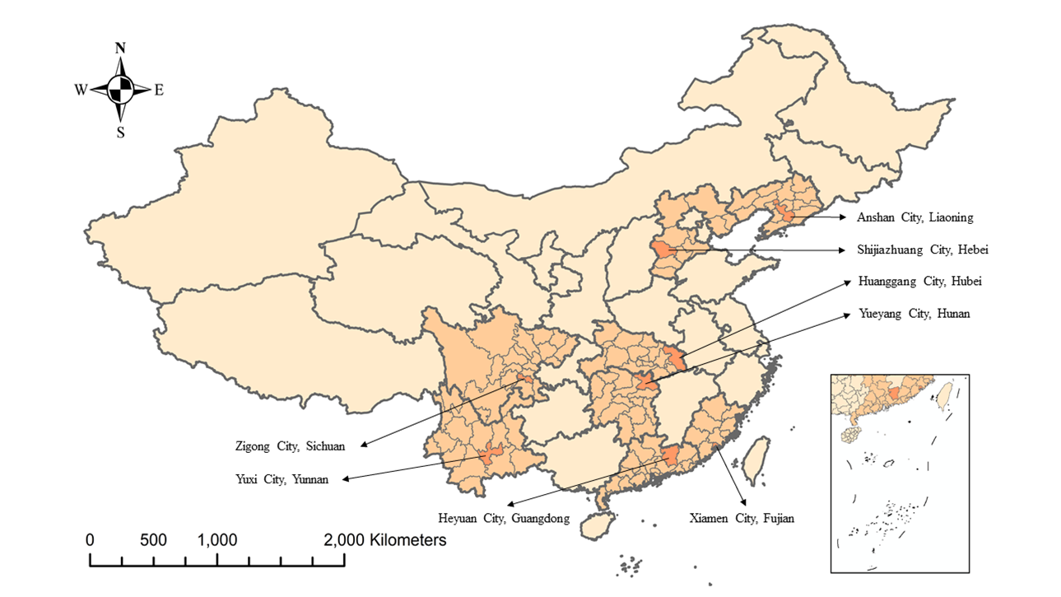

Figure S1. Spatial distribution of study sites

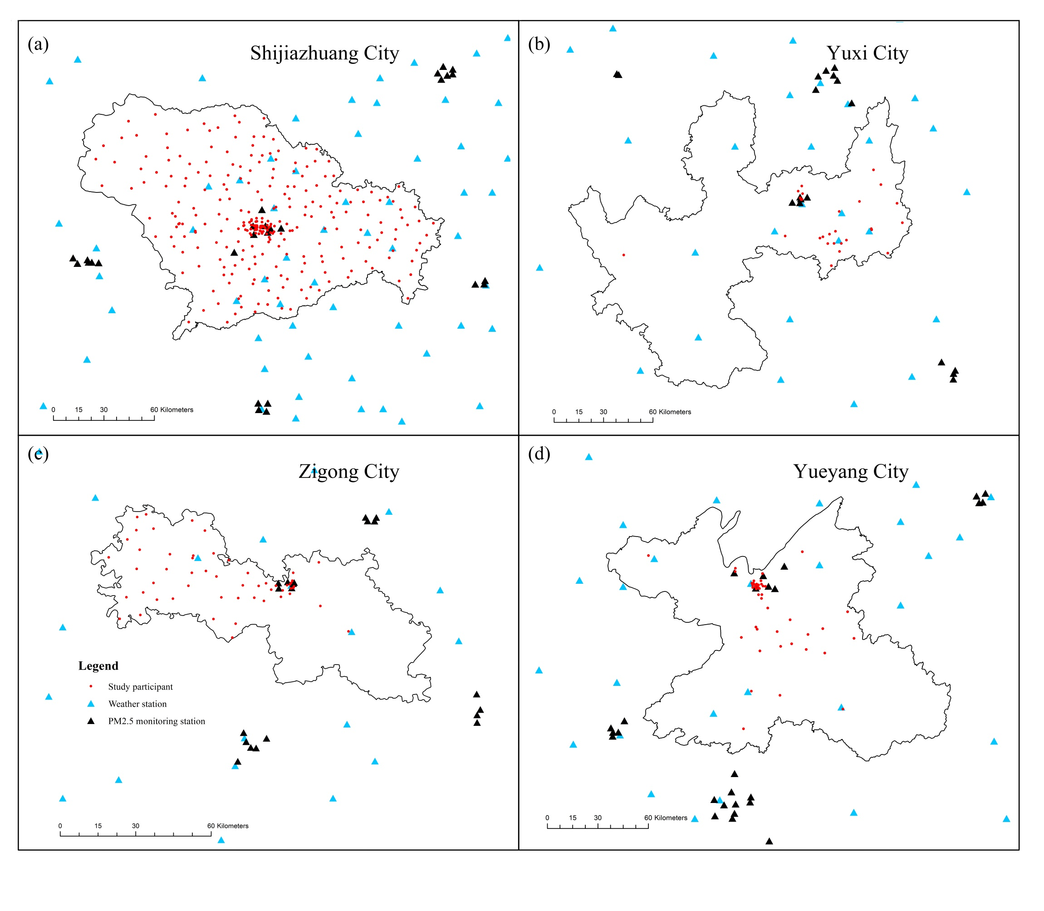

Figure S2 (a)-(d). Spatial distribution of study participants and monitoring stations

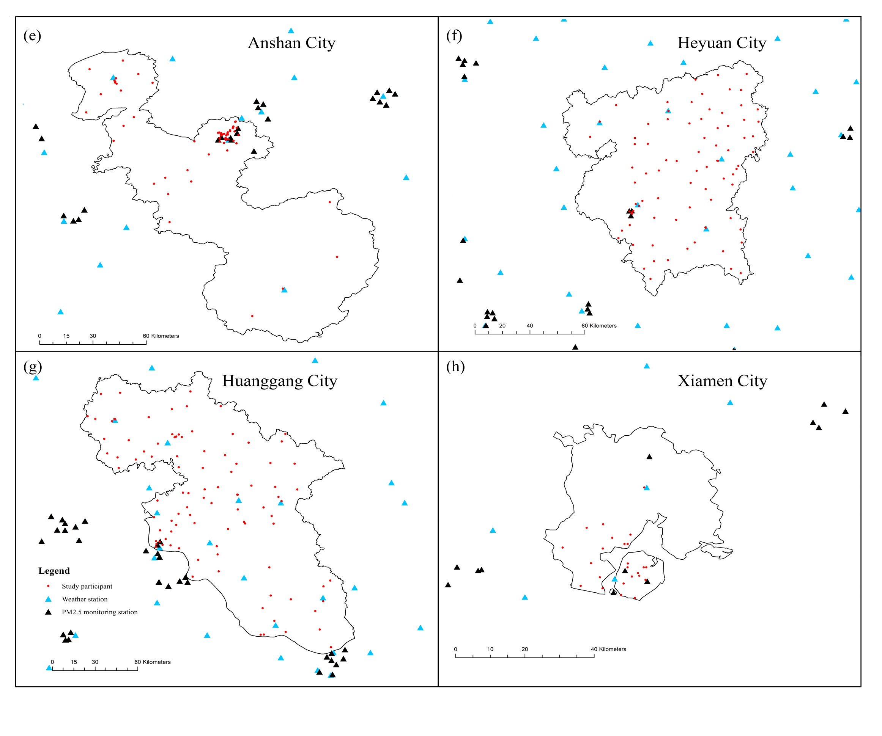

Figure S2 (e)-(h). Spatial distribution of study participants and monitoring stations

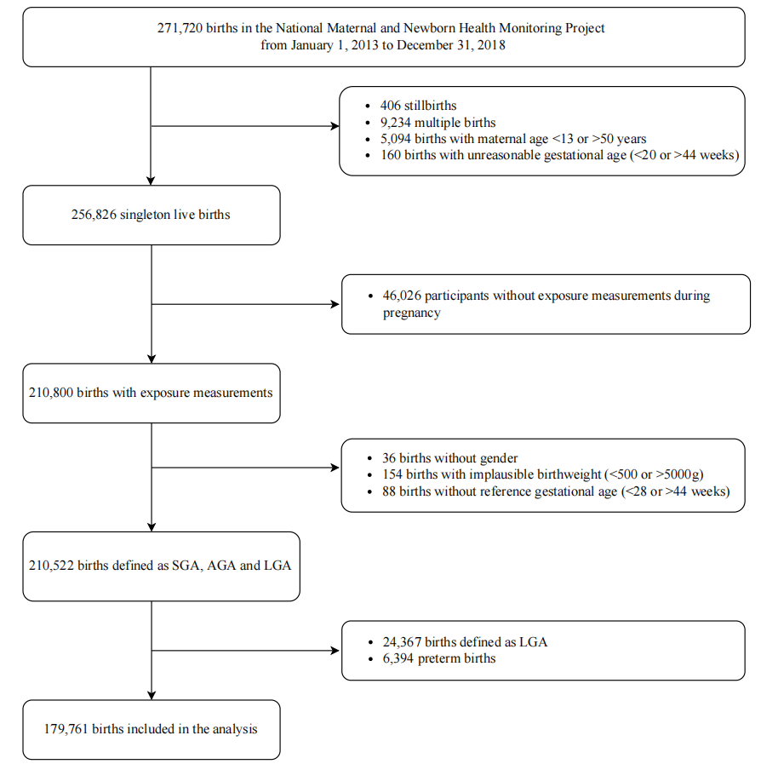

Figure S3. Flowchart of the study population

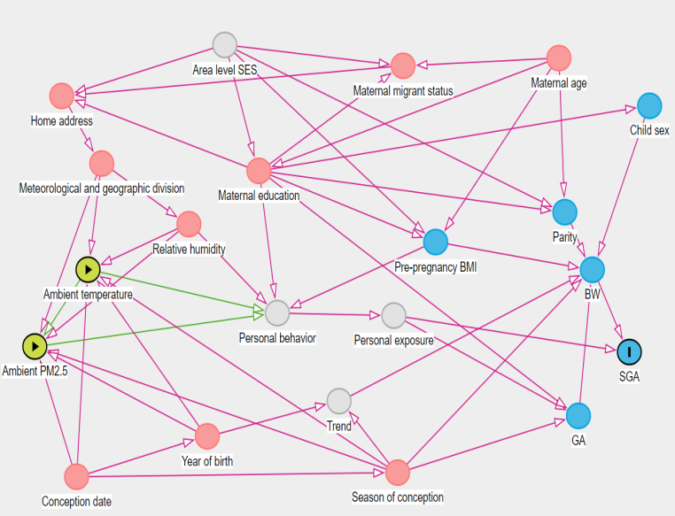
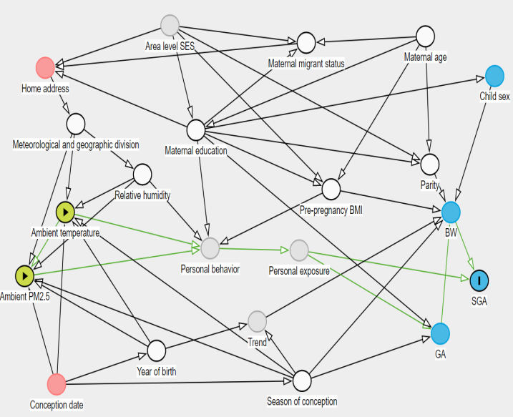


Figure S4. Illustration of potential confounding variables and possible selection bias in the association of ambient temperature and PM_{2.5} exposure with SGA and the minimal adjustment set to block all biasing paths
Directed Acyclic Graph (DAG) drawn and analyzed with DAGitty

