Appendix Figure 1. Diagram of the PAC outcomes

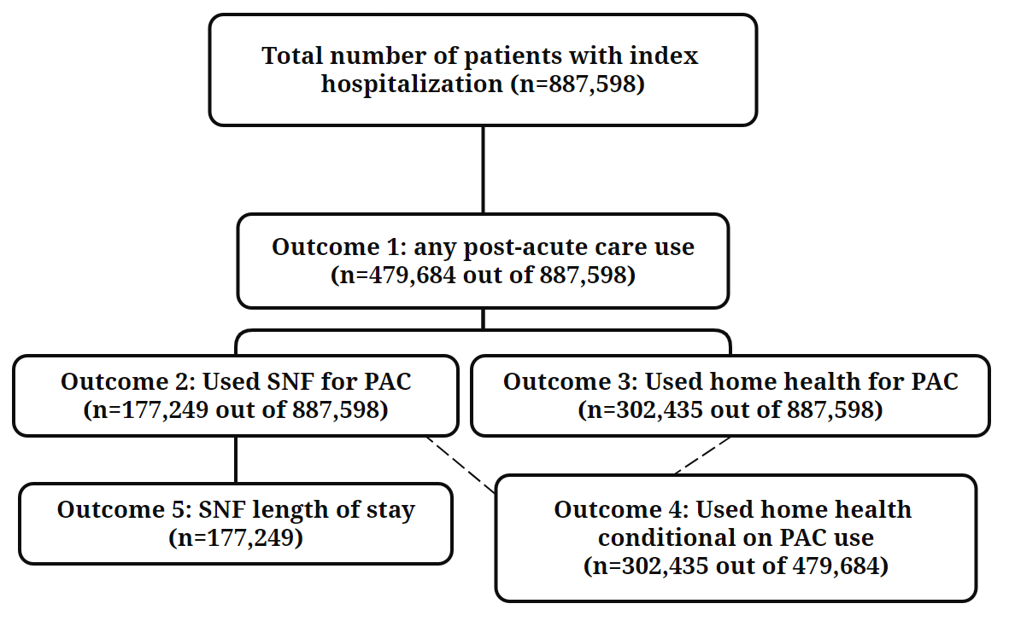

Appendix Figure 2. Standardized difference between HCBS users and non-HCBS users before and after propensity score weighting

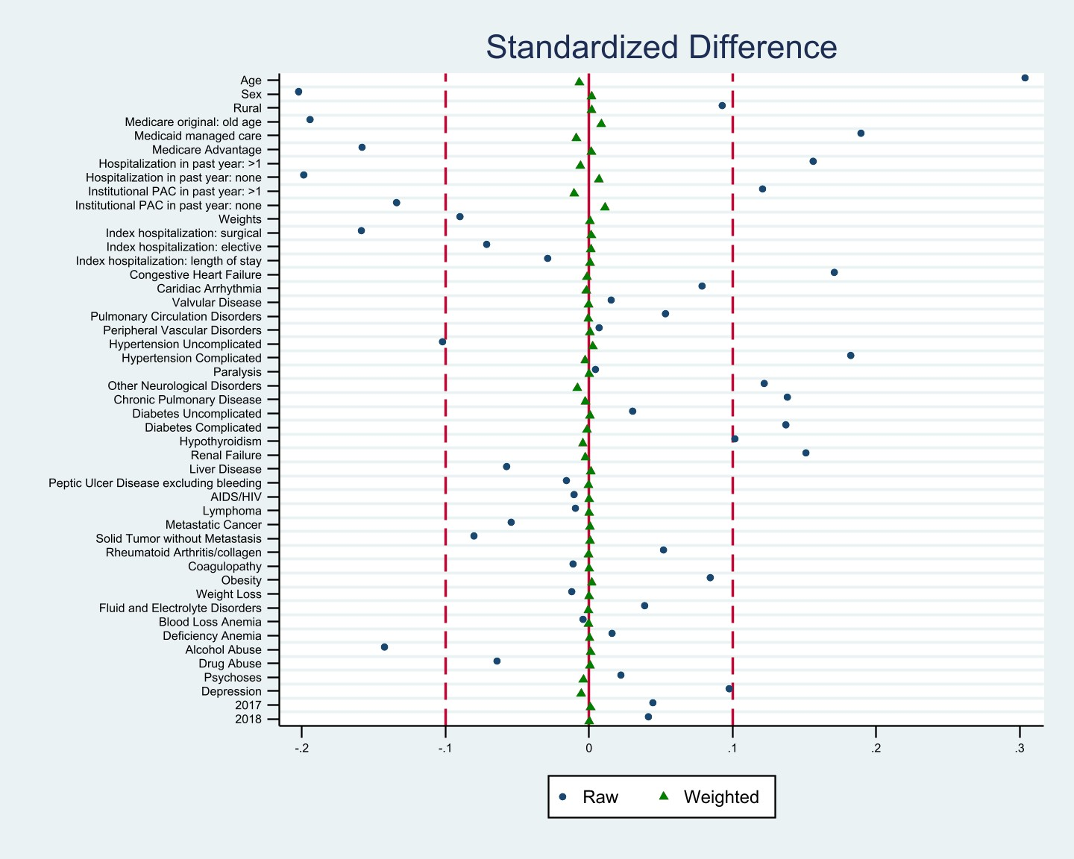

Appendix Table 1. Effects of Prior Medicaid HCBS Use on Medicare PAC Utilization: Full regression results for the main analysis
 | (1) | (2) | (3) | (4) | (5)
VARIABLES | Any PAC | Home Health unconditional | SNF unconditional | Home Health conditional on PAC | SNF LOS
HCBS user | 0.0558*** | 0.0814*** | -0.0256*** | 0.0919*** | -1.969***
 | (0.00116) | (0.00101) | (0.00109) | (0.00156) | (0.136)
age | 0.0119*** | 0.000944*** | 0.0110*** | -0.00758*** | 0.180***
 | (7.01e-05) | (6.23e-05) | (6.77e-05) | (9.40e-05) | (0.00843)
sex | -0.0357*** | -0.0215*** | -0.0142*** | -0.0111*** | 0.120
 | (0.00117) | (0.00101) | (0.00108) | (0.00159) | (0.141)
rural | -0.0190*** | -0.00180 | -0.0172*** | 0.0107*** | 1.208***
 | (0.00234) | (0.00200) | (0.00221) | (0.00307) | (0.262)
Medicare original reason: old age | -0.0234*** | -0.00572*** | -0.0177*** | 0.0138*** | -0.863***
 | (0.00131) | (0.00113) | (0.00122) | (0.00178) | (0.158)
Medicaid managed care | -0.00578*** | 0.0254*** | -0.0312*** | 0.0435*** | -1.786***
 | (0.00150) | (0.00127) | (0.00140) | (0.00208) | (0.212)
Medicare Advantage | -0.107*** | -0.0711*** | -0.0359*** | -0.0407***
 | (0.00123) | (0.00105) | (0.00114) | (0.00168)
Hospitalization in the past year, more than one | -0.0333*** | 0.0209*** | -0.0541*** | 0.0654*** | -1.621***
 | (0.00220) | (0.00198) | (0.00199) | (0.00298) | (0.258)
Hospitalization in the past year, once | 0.0330*** | -0.0211*** | 0.0541*** | -0.0715*** | 1.927***
 | (0.00159) | (0.00142) | (0.00146) | (0.00220) | (0.191)
Institutional PAC in the past year, more than one | 0.0468*** | -0.0439*** | 0.0907*** | -0.0972*** | 0.327
 | (0.00509) | (0.00456) | (0.00521) | (0.00611) | (0.509)
Institutional PAC in the past year, once | -0.111*** | 0.0163*** | -0.128*** | 0.114*** | -3.342***
 | (0.00476) | (0.00428) | (0.00484) | (0.00575) | (0.483)
Index hospitalization: DRG weights | -0.00409*** | 0.00977*** | -0.0139*** | 0.0177*** | -0.434***
 | (0.000610) | (0.000513) | (0.000586) | (0.000698) | (0.0709)
Index hospitalization: Surgical | 0.143*** | -0.0151*** | 0.158*** | -0.128*** | 2.459***
 | (0.00171) | (0.00147) | (0.00168) | (0.00213) | (0.199)
Index hospitalization: Elective | 0.0646*** | 0.0525*** | 0.0121*** | 0.0287*** | -8.311***
 | (0.00197) | (0.00178) | (0.00191) | (0.00258) | (0.211)
Index hospitalization: Length of stay | 0.0150*** | -0.00112*** | 0.0162*** | -0.0120*** | 0.0792***
 | (0.000156) | (0.000104) | (0.000159) | (0.000164) | (0.0151)
Congestive Heart Failure | 0.00265* | 0.0228*** | -0.0202*** | 0.0361*** | -0.629***
 | (0.00156) | (0.00139) | (0.00146) | (0.00208) | (0.185)
Cardiac Arrhythmia | 0.000216 | 0.00812*** | -0.00790*** | 0.0136*** | -0.117
 | (0.00123) | (0.00109) | (0.00116) | (0.00163) | (0.145)
Valvular Disease | -0.0114*** | 0.0107*** | -0.0222*** | 0.0283*** | -0.804***
 | (0.00189) | (0.00174) | (0.00177) | (0.00251) | (0.215)
Pulmonary Circulation Disorders | 0.0148*** | 0.0164*** | -0.00164 | 0.0146*** | -0.386
 | (0.00225) | (0.00208) | (0.00208) | (0.00298) | (0.264)
Peripheral Vascular Disorders | -0.00492*** | 0.0142*** | -0.0191*** | 0.0303*** | -0.588***
 | (0.00175) | (0.00159) | (0.00162) | (0.00237) | (0.209)
Hypertension Uncomplicated | 0.00409*** | 0.00695*** | -0.00286** | 0.0118*** | -0.391**
 | (0.00147) | (0.00126) | (0.00140) | (0.00198) | (0.169)
Hypertension Complicated | 0.00598*** | 0.0118*** | -0.00586*** | 0.0197*** | -0.519**
 | (0.00209) | (0.00185) | (0.00198) | (0.00279) | (0.244)
Paralysis | 0.145*** | -0.0212*** | 0.166*** | -0.118*** | 7.094***
 | (0.00318) | (0.00272) | (0.00335) | (0.00355) | (0.416)
Other Neurological Disorders | 0.0947*** | -0.0138*** | 0.109*** | -0.0892*** | 1.582***
 | (0.00150) | (0.00129) | (0.00152) | (0.00183) | (0.161)
Chronic Pulmonary Disease | -0.0174*** | 0.0257*** | -0.0432*** | 0.0608*** | -1.651***
 | (0.00119) | (0.00105) | (0.00110) | (0.00163) | (0.145)
Diabetes Uncomplicated | 0.00390*** | 0.0130*** | -0.00914*** | 0.0188*** | 0.0103
 | (0.00142) | (0.00125) | (0.00132) | (0.00195) | (0.178)
Diabetes Complicated | 0.0324*** | 0.0263*** | 0.00607*** | 0.0170*** | 0.132
 | (0.00141) | (0.00126) | (0.00133) | (0.00189) | (0.173)
Hypothyroidism | 0.00519*** | -0.00261** | 0.00780*** | -0.00912*** | -0.369**
 | (0.00142) | (0.00126) | (0.00137) | (0.00186) | (0.157)
Renal Failure | 0.00581*** | 0.00534*** | 0.000466 | 0.00608** | -0.583***
 | (0.00188) | (0.00169) | (0.00176) | (0.00251) | (0.219)
Liver Disease | -0.0303*** | -0.00170 | -0.0286*** | 0.0264*** | -1.291***
 | (0.00254) | (0.00218) | (0.00224) | (0.00369) | (0.331)
Peptic Ulcer Disease excluding bleeding | -0.0604*** | 0.00139 | -0.0618*** | 0.0614*** | -0.482
 | (0.00479) | (0.00423) | (0.00411) | (0.00695) | (0.658)
AIDS/HIV | -0.00913 | -0.0254*** | 0.0163* | -0.0223 | 0.888
 | (0.0100) | (0.00851) | (0.00840) | (0.0156) | (1.435)
Lymphoma | -0.0440*** | 0.0264*** | -0.0704*** | 0.0905*** | -3.667***
 | (0.00579) | (0.00526) | (0.00503) | (0.00826) | (0.707)
Metastatic Cancer | 0.0241*** | 0.0219*** | 0.00224 | 0.0154*** | -1.462***
 | (0.00388) | (0.00351) | (0.00337) | (0.00528) | (0.466)
Solid Tumor without Metastasis | -0.0547*** | 0.0360*** | -0.0907*** | 0.111*** | -1.913***
 | (0.00251) | (0.00229) | (0.00220) | (0.00356) | (0.316)
Rheumatoid Arthritis/collagen | 0.0288*** | 0.0142*** | 0.0146*** | 0.000613 | -1.109***
 | (0.00284) | (0.00257) | (0.00271) | (0.00378) | (0.299)
Coagulopathy | 0.0149*** | 0.00523*** | 0.00970*** | -0.00234 | -0.443*
 | (0.00208) | (0.00186) | (0.00199) | (0.00275) | (0.237)
Obesity | 0.0345*** | 0.00911*** | 0.0254*** | -0.0151*** | 0.640***
 | (0.00155) | (0.00138) | (0.00144) | (0.00211) | (0.189)
Weight Loss | 0.0593*** | -0.00691*** | 0.0662*** | -0.0512*** | 1.558***
 | (0.00194) | (0.00167) | (0.00194) | (0.00238) | (0.214)
Fluid and Electrolyte Disorders | 0.0221*** | 0.00629*** | 0.0158*** | -0.00877*** | -0.275**
 | (0.00114) | (0.000995) | (0.00107) | (0.00152) | (0.135)
Blood Loss Anemia | -0.0414*** | -0.00723* | -0.0342*** | 0.0238*** | -0.305
 | (0.00462) | (0.00413) | (0.00419) | (0.00650) | (0.620)
Deficiency Anemia | -0.00212 | 0.00512** | -0.00725*** | 0.0102*** | 0.349
 | (0.00228) | (0.00203) | (0.00213) | (0.00302) | (0.269)
Alcohol Abuse | 0.0345*** | -0.0332*** | 0.0676*** | -0.0986*** | -0.524*
 | (0.00293) | (0.00233) | (0.00277) | (0.00397) | (0.318)
Drug Abuse | -0.0340*** | -0.0218*** | -0.0122*** | -0.0151*** | -0.975**
 | (0.00324) | (0.00266) | (0.00293) | (0.00494) | (0.413)
Psychoses | -0.00182 | -0.0502*** | 0.0484*** | -0.105*** | 2.690***
 | (0.00321) | (0.00242) | (0.00313) | (0.00403) | (0.329)
Depression | 0.0381*** | -0.00712*** | 0.0452*** | -0.0422*** | 0.246
 | (0.00154) | (0.00134) | (0.00150) | (0.00199) | (0.169)
Year, 2017 | -0.0114*** | -0.00514*** | -0.00629*** | 0.00273 | -0.896***
 | (0.00131) | (0.00116) | (0.00125) | (0.00175) | (0.152)
Year, 2018 | -0.0219*** | -0.00871*** | -0.0132*** | 0.00493*** | -1.369***
 | (0.00139) | (0.00122) | (0.00131) | (0.00187) | (0.162)
Constant | -0.418*** | 0.0909*** | -0.508*** | 0.953*** | 22.57***
 | (0.00741) | (0.00656) | (0.00725) | (0.00970) | (0.852)
Observations | 887,598 | 887,598 | 887,598 | 479,684 | 177,249
R-squared | 0.154 | 0.057 | 0.166 | 0.152 | 0.112

Appendix Table 2. Results from stratified analysis – Medicare Advantage and Medicaid managed care

Panel 1. Medicare Advantage
 | Any PAC | Home Health unconditional | SNF unconditional | Home Health conditional on PAC | SNF LOS
HCBS user | 0.0488*** | 0.0681*** | -0.0193*** | 0.0900*** | NA
 | (0.00198) | (0.00161) | (0.00181) | (0.00276)
Observations | 307,169 | 307,169 | 307,169 | 145,404
R-squared | 0.170 | 0.066 | 0.184 | 0.181
Panel 2. Medicaid managed care
HCBS user | 0.0594*** | 0.0582*** | 0.00122 | 0.0541*** | -1.222***
 | (0.00189) | (0.00167) | (0.00177) | (0.00258) | (0.245)
Observations | 375,263 | 375,263 | 375,263 | 198,553 | 64,669
R-squared | 0.159 | 0.076 | 0.163 | 0.171 | 0.123

Appendix Table 3. Results from stratified analysis – Race/Ethnicity

Panel 1. Non-Hispanic White
 | Any PAC | Home Health unconditional | SNF unconditional | Home Health conditional on PAC | SNF LOS
HCBS user | 0.0422*** | 0.0883*** | -0.0461*** | 0.108*** | -2.112***
 | (0.00162) | (0.00139) | (0.00159) | (0.00206) | (0.172)
Observations | 441,071 | 441,071 | 441,071 | 259,327 | 110,229
R-squared | 0.152 | 0.060 | 0.176 | 0.155 | 0.127
Panel 2. Black
HCBS user | 0.0620*** | 0.0821*** | -0.0201*** | 0.0839*** | -1.347***
 | (0.00268) | (0.00238) | (0.00242) | (0.00371) | (0.370)
Observations | 176,136 | 176,136 | 176,136 | 92,599 | 28,639
R-squared | 0.162 | 0.069 | 0.177 | 0.175 | 0.173
Panel 3. Hispanic
HCBS user | 0.0748*** | 0.0617*** | 0.0131*** | 0.0444*** | -1.777***
 | (0.00275) | (0.00244) | (0.00235) | (0.00402) | (0.421)
Observations | 177,151 | 177,151 | 177,151 | 80,721 | 21,746
R-squared | 0.167 | 0.087 | 0.154 | 0.180 | 0.174
Panel 4. Other
HCBS user | 0.0904*** | 0.0718*** | 0.0186*** | 0.0487*** | -1.682***
 | (0.00380) | (0.00338) | (0.00350) | (0.00560) | (0.501)
Observations | 93,240 | 93,240 | 93,240 | 47,037 | 16,635
R-squared | 0.203 | 0.108 | 0.188 | 0.208 | 0.227

Appendix Table 4. Results from stratified analysis – Type of hospitalization and DRG group

Panel 1. Surgical DRG for index hospitalization
 | Any PAC | Home Health unconditional | SNF unconditional | Home Health conditional on PAC | SNF LOS
HCBS user | 0.0757*** | 0.0499*** | 0.0258*** | 0.0241*** | -1.062***
 | (0.00226) | (0.00208) | (0.00231) | (0.00279) | (0.238)
Observations | 223,452 | 223,452 | 223,452 | 142,413 | 55,998
R-squared | 0.152 | 0.074 | 0.179 | 0.160 | 0.170
Panel 2. Index hospitalization DRG - Septicemia
HCBS user | 0.0505*** | 0.103*** | -0.0525*** | 0.134*** | -2.601***
 | (0.00385) | (0.00337) | (0.00355) | (0.00533) | (0.517)
Observations | 85,042 | 85,042 | 85,042 | 44,733 | 15,099
R-squared | 0.187 | 0.101 | 0.203 | 0.222 | 0.245
Panel 3. Index hospitalization DRG – COPD
HCBS user | 0.0749*** | 0.0988*** | -0.0238*** | 0.108*** | -3.606***
 | (0.00609) | (0.00558) | (0.00464) | (0.0105) | (1.397)
Observations | 36,774 | 36,774 | 36,774 | 14,916 | 3,628
R-squared | 0.249 | 0.175 | 0.238 | 0.354 | 0.569
Panel 4. Index hospitalization DRG – Heart failure
HCBS user | 0.0591*** | 0.101*** | -0.0421*** | 0.109*** | -2.679***
 | (0.00552) | (0.00519) | (0.00452) | (0.00776) | (0.932)
Observations | 45,782 | 45,782 | 45,782 | 23,589 | 6,178
R-squared | 0.226 | 0.150 | 0.251 | 0.311 | 0.472
Panel 5. Index hospitalization DRG – Stroke
HCBS user | 0.0269*** | 0.0830*** | -0.0561*** | 0.0941*** | -3.029***
 | (0.00673) | (0.00617) | (0.00733) | (0.00784) | (0.904)
Observations | 24,727 | 24,727 | 24,727 | 18,106 | 7,639
R-squared | 0.228 | 0.172 | 0.272 | 0.258 | 0.337
Panel 6. Index hospitalization DRG – Pneumonia
HCBS user | 0.0588*** | 0.0943*** | -0.0354*** | 0.108*** | -2.345**
 | (0.00593) | (0.00530) | (0.00503) | (0.00970) | (1.024)
Observations | 38,286 | 38,286 | 38,286 | 17,324 | 5,199
R-squared | 0.260 | 0.170 | 0.259 | 0.341 | 0.541
Panel 7. Index hospitalization – Non-discretionary
HCBS user | 0.0689*** | 0.0922*** | -0.0232*** | 0.102*** | -2.237***
 | (0.00258) | (0.00225) | (0.00238) | (0.00347) | (0.332)
Observations | 179,898 | 179,898 | 179,898 | 95,506 | 34,236
R-squared | 0.198 | 0.081 | 0.234 | 0.222 | 0.173
Panel 8. Index hospitalization – Emergency
HCBS user | 0.0528*** | 0.0850*** | -0.0323*** | 0.101*** | -2.135***
 | (0.00134) | (0.00116) | (0.00125) | (0.00179) | (0.161)
Observations | 669,155 | 669,155 | 669,155 | 359,507 | 132,285
R-squared | 0.157 | 0.058 | 0.174 | 0.159 | 0.106

Appendix Table 5. Results from stratified analysis – rural residence
 | Any PAC | Home Health unconditional | SNF unconditional | Home Health conditional on PAC | SNF LOS
HCBS user | 0.0464*** | 0.0969*** | -0.0505*** | 0.123*** | -3.282***
 | (0.00299) | (0.00256) | (0.00279) | (0.00401) | (0.358)
Observations | 142,273 | 142,273 | 142,273 | 76,394 | 33,378
R-squared | 0.180 | 0.082 | 0.208 | 0.213 | 0.180

Appendix Table 6. Results from stratified analysis – high need population

 | (1) | (2) | (3) | (4) | (5)
VARIABLES | Any PAC | Home Health unconditional | SNF unconditional | Home Health conditional on PAC | SNF LOS
HCBS user | 0.0278*** | 0.0884*** | -0.0606*** | 0.1185*** | -2.230***
 | (0.00195) | (0.00174) | (0.00185) | (0.00257) | (0.227)
Observations | 323,830 | 323,830 | 323,830 | 185,185 | 72,877
R-squared | 0.156 | 0.067 | 0.184 | 0.180 | 0.135

Appendix Table 7. Results from alternative models

Panel 1. Probability model and logistic regression for binary outcomes (20% random sample)
Outcome | (1) Any PAC use |  | (2) Home Health use (unconditional) |  | (3) SNF use (unconditional) |  | (4) Home Health use conditional on PAC
VARIABLES | Linear | Logistic | Linear | Logistic | Linear | Logistic | Linear | Logistic
HCBS use | 0.0559*** | 0.0547*** | 0.0794*** | 0.0811*** | -0.0235*** | -0.0236*** | 0.0881*** | 0.0887***
 | (0.00256) | (0.00250) | (0.00224) | (0.00227) | (0.00240) | (0.00238) | (0.00349) | (0.00342)
AIC | 223,970.2 | 218,440.7 | 181,380.1 | 182,839.6 | 197,934.9 | 194,400.1 | 119,052 | 118,192.3
BIC | 224,464.5 | 254,855.7 | 181,874.4 | 216,752.7 | 198,429.2 | 228,940.9 | 119,516.4 | 147,495.3
Observations | 177,688 | 176,144 | 177,688 | 174,416 | 177,688 | 175,106 | 96,339 | 94,723

Panel 2. Linear model, Poisson regression, and Negative binomial regression for SNF length-of-stay
 | (5) SNF length of stay
VARIABLES | Linear | Poisson | Negative binomial
HCBS use | -1.951*** | -0.0609*** | -0.0372***
 | (0.134) | (0.00466) | (0.00355)
AIC | 1,627,045 | 3,589,429 | 3,884,111
BIC | 1,627,529 | 3,589,903 | 3,884,595
Observations | 177,249 | 176,929 | 176,929
Note: All models include hospital fixed effects. For non-linear models, coefficients are reported.

Appendix Table 8. Results from the subgroup of individuals receiving major joint replacement for the index hospitalization
 | (1) | (2) | (3) | (4) | (5)
VARIABLES | Any PAC | Home Health unconditional | SNF unconditional | Home Health conditional on PAC | SNF LOS
HCBS suer | 0.0262*** | -0.00905* | 0.0353*** | -0.0206*** | -0.452
 | (0.00398) | (0.00530) | (0.00585) | (0.00573) | (0.372)
Observations | 31,837 | 31,837 | 31,837 | 28,260 | 13,997
R-squared | 0.234 | 0.225 | 0.275 | 0.268 | 0.384

Appendix Figure 3. PAC use for patients receiving major joint replacement
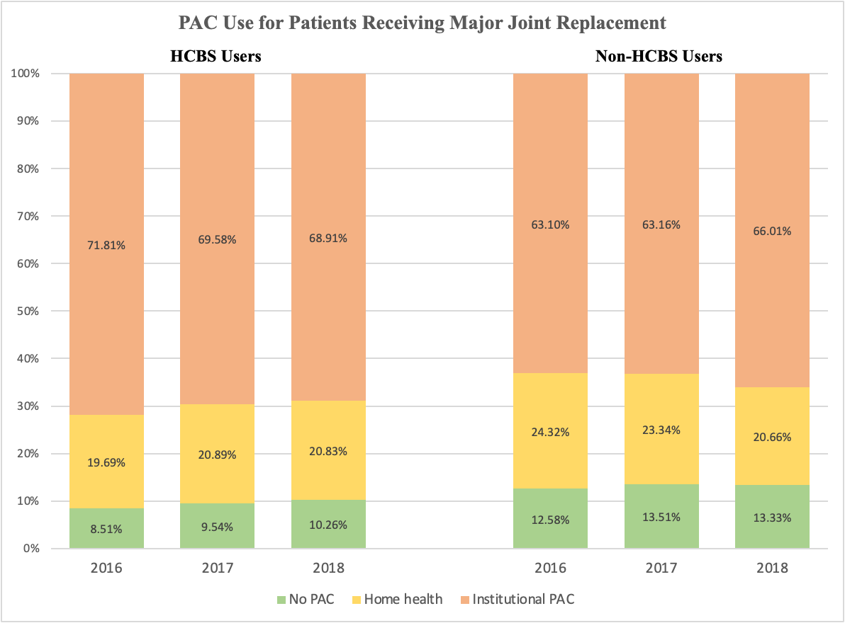

As shown in Appendix Table 8, our study found an unusual relationship between HCBS use and PAC utilization among patients undergoing major joint replacement. Existing HCBS users showed less home health use and more SNF use, deviating from our primary findings. During the study period (2016-2018), Medicare introduced alternative payment models encouraging home health substitution for institutional PAC. We examined PAC use by HCBS status among joint replacement patients over the years (Appendix Figure 3). We observed an increasing trend of SNF use among non-HCBS-using patients, a decreasing trend among HCBS users. This unadjusted trend is in the opposite direction of the finding of our multivariate analysis, suggesting the risk adjustment playing an important role.

