Appendix. Brief Summary of the Goodman-Bacon (2021) Decomposition
The Goodman-Bacon (2021) shows that in cases when the data contain $k=1 , …, K$ groups of units ordered by the time when they receive a binary treatment $T$ and a never treated group $U$, the two-way fixed effects (TWFE) estimate is a weighted average of all possible two-by-two difference-in-differences ($2×2$ DD) estimators.
$${\hat{β}}^{DD}=\sum_{k≠U}{S_{kU}{\hat{β}}_{kU}^{2×2}}+\sum_{k≠U}{\sum_{l>k}{\left[s_{kl}^{k}{\hat{β}}_{kl}^{2×2,k}+s_{kl}^{l}{\hat{β}}_{kl}^{2×2,l}\right]}}$$
In the above equation, the component $2×2$ DD estimators are:
- treated groups vs never-treated group ${\hat{β}}_{kU}^{2×2}≡\left({\overline{y}}_{k}^{POST\left(k\right)}-{\overline{y}}_{k}^{PRE\left(k\right)}\right)-\left({\overline{y}}_{U}^{POST\left(k\right)}-{\overline{y}}_{U}^{PRE\left(k\right)}\right)$,
- earlier-treated groups vs later-treated groups ${\hat{β}}_{kl}^{2×2,k}≡\left({\overline{y}}_{k}^{MID\left(k,l\right)}-{\overline{y}}_{k}^{PRE\left(k\right)}\right)-\left({\overline{y}}_{l}^{MID\left(k,l\right)}-{\overline{y}}_{l}^{PRE\left(k\right)}\right)$,
- later-treated groups vs earlier-treated groups ${\hat{β}}_{kl}^{2×2,l}≡\left({\overline{y}}_{l}^{POST\left(l\right)}-{\overline{y}}_{l}^{MID\left(k,l\right)}\right)-\left({\overline{y}}_{k}^{POST\left(l\right)}-{\overline{y}}_{k}^{MID\left(k,l\right)}\right)$.
The weight for each component $2×2$ DD estimator is a function of the size of the sub-sample, relative size of treatment and control groups, and treatment variance in the sub-sample. These weights are larger when the size of the sub-sample is larger, treatment and control groups are closer in size, or treatment variance in the sub-sample is larger.
The primary source of potential bias of TWFE estimator with staggered treatment timings is the third component $2×2$ DD estimator described above, in which earlier-treated groups serve as effective control for later-treated groups. In case of heterogeneous treatment effect, changes in the outcomes of already treated units will be contaminated by changes in treatment effect over time because we are subtracting the treatment effects of prior treated units from the estimate of future control units. Hence, we should exercise caution in situations where there exists a considerable difference in size (or direction) between the estimate obtained from the third component $2×2$ DD estimator and the overall TWFE estimate. This caution is especially warranted when the third component $2×2$ DD estimate holds significant weight within the overall TWFE estimate.
When data includes units treated throughout the study period (always-treated units), they enter the decomposition like never-treated units. If there are changes in treatment effect over time, the component $2×2$ DD estimator in which always-treated group serve as effective control for timing groups will also bias the TWFE estimate.
Controlling for covariates in the TWFE estimator will introduce an additional component $2×2$ DD estimator, within-timing-group comparisons, which measures the relationship between outcomes and changes over time in the predicted treatment status across units in the same treatment timing group. When covariates explain the treatment status well, we would expect the estimate of within-timing-group comparisons associate with minimal weight.
Appendix. Brief Summary of the Sun and Abraham (2021) Estimator and the and Sant’Anna (2021) Estimator
Both the Sun and Abraham (2021) estimator and the Callaway and Sant’Anna (2021) estimator first estimate the time-specific treatment effects for each treatment timing cohort, then generate the overall treatment effect by aggregating all time-specific treatment effects. More specifically, the Sun and Abraham (2021) estimator produces the overall treatment effect in three steps: 1) estimate cohort-time-specific treatment effects; 2) generate the weighted average treatment effect for each relative time period (event study design) using the sample shares of each cohort in the relative-time period as weights; and 3) obtain the overall treatment effect from the linear combination of treatment effects for all relative time periods. While the Callaway and Sant’Anna (2021) estimator also allows for event study type aggregation, it offers another method that first computes the average treatment effects for each treatment timing cohort and then generates the weighted average treatment effect across cohorts using the sample shares of each cohort as weights. These estimators mainly differ in two ways. First, the Sun and Abraham (2021) estimator allows only for never-treated and last-treated units as controls (when last-treated units are used as controls, they will not be used as treated units), while the Callaway and Sant’Anna (2021) estimator also allows for not-yet-treated units as controls. Second, Callaway and Sant’Anna (2021) better accommodates cases when the parallel trends assumption holds only after conditioning on covariates by leveraging the improved doubly robust difference-in-differences (DRDID) estimator proposed by Sant’Anna and Zhao (2020). More specifically, the improved DRDID estimator applies inverse probability reweighting based on pre-treatment covariates and it accommodates both linear and nonlinear working models for the nuisance functions. In contrast, the Sun and Abraham (2021) estimator controls for covariates linearly, which would be the correct model specification when the counterfactual trends are linear in the covariates (Baker et al., 2022).
Appendix Figure 1. Histograms of New Non-COVID-19 Deaths, New COVID-19 Deaths, and New Total Deaths in Nursing Homes
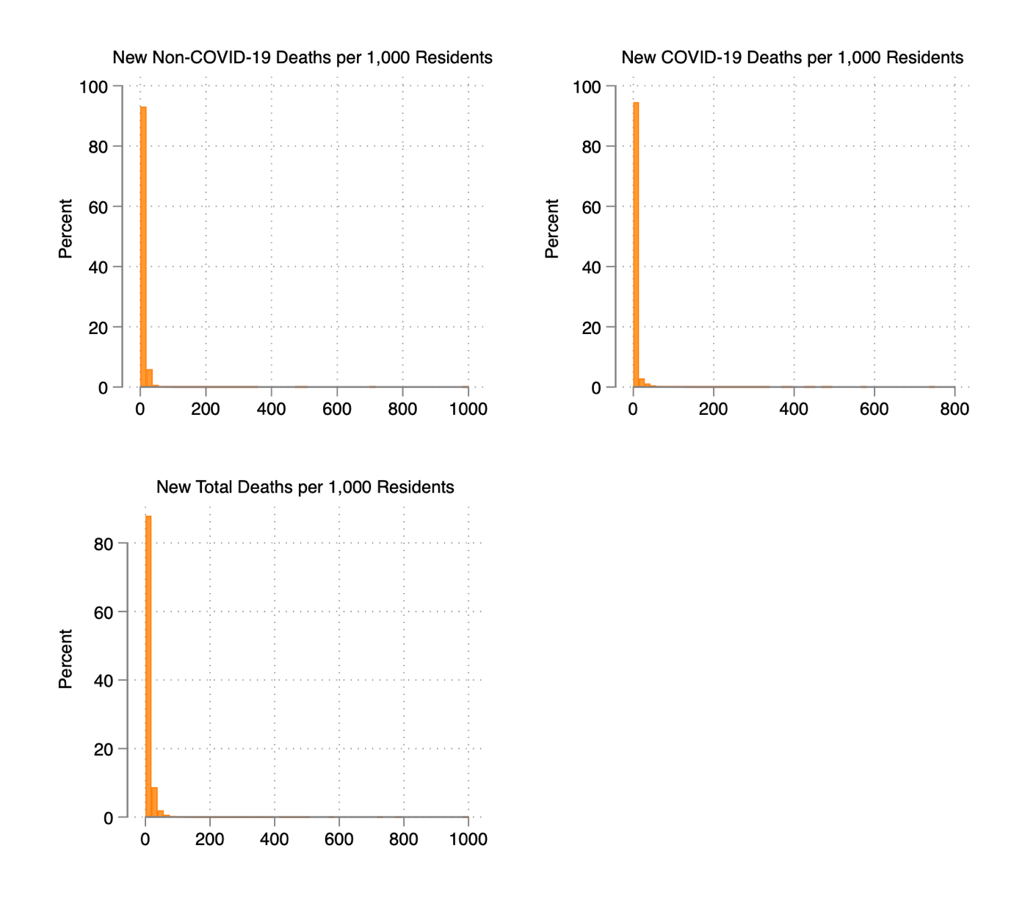

Appendix Figure 2. Covariates-Adjusted Trends in New Non-COVID-19 Deaths by State
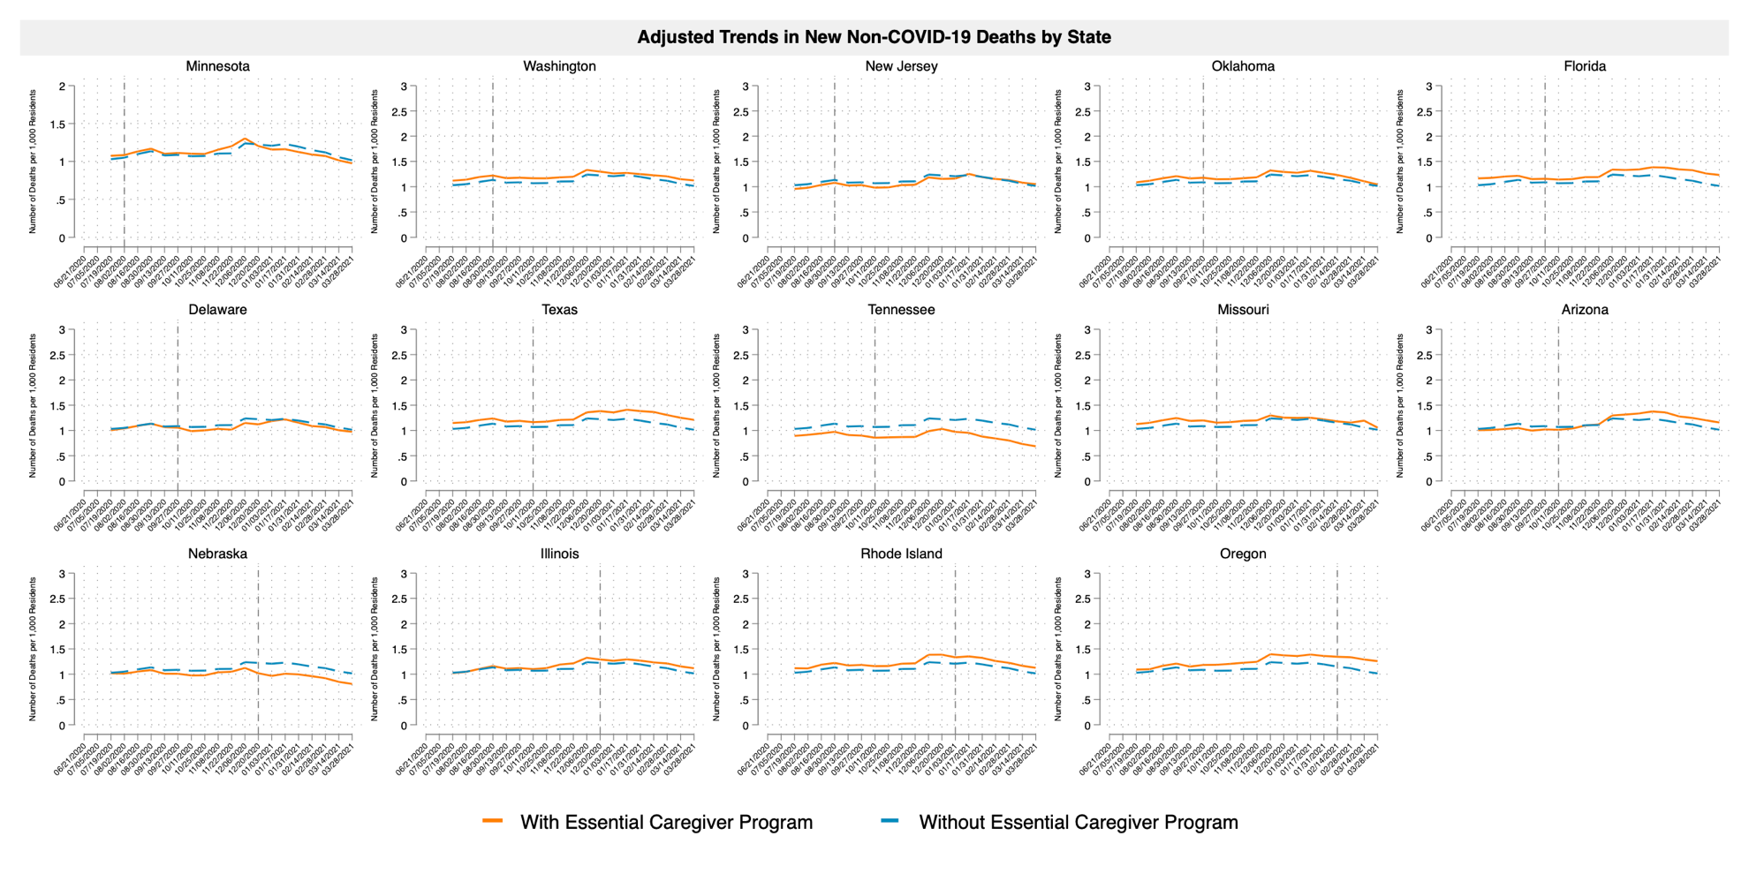
Note: (1) Dates on the x-axis representing the end date of each two-week period. (2) The vertical reference lines reflect treatment timing (when an Essential Caregiver policy was implemented) for each treatment cohort. (3) The log transformed new non-COVID-19 deaths plotted are regression-adjusted using the same set of covariates that we use in main analysis.

Appendix Figure 3. Covariates-Adjusted Trends in New COVID-19 Deaths by State
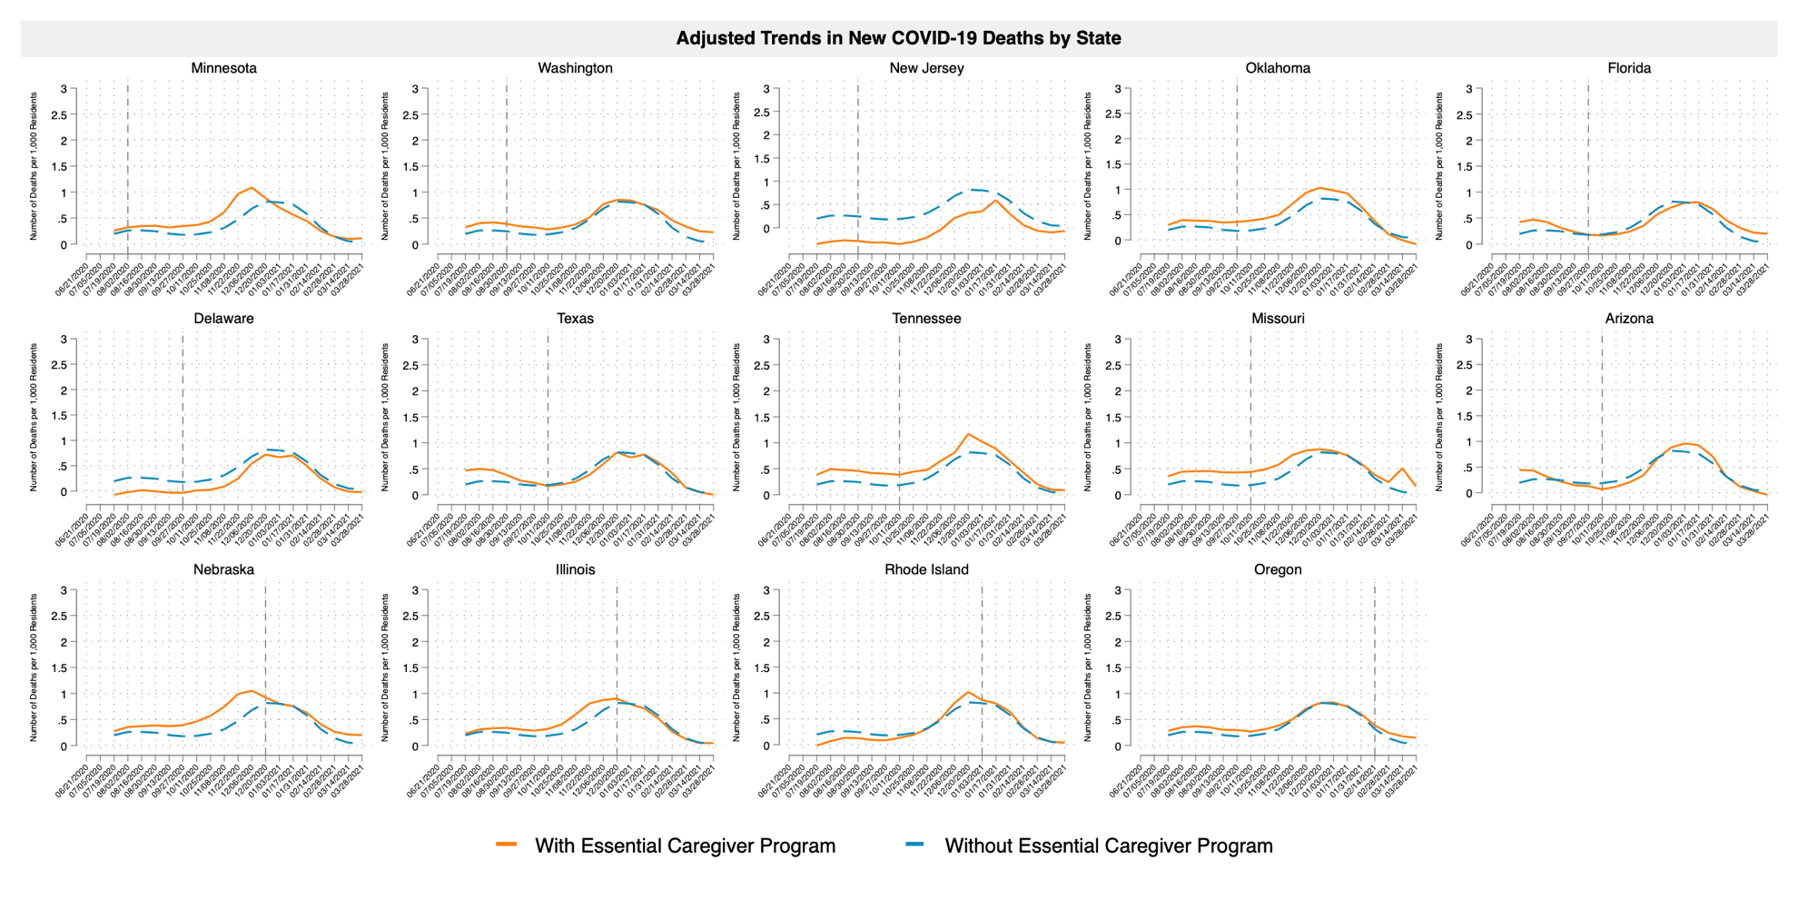
Note: (1) Dates on the x-axis representing the end date of each two-week period. (2) The vertical reference lines reflect treatment timing (when an Essential Caregiver policy was implemented) for each treatment cohort. (3) The log transformed new COVID-19 deaths plotted are regression-adjusted using the same set of covariates that we use in main analysis.

Appendix Figure 4. Covariates-Adjusted Trends in New Total Deaths by State
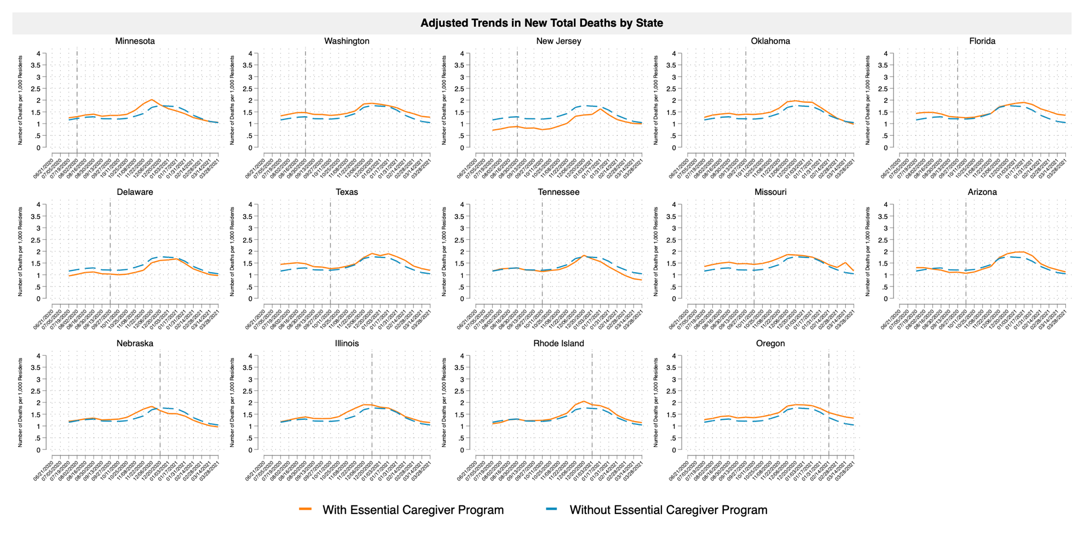
Note: (1) Dates on the x-axis representing the end date of each two-week period. (2) The vertical reference lines reflect treatment timing (when an Essential Caregiver policy was implemented) for each treatment cohort. (3) The log transformed new total deaths plotted are regression-adjusted using the same set of covariates that we use in main analysis.

Appendix Figure 5. Comparison of Adjusted Dynamic Effects of Essential Caregiver Policies Estimated Using Three Event Study Estimators
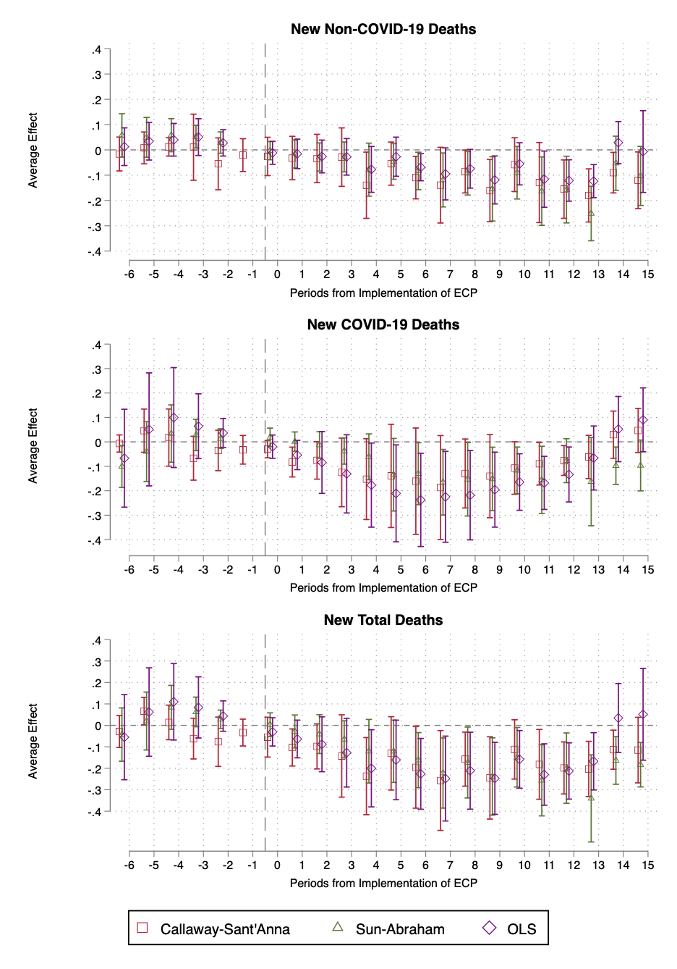
Note: (1) This figure overlays the plots of event study estimates and 95% confidence intervals for relative-time periods from -6 to 15 around the implementation period of Essential Caregiver policy constructed using three different estimators: Callaway and Sant’Anna (2021) estimator, Sun and Abraham (2021) estimator, and a dynamic version of two-way fixed effects estimator. (2) ECP: Essential Caregiver policy. (3) The log transformation outlined in the Empirical Strategy section is used for estimating the treatment effects for all three outcomes. (4) The bars represent 95 percent confidence intervals. Standard errors are clustered at state level.

Appendix Figure 6. Other COVID-19 Mitigation Policy Implementation Timelines
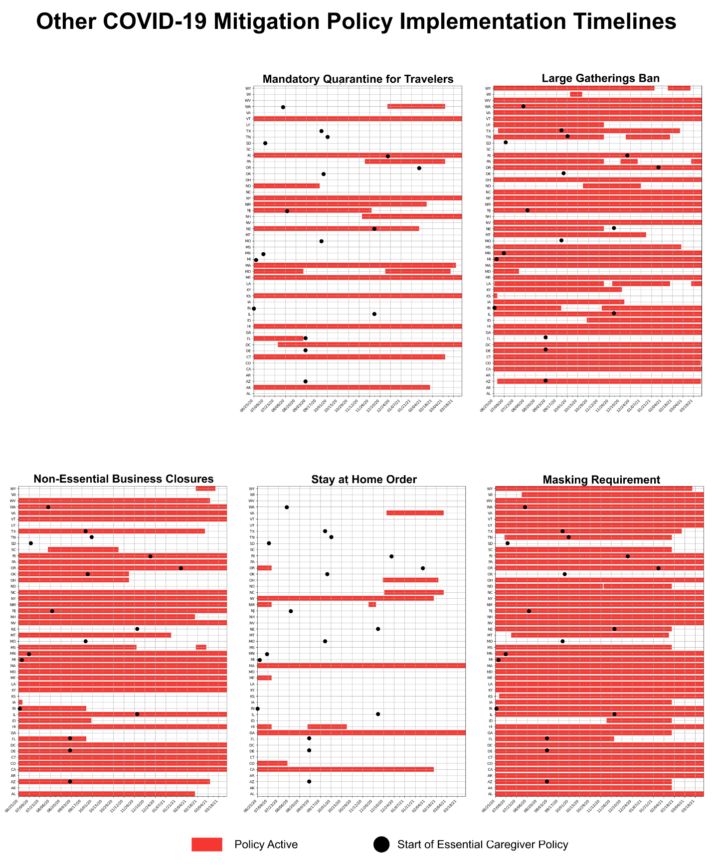
Note: For mandatory quarantine for travelers, this includes but is not limited to quarantine for all travelers, all air travelers only, from certain states only, and for international travel only. For non-essential business closure, this includes any type of non-essential business closure or reopening with limits such as reduced capacity. For stay-at-home orders, this includes but is not limited to statewide stay at home orders, curfews, and stay at home orders only for regions of high transmission or for certain high-risk groups. For masking requirements, this includes but is not limited to masking requirements for the general public, for certain employees only, and state actions that allow local officials to require masking for the general public.
Appendix Table 1. Effects of Essential Caregiver Policies on New Non-COVID-19 Deaths, New COVID-19 Deaths, and New Total Deaths in Nursing Homes in the Balanced Panel
 | TWFE  (1) | TWFE  (Restricted Sample)  (2) | SA  (3) | CS  (4)
New Non-COVID-19 Deaths per 1,000 Residents | -0.101* | -0.0959* | -0.0934*** | -0.0922*
 | (0.0522) | (0.0557) | (0.0281) | (0.0485)
New COVID-19 Deaths per 1,000 Residents | -0.0825 | -0.0588 | -0.1128*** | -0.1259**
 | (0.0732) | (0.0773) | (0.0197) | (0.0553)
New Total Deaths per 1,000 Residents | -0.147 | -0.126 | -0.1676*** | -0.1737***
 | (0.0918) | (0.0974) | (0.0303) | (0.0667)
Week FE | Yes | Yes | Yes | Yes
Facility FE | Yes | Yes | Yes | Yes
N | 206,074 | 185,383 | 185,383 | 176,643
Mean of New Non- COVID-19 Deaths per 1,000 Residents | 5.41 | 5.31 | 5.27 | 5.33
Mean of New COVID-19 Deaths per 1,000 Residents | 2.53 | 2.48 | 2.37 | 2.44
Mean of New Total Deaths per 1,000 Residents | 7.95 | 7.79 | 7.64 | 7.77
Note: (1) We construct this balanced panel by excluding observations of nursing homes with any missing weekly reports over the study period. (2) TWFE: the two-way fixed effects OLS regression. (3) Restricted sample: a sub-sample excluding observations of nursing homes in states without sufficient data points in pre-treatment period for examining parallel-trends assumption (Michigan, Indiana, South Dakota, and Minnesota) and in state (Nebraska) which we observe clear violation of parallel-trends assumption. (4) SA: the Sun and Abraham (2021) estimator. The results are estimated in the restricted sample. (5) CS: the Callaway and Sant’Anna (2021) estimator. The results are estimated in the restricted sample. (6) The log transformation outlined in the Empirical Strategy section is used for estimating the treatment effects for all three outcomes. (7) Standard errors clustered at state level are included in parentheses. (8) * p<0.10, ** p<0.05, *** p<0.01.
Appendix Table 2. Adjusted Dynamic Event Study Effects for New Non-COVID-19 Deaths in Nursing Homes, Estimated from the Callaway and Sant’Anna (2021) Estimator
 | Coefficient | Standard Error | P-value | 95% Confidence Intervals
Pre-treatment average effect | -0.0073 | 0.0063 | 0.2500 | -0.0197 | 0.0051
Post-treatment average effect | -0.0964 | 0.0376 | 0.0100 | -0.1701 | -0.0227
Pre-treatment (-10) | -0.1254 | 0.0345 | 0.0000 | -0.1931 | -0.0578
Pre-treatment (-9) | 0.1227 | 0.0381 | 0.0010 | 0.0480 | 0.1975
Pre-treatment (-8) | 0.0199 | 0.0497 | 0.6880 | -0.0775 | 0.1174
Pre-treatment (-7) | -0.0287 | 0.0490 | 0.5580 | -0.1247 | 0.0674
Pre-treatment (-6) | -0.0162 | 0.0342 | 0.6340 | -0.0832 | 0.0507
Pre-treatment (-5) | 0.0078 | 0.0321 | 0.8070 | -0.0551 | 0.0708
Pre-treatment (-4) | 0.0119 | 0.0185 | 0.5220 | -0.0244 | 0.0482
Pre-treatment (-3) | 0.0107 | 0.0666 | 0.8730 | -0.1199 | 0.1413
Pre-treatment (-2) | -0.0550 | 0.0523 | 0.2930 | -0.1574 | 0.0474
Pre-treatment (-1) | -0.0206 | 0.0331 | 0.5330 | -0.0856 | 0.0443
Treatment (implementation of ECP) | -0.0259 | 0.0386 | 0.5030 | -0.1015 | 0.0498
Post-treatment (1) | -0.0322 | 0.0438 | 0.4620 | -0.1181 | 0.0536
Post-treatment (2) | -0.0341 | 0.0487 | 0.4840 | -0.1295 | 0.0614
Post-treatment (3) | -0.0287 | 0.0590 | 0.6260 | -0.1443 | 0.0869
Post-treatment (4) | -0.1397 | 0.0668 | 0.0360 | -0.2706 | -0.0089
Post-treatment (5) | -0.0542 | 0.0435 | 0.2120 | -0.1394 | 0.0310
Post-treatment (6) | -0.1095 | 0.0429 | 0.0110 | -0.1935 | -0.0254
Post-treatment (7) | -0.1394 | 0.0763 | 0.0680 | -0.2890 | 0.0102
Post-treatment (8) | -0.0853 | 0.0432 | 0.0480 | -0.1701 | -0.0006
Post-treatment (9) | -0.1608 | 0.0627 | 0.0100 | -0.2837 | -0.0380
Post-treatment (10) | -0.0584 | 0.0543 | 0.2820 | -0.1647 | 0.0480
Post-treatment (11) | -0.1291 | 0.0807 | 0.1100 | -0.2872 | 0.0290
Post-treatment (12) | -0.1551 | 0.0589 | 0.0080 | -0.2706 | -0.0396
Post-treatment (13) | -0.1801 | 0.0536 | 0.0010 | -0.2851 | -0.0751
Post-treatment (14) | -0.0900 | 0.0408 | 0.0280 | -0.1700 | -0.0099
Post-treatment (15) | -0.1202 | 0.0572 | 0.0360 | -0.2323 | -0.0081
Note: (1) ECP: Essential Caregiver policy. (2) Number in parentheses reflects the number of two-week periods from the implementation of Essential Caregiver policy. (3) The log transformation outlined in the Empirical Strategy section is used for estimating the treatment effects. (4) Standard errors are clustered at state level.

Appendix Table 3. Adjusted Dynamic Event Study Effects for New COVID-19 Deaths in Nursing Homes, Estimated from the Callaway and Sant’Anna (2021) Estimator
 | Coefficient | Standard Error | P-value | 95% Confidence Intervals
Pre-treatment average effect | -0.0006 | 0.0065 | 0.9320 | -0.0134 | 0.0123
Post-treatment average effect | -0.0925 | 0.0494 | 0.0610 | -0.1894 | 0.0043
Pre-treatment (-10) | -0.0631 | 0.0149 | 0.0000 | -0.0924 | -0.0339
Pre-treatment (-9) | 0.0230 | 0.0080 | 0.0040 | 0.0073 | 0.0387
Pre-treatment (-8) | 0.0708 | 0.0168 | 0.0000 | 0.0379 | 0.1037
Pre-treatment (-7) | 0.0415 | 0.0240 | 0.0840 | -0.0055 | 0.0884
Pre-treatment (-6) | -0.0066 | 0.0179 | 0.7120 | -0.0418 | 0.0285
Pre-treatment (-5) | 0.0458 | 0.0450 | 0.3090 | -0.0424 | 0.1341
Pre-treatment (-4) | 0.0175 | 0.0597 | 0.7690 | -0.0995 | 0.1345
Pre-treatment (-3) | -0.0669 | 0.0458 | 0.1440 | -0.1566 | 0.0228
Pre-treatment (-2) | -0.0351 | 0.0422 | 0.4050 | -0.1179 | 0.0476
Pre-treatment (-1) | -0.0324 | 0.0299 | 0.2780 | -0.0909 | 0.0262
Treatment (implementation of ECP) | -0.0298 | 0.0180 | 0.0980 | -0.0652 | 0.0055
Post-treatment (1) | -0.0825 | 0.0311 | 0.0080 | -0.1435 | -0.0215
Post-treatment (2) | -0.0757 | 0.0392 | 0.0530 | -0.1524 | 0.0011
Post-treatment (3) | -0.1249 | 0.0716 | 0.0810 | -0.2653 | 0.0154
Post-treatment (4) | -0.1524 | 0.0844 | 0.0710 | -0.3178 | 0.0129
Post-treatment (5) | -0.1393 | 0.1078 | 0.1960 | -0.3504 | 0.0719
Post-treatment (6) | -0.1607 | 0.1110 | 0.1480 | -0.3783 | 0.0569
Post-treatment (7) | -0.1870 | 0.1086 | 0.0850 | -0.3998 | 0.0258
Post-treatment (8) | -0.1293 | 0.0720 | 0.0720 | -0.2704 | 0.0118
Post-treatment (9) | -0.1403 | 0.0867 | 0.1060 | -0.3101 | 0.0296
Post-treatment (10) | -0.1070 | 0.0548 | 0.0510 | -0.2145 | 0.0005
Post-treatment (11) | -0.0896 | 0.0443 | 0.0430 | -0.1765 | -0.0027
Post-treatment (12) | -0.0762 | 0.0311 | 0.0140 | -0.1372 | -0.0152
Post-treatment (13) | -0.0619 | 0.0451 | 0.1700 | -0.1503 | 0.0265
Post-treatment (14) | 0.0294 | 0.0493 | 0.5510 | -0.0672 | 0.1260
Post-treatment (15) | 0.0466 | 0.0462 | 0.3120 | -0.0438 | 0.1371
Note: (1) ECP: Essential Caregiver policy. (2) Number in parentheses reflects the number of two-week periods from the implementation of Essential Caregiver policy. (3) The log transformation outlined in the Empirical Strategy section is used for estimating the treatment effects. (4) Standard errors are clustered at state level.

Appendix Table 4. Adjusted Dynamic Event Study Effects for New Total Deaths in Nursing Homes, Estimated from the Callaway and Sant’Anna (2021) Estimator
 | Coefficient | Standard Error | P-value | 95% Confidence Intervals
Pre-treatment average effect | -0.0092 | 0.0080 | 0.2540 | -0.0249 | 0.0066
Post-treatment average effect | -0.1590 | 0.0548 | 0.0040 | -0.2664 | -0.0517
Pre-treatment (-10) | -0.1840 | 0.0368 | 0.0000 | -0.2561 | -0.1118
Pre-treatment (-9) | 0.1192 | 0.0381 | 0.0020 | 0.0445 | 0.1938
Pre-treatment (-8) | 0.0760 | 0.0450 | 0.0910 | -0.0122 | 0.1642
Pre-treatment (-7) | 0.0169 | 0.0527 | 0.7480 | -0.0863 | 0.1201
Pre-treatment (-6) | -0.0286 | 0.0380 | 0.4520 | -0.1032 | 0.0460
Pre-treatment (-5) | 0.0665 | 0.0327 | 0.0420 | 0.0023 | 0.1307
Pre-treatment (-4) | 0.0137 | 0.0411 | 0.7390 | -0.0669 | 0.0943
Pre-treatment (-3) | -0.0617 | 0.0484 | 0.2030 | -0.1566 | 0.0332
Pre-treatment (-2) | -0.0763 | 0.0586 | 0.1930 | -0.1913 | 0.0386
Pre-treatment (-1) | -0.0334 | 0.0319 | 0.2950 | -0.0959 | 0.0291
Treatment (implementation of ECP) | -0.0549 | 0.0474 | 0.2460 | -0.1478 | 0.0379
Post-treatment (1) | -0.1030 | 0.0441 | 0.0190 | -0.1894 | -0.0166
Post-treatment (2) | -0.0980 | 0.0536 | 0.0670 | -0.2030 | 0.0069
Post-treatment (3) | -0.1426 | 0.0979 | 0.1450 | -0.3345 | 0.0493
Post-treatment (4) | -0.2365 | 0.0917 | 0.0100 | -0.4161 | -0.0568
Post-treatment (5) | -0.1304 | 0.0872 | 0.1350 | -0.3013 | 0.0404
Post-treatment (6) | -0.1957 | 0.0970 | 0.0440 | -0.3859 | -0.0056
Post-treatment (7) | -0.2569 | 0.1186 | 0.0300 | -0.4894 | -0.0244
Post-treatment (8) | -0.1574 | 0.0642 | 0.0140 | -0.2833 | -0.0315
Post-treatment (9) | -0.2450 | 0.0979 | 0.0120 | -0.4368 | -0.0531
Post-treatment (10) | -0.1121 | 0.0705 | 0.1120 | -0.2502 | 0.0261
Post-treatment (11) | -0.1816 | 0.0830 | 0.0290 | -0.3443 | -0.0190
Post-treatment (12) | -0.1985 | 0.0619 | 0.0010 | -0.3197 | -0.0772
Post-treatment (13) | -0.2030 | 0.0657 | 0.0020 | -0.3317 | -0.0744
Post-treatment (14) | -0.1134 | 0.0465 | 0.0150 | -0.2044 | -0.0223
Post-treatment (15) | -0.1151 | 0.0780 | 0.1400 | -0.2679 | 0.0376
Note: (1) ECP: Essential Caregiver policy. (2) Number in parentheses reflects the number of two-week periods from the implementation of Essential Caregiver policy. (3) The log transformation outlined in the Empirical Strategy section is used for estimating the treatment effects. (4) Standard errors are clustered at state level.

Appendix Table 5. Adjusted Dynamic Event Study Effects on All Three Death Outcomes Stratified by Overall Quality of Nursing Homes, Estimated from the Callaway and Sant’Anna (2021) Estimator
 | High Quality Nursing Homes |  |  |  |  |  | Low Quality Nursing Homes
 | New Non-COVID-19 Deaths |  | New COVID-19 Deaths |  | New Total Deaths |  | New Non-COVID-19 Deaths |  | New COVID-19 Deaths |  | New Total Deaths
 | Coeff | P-value | Coeff | P-value | Coeff | P-value | Coeff | P-value | Coeff | P-value | Coeff | P-value
Pre-treatment average | 0.0053 | 0.5860 | 0.0070 | 0.3490 | 0.0092 | 0.4140 | -0.0411 | 0.2630 | -0.0612 | 0.0030 | -0.0620 | 0.2230
Post-treatment average | -0.1048 | 0.0030 | -0.0757 | 0.1740 | -0.1525 | 0.0070 | -0.0694 | 0.2760 | -0.0606 | 0.0050 | -0.1056 | 0.1680
Pre-treatment (-10) | -0.0479 | 0.6240 | 0.0063 | 0.8190 | -0.0453 | 0.6930
Pre-treatment (-9) | 0.0703 | 0.4510 | 0.0283 | 0.0620 | 0.0874 | 0.3130
Pre-treatment (-8) | -0.0451 | 0.4280 | 0.0653 | 0.0020 | 0.0111 | 0.8510
Pre-treatment (-7) | 0.0882 | 0.4370 | 0.0128 | 0.6960 | 0.0947 | 0.4160
Pre-treatment (-6) | -0.1042 | 0.2390 | -0.0999 | 0.0100 | -0.1994 | 0.0020
Pre-treatment (-5) | 0.0375 | 0.5540 | 0.0132 | 0.6330 | 0.0668 | 0.1650
Pre-treatment (-4) | -0.0588 | 0.1610 | 0.0279 | 0.6270 | -0.0473 | 0.3970
Pre-treatment (-3) | 0.0538 | 0.4730 | 0.0320 | 0.3110 | 0.0633 | 0.4820
Pre-treatment (-2) | 0.0147 | 0.7070 | -0.0279 | 0.3350 | -0.0156 | 0.7390 | -0.0620 | 0.2130 | -0.0709 | 0.0090 | -0.0641 | 0.3910
Pre-treatment (-1) | -0.0340 | 0.4710 | -0.0483 | 0.0540 | -0.0608 | 0.1560 | -0.0202 | 0.6360 | -0.0516 | 0.0120 | -0.0599 | 0.2150
ECP Implementation | -0.0444 | 0.3970 | -0.0305 | 0.1140 | -0.0552 | 0.2500 | -0.0884 | 0.2180 | -0.0311 | 0.5450 | -0.1291 | 0.1800
Post-treatment (1) | -0.0601 | 0.1720 | -0.0128 | 0.6980 | -0.0750 | 0.1390 | 0.0437 | 0.7670 | -0.0027 | 0.9740 | 0.0371 | 0.8530
Post-treatment (2) | -0.0550 | 0.2410 | -0.0286 | 0.5340 | -0.0784 | 0.1660 | -0.0375 | 0.6840 | 0.0090 | 0.8420 | -0.0518 | 0.4830
Post-treatment (3) | -0.0166 | 0.8260 | -0.1240 | 0.1460 | -0.1135 | 0.3350 | -0.0802 | 0.2650 | 0.0344 | 0.3110 | -0.0640 | 0.2580
Post-treatment (4) | -0.1055 | 0.0790 | -0.1456 | 0.1340 | -0.1979 | 0.0390 | -0.1927 | 0.1550 | -0.0321 | 0.1410 | -0.2232 | 0.1460
Post-treatment (5) | -0.0784 | 0.1540 | -0.1680 | 0.0700 | -0.1485 | 0.0520 | -0.1346 | 0.0170 | -0.0776 | 0.1830 | -0.1862 | 0.0180
Post-treatment (6) | -0.1006 | 0.0210 | -0.1024 | 0.3540 | -0.1640 | 0.0560 | -0.0067 | 0.9560 | -0.1422 | 0.0820 | -0.0920 | 0.5620
Post-treatment (7) | -0.1542 | 0.0460 | -0.1108 | 0.2250 | -0.2010 | 0.0490 | -0.0693 | 0.6220 | -0.1112 | 0.0590 | -0.1277 | 0.4370
Post-treatment (8) | -0.1465 | 0.0110 | -0.0722 | 0.4550 | -0.1768 | 0.0420 | 0.0179 | 0.8220 | -0.0726 | 0.4120 | -0.0331 | 0.7200
Post-treatment (9) | -0.2201 | 0.0000 | -0.1333 | 0.2110 | -0.2970 | 0.0050 | -0.0083 | 0.8730 | -0.0947 | 0.1910 | -0.0504 | 0.4520
Post-treatment (10) | -0.1422 | 0.0010 | -0.0942 | 0.2360 | -0.1932 | 0.0090 | -0.1593 | 0.0480 | -0.0860 | 0.1650 | -0.1511 | 0.0530
Post-treatment (11) | -0.1258 | 0.0550 | -0.0937 | 0.1480 | -0.1747 | 0.0400 | -0.1177 | 0.0120 | -0.1203 | 0.0100 | -0.1958 | 0.0000
Post-treatment (12) | -0.1364 | 0.0050 | -0.0496 | 0.2490 | -0.1636 | 0.0060
Post-treatment (13) | -0.1728 | 0.0210 | -0.0821 | 0.0970 | -0.2245 | 0.0060
Post-treatment (14) | -0.0356 | 0.4610 | 0.0168 | 0.8380 | -0.0739 | 0.2890
Post-treatment (15) | -0.0830 | 0.1240 | 0.0198 | 0.7040 | -0.1024 | 0.2410
Note: (1) ECP: Essential Caregiver policy. (2) Number in parentheses reflects the number of two-week periods from the implementation of Essential Caregiver policy. (3) The log transformation outlined in the Empirical Strategy section is used for estimating the treatment effects for all three outcomes. (4) Blank cells represent relative periods without sufficient records available for estimation. (5) Standard errors are clustered at state level.

Appendix Table 6. Adjusted Dynamic Event Study Effects on All Three Death Outcomes Stratified by Baseline Staffing Levels of Nursing Homes, Estimated from the Callaway and Sant’Anna (2021) Estimator
 | Nursing Homes with High-staffing Levels |  |  |  |  |  | Nursing Homes with Low-staffing Levels
 | New Non-COVID-19 Deaths |  | New COVID-19 Deaths |  | New Total Deaths |  | New Non-COVID-19 Deaths |  | New COVID-19 Deaths |  | New Total Deaths
 | Coeff | P-value | Coeff | P-value | Coeff | P-value | Coeff | P-value | Coeff | P-value | Coeff | P-value
Pre-treatment average | -0.0048 | 0.6200 | 0.0047 | 0.5310 | -0.0029 | 0.7920 | -0.0037 | 0.7140 | -0.0025 | 0.7940 | -0.0095 | 0.4550
Post-treatment average | -0.0999 | 0.0190 | -0.0923 | 0.2840 | -0.1549 | 0.0520 | -0.0632 | 0.0980 | -0.0819 | 0.0000 | -0.1260 | 0.0010
Pre-treatment (-10) | -0.0724 | 0.1430 | -0.0292 | 0.1600 | -0.0790 | 0.1410 | -0.2183 | 0.0010 | -0.0803 | 0.0470 | -0.3149 | 0.0000
Pre-treatment (-9) | 0.1062 | 0.0160 | -0.0115 | 0.5280 | 0.0833 | 0.0970 | 0.2190 | 0.0000 | 0.0491 | 0.0020 | 0.2448 | 0.0000
Pre-treatment (-8) | 0.1503 | 0.0140 | 0.0514 | 0.0310 | 0.1755 | 0.0010 | -0.1517 | 0.0550 | 0.1026 | 0.0000 | -0.0674 | 0.3680
Pre-treatment (-7) | -0.0948 | 0.0210 | 0.0610 | 0.0140 | -0.0363 | 0.4170 | 0.1061 | 0.1980 | 0.0381 | 0.3030 | 0.1682 | 0.0470
Pre-treatment (-6) | -0.0682 | 0.2210 | 0.0170 | 0.2480 | -0.0949 | 0.0600 | -0.0317 | 0.6900 | -0.0109 | 0.7500 | -0.0306 | 0.7090
Pre-treatment (-5) | -0.0588 | 0.3270 | 0.0301 | 0.4780 | 0.0078 | 0.8200 | 0.0726 | 0.0210 | 0.0173 | 0.7820 | 0.0906 | 0.1060
Pre-treatment (-4) | 0.0304 | 0.4770 | 0.0713 | 0.4760 | 0.0797 | 0.3010 | 0.0123 | 0.7300 | -0.0722 | 0.0960 | -0.0555 | 0.3020
Pre-treatment (-3) | -0.0287 | 0.5730 | -0.0569 | 0.0710 | -0.0976 | 0.0590 | 0.0999 | 0.1360 | -0.0303 | 0.6120 | 0.0100 | 0.8760
Pre-treatment (-2) | 0.0268 | 0.4430 | -0.0463 | 0.2500 | -0.0028 | 0.9440 | -0.1203 | 0.0450 | -0.0163 | 0.7410 | -0.1140 | 0.0720
Pre-treatment (-1) | -0.0394 | 0.1950 | -0.0398 | 0.1230 | -0.0645 | 0.0390 | -0.0245 | 0.5390 | -0.0222 | 0.5250 | -0.0262 | 0.4740
ECP Implementation | 0.0206 | 0.6760 | -0.0259 | 0.2670 | -0.0025 | 0.9570 | -0.0408 | 0.4320 | -0.0409 | 0.2170 | -0.0869 | 0.1680
Post-treatment (1) | -0.0100 | 0.8710 | -0.0642 | 0.1890 | -0.0568 | 0.2340 | -0.0183 | 0.7720 | -0.0783 | 0.0360 | -0.1030 | 0.1140
Post-treatment (2) | -0.0513 | 0.2540 | -0.0581 | 0.4270 | -0.0867 | 0.1110 | -0.0087 | 0.9040 | -0.0788 | 0.0580 | -0.0877 | 0.2750
Post-treatment (3) | -0.0614 | 0.3490 | -0.1390 | 0.2110 | -0.1668 | 0.1930 | 0.0203 | 0.7530 | -0.0687 | 0.1260 | -0.0649 | 0.2970
Post-treatment (4) | -0.1197 | 0.0630 | -0.1383 | 0.3080 | -0.2019 | 0.1190 | -0.1550 | 0.0530 | -0.1482 | 0.0120 | -0.2407 | 0.0040
Post-treatment (5) | -0.0535 | 0.2860 | -0.1488 | 0.3760 | -0.1279 | 0.1990 | 0.0089 | 0.8590 | -0.1108 | 0.0990 | -0.0654 | 0.2430
Post-treatment (6) | -0.0721 | 0.0950 | -0.1620 | 0.3690 | -0.1599 | 0.2980 | -0.0971 | 0.0600 | -0.1323 | 0.0630 | -0.1712 | 0.0200
Post-treatment (7) | -0.1741 | 0.1640 | -0.2255 | 0.1980 | -0.3013 | 0.1440 | -0.1188 | 0.0910 | -0.1447 | 0.0030 | -0.2199 | 0.0010
Post-treatment (8) | -0.0853 | 0.1130 | -0.1259 | 0.2220 | -0.1468 | 0.1080 | -0.1223 | 0.0280 | -0.1169 | 0.0410 | -0.1890 | 0.0040
Post-treatment (9) | -0.1743 | 0.0030 | -0.1800 | 0.2130 | -0.2755 | 0.0310 | -0.1111 | 0.0870 | -0.1027 | 0.0340 | -0.1764 | 0.0030
Post-treatment (10) | -0.0820 | 0.1550 | -0.1325 | 0.2180 | -0.1349 | 0.1620 | 0.0021 | 0.9600 | -0.1035 | 0.0080 | -0.0638 | 0.1440
Post-treatment (11) | -0.1916 | 0.1170 | -0.1101 | 0.2060 | -0.2357 | 0.1000 | -0.0720 | 0.1970 | -0.0987 | 0.0000 | -0.1459 | 0.0130
Post-treatment (12) | -0.1742 | 0.0320 | -0.0615 | 0.2310 | -0.1948 | 0.0470 | -0.1810 | 0.0160 | -0.0866 | 0.0050 | -0.2440 | 0.0040
Post-treatment (13) | -0.1549 | 0.0690 | -0.0593 | 0.3490 | -0.1794 | 0.0300 | -0.0474 | 0.5780 | -0.0147 | 0.7540 | -0.0419 | 0.6680
Post-treatment (14) | -0.1360 | 0.0320 | 0.0968 | 0.2850 | -0.1273 | 0.2650 | 0.0386 | 0.6320 | -0.0240 | 0.5080 | -0.0167 | 0.7540
Post-treatment (15) | -0.0786 | 0.4580 | 0.0566 | 0.1380 | -0.0808 | 0.5220 | -0.1079 | 0.0340 | 0.0397 | 0.4930 | -0.0995 | 0.0140
Note: (1) ECP: Essential Caregiver policy. (2) Number in parentheses reflects the number of two-week periods from the implementation of Essential Caregiver policy. (3) The log transformation outlined in the Empirical Strategy section is used for estimating the treatment effects for all three outcomes. (4) Standard errors are clustered at state level.

Appendix Table 7. Adjusted Dynamic Event Study Effects on All Three Death Outcomes Stratified by Nursing Homes Profit Status, Estimated from the Callaway and Sant’Anna (2021) Estimator
 | Not-for-Profit Nursing Homes |  |  |  |  |  | For-profit Nursing Homes
 | New Non-COVID-19 Deaths |  | New COVID-19 Deaths |  | New Total Deaths |  | New Non-COVID-19 Deaths |  | New COVID-19 Deaths |  | New Total Deaths
 | Coeff | P-value | Coeff | P-value | Coeff | P-value | Coeff | P-value | Coeff | P-value | Coeff | P-value
Pre-treatment average | -0.0727 | 0.0260 | -0.0024 | 0.8560 | -0.0618 | 0.0490 | -0.0002 | 0.9760 | -0.0011 | 0.8820 | -0.0012 | 0.8940
Post-treatment average | -0.1372 | 0.0180 | -0.0771 | 0.3240 | -0.2023 | 0.0270 | -0.0939 | 0.0150 | -0.0893 | 0.0100 | -0.1563 | 0.0010
Pre-treatment (-10) | -0.1250 | 0.0670 | -0.0203 | 0.4660 | -0.1465 | 0.0310 | -0.1286 | 0.0190 | -0.0880 | 0.0010 | -0.2148 | 0.0000
Pre-treatment (-9) | -0.0183 | 0.8130 | -0.0052 | 0.8540 | -0.0372 | 0.5230 | 0.1987 | 0.0000 | 0.0146 | 0.3600 | 0.1992 | 0.0000
Pre-treatment (-8) | -0.0424 | 0.6820 | 0.0190 | 0.5870 | 0.0332 | 0.6950 | 0.0013 | 0.9830 | 0.0756 | 0.0000 | 0.0568 | 0.3370
Pre-treatment (-7) | -0.0689 | 0.1630 | 0.2067 | 0.0000 | 0.0829 | 0.1390 | -0.0708 | 0.2750 | 0.0145 | 0.6770 | -0.0363 | 0.5990
Pre-treatment (-6) | 0.1501 | 0.1060 | -0.0253 | 0.7940 | 0.1094 | 0.0640 | -0.0010 | 0.9800 | 0.0164 | 0.5650 | 0.0291 | 0.4740
Pre-treatment (-5) | -0.4154 | 0.2070 | 0.0075 | 0.9590 | -0.3610 | 0.1510 | -0.0122 | 0.6920 | 0.0432 | 0.2650 | 0.0425 | 0.2580
Pre-treatment (-4) | -0.1667 | 0.1090 | -0.0474 | 0.3390 | -0.1908 | 0.0850 | 0.0632 | 0.0870 | -0.0149 | 0.8060 | 0.0375 | 0.5830
Pre-treatment (-3) | 0.0297 | 0.6160 | -0.0871 | 0.1300 | -0.0390 | 0.4640 | 0.0031 | 0.9460 | -0.0371 | 0.3500 | -0.0546 | 0.2910
Pre-treatment (-2) | 0.0022 | 0.9760 | -0.0694 | 0.3710 | -0.0067 | 0.9310 | -0.0402 | 0.4540 | -0.0140 | 0.7030 | -0.0486 | 0.4290
Pre-treatment (-1) | 0.0120 | 0.8650 | 0.0487 | 0.1020 | 0.0079 | 0.9070 | -0.0160 | 0.6660 | -0.0210 | 0.2370 | -0.0228 | 0.5260
ECP Implementation | 0.1018 | 0.2680 | -0.0147 | 0.5400 | 0.0510 | 0.5180 | -0.0213 | 0.5950 | -0.0481 | 0.0980 | -0.0625 | 0.2590
Post-treatment (1) | -0.0480 | 0.6120 | 0.0576 | 0.4420 | -0.0155 | 0.8530 | -0.0374 | 0.4010 | -0.1049 | 0.0050 | -0.1185 | 0.0170
Post-treatment (2) | -0.1096 | 0.4790 | -0.0340 | 0.7670 | -0.1269 | 0.5620 | -0.0626 | 0.2530 | -0.1185 | 0.0020 | -0.1552 | 0.0140
Post-treatment (3) | -0.0782 | 0.4910 | -0.1629 | 0.3130 | -0.2001 | 0.2290 | -0.0424 | 0.3430 | -0.1413 | 0.0120 | -0.1753 | 0.0130
Post-treatment (4) | -0.1019 | 0.2420 | -0.2328 | 0.1540 | -0.2166 | 0.0780 | -0.1534 | 0.0100 | -0.1365 | 0.0080 | -0.2469 | 0.0000
Post-treatment (5) | -0.1991 | 0.0570 | -0.1274 | 0.4850 | -0.2504 | 0.1860 | -0.0590 | 0.1950 | -0.0991 | 0.1800 | -0.1244 | 0.0690
Post-treatment (6) | -0.1494 | 0.1570 | -0.0806 | 0.6140 | -0.2283 | 0.1770 | -0.1026 | 0.0130 | -0.1576 | 0.0480 | -0.1994 | 0.0090
Post-treatment (7) | 0.0211 | 0.8490 | -0.0884 | 0.4790 | -0.0668 | 0.4570 | -0.1739 | 0.0400 | -0.1915 | 0.0190 | -0.2828 | 0.0060
Post-treatment (8) | -0.1910 | 0.0150 | -0.2042 | 0.0380 | -0.3714 | 0.0020 | -0.1061 | 0.0520 | -0.1064 | 0.0710 | -0.1676 | 0.0050
Post-treatment (9) | -0.1527 | 0.1570 | -0.1791 | 0.0660 | -0.2931 | 0.0520 | -0.1612 | 0.0190 | -0.1084 | 0.1760 | -0.2174 | 0.0150
Post-treatment (10) | -0.2333 | 0.2020 | -0.0872 | 0.2560 | -0.2994 | 0.1350 | -0.0818 | 0.1420 | -0.0909 | 0.0540 | -0.1210 | 0.0460
Post-treatment (11) | -0.1252 | 0.2060 | -0.0859 | 0.2460 | -0.2044 | 0.1400 | -0.1212 | 0.0650 | -0.0841 | 0.0110 | -0.1755 | 0.0060
Post-treatment (12) | -0.2505 | 0.0150 | -0.1288 | 0.0490 | -0.3522 | 0.0020 | -0.1447 | 0.0060 | -0.0679 | 0.0070 | -0.1838 | 0.0010
Post-treatment (13) | -0.3731 | 0.0090 | 0.0712 | 0.0850 | -0.3428 | 0.0040 | -0.1806 | 0.0060 | -0.0392 | 0.2070 | -0.1911 | 0.0060
Post-treatment (14) | -0.3184 | 0.0000 | 0.0155 | 0.3960 | -0.3269 | 0.0000 | -0.0082 | 0.8020 | 0.0158 | 0.7330 | -0.0407 | 0.4720
Post-treatment (15) | -0.0727 | 0.0260 | -0.0024 | 0.8560 | -0.0618 | 0.0490 | -0.0464 | 0.2880 | 0.0494 | 0.2650 | -0.0388 | 0.4610
Note: (1) ECP: Essential Caregiver policy. (2) Number in parentheses reflects the number of two-week periods from the implementation of Essential Caregiver policy. (3) The log transformation outlined in the Empirical Strategy section is used for estimating the treatment effects for all three outcomes. (4) Standard errors are clustered at state level.

Appendix Table 8. Adjusted Dynamic Event Study Effects on All Three Death Outcomes Stratified by Restriction Status, Estimated from the Callaway and Sant’Anna (2021) Estimator
 | ECP without Restrictions |  |  |  |  |  | ECP with Restrictions
 | New Non-COVID-19 Deaths |  | New COVID-19 Deaths |  | New Total Deaths |  | New Non-COVID-19 Deaths |  | New COVID-19 Deaths |  | New Total Deaths
 | Coeff | P-value | Coeff | P-value | Coeff | P-value | Coeff | P-value | Coeff | P-value | Coeff | P-value
Pre-treatment average | -0.0116 | 0.0770 | -0.0228 | 0.0240 | -0.0273 | 0.0050 | 0.0226 | 0.3600 | -0.0234 | 0.0190 | 0.0136 | 0.6670
Post-treatment average | -0.1126 | 0.0080 | -0.0897 | 0.1220 | -0.1648 | 0.0110 | -0.0269 | 0.3590 | -0.1156 | 0.0000 | -0.1535 | 0.0000
Pre-treatment (-10)
Pre-treatment (-9)
Pre-treatment (-8)
Pre-treatment (-7)
Pre-treatment (-6)
Pre-treatment (-5) | 0.0263 | 0.6060 | 0.0509 | 0.3860 | 0.0880 | 0.0230
Pre-treatment (-4) | 0.0161 | 0.4810 | 0.0078 | 0.9220 | 0.0111 | 0.8750 | -0.3359 | 0.0000 | -0.0886 | 0.0000 | -0.4205 | 0.0000
Pre-treatment (-3) | -0.0284 | 0.6860 | -0.0768 | 0.0920 | -0.1056 | 0.0080 | 0.4143 | 0.0000 | -0.0637 | 0.0010 | 0.3639 | 0.0000
Pre-treatment (-2) | -0.0640 | 0.2280 | -0.0682 | 0.0510 | -0.1043 | 0.0260 | 0.1596 | 0.0000 | 0.0350 | 0.1500 | 0.1920 | 0.0070
Pre-treatment (-1) | -0.0082 | 0.8090 | -0.0275 | 0.3360 | -0.0258 | 0.4610 | -0.1476 | 0.0000 | 0.0236 | 0.1390 | -0.0811 | 0.0320
ECP Implementation | -0.0299 | 0.5760 | -0.0156 | 0.4710 | -0.0496 | 0.4380 | -0.0616 | 0.2240 | -0.0984 | 0.1610 | -0.1862 | 0.0000
Post-treatment (1) | -0.0525 | 0.2850 | -0.0618 | 0.0780 | -0.1053 | 0.0570 | -0.0506 | 0.1690 | -0.1438 | 0.0000 | -0.1803 | 0.0000
Post-treatment (2) | -0.0611 | 0.3100 | -0.0684 | 0.1050 | -0.1158 | 0.0830 | 0.0792 | 0.0880 | -0.0442 | 0.0400 | 0.0047 | 0.9250
Post-treatment (3) | -0.0701 | 0.3160 | -0.1269 | 0.1440 | -0.1737 | 0.1560 | -0.0283 | 0.4890 | -0.0118 | 0.6490 | -0.0935 | 0.0550
Post-treatment (4) | -0.1646 | 0.0290 | -0.1700 | 0.0730 | -0.2625 | 0.0100 | -0.2250 | 0.0000 | -0.1335 | 0.0000 | -0.3655 | 0.0000
Post-treatment (5) | -0.0724 | 0.1240 | -0.1443 | 0.2590 | -0.1407 | 0.1780 | 0.0624 | 0.1600 | -0.1235 | 0.0250 | -0.0389 | 0.4790
Post-treatment (6) | -0.1293 | 0.0010 | -0.1989 | 0.1020 | -0.2313 | 0.0200 | 0.0617 | 0.0560 | -0.2152 | 0.0020 | -0.1057 | 0.0590
Post-treatment (7) | -0.1768 | 0.0500 | -0.2345 | 0.0570 | -0.3080 | 0.0260 | 0.0669 | 0.0970 | -0.0818 | 0.2420 | -0.0912 | 0.1230
Post-treatment (8) | -0.1018 | 0.0320 | -0.1667 | 0.0270 | -0.1920 | 0.0060 | 0.1431 | 0.0010 | -0.0506 | 0.4670 | 0.0549 | 0.2840
Post-treatment (9) | -0.1735 | 0.0130 | -0.1405 | 0.2120 | -0.2529 | 0.0350 | 0.0117 | 0.7390 | -0.2287 | 0.0000 | -0.1834 | 0.0010
Post-treatment (10) | -0.0621 | 0.3410 | -0.0832 | 0.1830 | -0.0955 | 0.2520 | -0.0268 | 0.4870 | -0.2485 | 0.0000 | -0.2078 | 0.0000
Post-treatment (11) | -0.1479 | 0.1060 | -0.0769 | 0.1360 | -0.1891 | 0.0500 | 0.0339 | 0.4200 | -0.2160 | 0.0000 | -0.1918 | 0.0000
Post-treatment (12) | -0.1853 | 0.0010 | -0.0659 | 0.0690 | -0.2203 | 0.0000 | -0.0736 | 0.0620 | -0.0982 | 0.0000 | -0.1633 | 0.0000
Post-treatment (13) | -0.1853 | 0.0020 | -0.0635 | 0.2140 | -0.1902 | 0.0110 | -0.1688 | 0.0000 | -0.0889 | 0.0020 | -0.3083 | 0.0000
Post-treatment (14) | -0.1046 | 0.0000 | 0.0885 | 0.0000 | -0.0676 | 0.0200 | -0.0614 | 0.2290 | -0.0439 | 0.0620 | -0.1680 | 0.0010
Post-treatment (15) | -0.0846 | 0.2280 | 0.0935 | 0.0000 | -0.0422 | 0.4930 | -0.1930 | 0.0000 | -0.0225 | 0.4200 | -0.2325 | 0.0000
Note: (1) ECP: Essential Caregiver policy. (2) Number in parentheses reflects the number of two-week periods from the implementation of Essential Caregiver policy. (3) The log transformation outlined in the Empirical Strategy section is used for estimating the treatment effects for all three outcomes. (4) Blank cells represent relative periods without sufficient records available for estimation. (5) Standard errors are clustered at state level.
Appendix Table 9. Adjusted Dynamic Event Study Effects on All Three Death Outcomes Stratified by Mandatory Status, Estimated from the Callaway and Sant’Anna (2021) Estimator
 | Mandatory ECP |  |  |  |  |  | Non-mandatory ECP
 | New Non-COVID-19 Deaths |  | New COVID-19 Deaths |  | New Total Deaths |  | New Non-COVID-19 Deaths |  | New COVID-19 Deaths |  | New Total Deaths
 | Coeff | P-value | Coeff | P-value | Coeff | P-value | Coeff | P-value | Coeff | P-value | Coeff | P-value
Pre-treatment average | -0.0020 | 0.8340 | -0.0243 | 0.1560 | -0.0172 | 0.3020 | 0.0168 | 0.2120 | -0.0013 | 0.9200 | 0.0163 | 0.3750
Post-treatment average | -0.1700 | 0.0000 | -0.1592 | 0.0720 | -0.2646 | 0.0000 | -0.0879 | 0.0850 | -0.0585 | 0.1470 | -0.1416 | 0.0010
Pre-treatment (-10)
Pre-treatment (-9)
Pre-treatment (-8)
Pre-treatment (-7)
Pre-treatment (-6)
Pre-treatment (-5) | -0.0375 | 0.2740 | 0.1296 | 0.0000 | 0.0989 | 0.0610
Pre-treatment (-4) | 0.0205 | 0.6010 | 0.0436 | 0.7380 | 0.0159 | 0.8960 | 0.0673 | 0.0070 | -0.0266 | 0.3130 | 0.0512 | 0.0590
Pre-treatment (-3) | 0.1131 | 0.1100 | -0.1321 | 0.0010 | -0.0051 | 0.9230 | -0.0323 | 0.4560 | 0.0286 | 0.2360 | -0.0289 | 0.4260
Pre-treatment (-2) | -0.1362 | 0.0140 | -0.1149 | 0.0230 | -0.1829 | 0.0000 | 0.0530 | 0.4840 | 0.0293 | 0.2310 | 0.0638 | 0.4470
Pre-treatment (-1) | 0.0302 | 0.4200 | -0.0478 | 0.1310 | -0.0129 | 0.8080 | -0.0209 | 0.6990 | -0.0364 | 0.2650 | -0.0209 | 0.5480
ECP Implementation | -0.1069 | 0.1860 | -0.0514 | 0.0090 | -0.1396 | 0.1540 | -0.0147 | 0.7350 | -0.0399 | 0.3220 | -0.0584 | 0.3850
Post-treatment (1) | -0.0696 | 0.2510 | -0.0938 | 0.0190 | -0.1492 | 0.0100 | -0.0313 | 0.2810 | -0.0289 | 0.5420 | -0.0645 | 0.2060
Post-treatment (2) | -0.1260 | 0.0050 | -0.0800 | 0.1490 | -0.1865 | 0.0000 | -0.0441 | 0.5800 | -0.0254 | 0.4710 | -0.0787 | 0.2550
Post-treatment (3) | -0.1304 | 0.2000 | -0.1756 | 0.1340 | -0.2818 | 0.0890 | -0.0182 | 0.6980 | -0.0387 | 0.2700 | -0.0564 | 0.3010
Post-treatment (4) | -0.2571 | 0.0000 | -0.2522 | 0.0240 | -0.3966 | 0.0000 | -0.0836 | 0.3620 | -0.0014 | 0.9850 | -0.1014 | 0.4740
Post-treatment (5) | -0.0710 | 0.2360 | -0.2401 | 0.1470 | -0.1924 | 0.1750 | -0.0882 | 0.3480 | 0.1024 | 0.5030 | -0.0034 | 0.9820
Post-treatment (6) | -0.1517 | 0.0000 | -0.2862 | 0.0720 | -0.3169 | 0.0050 | -0.0677 | 0.3490 | -0.1024 | 0.2770 | -0.1595 | 0.0010
Post-treatment (7) | -0.3157 | 0.0000 | -0.2757 | 0.1420 | -0.4654 | 0.0040 | -0.1209 | 0.1490 | -0.0863 | 0.1820 | -0.2277 | 0.0000
Post-treatment (8) | -0.1203 | 0.0240 | -0.1796 | 0.0710 | -0.2340 | 0.0050 | -0.1148 | 0.4510 | -0.1022 | 0.0800 | -0.1672 | 0.1470
Post-treatment (9) | -0.2367 | 0.0010 | -0.2000 | 0.2280 | -0.3579 | 0.0150 | -0.1006 | 0.1370 | -0.1691 | 0.0110 | -0.2243 | 0.0000
Post-treatment (10) | -0.0970 | 0.2400 | -0.1216 | 0.1480 | -0.1652 | 0.1270 | -0.0908 | 0.0120 | -0.1997 | 0.0010 | -0.2075 | 0.0000
Post-treatment (11) | -0.2616 | 0.0050 | -0.0845 | 0.1800 | -0.3075 | 0.0020 | -0.0549 | 0.4200 | -0.1933 | 0.0000 | -0.2117 | 0.0000
Post-treatment (12) | -0.2312 | 0.0000 | -0.0796 | 0.0750 | -0.2787 | 0.0000 | -0.1707 | 0.0070 | -0.0856 | 0.0260 | -0.2337 | 0.0000
Post-treatment (13) | -0.2048 | 0.0430 | -0.1092 | 0.0090 | -0.2325 | 0.0080 | -0.1950 | 0.0000 | -0.0413 | 0.3100 | -0.2433 | 0.0000
Post-treatment (14) |  |  |  |  |  |  | -0.0900 | 0.0280 | 0.0294 | 0.5510 | -0.1134 | 0.0150
Post-treatment (15) |  |  |  |  |  |  | -0.1202 | 0.0360 | 0.0466 | 0.3120 | -0.1151 | 0.1400
Note: (1) ECP: Essential Caregiver policy. (2) Number in parentheses reflects the number of two-week periods from the implementation of Essential Caregiver policy. (3) The log transformation outlined in the Empirical Strategy section is used for estimating the treatment effects for all three outcomes. (4) Blank cells represent relative periods without sufficient records available for estimation. (5) Standard errors are clustered at state level.
Appendix Table 10. Effects of Essential Caregiver Policies on New Non-COVID-19 Deaths, New COVID-19 Deaths, and New Total Deaths in Nursing Homes, Estimated from the Two-way Fixed Effects Regressions with Interaction between Essential Caregiver Policy Indicator and Community COVID-19 Prevalence
 | New Non-COVID-19 Deaths | New COVID-19 Deaths | New Total Deaths
ECP Indicator | -0.0926** | -0.043 | -0.1229
 | (0.0458) | (0.0638) | (0.0784)
County-level weekly new COVID-19 cases per 1000 people | 0.0098*** | 0.0364*** | 0.0323***
 | (0.0018) | (0.0034) | (0.0028)
Interaction Term | -0.0021 | -0.0065 | -0.0045
 | (0.0029) | (0.0061) | (0.0056)
Week FE | Yes | Yes | Yes
Facility FE | Yes | Yes | Yes
N | 231,941 | 231,941 | 231,941
Note: (1) ECP: Essential Caregiver policy; interaction term: interaction action between Essential Caregiver policy indicator and county-level weekly new COVID-19 cases per 1000 people. (2) The log transformation outlined in the Empirical Strategy section is used for estimating the treatment effects for all three outcomes. (3) Standard errors clustered at state level are included in parentheses. (3) * p<0.10, ** p<0.05, *** p<0.01.

Appendix Table 11. Effects of Essential Caregiver Policies on New Non-COVID-19 Deaths, New COVID-19 Deaths, and New Total Deaths in Nursing Homes before January 3rd, 2021
 | TWFE  (1) | TWFE  (Restricted Sample)  (2) | SA  (3) | CS  (4)
New Non-COVID-19 Deaths per 1,000 Residents | -0.0896* | -0.0809 | -0.0875* | -0.0719*
 | (0.0521) | (0.0557) | (0.0476) | (0.0386)
New COVID-19 Deaths per 1,000 Residents | -0.0461 | -0.0229 | -0.099* | -0.1199*
 | (0.0740) | (0.0786) | (0.0586) | (0.0651)
New Total Deaths per 1,000 Residents | -0.114 | -0.0902 | -0.1529** | -0.1543**
 | (0.0914) | (0.0968) | (0.0773) | (0.064)
Week FE | Yes | Yes | Yes | Yes
Facility FE | Yes | Yes | Yes | Yes
N | 159,604 | 143,259 | 143,201 | 137,679
Mean of New Non- COVID-19 Deaths per 1,000 Residents | 5.32 | 5.21 | 5.21 | 5.22
Mean of New COVID-19 Deaths per 1,000 Residents | 2.85 | 2.79 | 2.79 | 2.72
Mean of New Total Deaths per 1,000 Residents | 8.18 | 8.00 | 8.00 | 7.94
Note: (1) TWFE: the two-way fixed effects OLS regression. (2) Restricted sample: a sub-sample excluding observations of nursing homes in states without sufficient data points in pre-treatment period for examining parallel-trends assumption (Michigan, Indiana, South Dakota, and Minnesota) and in state (Nebraska) which we observe clear violation of parallel-trends assumption. (3) SA: the Sun and Abraham (2021) estimator. The results are estimated in the restricted sample. (4) CS: the Callaway and Sant’Anna (2021) estimator. The results are estimated in the restricted sample. (5) The log transformation outlined in the Empirical Strategy section is used for estimating the treatment effects for all three outcomes. (6) Standard errors clustered at state level are included in parentheses. (7) * p<0.10, ** p<0.05, *** p<0.01.
Appendix Table 12. Alternative Specification - Effects of Essential Caregiver Policies on New Non-COVID-19 Deaths, New COVID-19 Deaths, and New Total Deaths in Nursing Homes, Estimated from the Two-way Fixed Effects Negative Binomial Regressions
 | Full Sample
 | IRR
New Non- COVID-19 Deaths per 1,000 Residents | 0.847***
 | (0.008)
New COVID-19 Deaths per 1,000 Residents | 0.832***
 | (0.014)
New Total Deaths per 1,000 Residents | 0.843***
 | (0.007)
Week FE | Yes
Facility FE | Yes
N | 224,051
Mean of New Non- COVID-19 Deaths per 1,000 Residents | 5.36
Mean of New COVID-19 Deaths per 1,000 Residents | 2.57
Mean of New Total Deaths per 1,000 Residents | 7.93
Note: (1) IRR: incidence rate ratio. (2) Original outcomes are used when estimating the treatment effects. (3) Robust standard errors are included in parentheses. (4) * p<0.10, ** p<0.05, *** p<0.01.
Appendix Table 13. Full Results from the Two-way Fixed Effects OLS Regressions
 | Non- COVID-19 Deaths per 1,000 Residents | COVID-19 Deaths per 1,000 Residents | Total Deaths per 1,000 Residents
Essential Caregiver Policy | -0.103** | -0.0765 | -0.146*
 | (0.0491) | (0.0699) | (0.0868)
Period = 3 | 0 | 0 | 0
 | (.) | (.) | (.)
Period = 4 | 0.0616*** | 0.0548** | 0.0927***
 | (0.0151) | (0.0252) | (0.0258)
Period = 5 | 0.152*** | 0.0600** | 0.187***
 | (0.0185) | (0.0291) | (0.0281)
Period = 6 | 0.235*** | 0.0490* | 0.252***
 | (0.0175) | (0.0251) | (0.0253)
Period = 7 | 0.217*** | 0.00131 | 0.204***
 | (0.0196) | (0.0217) | (0.0250)
Period = 8 | 0.268*** | -0.0222 | 0.236***
 | (0.0282) | (0.0253) | (0.0365)
Period = 9 | 0.302*** | 0.000267 | 0.282***
 | (0.0359) | (0.0336) | (0.0496)
Period = 10 | 0.333*** | 0.0116 | 0.321***
 | (0.0392) | (0.0339) | (0.0529)
Period = 11 | 0.389*** | 0.0380 | 0.394***
 | (0.0377) | (0.0408) | (0.0569)
Period = 12 | 0.398*** | 0.0978* | 0.446***
 | (0.0375) | (0.0499) | (0.0613)
Period = 13 | 0.558*** | 0.288*** | 0.720***
 | (0.0480) | (0.0623) | (0.0818)
Period = 14 | 0.565*** | 0.377*** | 0.788***
 | (0.0492) | (0.0643) | (0.0830)
Period = 15 | 0.587*** | 0.429*** | 0.841***
 | (0.0426) | (0.0505) | (0.0634)
Period = 16 | 0.631*** | 0.362*** | 0.827***
 | (0.0367) | (0.0490) | (0.0553)
Period = 17 | 0.668*** | 0.332*** | 0.840***
 | (0.0427) | (0.0425) | (0.0558)
Period = 18 | 0.675*** | 0.180*** | 0.740***
 | (0.0466) | (0.0397) | (0.0552)
Period = 19 | 0.686*** | 0.0739 | 0.683***
 | (0.0422) | (0.0441) | (0.0559)
Period = 20 | 0.653*** | 0.00882 | 0.608***
 | (0.0497) | (0.0440) | (0.0603)
Period = 21 | 0.634*** | -0.0158 | 0.571***
 | (0.0463) | (0.0463) | (0.0564)
Number of certified beds | 0.000807 | 0.000348 | 0.00112
 | (0.00316) | (0.00121) | (0.00284)
NHC Overall 5-star rating | 0.00759 | 0.0183** | 0.0202*
 | (0.00953) | (0.00853) | (0.0103)
NHC Quality 5-star rating | -0.0135 | 0.0199** | 0.00106
 | (0.00878) | (0.00884) | (0.0113)
NHC Staffing 5-star rating | -0.0143 | -0.0161 | -0.0207
 | (0.00991) | (0.0109) | (0.0129)
Adjusted nurse aide hours per resident per day | 0.0262 | 0.431*** | 0.314**
 | (0.124) | (0.0822) | (0.154)
Adjusted LPN hours per resident per day | -0.135 | 0.0657 | -0.0808
 | (0.128) | (0.0968) | (0.168)
Adjusted RN hours per resident per day | 0.0724 | 0.270*** | 0.252**
 | (0.0946) | (0.0714) | (0.109)
Adjusted total nurse hours per resident per day | -0.0230 | -0.410*** | -0.305**
 | (0.112) | (0.0822) | (0.141)
Shortage of nursing staff | 0.0315** | 0.298*** | 0.249***
 | (0.0153) | (0.0209) | (0.0237)
Shortage of clinical staff | -0.0227 | -0.0961*** | -0.103***
 | (0.0272) | (0.0282) | (0.0360)
Shortage of aides | 0.0372** | 0.143*** | 0.130***
 | (0.0179) | (0.0207) | (0.0250)
Ownership (for-profit) | 0 | 0 | 0
 | (.) | (.) | (.)
Ownership (government) | 0.109 | -0.128** | -0.0327
 | (0.111) | (0.0504) | (0.119)
Ownership (not-for-profit) | 0.0771 | -0.0951 | 0.0227
 | (0.0672) | (0.0653) | (0.0820)
Hospital-based | 0.240 | -0.366*** | -0.0178
 | (0.201) | (0.104) | (0.259)
Chain membership | 0 | 0 | 0
 | (.) | (.) | (.)
Acuity index | 0 | 0 | 0
 | (.) | (.) | (.)
Percent Medicaid | 0 | 0 | 0
 | (.) | (.) | (.)
Percent Medicare | 0 | 0 | 0
 | (.) | (.) | (.)
Percent of county population of age 65 and over | 0 | 0 | 0
 | (.) | (.) | (.)
Median household income of county | 0 | 0 | 0
 | (.) | (.) | (.)
County-level weekly new COVID-19 cases per 1000 people | 0.00908*** | 0.0340*** | 0.0307***
 | (0.00156) | (0.00323) | (0.00288)
Lagged cumulative COVID-19 cases per 1,000 residents | 0.0000587 | 0.000455*** | 0.000420***
 | (0.0000395) | (0.0000611) | (0.0000553)
Lagged cumulative COVID-19 deaths per 1,000 residents | -0.00560*** | 0.00116*** | -0.00433***
 | (0.000244) | (0.000133) | (0.000272)
Lagged cumulative non-COVID-19 deaths per 1,000 residents | -0.0000373 | -0.00774*** | -0.00558***
 | (0.000112) | (0.000406) | (0.000329)
_cons | 1.397*** | 0.453*** | 1.665***
 | (0.385) | (0.142) | (0.361)
N | 231941 | 231941 | 231941
Note: (1) NHC star rating: Nursing Home Compare star rating, which ranges from 1 to 5, with 1 star indicating lowest rating and 5 stars indicating highest rating; ECP: Essential Caregiver policy; LPN: licensed practical nurse; RN: registered nurse. (2) The log transformation outlined in the Empirical Strategy section is used for estimating the treatment effects for all three outcomes. (3) Standard errors clustered at state level are included in parentheses. (4) * p<0.10, ** p<0.05, *** p<0.01.

