Supplementary Information
Understanding Boron Chemistry as the Surface Modification and Electrolyte Additive for Co-free Lithium-Rich Layered Oxide
Na Ri Park¹, Minghao Zhang^{1,*}, Bing Han¹, Weikang Li¹, Kun Qian¹, HongNam Nguyen², Shinichi Kumakura², and Ying Shirley Meng^{1, 3,*}
¹ Department of NanoEngineering, University of California San Diego, La Jolla, CA 92093, USA
² Umicore, Entrance 1A RBM-PCC, Watertorenstreet 37A, Olen, 2250, Belgium
³ Pritzker School of Molecular Engineering, The University of Chicago, Chicago, IL 60637, USA
Email: miz016@uchicago.edu; shirleymeng@uchicago.edu

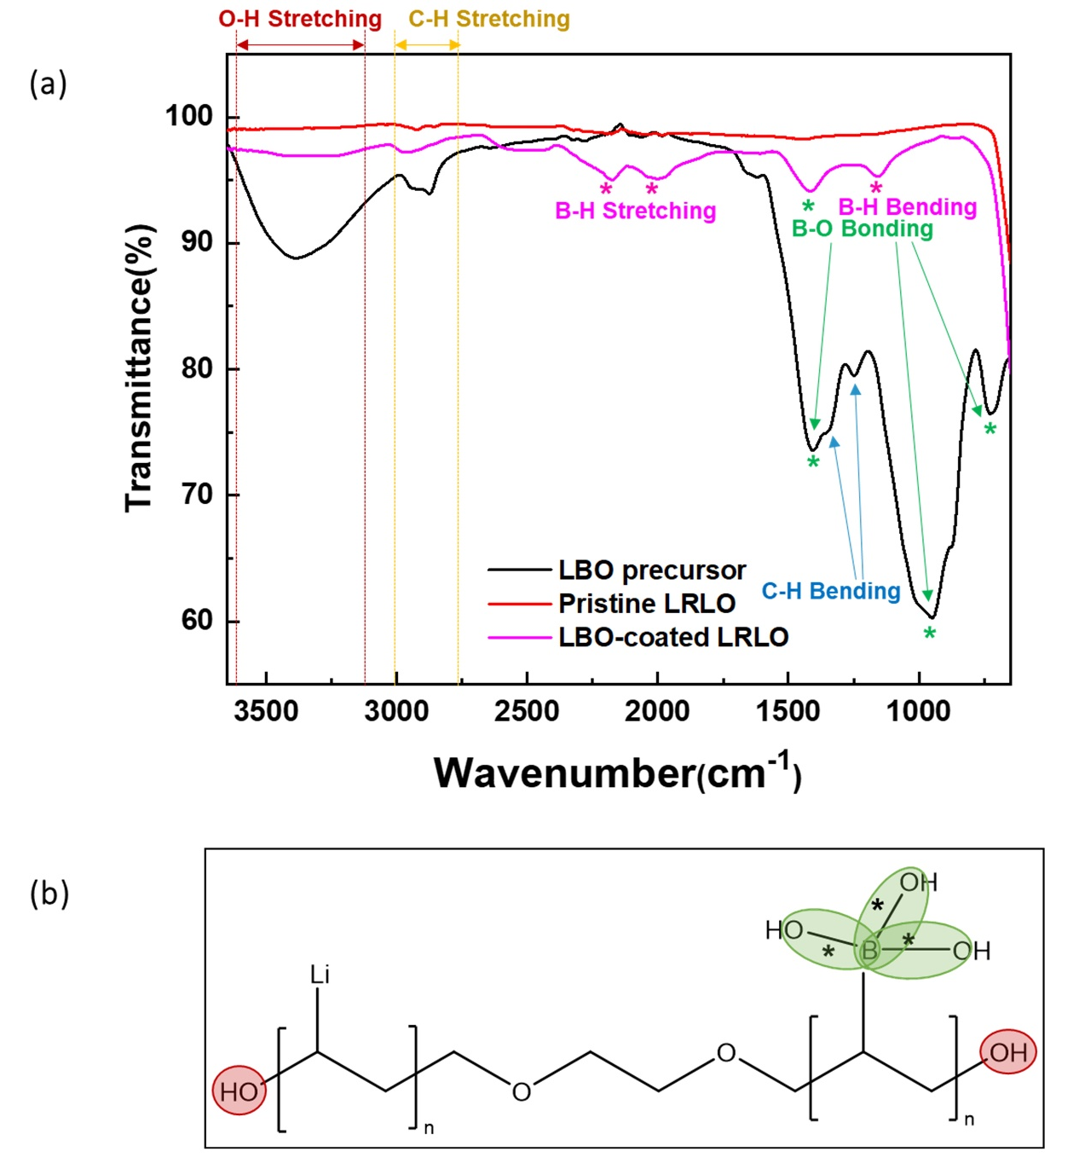

Figure S1. (a) FT-IR spectra of LBO precursor, pristine LRLO, and LBO-coated LRLO. (b) The anticipated structure of LBO precursor through FT-IR analysis.

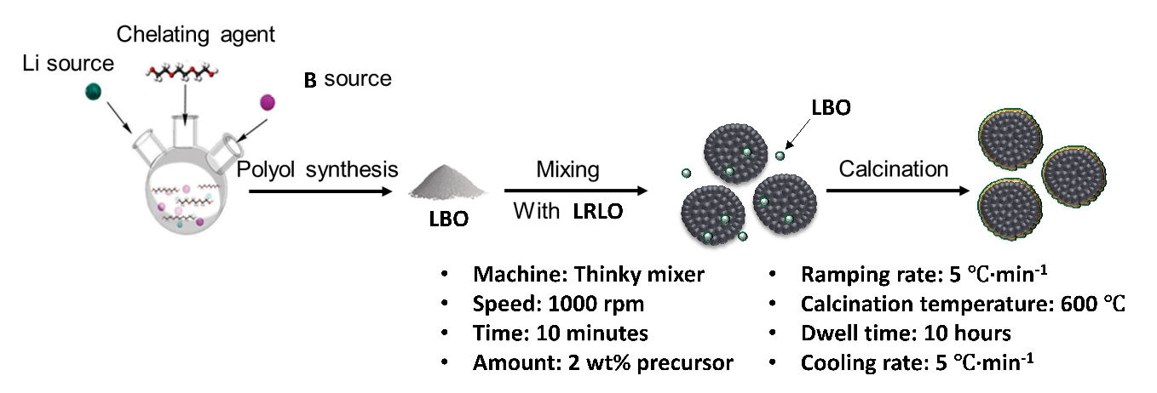
Figure S2. Scheme of the dry coating method for LRLO surface modification with LBO precursor synthesized through the polyol method.

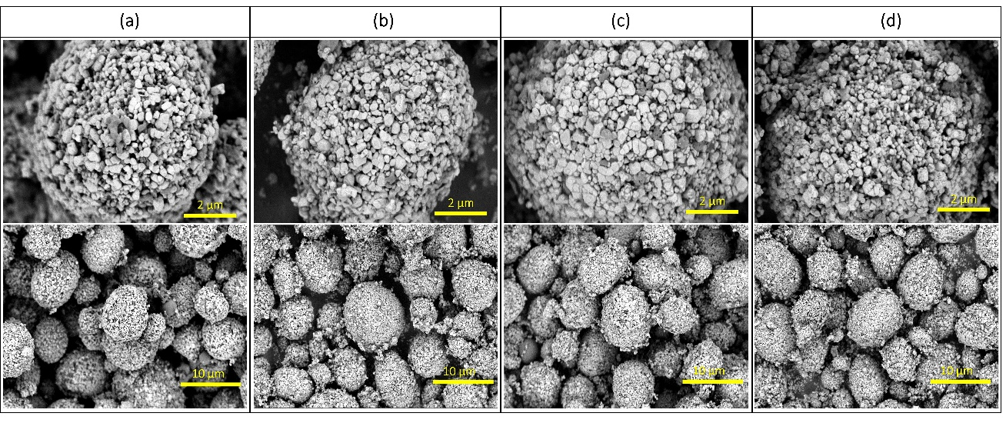
Figure S3. SEM/BSE images of LRLO after mixing with LBO at 1000 rpm for (a) 1 minute (b) 5 minutes (c) 10 minutes and (d) 20 minutes.

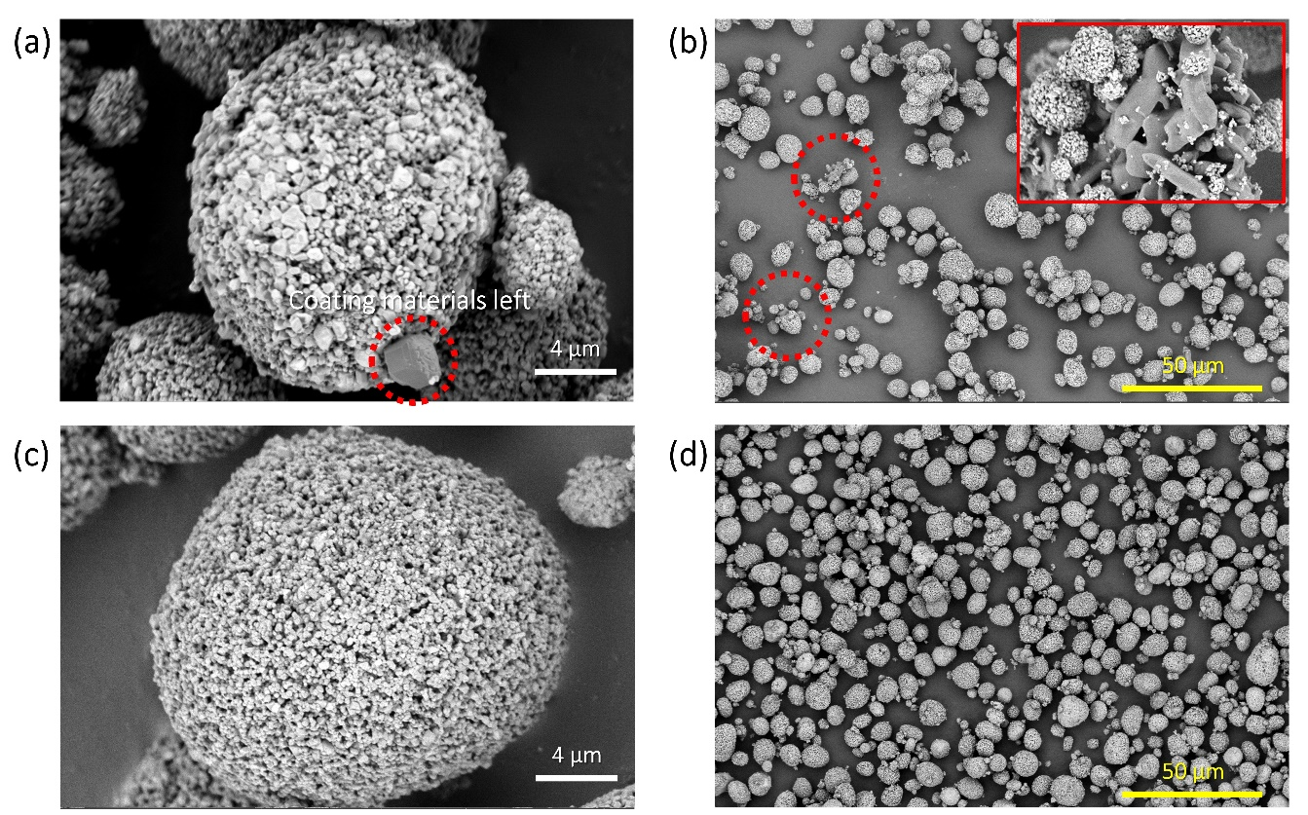
Figure S4. SEM/BSE images of LRLO after calcination at 600 ℃ for (a) 5 hours at high magnification (b) at low magnification (c) 10 hours at high magnification and (d) at low magnification.

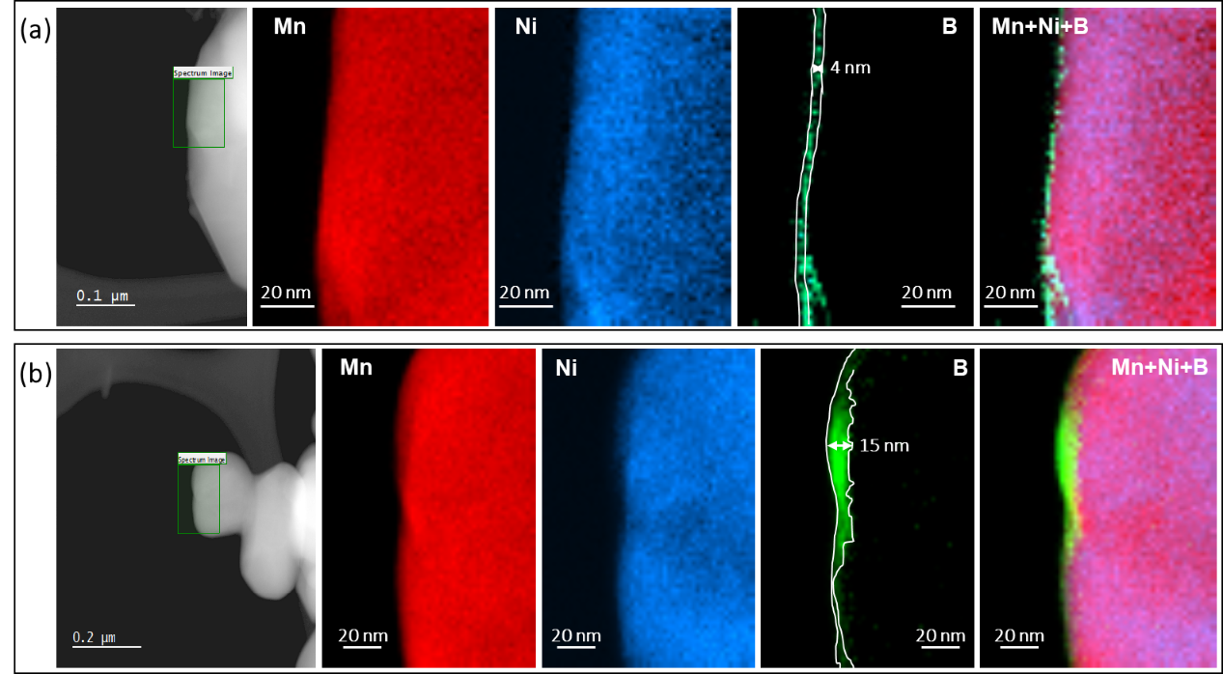
Figure S5. STEM-EELS mapping results of (a) 1 wt% LBO-coated LRLO and (b) 4 wt% LBO-coated LRLO.

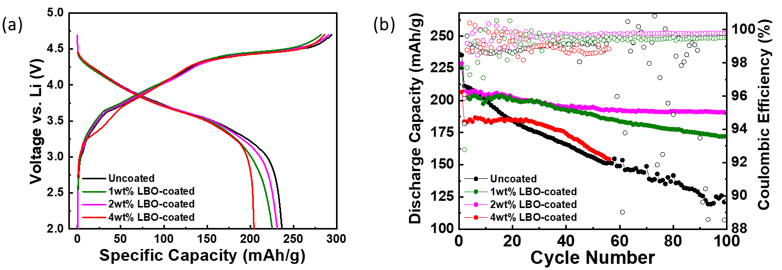
Figure S6. (a) Voltage profiles from uncoated and various wt% LBO-coated LRLO/graphite full cell. (b) Full cells cycling performances in the 2.0–4.55 V window at a current rate of C/10.

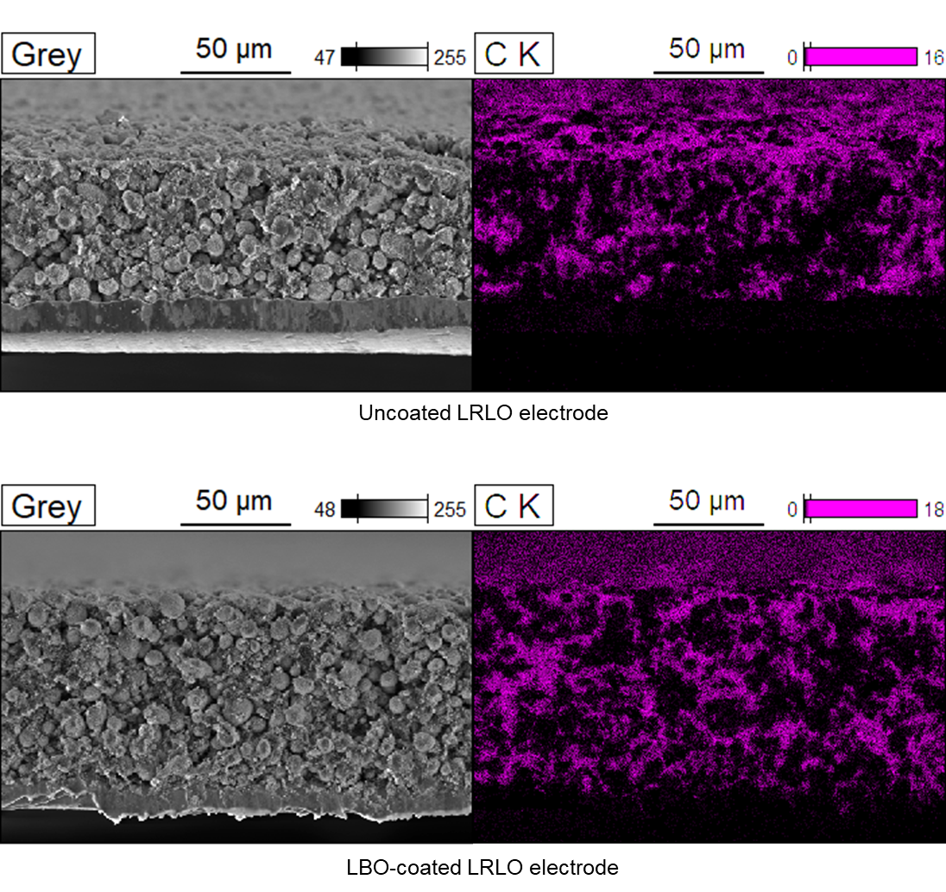
Figure S7. SEM-EDS analysis of uncoated and LBO-coated LRLO cathode with the cross-sectional view.

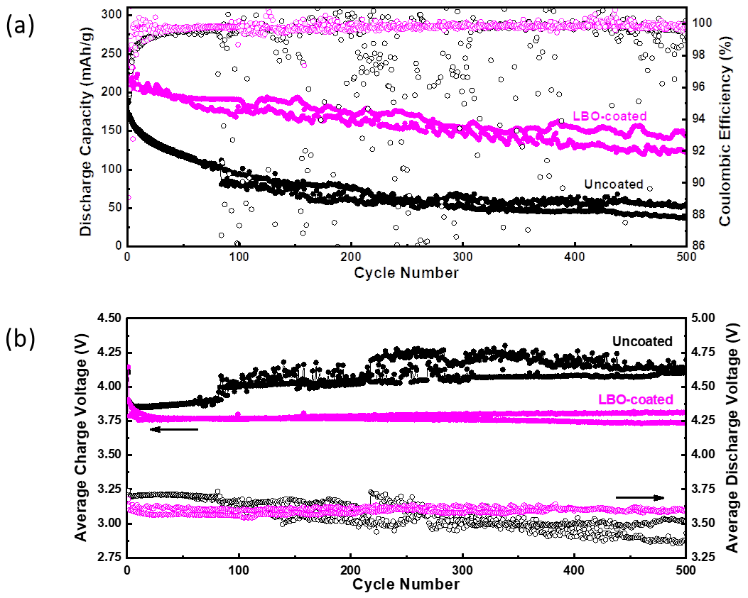
Figure S8. (a) Full cells cycling performance comparison with (b) the corresponding average charge and discharge voltage in the 2.0–4.55 V window at a current rate of C/10.

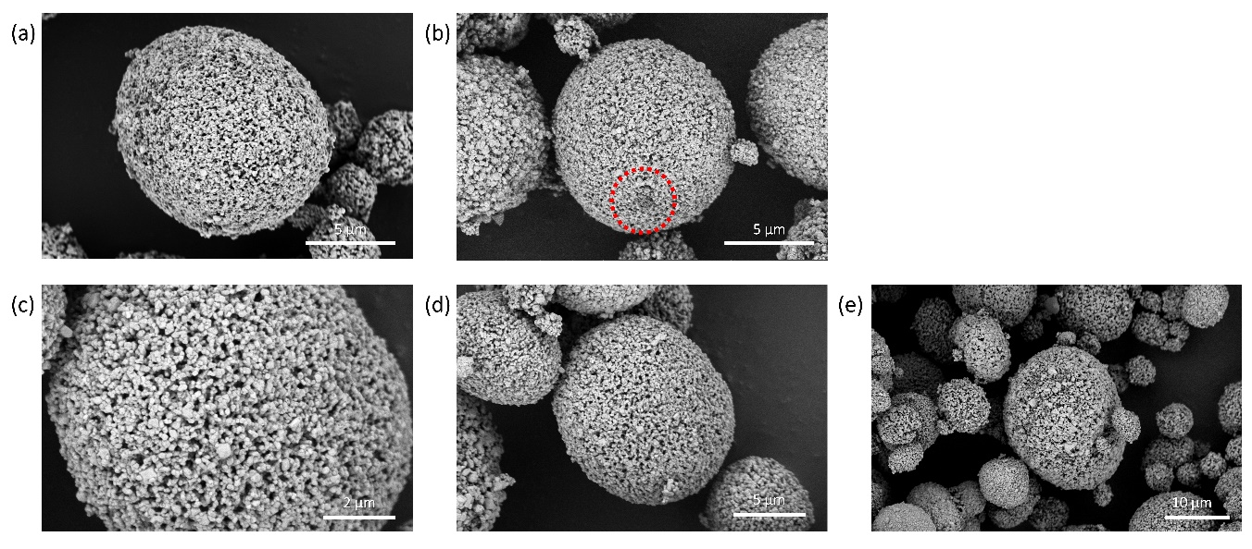
Figure S9. SEM/BSE images of (a) pristine LRLO (b) after mixing with LBO at 1000 rpm for 10 min (c, d, e) after calcination at 600 ℃ for 10 hrs.

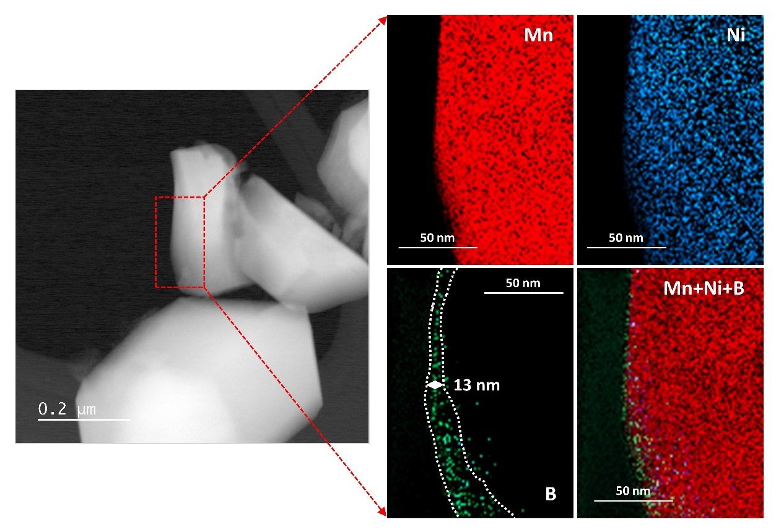
Figure S10. STEM-EELS mapping for manganese, nickel, and boron on LBO-coated LRLO after the formation cycle.
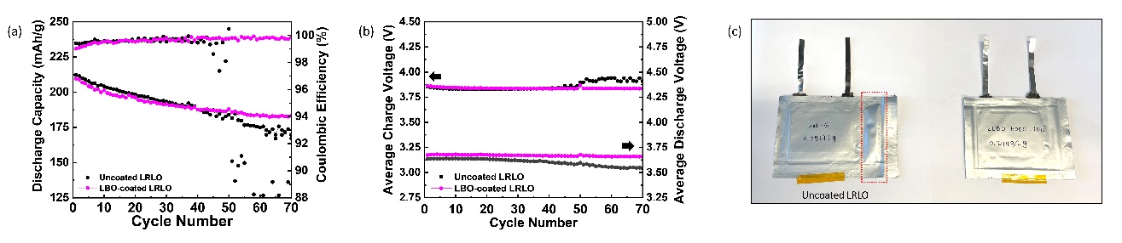
Figure S11. (a) Single layer pouch cell performance in the 2.0–4.55 V window at a current rate of C/10 (1 C = 270 mAh/g) with baseline electrolyte. (b) The average charge and discharge voltage. (c) Photos of pouch cells with uncoated LRLO and LBO-coated LRLO as the cathode.
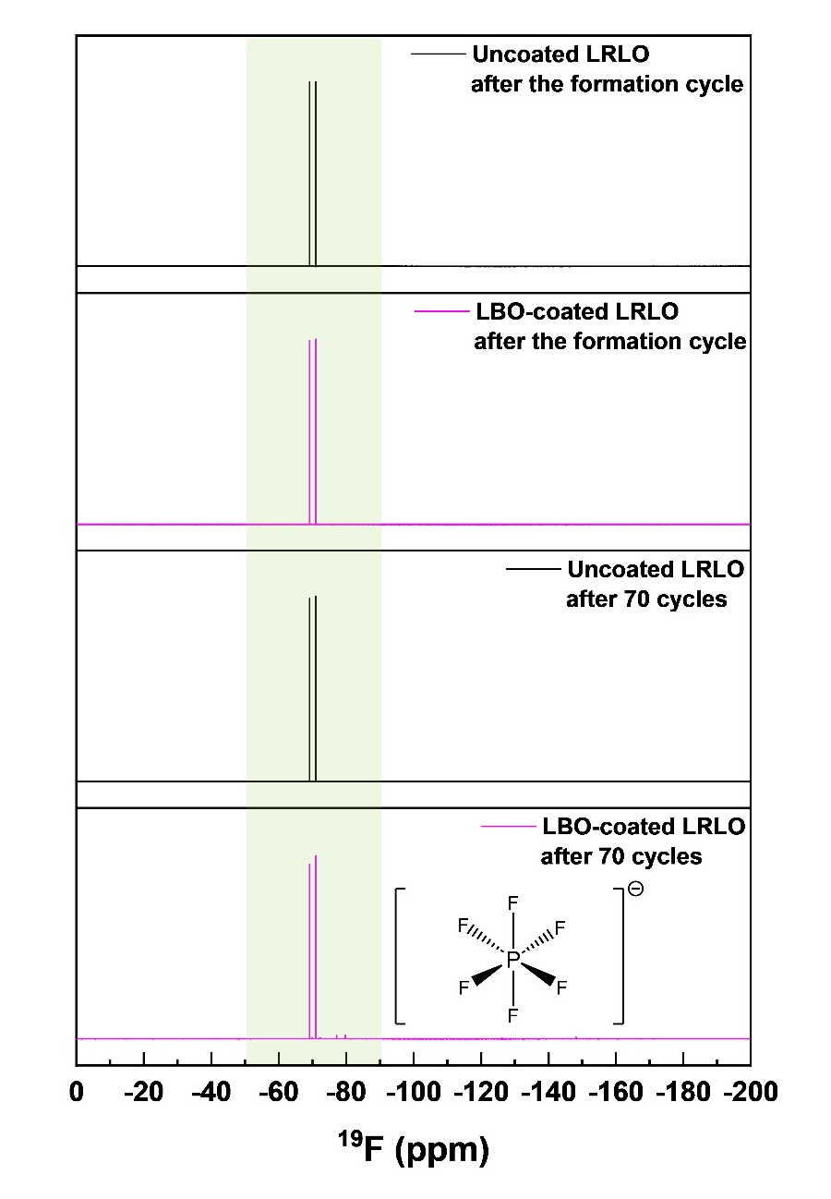
Figure S12. ¹⁹F-NMR from different electrolyte samples, including cycled electrolytes from uncoated/LBO-coated LRLO after the formation cycle and 70 cycles in single layer pouch cell.
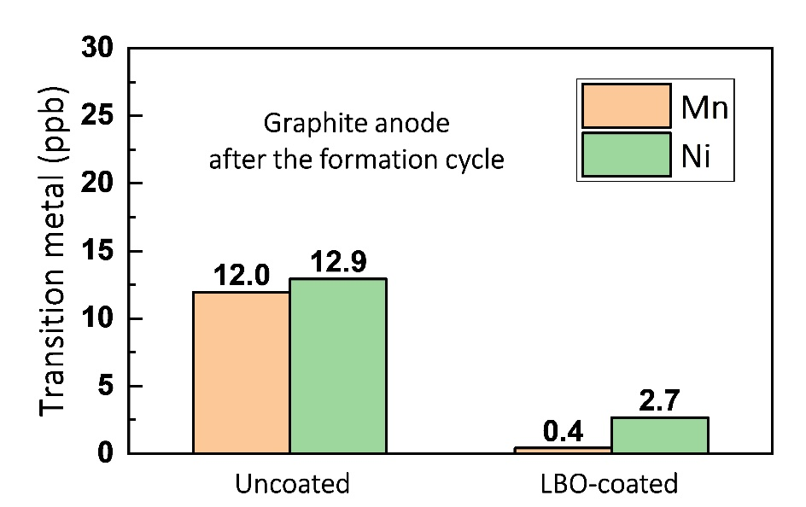
Figure S13. ICP-MS for transition metal (Mn and Ni) of graphite paired with uncoated and LBO-coated after the formation cycle.

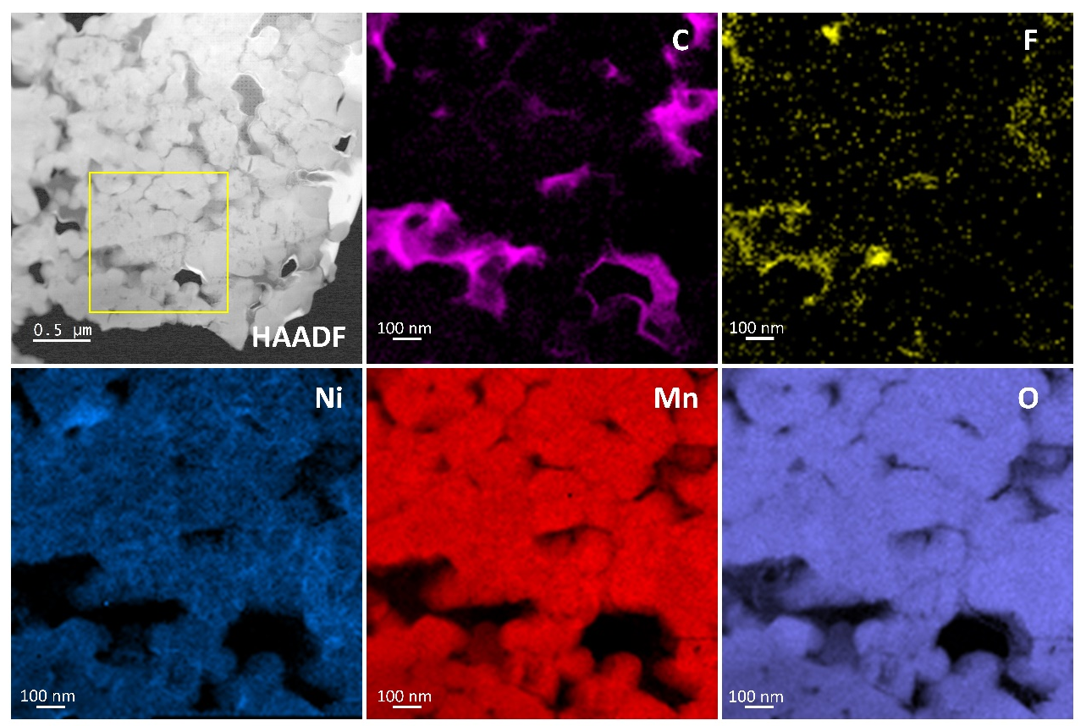
Figure S14. STEM-EELS carbon, fluorine, nickel, manganese, and oxygen mapping of uncoated LRLO after the formation cycle.
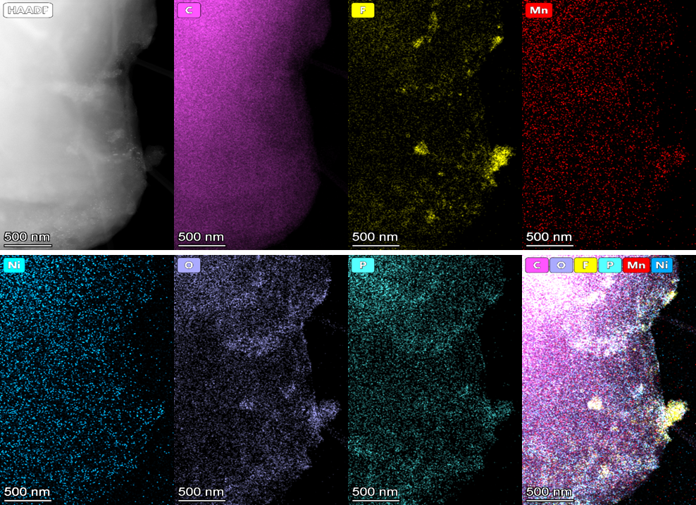
Figure S15. STEM-EDS mapping of SEI layer on graphite anode paired with uncoated LRLO after the formation cycle.
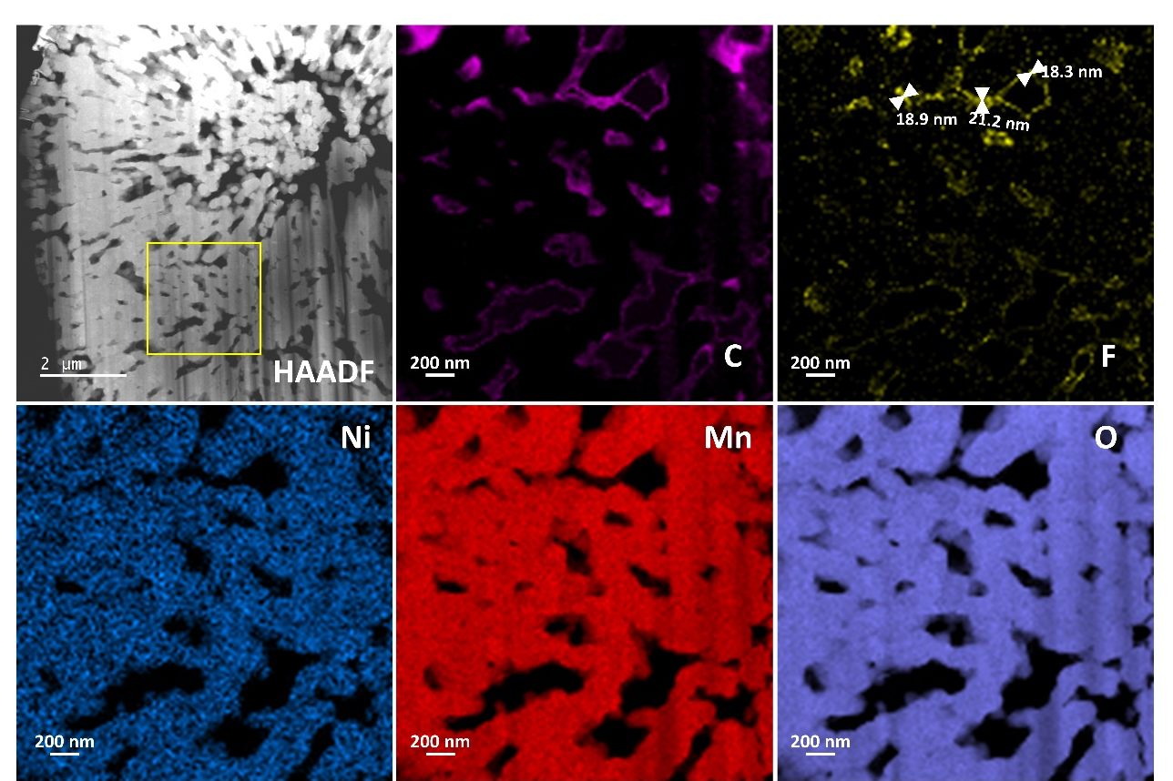
Figure S16. STEM-EELS carbon, fluorine, nickel, manganese, and oxygen mapping of LBO-coated LRLO after the formation cycle.
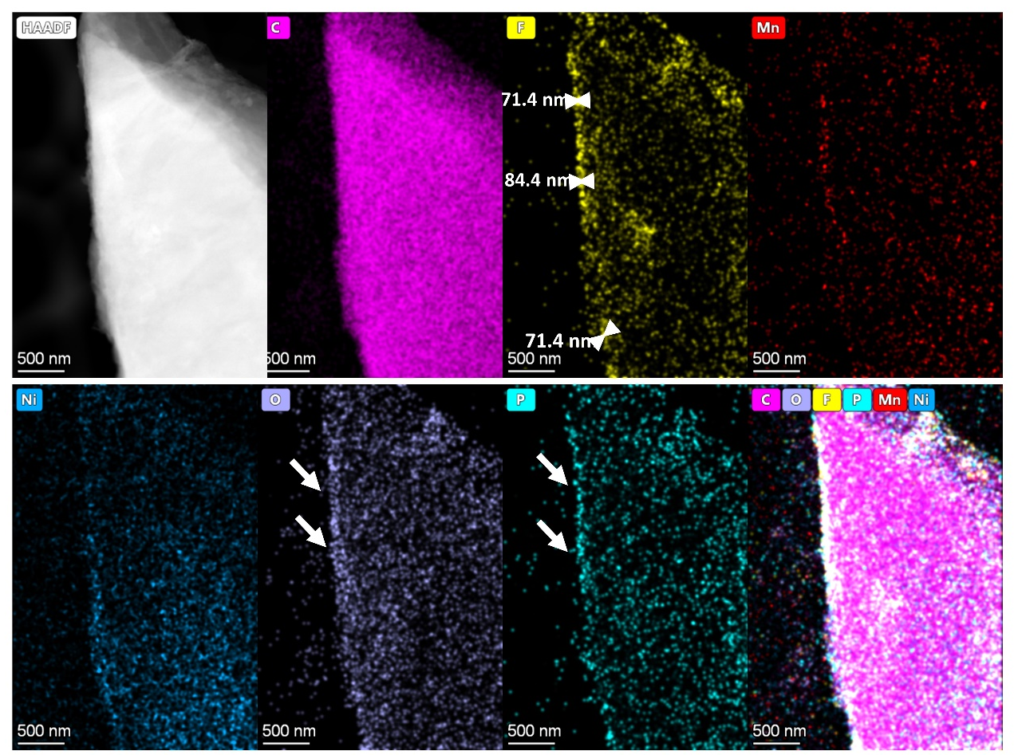
Figure S17. STEM-EDS mapping of SEI layer on graphite anode paired with LBO-coated LRLO after the formation cycle.
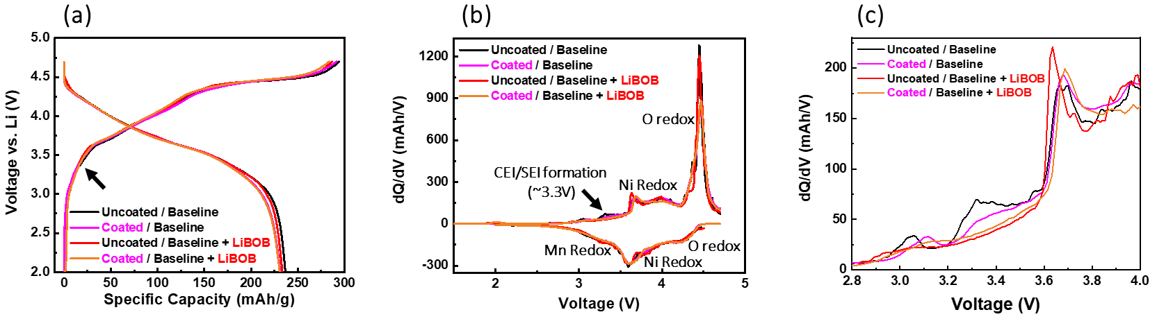
Figure S18. (a) Voltage profiles from uncoated and LBO-coated LRLO/graphite full cells with different electrolytes with (b) the corresponding dQ/dV plot. (c) dQ/dV plot within the CEI/SEI formation voltage range. The voltage window of full cells is 2.0–4.7 V at a current rate of C/20 for the formation cycle (1 C = 270 mAh/g).
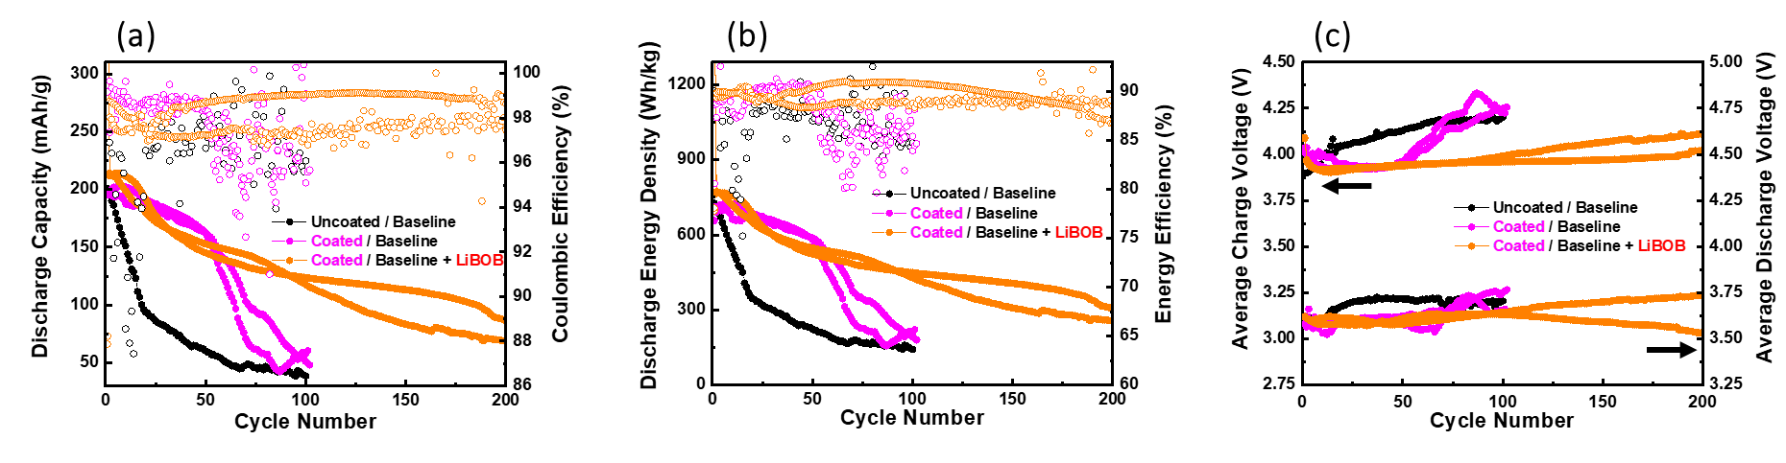
Figure S19. (a) Full cells cycling performances with the corresponding (b) energy density performances and (c) the average charge and discharge voltage at high temperature (45°C). The voltage window is 2.0–4.6 V at a current rate of C/3 (1 C = 270 mAh/g).
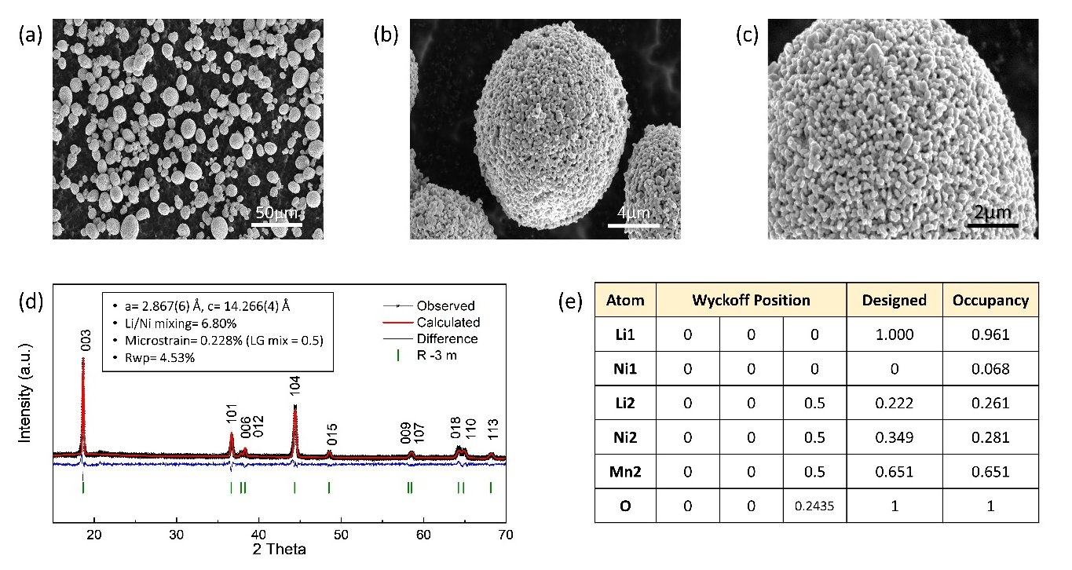
Figure S20. (a-c) SEM image of pristine LRLO material. (d) XRD Rietveld refinement of the pristine LRLO material. (e) Refined crystal structure parameters for the pristine LRLO.

Table S1. Electrode conductivity of uncoated and LBO-coated LRLO cathode through 2-point probe analysis.
Table S2. LRLO/graphite full cell performance summary.
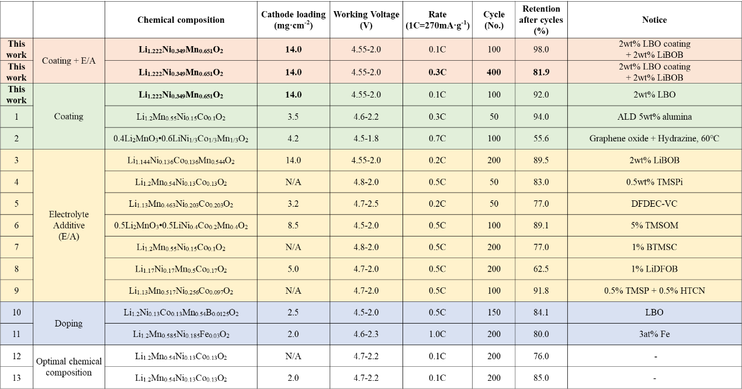

[1] Bettge, M., Li, Y., Sankaran, B., Rago, N. D., Spila, T., Haasch, R. T., Petrov, I., & Abraham, D. P. (2013). Improving high-capacity Li_{1.2}Ni_{0.15}Mn_{0.55}Co_{0.1}O₂-based lithium-ion cells by modifiying the positive electrode with alumina. Journal of Power Sources, 233, 346–357. https://doi.org/10.1016/j.jpowsour.2013.01.082

[2] Oh, P., Ko, M., Myeong, S., Kim, Y., & Cho, J. (2014). A novel surface treatment method and new insight into discharge voltage deterioration for high-performance 0.4Li2MnO3-0.6LiNi1/3Co1/3Mn1/3O2 cathode materials. Advanced Energy Materials, 4(16). https://doi.org/10.1002/aenm.201400631

[3] Li, Y., Li, W., Shimizu, R., Cheng, D., Nguyen, H. N., Paulsen, J., Kumakura, S., Zhang, M., & Meng, Y. S. (2022). Elucidating the Effect of Borate Additive in High-Voltage Electrolyte for Li-Rich Layered Oxide Materials. Advanced Energy Materials, 12(11). https://doi.org/10.1002/aenm.202103033

[4] Zhu, Y., Luo, X., Xu, M., Zhang, L., Yu, L., Fan, W., & Li, W. (2016). Failure mechanism of layered lithium-rich oxide/graphite cell and its solution by using electrolyte additive. Journal of Power Sources, 317, 65–73. https://doi.org/10.1016/j.jpowsour.2016.03.090

[5] Pham, H. Q., Hwang, E. H., Kwon, Y. G., & Song, S. W. (2016). Understanding the interfacial phenomena of a 4.7V and 55 ℃ Li-ion battery with Li-rich layered oxide cathode and graphite anode and its correlation to high-energy cycling performance. Journal of Power Sources, 323, 220–230. https://doi.org/10.1016/j.jpowsour.2016.05.038

[6] Lim, S. H., Cho, W., Kim, Y. J., & Yim, T. (2016). Insight into the electrochemical behaviors of 5V–class high–voltage batteries composed of lithium–rich layered oxide with multifunctional additive. Journal of Power Sources, 336, 465–474. https://doi.org/10.1016/j.jpowsour.2016.11.002

[7] Lan, J., Zheng, Q., Zhou, H., Li, J., Xing, L., Xu, K., Fan, W., Yu, L., & Li, W. (2019). Stabilizing a High-Voltage Lithium-Rich Layered Oxide Cathode with a Novel Electrolyte Additive. ACS Applied Materials and Interfaces, 11(32), 28841–28850. https://doi.org/10.1021/acsami.9b07441

[8] Cha, J., Han, J. G., Hwang, J., Cho, J., & Choi, N. S. (2017). Mechanisms for electrochemical performance enhancement by the salt-type electrolyte additive, lithium difluoro(oxalato)borate, in high-voltage lithium-ion batteries. Journal of Power Sources, 357, 97–106. https://doi.org/10.1016/j.jpowsour.2017.04.094

[9] Zhao, J., Liang, Y., Zhang, X., Zhang, Z., Wang, E., He, S., Wang, B., Han, Z., Lu, J., Amine, K., & Yu, H. (2021). In Situ Construction of Uniform and Robust Cathode–Electrolyte Interphase for Li-Rich Layered Oxides. Advanced Functional Materials, 31(8). https://doi.org/10.1002/adfm.202009192

[10] Sun, Z., Xu, L., Dong, C., Zhang, H., Zhang, M., Liu, Y., Zhou, Y., Han, Y., & Chen, Y. (2019). Enhanced cycling stability of boron-doped lithium-rich layered oxide cathode materials by suppressing transition metal migration. Journal of Materials Chemistry A, 7(7), 3375–3383. https://doi.org/10.1039/C8TA10786F

[11] Wu, F., Kim, G. T., Kuenzel, M., Zhang, H., Asenbauer, J., Geiger, D., Kaiser, U., & Passerini, S. (2019). Elucidating the Effect of Iron Doping on the Electrochemical Performance of Cobalt-Free Lithium-Rich Layered Cathode Materials. Advanced Energy Materials, 9(43). https://doi.org/10.1002/aenm.201902445

[12] Silvestri, L., Celeste, A., Tuccillo, M., & Brutti, S. (2023). Li-Rich Layered Oxides: Structure and Doping Strategies to Enable Co-Poor/Co-Free Cathodes for Li-Ion Batteries. In Crystals (Vol. 13, Issue 2). MDPI. https://doi.org/10.3390/cryst13020204

[13] Celeste, A., Brescia, R., Gigli, L., Plaisier, J., Pellegrini, V., Silvestri, L., & Brutti, S. (2023). Unravelling structural changes of the Li_{1.2}Mn_{0.54}Ni_{0.13}Co_{0.13}O₂ lattice upon cycling in lithium cell. Materials Today Sustainability, 21. https://doi.org/10.1016/j.mtsust.2022.100277

Table S3. Full cell – pouch cell assembling specification.
 | Specification
Material | Cathode: LRLO  Anode: NEI Graphite, (BE-200E, NEI Corporation, USA)
N/P ratio | 1.1
Voltage range | 2.0-4.7 V
Test protocols | Rest for 24 hours after assembling, then C/20 (1C= 270mA/g) for the initial cycle, then degassing and resealing are performed, then switch to C/10 for the subsequent cycles.
Separator | Celgard®
Electrolyte amount | 500 μl
Pouch bag type | EQ-alf-100-210 (MTI Corporation, USA)
Electrode tab | Cathode tab: EQ-PLiB-ATC4 (MTI Corporation, USA)  Anode tab: EQ-PLiB-NTA4 (MTI Corporation, USA)
Fixture | Insulating Plate: polycarbonate  Pressure sensor: DYHW-116 Mini Compression Force Sensor Load Cell  Indicator: TOKY® accurate micro digital differential pressure gauge

