Supplementary Figures
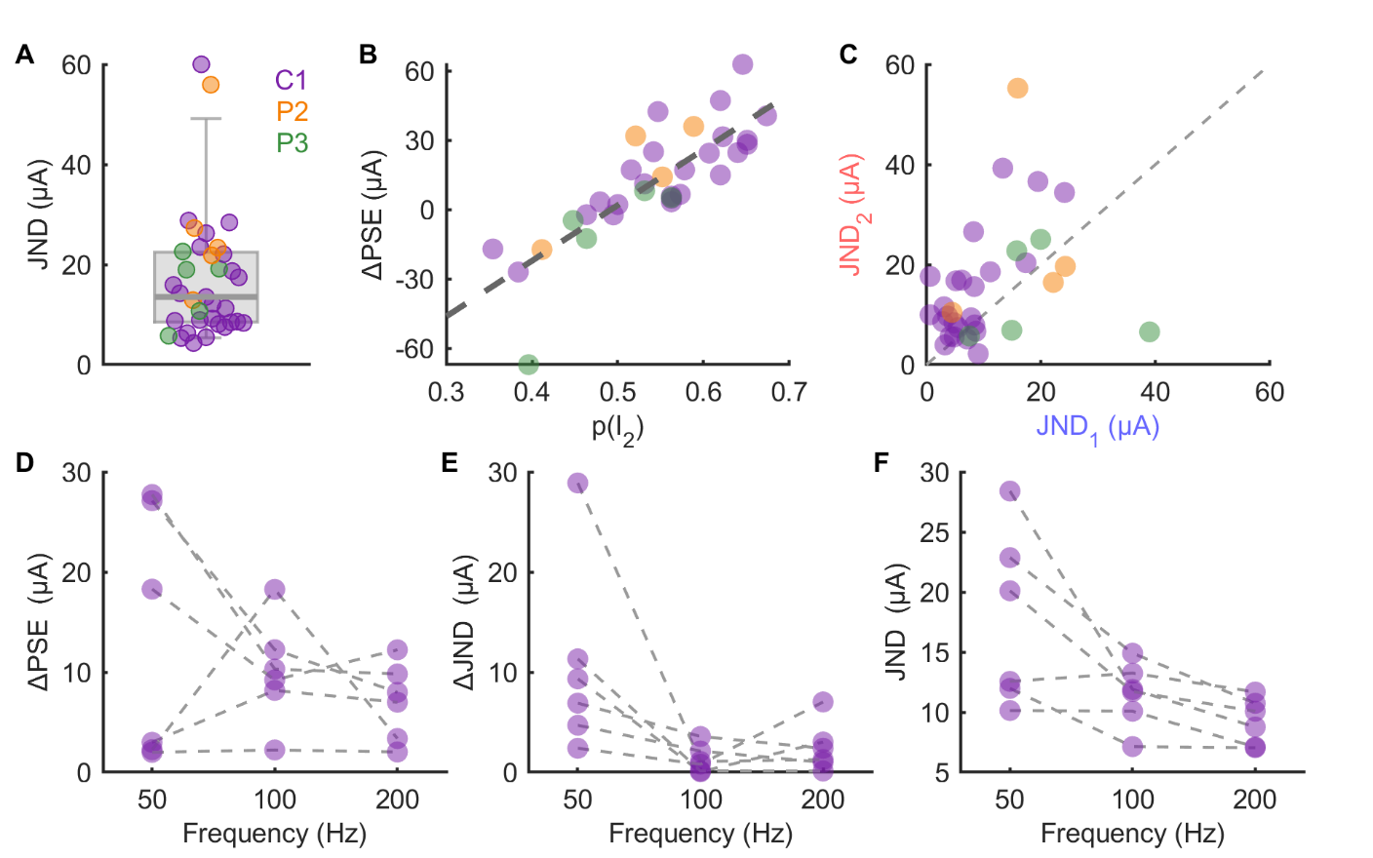
Supplementary Figure 1. A) JNDs for all electrodes tested with a 1s ISI. Box and whiskers indicate 5th, 25th, 50th, 75th, and 95th percentiles. B) The relationship between the proportion of trials in which the participant selected the second interval and the computed ΔPSE. C) JND computed on the subset of trials in which the standard was in the first interval (abscissa) versus those in which the standard was in the second interval (ordinate). D) The effect of frequency on ΔPSE, E) ΔJND, and F) JND.

