Appendix S1. Supporting information for “Simulating pollen flow and field sampling constraints helps revise seed sampling recommendations for conserving genetic diversity.”

Table of contents:
One-population supplemental results/methods:
Table S1. Parameters used for ideal sampling scenarios. | 2
Table S2. Parameters used for realistic sampling scenarios. | 4
Equation S1. Equation for the piecewise linear regression. | 6
Table S3. Results of the piecewise linear regression for ideal sampling, one-population simulations, including model coefficients, standard errors, and P values. | 7
Figure S1. Genetic diversity conservation for all realistic sampling scenarios for one-population simulations. | 9
Table S4. Results of the piecewise linear regression for realistic sampling, one-population simulations, including model coefficients, standard errors, and P values. | 10
Figure S2. Comparison of genetic diversity conservation between ideal and realistic sampling scenarios when 400 total seeds were sampled across one population. | 12
Table S5. Results of t-tests comparing the mean proportion of alleles conserved in ideal vs. realistic sampling scenarios when 400 seeds were sampled across one population. | 13

Two-population supplemental results/methods
Figure S3. Histogram indicating the range of alleles simulated in two-population simulations. | 14
Figure S4. Genetic diversity conservation for ideal sampling scenarios in simulations with two populations. | 15
Table S6. Results of the piecewise linear regression model for simulations with two populations and ideal sampling scenarios. | 16
Figure S5. Genetic diversity conservation for realistic sampling scenarios in simulations with two populations. | 18
Table S7. Results of the piecewise linear regression model for simulations with two populations and realistic sampling scenarios. | 19
Figure S6. Comparison of genetic diversity conservation between ideal and realistic sampling scenarios when 400 total seeds were sampled across two populations. | 21
Table S8. Results of t-tests comparing the mean proportion of alleles conserved in ideal vs. realistic sampling scenarios when 400 seeds were sampled across one population. | 22
One-population simulations

Table S1. All ideal sampling scenarios defined; note that the ellipses (...) represent continuation of the numeric series as listing all parameter values is not possible in this table. In these scenarios, an equal number of seeds per maternal plant is sampled (e.g., 5 seeds per plant). This represents a simplified, idealized version of sampling. In total, we define 935 ideal sampling scenarios that we repeat for each pollen donor type defined (2805 total). These scenarios are the same for both the one- and two-population simulations; however, in the case of the two-population simulations, these scenarios were repeated for both populations.
No. of maternal plant sampled | No. of seeds sampled per maternal plant | Pollen donor type | Total seeds sampled | Combinations
100 | 1,2,3…5 | Panmictic | 100, 200, 300…500 | 5
100 | 1,2,3…5 | Highly limited | 100, 200, 300…500 | 5
100 | 1,2,3…5 | Limited | 100, 200, 300…500 | 5
50 | 1,2,3,4,5…10 | Panmictic | 50,100,150…500 | 10
50 | 1,2,3,4,5…10 | Highly limited | 50,100,150…500 | 10
50 | 1,2,3,4,5…10 | Limited | 50,100,150…500 | 10
25 | 1,2,3,4,5,6,7...20 | Panmictic | 25,50,75…500 | 20
25 | 1,2,3,4,5,6,7...20 | Highly limited | 25,50,75…500 | 20
25 | 1,2,3,4,5,6,7...20 | Limited | 25,50,75…500 | 20
10 | 1,2,…50 | Panmictic | 10,20,30…500 | 50
10 | 1,2,…50 | Highly limited | 10,20,30…500 | 50
10 | 1,2,…50 | Limited | 10,20,30…500 | 50
5 | 1,2,…100 | Panmictic | 5,10,15…500 | 100
5 | 1,2,…100 | Highly limited | 5,10,15…500 | 100
5 | 1,2,…100 | Limited | 5,10,15…500 | 100
2 | 1,2,…250 | Panmictic | 2,4,6,8…500 | 250
2 | 1,2,…250 | Highly limited | 2,4,6,8…500 | 250
2 | 1,2,…250 | Limited | 2,4,6,8…500 | 250
1 | 1,2,…500 | Panmictic | 1,2,3,4…500 | 500
1 | 1,2,…500 | Highly limited | 1,2,3,4…500 | 500
1 | 1,2,…500 | Limited | 1,2,3,4…500 | 500

Table S2. All realistic sampling scenarios defined. In these scenarios, an unequal number of seeds per plant are sampled, such that of the total sample size, most of the seeds are being sampled from one plant, and significantly fewer seeds are sampled from the remaining plants. In total, we define 217 realistic sampling scenarios that we repeat for each pollen donor type defined (651 total). These scenarios are the same for both the one- and two-population simulations; however, in the case of the two-population simulations, these scenarios were repeated for both populations.
No. of maternal plants | No. of seeds/maternal (not a vector) | Pollen donor type | Total seeds | Combinations
100 | 1 plant with 50%, 1 with 1%, 98 with 0.5% | Panmictic | 200, 400 | 2
100 | 1 plant with 50%, 1 with 1%, 98 with 0.5% | Highly limited | 200, 400 | 2
100 | 1 plant with 50%, 1 with 1%, 98 with 0.5% | Limited | 200, 400 | 2
50 | 1 plant with 51%, 49 with 1% | Panmictic | 100, 200, 300, 400, 500 | 5
50 | 1 plant with 51%, 49 with 1% | Highly limited | 100, 200, 300, 400, 500 | 5
50 | 1 plant with 51%, 49 with 1% | Limited | 100, 200, 300, 400, 500 | 5
25 | 1 plant with 52%, 24 with 2% | Panmictic | 50, 100, 150…500 | 10
25 | 1 plant with 52%, 24 with 2% | Highly limited | 50, 100, 150…500 | 10
25 | 1 plant with 52%, 24 with 2% | Limited | 50, 100, 150…500 | 10
10 | 1 plant with 50%, other with 10%, 8 with 5% | Panmictic | 20,40,60…500 | 25
10 | 1 plant with 50%, other with 10%, 8 with 5% | Highly limited | 20,40,60…500 | 25
10 | 1 plant with 50%, other with 10%, 8 with 5% | Limited | 20,40,60…500 | 25
5 | 1 plant with 80%, 4 with 5% | Panmictic | 20,40…500 | 25
5 | 1 plant with 80%, 4 with 5% | Highly limited | 20,40…500 | 25
5 | 1 plant with 80%, 4 with 5% | Limited | 20,40…500 | 25
5 | 1 plant with 50%, 1 with 20%, 3 with 10% | Panmictic | 10,20,30,40…500 | 50
5 | 1 plant with 50%, 1 with 20%, 3 with 10% | Highly limited | 10,20,30,40…500 | 50
5 | 1 plant with 50%, 1 with 20%, 3 with 10% | Limited | 10,20,30,40…500 | 50
2 | 1 plant with 80%, 1 with 20% | Panmictic | 5,10,15…500 | 100
2 | 1 plant with 80%, 1 with 20% | Highly limited | 5,10,15…500 | 100
2 | 1 plant with 80%, 1 with 20% | Limited | 5,10,15…500 | 100

Equation S1. Equations representing the piecewise linear regression. Alpha (⍺) indicates the intercept; betas (ꞵ) indicate slopes for covariates; asterisks (*) indicate multiplication of terms, including interactions between covariates. The predictors included were the total seeds sampled per population (1–500), the number of maternal plants sampled (1, 2, 5, 10, 25, 50, 100), and pollen donor type (panmictic, highly limited, and limited). Interactions were included between all predictors to determine if the proportion of alleles conserved varies when sampling more maternal plants, a greater number of total seeds, and between each of the pollen donor types. Equation A (including log transformations on numeric predictors) was run for the subset of the data including 1–10 maternal plants, and Equation B was run on the subset of the data including 25–100 maternal plants.

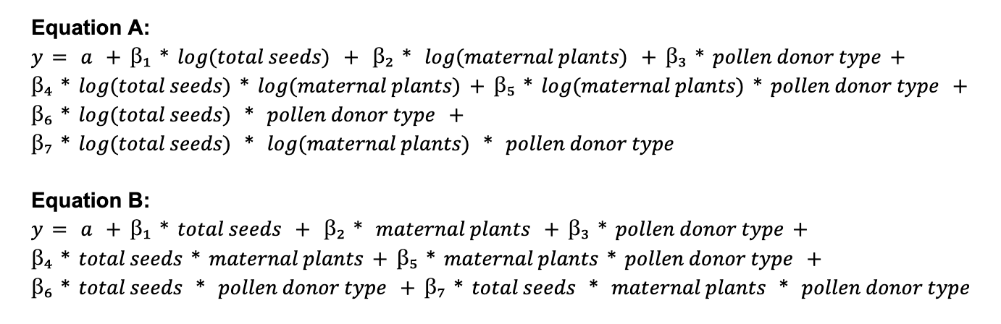

Table S3. Results of the piecewise linear regression model for simulations with one population and ideal sampling scenarios. The model coefficients for each variable and interaction, standard errors, and P values are shown. Colons (:) represent interaction terms. Table A indicates the results corresponding to Equation S1 A and Table B indicates the results for Equation S1 B. All coefficients for Equation S1 A were significant, and most from Equation S1 B were.

Table A:
Coefficients | Estimate | Std. error | P value
Intercept | 0.264 | 9.59E-4 | <0.001
log(total_seeds) | 0.112 | 1.81E-4 | <0.001
log(maternal_trees) | 0.086 | 1.20E-3 | <0.001
donor_typehighlyLimited | −0.027 | 1.26E-3 | <0.001
donor_typelimited | −0.026 | 1.36E-3 | <0.001
log(total_seeds):log(maternal_trees) | −0.015 | 2.24E-4 | <0.001
log(total_seeds):donor_typehighlyLimited | −0.112 | 2.55E-4 | <0.001
log(total_seeds):donor_typelimited | −0.048 | 2.55E-4 | <0.001
log(maternal_trees):donor_typehighlyLimited | 0.099 | 1.69E-3 | <0.001
log(maternal_trees):donor_typelimited | 0.051 | 1.69E-3 | <0.001
log(total_seeds):log(maternal_trees):donor_typehighlyLimited | 0.020 | 3.17E-4 | <0.001
log(total_seeds):log(maternal_trees):donor_typelimited | 0.012 | 3.17E-4 | <0.001

Table B:
Coefficients | Estimate | Std. error | P value
Intercept | 8.03E-1 | 2.46E-3 | <0.001
total_seeds | 3.04E-4 | 7.96E-6 | <0.001
maternal_trees | 9.18E-4 | 5.18E-5 | <0.001
donor_typehighlyLimited | −1.71E-2 | 3.48E-3 | <0.001
donor_typelimited | −8.40E-4 | 3.48E-3 | 0.809
total_seeds:maternal_trees | −2.00E-6 | 1.60E-7 | <0.001
total_seeds:donor_typehighlyLimited | −2.24E-4 | 1.13E-5 | <0.001
total_seeds:donor_typelimited | −9.08E-5 | 1.13E-5 | <0.001
maternal_trees:donor_typehighlyLimited | 2.98E-4 | 7.32E-5 | <0.001
maternal_trees:donor_typelimited | 3.57E-5 | 7.32E-5 | 0.626
total_seeds:maternal_trees:donor_typehighlyLimited | 1.82E-6 | 2.27E-7 | <0.001
total_seeds:maternal_trees:donor_typelimited | 8.76E-7 | 2.27E-7 | <0.001

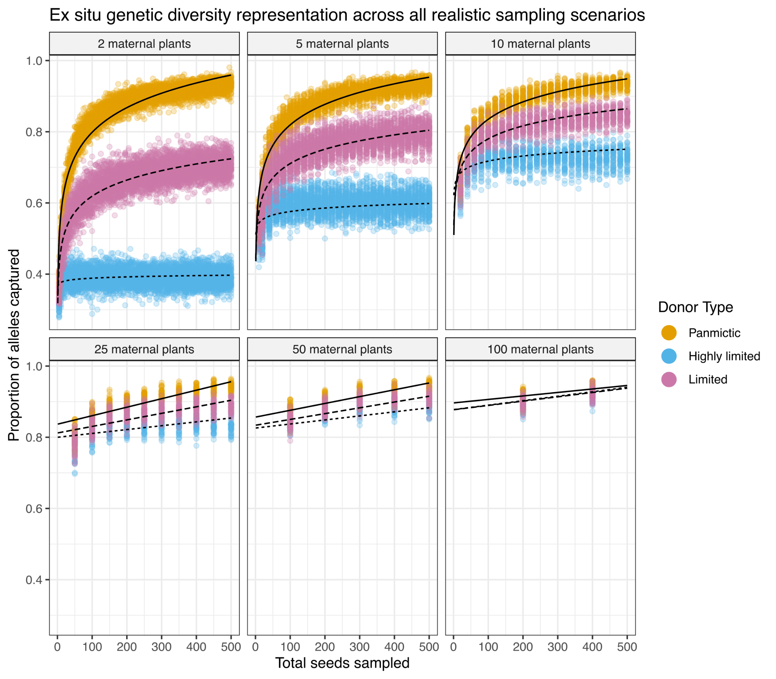
Figure S1. Genetic diversity conserved for all realistic sampling scenarios (compare to Figure 3 in main text showing “ideal” sampling) and donor types in simulations with one population. Genetic diversity conservation is shown on the y-axis in terms of the proportion of all wild alleles conserved by sampling, and the x-axis represents the total number of seeds sampled, ranging from 1 to 500. Each facet on the plot represents the number of unique maternal plants sampled. The different color points represent each pollen donor type, and each point on the plot is a single sampling scenario.
Table S4. Results of the piecewise linear regression model for simulations with one population and realistic sampling scenarios. The model coefficients for each variable and interaction, standard errors, and P values are shown. Colons (:) represent interaction terms. Table A indicates the results corresponding to Equation S1 A and Table B indicates the results for Equation S1 B. All coefficients for Equation S1 A were significant, and most from Equation S1 B were.

Table A:
Coefficients | Estimate | Std. error | P value
Intercept | 0.265 | 0.0040 | <0.001
log(total_seeds) | 0.112 | 0.0007 | <0.001
log(maternal_trees) | 0.106 | 0.0030 | <0.001
donor_typehighlyLimited | −0.011 | 0.0056 | 0.053
donor_typelimited | −0.041 | 0.0056 | <0.001
log(total_seeds):log(maternal_trees) | −0.018 | 0.0006 | <0.001
log(total_seeds):donor_typehighlyLimited | −0.114 | 0.0011 | <0.001
log(total_seeds):donor_typelimited | −0.042 | 0.0011 | <0.001
log(maternal_trees):donor_typehighlyLimited | 0.053 | 0.0043 | <0.001
log(maternal_trees):donor_typelimited | 0.030 | 0.0043 | <0.001
log(total_seeds):log(maternal_trees):donor_typehighlyLimited | 0.028 | 0.0008 | <0.001
log(total_seeds):log(maternal_trees):donor_typelimited | 0.010 | 0.0008 | <0.001

Table B:
Coefficients | Estimate | Std. error | P-value
Intercept | 0.8167 | 0.0039 | <0.001
total_seeds | 0.0003 | 1.232E-5 | <0.001
maternal_trees | 0.0008 | 9.249E-5 | <0.001
donor_typehighlyLimited | −0.0427 | 0.0054 | <0.001
donor_typelimited | −0.0265 | 0.0054 | <0.001
total_seeds:maternal_trees | −1.878E-6 | 2.928E-7 | <0.001
total_seeds:donor_typehighlyLimited | −1.832E-4 | 1.742E-5 | <0.001
total_seeds:donor_typelimited | −8.099E-5 | 1.742E-5 | <0.001
maternal_trees:donor_typehighlyLimited | 2.397E-4 | 1.308E-4 | 0.0670
maternal_trees:donor_typelimited | 7.253E-5 | 1.308E-4 | 0.5793
total_seeds:maternal_trees:donor_typehighlyLimited | 2.104E-6 | 4.140E-7 | <0.001
total_seeds:maternal_trees:donor_typelimited | 1.043E-6 | 4.140E-7 | 0.0118

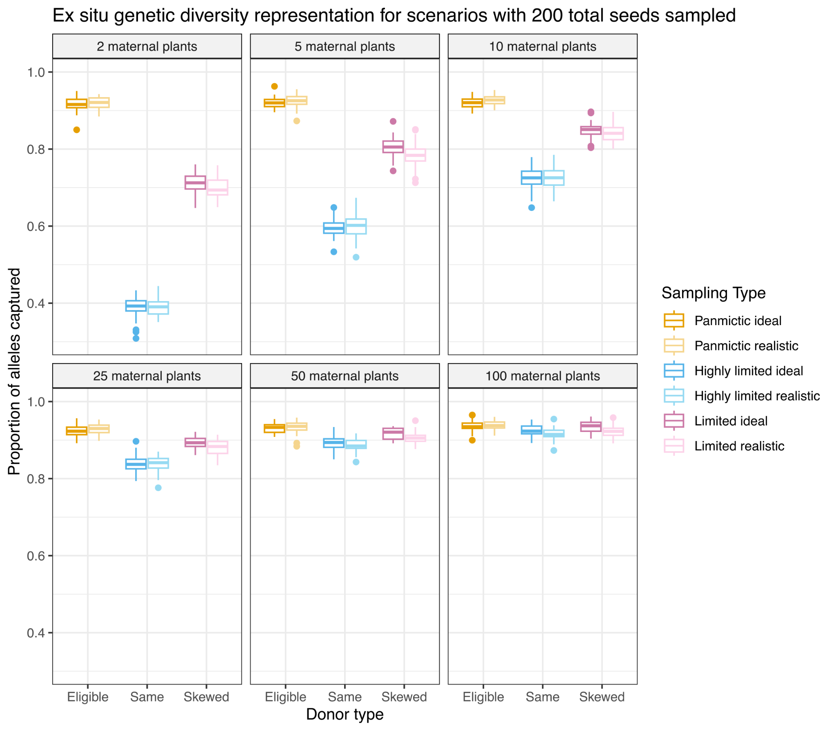
Figure S2. Genetic diversity conserved between ideal and realistic sampling scenarios for all pollen donor types when 400 total seeds are sampled across the population, for simulations with one population. The colors represent the type of sampling, ranging from lighter (realistic scenarios) to darker shades (ideal scenarios). The y-axis represents the proportion of wild alleles conserved by sampling, and the x-axis shows the pollen donation types. The plot is faceted based on the number of maternal plants sampled.
Table S5. Significance levels from t-tests comparing the mean proportion of alleles conserved in ideal vs. realistic sampling scenarios for each donor type when 400 seeds were sampled total in simulations with one population. Significant differences are highlighted in bold text. P values are shown with three significant figures.

Maternal plants sampled | Donor type | Proportion of alleles conserved (ideal) | Proportion of alleles conserved (realistic) | Difference (ideal − realistic) | P values | Adjusted P values
highly limited | 2 | 0.390 | 0.391 | −0.001 | 0.795 | 0.842
limited | 2 | 0.713 | 0.700 | 0.013 | 0.006 | 0.018
panmictic | 2 | 0.917 | 0.920 | −0.003 | 0.333 | 0.499
highly limited | 5 | 0.596 | 0.599 | −0.003 | 0.465 | 0.596
limited | 5 | 0.805 | 0.783 | 0.021 | <0.001 | 0.000
panmictic | 5 | 0.919 | 0.926 | −0.006 | 0.008 | 0.019
highly limited | 10 | 0.725 | 0.726 | −0.002 | 0.741 | 0.833
limited | 10 | 0.847 | 0.842 | 0.006 | 0.169 | 0.277
panmictic | 10 | 0.920 | 0.927 | −0.007 | 0.009 | 0.020
highly limited | 25 | 0.838 | 0.838 | 0.000 | 0.963 | 0.963
limited | 25 | 0.893 | 0.881 | 0.011 | 0.002 | 0.006
panmictic | 25 | 0.925 | 0.930 | −0.005 | 0.078 | 0.156
highly limited | 50 | 0.892 | 0.887 | 0.005 | 0.145 | 0.261
limited | 50 | 0.916 | 0.906 | 0.011 | <0.001 | 0.002
panmictic | 50 | 0.931 | 0.933 | −0.002 | 0.469 | 0.596
highly limited | 100 | 0.925 | 0.916 | 0.009 | 0.001 | 0.005
limited | 100 | 0.935 | 0.922 | 0.013 | <0.001 | 0.001
panmictic | 100 | 0.937 | 0.938 | −0.002 | 0.497 | 0.596

Two-population simulation results:
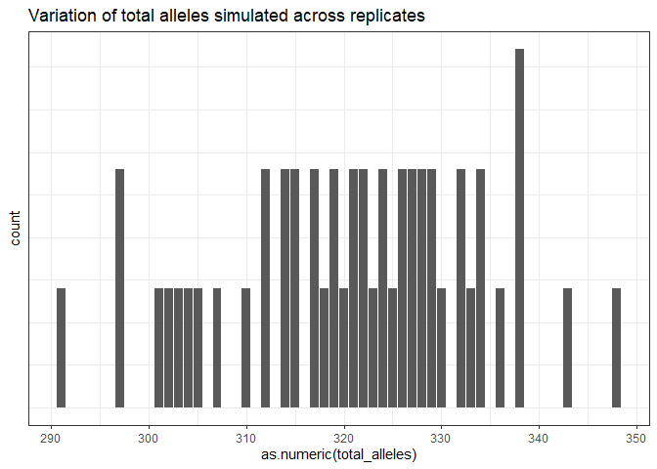
Figure S3. Range of total alleles simulated across simulation replicates for the simulations including two populations (roughly 290 to 350). Note that in this simulation with two populations (double the size of the one-population simulations), there is a greater number of total alleles simulated on average in the species.

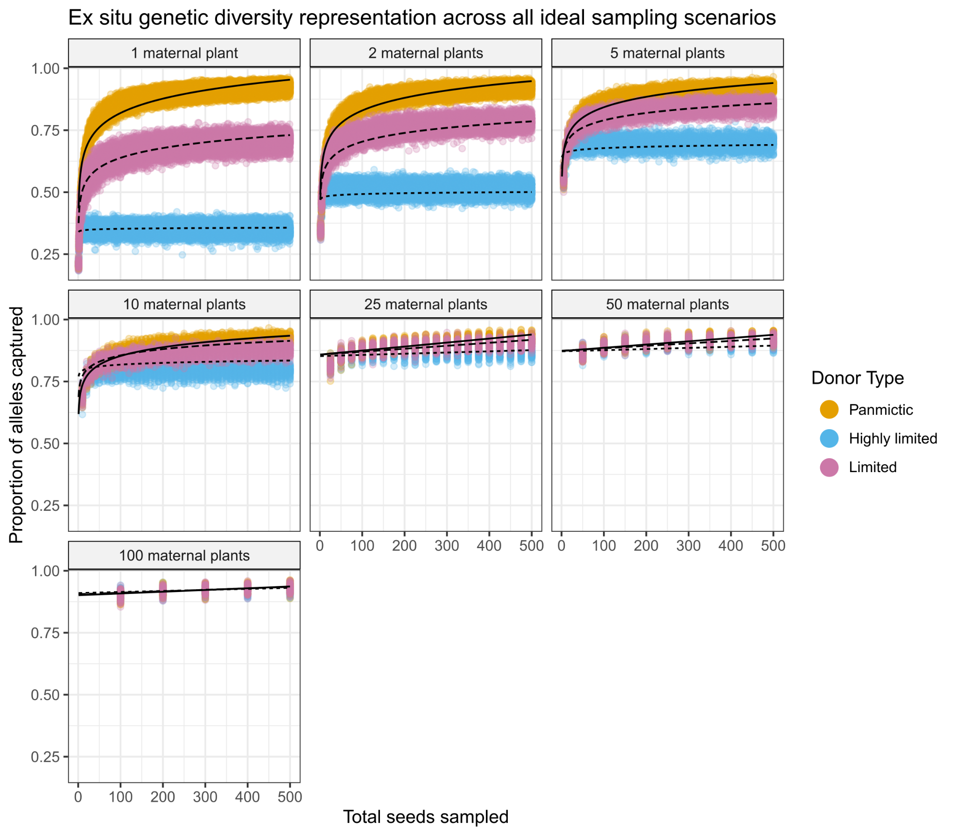
Figure S4. Genetic diversity conserved for all ideal sampling scenarios and donor types in simulations with two populations. Genetic diversity conservation is shown on the y-axis in terms of the proportion of all wild alleles conserved by sampling, and the x-axis represents the total number of seeds sampled, ranging from 2 to 1000 (here, the total sample size is doubled compared to our one-population simulations, as sampling is done for each population). Each facet on the plot represents the number of unique maternal plants sampled. The different color points represent each pollen donor type, and each point on the plot is a single sampling scenario. This plot is comparable to Figure 3 in the main text, where one population was sampled. Results are similar between one- and two-population simulations. However, here, the difference in genetic diversity conservation is less drastic between different pollen donor types.
Table S6. Results of the piecewise linear regression model for simulations with two populations and ideal sampling scenarios. The model coefficients for each variable and interaction, standard errors, and P values are shown. Colons (:) represent interaction terms. Table A indicates the results corresponding to Equation S1 A and Table B indicates the results for Equation S1 B. All coefficients for Equation S1 A were significant, and most from Equation S1 B were.

Table A:
Coefficients | Estimate | Std. error | P value
Intercept | 0.435 | 0.0009 | <0.001
log(total_seeds) | 0.084 | 0.0002 | <0.001
log(maternal_trees) | 0.080 | 0.0011 | <0.001
donor_typehighlyLimited | −0.095 | 0.0013 | <0.001
donor_typelimited | −0.060 | 0.0013 | <0.001
log(total_seeds):log(maternal_trees) | −0.014 | 0.0002 | <0.001
log(total_seeds):donor_typehighlyLimited | −0.081 | 0.0002 | <0.001
log(total_seeds):donor_typelimited | −0.026 | 0.0002 | <0.001
log(maternal_trees):donor_typehighlyLimited | 0.107 | 0.0016 | <0.001
log(maternal_trees):donor_typelimited | 0.056 | 0.0016 | <0.001
log(total_seeds):log(maternal_trees):donor_typehighlyLimited | 0.017 | 0.0003 | <0.001
log(total_seeds):log(maternal_trees):donor_typelimited | 0.005 | 0.0003 | <0.001

Table B:
Coefficients | Estimate | Std. error | P-value
Intercept | 0.8443 | 0.0021 | < 0.001
total_seeds | 0.0001 | 6.659E-6 | < 0.001
maternal_trees | 0.0006 | 4.331E-5 | < 0.001
donor_typehighlyLimited | −0.0111 | 0.0029 | < 0.001
donor_typelimited | −0.0020 | 0.0029 | 0.492
total_seeds:maternal_trees | −1.214E-6 | 1.342E-7 | <0.001
total_seeds:donor_typehighlyLimited | −1.416E-4 | 9.417E-6 | <0.001
total_seeds:donor_typelimited | −5.136E-5 | 9.417E-6 | <0.001
maternal_trees:donor_typehighlyLimited | 1.986E-4 | 6.125E-5 | 0.001
maternal_trees:donor_typelimited | 6.173E-5 | 6.125E-5 | 0.314
total_seeds:maternal_trees:donor_typehighlyLimited | 1.133E-6 | 1.898E-7 | <0.001
total_seeds:maternal_trees:donor_typelimited | 3.987E-7 | 1.898E-7 | 0.036

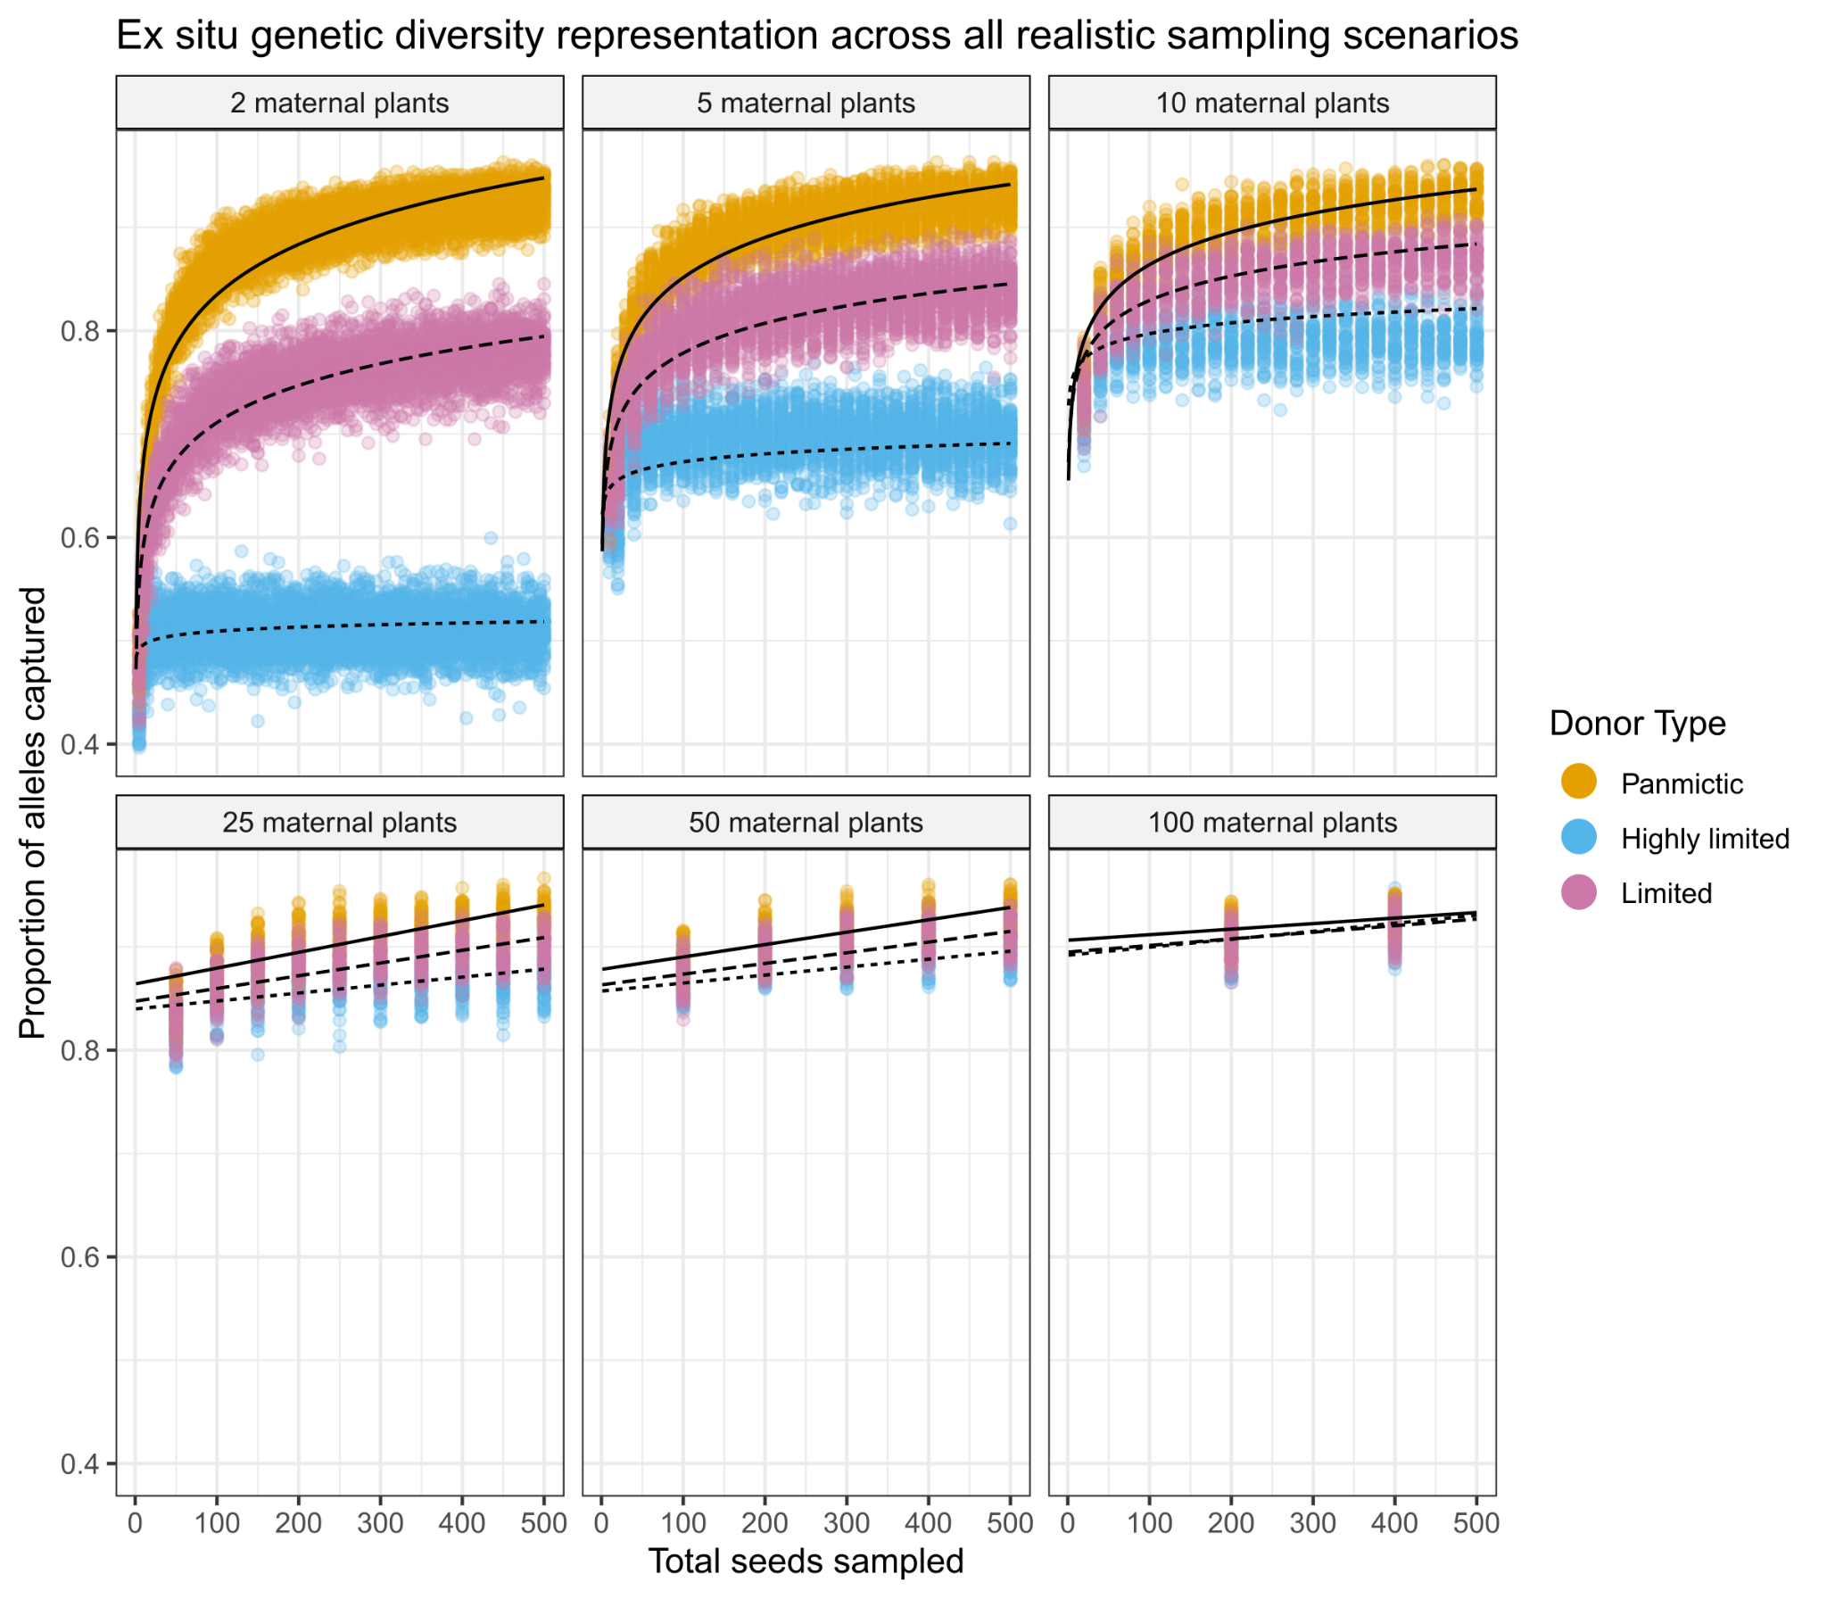
Figure S5. Genetic diversity conserved for all realistic sampling scenarios and donor types in simulations with two populations. Genetic diversity conservation is shown on the y-axis as the proportion of all wild alleles conserved by sampling, and the x-axis represents the total number of seeds sampled, ranging from two to 1000 (here, the total sample size is doubled compared to our one-population simulations, because sampling is done for each population). Each facet on the plot represents the number of unique maternal plants sampled. The different color points represent each pollen donor type, and each point on the plot is a single sampling scenario.
Table S7. Results of the piecewise linear regression model for simulations with two populations and realistic sampling scenarios. The model coefficients for each variable and interaction, standard errors, and P values are shown. Colons (:) represent interaction terms. Table A indicates the results corresponding to Equation S1 A and Table B indicates the results for Equation S1 B. All coefficients for Equation S1 A were significant, and most from Equation S1 B were.

Table A:
Coefficients | Estimate | Std. error | P value
Intercept | 0.4496 | 0.0035 | <0.001
log(total_seeds) | 0.0809 | 0.0007 | <0.001
log(maternal_trees) | 0.0892 | 0.0027 | <0.001
donor_typehighlyLimited | −0.0722 | 0.0049 | <0.001
donor_typelimited | −0.0634 | 0.0049 | <0.001
log(total_seeds):log(maternal_trees) | −0.0155 | 0.0005 | <0.001
log(total_seeds):donor_typehighlyLimited | −0.0792 | 0.0009 | <0.001
log(total_seeds):donor_typelimited | −0.0214 | 0.0009 | <0.001
log(maternal_trees):donor_typehighlyLimited | 0.0629 | 0.0038 | <0.001
log(maternal_trees):donor_typelimited | 0.0352 | 0.0038 | <0.001
log(total_seeds):log(maternal_trees):donor_typehighlyLimited | 0.0213 | 0.0007 | <0.001
log(total_seeds):log(maternal_trees):donor_typelimited | 0.0044 | 0.0007 | <0.001

Table B:
Coefficients | Estimate | Std. error | P value
Intercept | 0.0850 | 3.280E-3 | <0.001
total_seeds | 1.861E-4 | 1.049E-5 | <0.001
maternal_trees | 5.636E-4 | 7.877E-5 | <0.001
donor_typehighlyLimited | −0.0275 | 4.638E-3 | <0.001
donor_typelimited | −0.0185 | 4.638E-3 | <0.001
total_seeds:maternal_trees | −1.324E-6 | 2.494E-7 | <0.001
total_seeds:donor_typehighlyLimited | −1.090E-4 | 1.484E-5 | <0.001
total_seeds:donor_typelimited | −4.308E-5 | 1.484E-5 | 0.004
maternal_trees:donor_typehighlyLimited | 1.302E-4 | 1.114E-4 | 0.242
maternal_trees:donor_typelimited | 7.056E-5 | 1.114E-4 | 0.527
total_seeds:maternal_trees:donor_typehighlyLimited | 1.325E-6 | 3.526E-7 | <0.001
total_seeds:maternal_trees:donor_typelimited | 5.318E-7 | 3.526E-7 | 0.132

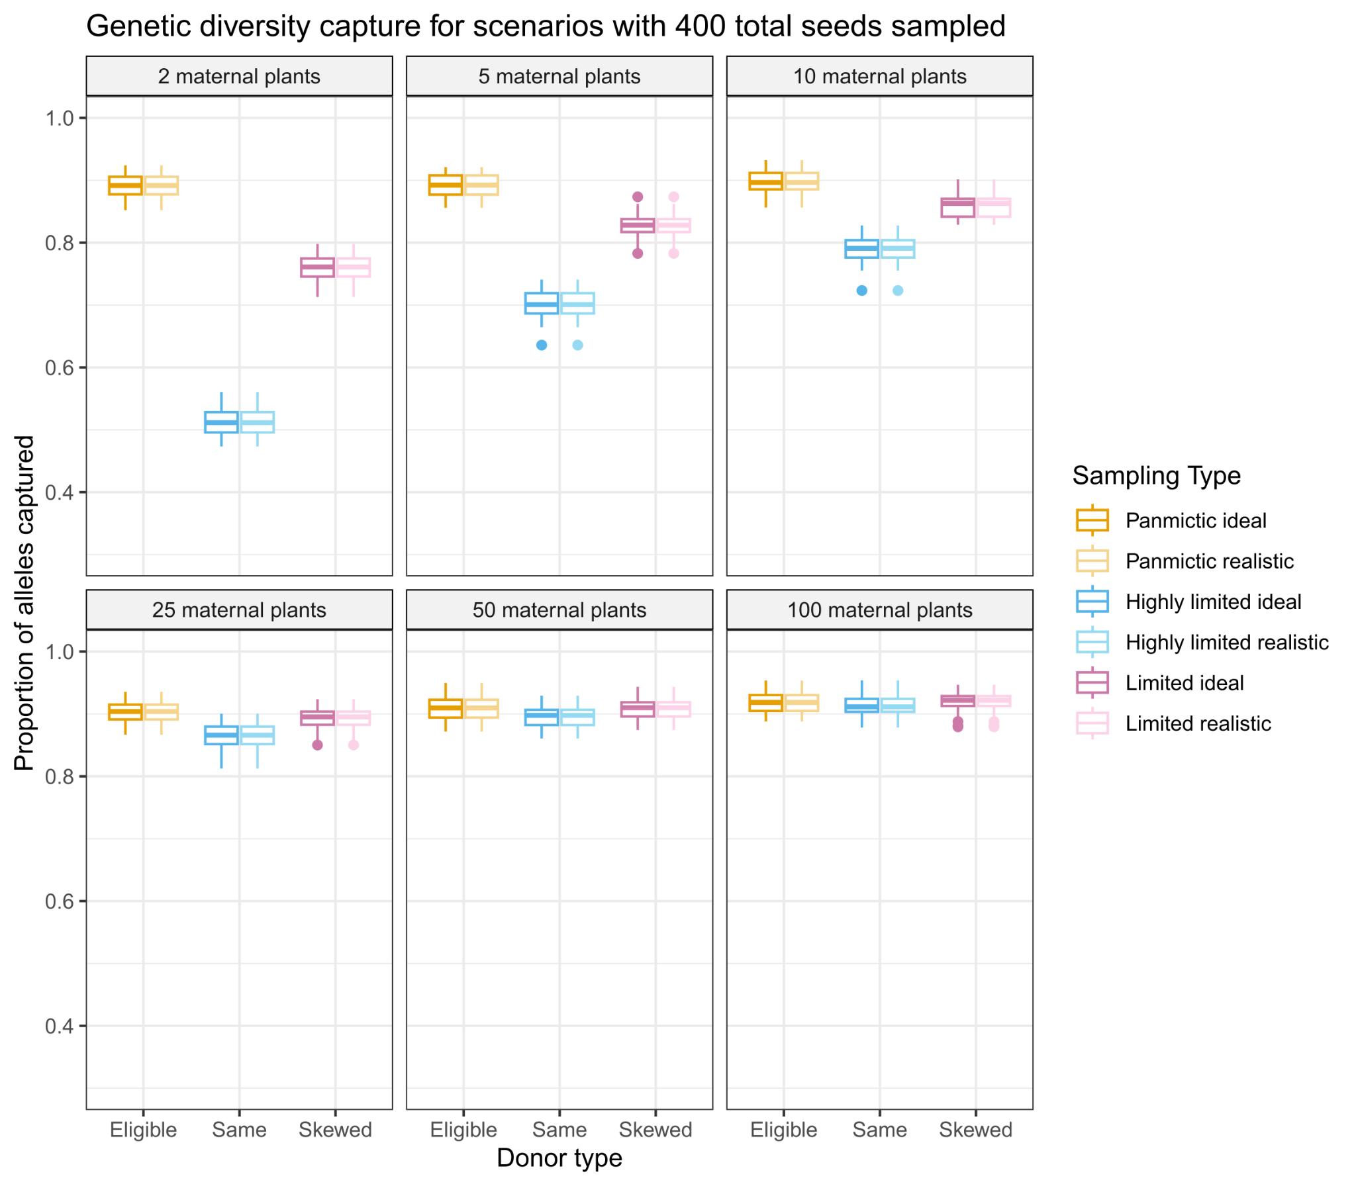
Figure S6. Genetic diversity conserved between ideal and realistic sampling scenarios for all pollen donor types when 400 total seeds are sampled across populations (200 seeds per population, for two populations), in simulations with two populations. The colors represent the type of sampling strategy, ranging from lighter (realistic scenarios) to darker shades (ideal scenarios). The y-axis represents the proportion of wild alleles conserved by sampling, and the x-axis shows the pollen donation types. The plot is faceted based on the number of maternal plants sampled. This figure is comparable to Figure 4 in the main text, where one population was sampled. Results are similar between one and two population simulations. However, here, the difference in genetic diversity conservation is less drastic between different pollen donor types.

Table S8. Significance levels from t-tests comparing the mean proportion of alleles conserved in ideal vs. realistic sampling scenarios for each donor type when 400 seeds were sampled total in simulations with one population. Significant differences are highlighted in bold text. P values are shown with three significant figures.

Maternal plants sampled | Donor type |  | Proportion of alleles conserved (ideal) | Proportion of alleles conserved (realistic) | Difference (ideal − realistic) | P values | Adjusted P values
highly limited | 2 | 0.512 |  | 0.512 | −0.0003 | 0.934 | 0.941
limited | 2 | 0.759 |  | 0.752 | 0.0070 | 0.102 | 0.229
panmictic | 2 | 0.891 |  | 0.895 | −0.0037 | 0.322 | 0.474
highly limited | 5 | 0.700 |  | 0.699 | 0.0014 | 0.718 | 0.861
limited | 5 | 0.828 |  | 0.814 | 0.0136 | <0.001 | 0.001
panmictic | 5 | 0.892 |  | 0.898 | −0.0055 | 0.082 | 0.211
highly limited | 10 | 0.789 |  | 0.792 | −0.0022 | 0.573 | 0.737
Limited | 10 | 0.859 |  | 0.854 | 0.0050 | 0.159 | 0.286
panmictic | 10 | 0.898 |  | 0.903 | −0.0052 | 0.151 | 0.286
highly limited | 25 | 0.864 |  | 0.863 | 0.0011 | 0.773 | 0.869
limited | 25 | 0.892 |  | 0.881 | 0.0106 | <0.001 | 0.015
panmictic | 25 | 0.903 |  | 0.906 | −0.0035 | 0.342 | 0.474
highly limited | 50 | 0.896 |  | 0.887 | 0.0090 | <0.001 | 0.021
limited | 50 | 0.908 |  | 0.895 | 0.01295 | <0.001 | <0.001
panmictic | 50 | 0.910 |  | 0.910 | −0.0003 | 0.941 | 0.941
highly limited | 100 | 0.915 |  | 0.899 | 0.0156 | <0.001 | <0.001
limited | 100 | 0.919 |  | 0.903 | 0.0157 | <0.001 | <0.001
panmictic | 100 | 0.919 |  | 0.914 | 0.0043 | 0.202 | 0.331

