Supporting Information

Figure S1. Forest Plots of Sample-Level Effects
Page 1
Figure S2. Cook’s Distance Plots
Page 2
Figure S3. Funnel Plots
Page 3

Lag Times (95% CI)
Correlation Coefficients (95% CI)

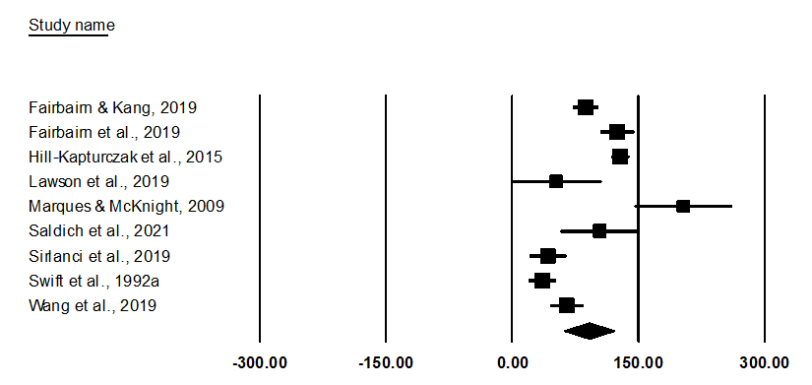
Figure S1. Forest plot of sample-level correlation coefficients (top panel) and lag times (bottom panel) together with 95% confidence intervals. Effect sizes displayed above are aggregated at the level of the sample (i.e., aggregated across devices within samples). Correlation coefficients reflect the TAC-BAC correlation reported within each sample, and lag times represent the amount of time (in minutes) TAC lagged behind BAC.

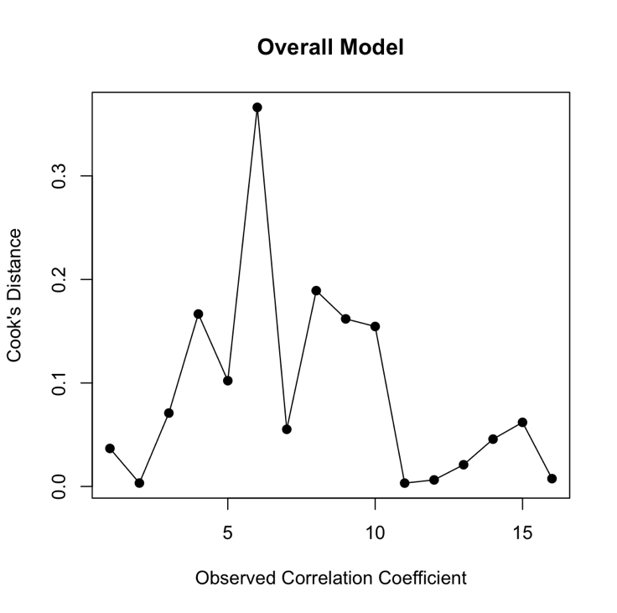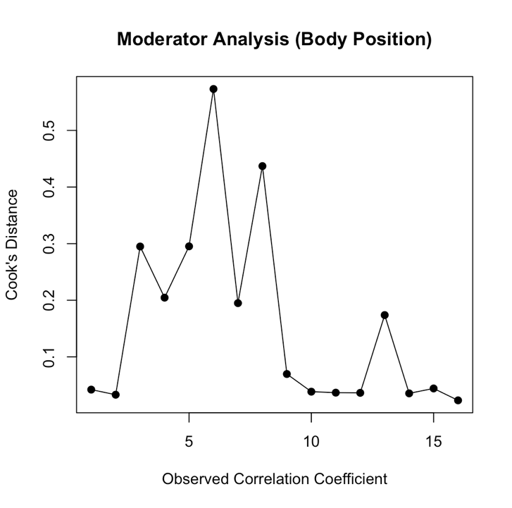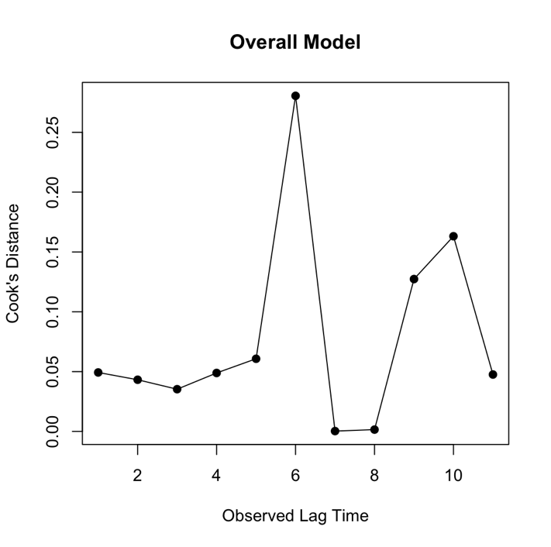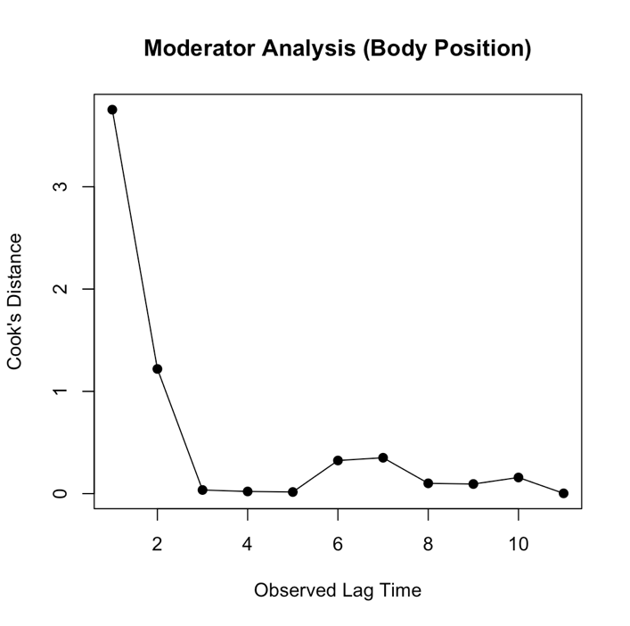
Figure S2. Cook’s distance plot of aggregated correlation coefficient (top left panel), aggregated lag time (bottom left panel), correlation coefficient by body position (top right panel) and lag time by body position (bottom right panel)

Figure S3. Funnel plots depicting effect sizes expressed as correlation coefficients (top panel) or raw mean difference scores (bottom panel) plotted against the inverse of the standard error. Dotted lines reflect average effect size.

