Reduction of household air pollution through clean fuel intervention and recovery of cellular immune balance

Rubhana Raqib*ª, Evana Akhtarª, Md. Ahsanul Haqª, Shyfuddin Ahmedª, Farjana Haqueª, Muhammad Ashique Haider Chowdhury^{ab}, Mohammad Hasan Shahriar^{c}, Bilkis Ara Begum^{d}, Mahbub Eunus^{c}, Golam Sarwar^{c}, Faruque Parvez^{e}, Yushuf Sharker^{f}, Habibul Ahsan^{bc}, Mohammed Yunusª

ªicddr,b, Dhaka-1212, Bangladesh; ^{b}Department of Public Health Sciences, University of Chicago, Chicago, USA; ^{c}U-Chicago Research Bangladesh, Mohakhali, Dhaka, Bangladesh; ^{d}Atomic Energy Commission, Dhaka, Bangladesh; ^{e}Mailman School of Public Health, Columbia University, New York; ^{f}Center for Data Research and Analytics, Maryland, USA

*Corresponding author:
Rubhana Raqib, PhD
Infectious Diseases Division, icddr,b,
Dhaka-1212, Bangladesh
Phone: +880-2-9827068, Fax: +880-28812529
Email: rubhana@icddrb.org

Table S1
Difference in PM_{2.5} and BC exposures between 24-hr and 48-hr measurements during the baseline assessment.
 | 24h (n=100) | 48h (n=200) | p-value
PM_{2.5} | 133.5(110.9, 199.0) | 135.7(104.2, 172.3) | 0.094
BC | 5.94(4.87, 9.28) | 6.19(5.11, 7.62) | 0.192
Data was presented as median with inter quartile range (IQR). Mann-Whitney U-test was used to estimate the p-value.
Table S2
Changes in house hold air pollution (HAP) and immune response from baseline to post-intervention with LPG.
 | Pre (n=198) | Post (n=198) | p-value
PM_{2·5} (µg/m³) | 158·9±73·7 | 85·6±57·3 | <0·001
BC (µg/m³) | 7·36±3·07 | 6·27±4·53 | 0·016
CO (µg/m³) | 1·02±0·52 | 0·25±0·42 | <0·001
CD4⁺T cells | 22·5±0·41 | 32·7±0·52 | <0·001
T regulatory cells | 7·19±0·13 | 3·56±0·18 | <0·001
CD8⁺T cells | 24·4±0·46 | 17·9±0·42 | <0·001
CD19⁺B cells | 19·0±0·50 | 6·68±0·29 | <0·001
Early/immature B cells | 4·76±3·36 | 14·2±8·16 | <0·001
Plasmablasts | 1·77±0·21 | 5·33±0·35 | <0·001
Memory B cells | 27·6±9·88 | 39·2±11·4 | <0·001
% Dividing Cells | 15·9±4·28 | 19·6±3·80 | 0·056
Proliferation Index | 2·12±0·69 | 1·72±0·61 | <0·001
Expansion Index | 1·93±0·21 | 1·56±0·06 | 0·001
Replication Index | 6·66±0·76 | 3·72±0·18 | <0·001
IgE, IU/ml | 478·6±3·63 | 338·8±3·47 | 0·012
Isoprostane, pg/ml | 1674±837·2 | 1520±678·8 | 0·003
Data given as geometric mean ± standard deviation. Paired sample t-test was used to estimate the p-value

Table S3
The effect of reduction of household air pollution (PM2.5) following LPG intervention on changes in proportions of peripheral lymphocytes.
 | CD4⁺ T cells | T regulatory cells | CD8⁺ T cells | CD19⁺ B cells | Early B cells | Plasmablasts§ | Memory B cells
 | β-(95% CI) | β-(95% CI) | β-(95% CI) | β-(95% CI) | β-(95% CI) | β-(95% CI) | β-(95% CI)
PM_{2.5} | 0.002(-0.01, 0.01) | -0.002(-0.01, 0.001) | 0.004(-0.003, 0.01) | 0.002(-0.01, 0.01) | 0.01(-0.004, 0.02) | -0.0002(-0.001, 0.001) | -0.02(-0.04, 0.002)
Intervention | 9.30(7.98, 10.6) ** | -3.79(-4.28, -3.30)** | -5.68(-6.68, -4.69)** | -12.2(-13.6, -10.8)** | 10.5(8.79, 12.1)** | 0.56(0.46, 0.66)** | 10.6(8.16, 13.1)**
Locality | 1.81(0.20, 3.41)* | 0.22(-0.26, 0.69) | 1.21(-0.39, 2.81) | 0.40(-0.84, 1.64) | 0.51(-0.95, 1.97) | -0.01(-0.09, 0.07) | 0.35(-2.40, 3.09)
Seasons | -0.85(-2.07, 0.38) | 0.43(-0.02, 0.89) | 1.00(0.09, 1.91)* | -0.14(-1.34, 1.06) | 1.34(-0.11, 2.79) | 0.04(-0.05, 0.12) | -0.06(-2.24, 2.11)
Age | 0.16(0.06, 0.27)* | 0.01(-0.02, 0.04) | -0.19(-0.30, -0.08)** | 0.03(-0.05, 0.11) | -0.02(-0.12, 0.08) | -0.01(-0.01, -0.004)* | -0.11(-0.38, 0.07)
^{ɤ}Temperature | 0.06(-0.10, 0.22) | 0.07(0.01, 0.13) | 0.08(-0.04, 0.20) | 0.01(-0.15, 0.16) | 0.08(-0.10, 0.26) | 0.01(-0.003, 0.02) | -0.11(-0.38, 0.16)
Note. Estimates were generated by using mixed effect models controlling for time, locality, seasonality, age and ^{ɤ}personal temperature. Change in PM_{2.5} markers= post-intervention – pre-intervention; change in immune responses= post-intervention – pre-intervention. Intervention (post- compared to pre-intervention); season (wet compared to dry season); locality (Matlab compared to Araihazar).
§Natural log transformation· * p-value ≤0.05, ** p-value ≤0.01. PM_{2.5}, particulate matter 2.5

Table S4
The effect of reduction of household air pollution (BC) following LPG intervention on changes in proportions of peripheral lymphocytes.
 | CD4⁺ T cells | T regulatory cells | CD8⁺ T cells | CD19⁺ B cells | Early B cells | Plasmablasts§ | Memory B cells
 | β-(95% CI) | β-(95% CI) | β-(95% CI) | β-(95% CI) | β-(95% CI) | β-(95% CI) | β-(95% CI)
BC | 0.05(-0.09, 0.20) | -0.07(-0.12, -0.02)** | 0.05(-0.06, 0.16) | 0.05(-0.09, 0.19) | 0.11(-0.05, 0.28) | 0.001(-0.01, 0.01) | -0.23(-0.46, -0.03)*
Intervention | 9.24(8.01, 10.5)** | -3.74(-4.20, -3.28)** | -6.16(-7.06, -5.26)** | -12.2(-13.5, -10.9)** | 10.2(8.61, 11.7)** | 0.56(0.47, 0.66)** | 11.7(9.38, 14.0)**
Locality | 1.76(0.11, 3.41)* | 0.30(-0.18, 0.78) | 1.35(-0.26, 2.96) | 0.27(-0.99, 1.53) | 0.33(-1.16, 1.82) | -0.02(-0.10, 0.06) | 0.44(-2.12, 3.21)
Seasons | -1.05(-2.30, 0.20) | 0.39(-0.07, 0.85) | 0.82(-0.10, 1.73) | -0.10(-1.32, 1.12) | 1.38(-0.10, 2.86) | 0.06(-0.03, 0.15) | 0.12(-2.12, 2.36)
Age | 0.17(0.06, 0.28) | 0.01(-0.02, 0.04) | -0.18(-0.28, -0.07)** | 0.02(-0.06, 0.11) | -0.02(-0.12, 0.08) | -0.01(-0.01, 0.004) | -0.11(-0.30, 0.08)
^{ɤ}Temperature | 0.07(-0.09, 0.23) | 0.06(0.004, 0.12)* | 0.08(-0.04, 0.20) | -0.02(-0.17, 0.13) | 0.07(-0.11, 0.25) | 0.01(-0.002, 0.02) | -0.05(-0.32, 0.23)
Note. Estimates were generated by using mixed effect models controlling for time, locality, seasonality, age and ^{ɤ}personal temperature. Change in PM_{2.5} markers= post-intervention – pre-intervention; change in immune responses= post-intervention – pre-intervention. Intervention (post- compared to pre-intervention); season (wet compared to dry season); locality (Matlab compared to Araihazar).
§Natural log transformation· * p-value ≤0.05, ** p-value ≤0.01. BC, Black carbon;

Table S5
The effect of reduction of household air pollution (CO) following LPG intervention on changes in proportions of peripheral lymphocytes.
 | CD4⁺ T cells | T regulatory cells | CD8⁺ T cells | CD19⁺ B cells | Early B cells | Plasmablasts§ | Memory B cells
 | β-(95% CI) | β-(95% CI) | β-(95% CI) | β-(95% CI) | β-(95% CI) | β-(95% CI) | β-(95% CI)
CO§ | 0.54(-0.89, 1.97) | 0.18(-0.32, 0.69) | -0.14(-1.24, 0.97) | -0.75(-2.02, 0.53) | -1.94(-3.47, -0.41)* | -0.11(-0.20, -0.02)** | -0.33(-2.72, 2.06)
Intervention | 9.63(8.22, 11.0)** | -3.63(-4.15, -3.11)** | -5.93(-6.98, -4.87)** | -12.9(-14.3, -11.5)** | 8.83(1.13, 10.5)** | 0.50(0.39, 0.60)** | 12.0(9.47 14.6)**
Locality | 2.09(0.49, 3.68)** | 0.18(-0.29, 0.65) | 1.25(-0.33, 2.83) | 0.28(-0.93, 1.49) | 0.49(-0.95, 1.92) | -0.02(-0.10, 0.06) | 0.31(-238, 3.00)
Seasons | -0.75(-1.95, 0.45) | 0.37(-0.08, 0.81) | 1.04(0.15, 1.94)* | -0.37(-1.55, 0.81) | 1.11(-0.31, 2.54) | 0.03(-0.05, 0.12) | 0.02(-2.13, 2.18)
Age | 0.16(0.05, 0.23) | 0.01(-0.02, 0.05) | -0.19(-0.30, -0.09)** | 0.03(-0.05, 0.11) | -0.05(-0.15, 0.05) | -0.01(-0.01, -0.002) | -0.11(-0.30, 0.07)
^{ɤ}Temperature | 0.07(-0.08, 0.23) | 0.07(0.02, 0.13)* | 0.07(-0.05, 0.19) | 0.01(-0.14, 0.15) | 0.07(-0.10, 0.25) | 0.01(-0.002, 0.02) | -0.05(-0.32, 0.21)
Note. Estimates were generated by using mixed effect models controlling for time, locality, seasonality, age and ^{ɤ}personal temperature. Change in PM_{2.5} markers= post-intervention – pre-intervention; change in immune responses= post-intervention – pre-intervention. Intervention (post- compared to pre-intervention); season (wet compared to dry season); locality (Matlab compared to Araihazar).
§Natural log transformation· * p-value ≤0.05, ** p-value ≤0.01. CO, Carbon monoxide.

Table S6
The effect of reduction of household air pollution (PM_{2·5,} BC and CO) following LPG intervention on changes in IgE and 8-isoprostane concentrations.
 | IgE§ |  | 8-isoprostane
 | β-(95% CI) | p | β-(95% CI) | p
PM_{2·5} | 0·003(-0·002, 0·001) | 0·674 | -0·95(-2·71, 0·76) | 0·495
BC | -0·01(-0·02, 0·02) | 0·888 | 8·61(-12·9, 29·7) | 0·365
$CO | 0·05(-0·01, 0·08) | 0·090 | 55·1(-21·6, 87·7) | 0·476
Intervention | -0·17(-0·36, -0·06) | 0·038 | -161·2(-350·4, 30·0) | 0·110
Locality | 0·15(0·02, 0·22) | 0·030 | -492·1(-650, -327·4) | <0·001
Season | -0·04(-0·17, 0·06) | 0·311 | -36·1(-208·6, 136·5) | 0·681
Age | 0·01(-0·003, 0·01) | 0·238 | -7·55(-18·2, 3·19) | 0·168
^{ɤ}Temperature | 0.001(-0.01, 0.10) | 0.455 | -2.32(-4.45, 7.98) | 0.545
Note· Estimates were generated by using mixed effect model controlling for time, locality, seasonality, age and ^{ɤ}personal temperature. Change in HAP exposures= post-intervention – pre-intervention; change in IgE/8-isoprostane levels= post-intervention – pre-intervention. Intervention (post- compared to pre-intervention); season (wet compared to dry season); locality (Matlab compared to Araihazar).
§Natural log transformation. HAP, household air pollution; PM_{2·5}, particulate matter 2·5; BC, Black carbon; CO, Carbon monoxide; LPG, liquefied petroleum gas.

Table S7
Associations between PM_{2·5} exposure and proportions of immune cells
Exposure | CD4⁺ T cells | T regulatory cells | CD8⁺ T cells | CD19⁺ B cells | Early B cells | Plasmablasts§ | Memory B cells
Exposure | β-(95% CI) | β-(95% CI) | β-(95% CI) | β-(95% CI) | β-(95% CI) | β-(95% CI) | β-(95% CI)
¹PM_{2·5} | -0·60(-0·82, -0·38)** | 0·15(0·07, 0·22)** | 0·34(0·15, 0·53)** | 0·77(0·57, 0·98)** | -0·55(-0·76, -0·33)** | -0·84(-1·18, -0·51)** | -0·18(-0·30, -0·06)**
²PM_{2·5}+BC | 0·67(-0·34, 1·68) | 0·20(0·11, 0·28)** | 0·43(-0·44, 1·29) | -0·19(-1·15, 0·76) | 0·62(-0·38, 1·61) | -0·75(-2·28, 0·79) | -0·16(-0·70, 0·38)
Note. Mixed effect model was used to estimate the p-value; model-1 was adjusted by age, locality, and seasonality and model-2 was additionally adjusted by BC. Change in HAP exposures= post-intervention – pre-intervention; change in immune responses= post-intervention – pre-intervention. * p-value ≤0·05, ** p-value ≤0·01
§Natural log transformation. PM_{2·5}, particulate matter 2·5

Table S8
Association of household air pollution exposure and plasma concentration of plasma IgE and 8-isoprostane.
 | % IgE§ |  | 8-isoprostane
 | β-(95% CI) | p | β-(95% CI) | p
BC
<6·0 | 0·003(-0·04, 0·04) | 0.877 | -10·5(-60·1, 42·0) | 0·729
>6·0 | -0·01(-0·04, 0·02) | 0.592 | 15·5(-36·7, 42·7) | 0.882
CO
<1·0 | 0·20(0·002, 0·33) | 0·048 | 254·3(21·3, 478·2) | 0·033
>1·0 | 0·03(-0·10, 0·15) | 0·679 | 35·8(-133·1, 204·6) | 0.677
Note. Mixed effect model was applied to determine the association between household air pollutants (BC, CO) and outcome variables (IgE and 8-isoprostane), at values below and above spline knots introduced at BC (6·0 μg/m³) and CO (1·0 μg/m³). The model was adjusted by age, locality, seasonality and personal temperature.
§Natural log transformation. PM_{2·5}, particulate matter 2·5

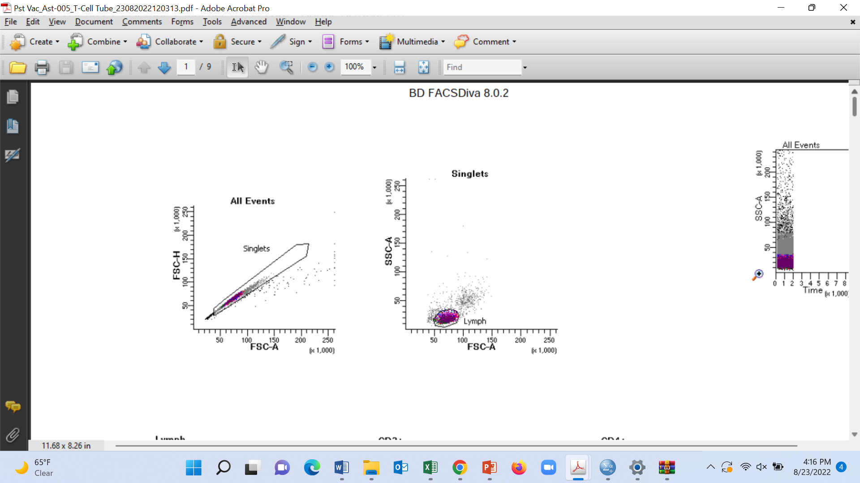  - Gating strategy | 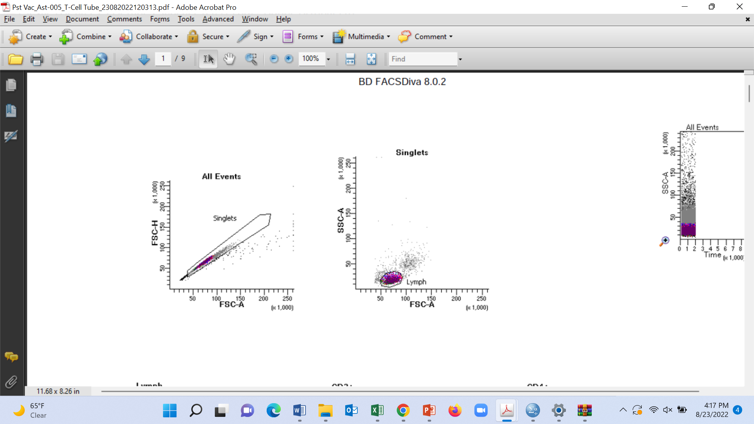 | Lymph  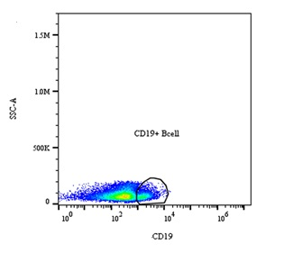
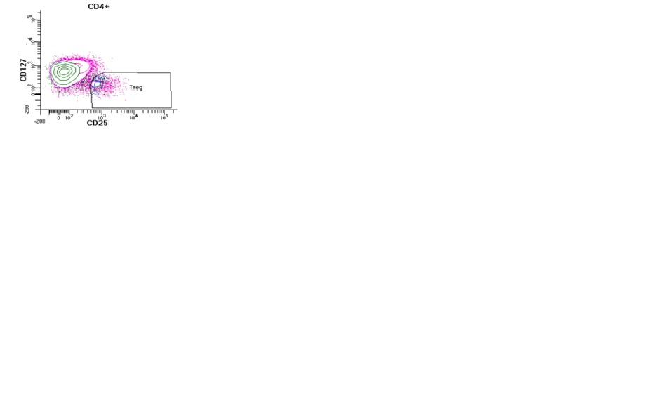 | Lymph  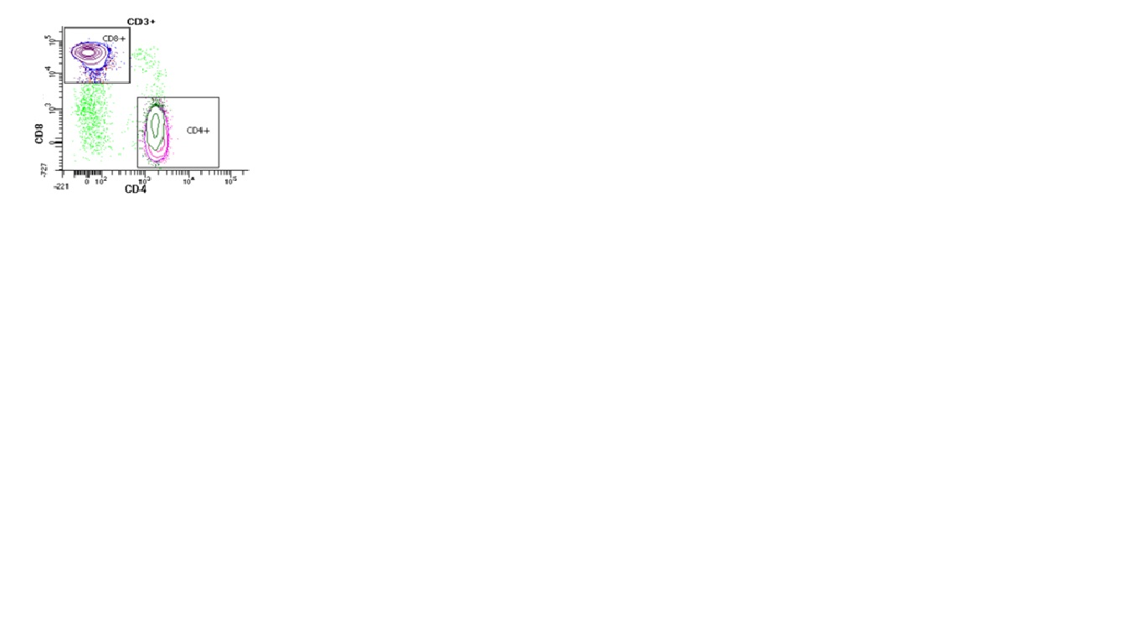 | 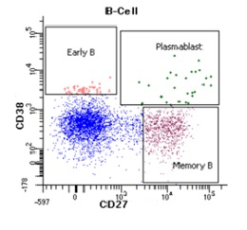
- Proliferation analysis  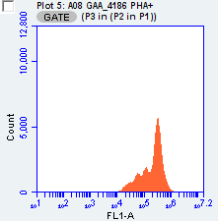 | Proliferation Index: 1·21  Percent dividing cells:13·5  Expansion Index: 1·20  Replication Index: 2·50
Figure S1. The process of gating of immune cell subtypes and proliferation response. A. represents the gating strategy of T and B cell subtypes, B. shows the cell proliferation response evaluated by flow cytometry for carboxy fluorescein succinimidyl ester (CFSE) intensity histogram

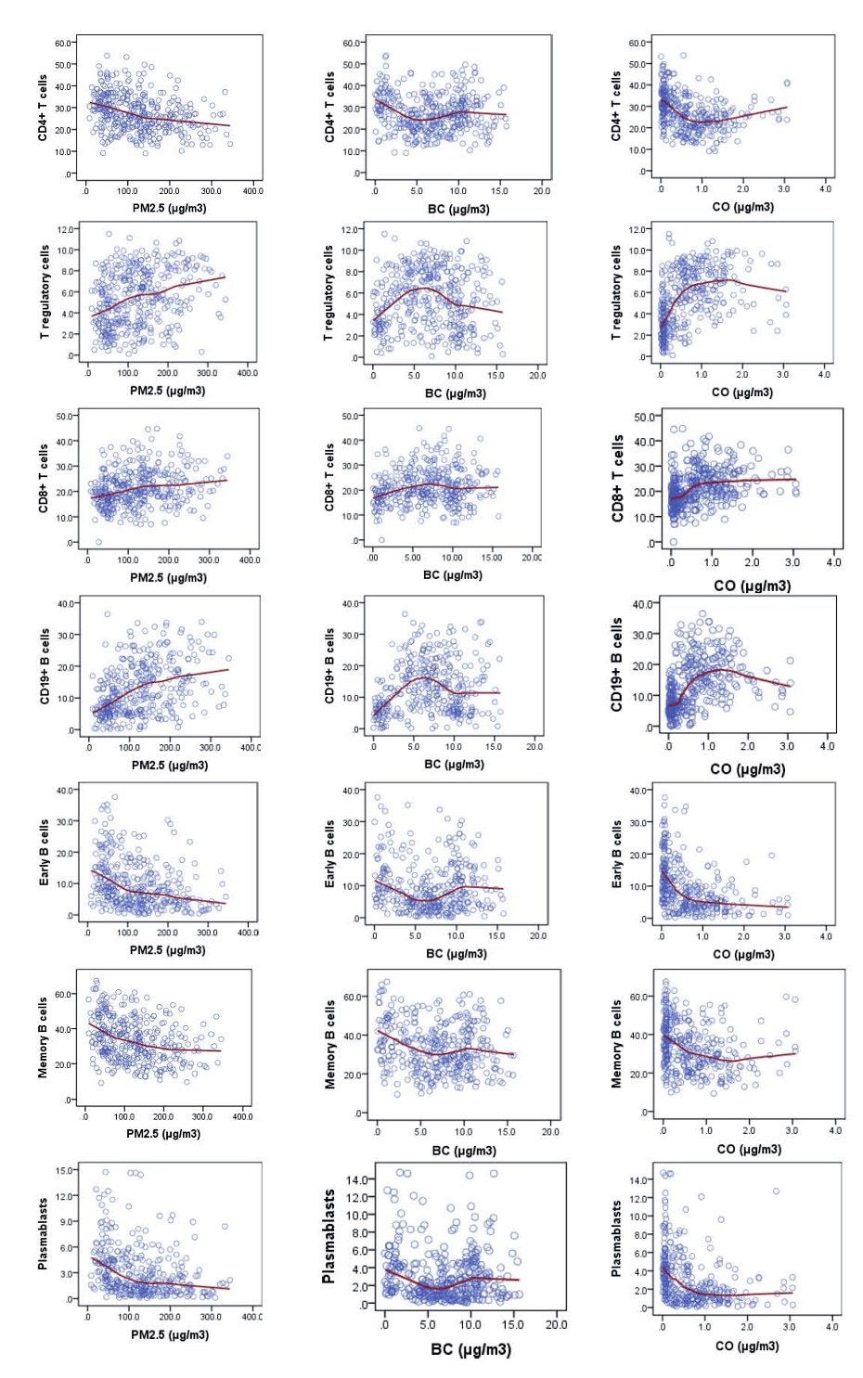
Figure S2. Association between household air pollution (PM_{2·5}, BC, CO) and lymphocyte sub-populations. In the scatter plots, the solid line represents a LOWESS (Locally Weighted Scatterplot Smoothing) moving-average curve for the raw data. PM_{2·5}, particulate matter 2·5; BC, Black carbon; CO, Carbon monoxide.
Methods
Method S1: Measurement of HAP at 48 and 24-h intervals
The Bangladesh GEOHealth study had two components, one was cross-sectional assessment of association of HAP with different health parameters; and the other was a clean fuel intervention trial (pre- and post). In the cross-sectional component, a group of women underwent 24-hr HAP measurement by the same device. In the intervention group (n=200) at baseline, we measured 48-hr of HAP exposure assessment. The data was compared and no significant difference was found.
In the intervention study, even though 48-hour HAP data was collected from women at baseline, we faced many challenges from the participants for compliance of wearing the heavy device for 48-hr. Thus, at the end line when the intervention was completed and the households were no longer receiving free LPG, participants were reluctant to carry the monitor for 48 hr. At this point, with great efforts we managed to convince the women to wear the device for at least 24-hr. We had additional challenges in terms of non-functionality of two air monitoring devices out of six which made timely completion of exposure assessment quite difficult. As we did not find any significant difference in HAP between 24-hr and 48-hr measurements during the baseline assessment, we therefore, carried out 24-h exposure measurement at post-intervention.

Method S2: Within and between MicroPEM device variation in personal exposure measurement
As a proxy for within-device variability, the same RTI-MicroPEM monitor was used to measure personal exposure in different participants (women) from different households in the same village within a month. Concordance correlation coefficient (CCC) and Pearson’s correlation coefficient (CC) were measured for each MicroPEM monitor after stratifying the women into two groups: one group (n=6) consisted of HAP measurements in the first two weeks (week 1 and 2); the 2nd group (n=6) consisted of measurements in next two consecutive weeks (week 3 and 4). We found moderate to strong agreement within-the-device for the exposure measurements.
Table S9. Within device correlation for personal exposure measurement among different participants in the same village.
 | Monitor #1 | Monitor #2 | Monitor #3 | Monitor #4 | Monitor #5 | Monitor #6
CCC | 0.771 | 0.716 | 0.545 | 0.665 | 0.496 | 0.725
CC | 0.768 | 0.897 | 0.786 | 0.981 | 0.718 | 0.912
95% CI | 0.30, 0.95 | 0.19, 0.92 | -0.03, 0.89 | -0.01, 0.83 | 0.07, 0.79 | 0.62, 0.97
p-value | 0.012 | 0.010 | 0.066 | 0.066 | 0.027 | 0.001
N | 6 | 6 | 6 | 6 | 6 | 6
Note: CCC, concordance correlation coefficient; CC, correlation coefficient (Pearson’s); CI, confidence interval
We also determined between device CCC when different MicroPEM monitors were used in the same village/location in different participants within a period of one month. We found moderate to strong agreement between the monitors in a village. The results indicated that the performance of RTI device was generally robust and the HAP exposure was assessed with good accuracy in both intra- and inter-monitor measurements.
Table S10. Correlation between devices in personal exposure measurements among different participants in the same village.
 |  | Monitor #5 | Monitor #6
Monitor #4 | CCC | 0.475 | 0.697
Monitor #4 | CC | 0.991 | 0.937
Monitor #4 | 95% CI | -0.02, 0.80 | 0.44, 0.86
Monitor #4 | p-value | 0.086 | 0.001
Monitor #4 | N | 7 | 7
Monitor #5 | CCC |  | 0.667
Monitor #5 | CC |  | 0.915
Monitor #5 | 95% CI |  | 0.34, 0.84
Monitor #5 | p-value |  | 0.002
Monitor #5 | N |  | 7
Note: CCC, concordance correlation coefficient; CC, correlation coefficient (Pearson’s) ; CI, confidence interval

Method S3: Calculations of Black Carbon measurement
The level of BC in the fine fraction of the samples was determined by reflectance measurement using an EEL-type smoke-stain reflectometer. BC was estimated from the measurement of the coefficient of absorption of particles in the sample (b_{ap}) which was calculated as
2b_{ap}=ln(I₀/I),
Where I₀ is incident light intensity and I is reflected light intensity.
After measuring the b_{ap}, BC was measured as
BC = [2b_{ap}/ε]µg/cm⁻²
Where ε is the absorption efficiency in m²/g, b_{ap} is in µm⁻¹, and BC is in µg/m². Values of the absorption efficiency ε vary from ~9 to 12 m²/g. Here we used 10 m²/g that is generally accepted value for diesel-associated carbon.

