SUPPLEMENTARY INFORMATION

Prognostic, biological, and structural implications of FLT3-JMD point mutations in acute myeloid leukemia: an analysis of Alliance studies

Participating institutions
The following Cancer and Leukemia Group B (CALGB)/Alliance for Clinical Trials in Oncology (Alliance) institutions participated in this study and contributed five or more patients. For each institution, the current or last principal investigator are listed as follows: The Ohio State University Medical Center, Columbus, OH: Claire F. Verschraegen; Wake Forest University School of Medicine, Winston-Salem, NC: Heidi D. Klepin; North Shore University Hospital, Manhasset, NY: Jonathan E. Kolitz; Dana Farber Cancer Institute, Boston, MA: Harold J. Burstein; Washington University School of Medicine, St. Louis, MO: Nancy L. Bartlett; University of North Carolina, Chapel Hill, NC: Matthew I. Milowsky; Roswell Park Cancer Institute, Buffalo, NY: Ellis G. Levine; University of Iowa Hospitals, Iowa City, IA: Umar Farooq; University of Maryland Greenebaum Cancer Center, Baltimore, MD: Heather D. Mannuel; University of Chicago Medical Center, Chicago, IL: Hedy L. Kindler; Dartmouth Medical School, Lebanon, NH: Konstantin H. Dragnev; Duke University Medical Center, Durham, NC: Jeffrey Crawford; Christiana Care Health Services, Inc., Newark, DE: Gregory A. Masters; Ft. Wayne Medical Oncology/Hematology, Ft. Wayne, IN: Sreenivasa Nattam; Rhode Island Hospital, Providence, RI: Howard P. Safran; Weill Medical College of Cornell University, New York, NY: Scott Tagawa; SUNY Upstate Medical University, Syracuse, NY: Stephen L. Graziano; Western Pennsylvania Hospital, Pittsburgh, PA: Gene G. Finley; University of Massachusetts Medical Center, Worcester, MA: William V. Walsh; University of California San Diego Moores Cancer Center, San Diego, CA: Lyudmila A. Bazhenova; Eastern Maine Medical Center, Bangor, ME: Sarah J. Sinclair; Mount Sinai School of Medicine, New York, NY: Michael A. Schwartz; University of Vermont Cancer Center, Burlington, VT: Peter A. Kaufman; Walter Reed National Military Medical Center, Bethesda, MD: Karen G. Zeman; University of Alabama at Birmingham, Birmingham, AL: Robert Diasio; Long Island Jewish Medical Center, Lake Success, NY: Jonathan E. Kolitz; Massachusetts General Hospital, Boston, MA: David Ryan; University of Missouri/Ellis Fischel Cancer Center, Columbia, MO: Puja Nistala; University of Illinois, Chicago, IL: John G. Quigley; University of Puerto Rico, San Juan, Puerto Rico: Eileen I. Pacheco; University of California at San Francisco, San Francisco, CA: Charalambos Andreadis; Virginia Commonwealth University, Richmond, VA: Zhijian Chen; University of Minnesota, Minneapolis, MN: Robert A. Kratzke; University of Tennessee Cancer Center, Memphis, TN: Harvey B. Niell; University of Nebraska Medical Center, Omaha, NE: Apar Ganti.

Patients and treatment
A total of 1059 patients under the age of 60 years diagnosed with de novo acute myeloid leukemia (AML) who were included in outcome analyses were treated on the following Cancer and Leukemia Group B (CALGB)/Alliance for Clinical Trials in Oncology (Alliance) studies: 19808 (n=326), 10503 (n=310), 9621 (n=171), 9222 (n=89), 10603 (n=77), 8525 (n=58), 9022 (n=14), 8821 (n=8), 8721 (n=2), 9120 (n=2), 10502 (n=1), and 10201 (n=1). Patients enrolled on CALGB 19808 were randomly assigned to receive induction chemotherapy with cytarabine, daunorubicin, and etoposide with or without a multidrug resistance protein inhibitor PSC-833 (valspodar).¹ Upon achievement of complete remission (CR), patients were assigned to intensification with high-dose cytarabine and etoposide for stem-cell mobilization followed by myeloablative treatment with busulfan and etoposide supported by autologous peripheral blood hematopoietic stem-cell transplantation (HSCT). Patients enrolled on CALGB 10503 were assigned to receive induction chemotherapy consisting of cytarabine, daunorubicin, and etoposide. Upon achievement of CR, patients received high-dose cytarabine (HiDAC) and etoposide for stem-cell mobilization followed by myeloablative treatment with busulfan and etoposide supported by autologous peripheral HSCT. Patients not eligible for HSCT received HiDAC. After intensification, patients received the DNA methyltransferase inhibitor decitabine for maintenance.² Patients enrolled on CALGB 9621 were treated similarly to those on CALGB 19808, as reported previously.³ Patients on protocol CALGB 9222 received induction chemotherapy consisting of cytarabine in combination with daunorubicin followed by consolidation with one cycle of HiDAC. Different doses of mitoxantrone were explored as well, and the consolidation treatment was randomized to three cycles of monotherapy with HiDAC or consolidation with one cycle of HiDAC, a cycle of cyclophosphamide and etoposide, and one cycle of mitoxantrone and diaziquone.⁴ In CALGB 10603, cytarabine and daunorubicin followed by consolidation with HiDAC was applied with or without PKC-412.⁵ Patients enrolled onto CALGB 8525 received induction chemotherapy consisting of cytarabine and daunorubicin, and were randomly assigned to consolidation with different doses of cytarabine followed by maintenance treatment.⁶ Patients enrolled onto CALGB 9022 received induction chemotherapy consisting of cytarabine in combination with daunorubicin followed by consolidation with one cycle of HiDAC, a cycle of cyclophosphamide and etoposide, and one cycle of mitoxantrone and diaziquone.⁷ Patients enrolled on CALGB 8821 received cytarabine combined with daunorubicin as induction and mitoxantrone/diaziquone, and etoposide/cyclophosphamide were then successively administered in two intensification courses.⁸

SUPPLEMENTARY REFERENCES

1. Kolitz JE, George SL, Marcucci G, Vij R, Powell BL, Allen SL, et al. P-glycoprotein inhibition using valspodar (PSC-833) does not improve outcomes for patients under age 60 years with newly diagnosed acute myeloid leukemia: Cancer and Leukemia Group B study 19808. Blood. 2010;116:1413-21.
2. Blum W, Sanford BL, Klisovic R, DeAngelo DJ, Uy G, Powell BL, et al. Maintenance therapy with decitabine in younger adults with acute myeloid leukemia in first remission: a phase 2 Cancer and Leukemia Group B study (CALGB 10503). Leukemia. 2017;31:34-9.
3. Kolitz JE, George SL, Dodge RK, Hurd DD, Powell BL, Allen SL, et al. Dose escalation studies of cytarabine, daunorubicin, and etoposide with and without multidrug resistance modulation with PSC-833 in untreated adults with acute myeloid leukemia younger than 60 years: final induction results of Cancer and Leukemia Group B study 9621. J Clin Oncol. 2004;22:4290-301.
4. Moore JO, George SL, Dodge RK, Amrein PC, Powell BL, Kolitz JE, et al. Sequential multiagent chemotherapy is not superior to high-dose cytarabine alone as postremission intensification therapy for acute myeloid leukemia in adults under 60 years of age: Cancer and Leukemia Group B study 9222. Blood. 2005;105:3420-7.
5. Stone RM, Mandrekar SJ, Sanford BL, Laumann K, Geyer S, Bloomfield CD, et al. Midostaurin plus chemotherapy for acute myeloid leukemia with a FLT3 mutation. N Engl J Med. 2017;377:454-64.
6. Mayer RJ, Davis RB, Schiffer CA, Berg DT, Powell BL, Schulman P, et al. Intensive postremission chemotherapy in adults with acute myeloid leukemia. N Engl J Med. 1994;331:896-903.
7. Moore JO, Dodge RK, Amrein PC, Kolitz J, Lee EJ, Powell B, et al. Granulocyte-colony stimulating factor (filgrastim) accelerates granulocyte recovery after intensive postremission chemotherapy for acute myeloid leukemia with aziridinyl benzoquinone and mitoxantrone: Cancer and Leukemia Group B study 9022. Blood. 1997;89:780-8.
8. Schiffer CA, Davis RB, Schulman P, Cooper B, Coyle T, Lee E, et al. Intensive post remission therapy of acute myeloid leukemia (AML) with cytoxan/etoposide (CY/VP16) and diazaquone/mitoxantrone (AZQ/MITO). Blood. 1991;78(suppl):460 (abstract 1829).

Supplementary Table 1. Comparison of clinical characteristics by FLT3 mutation in younger patients (aged <60 years) with de novo AML

Characteristic | All patients  (n=1059) | JMD  (n=13) | TKD  (n=87) | ITD  (n=242) | ITD+TKD  (n=13) | WT  (n=704) | P*
Age (years) |  |  |  |  |  |  | 0.27
Median  Range | 44  17-59 | 37  22-59 | 46  19-59 | 45  17-59 | 51  23-59 | 44  17-59
Sex, no. (%) |  |  |  |  |  |  | 0.02
Male | 571 (54) | 9 (69) | 40 (46) | 121 (50) | 3 (23) | 398 (57)
Female | 488 (46) | 4 (31) | 47 (54) | 121 (50) | 10 (77) | 306 (43)
Race, no. (%) |  |  |  |  |  |  | 0.17
White | 893 (86) | 8 (62) | 75 (88) | 207 (87) | 12 (92) | 591 (85)
Non-white | 150 (14) | 5 (38) | 10 (12) | 32 (13) | 1 (8) | 102 (15)
Hemoglobin (g/dL) |  |  |  |  |  |  | 0.73
Median  Range | 9.1  2.3-25.1 | 8.2  6.9-12.0 | 9.2  2.3-25.1 | 8.9  3.3-15.8 | 9.2  6.8-11.0 | 9.2  3.1-15.8
Platelet count (x10⁹/L) |  |  |  |  |  |  | 0.59
Median  Range | 53  4-648 | 70  21-380 | 48  4-277 | 55  5-369 | 54  12-250 | 51  7-648
WBC count (x10⁹/L) |  |  |  |  |  |  | <0.001
Median  Range | 24.9  0.4-560 | 27.1  2.7-127.7 | 34.4  1.9-298 | 40.9  0.8-475 | 20.6  8.7-105.1 | 19.9  0.4-560
% Blood blasts |  |  |  |  |  |  | <0.001
Median  Range | 56  0-98 | 67  1-92 | 62  0-91 | 66.5  0-97 | 65  14-96 | 50  0-98
% Bone marrow blasts |  |  |  |  |  |  | <0.001
Median  Range | 67  0-99 | 74  29-96 | 70  2-94 | 74  0-97 | 67  30-89 | 63  7-99
Extramedullary involvement, no. (%) |  |  |  |  |  |  | 0.003
Present | 281 (28) | 3 (23) | 36 (45) | 67 (29) | 5 (45) | 170 (25)
Absent | 734 (72) | 10 (77) | 44 (55) | 167 (71) | 6 (55) | 507 (75)
ELN 2022 group, no. (%) |  |  |  |  |  |  | <0.001
Favorable | 446 (43) | 7 (54) | 64 (74) | 18 (8) | 1 (8) | 356 (52)
Intermediate | 274 (28) | 2 (15) | 9 (11) | 151 (70) | 9 (75) | 103 (15)
Adverse | 286 (29) | 4 (31) | 11 (13) | 46 (22) | 2 (17) | 223 (33)

* P-values for categorical variables are from Fisher’s exact test, P-values for continuous variables are from Kruskal-Wallis test.

Supplementary Table 2. Summary of IC50 values from cell viability assays.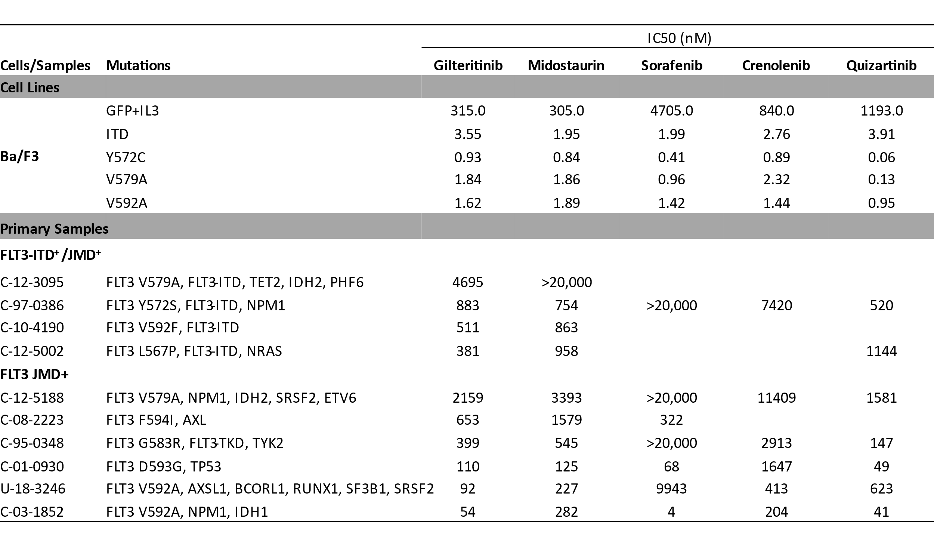

Supplementary Figure 1
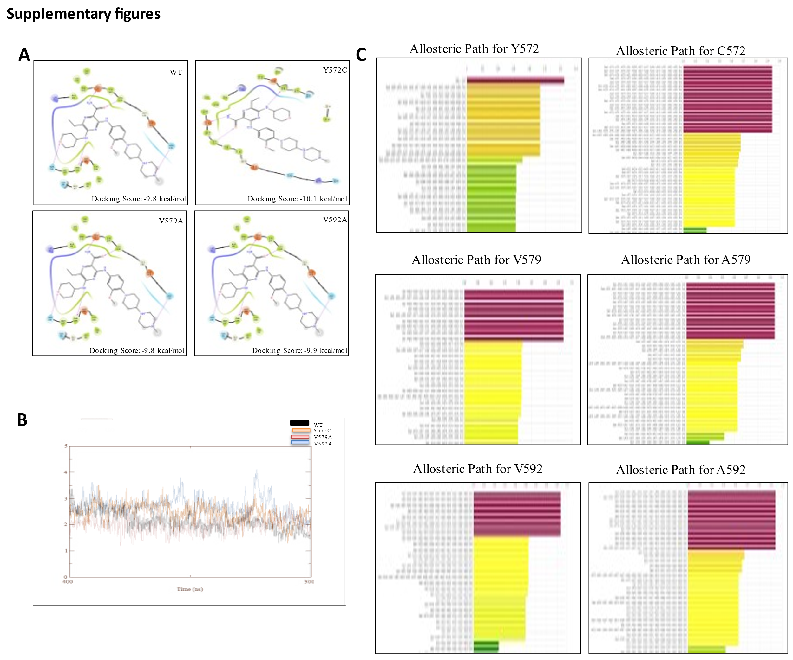

Supplementary Figure 1: Structural analysis of FLT3-JMD point mutations (A) 2-D ligand binding diagram and docking scores representing minimal changes in the ligand orientation. (B) Consolidated plot of RMSF trajectory of the binding pocket for 400 to 500 ns showing minimal deviation from of the mutant structures from the wild-type (WT) structure. (C) Comparison of changes in allosteric pathways, that indicate perturbation propagation from the mutated site to the critical residues of the binding pocket, shows increased pathways and residue number in mutated sites as compared to their WT counterparts.

