
Geochemistry, Geophysics, Geosystems
Supporting Information for
Carbon storage in the Earth’s deep interior implied by carbonate-silicate-metal melt miscibility
A.H. Davis¹, N.V. Solomatova², R. Caracas^{1,3}, and A.J. Campbell⁴
¹The Center for Earth Evolution and Dynamics (CEED), University of Oslo, Oslo, Norway. ²Terramera, Vancouver, British Columbia, Canada. ³Université de Paris, Institut de Physique du Globe de Paris, CNRS, Paris, France. ⁴Department of the Geophysical Sciences, University of Chicago, Chicago, IL, USA.

Contents of this file

Figures S1 to S4
Tables S1 to S9

Introduction
Here, we show an example of the contribution of ΔH_{mix}, ΔS_{mix}, and ΔV_{mix} to ΔG_{mix} at 136 GPa on the MgCO₃-MgSiO₃ binary (Figure S1). Then, we show the effect of the β value on ΔG_{mix} along the MgCO₃-MgSiO₃ binary (Figure S2). In Figure S3, we show the binary and ternary interaction terms fit from the multicomponent mixing volume model as a function of pressure. We show an example of ΔG_{mix} at 0 GPa in the MgCO₃-MgSiO₃-Fe ternary system (Figure S4). We then present tables of data containing the densities and molar volumes for each of the component melts (Tables S1-S7), the Birch-Murnaghan equation of state parameters (Table S8), and the calculated binary and ternary interaction terms and mixing volumes for each multicomponent melt (Table S9).

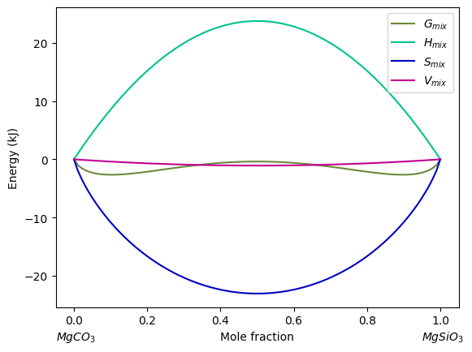
Figure S1. Calculated ΔG_{mix} at 136 GPa on the MgCO₃-MgSiO₃ binary. The teal line is the contribution of the ΔH_{mix} term to ΔG_{mix}. The blue line is the contribution of -TΔS_{mix}, and the pink line is the contribution of PΔV_{mix}. The sum of the teal, blue, and pink lines yields ΔG_{mix.}

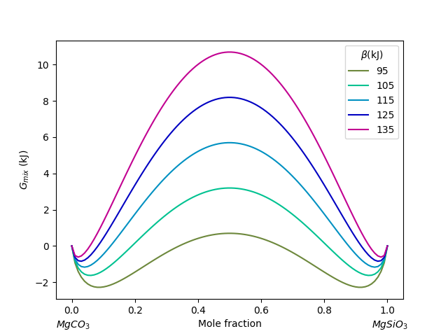
Figure S2. Calculated ΔG_{mix} at 0 GPa on the MgCO₃-MgSiO₃ binary for various values of β in the ΔH_{mix} term.

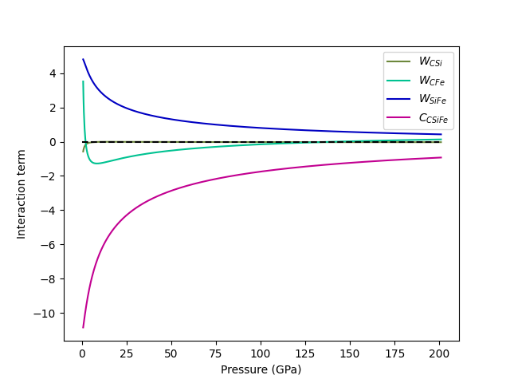
Figure S3. Binary and ternary interaction terms for the power series multicomponent model. The ternary interaction term has the largest magnitude, indicating the largest deviation from an ideal solution.

Table S1
Densities and Molar Volumes of MgCO₃ Melt at Different Pressures
Melt | Pressure (GPa) | Density (g/cc) | Molar Volume (cc/mol)
MgCO₃ | 1.12 | 1.37 | 12.31
MgCO₃ | 3.64 | 1.85 | 9.11
MgCO₃ | 11.5 | 2.46 | 6.85
MgCO₃ | 42.9 | 3.36 | 5.02
MgCO₃ | 78.2 | 3.92 | 4.30
MgCO₃ | 109.0 | 4.31 | 3.91
MgCO₃ | 138.0 | 4.61 | 3.66

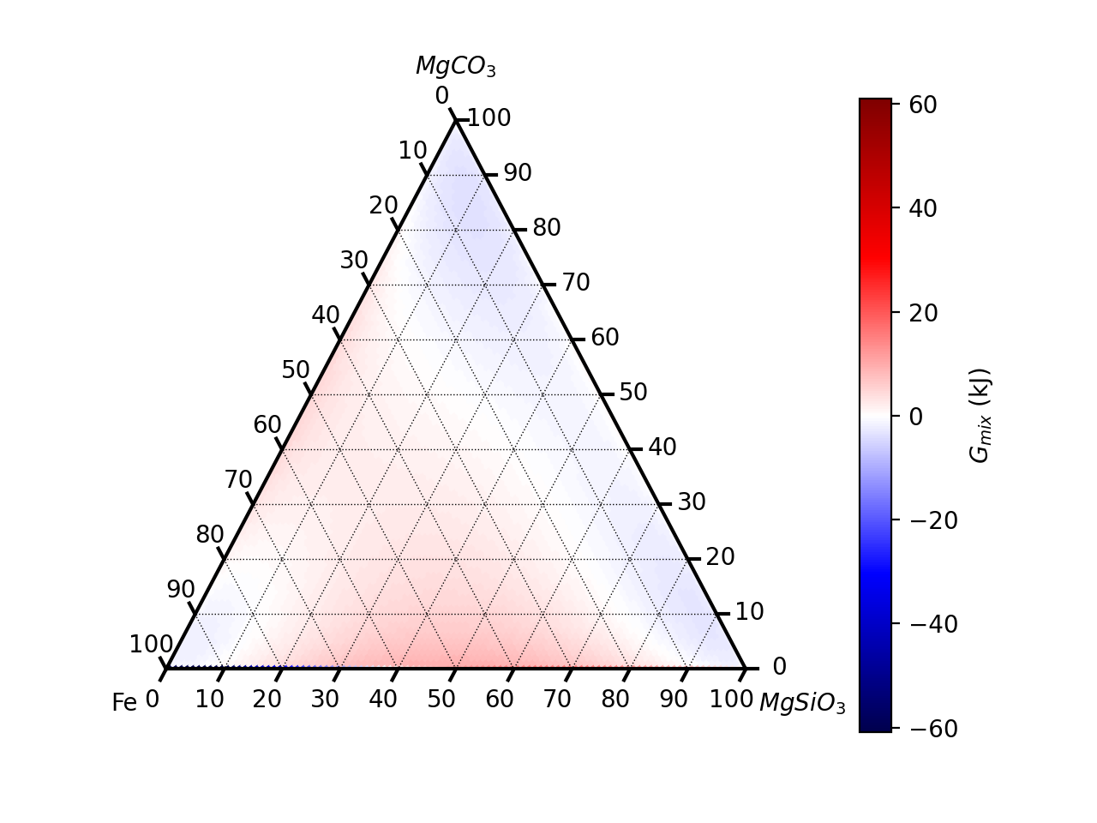
Figure S4. Calculated ΔG_{mix} at 0 GPa on the MgCO₃-MgSiO₃-Fe ternary. The shape of ΔG_{mix} is as expected with limited miscibility near the endmembers along each of the binaries.
Table S4
Densities and Molar Volumes of Carbonate-Silicate Melt at Different Pressures
Melt | Pressure (GPa) | Density (g/cc) | Molar Volume (cc/mol)
Mg(C,Si)O₃ | 0.24 | 1.5 | 12.31
Mg(C,Si)O₃ | 2.28 | 2.03 | 9.1
Mg(C,Si)O₃ | 11.5 | 2.69 | 6.87
Mg(C,Si)O₃ | 47.3 | 3.68 | 5.02
Mg(C,Si)O₃ | 86.2 | 4.29 | 4.31
Mg(C,Si)O₃ | 122.0 | 4.73 | 3.9
Mg(C,Si)O₃ | 158.0 | 5.05 | 3.66

Table S3
Densities and Molar Volumes of Fe Melt at Different Pressures
Melt | Pressure (GPa) | Density (g/cc) | Molar Volume (cc/mol)
Fe | 3.16 | 4.89 | 11.42
Fe | 26.2 | 6.94 | 8.05
Fe | 65.9 | 8.6 | 6.46
Fe | 81.5 | 9.17 | 6.09
Fe | 113.0 | 10.02 | 5.57

Table S2
Densities and Molar Volumes of MgSiO₃ Melt at Different Pressures
Melt | Pressure (GPa) | Density (g/cc) | Molar Volume (cc/mol)
MgSiO₃ | -0.76 | 1.63 | 12.32
MgSiO₃ | 1.35 | 2.2 | 9.13
MgSiO₃ | 11.5 | 2.93 | 6.85
MgSiO₃ | 51.9 | 4.0 | 5.02
MgSiO₃ | 96.6 | 4.67 | 4.30
MgSiO₃ | 142.0 | 5.14 | 3.91
MgSiO₃ | 182.0 | 5.49 | 3.66

Table S7
Densities and Molar Volumes of Carbonate-Silicate-Metal Melt at Different Pressures
Melt | Pressure (GPa) | Density (g/cc) | Molar Volume (cc/mol)
Mg(C,Si)O₃ + Fe | 0.86 | 1.99 | 11.12
Mg(C,Si)O₃ + Fe | 13.6 | 3.21 | 6.89
Mg(C,Si)O₃ + Fe | 25.4 | 3.67 | 6.03
Mg(C,Si)O₃ + Fe | 46.2 | 4.22 | 5.24
Mg(C,Si)O₃ + Fe | 51.9 | 4.34 | 5.1
Mg(C,Si)O₃ + Fe | 73.8 | 4.74 | 4.67
Mg(C,Si)O₃ + Fe | 93.4 | 5.04 | 4.39
Mg(C,Si)O₃ + Fe | 118.0 | 5.35 | 4.14
Mg(C,Si)O₃ + Fe | 148.0 | 5.7 | 3.88

Table S6
Densities and Molar Volumes of Silicate-Metal Melt at Different Pressures
Melt | Pressure (GPa) | Density (g/cc) | Molar Volume (cc/mol)
MgSiO₃ + Fe | -0.02 | 2.12 | 11.11
MgSiO₃ + Fe | 1.14 | 2.32 | 10.18
MgSiO₃ + Fe | 2.01 | 2.48 | 9.48
MgSiO₃ + Fe | 5.83 | 2.87 | 8.24
MgSiO₃ + Fe | 27.1 | 3.81 | 6.19
MgSiO₃ + Fe | 96.8 | 5.21 | 4.52
MgSiO₃ + Fe | 171.0 | 6.07 | 3.88

Table S5
Densities and Molar Volumes of Carbonate-Metal Melt at Different Pressures
Melt | Pressure (GPa) | Density (g/cc) | Molar Volume (cc/mol)
MgCO₃ + Fe | 1.66 | 1.86 | 12.31
MgCO₃ + Fe | 2.28 | 2.03 | 9.1
MgCO₃ + Fe | 3.07 | 2.18 | 6.87
MgCO₃ + Fe | 5.8 | 2.51 | 5.02
MgCO₃ + Fe | 20.4 | 3.34 | 4.31
MgCO₃ + Fe | 73.6 | 4.57 | 3.9
MgCO₃ + Fe | 130.0 | 5.33 | 3.66

Table S9
Binary/Ternary Mixing Parameters and Calculated Mixing Volumes for Binary and Ternary Melt Mixtures at 24, 50, and 136 GPa

Melt | Pressure (GPa) | Mixing parameter | Mixing volume (cc/mol)
Mg(C,Si)O₃ | 24 | -0.01 | -0.003
Mg(C,Si)O₃ | 50 | -0.02 | -0.005
Mg(C,Si)O₃ | 136 | -0.03 | -0.007
MgCO₃ + Fe | 24 | -0.94 | -0.08
MgCO₃ + Fe | 50 | -0.52 | -0.05
MgCO₃ + Fe | 136 | -0.02 | -0.002
MgSiO₃ + Fe | 24 | 2.00 | 0.18
MgSiO₃ + Fe | 50 | 1.31 | 0.12
MgSiO₃ + Fe | 136 | 0.62 | 0.05
Mg(C,Si)O₃ + Fe | 24 | -1.14 | -0.002
Mg(C,Si)O₃ + Fe | 50 | -0.66 | 0.008
Mg(C,Si)O₃ + Fe | 136 | -0.13 | 0.018

Table S8
Birch-Murnaghan Equation of State Fit Parameters for Simulated Melt Compositions
Melt | K₀ (GPa) | V₀ (Å³) | K₀’
MgCO₃ | 2 (3) | 2.8 (8) x 10³ | 6 (2)
MgSiO₃ | 10 (2) | 2.03 (7) x 10³ | 5.9 (3)
Fe | 19 (2) | 2.32 (5) x 10³ | 4.6 (1)
Mg(C,Si)O₃ | 5 (4) | 2.3 (3) x 10³ | 5.8 (9)
MgCO₃ + Fe | 20 (5) | 2.2 (2) x 10³ | 4†
MgSiO₃ + Fe | 11 (1) | 2.40 (4) x 10³ | 5.3 (1)
Mg(C,Si)O₃ + Fe | 6 (3) | 2.6 (2) x 10³ | 5.9 (5)
Pyrolite¹ | 12 (1) | 1.83 (3) x 10³ | 5.4 (1)
Pyrolite + 8CO¹ | 5 (1) | 2.36 (7) x 10³ | 6.2 (3)
Note. ¹From Solomatova et al. (2019). †Held fixed.

