Supplementary Materials
Stone Decision Engine accurately predicts stone removal and treatment complications for extracorporeal shock wave lithotripsy and laser ureterorenoscopy patients

Authors: Peter A Noble^{1*}, Blake D. Hamilton², Glenn Gerber³.
Affiliations
¹Department of Microbiology, University of Alabama Birmingham, Birmingham, AL 35294.
²School of Medicine, University of Utah, Salt Lake City, USA 84132
³University of Chicago Medical Center, Chicago, IL 60637

*Correspondence to: Peter A Noble: panoble2017@gmail.com, Phone: 206-409-6664.

Draft version date
January 17, 2024

Contents
- FIGURES S1 -- S4
- TABLES S1 – S16

- FIGURES S1 – S4

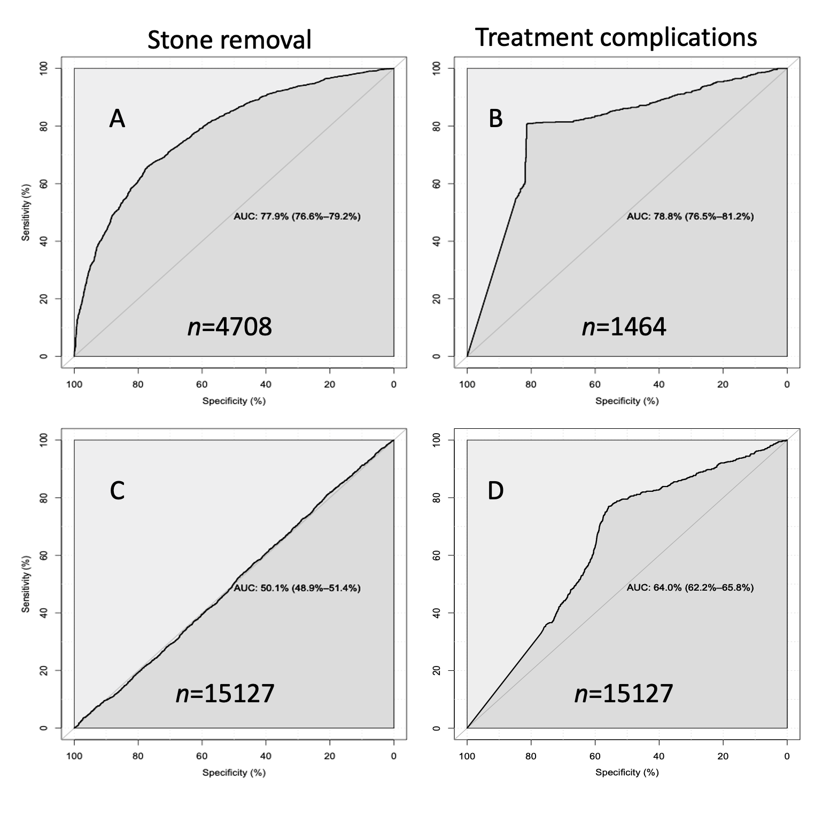
Fig. S1. AUCs of SWL stone removal and treatment complications for ANN models built using balanced data sets. A, B; AUCs based on model tested with 70% training/30% testing and validation data sets; C, D; AUCs obtained by testing the models on the entire dataset.

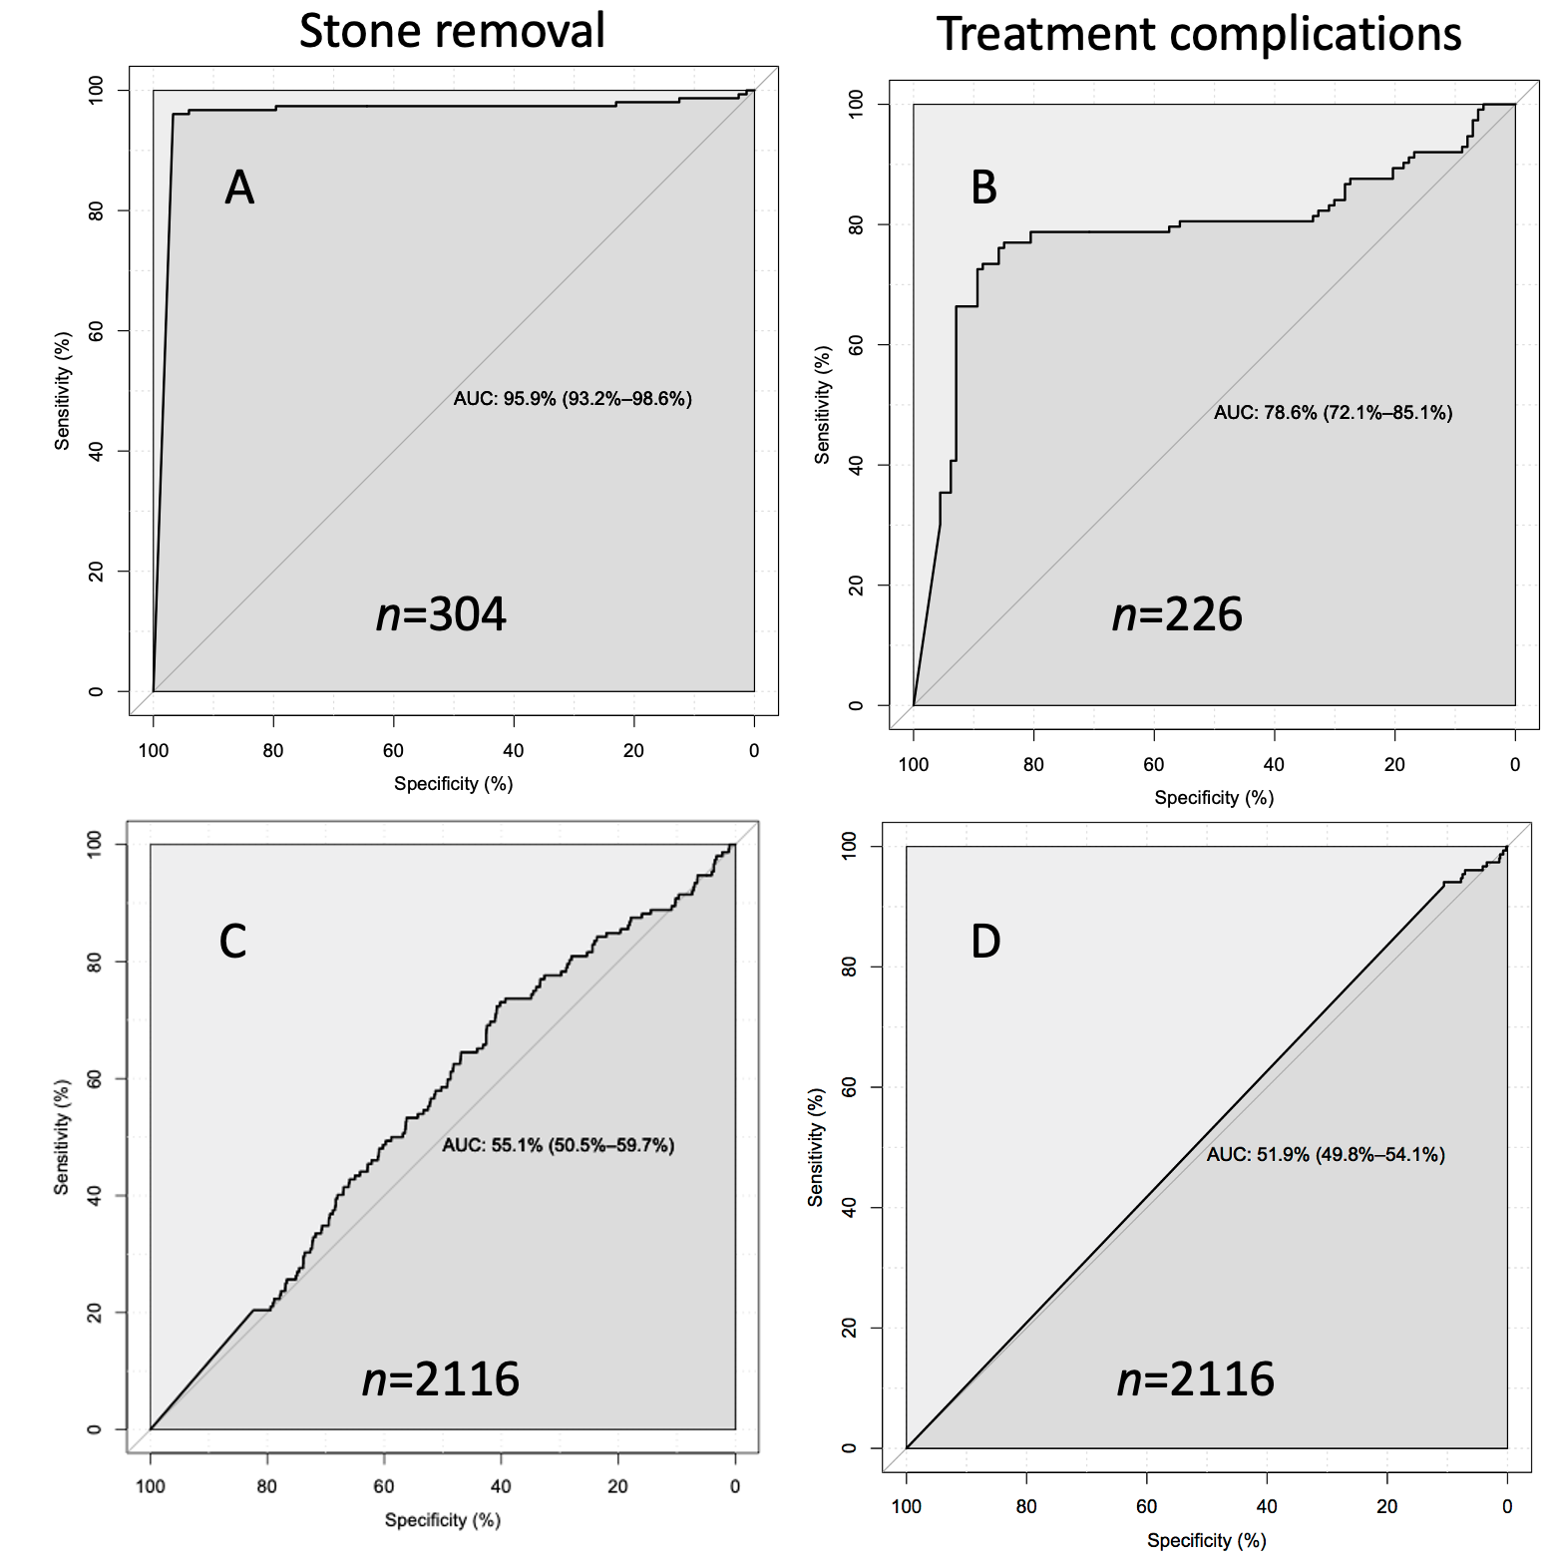
Fig. S2. AUCs of URS stone removal and treatment complications for ANN models built using balanced data sets and tested with entire data sets. A, B; AUCs based on models tested with 70% training/30% test and validation data sets; C, D; AUCs obtained by testing the models on the entire dataset.

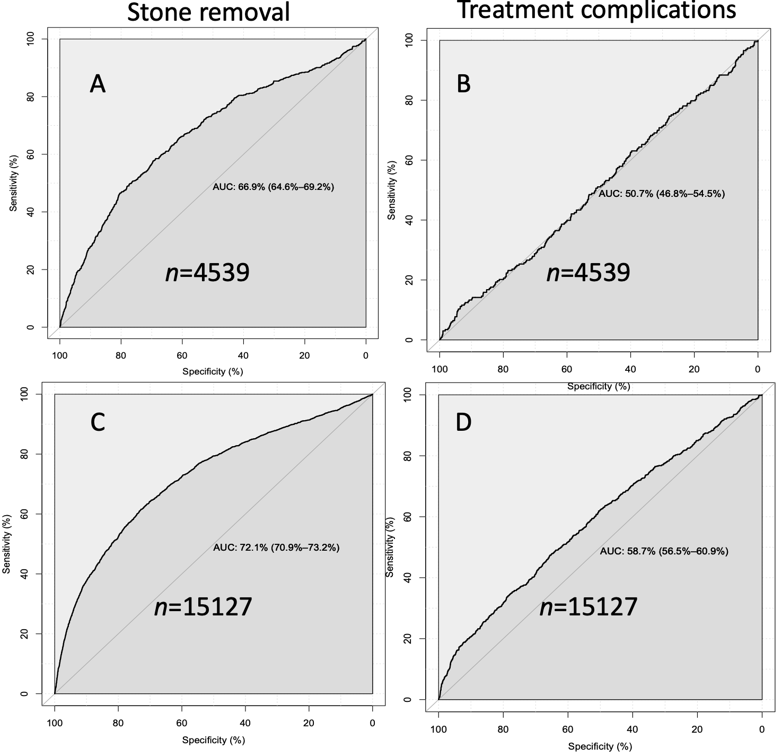
Fig. S3. AUCs of SWL stone removal and treatment complications for ANN models built using SMOTED data sets and tested with validation (A, B) and the entire data set (C, D).
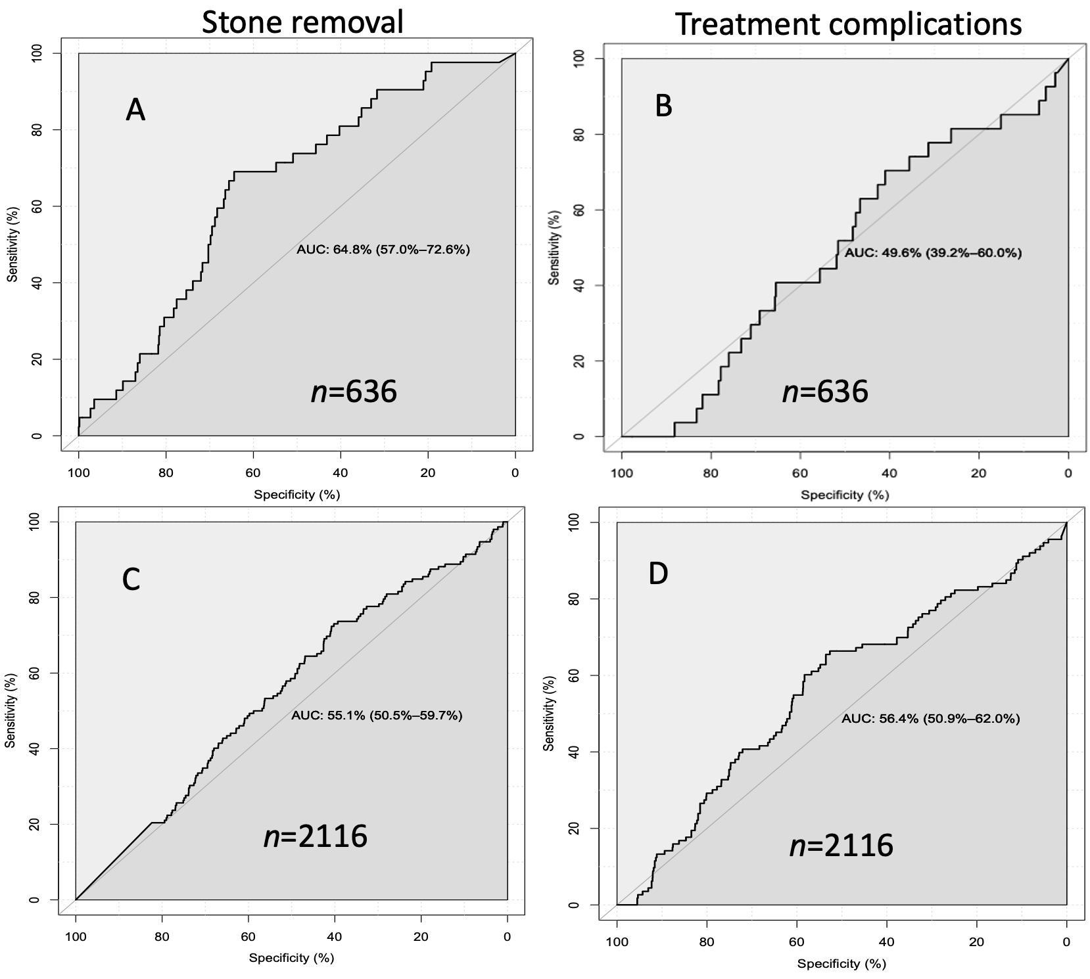
Fig. S4. AUCs of URS stone removal and treatment complications for ANN models built using SMOTED data sets and tested with validation (A, B) and the entire data set (C, D).

- TABLES S1 – S16

Table S1. Confusion matrix of SWL ‘Stone removal’ using balanced data set (n=4708 records).
Actual (below) /Predictions (across) | 0 | 1 | Sum
0 | 38.7% (n=1824) | 11.2% (n=530) | 2354
1 | 15.0% (n=710) | 34.9% (n=1644) | 2354
 |  |  | 73.7% (n=4708)
0, stone removal success; 1, stone removal failure.

Table S2. Confusion matrix of SWL ‘Stone removal’ model (Table S1) using the entire data set (n=15127 records).
Actual (below) /Predictions (across) | 0 | 1 | Sum
0 | 17.6% (n=2663) | 66.8% (n=10110) | 12773
1 | 11.0% (n=1659) | 4.6% (n=694) | 2353
 |  |  | 22.2% (n=15126)
0, stone removal success; 1, stone removal failure.

Table S3. Confusion matrix of SWL ‘Treatment complication’ model using balanced data set (n=1466 records).
Actual (below) /Predictions (across) | 0 | 1 | Sum
0 | 40.5% (n=594) | 9.4% (n=138) | 732
1 | 9.6% (n=140) | 40.5% (n=594) | 734
 |  |  | 81.0% (n=1466)
0, No treatment complications; 1, Treatment complication
Table S4. Confusion matrix of SWL ‘Treatment complications’ model (Table S3) using the entire data set (n=15127 records).
Actual (below) /Predictions (across) | 0 | 1 | Sum
0 | 52.9% (n=8004) | 42.2% (n=6391) | 14395
1 | 1.1% (n=167) | 3.7% (n=564) | 731
 |  |  | 56.6% (n=15126)
0, No treatment complications; 1, Treatment complication
Table S5. Confusion matrix of URS ‘Stone removal’ using a balanced data set (n=304 records).
Actual (below) /Predictions (across) | 0 | 1 | Sum
0 | 46.4% (n=141) | 3.6% (n=11) | 152
1 | 3.6% (n=11) | 46.4% (n=141) | 152
 |  |  | 92.8% (n=304)
0, stone removal success; 1, stone removal failure.

Table S6. Confusion matrix of URS ‘Stone removal’ model (Table S5) using the entire data set (n=2116 records).
Actual (below) /Predictions (across) | 0 | 1 | Sum
0 | 9.2% (n=195) | 83.6% (n=1769) | 1964
1 | 0.4% (n=9) | 6.8% (n=143) | 152
 |  |  | 16.0% (n=2116)
0, stone removal success; 1, stone removal failure.

Table S7. Confusion matrix of URS ‘Treatment complications’ using a balanced data set (n=226 records).
Actual (below) /Predictions (across) | 0 | 1 | Sum
0 | 43.4% (n=98) | 6.6% (n=15) | 113
1 | 13.3% (n=30) | 36.7% (n=83) | 113
 |  |  | 80.1% (n=226)
0, No treatment complications; 1, Treatment complications.

Table S8. Confusion matrix of URS ‘Treatment complications’ model (Table S7) using the entire data set (n=2116 records).
Actual (below) /Predictions (across) | 0 | 1 | Sum
0 | 59.2% (n=1252) | 35.5% (n=751) | 2003
1 | 1.4% (n=30) | 3.9% (n=83) | 113
 |  |  | 63.1% (n=2116)
0, No treatment complications; 1, Treatment complications.

Table S9. Confusion matrix of SMOTED SWL stone removal success model using validation data set (hold out; n=4539).
Actual (below) /Predictions (across) | 0 | 1 | Sum
0 | 80% (n=3613) | 5% (n=220) | 3833
1 | 13%(n=571) | 3% (n=135) | 706
 |  |  | 82.5% (n=4539)
0, stone removal success; 1, stone removal failure.

Table S10. Confusion matrix of SMOTED SWL stone removal success model using entire data set (n=15127).
Actual (below) /Predictions (across) | 0 | 1 | Sum
0 | 81% (n=12185) | 4% (n=588) | 12773
1 | 12% (n=1796) | 4% (n=557) | 2353
 |  |  | 84.2% (n=15126)
0, stone removal success; 1, stone removal failure.

Table S11. Confusion matrix of SMOTED SWL treatment complications model using validation data (hold out; n=4539).
Actual/Predictions | 0 | 1
0 | 94% (n=4260) | 1% (n=46) | 4306
1 | 5% (n=226) | 0% (n=7) | 233
 |  |  | 94.0% (n=4539)
0, No treatment complications; 1, Treatment complications.

Table S12. Confusion matrix of SMOTED SWL treatment complications model using entire data set (n=15126).
Actual (below) /Predictions (across) | 0 | 1 | Sum
0 | 94% (n=14257) | 1% (n=138) | 14395
1 | 5% (n=693) | 0% (n=38) | 731
 |  | s | 94.4% (n=15126)
0, No treatment complications; 1, Treatment complications.

Table S13. Confusion matrix of SMOTED URS stone removal model using validation data set (hold out; n=636).
Actual (below) /Predictions (across) | 0 | 1 | Sum
0 | 89% (n=564) | 5% (n=29) | 593
1 | 6% (n=38) | 1% (n=4) | 42
 |  |  | 89.4% (n=635)
0, stone removal success; 1, stone removal failure.

Table S14. Confusion matrix of SMOTED URS stone removal model using entire data set (n=2116).
Actual (below) /Predictions (across) | 0 | 1 | Sum
0 | 93% (n=1964) | 0% (n=0) | 1964
1 | 7% (n=152) | 0% (n=0) | 152
 |  |  | 88.6% (n=2116)
0, No treatment complications; 1, Treatment complications.

Table S15. Confusion matrix of SMOTED URS treatment complications model using validation data set (hold out; n=636).
Actual (below) /Predictions (across) | 0 | 1 | Sum
609 | 88% (n=557) | 8% (n=52) | 609
27 | 4% (n=23) | 1% (n=4) | 27
 |  |  | 88.2% (n=636)
0, No treatment complications; 1, Treatment complications.

Table S16. Confusion matrix of SMOTED URS treatment complications model using entire data set (n=2116).
Actual (below) /Predictions (across) | 0 | 1 | Sum
0 | 92% (n=1955) | 2% (n=48) | 2003
1 | 5% (n=108) | 0% (n=5) | 113
 |  |  | 92.6% (n=2116)
0, No treatment complications; 1, Treatment complications.

