Supplemental Information for
Effect of Charged Block Length Mismatch on Double Diblock Polyelectrolyte Complex Micelle Cores
Kaden C. Stevens,¹ Matthew V. Tirrell*¹
¹Pritzker School of Molecular Engineering, The University of Chicago, Chicago, Illinois 60637, USA
Table of Contents
1. Experimental 2
2. PEC Images 4
3. Nuclear Magnetic Resonance (NMR) 5
4. Transmission Electron Microscopy (TEM) 6
5. Small-angle X-ray Scattering (SAXS) 7
6. SI References 8

1. Experimental
1.1 Materials
All solvents and chemicals were purchased from Sigma-Aldrich and used without any further purification unless otherwise noted. Gen 3 Grubbs Catalyst (G3) was prepared from reacting pyridine and Gen 2 Grubbs obtained from Sigma-Aldrich through standard literature procedure.¹
1.2 Monomer Synthesis
To prepare ROMP monomer NB we utilized previously described methods.² 250 mL of anhydrous tetrahydrofuran (THF) was cannula transferred into a flame dried 500 mL glass round bottom flask filled with 4.5 g of cis-endo-2,3-bis(hydroxymethyl)bicyclo[2.2.1]hept-5-ene. Dry triethyl amine (TEA) was added. Next, an addition funnel was attached to the apparatus and filled with 25mL of dry THF and 10.5 mL of α-bromoisobutyryl bromide (BIB). The round bottom was placed in an ice bath and BIB solution was added dropwise over the course of 30 minutes. White TEA salts precipitated out of solution as the reaction proceeded. The solution was left to stir at room temperature overnight. The crude product was filtered, concentrated, redissolved in diethyl ether and washed once with water (200 mL) twice with saturated sodium bicarbonate (200 mL) and once again with water before the magnesium sulfate was added to the organic phase. Once dry, the solution was concentrated via vacuum overnight, resulting in a yellow beige powder. The crude product was purified via column chromatography using 20:1 hexane:ethyl acetate. Fractions containing product were identified via thin-layer chromatography (TLC) with iodine staining and subsequently concentrated via rotary evaporation, dissolved in ethyl acteate, filtered through 0.2 um polytetrafluoroethylene (PTFE) filters and allowed to crystallize in a 70x55mm crystallization dish overnight, resulting in white crystals of NB.
1.3 PolyNB Synthesis
ROMP polymerizations of the Poly(NB) macroinitiator were carried out in an inert glovebox. A 1 M stock of NB in CHCl2 and 5mM Stock of G3 in CH₂Cl₂ were used to add the appropriate amounts of NB and G3 to the reaction vessel. The reaction was allowed to proceed for 15 minutes and then quenched with an excess of ethyl vinyl ether and stirred for an additional 30 minutes before removal from the glovebox. The mixture was diluted with CH₂Cl₂ and precipitated into MeOH via dropwise addition. The precipitate was filtered and dried via vacuum to give Poly(NB).
1.4 Bottlebrush Synthesis
Bottlebrush polymers were grown via a grafting from approach using ATRP off our polyNB macroinitiator. We aimed for low conversion to avoid the well-known tendency of multifunctional initiators to couple at low polymerization conversions.³
To grow polyNB-g-DMAEMA, we dissolved PNB, N,N,N′,N′′,N′′-Pentamethyldiethylenetriamine and DMAEMA in anisole such that DMAEMA was at 0.5 M. The solution was degassed using ultrapure Argon for 30 minutes. CuCl and CuCl₂ were added at a ratio of 1:0.25:1 of CuCl:CuCl₂:initiating sites. The polymers were precipitated into hexanes, dissolved into CHCl₃, filtered through a silica plug and reprecipitated into hexanes before being dried via vacuum. PolyNB-g-DMAEMA was then dissolved in dioxane and introduced to iodomethane at a 4-6x excess of iodomethane to amine. The resulting yellow mixture was filtered and the solid collected was dissolved in water in the presence of a counterion exchange resin at 1:10:100 mass ratio of polymer:resin:water. This mixture was stirred for 24 hours and then filtered. The filtered solution was then dialyzed against four liters of 3 M NaCl for three days, with the solution changed once per day before being dialyzed against DI H₂O. The solution was filtered and lyophilized to provide a white powder.
PolyNB-g-tBMA was synthesized using the same procedures as polyNB-g-DMAEMA except the solvent was ethyl acetate. The polymer was precipitated in methanol, redissolved in CHCl₃, filtered through a silica plug and precipitated in methanol again before being dried via vacuum. The resulting polymer was dissolved in hexafluoro-2-propanol (HFIP) at 50 mg/mL before concentrated HCl was added slowly at 2x excess of tert-butyl groups. Upon the addition of acid, the polymer crashed out of solution as a waxy white solid. The minimum amount of water to dissolve the polymer was added to allow the reaction to proceed for 8 hours at room temperature. The resulting mixture was dialyzed against four liters of DI water for 5 days with the water changed twice a day. De-tert butylation efficiency was checked via 1H NMR. If necessary, this procedure was repeated to achieve full de-tert butylation.
1.5 Polymer Characterization
To determine polymer molecular weight and dispersity, size exclusion chromatography-multi-angle light scattering (SEC-MALS) was performed on a Shimadzu Prominence LC system with a Wyatt Dawn Heleos MALS detector with a 658 nm laser and a SPD-M30A Photodiode Array detector. The eluent was chromatography grade tetrahydrofuran running at 1 mL/min at 25 °C. Wyatt Astra software was used to process the data. The polymers dn/dc was measured. ¹H NMR spectra were obtained using either D₂O or CD₂Cl₂ on a Bruker Avance 400 MHz NMR spectrometer at room temperature (25C).
1.6 Complex Preparation
Complexes were prepared at 1:1 charge stoichiometric conditions between anionic and cationic repeat units. The complexes were formed by sequential addition of water, NaCl stock solution, polycation and polyanion and immediately vortexed. All solutions were titrated to a pH of 10 to ensure all polyelectrolytes were fully charged. The total polymer concentration for each sample was fixed at 10 mg/mL.
1.7 Optical Microscopy
To directly image BPEC morphology at the microscale, we used optical phase contrast microscopy on a Leica DMI 6000B. Images were acquired using Leica Application Suite software. PEC samples were prepared at 100 μL total volume and transferred into ultralow attachment 96-well plates immediately after having been vortexed. These plates were sealed to minimize evaporation. Microscopy samples were allowed to age overnight to ensure the phase separation process was largely completed.
1.8 Rheology
Rheology experiments were performed on a stress-controlled Discovery HR-3 rheometer from TA Instruments. A 20 mm parallel plate geometry was used. During measurements, supernatant was added to a solvent trap attachment and around the complex to ensure the BPEC stayed hydrated throughout. Frequency sweeps were performed at 45 to 15°C.
1.9 Transmission Electron Microscopy
Cryo-TEM images were obtained using a Thermo Titan Krios G3i at 300kV at 81,000x with a Gatan 3 direct detector. Bottlebrush and BPEC Samples were prepared at 0.5 mg/mL total polymer concentration. Then, 3.5 μL of sample was blotted onto a plasma cleaned Quantifoil copper grid 200 mesh 1.2/1.3, blotted for 1 second, and rapidly plunged into liquid ethane.

1.10 Small Angle X-ray Scattering (SAXS)
SAXS was collected at beamline 12-ID-B at the Advanced Photon Source at Argonne National Laboratory. Samples were loaded into holes drilled in an aluminum strip and sealed with Kapton tape to minimize evaporation and irradiated with 14 keV photon energy at 4 and 2.4 meter detector distance. Data reduction, background subtraction and data fitting were performed using the Irena plugin package within Igor. Data were fit with a two-level Beaucage model where the R_{g} of the first level were set to low intensity and high size values so as not to interfere with modeling of the Porod slope at low q.

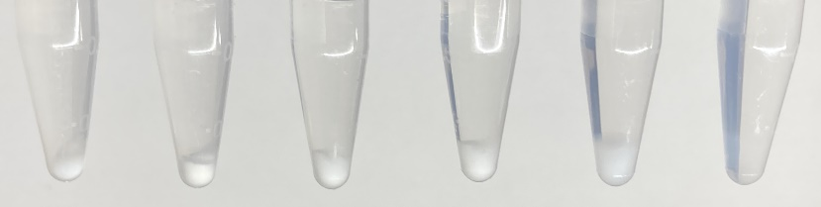
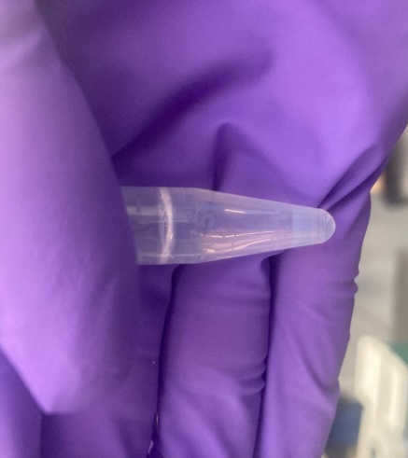
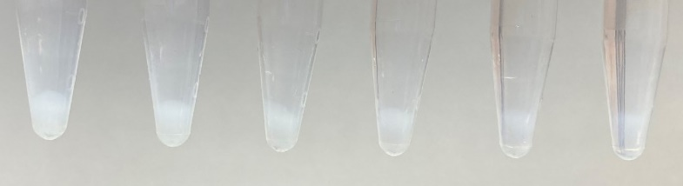
2. PEC Images
(A)
(B)
(C)
Figure S1. Photographs of BPECs of PMANa and PTMAEMA_{L} with matched sidechains as a function going from (A) 0-500 mM NaCl from left to right in 100 mM increments (B) 400-500 mM NaCl from left to right in 20 mM increments. (C) Photograph of BPECs with 500 mM added salt with a colored background to make the faint complex more visually apparent.

3. Nuclear Magnetic Resonance (NMR)
Figure S2 ¹H NMR of (top) PNB macroinitiator in CD₂Cl₂ (middle) PNB-g-TMAEMA in D₂O and (bottom) PNB-g-MANa in D₂O.

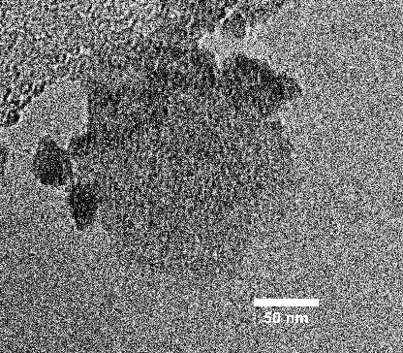
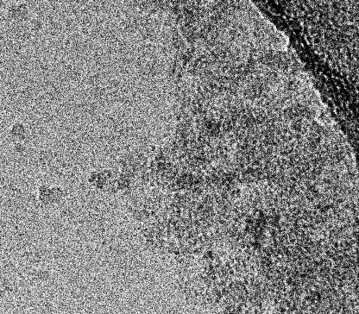
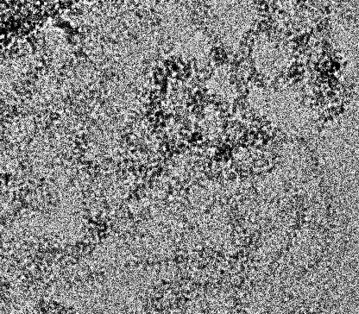
4. Transmission Electron Microscopy (TEM)
Figure S3. Cryo-TEM microscopy of bottlebrushes of BPECs with matched sidechains at 0, 250 and 500 added NaCl from left to right. These images more clearly demonstrate the difference between lightly filled spaces in the 250 mM added salt samples and the empty spaces outside the complex. These images were acquired at 120,000 x magnification. Scale bar is 50 nm.
0 mM
250 mM
500 mM

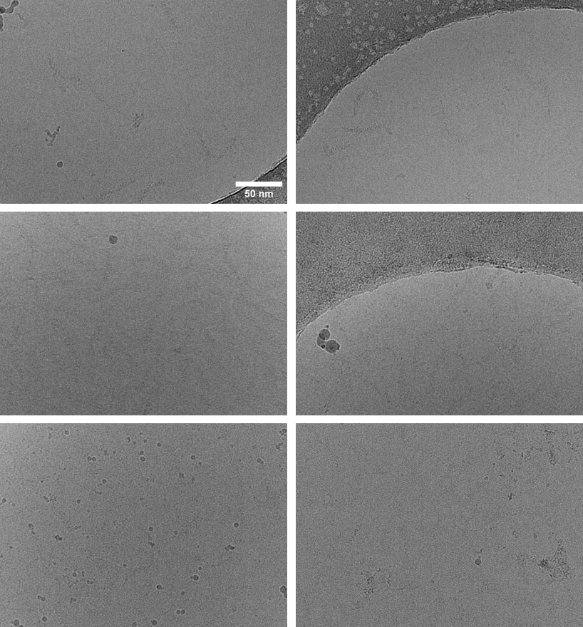
Figure S4. Cryo-TEM microscopy of PMANa bottlebrushes 0, 250 and 500 added NaCl top to bottom.

0 mM
250 mM
500 mM
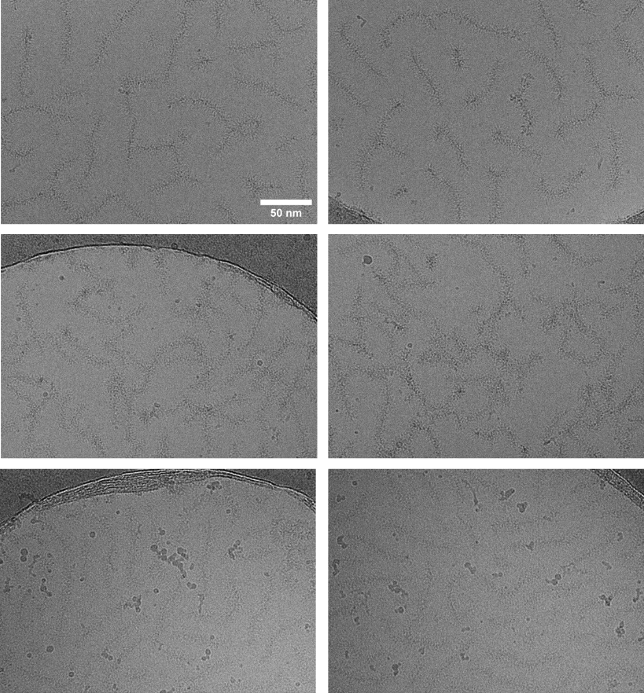
0 mM
250 mM
500 mM
Figure S5 Cryo-TEM microscopy of PTMAEMA_{L} bottlebrushes 0, 250 and 500 added NaCl top to bottom.

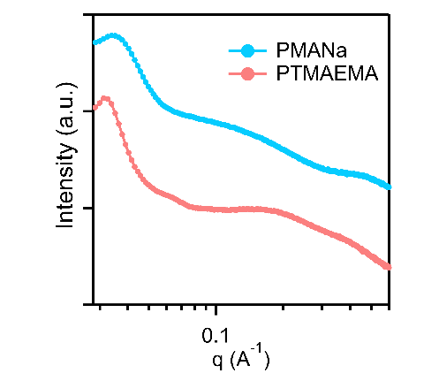
5. Small-angle X-ray Scattering (SAXS)
Figure S6 SAXS of bottlebrushes at 20 wt%. Correlation peaks at low q correspond to average inter-bottlebrush distances of 17.7 nm and 19.3 nm for PMANa and PTMAEMA_{L}, respectively.

References
1. Love, J. A.; Morgan, J. P.; Trnka, T. M.; Grubbs, R. H. A practical and highly active ruthenium‐based catalyst that effects the cross metathesis of acrylonitrile. Angewandte Chemie 2002, 114 21, 4207-4209.

2. Yamauchi, Y.; Horimoto, N. N.; Yamada, K.; Matsushita, Y.; Takeuchi, M.; Ishida, Y. Two‐Step Divergent Synthesis of Monodisperse and Ultra‐Long Bottlebrush Polymers from an Easily Purifiable ROMP Monomer. Angewandte Chemie 2021, 133 3, 1552-1558. DOI: 10.1002/ange.202009759.

3. Matyjaszewski, K.; Miller, P. J.; Pyun, J.; Kickelbick, G.; Diamanti, S. Synthesis and Characterization of Star Polymers with Varying Arm Number, Length, and Composition from Organic and Hybrid Inorganic/Organic Multifunctional Initiators. Macromolecules 1999, 32 20, 6526-6535. DOI: 10.1021/ma9904823.

