Supporting Information

Prediction of the Essential Intermolecular Contacts for Side-Binding of VASP on F-Actin

Fikret Aydin^{#,1,a}, Harshwardhan H. Katkar^{#,1,b}, Alisha Morganthaler^{#,2}, Alyssa J. Harker², David R. Kovar², Gregory A. Voth^{1,*}
¹ Department of Chemistry, Chicago Center for Theoretical Chemistry, The James Franck Institute, and Institute for Biophysical Dynamics, University of Chicago, Chicago, IL 60637
² Department of Biochemistry and Molecular Biology and Department of Molecular Genetics and Cell Biology, University of Chicago, Chicago, IL 60637
#Authors Contributed Equally

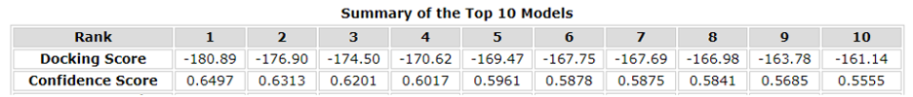
Table S1: Docking score for FAB binding to F-actin. The highest docking score corresponds to the binding site on F-actin shown in Figure 2 of the main article.
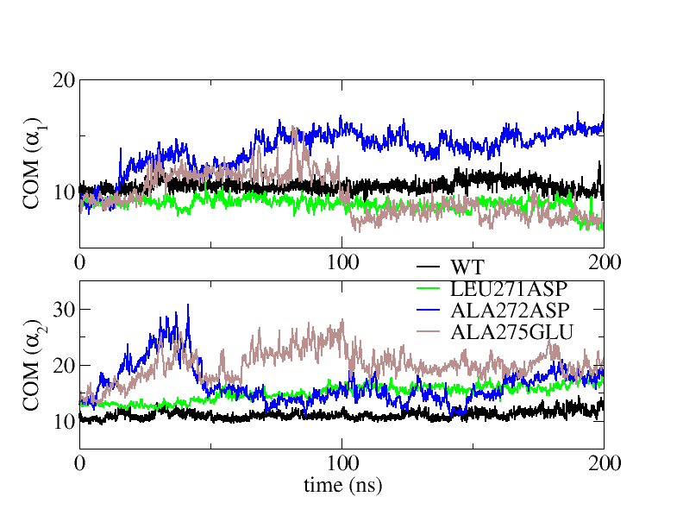
Figure S1: Center-of-mass distance between each helix and nearby F-actin residues. Center-of-mass was calculated using Cα atoms only. Nearby F-actin residues were those with an initial Cα-Cα distance of 12 Å from FAB.

