Geophysical Research Letters
Supporting Information for
Convective Self-Aggregation Occurs Without Radiative Feedbacks in Warm Climates
Lin Yao¹ and Da Yang^{1,2}

¹University of California, Davis, CA, USA.
²Lawrance Berkeley National Laboratory, Berkeley, CA, USA.

Contents of this file:
- Text S1 to S2
- Figures S1 to S3

Text S1. SGS Decomposition
We decompose the total SGS variance production into contributions from surface fluxes and other SGS processes (Equation (3)). Figure S1 shows that both processes contribute to the total SGS variance production significantly. Surface fluxes have a negative contribution to CSA in climates warmer than 280 K. This negative role is consistent with the LMSE variance analysis and mechanism-denial experiments for surface fluxes at 300 K in Yao, Yang and Tan (2022) (their Figures 4 and B2), where CSA reaches a slightly stronger magnitude with homogenized surface fluxes. On the other hand, the role of surface fluxes is positive at 280 K, which may be attributed to the WISHE feedback (Wing and Emanuel 2014), but further decomposition is needed to confirm the hypothesis.

Figure S2 shows the vertical structure of LMSE variance production from other SGS processes excluding surface fluxes. The contribution is dominant in the lower troposphere, where turbulence mixes air particles and damps the LMSE variance.

Text S2. 2D simulations at 315 K
We perform additional 2D simulations at 315 K to test the robustness of our 2D findings. Figure S3 presents the development of CSA in both the control and mechanism-denial experiments. This result further supports our hypothesis that CSA occurs without radiative feedbacks in a warmer climate.

Supplemental Figures.
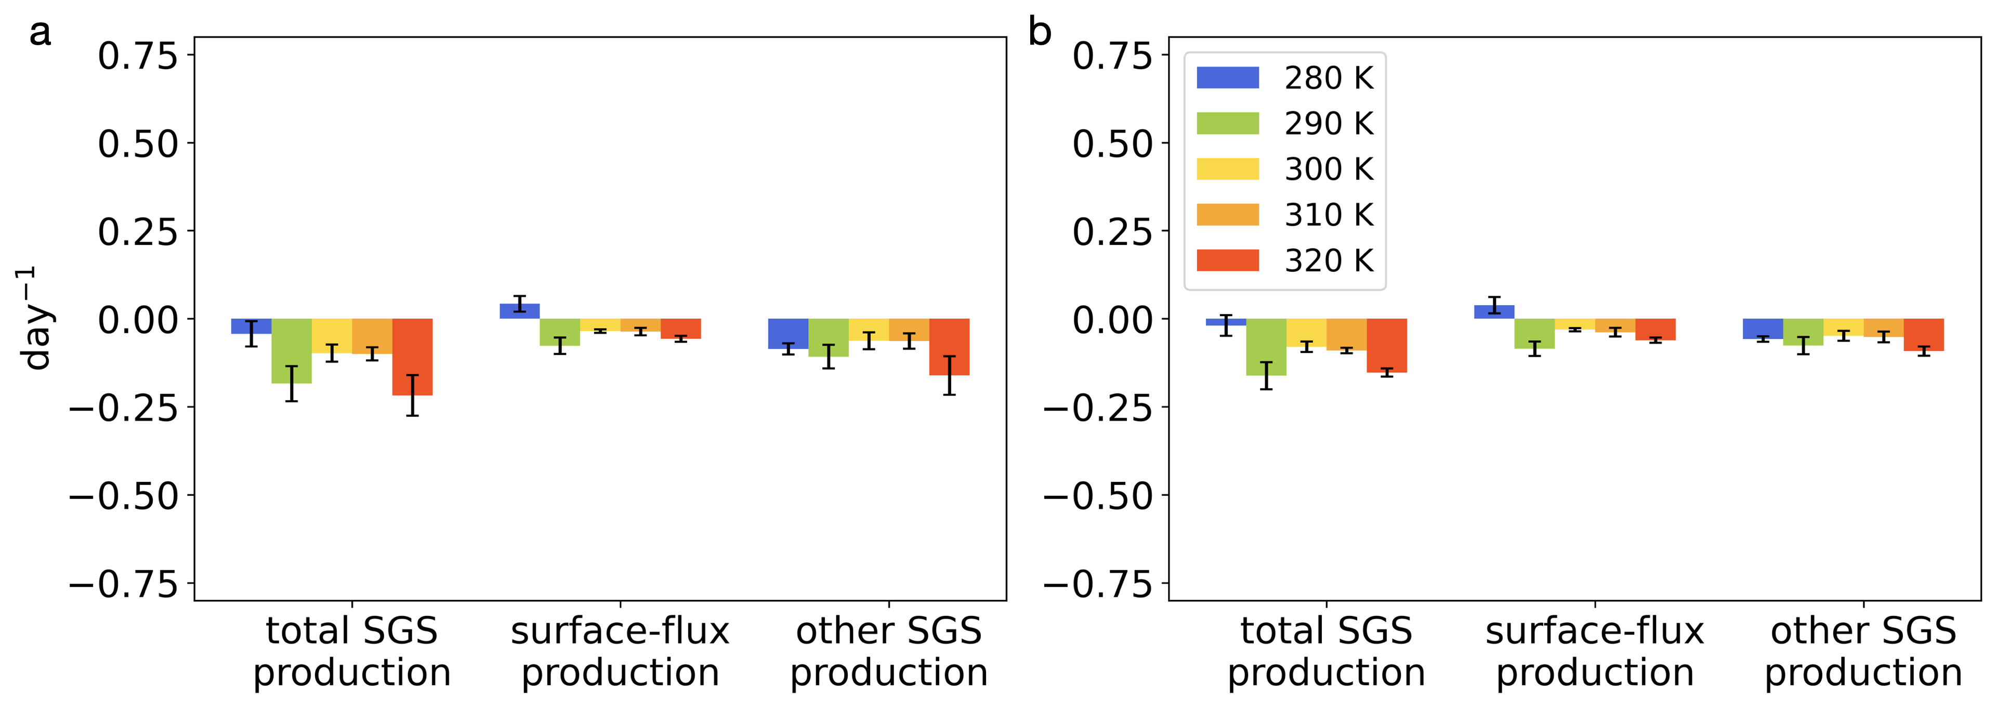
Figure S1. The decomposition of the total SGS variance production (Equation (3)) in the (a) development and (b) mature stages.

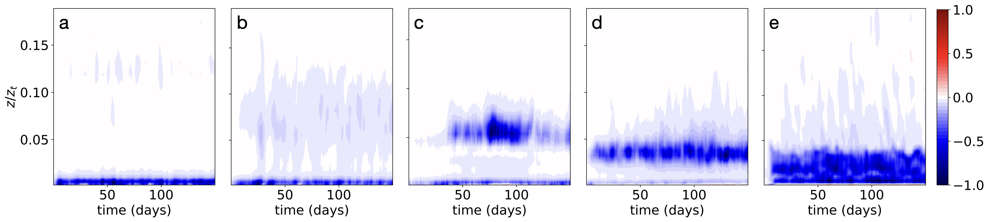
Figure S2. The vertical distribution of LMSE variance production from other SGS processes excluding surface fluxes among various climates (280-320 K). The formula is $\overline{{F^{'}∂}_{z}\left(h^{'}\right)}$ (see Equation (3)). Each panel has been normalized by the maximum absolute value of $\overline{{F^{'}∂}_{z}\left(h^{'}\right)}$ in the respective climate.

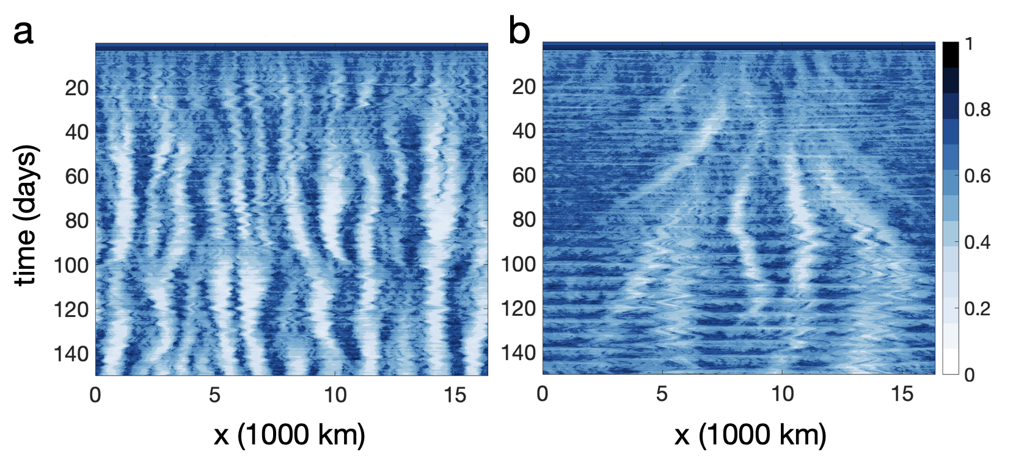
Figure S3. Hovmöller diagrams of CRH in the 2D (a) control and (b) mechanism-denial experiments at 315 K.

