Supplemental Figure 1. Flat purple mat collected intact with underlying sediment and overlying water column, collected in 2014. The polycarbonate core was 20 cm tall and 7 cm diameter. Purple microbial mat (top half of core tube) was ~mm thick and filaments easily covered tube sides as seen on the right of the image.
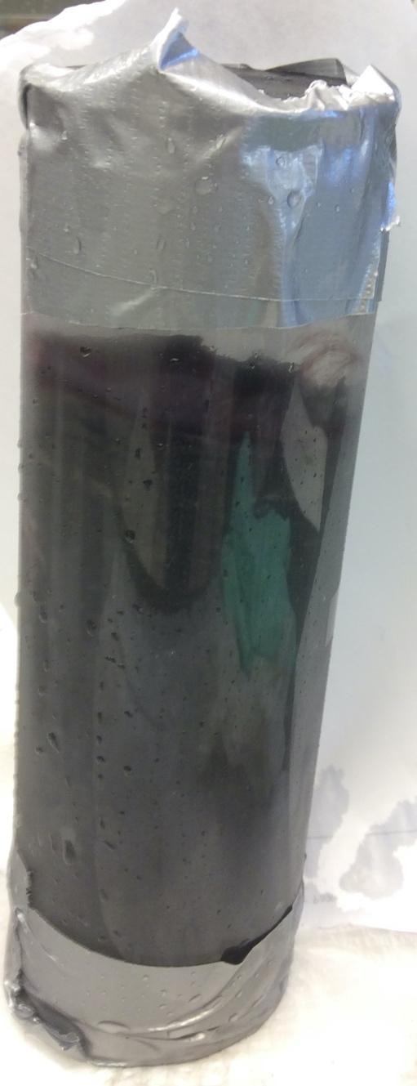
Supplemental Figure 2. δ¹⁸O and modeled percentage of groundwater at specific locations in MIS arena in 2016. Samples collected in spring are marked purple, and yellow for samples collected in autumn. The moored buoy in 2015 was located at 45° 11.918'N, 83° 19.662'W.
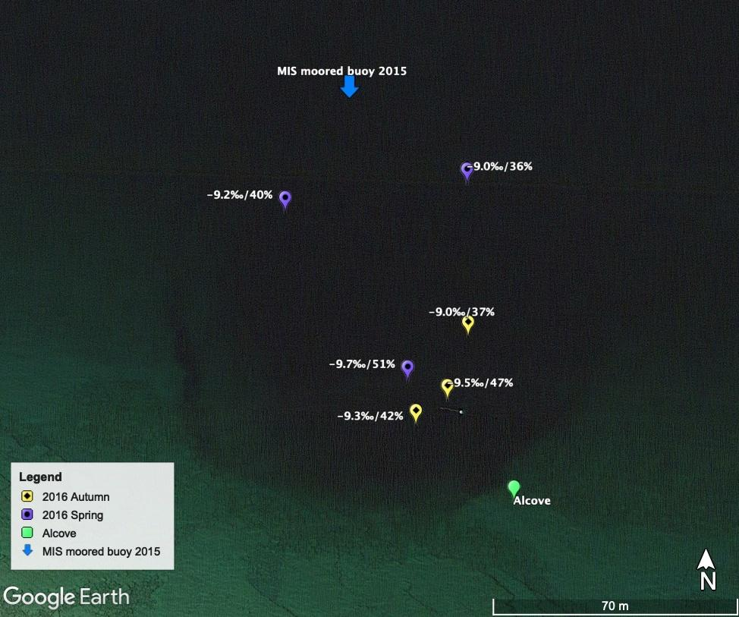

Supplemental Figure 3. Quantities of light available at 23 m in the MIS arena or in the open water outside of MIS (“open”) from hyperspectral casts. The available light (y-axis) is plotted for each wavelength (x-axis) of PAR. Different sampling days are represented with colors, and separate casts from the same day are in solid or dashed lines.

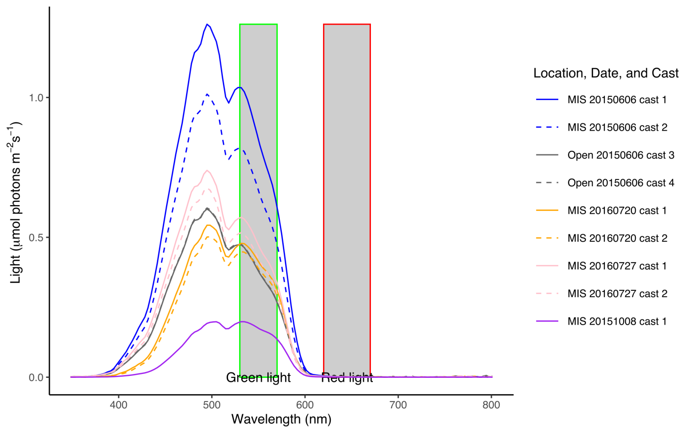
Supplemental Figure 4. Calculated k-extinction coefficients at 23 m in the MIS arena or away from the arena (“open”) from hyperspectral casts. The extinction coefficient (y-axis) is plotted for each wavelength (x-axis) of PAR. Different sampling days are represented with colors, and separate casts from the same day are in solid or dashed lines.

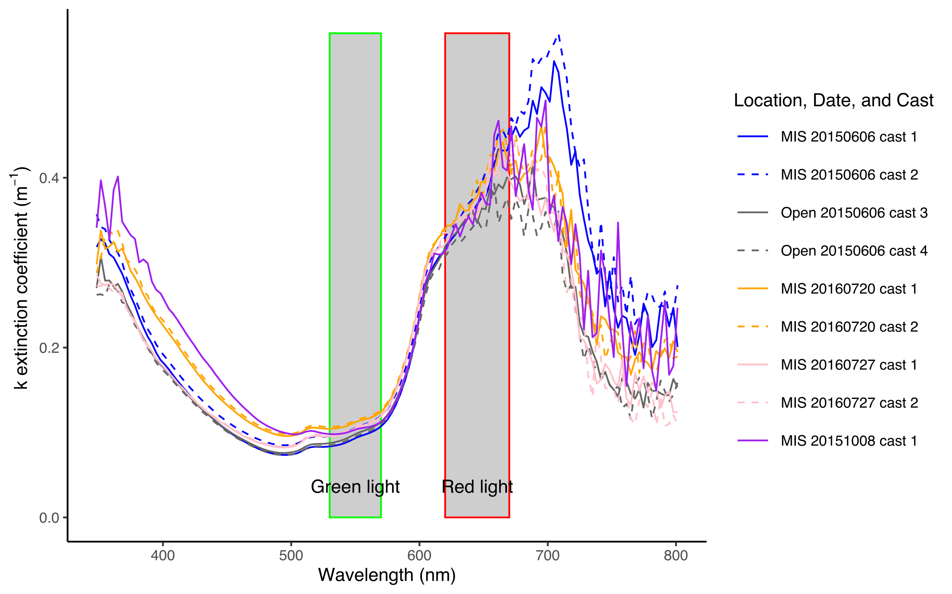
Supplemental Figure 5. Specific conductivity measured with hand-held probe or calculated from ion chemistry (IC and ICPMS) in water samples. Units are μS cm⁻¹.

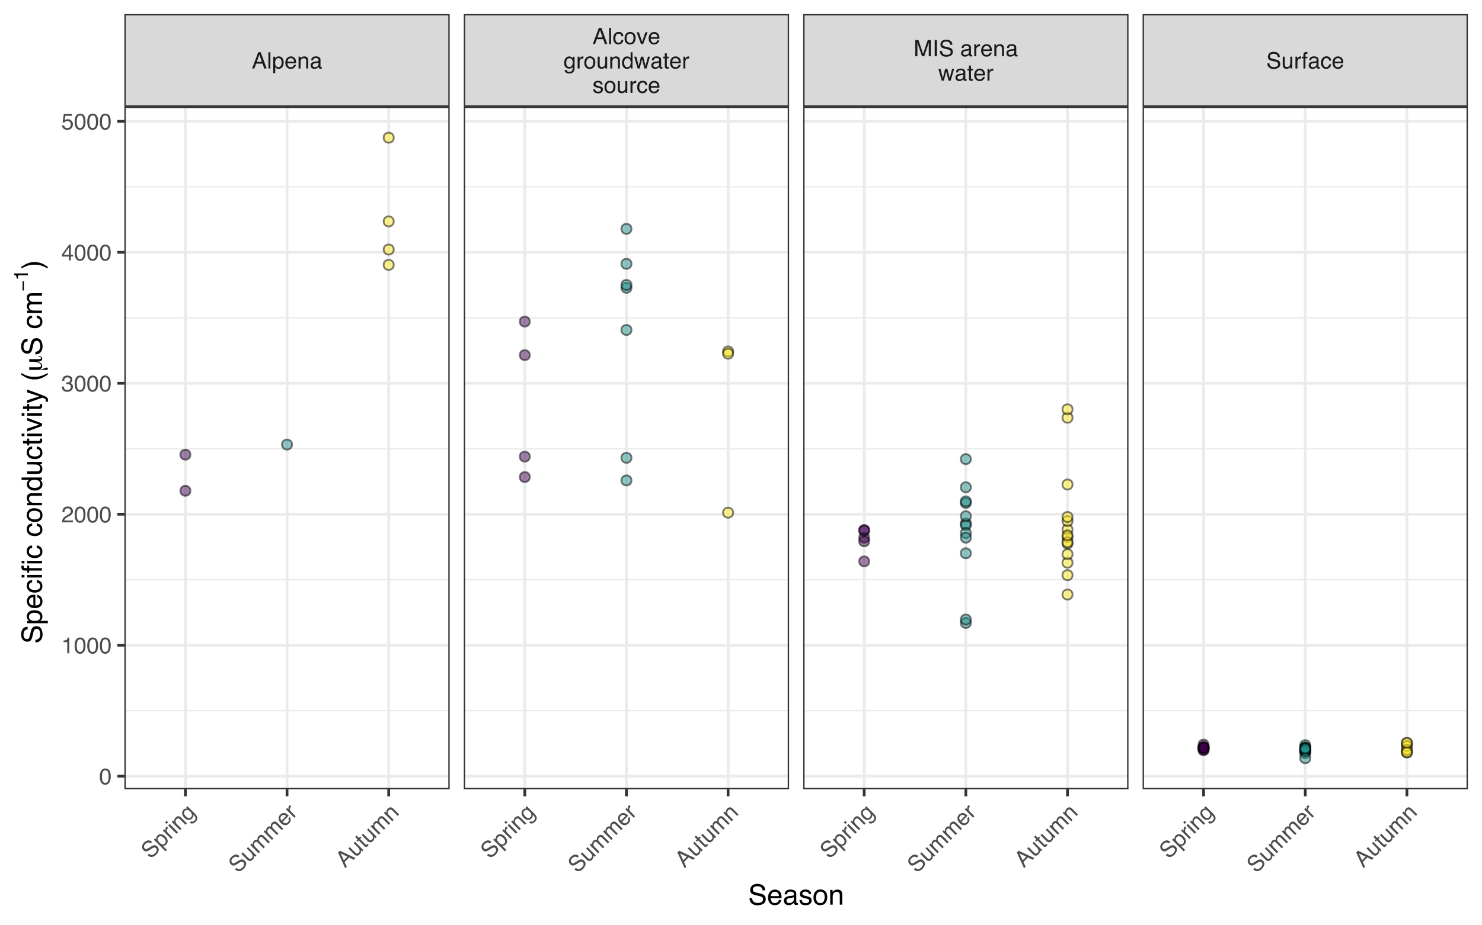
Supplemental Figure 6. d-excess (difference between measured values of δD and modeled δD from measured values of δ¹⁸O) for water samples at each location per season. The mean for each season is presented as the colored horizontal line, and box and whiskers summarize 25-75th percentiles of observations (colored circles). For context, the average d-excess for the Great Lakes is +3.2‰.

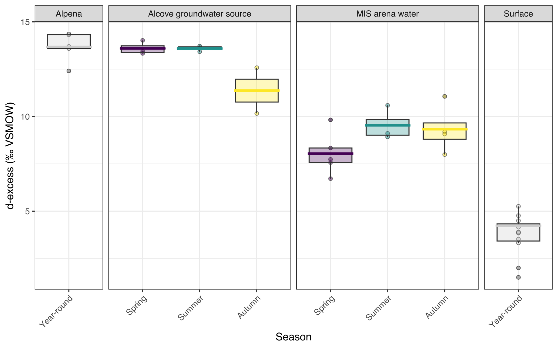
Supplemental Figure 7. Measured ion concentrations in water samples compared to predicted ion concentrations based on δ¹⁸O-derived linear mixing model. Colored points represent measurements of ions of interest: A, sulfate; B, calcium; C, fluoride; D, sodium; E, magnesium, and F, chloride. The horizontal colored line is the mean measured concentration per season unit. For each season, the gray box represents the mean predicted concentrations and standard deviations using the concentrations measured in Alpena fountain and the isotope-derived linear mixing model between surface water and Alpena fountain water.

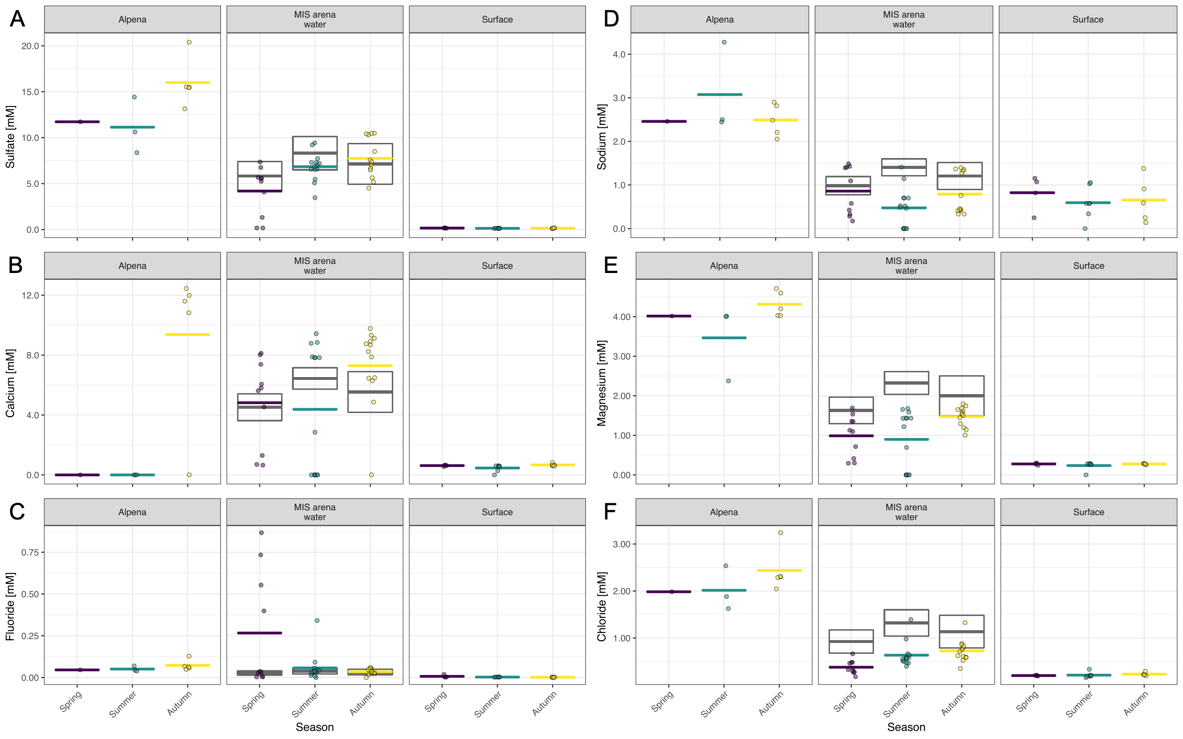
Supplemental Figure 8. Relative abundance of relevant bacterial taxonomic groups in samples, grouped by month and year. Relative abundances of key genera were summed and presented, and classes and phyla without those genera are represented.
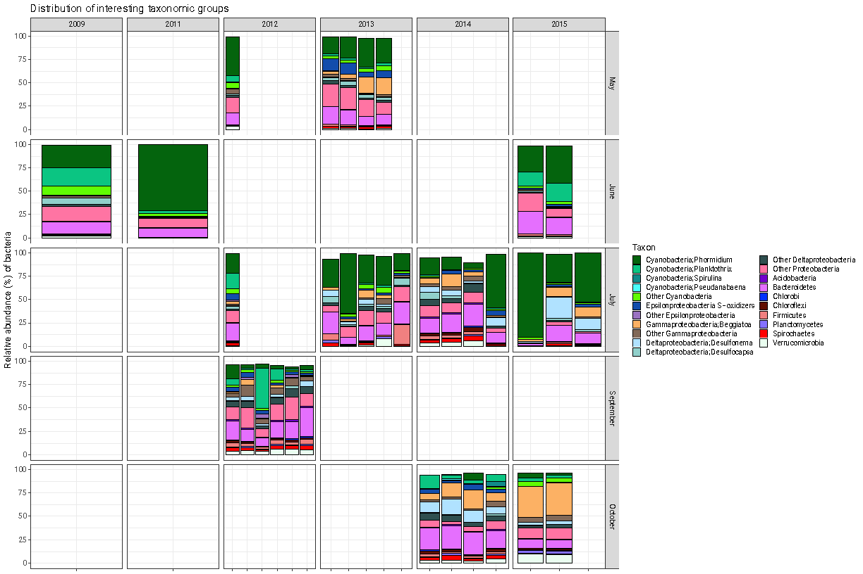
Supplemental Figure 9. Correlation network showing significant (p < 0.001) relationships in relative abundances of 60 genera. Bray-Curtis distance matrix was calculated from read counts of genera and used to generate a correlation network. Line thickness conveys strength of the correlation
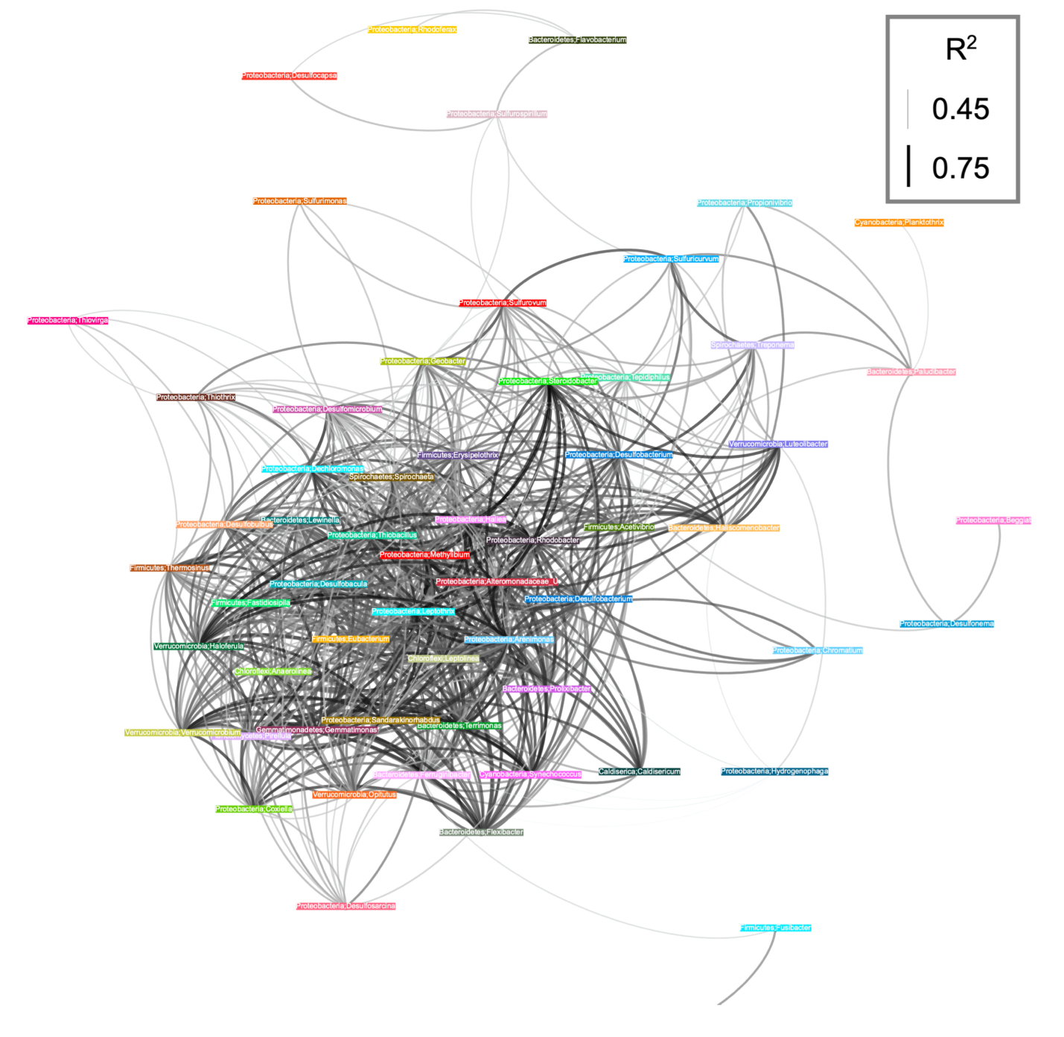
Supplemental Table 1. (this and next 4 pages) Summary table of metagenome- assembled- genomic (MAG) bins from MIS metagenomic co-assembly of 15 samples. Our oscillatorial cyanobacterial bins had 95.8% completion/11.3% redundancy (Pseudanabaena, 4.3Mbp), 70.5%/56.3% (Phormidium, 11.0Mbp), 91.6%/42.3% (Planktothrix, 5.7Mbp), 22.5%/1.41% (Spirulina, 1.12Mbp) as well as 527kbp of cyanobacterial scaffolds that were not able to be confidently binned.
Bin name | Classification | Bin Quality | Length (bp) | Completion (%) | Redundancy (%) | Mean gDNA coverage | Mean cDNA coverage
bin_208 | Alphaproteobacteria; Rickettsia | Medium | 1036760 | 71.83 | 0.0 | 0.04 | 0.0
bin_118 | Bacteria | High | 3917186 | 98.59 | 1.41 | 0.77 | 3.62
bin_156 | Bacteria | Low | 3085822 | 63.38 | 0.0 | 1.20 | 0.13
bin_146 | Bacteria | Low | 2304693 | 0.0 | 0.0 | 0.14 | 0.02
bin_51 | Bacteria | Low | 1580267 | 0.0 | 0.0 | 0.55 | 0.16
bin_220 | Bacteria | Low | 1483107 | 19.72 | 0.0 | 0.68 | 0.03
bin_103 | Bacteria | Low | 1266519 | 0.0 | 0.0 | 0.57 | 0.02
bin_157 | Bacteria | Low | 163623 | 0.0 | 0.0 | 0.05 | 0.0
bin_168 | Bacteria | Low | 157396 | 0.0 | 0.0 | 0.04 | 0.0
bin_182 | Bacteria | Medium | 2968070 | 88.73 | 1.41 | 0.06 | 3.84
bin_50 | Bacteria | Medium | 3858105 | 87.32 | 8.45 | 1.06 | 0.39
Bin_7_3- contigs | Bacteria | Medium | 3971796 | 85.92 | 1.41 | 5.29 | 0.54
bin_212 | Bacteria | Medium | 2393843 | 83.10 | 5.63 | 1.18 | 0.77
bin_47 | Bacteria | Medium | 3407323 | 53.52 | 1.41 | 0.19 | 0.02
bin_105 | Bacteria | Medium | 4024241 | 70.42 | 1.41 | 4.10 | 0.05
bin_64 | Bacteria; Silvanigrellales | Low | 232602 | 0.0 | 0.0 | 0.02 | 0.04
bin_250 | Bacteria; Vampirococcus | Medium | 1008733 | 53.52 | 1.41 | 0.15 | 0.02
bin_9 | Bacteroidetes | High | 4643096 | 100.0 | 2.82 | 0.76 | 0.04
bin_33 | Bacteroidetes | High | 3200533 | 98.59 | 2.82 | 0.33 | 0.37
bin_28 | Bacteroidetes | High | 4812335 | 98.59 | 1.41 | 1.22 | 3.04
bin_207 | Bacteroidetes | High | 2366644 | 92.96 | 0.0 | 0.31 | 3.83
bin_228 | Bacteroidetes | High | 6581157 | 94.37 | 4.23 | 0.14 | 0.01
bin_57 | Bacteroidetes | High | 3922016 | 97.18 | 1.41 | 0.23 | 3.00
bin_160 | Bacteroidetes | Low | 1482139 | 43.66 | 0.0 | 0.76 | 0.07
bin_202 | Bacteroidetes | Low | 3626904 | 32.39 | 2.82 | 0.65 | 0.12
bin_87 | Bacteroidetes | Low | 720606 | 42.25 | 0.0 | 1.20 | 4.46
bin_124 | Bacteroidetes | Low | 1128359 | 36.62 | 0.0 | 0.08 | 0.02
bin_224 | Bacteroidetes | Low | 1116623 | 35.21 | 0.0 | 0.38 | 0.03
bin_113 | Bacteroidetes | Low | 823305 | 0.0 | 0.0 | 0.26 | 0.03
bin_23 | Bacteroidetes | Low | 347815 | 0.0 | 0.0 | 0.91 | 0.03
bin_261 | Bacteroidetes | Low | 54079 | 0.0 | 0.0 | 0.07 | 0.0
bin_178 | Bacteroidetes | Low | 371388 | 0.0 | 0.0 | 0.25 | 0.04
bin_92 | Bacteroidetes | Medium | 3783221 | 87.32 | 1.41 | 0.40 | 0.04
bin_69 | Bacteroidetes | Medium | 3315494 | 91.55 | 4.23 | 0.69 | 0.04
Supplemental Table 1.
bin_88 | Bacteroidetes | Medium | 2317404 | 80.28 | 2.82 | 0.36 | 0.04
bin_153 | Bacteroidetes | Medium | 2962889 | 71.83 | 8.45 | 0.17 | 39.29
bin_117 | Bacteroidetes | Medium | 1688616 | 63.38 | 0.0 | 1.43 | 0.06
bin_239 | Bacteroidetes | Medium | 2545173 | 69.01 | 1.41 | 0.29 | 0.03
bin_3 | Bacteroidetes | Medium | 4300737 | 61.97 | 1.41 | 0.36 | 0.02
bin_54 | Bacteroidetes; Bernardetia | Low | 571641 | 47.89 | 1.41 | 0.76 | 84.01
bin_176 | Bacteroidetes; Draconibacterium | Low | 945589 | 0.0 | 0.0 | 0.66 | 0.09
bin_197 | Bacteroidetes; Draconibacterium | Low | 1178942 | 0.0 | 0.0 | 0.33 | 0.09
bin_169 | Bacteroidetes; Draconibacterium | Medium | 2672817 | 54.93 | 0.0 | 0.49 | 0.16
bin_242 | Bacteroidetes; Flavobacterium | Low | 788631 | 0.0 | 0.0 | 0.31 | 0.03
bin_96 | Bacteroidetes; Flavobacterium | Low | 339985 | 0.0 | 0.0 | 9.98 | 0.24
bin_227 | Bacteroidetes; Flavobacterium | Medium | 2930134 | 76.06 | 0.0 | 0.94 | 0.04
bin_75 | Bacteroidetes; Paludibacter | Low | 602309 | 46.48 | 0.0 | 2.13 | 0.06
bin_100 | Bacteroidetes; Paludibacter | Low | 1400511 | 0.0 | 0.0 | 4.63 | 0.09
bin_132 | Bacteroidetes; Paludibacter | Medium | 4302557 | 84.51 | 1.41 | 1.57 | 2.41
bin_112 | Bacteroidetes; Paludibacter | Medium | 2800085 | 64.79 | 4.23 | 3.58 | 0.11
bin_200 | Betaproteobacteria | Low | 218076 | 28.17 | 0.0 | 1.73 | 0.05
bin_111 | Betaproteobacteria | Low | 637507 | 0.0 | 0.0 | 1.85 | 0.04
bin_127 | Betaproteobacteria | Medium | 3724154 | 70.42 | 2.82 | 1.17 | 0.05
bin_91 | Betaproteobacteria | Medium | 3172373 | 80.28 | 0.0 | 1.99 | 0.06
bin_151 | Betaproteobacteria | Medium | 2184168 | 76.06 | 1.41 | 1.82 | 0.05
bin_77 | Betaproteobacteria; Candidatus Accumulibacter | Low | 427799 | 0.0 | 0.0 | 1.05 | 0.0
bin_122 | Betaproteobacteria; Candidatus Accumulibacter | Medium | 3455847 | 74.65 | 2.82 | 0.79 | 0.01
bin_131 | Betaproteobacteria; Collimonas | High | 1613140 | 97.18 | 0.0 | 0.03 | 0.01
Bin_4_4-contigs | Betaproteobacteria; Hydrogenophaga | High | 3519382 | 92.96 | 1.41 | 10.93 | 0.24
bin_70 | Betaproteobacteria; Hydrogenophaga | Medium | 2249573 | 70.42 | 0.0 | 4.68 | 0.11
Bin_7_6-contigs | Betaproteobacteria; Methylibium | Low | 1954091 | 29.58 | 0.0 | 1.38 | 0.02
Bin_4_1-contigs | Betaproteobacteria; Rhodoferax | n/a | 4187395 | 90.14 | 90.14 | 7.22 | 1.56
bin_44 | Betaproteobacteria; Rhodoferax | Low | 2317582 | 45.07 | 0.0 | 1.30 | 0.14
bin_106 | Betaproteobacteria; Rhodoferax | Low | 2418005 | 0.0 | 0.0 | 3.78 | 0.08
Supplemental Table 1.
bin_114 | Betaproteobacteria; Rhodoferax | Low | 1033036 | 0.0 | 0.0 | 0.72 | 0.02
bin_38 | Betaproteobacteria; Rhodoferax | Low | 1189669 | 0.0 | 0.0 | 2.36 | 0.05
bin_167 | Betaproteobacteria; Rhodoferax | Low | 569153 | 0.0 | 0.0 | 1.39 | 0.22
bin_229 | Betaproteobacteria; Rhodoferax | Medium | 4595121 | 87.32 | 1.41 | 0.48 | 0.26
bin_246 | Betaproteobacteria; Rhodoferax | Medium | 2662737 | 69.01 | 2.82 | 1.46 | 0.04
bin_46 | Betaproteobacteria; Rhodoferax | Medium | 2729705 | 66.20 | 5.63 | 2.00 | 0.05
bin_144 | Betaproteobacteria; Sideroxydans | Low | 1077631 | 38.03 | 4.23 | 0.43 | 0.61
Bin_4_3_4-contigs | Betaproteobacteria; Sulfuritalea | Medium | 3046083 | 67.61 | 1.41 | 0.22 | 0.65
bin_193 | Chlorobi | Medium | 2240036 | 67.61 | 1.41 | 0.11 | 0.89
bin_123 | Chloroflexi | Low | 2116432 | 38.03 | 2.82 | 1.22 | 0.03
bin_120 | Chloroflexi | Medium | 2823555 | 85.92 | 2.82 | 1.02 | 2.73
bin_187 | Chloroflexi | Medium | 4444501 | 61.97 | 1.41 | 0.43 | 35.36
bin_154 | Chloroflexi; Anaerolinea | Low | 820620 | 22.54 | 1.41 | 0.73 | 0.05
bin_179 | Chloroflexi; Anaerolinea | Low | 919484 | 0.0 | 0.0 | 0.79 | 0.04
bin_190 | Chloroflexi; Anaerolinea | Low | 406092 | 0.0 | 0.0 | 0.53 | 0.04
bin_232 | Chloroflexi; Anaerolinea | Low | 476289 | 0.0 | 0.0 | 0.16 | 0.0
bin_8 | Chloroflexi; Anaerolinea | Medium | 4061672 | 63.38 | 1.41 | 0.34 | 0.01
bin_141 | Chloroflexi; Anaerolinea | Medium | 3352447 | 49.30 | 1.41 | 0.50 | 0.02
bin_43 | Chloroflexi; Anaerolinea | Medium | 1290979 | 56.34 | 1.41 | 0.22 | 0.06
bin_180 | Cyanobacteria; Oscillatoriales | Low | 527123 | 0.0 | 0.0 | 0.73 | 0.05
Bin_1 | Cyanobacteria; Phormidium | n/a | 11033395 | 70.42 | 56.34 | 203.01 | 181.21
bin_235_243 | Cyanobacteria; Planktothrix | n/a | 5709010 | 91.55 | 42.25 | 28.57 | 1.54
bin_143 | Cyanobacteria; Pseudanabaena | Medium | 4277160 | 95.77 | 11.27 | 0.46 | 0.07
bin_256 | Cyanobacteria; Spirulina | Low | 1128073 | 22.54 | 1.41 | 1.18 | 0.98
bin_90 | Deltaproteobacteria | Low | 1629916 | 43.66 | 0.0 | 0.79 | 0.03
bin_145_29 | Deltaproteobacteria | Low | 998016 | 0.0 | 0.0 | 0.13 | 0.02
bin_5 | Deltaproteobacteria | Medium | 2954443 | 77.46 | 0.0 | 0.34 | 0.02
bin_65 | Deltaproteobacteria; Bdellovibrio | Low | 434310 | 0.0 | 0.0 | 0.07 | 0.0
bin_204 | Deltaproteobacteria; Desulfobacteraceae | Low | 1256801 | 45.07 | 1.41 | 6.42 | 0.21
Supplemental Table 1.
bin_101 | Deltaproteobacteria; Desulfobacteraceae | Medium | 3961593 | 88.73 | 4.23 | 0.41 | 0.03
bin_83 | Deltaproteobacteria; Desulfobacteraceae | Medium | 2395034 | 67.61 | 4.23 | 0.95 | 2.37
bin_26 | Deltaproteobacteria; Desulfobacula | High | 3688401 | 97.18 | 4.23 | 0.20 | 0.03
bin_102 | Deltaproteobacteria; Desulfobulbaceae | Medium | 3062052 | 71.83 | 1.41 | 0.57 | 0.03
bin_170 | Deltaproteobacteria; Desulfobulbaceae | Medium | 2433296 | 61.97 | 5.63 | 0.70 | 0.03
bin_61 | Deltaproteobacteria; Desulfocapsa | Low | 1160311 | 21.13 | 0.0 | 1.41 | 0.07
bin_85 | Deltaproteobacteria; Desulfocapsa | Low | 574286 | 0.0 | 0.0 | 2.22 | 15.58
bin_6 | Deltaproteobacteria; Desulfomicrobium | Low | 1947632 | 26.76 | 0.0 | 1.24 | 1.38
bin_209 | Deltaproteobacteria; Halobacteriovorax | High | 3253134 | 91.55 | 2.82 | 0.09 | 0.77
bin_67 | Epsilonproteobacteria | Low | 665089 | 21.13 | 0.0 | 1.23 | 63.48
bin_25 | Epsilonproteobacteria | Low | 317211 | 30.99 | 0.0 | 0.46 | 0.15
Bin_6_9-contigs | Epsilonproteobacteria; Arcobacter | High | 1997449 | 97.18 | 0.0 | 7.00 | 0.11
bin_49 | Epsilonproteobacteria; Sulfuricurvum | High | 2217859 | 95.77 | 0.0 | 1.37 | 0.12
Bin_6_3-contigs | Epsilonproteobacteria; Sulfurimonas | High | 2205377 | 98.59 | 1.41 | 0.42 | 0.02
bin_94 | Epsilonproteobacteria; Sulfurospirillum | Low | 501389 | 0.0 | 0.0 | 1.07 | 0.07
bin_233 | Epsilonproteobacteria; Sulfurospirillum | Medium | 797513 | 53.52 | 0.0 | 2.24 | 0.14
Bin_10_2-contigs | Eukaryota | Low | 8793166 | 32.53 | 3.61 | 0.02 | 0.01
bin_2 | Eukaryota | n/a | 13858755 | 21.69 | 25.30 | 0.03 | 0.37
bin_159 | Fibrobacteres | Low | 900344 | 0.0 | 0.0 | 0.60 | 0.03
bin_194 | Firmicutes - Clostridia | Low | 329682 | 29.58 | 1.41 | 0.26 | 0.0
bin_86 | Firmicutes - Clostridia | Medium | 3921580 | 60.56 | 1.41 | 0.26 | 0.03
bin_78 | Gammaproteobacteria | Low | 3197050 | 46.48 | 5.63 | 1.01 | 0.04
bin_73 | Gammaproteobacteria | Low | 2387643 | 33.80 | 4.23 | 1.64 | 0.09
bin_164 | Gammaproteobacteria | Low | 948971 | 0.0 | 0.0 | 2.04 | 0.30
bin_37 | Gammaproteobacteria | Low | 595635 | 0.0 | 0.0 | 5.24 | 0.26
bin_99 | Gammaproteobacteria | Low | 540621 | 0.0 | 0.0 | 0.43 | 0.0
bin_45 | Gammaproteobacteria; Methylococcaceae | High | 2731051 | 95.77 | 2.82 | 0.29 | 0.10
bin_149 | Gammaproteobacteria; Methylovulum | Low | 1412910 | 56.34 | 4.23 | 0.05 | 4.96
bin_234 | Gammaproteobacteria; Thioploca | Low | 750004 | 0.0 | 0.0 | 0.13 | 0.0
bin_35 | Gammaproteobacteria; Thioploca | Low | 666513 | 0.0 | 0.0 | 13.76 | 0.22
bin_247 | Gammaproteobacteria; Thioploca | Low | 902565 | 0.0 | 0.0 | 2.75 | 0.07
bin_188 | Gammaproteobacteria; Thioploca | Low | 687171 | 0.0 | 0.0 | 2.99 | 0.10
bin_158 | Gammaproteobacteria; Thiotrichaceae | Medium | 2018828 | 77.46 | 1.41 | 0.24 | 13.05
bin_16 | Spirochaetes | Low | 1665686 | 0.0 | 0.0 | 0.81 | 0.03
bin_134 | Spirochaetes | Low | 1818317 | 23.94 | 2.82 | 0.29 | 0.03
bin_162 | Spirochaetes | Low | 1282009 | 21.13 | 4.23 | 0.87 | 0.04
bin_219 | Spirochaetes | Low | 976721 | 0.0 | 0.0 | 0.24 | 0.02
bin_172 | Spirochaetes | Low | 1252337 | 0.0 | 0.0 | 0.86 | 0.03
bin_201 | Spirochaetes | Low | 437961 | 0.0 | 0.0 | 0.41 | 0.03
bin_257 | Spirochaetes | Low | 194932 | 0.0 | 0.0 | 0.33 | 0.03
bin_199 | Spirochaetes | Medium | 3969302 | 90.14 | 7.04 | 1.31 | 0.73
bin_251 | Spirochaetes | Medium | 2806768 | 43.66 | 1.41 | 1.10 | 0.03
bin_262 | Tenericutes | Low | 629939 | 46.48 | 1.41 | 0.09 | 0.0
bin_79 | Unknown | Low | 575930 | 40.85 | 0.0 | 0.04 | 2.68
Bin_3_1 | Unknown | Low | 23570043 | 87.32 | 254.93 | 0.31 | 20.59
Bin_3_3 | Unknown | Low | 19802335 | 90.14 | 236.62 | 6.19 | 17.77
bin_155 | Verrucomicrobia | Low | 548848 | 50.70 | 1.41 | 0.51 | 0.03
bin_66 | Verrucomicrobia | Low | 2006576 | 50.70 | 0.0 | 0.13 | 0.01
bin_72 | Verrucomicrobia | Low | 1332738 | 45.07 | 0.0 | 0.42 | 0.05
bin_165 | Verrucomicrobia | Low | 450480 | 0.0 | 0.0 | 0.92 | 0.03
bin_89 | Verrucomicrobia; Akkermansia | Medium | 3062395 | 70.42 | 2.82 | 0.39 | 5.75

Supplemental Table 2. Summary of read depth from 16S rRNA gene amplicon sequencing. Samples are ordered by season and chronologically. “Total reads” represents the read depth after quality filtering and chimera checking. “Total bacterial reads” represents the total after filtering out sequences assigned to eukarya and archaea.

Season | Year | Sample Name | Total reads | Total bacterial reads
Spring | 2009 | MIS.0609.01.000 | 12565 | 11594
Spring | 2011 | MIS.0611.03.000 | 10298 | 10046
Spring | 2012 | M3-3 | 43956 | 33204
Spring | 2013 | MIS.0513.01.000 | 14978 | 11418
Spring | 2013 | MIS.0513.02.000 | 32381 | 24837
Spring | 2013 | MIS.0513.03.000 | 45040 | 32484
Spring | 2013 | MIS.0513.04.000 | 56110 | 27751
Spring | 2015 | MIS.2015.027A-2 | 40290 | 37133
Spring | 2015 | MIS.2015.027A-3 | 40179 | 36652
Summer | 2012 | M1-1 | 24874 | 13618
Summer | 2013 | MIS.0713.03.000 | 31 | 30
Summer | 2013 | MIS.0713.07.000 | 12138 | 9027
Summer | 2013 | MIS.0713.08.000 | 10668 | 5412
Summer | 2013 | MIS.0713.09.000 | 57 | 49
Summer | 2013 | MIS.0713.11.000 | 10107 | 8492
Summer | 2014 | MIS.0714.013_mat | 12272 | 9708
Summer | 2014 | MIS.0714.020_mat | 25150 | 17827
Summer | 2014 | MIS.0714.024_mat | 26316 | 18826
Summer | 2014 | MIS.0714.028.000 | 69010 | 65842
Summer | 2015 | MIS.2015.060A-2 | 45208 | 42938
Summer | 2015 | MIS.2015.060B-2 | 26732 | 16856
Summer | 2015 | MIS.2015.060G | 37465 | 31762
Autumn | 2012 | MIS.0912.LK1.000a | 51857 | 45498
Autumn | 2012 | MIS.0912.LK1.000b | 109219 | 88262
Autumn | 2012 | MIS.0912.LK3.000 | 9526 | 8711
Autumn | 2012 | MIS.0912.LK4.000 | 19567 | 17191
Autumn | 2012 | MIS.0912.LK5.000 | 46519 | 39199
Autumn | 2012 | MIS.0912.LK6.000 | 94097 | 77630
Autumn | 2014 | MIS.0914.003_mat | 34022 | 26098
Autumn | 2014 | MIS.0914.015.000A | 48060 | 41678
Autumn | 2014 | MIS.0914.020_mat | 34177 | 30302
Autumn | 2014 | MIS.0914.021_mat | 33585 | 29322
Autumn | 2015 | MIS.2015.100A-2 | 43132 | 25500
Autumn | 2015 | MIS.2015.100B-2 | 45623 | 31508

Supplemental Table 3. Light quality and quantity metrics from hyperspectral profiles. Seven hyperspectral casts in MIS arena and 2 open water casts were conducted in 2015-2016, from which we determined k-extinction coefficients and available energy (μmol photons m⁻² s⁻¹) for each measured wavelength of light between 350-800 nm. This summarizes the k-extinction coefficient and energy at depth for the range of green wavelengths (530-570 nm) and the range of red wavelengths (620-670 nm), per cast, per day, and per month.
 |  | 2015 0606 cast 1 | 2015 0606 cast 2 | 2015 0606 cast 3 | 2015 0606 cast 4 | 2015 1008 cast 1 | 2016 0720 cast 1 | 2016 0720 cast 2 | 2016 0727 cast 1 | 2016 0727 cast 2
k-extinction coefficients (m⁻¹) | Green | 0.093 | 0.105 | 0.098 | 0.095 | 0.103 | 0.112 | 0.114 | 0.105 | 0.107
k-extinction coefficients (m⁻¹) | Red | 0.374 | 0.391 | 0.361 | 0.345 | 0.373 | 0.385 | 0.392 | 0.374 | 0.373
energy at 23 m (μmol photons m⁻² s⁻¹) | Green | 0.852 | 0.669 | 0.382 | 0.385 | 0.175 | 0.413 | 0.388 | 0.474 | 0.426
energy at 23 m (μmol photons m⁻² s⁻¹) | Red | 0.002 | 0.001 | 0.001 | 0.002 | 0.000 | 0.001 | 0.001 | 0.002 | 0.001
average daily k-extinction coefficient (m⁻¹) | Green | 0.099 | 0.099 | 0.097 | 0.097 | NA | 0.113 | 0.113 | 0.106 | 0.106
average daily k-extinction coefficient (m⁻¹) | Red | 0.383 | 0.383 | 0.353 | 0.353 | NA | 0.389 | 0.389 | 0.373 | 0.373
standard deviation | Green | 0.009 | 0.009 | 0.007 | 0.007 | NA | 0.006 | 0.006 | 0.007 | 0.007
standard deviation | Red | 0.041 | 0.041 | 0.024 | 0.024 | NA | 0.035 | 0.035 | 0.032 | 0.032
average monthly k-extinction coefficient  (m⁻¹) | Green | NA | NA | NA | NA | NA | 0.109 | 0.109 | 0.109 | 0.109
average monthly k-extinction coefficient  (m⁻¹) | Red | NA | NA | NA | NA | NA | 0.381 | 0.381 | 0.381 | 0.381
standard deviation | Green | NA | NA | NA | NA | NA | 0.007 | 0.007 | 0.007 | 0.007
standard deviation | Red | NA | NA | NA | NA | NA | 0.034 | 0.034 | 0.034 | 0.034
Supplemental Table 4. Specific conductivity in water parcels. Units are in μS cm⁻¹.
Date | Season | Alpena | Alcove | Arena | Surface
20120531 | Spring |  |  | 1821 | 219
20120725 | Summer |  |  | 1930 | 217
20120927 | Autumn | 4875 |  | 1883 | 251
20130509 | Spring |  |  | 1793 | 220
20130718 | Summer |  | 3407 | 2086 | 206
20130928 | Autumn |  |  | 1825
20140724 | Summer |  | 3729 | 1702 | 175
20140924 | Autumn | 3904 | 3243 | 1630 | 182
20150604 | Spring | 2179 | 2440 |  | 203
20150604 | Spring |  | 2284 |  | 214
20150604 | Spring |  |  |  | 218
20150731 | Summer |  | 2431 | 1916 | 237
20150731 | Summer |  | 3912 | 2206 | 194
20150731 | Summer |  | 4179 | 2098 | 195
20150731 | Summer
20151007 | Autumn |  | 2012 | 1948 | 229
20151007 | Autumn | 4021 |  | 2737 | 201
20151007 | Autumn | 4236 |  | 2801
20160609 | Spring |  | 3215 | 1880 | 219
20160609 | Spring |  |  | 1640
20160722 | Summer |  |  | 1170 | 217
20160928 | Autumn |  |  | 1535
20160928 | Autumn |  |  | 2227
20160928 | Autumn |  |  | 1979 | 255
20160928 | Autumn |  | 3226 | 1776 | 182
20170601 | Spring |  | 3471 |  | 198
20170601 | Spring |  |  |  | 241
20170809 | Summer |  | 3751
20170809 | Summer |  | 2258 | 1856 | 218
20170809 | Summer |  |  |  | 192
20170810 | Summer |  |  | 2421 | 192
20170810 | Summer |  |  | 1821 | 205
20170910 | Autumn |  |  | 1787
20170926 | Autumn |  |  | 1839
20170927 | Autumn |  |  | 1695
20170928 | Autumn |  |  | 1387
20180710 | Summer |  |  | 1985 | 211
20180710 | Summer | 2532 |  |  | 137
20190612 | Spring | 2455 |  |  | 217
20190612 | Spring |  |  | 1874
Average |  | 3457 | 3111 | 1908 | 208
Supplemental Table 5. (this and next 2 pages) δ¹⁸O and δD measured in water samples from Alpena fountain, MIS Arena water and specific locations in the arena (when available), the Alcove groundwater source of the sinkhole, and the surface of the lake above the sinkhole. Alcove waters (45° 11.900'N, 83° 19.639'W) and Alpena fountain were sampled in the same locations. Surface waters were sampled above the sinkhole arena.
Year | Date | Season | Sample | Location | Specific Site | δ¹⁸O(‰) | δD (‰)
2015 | 20151007 | Autumn | ALP.2015.008 | Alpena |  | -12.2 | -83.8
2015 | 20151007 | Autumn | ALP.2015.014 | Alpena |  | -12.1 | -82.6
2017 | 20170810 | Summer | ALP.2017.Aug | Alpena |  | -12.4 | -86.9
2017 | 20170912 | Autumn | ALP.2017.Sept | Alpena |  | -12.3 | -84.2
2018 | 20180710 | Summer | ALP.2018.July | Alpena |  | -12.1 | -83.3
2015 | 20150604 | Spring | MIS.2015.008 | Alcove |  | -11.4 | -78.0
2015 | 20150731 | Summer | MIS.2015.047 | Alcove |  | -11.5 | -78.3
2015 | 20151007 | Autumn | MIS.2015.079 | Alcove |  | -10.1 | -71.0
2016 | 20160609 | Spring | MIS2016.001 | Alcove |  | -11.4 | -77.5
2016 | 20160928 | Autumn | MIS.2016.322 | Alcove |  | -11.3 | -77.7
2017 | 20170531 | Spring | MIS.2017.005 | Alcove |  | -11.5 | -78.3
2017 | 20170809 | Summer | MIS.2017.062 | Alcove |  | -11.5 | -78.5
2017 | 20170810 | Summer | MIS.2017.080 | Alcove |  | -11.6 | -79.1
2015 | 20150731 | Summer | MIS.2015.042 | Arena |  | -9.7 | -68.8
2015 | 20151007 | Autumn | MIS.2015.077 | Arena |  | -10.4 | -71.9
2016 | 20160609 | Spring | MIS2016.009 | Arena | 45° 11.918'N, 83° 19.662'W | -9.7 | -68.0
2016 | 20160609 | Spring | MIS2016.016 | Arena | 45° 11.944'N, 83° 19.689'W | -9.2 | -65.9
2016 | 20160609 | Spring | MIS2016.023 | Arena | 45° 11.949'N, 83° 19.649'W | -9.0 | -65.1
2016 | 20160928 | Autumn | MIS.2016.Arena D3-4 | Arena | 45° 11.912'N, 83° 19.661'W | -9.3 | -65.2
2016 | 20160928 | Autumn | MIS.2016.325 | Arena | 45° 11.925'N, 83° 19.649'W | -9.0 | -64.3
2016 | 20160928 | Autumn | MIS.2016.328 | Arena | 45° 11.915'N, 83° 19.654'W | -9.5 | -67.2
2017 | 20170531 | Spring | MIS.2017.012 | Arena | 45° 11.932'N, 83° 19.677'W | -8.8 | -63.0
2017 | 20170531 | Spring | MIS.2017.013 | Arena | 45° 11.932'N, 83° 19.677'W | -8.8 | -62.3
2017 | 20170810 | Summer | MIS.2017.083 | Arena | 45° 11.932'N, 83° 19.677'W | -10.3 | -71.4
2018 | 20180710 | Summer | P7.2018.July | Arena | 45° 11.932'N, 83° 19.677'W | -9.9 | -70.0
2015 | 20150604 | Spring | MIS.2015.001 | Surface |  | -7.1 | -52.9
2015 | 20151007 | Autumn | MIS.2015.073 | Surface |  | -7.1 | -53.2
2016 | 20160609 | Spring | MIS2016.026 | Surface |  | -7.1 | -52.5
2016 | 20160928 | Autumn | MIS.2016.319 | Surface |  | -7.0 | -52.0
2017 | 20170531 | Spring | MIS.2017.002 | Surface |  | -7.1 | -52.4
2017 | 20170809 | Summer | MIS.2017.056 | Surface |  | -7.2 | -52.4
2017 | 20170810 | Summer | MIS.2017.077 | Surface |  | -7.2 | -53.2
2018 | 20180710 | Summer | SFC.2018.July | Surface |  | -7.2 | -54.1

Supplemental Table 6. (this and next page) The average and standard deviation of relative abundances of key taxonomic groups by season unit.
Taxon | Season | Mean (%) | Standard Deviation (%)
Cyanobacteria;Phormidium | Spring | 33.55 | 15.94
Cyanobacteria;Phormidium | Summer | 35.55 | 23.92
Cyanobacteria;Phormidium | Autumn | 4.19 | 3.96
Cyanobacteria;Planktothrix | Spring | 8.05 | 7.83
Cyanobacteria;Planktothrix | Summer | 1.88 | 4.36
Cyanobacteria;Planktothrix | Autumn | 8.43 | 11.54
Cyanobacteria;Spirulina | Spring | 0.02 | 0.03
Cyanobacteria;Spirulina | Summer | 0.04 | 0.09
Cyanobacteria;Spirulina | Autumn | 0.55 | 1.65
Cyanobacteria;Pseudanabaena | Spring | 0.00 | 0.01
Cyanobacteria;Pseudanabaena | Summer | 0.01 | 0.03
Cyanobacteria;Pseudanabaena | Autumn | 0.15 | 0.30
Other Cyanobacteria | Spring | 4.36 | 2.48
Other Cyanobacteria | Summer | 2.47 | 1.96
Other Cyanobacteria | Autumn | 2.43 | 1.42
Epsilonproteobacteria S-oxidizers | Spring | 4.81 | 5.07
Epsilonproteobacteria S-oxidizers | Summer | 2.41 | 1.93
Epsilonproteobacteria S-oxidizers | Autumn | 3.11 | 1.66
Other Epsilonproteobacteria | Spring | 0.06 | 0.08
Other Epsilonproteobacteria | Summer | 0.22 | 0.30
Other Epsilonproteobacteria | Autumn | 0.96 | 1.26
Gammaproteobacteria;Beggiatoa | Spring | 4.78 | 7.40
Gammaproteobacteria;Beggiatoa | Summer | 5.25 | 4.11
Gammaproteobacteria;Beggiatoa | Autumn | 10.79 | 12.19
Other Gammaproteobacteria | Spring | 2.27 | 1.46
Other Gammaproteobacteria | Summer | 2.20 | 1.89
Other Gammaproteobacteria | Autumn | 5.55 | 2.93
Deltaproteobacteria;Desulfonema | Spring | 0.34 | 0.45
Deltaproteobacteria;Desulfonema | Summer | 5.95 | 5.95
Deltaproteobacteria;Desulfonema | Autumn | 6.06 | 4.97
Deltaproteobacteria;Desulfocapsa | Spring | 2.67 | 1.99
Deltaproteobacteria;Desulfocapsa | Summer | 3.00 | 2.57
Deltaproteobacteria;Desulfocapsa | Autumn | 0.94 | 0.88
Other Deltaproteobacteria | Spring | 1.85 | 1.19
Other Deltaproteobacteria | Summer | 3.06 | 2.53
Other Deltaproteobacteria | Autumn | 5.76 | 2.03
Other Proteobacteria | Spring | 16.44 | 5.23
Other Proteobacteria | Summer | 9.13 | 5.27
Other Proteobacteria | Autumn | 12.25 | 6.19
Acidobacteria | Spring | 0.33 | 0.17
Acidobacteria | Summer | 0.52 | 0.55
Acidobacteria | Autumn | 1.09 | 0.38
Bacteroidetes | Spring | 14.73 | 4.72
Bacteroidetes | Summer | 15.52 | 6.44
Bacteroidetes | Autumn | 18.31 | 6.92
Chlorobi | Spring | 0.13 | 0.08
Chlorobi | Summer | 0.31 | 0.39
Chlorobi | Autumn | 0.78 | 0.39
Chloroflexi | Spring | 0.23 | 0.11
Chloroflexi | Summer | 0.94 | 1.37
Chloroflexi | Autumn | 1.75 | 0.68
Firmicutes | Spring | 1.16 | 0.87
Firmicutes | Summer | 3.46 | 5.56
Firmicutes | Autumn | 2.80 | 1.50
Planctomycetes | Spring | 0.24 | 0.15
Planctomycetes | Summer | 0.93 | 1.00
Planctomycetes | Autumn | 1.60 | 0.73
Spirochaetes | Spring | 1.12 | 1.07
Spirochaetes | Summer | 1.98 | 1.56
Spirochaetes | Autumn | 2.87 | 1.46
Verrucomicrobia | Spring | 1.42 | 0.96
Verrucomicrobia | Summer | 2.07 | 2.66
Verrucomicrobia | Autumn | 5.07 | 2.46
Supplemental Table 7. (this and next 2 pages) The average and standard deviation of relative abundances of Deltaproteobacterial putative sulfate reducers in each season unit.
Taxon | Season | Mean (%) | Standard Deviation (%)
Desulfarculales;Desulfarculaceae;Desulfarculus | Spring | 0.00 | 0.00
Desulfarculales;Desulfarculaceae;Desulfarculus | Summer | 0.00 | 0.00
Desulfarculales;Desulfarculaceae;Desulfarculus | Autumn | 0.00 | 0.00
Desulfarculales;Desulfarculaceae;Other | Spring | 0.00 | 0.01
Desulfarculales;Desulfarculaceae;Other | Summer | 0.02 | 0.05
Desulfarculales;Desulfarculaceae;Other | Autumn | 0.06 | 0.03
Desulfobacterales;Desulfobacteraceae;Desulfatibacillum | Spring | 0.00 | 0.00
Desulfobacterales;Desulfobacteraceae;Desulfatibacillum | Summer | 0.00 | 0.01
Desulfobacterales;Desulfobacteraceae;Desulfatibacillum | Autumn | 0.00 | 0.00
Desulfobacterales;Desulfobacteraceae;Desulfatiferula | Spring | 0.00 | 0.01
Desulfobacterales;Desulfobacteraceae;Desulfatiferula | Summer | 0.01 | 0.02
Desulfobacterales;Desulfobacteraceae;Desulfatiferula | Autumn | 0.03 | 0.02
Desulfobacterales;Desulfobacteraceae;Desulfobacter | Spring | 0.01 | 0.02
Desulfobacterales;Desulfobacteraceae;Desulfobacter | Summer | 0.00 | 0.01
Desulfobacterales;Desulfobacteraceae;Desulfobacter | Autumn | 0.03 | 0.03
Desulfobacterales;Desulfobacteraceae;Desulfobacterium | Spring | 0.19 | 0.15
Desulfobacterales;Desulfobacteraceae;Desulfobacterium | Summer | 0.34 | 0.40
Desulfobacterales;Desulfobacteraceae;Desulfobacterium | Autumn | 0.85 | 0.52
Desulfobacterales;Desulfobacteraceae;Desulfobacula | Spring | 0.03 | 0.02
Desulfobacterales;Desulfobacteraceae;Desulfobacula | Summer | 0.12 | 0.12
Desulfobacterales;Desulfobacteraceae;Desulfobacula | Autumn | 0.31 | 0.21
Desulfobacterales;Desulfobacteraceae;Desulfococcus | Spring | 0.00 | 0.00
Desulfobacterales;Desulfobacteraceae;Desulfococcus | Summer | 0.00 | 0.00
Desulfobacterales;Desulfobacteraceae;Desulfococcus | Autumn | 0.00 | 0.00
Desulfobacterales;Desulfobacteraceae;Desulfofaba | Spring | 0.00 | 0.00
Desulfobacterales;Desulfobacteraceae;Desulfofaba | Summer | 0.00 | 0.00
Desulfobacterales;Desulfobacteraceae;Desulfofaba | Autumn | 0.00 | 0.00
Desulfobacterales;Desulfobacteraceae;Desulfonema | Spring | 0.84 | 1.62
Desulfobacterales;Desulfobacteraceae;Desulfonema | Summer | 5.29 | 5.57
Desulfobacterales;Desulfobacteraceae;Desulfonema | Autumn | 6.06 | 4.97
Desulfobacterales;Desulfobacteraceae;Desulforegula | Spring | 0.00 | 0.00
Desulfobacterales;Desulfobacteraceae;Desulforegula | Summer | 0.00 | 0.00
Desulfobacterales;Desulfobacteraceae;Desulforegula | Autumn | 0.00 | 0.01
Desulfobacterales;Desulfobacteraceae;Desulfosarcina | Spring | 0.02 | 0.03
Desulfobacterales;Desulfobacteraceae;Desulfosarcina | Summer | 0.07 | 0.19
Desulfobacterales;Desulfobacteraceae;Desulfosarcina | Autumn | 0.15 | 0.18
Desulfobacterales;Desulfobacteraceae;Desulfotignum | Spring | 0.00 | 0.00
Desulfobacterales;Desulfobacteraceae;Desulfotignum | Summer | 0.00 | 0.01
Desulfobacterales;Desulfobacteraceae;Desulfotignum | Autumn | 0.01 | 0.01
Desulfobacterales;Desulfobacteraceae;Other | Spring | 0.03 | 0.03
Desulfobacterales;Desulfobacteraceae;Other | Summer | 0.32 | 0.83
Desulfobacterales;Desulfobacteraceae;Other | Autumn | 0.24 | 0.16
Desulfobacterales;Desulfobulbaceae;Desulfobacterium | Spring | 0.22 | 0.22
Desulfobacterales;Desulfobulbaceae;Desulfobacterium | Summer | 0.48 | 0.56
Desulfobacterales;Desulfobulbaceae;Desulfobacterium | Autumn | 0.59 | 0.35
Desulfobacterales;Desulfobulbaceae;Desulfobulbus | Spring | 0.14 | 0.20
Desulfobacterales;Desulfobulbaceae;Desulfobulbus | Summer | 0.10 | 0.09
Desulfobacterales;Desulfobulbaceae;Desulfobulbus | Autumn | 0.20 | 0.12
Desulfobacterales;Desulfobulbaceae;Desulfocapsa | Spring | 2.40 | 1.84
Desulfobacterales;Desulfobulbaceae;Desulfocapsa | Summer | 2.72 | 2.38
Desulfobacterales;Desulfobulbaceae;Desulfocapsa | Autumn | 0.94 | 0.88
Desulfobacterales;Desulfobulbaceae;Desulfopila | Spring | 0.00 | 0.00
Desulfobacterales;Desulfobulbaceae;Desulfopila | Summer | 0.00 | 0.00
Desulfobacterales;Desulfobulbaceae;Desulfopila | Autumn | 0.00 | 0.00
Desulfobacterales;Desulfobulbaceae;Desulforhopalus | Spring | 0.01 | 0.02
Desulfobacterales;Desulfobulbaceae;Desulforhopalus | Summer | 0.02 | 0.04
Desulfobacterales;Desulfobulbaceae;Desulforhopalus | Autumn | 0.03 | 0.02
Desulfobacterales;Desulfobulbaceae;Desulfotalea | Spring | 0.00 | 0.00
Desulfobacterales;Desulfobulbaceae;Desulfotalea | Summer | 0.00 | 0.00
Desulfobacterales;Desulfobulbaceae;Desulfotalea | Autumn | 0.00 | 0.00
Desulfobacterales;Desulfobulbaceae;Desulfurivibrio | Spring | 0.00 | 0.00
Desulfobacterales;Desulfobulbaceae;Desulfurivibrio | Summer | 0.00 | 0.00
Desulfobacterales;Desulfobulbaceae;Desulfurivibrio | Autumn | 0.00 | 0.00
Desulfobacterales;Desulfobulbaceae;Other | Spring | 0.00 | 0.00
Desulfobacterales;Desulfobulbaceae;Other | Summer | 0.00 | 0.00
Desulfobacterales;Desulfobulbaceae;Other | Autumn | 0.00 | 0.00
Desulfobacterales;Nitrospinaceae;Nitrospinaceae | Spring | 0.00 | 0.00
Desulfobacterales;Nitrospinaceae;Nitrospinaceae | Summer | 0.00 | 0.01
Desulfobacterales;Nitrospinaceae;Nitrospinaceae | Autumn | 0.00 | 0.00
Desulfobacterales;Other | Spring | 0.00 | 0.01
Desulfobacterales;Other | Summer | 0.02 | 0.04
Desulfobacterales;Other | Autumn | 0.06 | 0.06
Desulfovibrionales;Desulfohalobiaceae;Desulfovermiculus | Spring | 0.00 | 0.00
Desulfovibrionales;Desulfohalobiaceae;Desulfovermiculus | Summer | 0.01 | 0.01
Desulfovibrionales;Desulfohalobiaceae;Desulfovermiculus | Autumn | 0.03 | 0.02
Desulfovibrionales;Desulfomicrobiaceae;Desulfomicrobium | Spring | 0.21 | 0.20
Desulfovibrionales;Desulfomicrobiaceae;Desulfomicrobium | Summer | 0.18 | 0.25
Desulfovibrionales;Desulfomicrobiaceae;Desulfomicrobium | Autumn | 0.22 | 0.19
Desulfovibrionales;Desulfonatronaceae;Desulfonatronum | Spring | 0.00 | 0.00
Desulfovibrionales;Desulfonatronaceae;Desulfonatronum | Summer | 0.00 | 0.00
Desulfovibrionales;Desulfonatronaceae;Desulfonatronum | Autumn | 0.00 | 0.00
Desulfovibrionales;Desulfovibrionaceae;Desulfovibrio | Spring | 0.04 | 0.06
Desulfovibrionales;Desulfovibrionaceae;Desulfovibrio | Summer | 0.04 | 0.03
Desulfovibrionales;Desulfovibrionaceae;Desulfovibrio | Autumn | 0.10 | 0.05
Desulfurellales;Desulfurellaceae;Other | Spring | 0.00 | 0.00
Desulfurellales;Desulfurellaceae;Other | Summer | 0.00 | 0.00
Desulfurellales;Desulfurellaceae;Other | Autumn | 0.00 | 0.00
Desulfuromonadales;Desulfuromonadaceae;Desulfuromonas | Spring | 0.00 | 0.00
Desulfuromonadales;Desulfuromonadaceae;Desulfuromonas | Summer | 0.00 | 0.00
Desulfuromonadales;Desulfuromonadaceae;Desulfuromonas | Autumn | 0.00 | 0.00
Desulfuromonadales;Desulfuromonadaceae;Other | Spring | 0.00 | 0.00
Desulfuromonadales;Desulfuromonadaceae;Other | Summer | 0.00 | 0.00
Desulfuromonadales;Desulfuromonadaceae;Other | Autumn | 0.00 | 0.00
Desulfuromonadales;Desulfuromonadaceae;Pelobacter | Spring | 0.02 | 0.03
Desulfuromonadales;Desulfuromonadaceae;Pelobacter | Summer | 0.02 | 0.03
Desulfuromonadales;Desulfuromonadaceae;Pelobacter | Autumn | 0.03 | 0.05
Desulfuromonadales;Geobacteraceae;Geobacter | Spring | 0.32 | 0.39
Desulfuromonadales;Geobacteraceae;Geobacter | Summer | 0.11 | 0.12
Desulfuromonadales;Geobacteraceae;Geobacter | Autumn | 0.34 | 0.49
Desulfuromonadales;Geobacteraceae;Geothermobacter | Spring | 0.00 | 0.00
Desulfuromonadales;Geobacteraceae;Geothermobacter | Summer | 0.00 | 0.00
Desulfuromonadales;Geobacteraceae;Geothermobacter | Autumn | 0.00 | 0.00
Desulfuromonadales;Other | Spring | 0.00 | 0.01
Desulfuromonadales;Other | Summer | 0.02 | 0.03
Desulfuromonadales;Other | Autumn | 0.05 | 0.04
Syntrophobacterales;Syntrophaceae;Desulfobacca | Spring | 0.00 | 0.00
Syntrophobacterales;Syntrophaceae;Desulfobacca | Summer | 0.00 | 0.01
Syntrophobacterales;Syntrophaceae;Desulfobacca | Autumn | 0.01 | 0.01
Syntrophobacterales;Syntrophaceae;Desulfomonile | Spring | 0.01 | 0.01
Syntrophobacterales;Syntrophaceae;Desulfomonile | Summer | 0.02 | 0.03
Syntrophobacterales;Syntrophaceae;Desulfomonile | Autumn | 0.03 | 0.03
Syntrophobacterales;Syntrophobacteraceae;Desulfovirga | Spring | 0.00 | 0.00
Syntrophobacterales;Syntrophobacteraceae;Desulfovirga | Summer | 0.00 | 0.01
Syntrophobacterales;Syntrophobacteraceae;Desulfovirga | Autumn | 0.01 | 0.01
Supplemental Table 8. (this and next 2 pages) Weighted averages of log₂-normalized abundances of proteins across each season. Log₂-normalized abundances and spectral abundance of proteins in samples from respective season units were used to generate weighted averages and standard deviations (when a protein was observed in more than 1 sample in each season unit). Proteins found to be significantly differentially abundant between spring and summer are noted with "a", between spring and autumn with "b", and between summer and autumn with "c".
Protein | Short name | System | Organism | Spring | Summer | Autumn | Significant relationships
3300002024_MIS_11767773 | GroES | Central metabolism | Phormidium | 0.43 ± 0.29 | 0.92 ± 0.29 | -2.87 ± 0.2 | bc
3300002024_MIS_11047972 | L7/L12 | Central metabolism | Phormidium | -1.02 ± 0.9 | -0.17 ± 0.14 | -2.25 ± 0.32 | c
3300002027_MIS_100694095 | groEL | Central metabolism | Phormidium | -0.62 ± 0.42 | 0.35 ± 0.31 | -2.59 ± 0.19 | bc
3300002027_MIS_101997102 | glnA | Nitrogen metabolism | Phormidium | -3.22 | 0.76 ± 0.67
3300002027_MIS_100173914 | apcA | Photosynthesis | Phormidium | -2.03 ± 0.55 | 0.21 ± 0.67 | -3 ± 0.38 | ac
3300002027_MIS_100173913 | apcB | Photosynthesis | Phormidium | -0.62 ± 0.15 | 0.15 ± 0.46 | -2.61 ± 0.64 | c
3300002027_MIS_101595453 | apcF | Photosynthesis | Phormidium | -0.62 ± 0.01 | 0.17 ± 0.3 | -1.53 | a
3300002027_MIS_101997101 | apcF | Photosynthesis | Phormidium | -2.21 | -0.52
3300002027_MIS_100523012 | cpcA | Photosynthesis | Phormidium | -1.01 ± 0.17 | -0.47 ± 0.55 | -3.65 ± 0.38 | bc
3300002027_MIS_100523013 | cpcB | Photosynthesis | Phormidium | -1.8 ± 0.2 | 0.33 ± 0.38 | -0.94 ± 1.31 | a
3300002027_MIS_101905321 | cpcB | Photosynthesis | Phormidium | -2.89 ± 0.58 | 0.1 ± 0.13 | -1.43 ± 0.49 | a
3300002027_MIS_100217001 | CpeA | Photosynthesis | Phormidium | -2.52 ± 0.55 | 0.05 ± 0.31 | -4.04 ± 2.25 | a
3300002027_MIS_101906971 | CpeA | Photosynthesis | Phormidium | 1 ± 0.33 | -2.22 ± 1.4 | -0.5 ± 0.45 | b
3300002027_MIS_101906972 | CpeB | Photosynthesis | Phormidium | 1.55 ± 0.45 | -1.87 ± 1.34 | -0.76 ± 0.53 | ab
3300002024_MIS_10075351 | cpeE | Photosynthesis | Phormidium | -0.92 ± 0.27 | 1.29 ± 0.28 | -2.77 | a
3300002027_MIS_101945691 | cpeE | Photosynthesis | Phormidium | -0.83 ± 0.04 | 0.41 ± 0.15 | -2.34 ± 0.29 | abc
3300002026_MIS_100342443 | psaB | Photosynthesis | Phormidium | -0.22 ± 0.68 | -0.09 ± 0.18 | -1.44 ± 0.24 | c
3300002027_MIS_100129452 | psaD | Photosynthesis | Phormidium | -0.41 ± 1.11 | 0.45 ± 0.32 | -2.89 ± 0.13 | c
3300002024_MIS_11788891 | SOD | Photosynthesis | Phormidium | 0.14 ± 0.25 | 0.07 ± 0.29
3300002027_MIS_101999963 | trxA | Photosynthesis | Phormidium | 0.35 ± 0.45 | 0.2 ± 0.3 | -3.32 ± 0.48 | bc
3300002027_MIS_101849361 | CnaB | Central metabolism | Phormidium | 3.56 ± 0.01 | 1.33 ± 0.26 |  | a
3300002027_MIS_100753761 | AtpD | Central metabolism | Planktothrix | -1.99 ± 0.89 | 0.41 ± 0.49 | -2.26 ± 0.15 | c
3300002026_MIS_100162309 | apcA | Photosynthesis | Planktothrix | 1.54 ± 0.54 | 0.7 ± 0.34 | -1.69 ± 0.19 | bc
3300002026_MIS_1001623010 | apcB | Photosynthesis | Planktothrix | 0.12 ± 0.36 | 0.03 ± 0.28 | -1.7 ± 0.15 | bc
3300002026_MIS_1001623011 | apcC | Photosynthesis | Planktothrix | 0.42 ± 0.74
3300002027_MIS_100155491 | cpcB | Photosynthesis | Planktothrix | 2.42 ± 0.84 | -2.58 ± 1.29 | -1.45 ± 0.39 | ab
3300002027_MIS_100354662 | trxA | Photosynthesis | Planktothrix | 2.95 ± 0.47 |  | -0.11 ± 0.18 | b
3300002027_MIS_100969412 | n/a | Unknown | Planktothrix | 3.23 ± 0.3 | -1.87 ± 2.42 | -0.8 ± 0.27 | b
3300002026_MIS_1000534011 | groEL | Central metabolism | Pseudanabaena | -1.94 ± 0.66 | 0.4 ± 0.34 | -3.65 ± 1.02 | a
3300002026_MIS_1001557613 | CpeB | Photosynthesis | Pseudanabaena | -2.91 ± 1.16 | -0.49 ± 0.33 | -3.74 ± 0.12 | c
3300002024_MIS_10041832 | psbD | Photosynthesis | Pseudanabaena | -0.24 ± 0.53 | -2.62 ± 0.39 | -1.3 ± 0.29 | ac
3300002027_MIS_101689572 | cpcA | Photosynthesis | Spirulina | 0.75 ± 0.5 | -2.32 ± 0.95 | -0.66 ± 0.15 | a
3300002027_MIS_101689573 | cpcB | Photosynthesis | Spirulina | 0.78 ± 1.52 | -5.28 ± 1.1 | -2.76 ± 0.54 | ac
3300002026_MIS_100206493 | n/a | Unknown | Unknown cyanobacterium | 3.54 ± 0.51 | -0.81 | -0.43 ± 0.48 | b
3300002024_MIS_10280361 | AtpA | Central metabolism | Putative bacillariophyte diatom | -0.01 ± 0.24 | -3.19 | -1.43 ± 0.41 | b
3300002026_MIS_1000043450 | rbcL | Carbon metabolism | Putative bacillariophyte diatom | 0.21 ± 0.18 | -3.21 | -0.92 ± 0.11 | b
3300002026_MIS_1000010375 | AtpD | Central metabolism | Putative bacillariophyte diatom | -0.01 ± 0.25 | -3.37 ± 0.49 | -1.37 ± 0.48 | ac
3300002026_MIS_1000769711 | CpcG | Photosynthesis | Putative chloroplast genome | 0.71 ± 1.31 | -4.04 ± 0.65 | -2.16 ± 0.35 | ac
3300002026_MIS_1000769710 | pecA | Photosynthesis | Putative chloroplast genome | 1.8 ± 1.1 | -3.63 ± 1.36 | -2.34 ± 0.29 | a
3300002026_MIS_1000265839 | psaA | Photosynthesis | Putative chloroplast genome | -0.18 ± 0.06 |  | -1.03 ± 0.55
3300002026_MIS_1000265837 | psaF | Photosynthesis | Putative chloroplast genome | -0.09 ± 0.31 | -4.79 ± 1.25 | -1.58 ± 0.66 | ac
3300002026_MIS_1000265832 | psaL | Photosynthesis | Putative chloroplast genome | 0.03 ± 0.36 | -4.31 | -0.01 ± 0.2
3300002024_MIS_10189961 | AtpA | Central metabolism | Anaerolinea | -0.74 ± 0.13 | 0.17 ± 0.2 | -1.92 ± 0.25 | abc
3300002026_MIS_100100153 | n/a | Unknown | Bacteria | -2.13 ± 0.4 | -0.11 ± 0.31 | -2.2 ± 1.95 | a
3300002024_MIS_10898911 | GapA | Calvin-Benson-Bassham Cycle | Beggiatoa |  | -1.87 ± 1.11 | 1.36 ± 0.21 | c
3300002026_MIS_1003449713 | GroES | Central metabolism | Beggiatoa |  | -0.38 | 0.16
3300002026_MIS_1000443213 | L14 | Central metabolism | Beggiatoa |  |  | 0.47 ± 0.21
3300002027_MIS_101719261 | OMP | Central metabolism | Beggiatoa |  | -2.48 ± 1.39 | 1.38 ± 0.39 | c
3300002026_MIS_100330993 | glnA | Nitrogen metabolism | Beggiatoa |  |  | -0.93
3300002024_MIS_11106572 | DsrC | Sulfur oxidation | Beggiatoa |  |  | 0.42
3300002027_MIS_100764955 | DsrC | Sulfur oxidation | Beggiatoa |  | -2.67 ± 1.21 | -0.97 ± 1.18
3300002024_MIS_11408701 | rdsrA | Sulfur oxidation | Beggiatoa |  |  | -0.12
3300002027_MIS_101406783 | rdsrA | Sulfur oxidation | Beggiatoa |  | -2.13 ± 1.26 | 0.37 ± 0.98
3300002026_MIS_1000340919 | fusA, GFM, EFG | Translation | Beggiatoa |  |  | 0.39
3300002027_MIS_101075071 | n/a | Unknown | Beggiatoa |  | -3.53 ± 0.65 | 0.69 ± 0.44 | c
3300002027_MIS_100225507 | aprB | Sulfate/sulfite reduction | Desulfobacteraceae |  | -0.06 ± 0.95 | -1.32 ± 0.18
3300002024_MIS_11625411 | AtpD | Central metabolism | Desulfotalea | -3.75 | -2.25 ± 0.92 | 0.24 ± 0.48 | c
3300002024_MIS_10135141 | dsrA | Sulfate/sulfite reduction | SRB |  | -0.14
3300002027_MIS_101924972 | DsrC | Sulfate/sulfite reduction | SRB |  | -0.08 ± 1.58
3300002026_MIS_100111357 | OMP | Central metabolism | Methylococcaceae |  | -2.29 ± 0.85 | 1.93 ± 0.3 | c
3300002024_MIS_10200811 | Fba | Carbon fixation | Rhodoferax | -2.7 ± 0.31 | 0.18 ± 0.5 |  | a
3300002027_MIS_100411962 | UBC | Central metabolism | Eukaryote | 0.01 | -3.64 ± 0.85 | 0 ± 0.3 | c
3300002024_MIS_10574951 | ACTB_G1 | Signal transduction | Eukaryote | 1.09 ± 0.42 | -1.77 ± 0.3 | -1.49 ± 0.23 | ab
3300002024_MIS_11767773 | GroES | Central metabolism | Phormidium | 0.43 ± 0.29 | 0.92 ± 0.29 | -2.87 ± 0.2 | bc
3300002024_MIS_11047972 | L7/L12 | Central metabolism | Phormidium | -1.02 ± 0.9 | -0.17 ± 0.14 | -2.25 ± 0.32 | c
3300002027_MIS_100694095 | groEL | Central metabolism | Phormidium | -0.62 ± 0.42 | 0.35 ± 0.31 | -2.59 ± 0.19 | bc
3300002027_MIS_101997102 | glnA | Nitrogen metabolism | Phormidium | -3.22 | 0.76 ± 0.67

