Online Appendix
Figure A1.
Caption: Number of home health episodes per 1,000 enrolled Medicare beneficiaries, stratified by whether the episode was covered by TM or MA and whether it was initiated in the community or after hospital or SNF discharge (excluding race as a covariate).
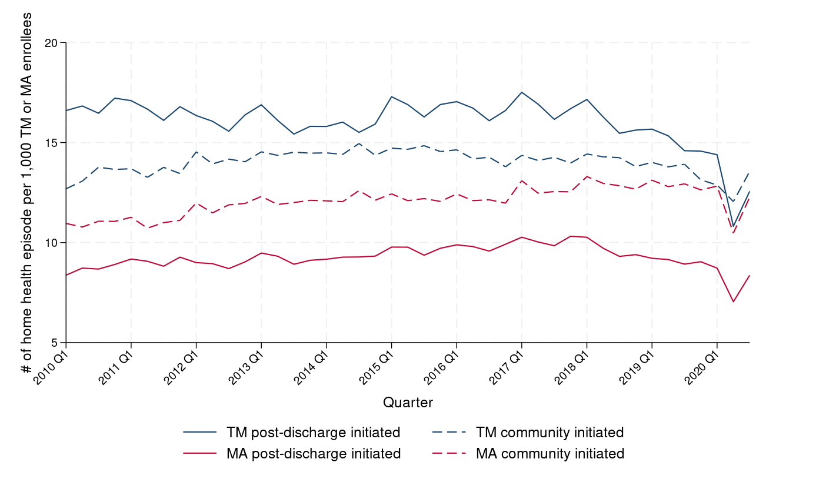
Note: The number of traditional Medicare-covered home health episodes is per 1,000 TM enrollees in that calendar quarter; the number of MA-covered home health episodes is per 1,000 MA enrollees in that calendar quarter. Estimates are adjusted for age, sex, and dual eligibility of TM and MA enrolled beneficiaries in each county-quarter and weighted by the total number of beneficiaries enrolled in TM or MA in each county.

Figure A2.
Caption: Number of home health episodes for dually eligible beneficiaries per 1,000 individuals who are either dually eligible and enrolled in TM or dually eligible and enrolled in MA, stratified by whether the episode was covered by TM or MA and whether it was initiated in the community or after hospital or SNF discharge (excluding race as a covariate).
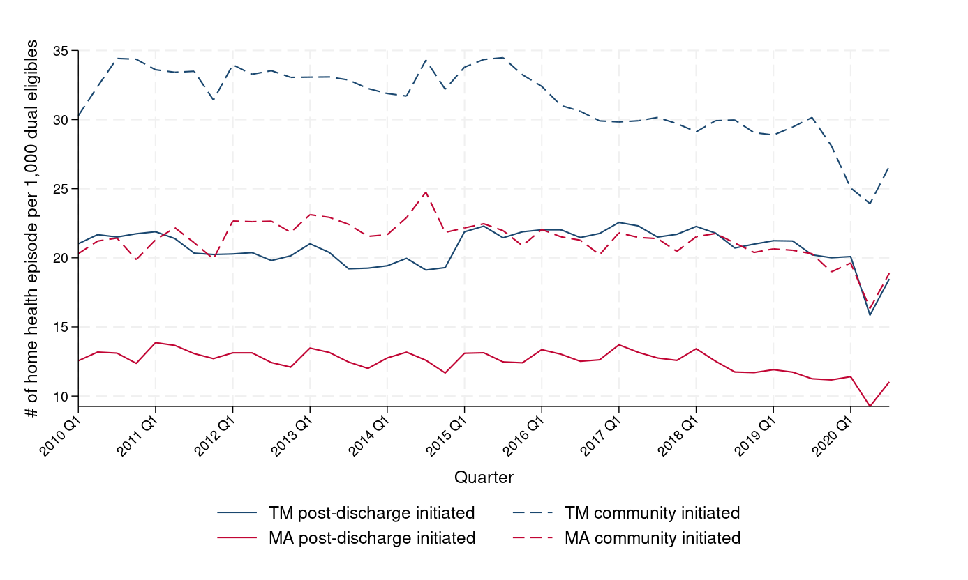
Note: For each stratum, the number of home health episodes among dually eligible beneficiaries is per 1,000 dually eligible beneficiaries who are enrolled in TM or dually eligible beneficiaries who are enrolled in MA in that calendar quarter. Estimates are adjusted for age, sex, and dual eligibility of TM and MA enrolled beneficiaries in each county-quarter and weighted by the total number of dually eligible beneficiaries in each county.

Figure A3.
Caption: Number of home health episodes for non-dually eligible beneficiaries per 1,000 individuals who are either not dually eligible and enrolled in TM or not dually eligible and enrolled in MA, stratified by whether the episode was covered by TM or MA and whether it was initiated in the community or after hospital or SNF discharge (excluding race as a covariate).
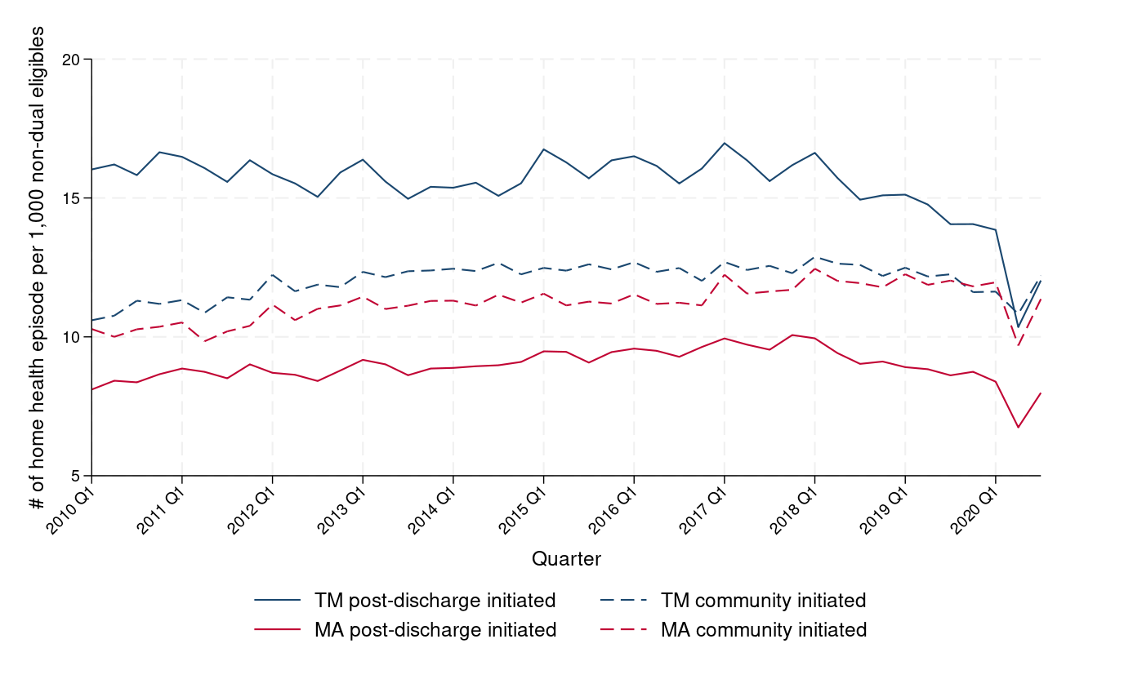
Note: For each stratum, the number of home health episodes among non-dually eligible beneficiaries is per 1,000 non-dually eligible beneficiaries who are enrolled in TM or non-dually eligible beneficiaries who are enrolled in MA in that calendar quarter. Estimates are adjusted for age, sex, and dual eligibility of TM and MA enrolled beneficiaries in each county-quarter and weighted by the total number of non-dually eligible beneficiaries in each county.

Figure A4.
Caption: Median length of home health episode (in days), stratified by whether the episode was covered by TM or MA and whether it was initiated in the community or after hospital or SNF discharge (excluding race as a covariate).
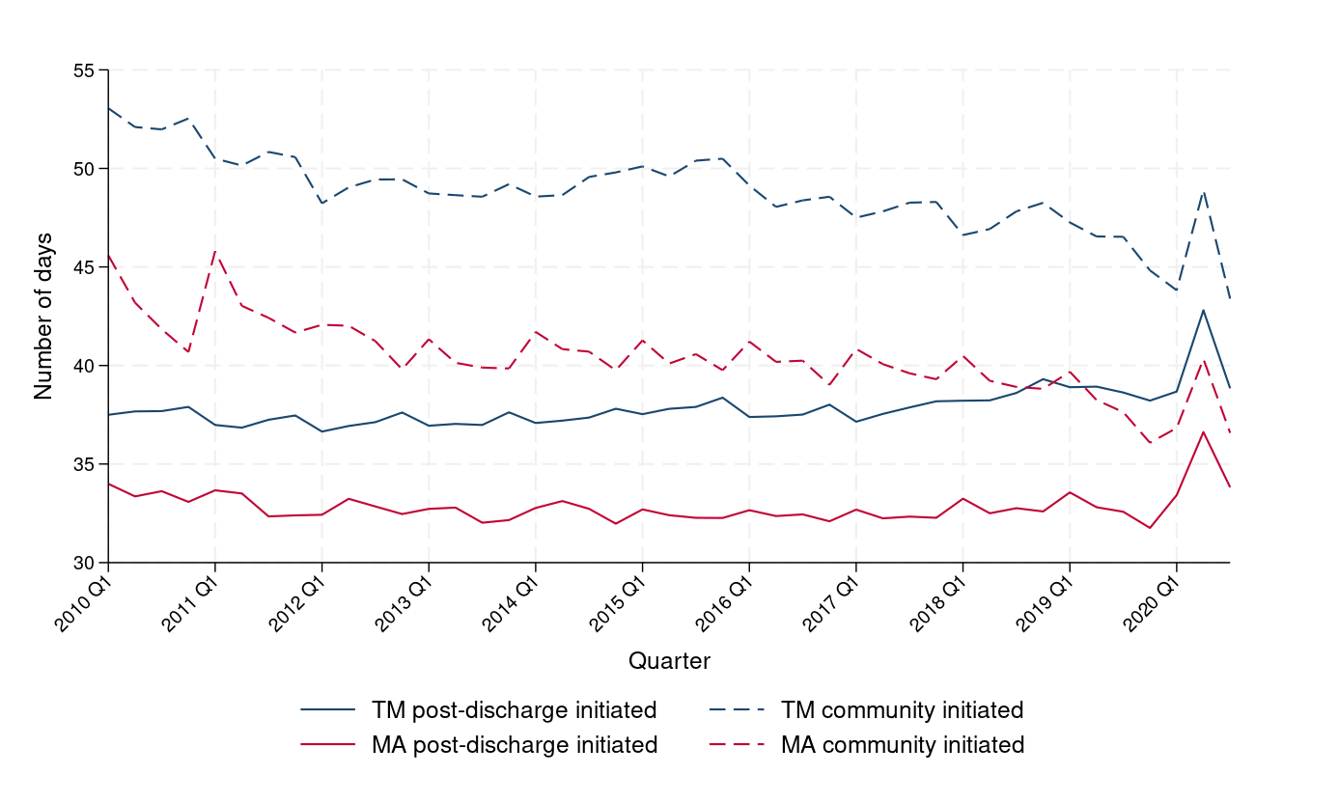
Note: Estimates are adjusted for age, sex, and dual eligibility of TM and MA enrolled beneficiaries in each county and weighted by the total number of beneficiaries enrolled in TM or MA of each county-quarter.

