285,441 Included Cases
Supplemental Figure 1: CONSORT diagram illustrating patients selected for this study.

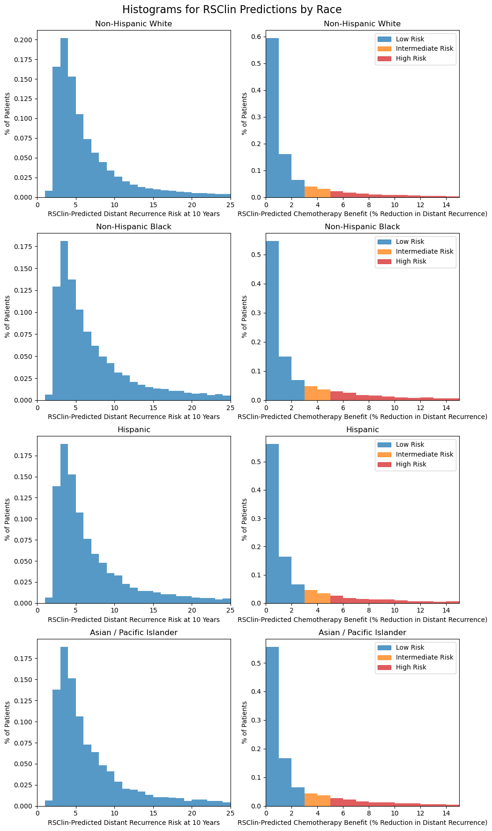
Supplemental Figure 2: Distribution of RSClin Predicted Distant Recurrence Risk and Chemotherapy Benefit, Stratified by Race / Ethnicity.

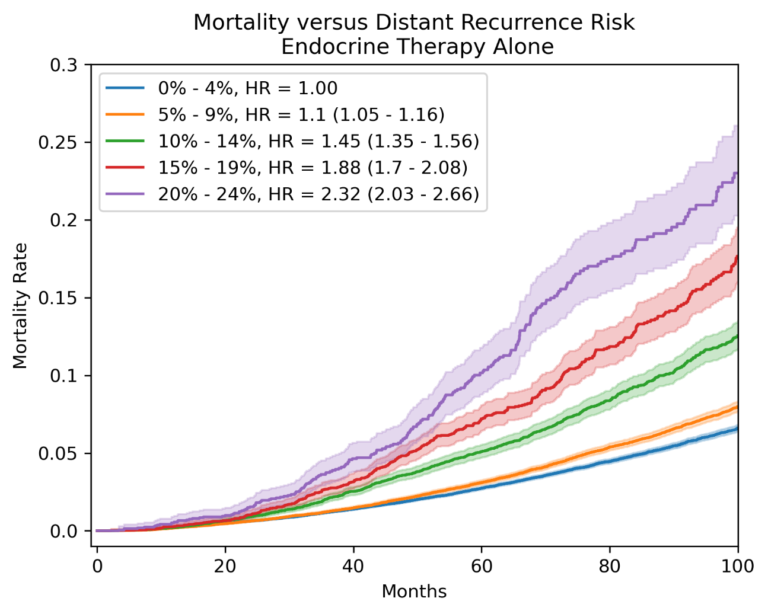
Supplemental Figure 3: Correlation of RSClin Predicted Recurrence Rate and Actual Mortality Rate in Patients Treated with Endocrine Therapy. Patient mortality is stratified by predicted distant recurrence risk, and a monotonic decline in survival is seen with increasing predicted risk. Inverse probability of treatment weighting is applied to survival curves and hazard ratios, with hazard ratios listed for the adjusted model incorporating age and comorbidity index.
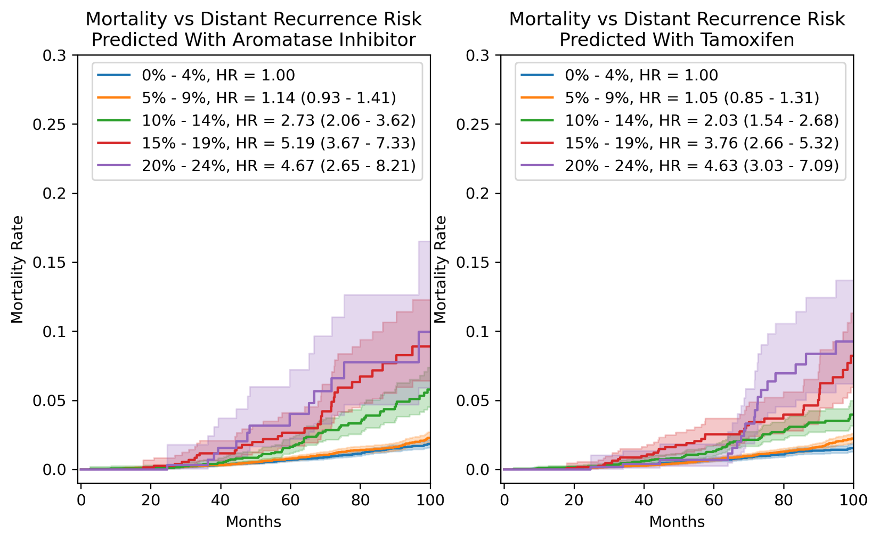
Supplemental Figure 4: Correlation of RSClin Predicted Recurrence Rate for Treatment with Aromatase Inhibitor versus Tamoxifen and Actual Mortality Rate in Patients Under 50 Receiving Endocrine Therapy. Patient mortality is stratified by RSClin predicted distant recurrence risk on aromatase inhibitor (left) and predicted distant recurrence risk on tamoxifen (right). Of note, all evaluated patients received endocrine therapy but the specific therapy in NCDB is not recorded – the patient population is the same in both graphs, but they are stratified by RSClin predictions for treatment with aromatase inhibitor versus tamoxifen. A monotonic decline in survival is seen with increasing predicted risk, except in the two highest risk categories for patients receiving aromatase inhibitors – although this sample size was small in the high-risk groups. Inverse probability of treatment weighting is applied to survival curves and hazard ratios, with hazard ratios listed for the adjusted model incorporating age and comorbidity index.

Supplemental Figure 5: Correlation of RSClin Predictions and Mortality Rate in Patients Treated with or without Chemotherapy in Patients Under 50. Mortality rate is compared between patients under age 50 treated with and without chemotherapy within three subgroups of RSClin predicted chemotherapy benefit (reported as absolute reduction in 10 year distant recurrence rate with chemotherapy). RSClin predictions are calculated presuming treatment with aromatase inhibitor (left) and tamoxifen (right). A trend towards survival benefit is seen starting at the 3 – 5% subgroup, which becomes significant only when using calculations with aromatase inhibitor treatment for the >5% subgroup. Inverse probability of treatment weighting is applied to mitigate effect of patient fitness on treatment decisions, and hazard ratios are listed for chemotherapy benefit in a multivariable Cox model that also incorporates age and comorbidity index.
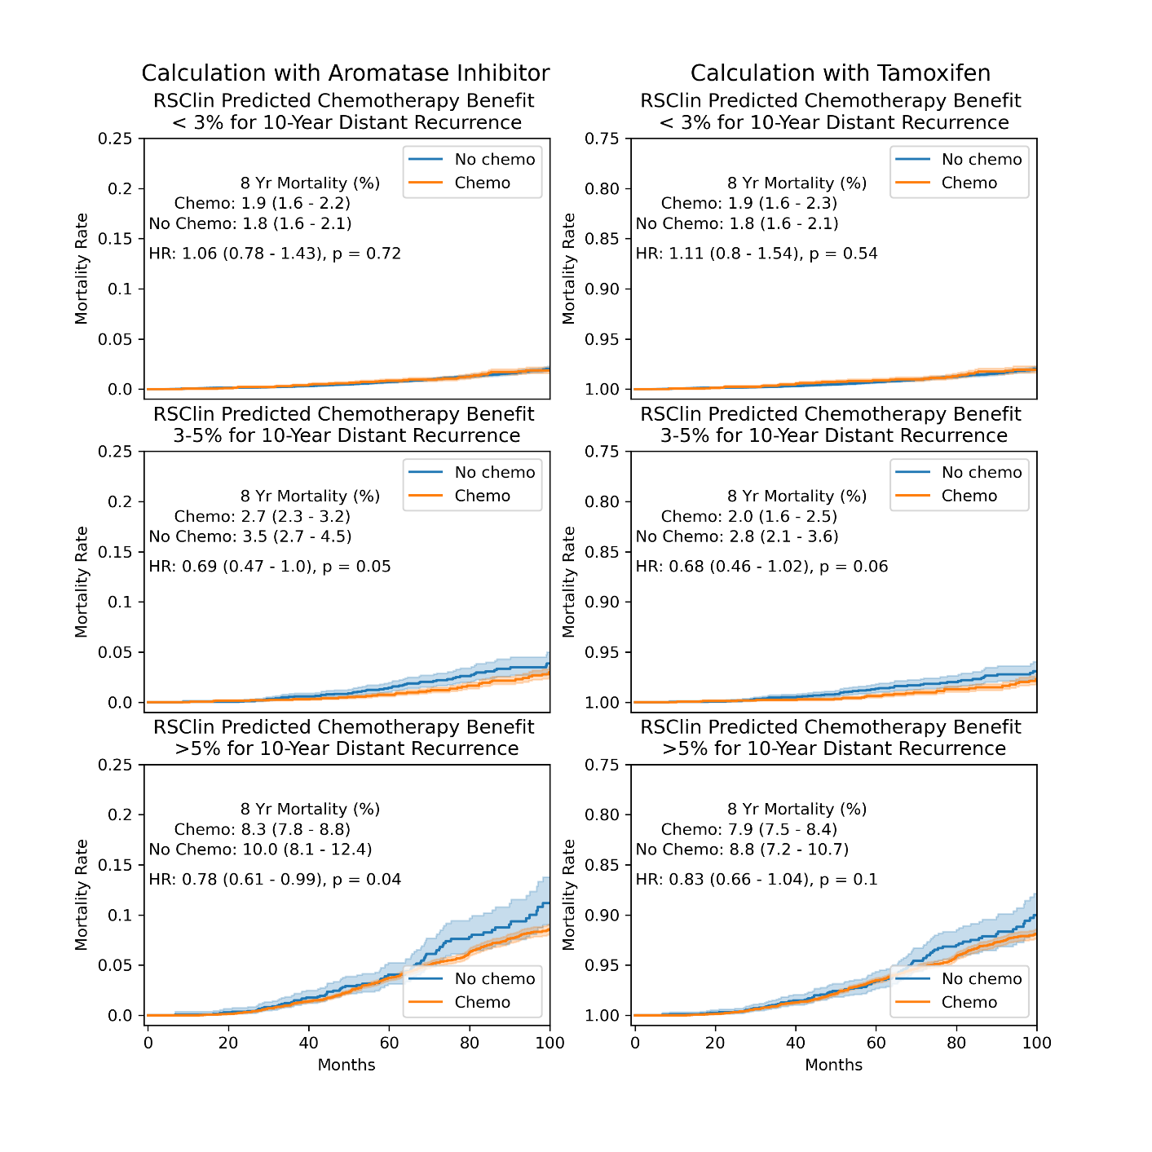

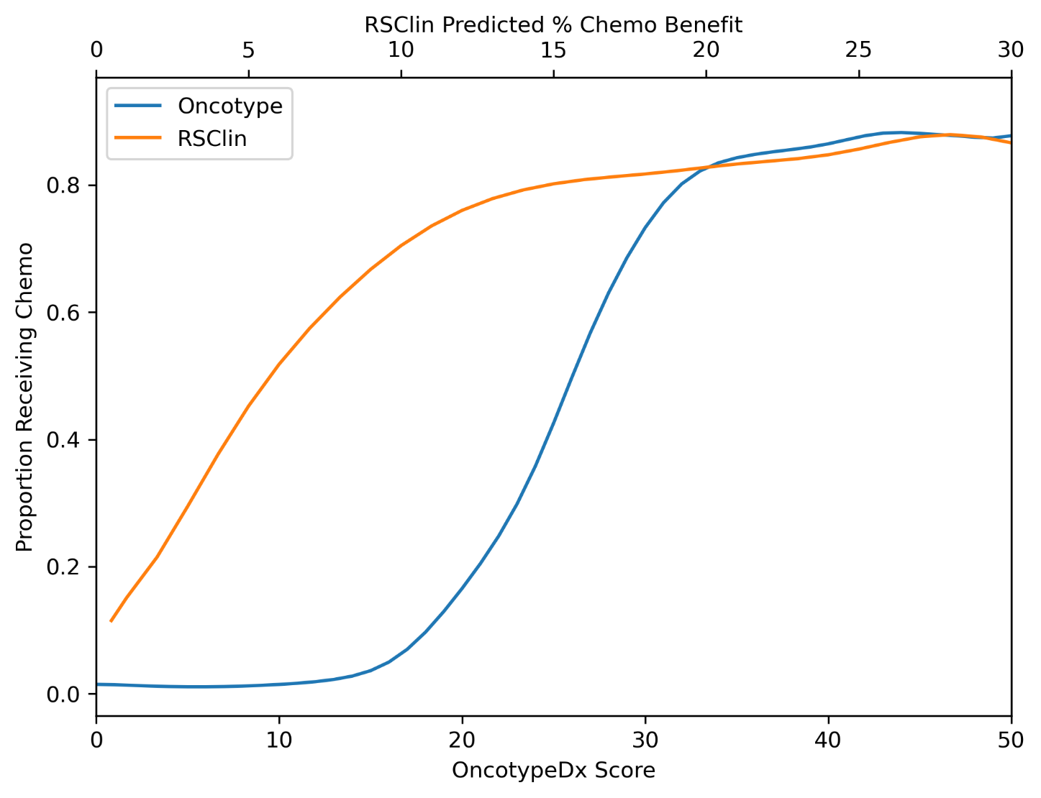
Supplemental Figure 6: Use of Chemotherapy as a Function of OncotypeDx and RSClin Predicted Chemotherapy Benefit in NCDB. Plots are illustrated with Gaussian smoothing.

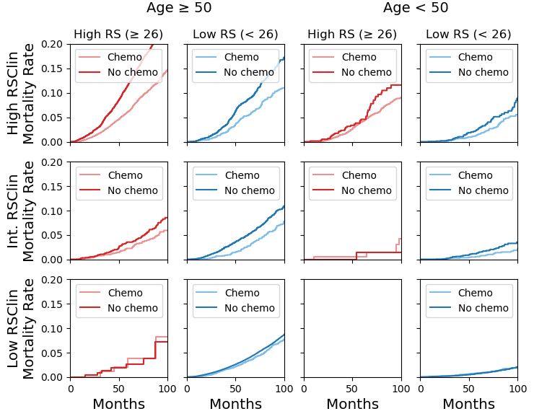
Supplemental Figure 7: Mortality Rate in Patients in Discordant RSClin and OncotypeDx Risk Groups, in Subgroups of Age. High RSClin is defined as predicted absolute chemotherapy benefit of ≥ 5%, intermediate as between 3 - 5%, and a low risk as less than 3%. High OncotypeDx recurrence score (RS) is defined as score of 26 or higher. Inverse probability of treatment weighting is applied to survival curves. Data is presented for subgroups of age under 50 (approximating premenopausal patients) and age 50 or older.

Supplemental Table 1: Patient Demographics Weighted by Inverse Probability of Treatment. Number of patients listed in each category are weighted by inverse probability of treatment, showing similarity for variables incorporated in weighting. Weighting was done for age, comorbidity score, race / ethnicity, and insurance status.
 |  | Overall | Chemo | No Chemo
Age, mean (SD) |  | 59.5 (75.2) | 59.5 (35.0) | 59.5 (6.5)
Race / Ethnicity, n (%) | Asian | 23533 (4.1) | 11845 (4.1) | 11688 (4.1)
Race / Ethnicity, n (%) | Hispanic | 27585 (4.8) | 13802 (4.8) | 13783 (4.8)
Race / Ethnicity, n (%) | Native American | 1459 (0.3) | 615 (0.2) | 843 (0.3)
Race / Ethnicity, n (%) | Non-Hispanic Black | 43458 (7.6) | 21535 (7.5) | 21923 (7.7)
Race / Ethnicity, n (%) | Non-Hispanic White | 472162 (82.7) | 236378 (82.8) | 235784 (82.6)
Race / Ethnicity, n (%) | Other | 2648 (0.5) | 1274 (0.4) | 1373 (0.5)
Insurance, n (%) | Government / Uninsured | 232082 (40.7) | 115439 (40.4) | 116643 (40.9)
Insurance, n (%) | Private / Managed | 338765 (59.3) | 170012 (59.6) | 168753 (59.1)
Charlson/Dayo Score,  n (%) | 0 | 478864 (83.9) | 238976 (83.7) | 239888 (84.1)
Charlson/Dayo Score,  n (%) | >= 1 | 91984 (16.1) | 46475 (16.3) | 45508 (15.9)

Supplemental Table 2: Distribution of RSClin Input Variables and Predictions by Sex.

 |  | Overall | Female | Male | P-Value
n |  | 285441 | 283447 | 1994
Age, mean (SD) |  | 59.5 (10.5) | 59.5 (10.5) | 63.4 (10.3) | <0.001
Grade, n (%) | 1 | 84015 (29.4) | 83683 (29.5) | 332 (16.6) | <0.001
Grade, n (%) | 2 | 161435 (56.6) | 160240 (56.5) | 1195 (59.9)
Grade, n (%) | 3 | 39991 (14.0) | 39524 (13.9) | 467 (23.4)
Tumor Size (mm), mean (SD) |  | 16.8 (13.4) | 16.8 (13.4) | 19.7 (9.9) | <0.001
OncotypeDx Score, mean (SD) |  | 16.3 (9.0) | 16.3 (9.0) | 15.2 (10.1) | <0.001
OncotypeDx Score Group, n (%) | High (26+) | 33468 (11.7) | 33203 (11.7) | 265 (13.3) | <0.001
OncotypeDx Score Group, n (%) | Intermediate (11 - 25) | 180769 (63.3) | 179750 (63.4) | 1019 (51.1)
OncotypeDx Score Group, n (%) | Low (0 - 10) | 71204 (24.9) | 70494 (24.9) | 710 (35.6)
RSClin Predicted Percent Risk of Distant Recurrence at 10 Years with AI Alone, mean (SD) |  | 7.0 (7.6) | 7.0 (7.6) | 8.4 (8.5) | <0.001
RSClin Predicted Benefit of Chemotherapy (Absolute Percent Reduction in Distant Recurrence), mean (SD) |  | 2.5 (5.4) | 2.5 (5.4) | 2.9 (5.7) | 0.002
Predicted Benefit of Chemotherapy Groups, n (%) | High (> 5%) | 31873 (11.2) | 31582 (11.1) | 291 (14.6) | <0.001
Predicted Benefit of Chemotherapy Groups, n (%) | Intermediate (3 - 5%) | 27090 (9.5) | 26898 (9.5) | 192 (9.6)
Predicted Benefit of Chemotherapy Groups, n (%) | Low (< 3%) | 226478 (79.3) | 224967 (79.4) | 1511 (75.8)
Chemotherapy, n (%) | Chemo | 41789 (14.6) | 41501 (14.6) | 288 (14.4) | 0.828
Chemotherapy, n (%) | No Chemo | 243652 (85.4) | 241946 (85.4) | 1706 (85.6)

Supplemental Table 3: Distribution of RSClin Input Variables and Predictions by Race and Ethnicity.

 |  | Overall | Asian | Hispanic | Native American | Non-Hispanic Black | Non-Hispanic White | P-Value
n |  | 285441 | 11735 | 13788 | 814 | 21937 | 235804
Age, mean (SD) |  | 59.5 (10.5) | 55.6 (10.9) | 56.4 (10.9) | 58.3 (9.9) | 58.6 (10.6) | 60.0 (10.3) | <0.001
Grade, n (%) | 1 | 84015 (29.4) | 2916 (24.8) | 3520 (25.5) | 280 (34.4) | 5318 (24.2) | 71606 (30.4) | <0.001
Grade, n (%) | 2 | 161435 (56.6) | 6971 (59.4) | 8064 (58.5) | 435 (53.4) | 12377 (56.4) | 132803 (56.3)
Grade, n (%) | 3 | 39991 (14.0) | 1848 (15.7) | 2204 (16.0) | 99 (12.2) | 4242 (19.3) | 31395 (13.3)
Tumor Size (mm), mean (SD) |  | 16.8 (13.4) | 17.3 (10.6) | 17.7 (14.1) | 17.4 (10.5) | 17.9 (15.0) | 16.7 (13.3) | <0.001
OncotypeDx Score, mean (SD) |  | 16.3 (9.0) | 16.1 (9.0) | 16.1 (9.1) | 16.1 (9.3) | 17.4 (10.2) | 16.2 (8.9) | <0.001
OncotypeDx Score Group, n (%) | High (26+) | 33468 (11.7) | 1381 (11.8) | 1569 (11.4) | 93 (11.4) | 3421 (15.6) | 26863 (11.4) | <0.001
OncotypeDx Score Group, n (%) | Intermediate (11 - 25) | 180769 (63.3) | 7337 (62.5) | 8704 (63.1) | 517 (63.5) | 13449 (61.3) | 149877 (63.6)
OncotypeDx Score Group, n (%) | Low (0 - 10) | 71204 (24.9) | 3017 (25.7) | 3515 (25.5) | 204 (25.1) | 5067 (23.1) | 59064 (25.0)
RSClin Predicted Percent Risk of Distant Recurrence at 10 Years with AI Alone, mean (SD) |  | 7.0 (7.6) | 7.5 (7.7) | 7.5 (7.9) | 7.2 (8.4) | 8.5 (9.3) | 6.9 (7.4) | <0.001
RSClin Predicted Benefit of Chemotherapy (Absolute Percent Reduction in Distant Recurrence), mean (SD) |  | 2.5 (5.4) | 2.6 (5.4) | 2.6 (5.6) | 2.6 (5.9) | 3.4 (7.0) | 2.4 (5.2) | <0.001
Predicted Benefit of Chemotherapy Groups, n (%) | High (> 5%) | 31873 (11.2) | 1505 (12.8) | 1692 (12.3) | 85 (10.4) | 3477 (15.8) | 24965 (10.6) | <0.001
Predicted Benefit of Chemotherapy Groups, n (%) | Intermediate (3 - 5%) | 27090 (9.5) | 1228 (10.5) | 1423 (10.3) | 83 (10.2) | 2385 (10.9) | 21838 (9.3)
Predicted Benefit of Chemotherapy Groups, n (%) | Low (< 3%) | 226478 (79.3) | 9002 (76.7) | 10673 (77.4) | 646 (79.4) | 16075 (73.3) | 189001 (80.2)
Chemotherapy, n (%) | Chemo | 41789 (14.6) | 1918 (16.3) | 2218 (16.1) | 92 (11.3) | 3922 (17.9) | 33437 (14.2) | <0.001
Chemotherapy, n (%) | No Chemo | 243652 (85.4) | 9817 (83.7) | 11570 (83.9) | 722 (88.7) | 18015 (82.1) | 202367 (85.8)

Supplemental Table 4: Mortality Rate as a Function of RSClin Predicted Distant Recurrence Rate. Hazard ratios are calculated in comparison to the 0 – 4% group. Adjusted analysis statistics are calculated with inverse probability of treatment weighting, with hazard ratios indicated for a multivariable Cox model that also includes age and comorbidity index.
 |  |  |  |  | Adjusted
Predicted Rate of Distant Recurrence | n | 8 Year Mortality Rate (%, 95% CI) | HR (95% CI) | p | 8 Year Mortality Rate (%, 95% CI) | HR (95% CI) | p
0% - 4% | 124496 | 6.4 (6.1 - 6.6) | 1 (ref) | -- | 6.1 (5.9 - 6.3) | 1 (ref) | --
5% - 9% | 65567 | 7.7 (7.4 - 8.1) | 1.1 (1.05 - 1.15) | < 0.01 | 7.4 (7.1 - 7.7) | 1.1 (1.05 - 1.16) | < 0.01
10% - 14% | 14093 | 12.2 (11.3 - 13.1) | 1.76 (1.64 - 1.89) | < 0.01 | 11.7 (10.9 - 12.6) | 1.45 (1.35 - 1.56) | < 0.01
14% - 19% | 5099 | 16.6 (14.9 - 18.4) | 2.44 (2.22 - 2.69) | < 0.01 | 16.1 (14.5 - 17.7) | 1.88 (1.7 - 2.08) | < 0.01
20% - 24% | 2090 | 21.5 (19.1 - 24.9) | 3.37 (2.96 - 3.83) | < 0.01 | 21.0 (18.7 - 24.0) | 2.32 (2.03 - 2.66) | < 0.01

Supplemental Table 5: Mortality Rate as a Function of RSClin Predicted Distant Recurrence Rate Presuming Treatment with Aromatase Inhibitor in Patients Under 50. Hazard ratios are calculated in comparison to the 0 – 4% group. Adjusted analysis statistics are calculated with inverse probability of treatment weighting, with hazard ratios indicated for a multivariable Cox model that also includes age and comorbidity index.
 |  |  |  |  | Adjusted
Predicted Rate of Distant Recurrence on Aromatase Inhibitor | n | 8 Year Mortality Rate (%, 95% CI) | HR (95% CI) | p | 8 Year Mortality Rate (%, 95% CI) | HR (95% CI) | p
0% - 4% | 19699 | 1.7 (1.4 - 2.0) | 1 | -- | 1.7 (1.5 - 2.0) | 1 | --
5% - 9% | 13579 | 2.0 (1.6 - 2.4) | 1.13 (0.92 - 1.39) | 0.24 | 2.0 (1.7 - 2.4) | 1.14 (0.93 - 1.41) | 0.21
10% - 14% | 2629 | 5.2 (3.9 - 6.9) | 2.72 (2.07 - 3.58) | < 0.01 | 5.1 (4.0 - 6.5) | 2.73 (2.06 - 3.62) | < 0.01
14% - 19% | 857 | 9.0 (6.2 - 13.0) | 4.98 (3.53 - 7.02) | < 0.01 | 8.9 (6.4 - 12.3) | 5.19 (3.67 - 7.33) | < 0.01
20% - 24% | 334 | 7.5 (4.2 - 13.4) | 4.41 (2.5 - 7.77) | < 0.01 | 7.7 (4.7 - 12.6) | 4.67 (2.65 - 8.21) | < 0.01

Supplemental Table 6: Mortality Rate as a Function of RSClin Predicted Distant Recurrence Rate Presuming Treatment with Tamoxifen in Patients Under 50. Hazard ratios are calculated in comparison to the 0 – 4% group. Adjusted analysis statistics are calculated with inverse probability of treatment weighting, with hazard ratios indicated for a multivariable Cox model that also includes age and comorbidity index.
 |  |  |  |  | Adjusted
Predicted Rate of Distant Recurrence on Tamoxifen | n | 8 Year Mortality Rate (%, 95% CI) | HR (95% CI) | p | 8 Year Mortality Rate (%, 95% CI) | HR (95% CI) | p
0% - 4% | 13895 | 1.4 (1.2 - 1.8) | 1 | -- | 1.4 (1.2 - 1.7) | 1 | --
5% - 9% | 17070 | 2.0 (1.7 - 2.4) | 1.05 (0.84 - 1.3) | 0.68 | 2.0 (1.8 - 2.4) | 1.05 (0.85 - 1.31) | 0.66
10% - 14% | 4011 | 3.5 (2.7 - 4.6) | 2.05 (1.56 - 2.69) | < 0.01 | 3.5 (2.8 - 4.4) | 2.03 (1.54 - 2.68) | < 0.01
14% - 19% | 1288 | 6.9 (4.7 - 10.0) | 3.67 (2.61 - 5.17) | < 0.01 | 6.7 (4.8 - 9.3) | 3.76 (2.66 - 5.32) | < 0.01
20% - 24% | 586 | 9.3 (5.9 - 14.6) | 4.47 (2.92 - 6.84) | < 0.01 | 9.3 (6.2 - 13.7) | 4.63 (3.03 - 7.09) | < 0.01

Supplemental Table 7: Comparative Accuracy of RSClin Distant Recurrence Risk and Clinical Variables for Prediction of Overall Survival. To determine if RSClin predictions of 10-year distant recurrence risk on aromatase inhibitor can be used to predict overall survival in patients receiving hormonal therapy (as most cases of distant recurrence will lead to cancer related mortality), Cox models were formulated with combinations of RSClin predicted risk and other clinical prognostic variables. RSClin predicted risk performs at least as well as the combination of tumor size, grade, and recurrence score. Since age is strongly correlated with non-cancer mortality, we did not compare RSClin predictions alone to combinations with age. However, RSClin predictions combined with age performs at least as well as age, tumor size, grade, and recurrence score.
Model Covariates | Concordance Index
RSClin Predicted Recurrence | 0.574
Tumor Size | 0.572
Grade | 0.544
Recurrence Score | 0.543
Tumor Size, Grade | 0.572
Tumor Size, Grade, Recurrence Score | 0.570
RSClin Predicted Recurrence, Age | 0.719
Tumor Size, Age | 0.711
Grade, Age | 0.708
Recurrence Score, Age | 0.710
Tumor Size, Grade, Age | 0.712
Tumor Size, Grade, Recurrence Score, Age | 0.713

Supplemental Table 8: Survival Benefit of Chemotherapy, Stratified by RSClin Predicted Benefit. Adjusted analysis statistics are calculated with inverse probability of treatment weighting, with hazard ratios listed for chemotherapy in a multivariable Cox model that also includes age and comorbidity index.

 |  |  |  |  |  |  | Adjusted
Predicted Chemo Benefit | No Chemo (n) | Chemo (n) | 8 Year Mortality Rate (No Chemo) | 8 Year Mortality Rate (Chemo) | HR | p | 8 Year Mortality Rate (No Chemo) | 8 Year Mortality Rate (Chemo) | HR | p
< 3% | 190283 | 9080 | 7.1 (6.9 - 7.3) | 4.9 (4.4 - 5.5) | 0.66 (0.6 - 0.74) | < 0.01 | 6.8 (5.8 - 6.3) | 6.1 (6.6 - 7.0) | 0.99 (0.89 - 1.11) | 0.91
3-5% | 14804 | 9162 | 9.3 (8.6 - 10.1) | 5.5 (4.8 - 6.2) | 0.53 (0.47 - 0.61) | < 0.01 | 8.9 (6.2 - 6.8) | 6.5 (8.3 - 9.7) | 0.68 (0.6 - 0.79) | < 0.01
> 5% | 8631 | 20927 | 20.5 (19.2 - 21.9) | 11.6 (11.0 - 12.2) | 0.51 (0.47 - 0.55) | < 0.01 | 19.9 (12.9 - 13.4) | 13.1 (18.7 - 21.1) | 0.66 (0.61 - 0.72) | < 0.01

Supplemental Table 9: Survival Benefit of Chemotherapy, Stratified by RSClin Predicted Benefit Computed with Aromatase Inhibitor Therapy, in Patients Under Age 50. Adjusted analysis statistics are calculated with inverse probability of treatment weighting, with hazard ratios listed for chemotherapy in a multivariable Cox model that also includes age and comorbidity index.

 |  |  |  |  |  |  | Adjusted
Predicted Chemo Benefit | No Chemo (n) | Chemo (n) | 8 Year Mortality Rate (No Chemo) | 8 Year Mortality Rate (Chemo) | HR | p | 8 Year Mortality Rate (No Chemo) | 8 Year Mortality Rate (Chemo) | HR | p
< 3% | 32875 | 3027 | 1.8 (1.6 - 2.1) | 1.9 (1.4 - 2.6) | 1.08 (0.8 - 1.45) | 0.62 | 1.8 (1.6 - 2.2) | 1.9 (1.6 - 2.1) | 1.06 (0.78 - 1.43) | 0.72
3-5% | 3022 | 2733 | 3.5 (2.6 - 4.7) | 2.7 (1.9 - 3.7) | 0.69 (0.47 - 0.99) | 0.04 | 3.5 (2.3 - 3.2) | 2.7 (2.7 - 4.5) | 0.69 (0.47 - 1.0) | 0.05
> 5% | 1485 | 6135 | 10.1 (7.9 - 12.9) | 8.3 (7.3 - 9.3) | 0.78 (0.61 - 0.99) | 0.04 | 10.0 (7.8 - 8.8) | 8.3 (8.1 - 12.4) | 0.78 (0.61 - 0.99) | 0.04

Supplemental Table 10: Survival Benefit of Chemotherapy, Stratified by RSClin Predicted Benefit Computed with Tamoxifen Therapy, in Patients Under Age 50. Adjusted analysis statistics are calculated with inverse probability of treatment weighting, with hazard ratios listed for chemotherapy in a multivariable Cox model that also includes age and comorbidity index.

 |  |  |  |  |  |  | Adjusted
Predicted Chemo Benefit | No Chemo (n) | Chemo (n) | 8 Year Mortality Rate (No Chemo) | 8 Year Mortality Rate (Chemo) | HR | p | 8 Year Mortality Rate (No Chemo) | 8 Year Mortality Rate (Chemo) | HR | p
< 3% | 31918 | 2499 | 1.8 (1.6 - 2.1) | 1.9 (1.3 - 2.7) | 1.11 (0.81 - 1.53) | 0.51 | 1.8 (1.6 - 2.3) | 1.9 (1.6 - 2.1) | 1.11 (0.8 - 1.54) | 0.54
3-5% | 3432 | 2511 | 2.8 (2.1 - 3.8) | 2.1 (1.4 - 3.1) | 0.7 (0.47 - 1.04) | 0.07 | 2.8 (1.6 - 2.5) | 2.0 (2.1 - 3.6) | 0.68 (0.46 - 1.02) | 0.06
> 5% | 2032 | 6885 | 8.9 (7.1 - 11.1) | 7.8 (7.0 - 8.8) | 0.82 (0.66 - 1.03) | 0.09 | 8.8 (7.5 - 8.4) | 7.9 (7.2 - 10.7) | 0.83 (0.66 - 1.04) | 0.1

Supplemental Table 11: Mortality Rate in Patients in Discordant RSClin and OncotypeDx Risk Groups. Adjusted analysis statistics are calculated with inverse probability of treatment weighting, with hazard ratios indicated for a multivariable Cox model that also includes age and comorbidity index. High OncotypeDx recurrence score is defined as ≥ 26, and low OncotypeDx recurrence score is defined as < 26. High RSClin predicted chemotherapy benefit is defined as > 5%, intermediate as 3 – 5%, and low as < 3%.

Group | No Chemo (n) | Chemo (n) | HR (95%CI) |  | p |  | 8yr Mortality % (95%CI), Chemo | 8yr Mortality % (95%CI), No Chemo
High OncotypeDx,  High RSClin | 6174 | 20045 | 0.63 (0.57-0.69) |  | < 0.01 |  | 13.1 (12.9-13.4) | 21.1 (19.8-22.6)
Low OncotypeDx,  High RSClin | 5361 | 3847 |  | 0.71 (0.58-0.86) |  | < 0.01 | 9.0 (8.5-9.5) | 13.6 (12.2-15.2)
High OncotypeDx,  Intermediate RSClin | 2044 | 2413 | 0.76 (0.55-1.04) |  | 0.09 |  | 5.5 (5.0-6.0) | 7.8 (6.2-9.7)
Low OncotypeDx,  Intermediate RSClin | 9856 | 3784 | 0.66 (0.53-0.82) |  | < 0.01 |  | 5.6 (5.2-6.0) | 8.3 (7.5-9.2)
High OncotypeDx,  Low RSClin | 262 | 157 | 1.7 (0.41-6.99) |  | 0.46 |  | 8.1 (5.7-11.4) | 7.2 (3.4-14.8)
Low OncotypeDx,  Low RSClin | 190021 | 8923 | 0.99 (0.88-1.11) |  | 0.9 |  | 6.1 (5.8-6.3) | 6.8 (6.6-7.0)

Supplemental Table 12: Mortality Rate in Patients 50 Years Old or Older in Discordant RSClin and OncotypeDx Risk Groups. Adjusted analysis statistics are calculated with inverse probability of treatment weighting, with hazard ratios indicated for a multivariable Cox model that also includes age and comorbidity index. High OncotypeDx recurrence score is defined as ≥ 26, and low OncotypeDx recurrence score is defined as < 26. High RSClin predicted chemotherapy benefit is defined as > 5%, intermediate as 3 – 5%, and low as < 3%.

Group | No Chemo (n) | Chemo (n) | HR (95%CI) |  | p |  | 8yr Mortality % (95%CI), Chemo | 8yr Mortality % (95%CI), No Chemo
High OncotypeDx,  High RSClin | 5547 | 15088 | 0.63 (0.58-0.7) |  | < 0.01 |  | 13.8 (13.5-14.1) | 22.4 (21.0-24.0)
Low OncotypeDx,  High RSClin | 3912 | 1883 |  | 0.76 (0.6-0.95) |  | 0.02 | 10.7 (10.0-11.4) | 16.7 (14.9-18.8)
High OncotypeDx,  Intermediate RSClin | 1934 | 2184 | 0.74 (0.53-1.03) |  | 0.08 |  | 5.6 (5.1-6.2) | 8.2 (6.6-10.3)
Low OncotypeDx,  Intermediate RSClin | 7535 | 2066 | 0.67 (0.53-0.85) |  | < 0.01 |  | 7.0 (6.5-7.5) | 10.2 (9.2-11.3)
High OncotypeDx,  Low RSClin | 262 | 156 | 1.7 (0.41-6.97) |  | 0.46 |  | 8.2 (5.8-11.5) | 7.2 (3.4-14.8)
Low OncotypeDx,  Low RSClin | 157146 | 5897 | 0.99 (0.88-1.12) |  | 0.89 |  | 7.2 (6.9-7.5) | 8.0 (7.8-8.2)

Supplemental Table 13: Mortality Rate in Patients Younger than 50 Years Old in Discordant RSClin and OncotypeDx Risk Groups, Presuming Treatment with Aromatase Inhibitor. Adjusted analysis statistics are calculated with inverse probability of treatment weighting, with hazard ratios indicated for a multivariable Cox model that also includes age and comorbidity index. High OncotypeDx recurrence score is defined as ≥ 26, and low OncotypeDx recurrence score is defined as < 26. High RSClin predicted chemotherapy benefit is defined as > 5%, intermediate as 3 – 5%, and low as < 3%.
Group | No Chemo (n) | Chemo (n) | HR (95%CI) |  | p | 8yr Mortality % (95%CI), Chemo | 8yr Mortality % (95%CI), No Chemo
High OncotypeDx,  High RSClin | 627 | 4957 | 0.78 (0.57-1.08) |  | 0.14 | 8.8 (8.3-9.4) | 11.6 (8.8-15.1)
Low R OncotypeDx,  High RSClin | 1449 | 1964 |  | 0.57 (0.39-0.83) | < 0.01 | 5.2 (4.5-6.1) | 7.0 (5.3-9.3)
High OncotypeDx,  Intermediate RSClin | 110 | 229 | 1.89 (0.21-16.85) |  | 0.57 | 3.0 (1.7-5.4) | 1.5 (0.3-7.9)
Low OncotypeDx,  Intermediate RSClin | 2321 | 1718 | 0.62 (0.39-1.0) |  | 0.05 | 1.8 (1.4-2.4) | 3.3 (2.4-4.4)
High OncotypeDx,  Low RSClin | 0 | 1 | - |  | - | - | -
Low OncotypeDx,  Low RSClin | 32875 | 3026 | 1.06 (0.78-1.43) |  | 0.72 | 1.9 (1.6-2.2) | 1.8 (1.7-2.1)

