A practical guide to cross-cultural and multi-sited data collection in the biological and behavioural sciences
Laure Spake, Anushé Hassan, Susan B. Schaffnit, Nurul Alam, Abena S. Amoah, Jainaba Badjie, Carla Cerami, Amelia Crampin, Albert Dube, Miranda P. Kaye, Renee Kotch, Frankie Liew, Estelle McLean, Shekinah Munthali-Mkandawire, Lusako Mwalwanda, Anne-Cathrine Petersen, Andrew M. Prentice, Fatema tuz Zohora, Joseph Watts, Rebecca Sear, Mary K. Shenk, Richard Sosis, John H. Shaver

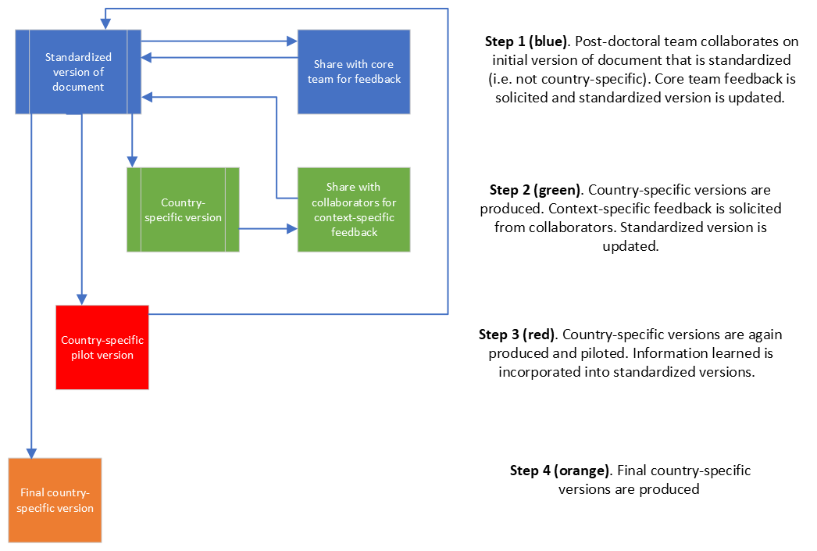

Supplementary Figure S1. Illustration of the instrument and document design process for all components of the project

