Supplementary Figures
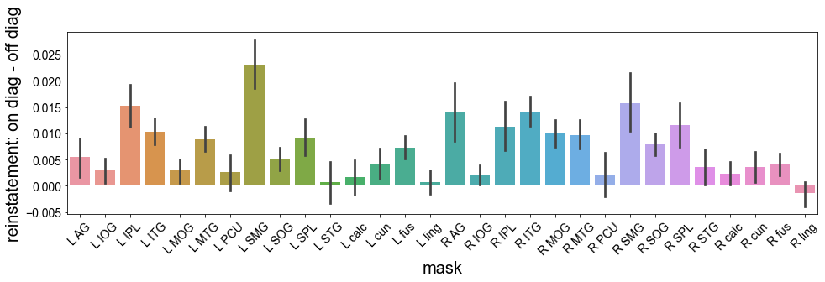
Supplementary Figure 1. Average within-subject reinstatement for each ROI. Error bars reflect standard error of the mean.

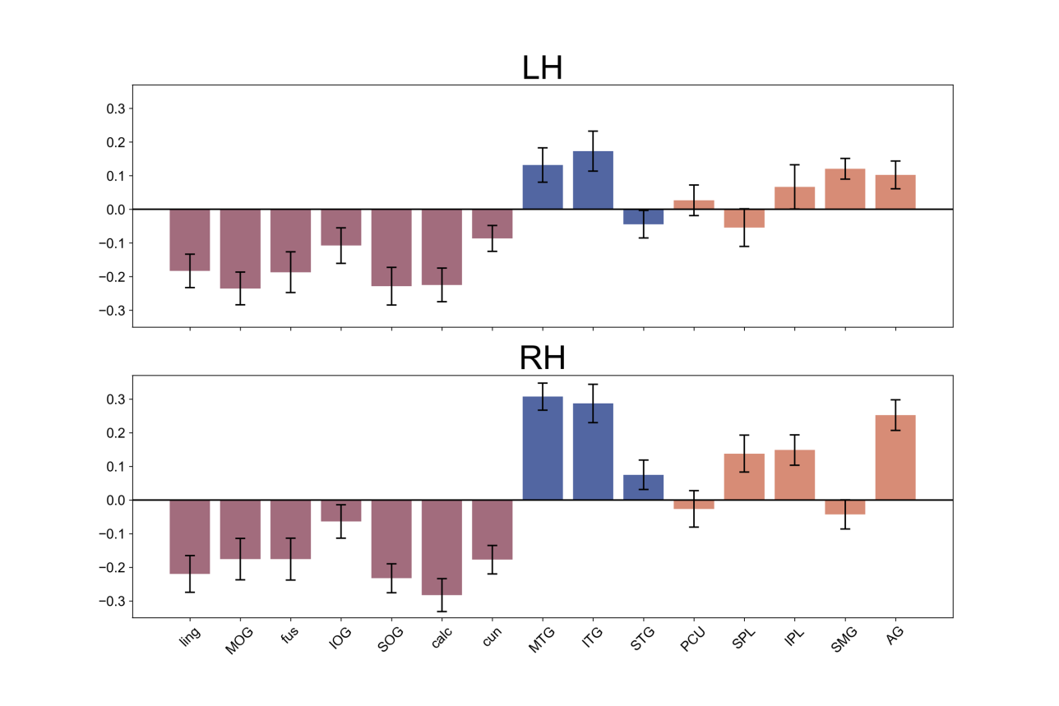
Supplementary Figure 2. Average within-subject correlation between across-item retrieval similarity and reinstatement for each ROI, plotted by hemisphere. Error bars reflect standard error of the mean.

