Inorganic carbon is overlooked in global soil carbon research: A bibliometric analysis
Sajjad Raza^{a,b,c,d}, Annie Irshad^{b}, Andrew Margenot^{b}, Kazem Zamanian^{a,e}, Nan Li^{f,g}, Sami Ullah^{h}, Khalid Mehmood^{i}, Muhammad Ajmal Khan^{j}, Nadeem Siddique^{k}, Jianbin Zhou^{l}, Sacha J. Mooney^{c}, Irina Kurganova^{m,n}, Xiaoning Zhao^{a*}, Yakov Kuzyakov^{o,p}
ª School of Geographical Sciences, Nanjing University of Information Science & Technology, Nanjing 210044, China
^{b} Department of Crop Sciences, University of Illinois Urbana-Champaign, Urbana, IL 61801, United States
^{c} School of Biosciences, University of Nottingham, Sutton Bonington Campus, Leicestershire LE12 5RD, United Kingdom
^{d} Pritzker School of Molecular Engineering, University of Chicago, Chicago, Illinois 60637, United States

^{e} Institute of Soil Science, Leibniz University of Hannover, Herrenhäuser Straße 2, 30419 Hannover, Germany
^{f} Department of Environmental Sciences, University of California, Riverside, California 92521, United States
^{g} US Salinity Laboratory (USDA-ARS), Agricultural Water Efficiency and Salinity Research Unit, Riverside, California 92507, USA
^{h} School of Geography, Earth & Environmental Sciences, University of Birmingham, Birmingham, UK
^{i} Institute of Environmental Health and Ecological Security, School of the Environment and Safety Engineering, Jiangsu University, Zhenjiang, Jiangsu 212013, China
^{j} Deanship of Library Affairs, Imam Abdulrahman Bin Faisal University, Dammam, Saudi Arabia
^{k} Gad and Birgit Rausing Library, Lahore University of Management Sciences, Lahore, Pakistan
^{l} College of Natural Resources and Environment, Northwest A&F University, Yangling, Shaanxi 712100, China
^{m} Institute of Physicochemical and Biological Problems of Soil Science, Russian Academy of Sciences, Pushchino, 142290, Russia
^{n} Tyumen State University, 6 Volodarskogo Street, 625003 Tyumen, Russia
º Department of Soil Science of Temperate Ecosystems, University of Göttingen, 37077 Göttingen, Germany
^{p} Peoples Friendship University of Russia (RUDN University), 117198 Moscow, Russia

Supplementary Information
Queries Details
A set of queries were searched in the Web of Science Core Collection to extract complete historical data of soil carbon research, including share by organic (SOC) and inorganic carbon (SIC) pools, and the research focused on climate change. All the data search was conducted on January 13, 2024.
Query 1: Soil organic carbon research
TS=("Soil Organic Carbon" OR "Organic Carbon in Soil" OR "Organic Carbon from Soil" OR “Organic Carbon of Soil” OR “Soil Organic Matter” OR “Organic Matter in Soil” OR “Organic Matter from Soil” OR “Organic Matter of Soil”) (1)
Query 2: Soil organic carbon research focused on climate change
TS=("Soil Organic Carbon" OR "Organic Carbon in Soil" OR "Organic Carbon from Soil" OR “Organic Carbon of Soil” OR “Soil Organic Matter” OR “Organic Matter in Soil” OR “Organic Matter from Soil” OR “Organic Matter of Soil”) AND TS=("Climate Change*" OR "Global Change*" OR "Global Warming" OR “Temperature Rise” OR “Climate Crisis” OR “Climate Action” OR “Greenhouse Effect” OR "Greenhouse Gas*" OR "Carbon Emission*" OR "Carbon Loss*" OR "Carbon Release*" OR "Carbon Efflux*" OR "Carbon Flux*" OR "Carbon Sequestration" OR "Carbon Source*" OR "Carbon Sink*" OR "Carbon Stock*" OR "Carbon Uptake*" OR "Carbon Gain*" OR "Carbon Accumulation*" OR "Carbon Buildup*" OR "Carbon Balance*" OR "Carbon Budget" OR “Carbon Footprint*” OR "Carbon Dioxide" OR "CO2" OR "Methane" OR "CH4" OR "Nitrous Oxide" OR "N2O") (2)
Query 3: Soil inorganic carbon research
TS=("Soil Inorganic Carbon" OR “Inorganic Carbon in Soil” OR “Inorganic Carbon from Soil” OR “Inorganic Carbon of Soil” OR "Soil Carbonate*" OR "Soil CaCO3" OR "Soil Calcium Carbonate*" OR "Pedogenic Carbonate*" OR "Carbonate* in Soil*" OR "Carbonate* from Soil*" OR “Carbonate* of Soil” OR “Soil Bicarbonate*” OR “Bicarbonate* in Soil” OR “Bicarbonate* of Soil” OR “Bicarbonate* from Soil” OR “Soil Calcite” OR “Soil Aragonite” OR “Soil Dolomite” OR “Soil MgCO3” OR “Soil CaMg(CO3)2” OR “Soil Whewellite” OR “Soil Weddellite”) (3)
Query 4: Soil inorganic carbon focused on climate change
TS=("Soil Inorganic Carbon" OR “Inorganic Carbon in Soil” OR “Inorganic Carbon from Soil” OR “Inorganic Carbon of Soil” OR "Soil Carbonate*" OR "Soil CaCO3" OR "Soil Calcium Carbonate*" OR "Pedogenic Carbonate*" OR "Carbonate* in Soil*" OR "Carbonate* from Soil*" OR “Carbonate* of Soil” OR “Soil Bicarbonate*” OR “Bicarbonate* in Soil” OR “Bicarbonate* of Soil” OR “Bicarbonate* from Soil” OR “Soil Calcite” OR “Soil Aragonite” OR “Soil Dolomite” OR “Soil MgCO3” OR “Soil CaMg(CO3)2” OR “Soil Whewellite” OR “Soil Weddellite”) AND TS=("Climate Change*" OR "Global Change*" OR "Global Warming" OR “Temperature Rise” OR “Climate Crisis” OR “Climate Action” OR “Greenhouse Effect” OR "Greenhouse Gas*" OR "Carbon Emission*" OR "Carbon Loss*" OR "Carbon Release*" OR "Carbon Efflux*" OR "Carbon Flux*" OR "Carbon Sequestration" OR "Carbon Source*" OR "Carbon Sink*" OR "Carbon Stock*" OR "Carbon Uptake*" OR "Carbon Gain*" OR "Carbon Accumulation*" OR "Carbon Buildup*" OR "Carbon Balance*" OR "Carbon Budget" OR “Carbon Footprint*” OR "Carbon Dioxide" OR "CO2" OR "Methane" OR "CH4" OR "Nitrous Oxide" OR "N2O") (4)

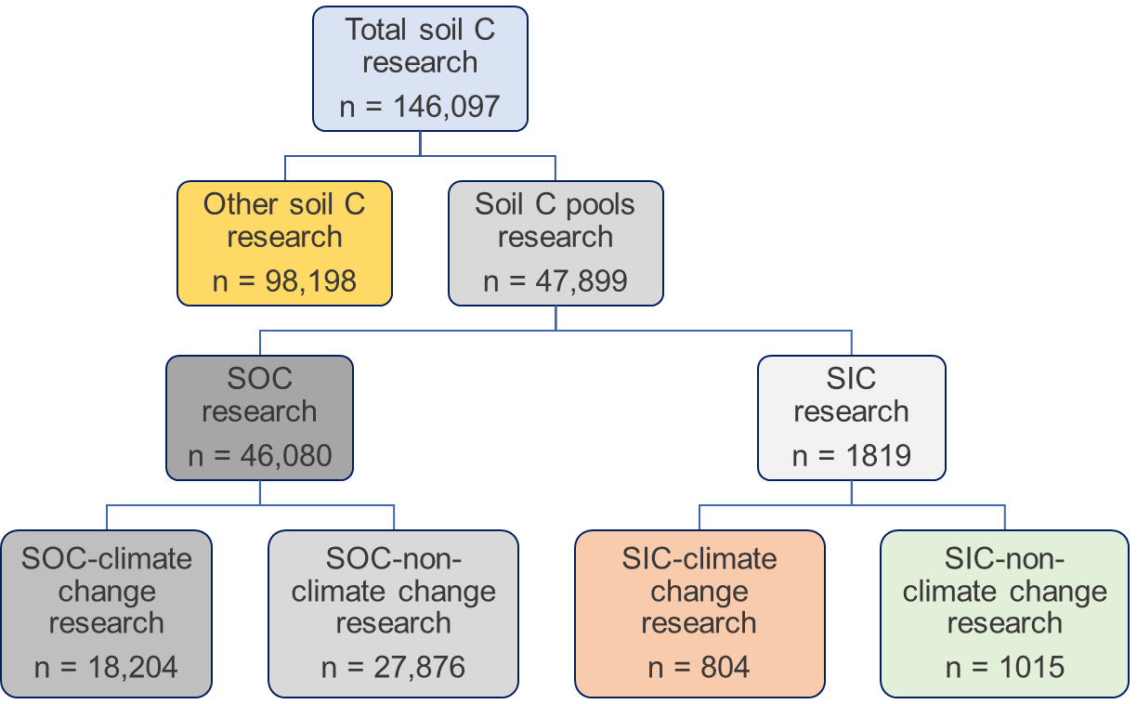
Figure S1. Systematic scheme showing global research papers on soil carbon with contributions of SOC and SIC pools and the research focused on climate change. This study only focuses on global research by soil C pools (n = 47,899) and their share for climate change. The number of papers in the Web-of-Science from 1905 To 2023. The total soil carbon research papers were extracted from Web of Science using this query: TS=(“Soil”) AND TS=(“Carbon”).

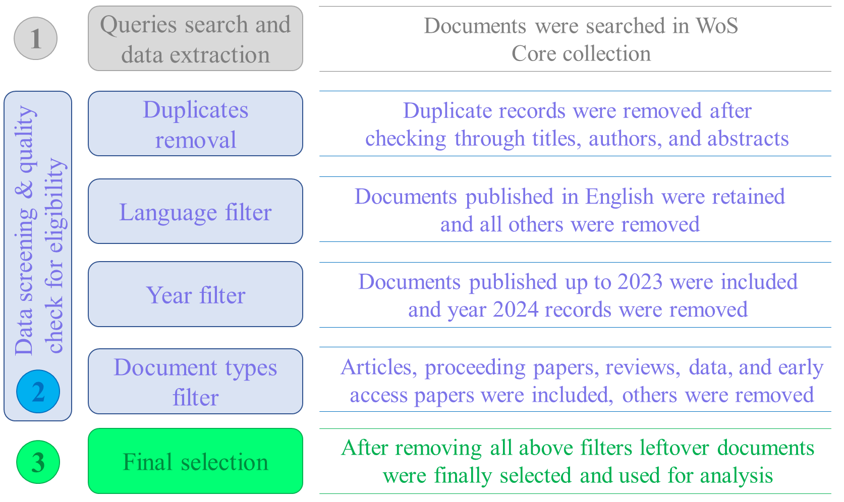
Figure S2. Flow chart diagram showing data search and selection processes. Publications after initial data search were passed through four filters (duplicates, language, year, publication type) to isolate publications relevant to the four research questions of this bibliometric analysis.

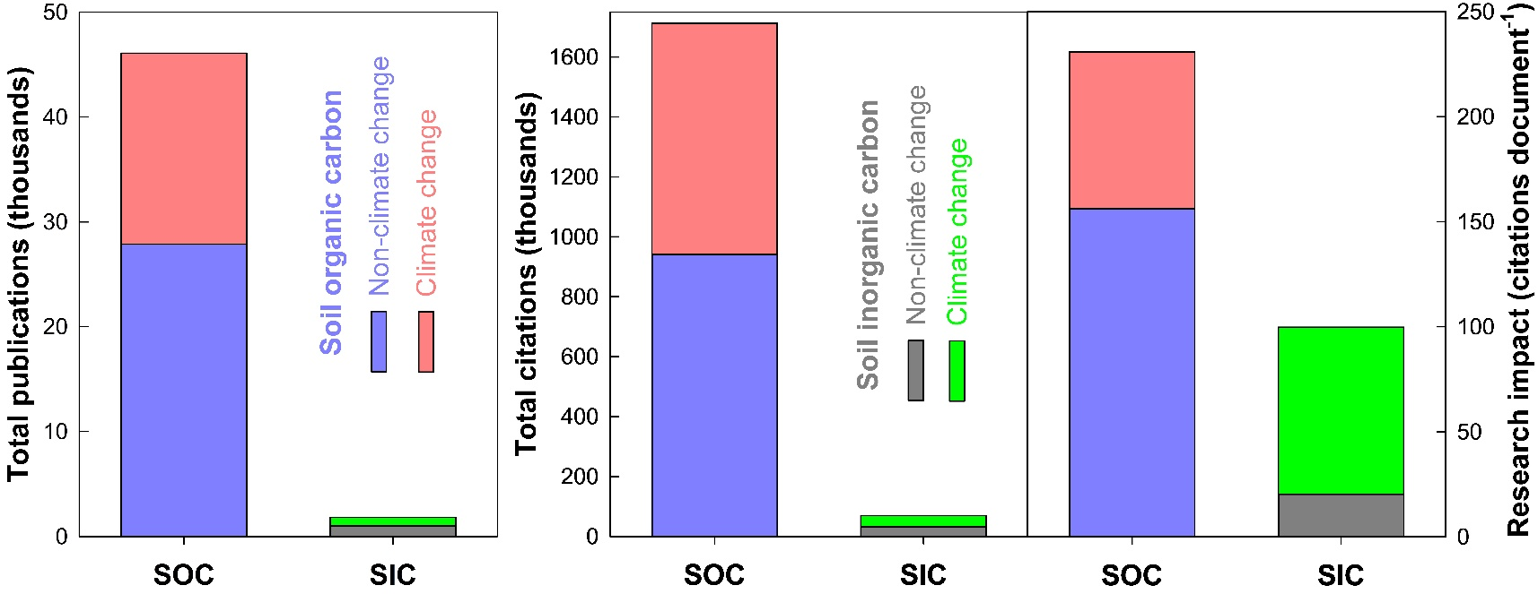
Results
Figure S3. Global soil C research productivity represented by number of publications, citations, and research impact (citations document⁻¹) with contributions from SOC (blue and red bars) and SIC (grey and green bars) pools. The light red and green colors on the top of vertical stacked bars represent SOC and SIC publications and citations related to climate change, whereas the purple and grey colored section of the bars represents non-climate change publications.

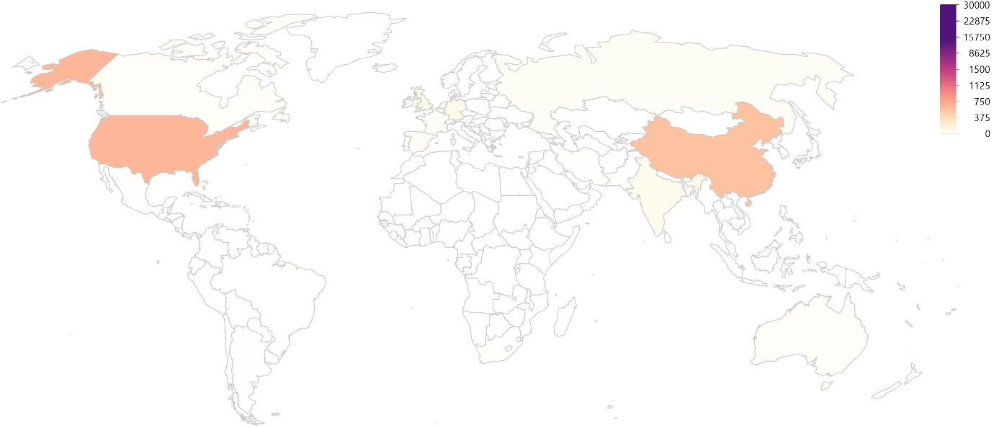
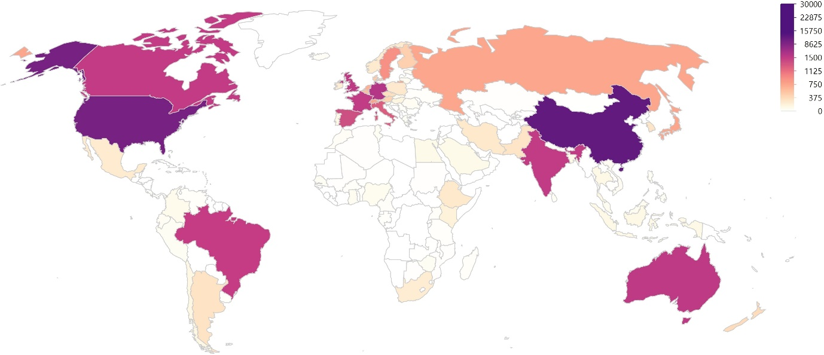
Figure S4. Contributions by countries in SOC (top) and SIC (bottom) research focused on climate change. The numbers on the scale represent the number of publications by each country.

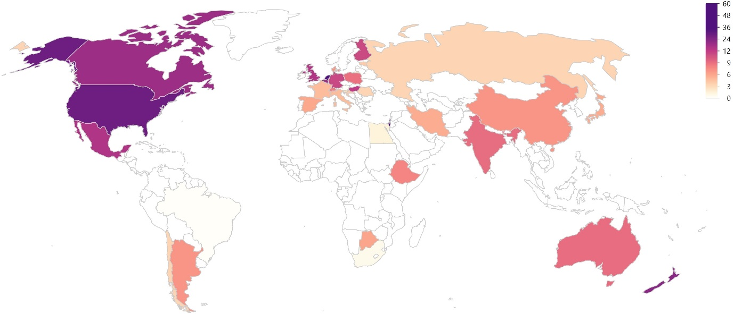
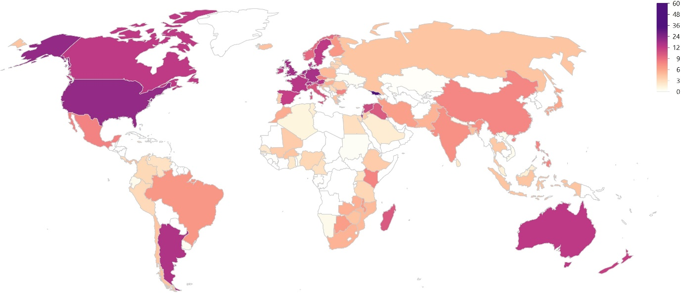
Figure S5. Distribution of research impact (citations publication⁻¹) among countries for SOC (top) and SIC (bottom) research focused on climate change.
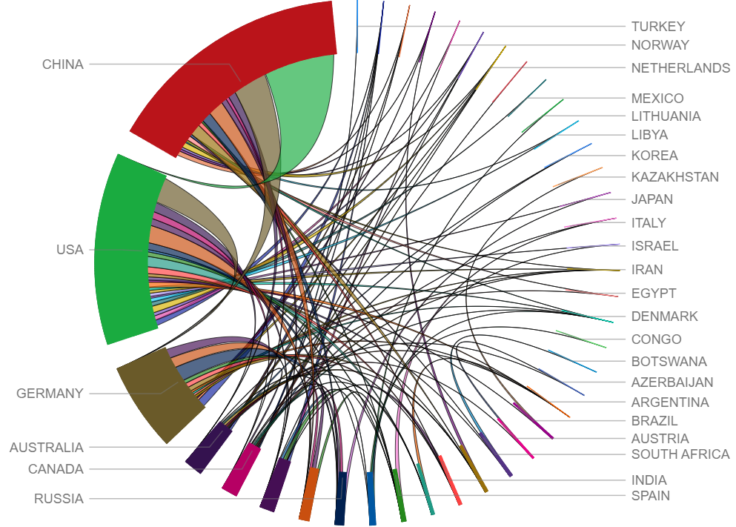
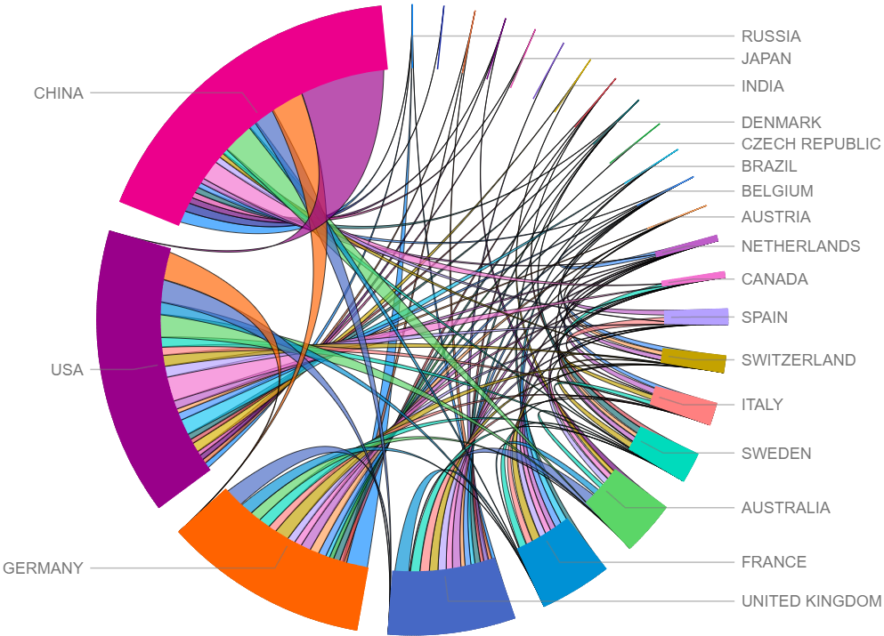
Figure S6. Global share in collaboration by countries for SOC (top) and SIC (bottom) research focused on climate change. The figure shows results for top 100 collaboration between countries producing maximum research publications.
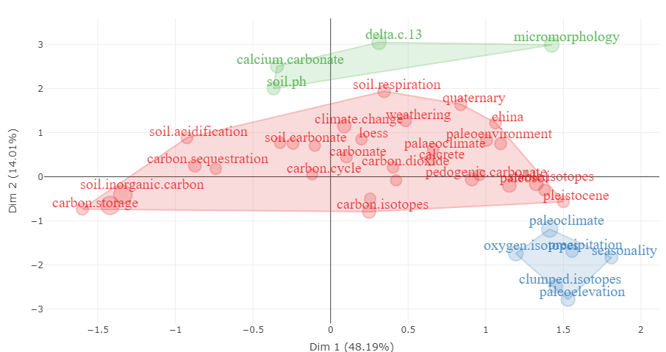
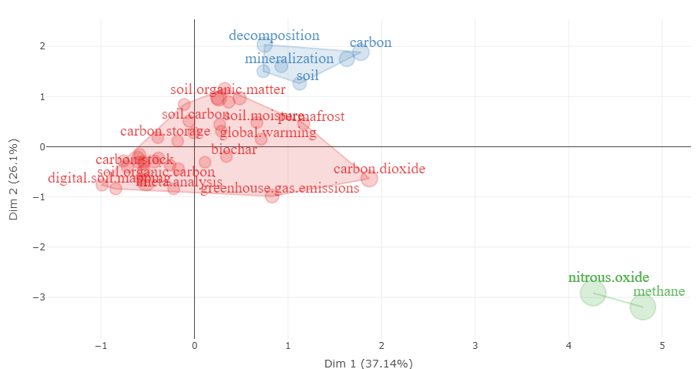

Figure S7. Conceptual structural map with two dimensions showing the distribution of keywords for SOC (top) and SIC (bottom) research focused on climate change.

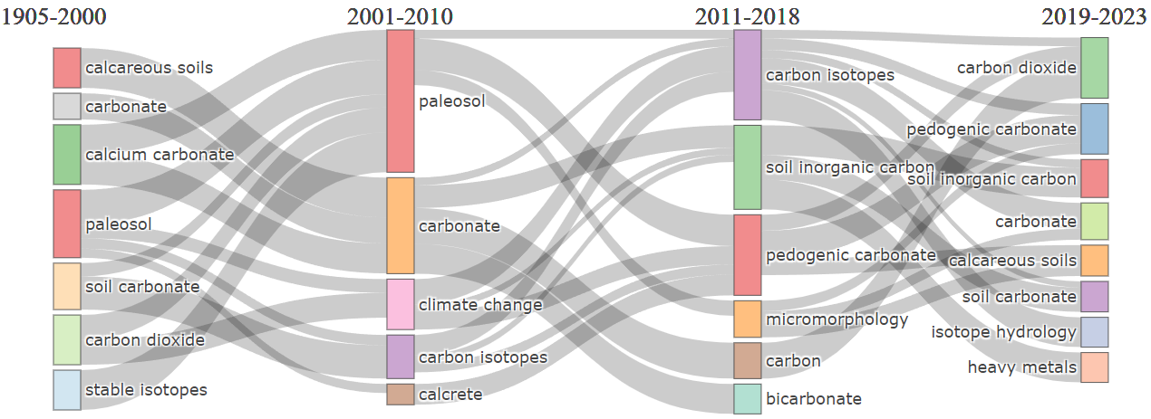
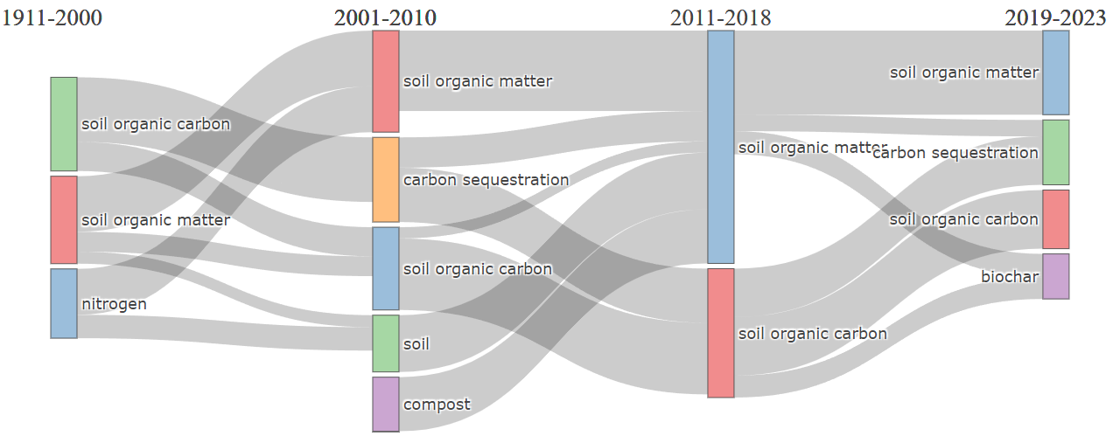
Figure S8. Thematic evolution of keywords for SOC (top) and SIC (bottom) research. The diagram presents the themes labeled by keywords with the highest frequency and corresponding time periods. The frequency of the keywords is shown by the size of the nodes for the corresponding themes. The development of the themes has been shown by the flow between the nodes. Not shown are themes lacking linkages with other themes.

SOC – Climate Change Research Trends
Institution | Country | FPY* | TP* | TC* | RI*
Chinese Academy of Sciences | China | 1995 | 4790 | 144838 | 30
United States Department of Agriculture | USA | 1991 | 1056 | 71684 | 68
University of Chinese Academy of Sciences | China | 2002 | 1028 | 26292 | 26
Indian Council of Agricultural Research | India | 1999 | 918 | 17828 | 19
INRAE | France | 1995 | 899 | 53355 | 59
United States Department of Energy | USA | 1994 | 759 | 55837 | 74
University of California System | USA | 1991 | 750 | 76232 | 102
Centre National De La Recherche Scientifique | France | 1992 | 695 | 43389 | 62
Northwest A&F University | China | 2005 | 651 | 15373 | 24
Colorado State University | USA | 1991 | 557 | 56107 | 101
SIC – Climate Change Research Trends
Institution | Country | FP | TP | TC | RI
Chinese Academy of Sciences | China | 1999 | 193 | 5754 | 30
University of California System | USA | 1991 | 65 | 5399 | 83
Northwest A&F University | China | 2014 | 49 | 1169 | 24
University of Chinese Academy of Sciences | China | 2006 | 31 | 501 | 16
University System of Ohio | USA | 1998 | 29 | 5544 | 191
University of Gottingen | Germany | 2006 | 29 | 1688 | 58
University of Michigan | USA | 1995 | 29 | 1449 | 50
University of Michigan System | USA | 1995 | 29 | 1449 | 50
Centre National De La Recherche Scientifique | France | 2010 | 28 | 840 | 30
Peking University | China | 2010 | 28 | 761 | 27
Table S1. World’s most productive institutions in soil organic (SOC) and inorganic carbon (SIC) research focused on climate change
*FPY: First publication year, TP: Total publications, TC: Total citations, RI: Research impact

SOC – Climate Change Research Trends
Funding agency | Country | FPY* | TP* | TC* | RI*
National Natural Science Foundation | China | 2008 | 3785 | 97690 | 26
National Science Foundation | USA | 2006 | 2334 | 195829 | 84
Chinese Academy of Sciences | China | 2008 | 1492 | 51155 | 34
National Key R & D Program | China | 2010 | 1067 | 24459 | 23
Department of Energy | USA | 2008 | 815 | 62580 | 77
United States Department of Agriculture | USA | 2006 | 801 | 35731 | 45
Natural Environment Research Council | UK | 2005 | 633 | 39656 | 63
European Union | Europe | 2007 | 450 | 24367 | 54
German Research Foundation | Germany | 2008 | 434 | 18576 | 43
National Basic Research Program | China | 2008 | 414 | 18189 | 44
SIC – Climate Change Research Trends
Funding agency | Country | FPY | TP | TC | RI
National Science Foundation | USA | 2009 | 242 | 11358 | 47
National Natural Science Foundation | China | 2008 | 196 | 4490 | 23
Chinese Academy of Sciences | China | 2010 | 58 | 2305 | 40
National Key R & D Program | China | 2014 | 42 | 677 | 16
Natural Environment Research Council | UK | 2009 | 37 | 2367 | 64
National Basic Research Program | China | 2008 | 33 | 1696 | 51
German Research Foundation | Germany | 2010 | 26 | 1167 | 45
United States Department of Agriculture | USA | 2009 | 20 | 507 | 25
Geological Society of America | USA | 2008 | 19 | 862 | 45
Fundamental Research Funds for Central Universities | China | 2014 | 16 | 406 | 25
Table S2. World’s most productive funding agencies in soil organic (SOC) and inorganic carbon (SIC) research focused on climate change

*FPY: First publication year, TP: Total publications, TC: Total citations, RI: Research impact

