Supplementary material

A global network for operational flood risk reduction

Lorenzo Alfieri, Sagy Cohen, John Galantowicz, Guy J-P. Schumann, Mark A. Trigg, Ervin Zsoter, Christel Prudhomme, Andrew Kruczkiewicz, Erin Coughlan de Perez, Zachary Flamig, Roberto Rudari, Huan Wu, Robert F. Adler, Robert G. Brakenridge, Albert Kettner, Albrecht Weerts, Patrick Matgen, Saiful A.K.M Islam, Tom de Groeve and Peter Salamon

email: Lorenzo.Alfieri@ec.europa.eu

Table S1: A non-exhaustive list of GFP flood products regularly updated on the web, grouped by category.
Category | Name | Predicted or measured variable | Maximum lead time (>0) or latency (<0) | References
Early warning systems | EFI, SOT | extremes of rainfall, wind, temperature | 15 days | www.ecmwf.int , Lalaurette (2003), Zsoter et al. (2015)
 | GloFAS | discharge, flood occurrence | 15 to 30 days | www.globalfloods.eu, Alfieri et al. (2013), Hirpa et al. (2016)
 | GLOFFIS, GLOSSIS | floods, storm surges | 10 days | globalfloodforecast.com
Scenario analysis | Inundation maps (modeled) | flood depth and extent | NA | data.jrc.ec.europa.eu/collection/floods, Dottori et al. (2016), Pappenberger et al. (2012), Sampson et al. (2015), UNISDR (2015), Ward et al. (2013), Yamazaki et al. (2011)
 | Inundation maps (satellite) | flood extent | NA | floodobservatory.colorado.edu
Hydrological modelling | GFMS | discharge, flood occurrence | 5 days | flood.umd.edu, Wu et al. (2012)
 | Floods.Global | discharge | 3 days | floods.global
Monitoring | River Watch | discharge | -2 days | floodobservatory.colorado.edu/DischargeAccess.html
 | NASA NRT-GFM | flood extent | -1 day | floodmap.gsfc.nasa.gov, floodobservatory.colorado.edu, Brakenridge et al. (2017)
 | FloodScan | flood extent | -1 day | product.aer.com/index.php/floodscan
 | GloFIMR | flood extent | available upon request | sdml.ua.edu/glofimr
 | GDACS | multi-hazard | -1 day | www.gdacs.org

Case study #2 - Hurricane Harvey flooding in Texas and Louisiana, August-September 2017
Hurricane Harvey made landfall as a Category 4 storm at the Texas Gulf Coast (near Rockport) on August 25 2017, causing wind damage and storm surge-induced coastal flooding. The storm slowly moved east along the coast (meandering in and out of Gulf waters), in effect, stalling over southeast Texas and southwest Louisiana until September 1st. The slow moving storm produced historically high amounts of rain over the region, with maximum accumulated rainfall of over 1,500 mm in southeast Texas. This led to catastrophic riverine and flash flooding in the region. Houston Metropolitan area (Texas) received over 750 mm of rainfall between August 24 and September 1, leading to widespread urban flooding, displacing scores of people and damaging properties and infrastructures. It was estimated that the Hurricane As of September 5, Moody's Analytics had estimated total damages from Hurricane Harvey at up to $108 billion, ranking it as the costliest natural disaster in US history.
The GFP is not regularly activated for flooding events in first-world countries, as these typically have established flood prediction and observation capabilities. As a result, GFP activation for this event evolved as its magnitude became apparent. Below we provide a chronology of GFP activities for Hurricane Harvey:
August 27 (2 days after landfall): the Dartmouth Flood Observatory (DFO) sent a limited-distribution email (not via GFP mailing list) informing about the activation of the ‘International Charter’, setting up of a DFO event webpage, and outlining available satellite imagery resources from before the flooding. The email led to inclusion of the recipients in the Federal Emergency Management Agency (FEMA) daily Remote Sensing Coordination and Geospatial Coordination calls which was later proved instrumental in connecting GFP products to the hurricane response community (including for the following flood events in Florida and Puerto Rico). The email was shared with NOAA National Water Center. A few hours following the initial email, precipitation and inundation predictions from GFMS were shared the same email distribution.
August 28 (flooding in Houston Metropolitan area): The first email was sent to the GFP mailing list on August 28, proposing using this event as a case study to test GFP prediction and monitoring systems. The same email also included streamflow predictions from the Flooded Locations And Simulated Hydrographs Project (FLASH; http://blog.nssl.noaa.gov/flash/). These predictions were re-distributed to a range of stakeholders (e.g. FEMA, NASA), an action which thereafter became standard operating procedure, with growing list of recipients.
August 29: DFO shared (via FEMA Geospatial Coordination email distribution) an update on flood mapping and modeling efforts, including using (non-georeferenced) Radarsat images (from Aug 28) to map flooding, and sharing JPL-produced flood maps from the ALOS-2 satellite. The confidence in these products were relatively low. Atmospheric and Environmental Research (AER) shared (via GFP mailing list) a large-scale 90-m resolution flood map of the impacted area, analysed from the AMSR2 (passive microwave) sensor using an experimental configuration of the FloodScan system. Link between DFO/GFP to the State Operations Center of the Texas Division of Emergency Management (TDEM) was established which initiated data sharing on the TDEM (closed to outside users) data server.
August 30: Following an overpass by Sentinel-1 satellite, SAR-based flood maps were shared by Luxembourg Institute of Science and Technology (LIST), JPL and DFO. DFO ftp server was used to store and distribute the GIS files of these, and future, products relating to this event. AER produced an updated maximum flood map for the region using new AMSR2, which was shared via the GFP mailing list. It was then distributed to the FEMA Geospatial Coordination mailing list (over 300 recipients) and was uploaded to the TDEM data server.
August 31: Additional Sentinel-1 imagery was shared by LIST via the GFP mailing list. A request was made by USGS personnel for further data relating to the AER flood map that was shared the day before. DFO provided an updated inventory of GFP-produced flood maps and links to its event-dedicated web-portal and ftp server. The Surface Dynamics Modeling Lab (SDML), a GFP partner institute, shared (to FEMA, TDEM, NWC, DFO and AER) a floodwater depth map based on the AER maximum flood extent map. The procedure for compiling such maps was developed in collaboration with DFO. AER shared (via GFP mailing list) updated large-scale maximum flood extent maps incorporating AMSR2 data from August 30 and set up a FloodScan web interface with daily Hurricane Harvey maps (https://product.aer.com/FloodScan_Harvey). LIST shared SAR-based flood map covering the Houston area from a 30 August Sentinel-1 pass. Aerial photography was becoming available via NOAA but with limited coverage outside the coast.
September 1: AER shared updates from AMSR2 passes on 31 August, revealing the extent of flooding in east Texas (Beaumont area) after the last rain bands moved off to the northeast. SDML shared a building impact map based on AER maximum flood extent map and address points layer from the TDEM server (uploaded by University of Texas, Austin). FEMA personnel requested access to the data for further analysis.
September 3-5: AER shared final maximum flood extent estimates incorporating all AMSR2 data 26 August - 2 September with expanded coverage into Louisiana (Figure 8). LIST shared flood maps from two Sentinel-1 passes on 4 September.

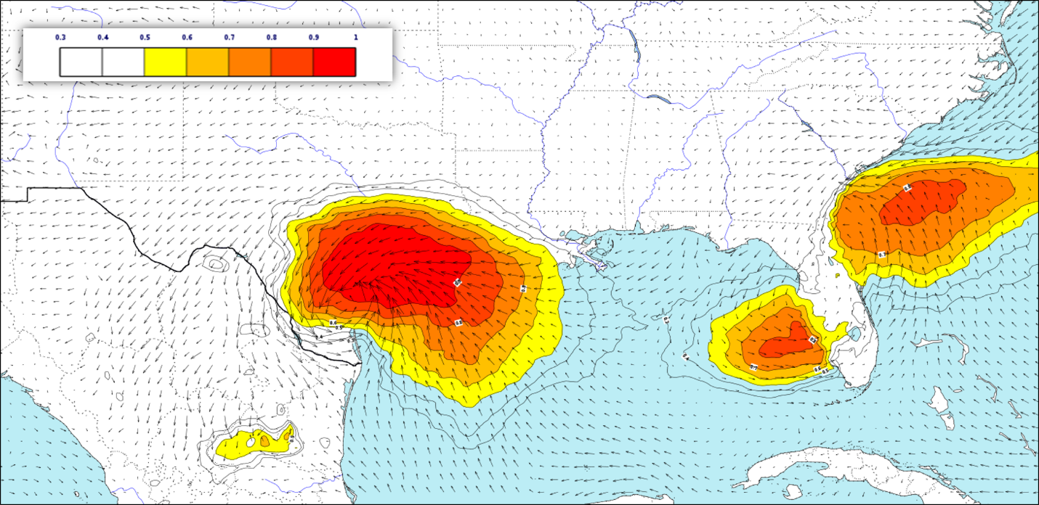
Figure S1: EFI of 48 hour accumulated precipitation for 26-27 August 2017 during the landfall of Tropical Storm Harvey in southern Texas, based on ECMWF ensemble forecasts of 25 August 2017 12 UTC. 10 m wind fields are also shown with arrows.

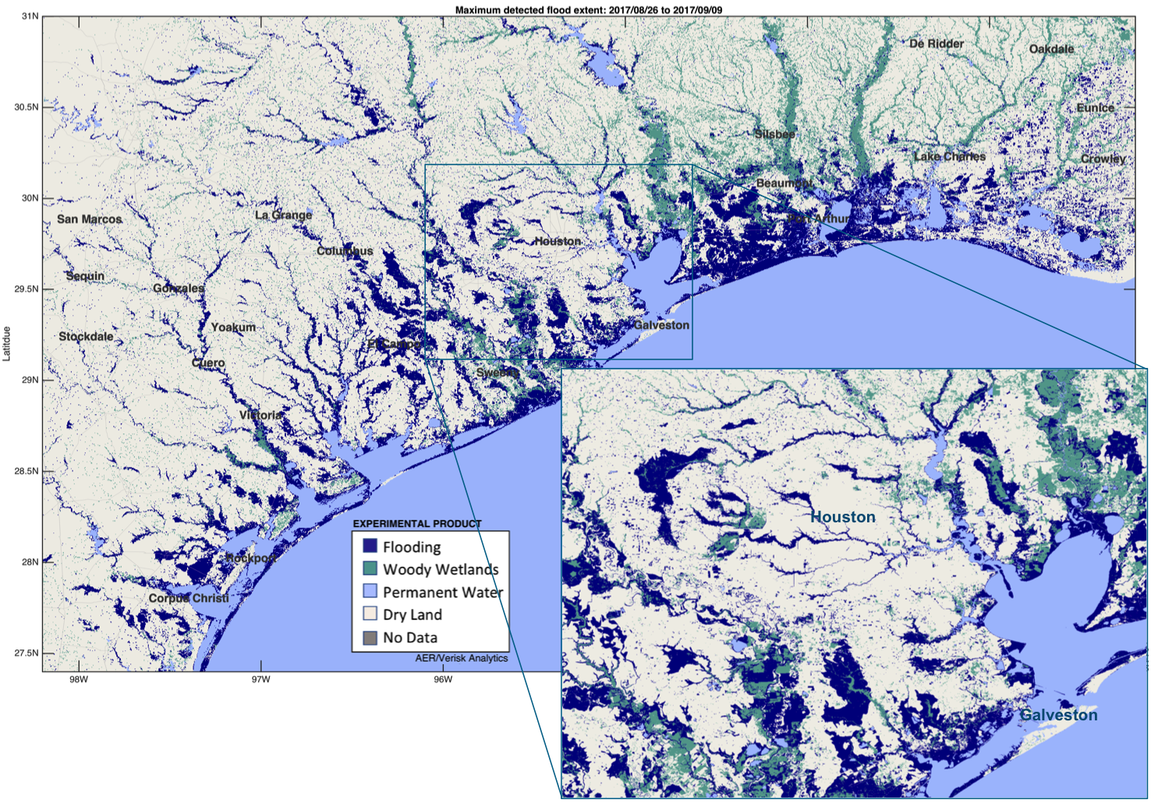
Figure S2: Maximum detected flood extent in Texas and Louisiana, USA, following Hurricane Harvey, 26 August to 9 September 2017, from AER’s FloodScan algorithm, based on AMSR2 passive microwave remote sensing data downscaled to 90-m resolution. Areas designated as woody wetlands are assumed to be flooded during this event.

https://www.cnbc.com/2017/09/11/harvey-and-irma-economic-hit-could-total-200-billion-moodys.html

