Supplementary Appendix
Figure S1. Evaluation of Common Support for Treated and Control Patients by Centile of Propensity Score – Vitamin D₂
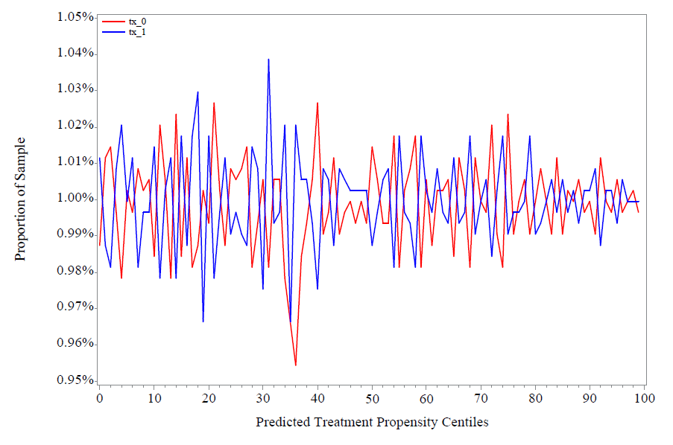
Notes: tx_1 represents Vitamin D₃ treated patients between January 1, 2019 and December 31, 2020. Tx_0 represents untreated controls over the same period. Common Support was evaluated to ensure strong matches were obtained following 1-1 patient propensity score matching on predicted Vitamin D₃ treatment probabilities.
Sources: VA EHR and Medicare Claims Data.

Figure S2. Evaluation of Common Support for Treated and Control Patients by Centile of Propensity Score – Vitamin D₃
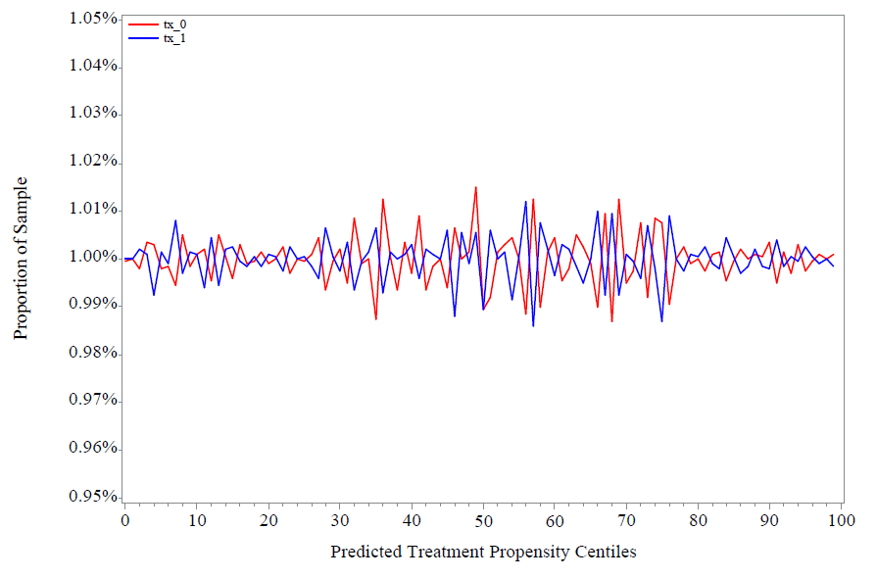
Notes: tx_1 represents Vitamin D₃ treated patients between January 1, 2019 and December 31, 2020. Tx_0 represents untreated controls over the same period. Common Support was evaluated to ensure strong matches were obtained following 1-1 patient propensity score matching on predicted Vitamin D₃ treatment probabilities.
Sources: VA HER and Medicare Claims Data.

Table S1. Evaluation of Balance in Covariates used in the 1-1 Propensity-Score Matching Model After Matching – Vitamin D₂
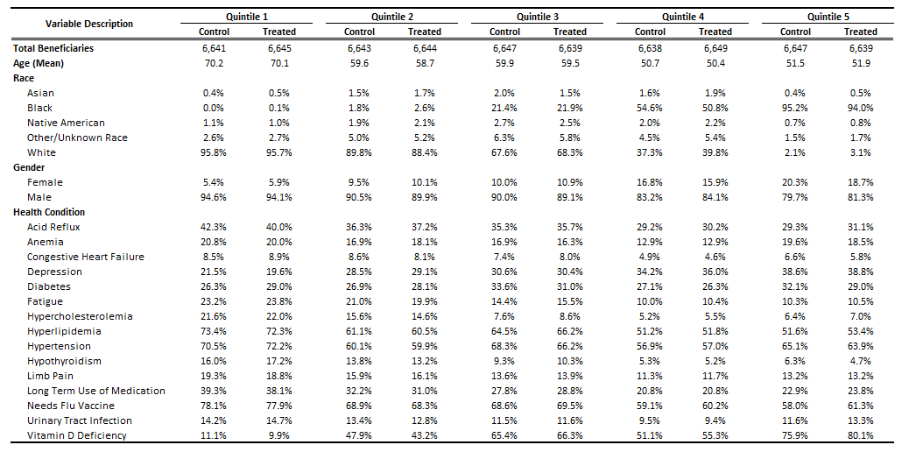
Notes: Each cell represents average values of covariates in each quintile of Vitamin D₃ treatment propensity among treated and control patients. Covariate balance was evaluated to determine minimal patient characteristic differences following 1-1 propensity score matching on patient Vitamin D₃ treatment probabilities.
Sources: VA and Medicare Claims Data

Table S2. Evaluation of Balance in Covariates used in the 1-1 Propensity-Score Matching Model After Matching – Vitamin D₃
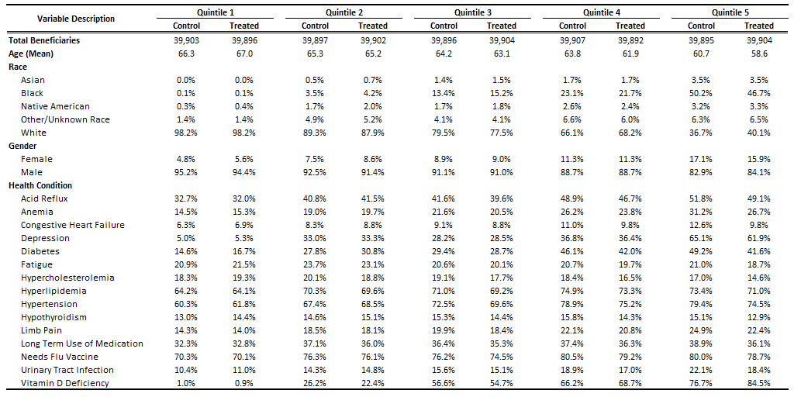
Notes: Each cell represents average values of covariates in each quintile of Vitamin D₃ treatment propensity among treated and control patients. Covariate balance was evaluated to determine minimal patient characteristic differences following 1-1 propensity score matching on patient Vitamin D₃ treatment probabilities.
Sources: VA and Medicare Claims Data

Table S3. Average and Standard Deviations of Vitamin D Average Dosage and Cumulative Dosage Variables
Dosage Type | Vitamin D₂ | Vitamin D₃
Average Dosage
Mean | 49,979 | 2290
Standard Deviation | 985 | 6848
Cumulative Dosage
Mean | 632,210 | 151,330
Standard Deviation | 296,314 | 246,531

Sources: VA and Medicare Claims Data

