Gestational PM_{2.5} exposure may increase the risk of small for gestational age through maternal blood pressure and hemoglobin: A mediation analysis based on a prospective cohort in China, 2014-2018
Zhenghong Zhu, Huanqing Hu, Tarik Benmarhnia, Zhoupeng Ren, Jiajun Luo, Wei Zhao, Sidi Chen, Kaipu Wu, Xiaoxin Zhang, Liyun Wang, Jiangli Di, Cunrui Huang, Qiong Wang
Supplementary Materials
Table S1. Correlations between PM_{2.5} and other pollutants
Table S2. Estimated effects of hemoglobin (per 1 g/L increase) and blood pressure (mmHg) on SGA
Table S3. Estimated association between hemoglobin (per 1 g/L increase) and blood pressure (mmHg)
Table S4. Estimated ORs and 95% CIs for SGA associated with a per 10 ug/m³ increase in ambient PM_{2.5} at ambient temperatures with different degrees of freedom
Table S5. Estimated effects of ambient PM_{2.5} (per 10 ug/m3 increase) on SGA, blood pressure (mmHg), and hemoglobin (g/L) in two-pollutant model
Table S6. Estimated effects of ambient PM_{2.5} (per 10 ug/m3 increase) on SGA subjects with gestational age greater than or equal to 37 weeks
Table S7. Estimates of the independent mediating effects of BP and Hb on the association between exposure to PM_{2.5} and SGA during pregnancy (n=36,161)
Table S8. Estimates of the joint mediating effects of BP and Hb on the association between exposure to PM_{2.5} and SGA during pregnancy (n=36,161)
Figure S1. Spatial distribution of study sites
Figure S2 (a)-(h). Distribution of study counties (districts) and monitoring stations
Figure S3. Flowchart of the study population
Figure S4. Illustration of potential confounding variables and possible selection bias in the association between PM_{2.5} exposure and SGA and the minimal adjustment set to block all biasing paths

Table S1. Correlations between PM_{2.5} and other pollutants.
 | PM_{2.5} | CO | NO₂ | O₃ | SO₂
PM_{2.5} | 1.00 | 0.68 | 0.84 | -0.11 | 0.77
CO |  | 1.00 | 0.55 | -0.11 | 0.79
NO₂ |  |  | 1.00 | -0.11 | 0.66
O₃ |  |  |  | 1.00 | -0.12
SO₂ |  |  |  |  | 1.00

Table S2. Estimated effects of hemoglobin (per 1 g/L increase) and blood pressure (mmHg) on SGA
Exposure ª | OR (95% CI) ^{b}
SBP_WP | 1.012 (1.010, 1.015)
SBP_T1 | 1.002 (0.999, 1.004)
SBP_T2 | 0.993 (0.989, 0.997)
SBP_T3 | 1.017 (1.014, 1.021)
DBP_WP | 1.027 (1.023, 1.031)
DBP_T1 | 1.002 (0.998, 1.005)
DBP_T2 | 0.995 (0.990, 1.000)
DBP_T3 | 1.027 (1.022, 1.032)
Hb_WP | 1.016 (1.013, 1.018)
Hb_T1 | 0.993 (0.990, 0.996)
Hb_T2 | 1.003 (1.000, 1.007)
Hb_T3 | 1.018 (1.015, 1.021)
- DBP_WP: maternal DBP during the whole pregnancy; DBP_T1: maternal DBP in the first trimester, DBP_T2: maternal DBP in the second trimester; DBP_T3: maternal DBP in the third trimester. Hb_WP: maternal Hb during the whole pregnancy; Hb_T1: maternal Hb in the first trimester; Hb_T2: maternal Hb in the second trimester; Hb_T3: maternal Hb in the third trimester.
- Adjusted for maternal age, pre-pregnancy body BMI, province, maternal education, maternal migrant status, year of birth, parity, and the mean temperature over the same gestational period as the exposure.

Table S3. Estimated association between hemoglobin (per 1 g/L increase) and blood pressure (mmHg)
Exposure | Outcome | β (95%CI) ª
Hb_T2 | SBP_T2 | 0.057 (0.052, 0.062)
 | DBP_T2 | 0.094 (0.091, 0.098)
Hb_T3 | SBP_T3 | 0.059 (0.055, 0.064)
 | DBP_T3 | 0.088 (0.084, 0.092)
Hb_WP | SBP_WP | 0.073 (0.068, 0.078)
 | DBP_WP | 0.096 (0.092, 0.099)
- Adjusted maternal age, pre-pregnancy BMI, and the mean temperature over the trimester.

Table S4. Estimated ORs and 95% CIs for SGA associated with a per 10 ug/m³ increase in ambient PM_{2.5} at ambient temperatures with different degrees of freedom
Exposure | OR (95% CI) ª
Degrees of freedom | 4 | 5 | 6
PM_{2.5}_WP | 1.024 (1.000,1.047) | 1.025 (1.002,1.049) | 1.025 (1.002,1.049)
PM_{2.5}_T1 | 1.004 (0.993,1.016) | 1.005 (0.994,1.017) | 1.005 (0.993,1.016)
PM_{2.5}_T2 | 1.022 (1.008,1.037) | 1.024 (1.009,1.038) | 1.025 (1.010,1.040)
PM_{2.5}_T3 | 0.997 (0.987,1.008) | 0.997 (0.986,1.008) | 0.997 (0.986,1.007)
- Adjusted for maternal age, pre-pregnancy BMI, province, maternal education, maternal migrant status, year of birth, parity, and the average temperature in the same period as PM_{2.5} exposure.

Table S5. Estimated effects of ambient PM_{2.5} (per 10 ug/m3 increase) on SGA, blood pressure (mmHg), and hemoglobin (g/L) in two-pollutant model
Exposure | Outcome ª | OR (95%CI) ^{b}
PM_{2.5}_T2 | SGA | 1.023 (1.009, 1.037)
PM_{2.5}_WP | SGA | 1.025 (1.002, 1.048)
 |  | β (95%CI) ^{b}
PM_{2.5}_T2 | SBP_T2 | 0.097 (0.065, 0.130)
 | DBP_T2 | 0.076 (0.052, 0.099)
 | Hb_T2 | 0.028 (-0.006, 0.062)
PM_{2.5}_T2 | SBP_T3 | 0.050 (0.018, 0.083)
 | DBP_T3 | -0.009 (-0.034, 0.015)
 | Hb_T3 | 0.067 (0.032, 0.101)
PM_{2.5}_WP | SBP_T3 | 0.078 (0.018, 0.138)
 | DBP_T3 | -0.035 (-0.080, 0.010)
 | Hb_T3 | 0.097 (0.034, 0.160)
- Outcome: mean value of blood pressure and hemoglobin in the second or third trimester.
- Adjusted for maternal age, pre-pregnancy BMI, province, maternal education, maternal migrant status, year of birth, parity, and the average temperature in the same period as PM_{2.5} exposure.

Table S6. Estimated effects of ambient PM_{2.5} (per 10 ug/m3 increase) on SGA subjects with gestational age greater than or equal to 37 weeks
Exposure | Outcome | OR (95% CI) ª
PM_{2.5}_WP | SGA | 1.027 (1.003, 1.051)
PM_{2.5}_T1 | SGA | 1.005 (0.994, 1.017)
PM_{2.5}_T2 | SGA | 1.024 (1.009, 1.038)
PM_{2.5}_T3 | SGA | 0.998 (0.987, 1.009)
- Adjusted for maternal age, pre-pregnancy BMI, province, maternal education, maternal migrant status, year of birth, parity, and the average temperature in the same period as PM_{2.5} exposure.

Table S7. Estimates of the independent mediating effects of BP and Hb on the association between exposure to PM_{2.5} and SGA during pregnancy (n=36,161)
Exposure | Mediator | R^{TE} (95% CI) ª | R^{NDE} (95% CI) ª | R^{NIE} (95% CI) ª | PM (%) ª
PM_{2.5}_T2 | SBP_T2 | 1.022 (1.003, 1.041) | 1.023 (1.004, 1.042) | 1.0000 (0.9998, 1.0003)) | -
 | DBP_T2 |  | 1.023 (1.003, 1.042) | 1.0009 (1.0003, 1.0015) | 4.24 (1.45, 7.03)
 | Hb_T2 |  | 1.023 (1.003, 1.042) | 1.0010 (1.0004, 1.0017) | 4.82 (1.70, 7.93)
PM_{2.5}_T2 | SBP_T3 | 1.022 (1.003, 1.041) | 1.023 (1.003, 1.042) | 1.0009 (1.0001, 1.0017) | 4.38 (0.61, 8.15)
 | DBP_T3 |  | 1.024 (1.004, 1.043) | 1.0010 (0.9998, 1.0021) | 4.51 (-0.59. 9.61)
 | Hb_T3 |  | 1.022 (1.003, 1.041) | 1.0008 (1.0001, 1.0015) | 3.89 (0.58, 7.19)
PM_{2.5}_WP | SBP_T3 | 0.998 (0.965, 1.032) | 0.996 (0.963, 1.030) | 1.0011, (0.9995, 1.0028) | -
 | DBP_T3 |  | 0.997 (0.964, 1.031) | 1.0007 (0.9984, 1.0030) | -
 | Hb_T3 |  | 0.996 (0.964, 1.030) | 1.0016 (1.0001, 1.0031) | -
- R^{TE}: total effect risk ratio; R^{NDE}: natural direct effect risk ratio; R^{NIE}: natural indirect effect risk ratio; PM: proportion mediated

Table S8. Estimates of the joint mediating effects of BP and Hb on the association between exposure to PM_{2.5} and SGA during pregnancy (n=36,161)
Exposure | Mediators ª | R^{TE} (95% CI) ª | R^{NDE} (95% CI) ª | R^{NIE} (95% CI) ª | PM (%) ª
PM_{2.5}_T2 | SBP_T2 and Hb_T2 | 1.022 (1.003, 1.041) | 1.023 (1.004, 1.042) | 1.0010 (1.0003, 1.0017) | 4.68 (1.56, 7.79)
 | DBP_T2 and Hb_T2 |  | 1.023 (1.003, 1.042) | 1.0018 (1.0009, 1.0027) | 8.46 (4.57, 12.40)
PM_{2.5}_T2 | SBP_T3 and Hb_T3 | 1.022 (1.003, 1.041) | 1.023 (1.003, 1.042) | 1.0017 (1.0007, 1.0027) | 7.75 (3.01, 12.50)
 | DBP_T3 and Hb_T3 |  | 1.024 (1.004, 1.043) | 1.0016 (1.0004, 1.0029) | 7.49 (1.77 13.20)
PM_{2.5}_WP | SBP_T3 and Hb_T3 | 0.998 (0.965, 1.032) | 0.996 (0.963, 1.030) | 1.0025 (1.0004, 1.0047) | -
 | DBP_T3 and Hb_T3 |  | 0.997 (0.964, 1.031) | 1.0019 (0.9994, 1.0045) | -
- R^{TE}: total effect risk ratio; R^{NDE}: natural direct effect risk ratio; R^{NIE}: natural indirect effect risk ratio; PM: proportion mediated

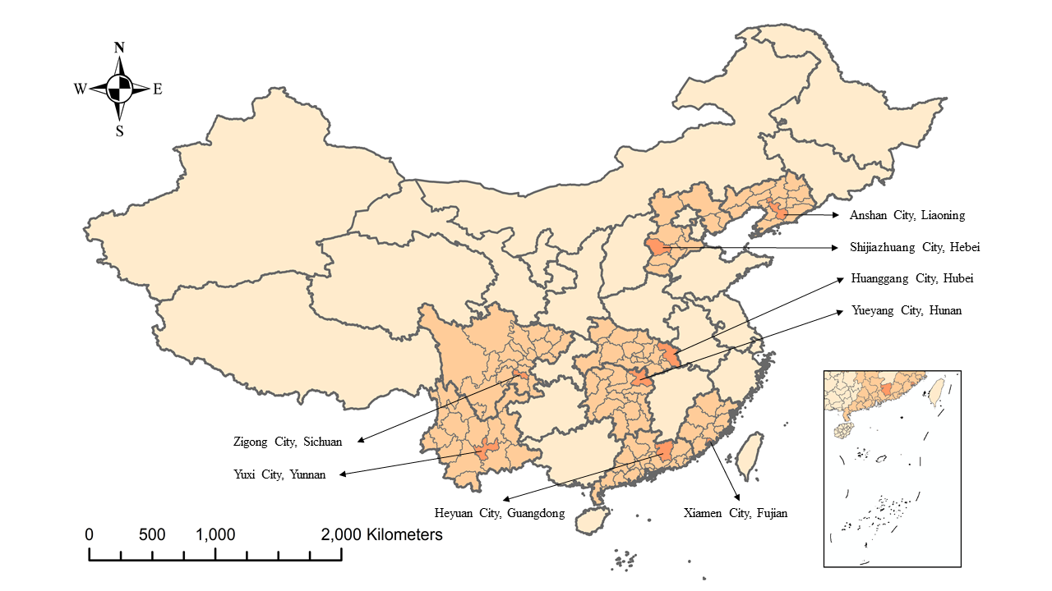

Figure S1. Spatial distribution of study sites

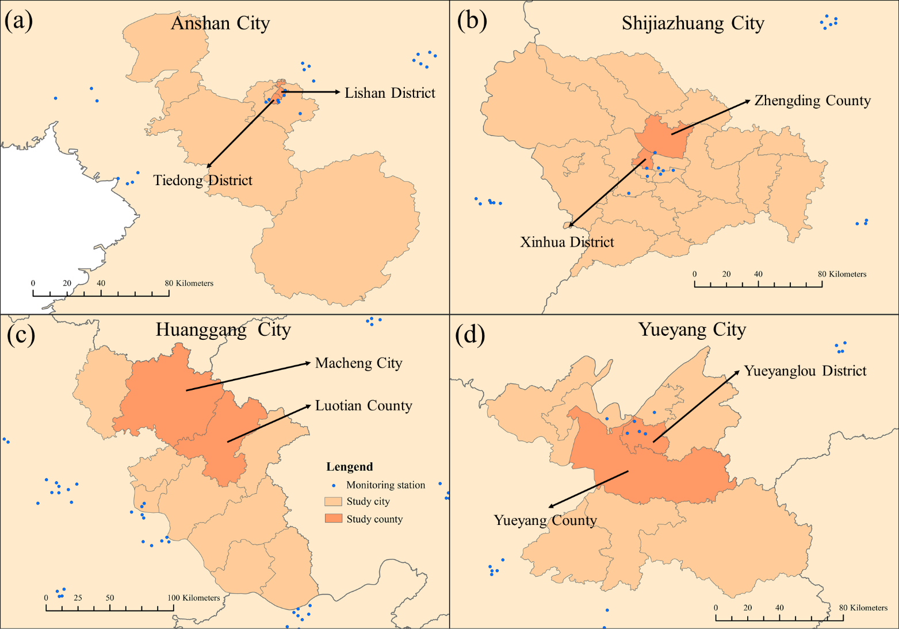

Figure S2 (a)-(d). Distribution of study counties (districts) and monitoring stations
The study counties (districts) : (a) Lishan District and Tiedong District of Anshan City; (b) Xinhua District and Zhengding County of Shijiazhuang City; (c) Macheng City and Luotian County of Huanggang City; (d) Yueyanglou District and Yueyang County of Yueyang City.

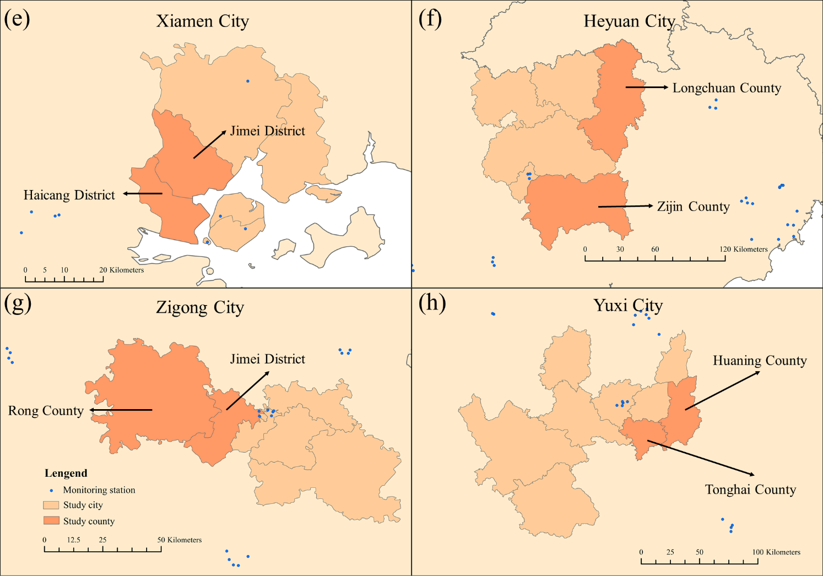

Figure S2 (e)-(h). Distribution of study counties (districts) and monitoring stations.
The study counties (districts) : (e) Haicang District and Jimei District of Xiamen City; (f) Zijin County and Longchuan County of Heyuan City; (g) Gongjing District and Rong County of Zigong City; (h) Tonghai County and Huaning County of Yuxi City

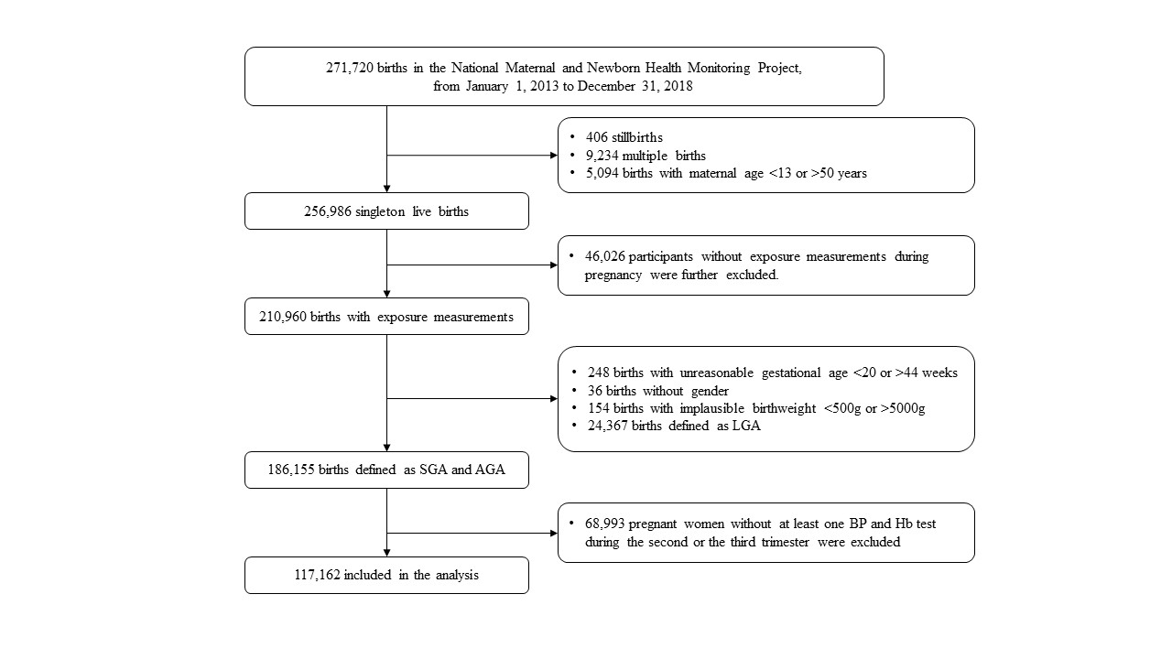

Figure S3. Flowchart of the study population
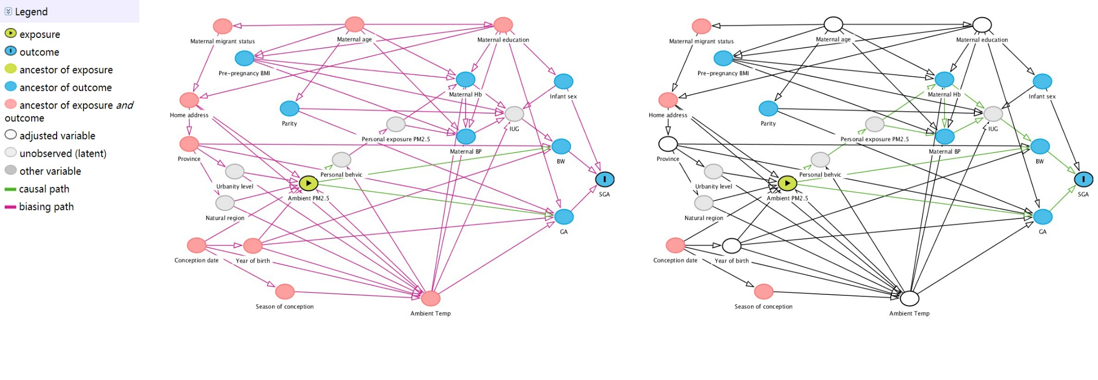
Figure S4. Illustration of potential confounding variables and possible selection bias in the association between PM_{2.5} exposure and SGA and the minimal adjustment set to block all biasing paths
Directed Acyclic Graph (DAG) drawn and analyzed with DAGitty

