Supplemental Table 1: Demographics and Characteristics of Transplant Recipients in UNOS Cohort.
 | Overall  (N=13,930) | Static Cold Storage  (N=13,477) | Ex-Vivo Lung Perfusion  (N=453) | P-Value
Female (%) | 5,549 (39.8%) | 5,351 (39.7%) | 198 (43.7%) | 0.10
Age at Transplant | 57.7 (12.6) | 57.7 (12.6) | 58.2 (11.7) | 0.92
Race |  |  |  | 0.24
White | 10,843 (77.8%) | 10,491 (77.8%) | 352 (77.7%) | 0.24
Black | 1,359 (9.8%) | 1,304 (9.7%) | 55 (12.1%) | 0.24
Hispanic/Latino | 1,275 (9.2%) | 1,243 (9.2%) | 32 (7.1%) | 0.24
Asian and  Pacific Islander | 345 (2.5%) | 336 (2.5%) | 9 (2%) | 0.24
Primary Diagnosis |  |  |  | 0.05*
Pulmonary Fibrosis | 6,120 (43.9%) | 5, 944 (44.1%) | 176 (38.9%) | 0.05*
COPD/Emphysema | 2,624 (18.8%) | 2,519 (18.7%) | 105 (23.2%) | 0.05*
Cystic Fibrosis | 1,119 (8.0%) | 1,092 (8.1%) | 27 (6.0%) | 0.05*
Other | 4,067 (29.2%) | 3,922 (29.1%) | 145 (32.0%) | 0.05*
Transplant Procedure Type |  |  |  | <0.001*
Bilateral | 10,368 (74.4%) | 9,989 (74.1%) | 379 (83.7%) | <0.001*
Single Left | 1,888 (13.6%) | 1,847 (13.7%) | 41 (9.1%) | <0.001*
Single Right | 1,674 (12.0%) | 1,641 (12.2%) | 33 (7.3%) | <0.001*
From Donor after Cardiac Death (DCD) | 721 (5.2%) | 581 (4.3%) | 140 (30.9%) | <0.001*
Karnofsky Score at Transplant, N=13,692 | 47.6 (17.5) | 47.5 (17.5) | 50.4 (17.4) | <0.001*
Karnofsky Score at 1 year Follow-Up Visit, N=10,131 | 72.5 (31.0) | 72.7 (30.9) | 66.5 (34.4) | <0.001*
Length of Stay Post-Transplant (Days) | 28.6 (34.9) | 28.4 (34.6) | 36.3 (40.7) | <0.001*
EVLP Length (Min), N=401 | - | - | 289.4 (168.4)
Waitlist Time | 111.6 (179.9) | 111 (179) | 130 (200) | 0.02*

Continuous variables are presented as mean value with standard deviation and categorical variables are presented as percentage of the cohort. Reported p-values are the result of students T-tests and Chi-square tests for continuous and categorical variables.

Supplemental Table 2: Demographics and Characteristics of transplant recipients in University of Chicago Cohort.

 | Overall  N=58 | Static Cold Storage  N=30 | Ex-Vivo Lung Perfusion  N=28 | P-Value
Female (%), N=56 | 25% | 16.7% | 34.6% | 0.12
Age at Transplant, N=58 | 57.7 (13.1) | 59.3 (11.9) | 55.9 (14.2) | 0.29
Race, N=56 |  |  |  | 0.11
White | 60.7% | 73.3% | 46.1%
Black | 17.9% | 13.3% | 23.1%
Other | 21.4% | 13.4% | 30.8%
Transplant Procedure Type, N=58 |  |  |  | 0.32
Bilateral | 91.4% | 86.7% | 96.4%
Single Left | 3.4% | 6.7% | 0.0%
Single Right | 5.2% | 6.6% | 3.6%
Lung Allocation Score, N=57 | 57.8 (23.7) | 56.5 (21.4) | 59.1 (26.3) | 0.87
Cold Ischemia Time (Min)
Left Lung, N=44 | 225.3 (98.0) | 320.6 (94.2) | 168.9 (38.8) | <0.001*
Right Lung, N=42 | 235.4 (107.9) | 348.3 (93.9) | 165.9 (24.7) | <0.001*
EVLP Length (Min)
Left Lung, N=25 | - | - | 351.8 (104.3)
Right Lung, N=24 | - | - | 392.1 (129.3)
Waitlist Time (Days), N=58 | 82.3 (130.5) | 79.6 (123.7) | 85.1 (139.7) | 0.66
Pretransplant Status, N=58
Home | 38 (65.5%) | 21 (70%) | 17 (60.7%)
Admitted (Not ICU) | 1 (1.7%) | 1 (3.3%) | 0 (0%) | 0.40
ICU | 19 (32.8%) | 8 (26.7%) | 11 (39.3%)

Continuous variables are presented as median value with standard deviation and categorical variables are presented as percentage of the cohort. Reported p-values are the result of students T-tests and Chi-square tests for continuous and categorical variables.
Figure S1: Consort Diagram demonstrating included lung transplant patients from University of Chicago
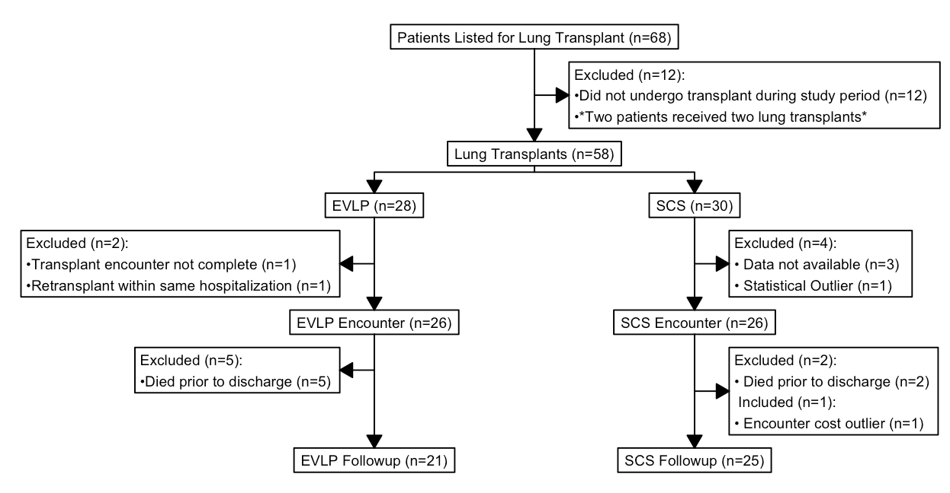

Figure S2: Unadjusted Post-Transplant Kaplan-Meier Survival Curve of UNOS Lung Transplant Recipients.

Figure S3: Unadjusted Post-Transplant Kaplan-Meier Survival Curve of UCM Lung Transplant Recipients.

