Supplementary materials: Should journals allow authors to suggest reviewers?
Daniel E. Acuna¹, Misha Teplitskiy², James A. Evans³, Konrad Kording⁴
¹School of Information Studies, Syracuse University
²School of Information, University of Michigan
³Department of Sociology, University of Chicago
⁴Department of Neuroscience, University of Pennsylvania

Distribution of review outcome per type of reviewer and review round
S1 Figure. Distribution of review outcomes
S1 Table. Distribution of review outcomes
Review round | Type of reviewer | Reject | Major Revision | Minor Revision | Accept
1 | Author-opposed | 46% | 36% | 16% | 2%
1 | Editor-suggested | 24% | 43% | 28% | 5%
1 | Author-suggested | 11% | 34% | 44% | 11%
2 | Author-opposed | 20% | 25% | 20% | 35%
2 | Editor-suggested | 9% | 13% | 24% | 55%
2 | Author-suggested | 4% | 7% | 19% | 69%
3 | Author-opposed | 50% | - | - | 50%
3 | Editor-suggested | 9% | 10% | 18% | 63%
3 | Author-suggested | 5% | 4% | 24% | 67%
4 | Author-opposed | - | - | - | -
4 | Editor-suggested | 8% | 10% | 24% | 58%
4 | Author-suggested | - | 6% | 18% | 76%

Distribution of review outcomes per panel compositions
S2 Table. Distribution of review outcomes per panel composition
Review round | Panel composition | Reject | Major Revision | Minor Revision | Accept
1 | Mixed with author-opposed | 23% | 40% | 30% | 7%
1 | All editor-suggested | 25% | 43% | 27% | 5%
1 | Mixed no author-opposed | 17% | 39% | 36% | 8%
1 | All author-suggested | 9% | 32% | 47% | 12%
2 | Mixed with author-opposed | 13% | 23% | 13% | 50%
2 | All editor-suggested | 9% | 13% | 24% | 54%
2 | Mixed no author-opposed | 7% | 10% | 21% | 61%
2 | All author-suggested | 3% | 5% | 18% | 74%
3 | Mixed with author-opposed | 14% | 43% | - | 43%
3 | All editor-suggested | 9% | 9% | 19% | 63%
3 | Mixed no author-opposed | 8% | 9% | 19% | 63%
3 | All author-suggested | - | - | 14% | 86%
4 | Mixed with author-opposed | - | - | - | -
4 | All editor-suggested | 11% | 9% | 24% | 55%
4 | Mixed no author-opposed | 2% | 10% | 21% | 67%
4 | All author-suggested | - | - | - | 100%

Number of authors per article
S3 Table. Authors per article
Avg authors | Min authors | Max authors | Median authors | IQR authors
5.862649 | 1 | 46 | 5 | 5

Rejection after revision decision
S4 Table. Fate of articles asked to be revised during first review round
Total review rounds | Manuscripts | Rejected | Percent rejected of totalª
1 | 4045 | 1828 | 23.0%
2 | 3207 | 286 | 3.6%
3 | 613 | 42 | 0.5%
4 | 87 | 8 | 0.1%
5 | 8 | 0 | 0.0%
6 | 4 | 0 | 0.0%
8 | 1 | 0 | 0.0%
ª Of total manuscripts: 7965

Inter-rater agreement
S5 Table. Inter-rater agreement using Gwet el al. (2008)
Review round | Two reviewers | Three reviewers
1 | 0.211 (p < 0.001) | 0.157 (p < 0.001)
2 | 0.345 (p < 0.001) | 0.220 (p < 0.001)
3 | 0.461 (p < 0.001) | 0.306 (p < 0.01)

Review quality per type of reviewer
S6 Table. Standardized review scores by editor
Type of reviewer | Accept | Major Revision | Minor Revision | Reject
Author-opposed | 0.10  (SE= 0.6, N=2) | 0.10  (SE=0.2, N=14) | -0.22  (SE=0.44, N=6) | -0.08  (SE=0.4 , N=13)
Editor-suggested | -0.12  (SE= 0.03, N=1,253) | 0.14  (SE= 0.01, N= 2,809) | -0.04  (SE=0.02, N=2,195) | 0.01  (SE= 0.02 , N= 1,639)
Author-suggested | -0.15  (SE=0.04, N=598) | 0.10  (SE=0.03, N=703) | -0.11 (SE=0.03, N=988) | -0.16  (SE= 0.07 , N= 235)

S7 Table. Percent of total and number of reviews with editor's score
Review round | Reviews with score
1 | 32.3% (N= 7,744)
2 | 10.0% (N= 2,390)
3 | 1.2% (N= 285)
4 | 0.1% (N= 31)

Ordinal regression reviewer decision vs. type of reviewer and review round
We created an ordinal regression on the reviewer decision as a function of the type of reviewer and review round (Table 7.1). Similarly, to the main text, we found that the odds ratio of the editor suggested (using as baseline the author-opposed) 2.58, and the author suggestion is larger still (again compared to author-opposed) at 5.52. As the odds ratio relative different between these two levels is about the same (i.e., 2.6), we think it is reasonable that our main analysis used a linear codification of the decision within a simple linear regression.
S8 Table. Ordinal regression outcome
 | Decision
 | Odds Ratios | CI | p
Thresholds  Reject | Major Revision | 0.87 | 0.56 – 1.36 | 0.550
Major Revision | Minor  Revision | 4.75 | 3.04 – 7.41 | <0.001
Minor Revision | Accept | 25.07 | 16.04 – 39.19 | <0.001
Predictors  Type of reviewer  [Editor-suggested] | 2.58 | 1.65 – 4.03 | <0.001
Type of reviewer  [Author-suggested] | 5.52 | 3.53 – 8.63 | <0.001
Review round | 6.78 | 6.43 – 7.15 | <0.001
Observations | 23,964
R² Nagelkerke | 0.272

Model checks for regressions
In this section, we do standard checks for the two regression analyses present in the text: regression for analyzing effect of type of reviewer and review round on the decision and regression for analyzing effect of h-index, type of reviewer, and revision number on review outcomes.

Regression 1
S2 Figure. Model diagnostics plot before correction
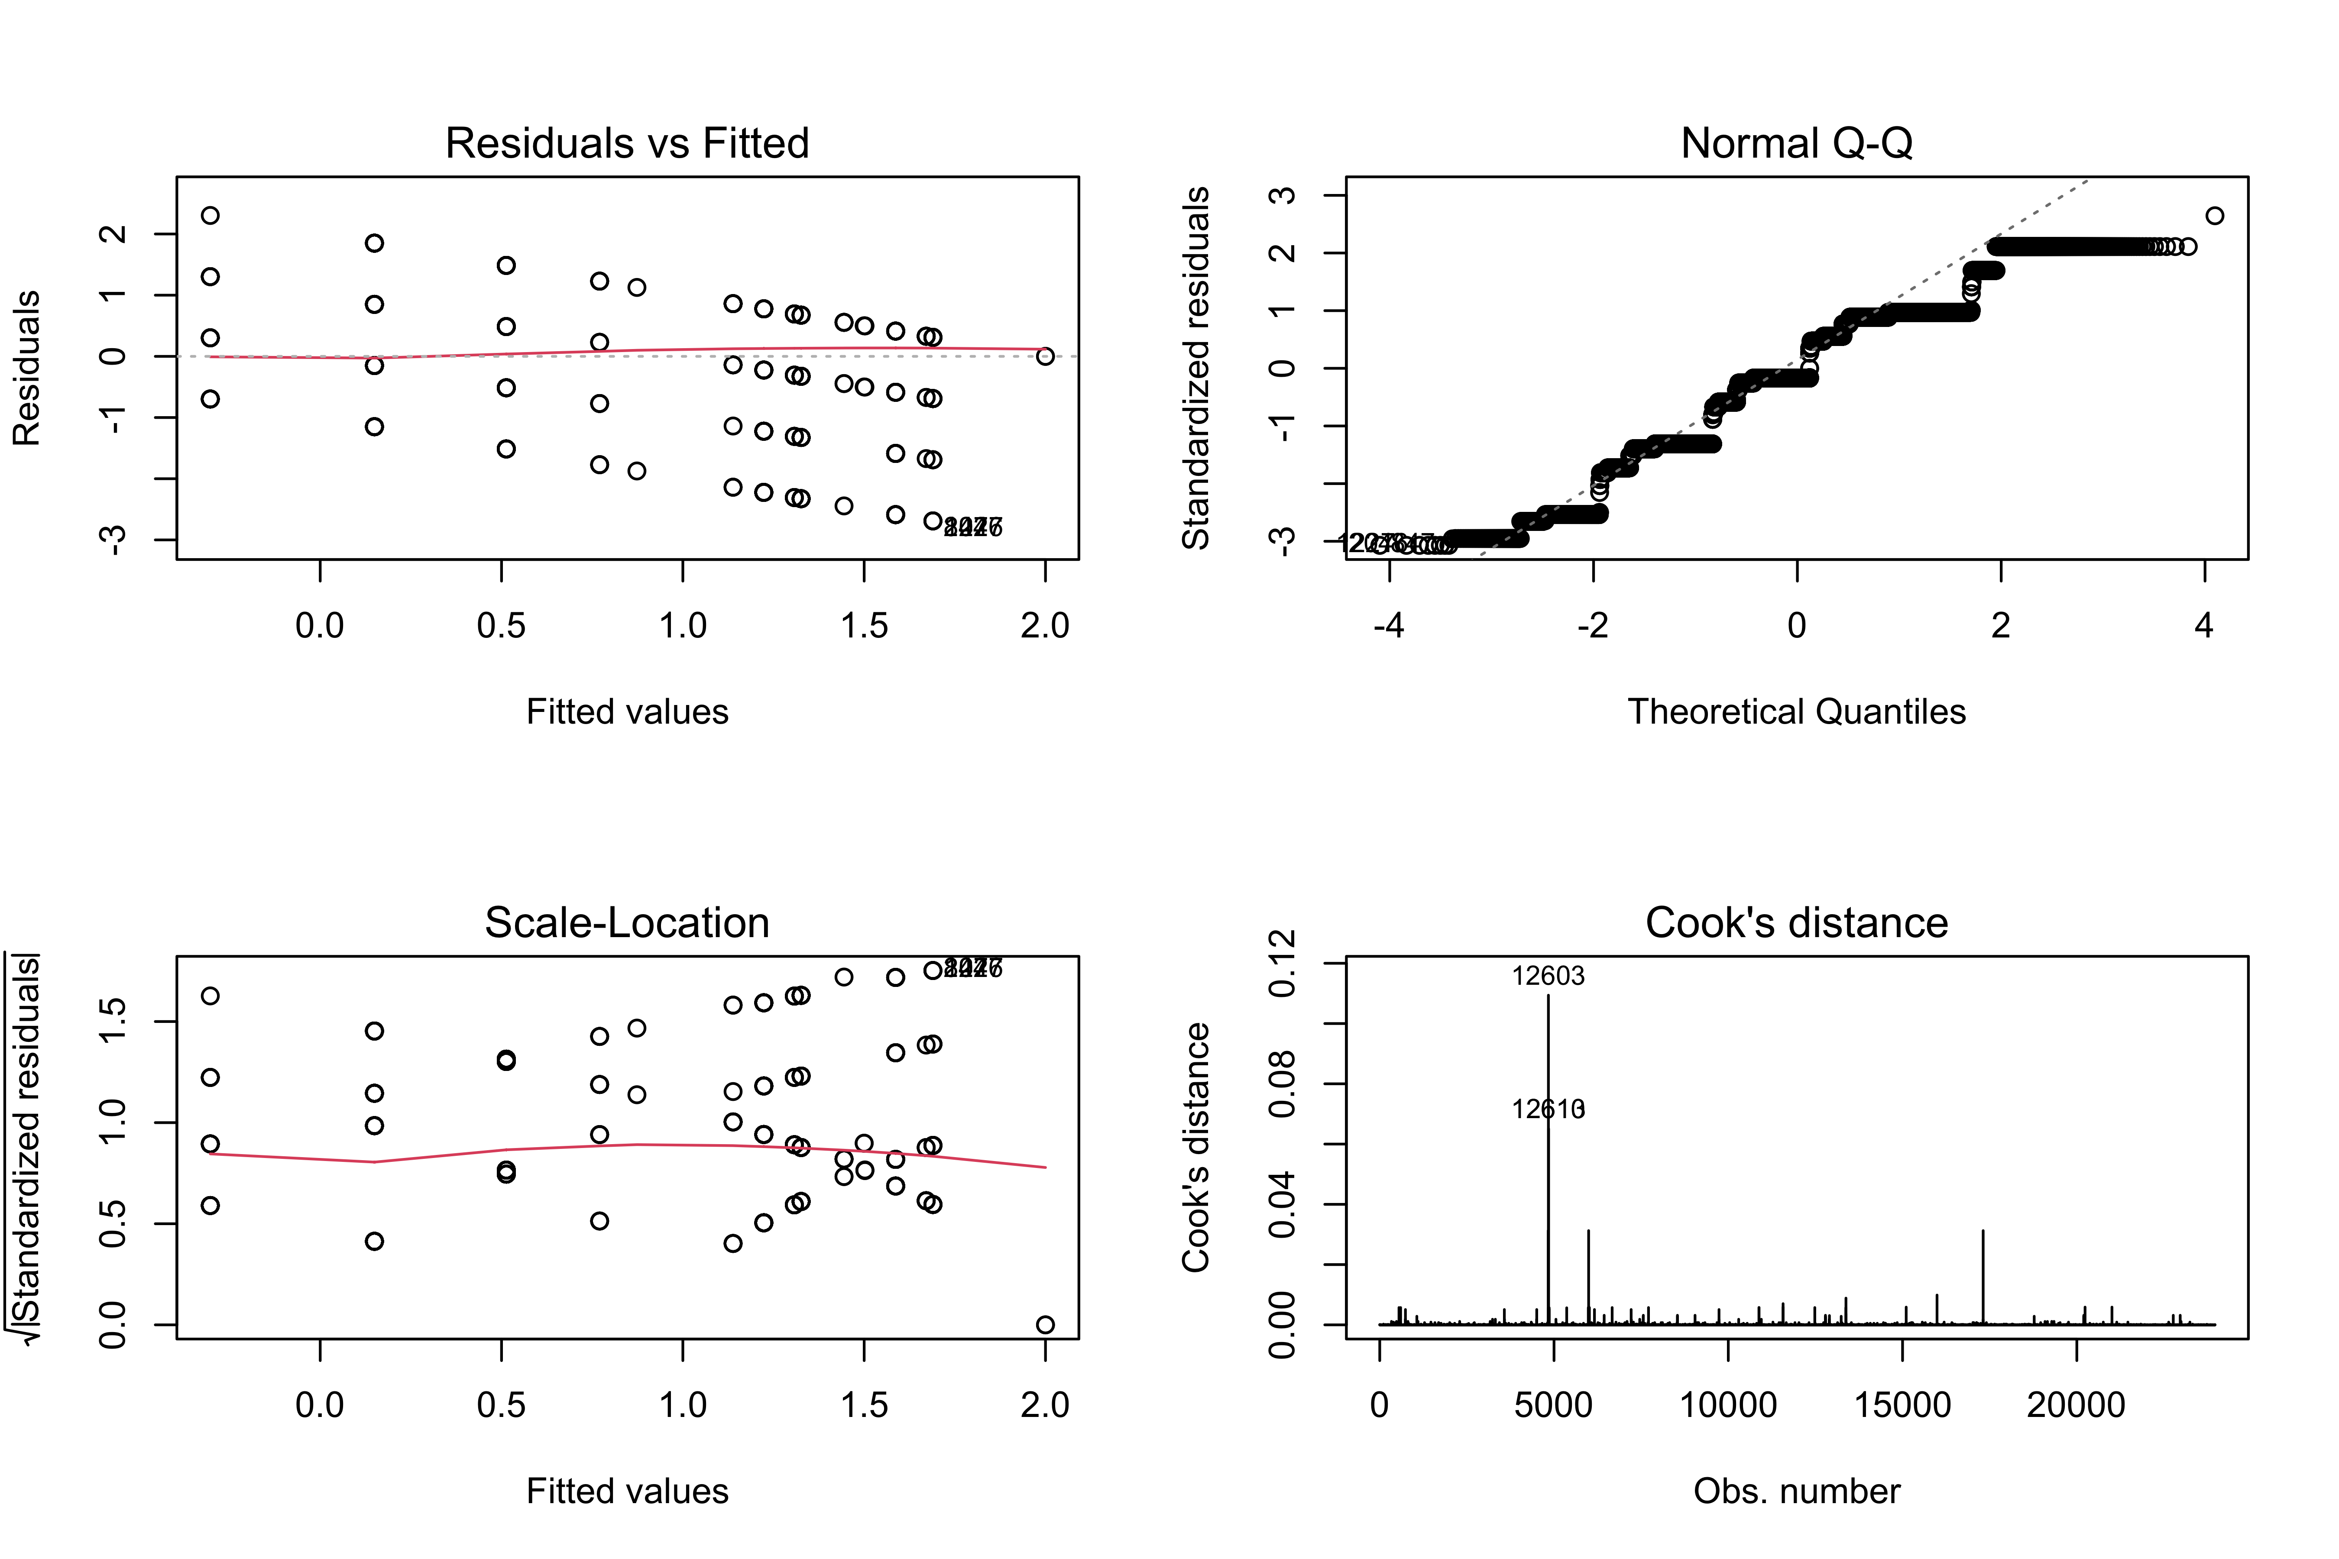

We identify points of high leverage (i.e., potentially influential) to be 2,829. After removing these points, we re-run the regression with the following diagnostics plot:

S3 Figure. Model diagnostics plot after correction
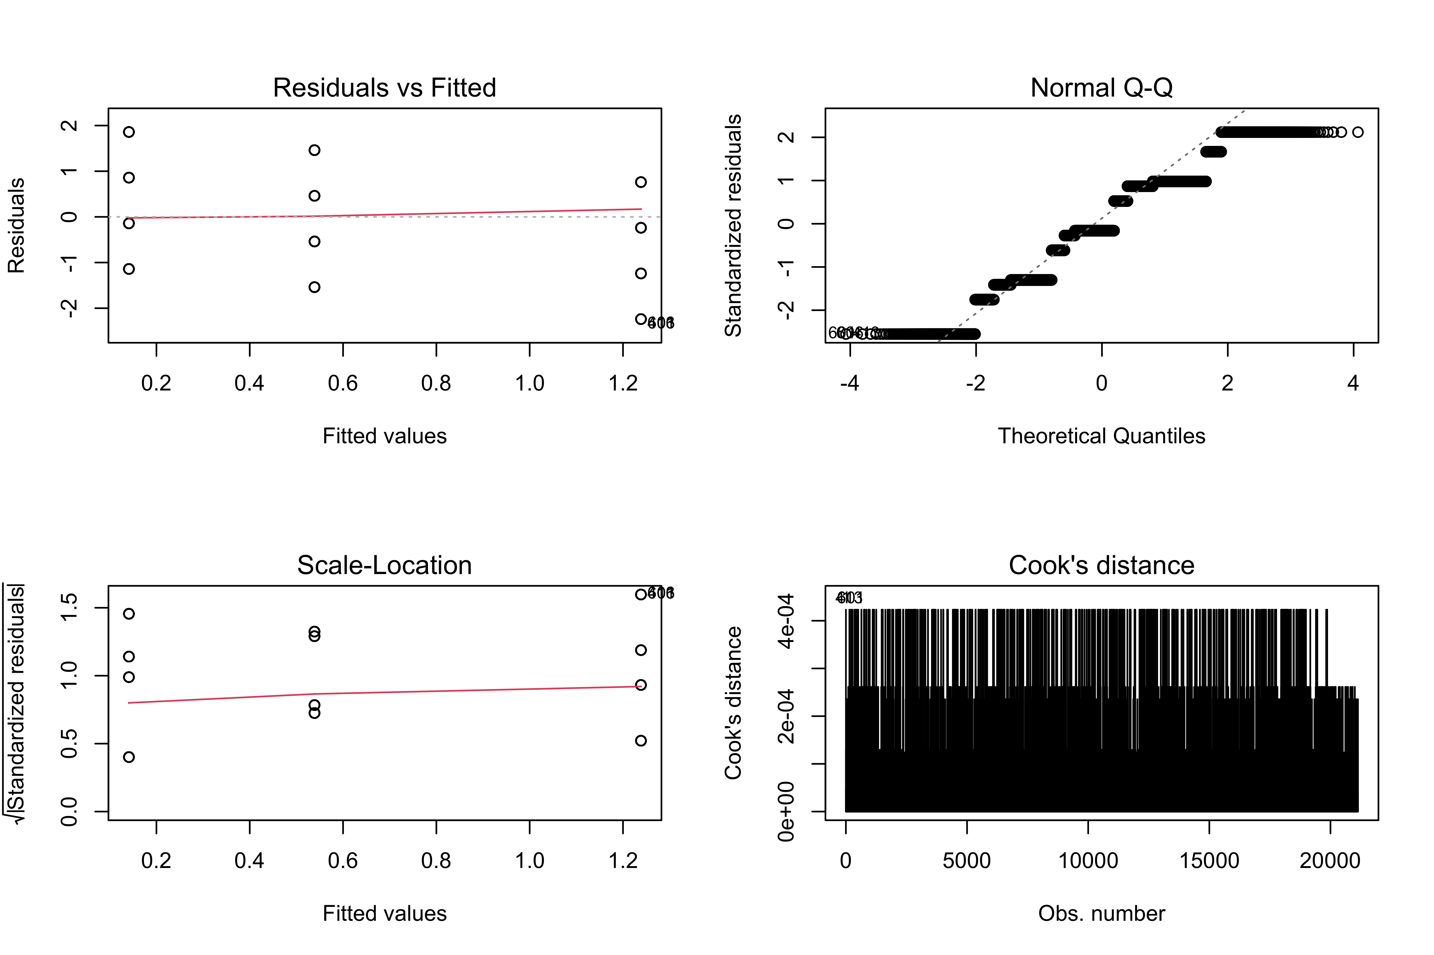
This new model, however, losses the datapoints from author-opposed reviewers, which seemed highly influential. However, this new regression produced a similar contrast between author-suggested reviewer and editor-suggested reviewer (contrast = 0.398, t(21,132) = 24.7, p < 0.001, Cohen’s d = 0.453). In fact, compared to the main text, the contrast now is larger and the effect size, given by Cohen's score is larger too (from main text: contrast = 0.364, t(23,954) = 27.4, p < 0.001, Cohen’s d = 0.415).

References

Gwet, K. L. (2008). “Computing inter-rater reliability and its variance in the presence of high agreement." British Journal of Mathematical and Statistical Psychology, 61, 29-48.

