Supplemental Materials
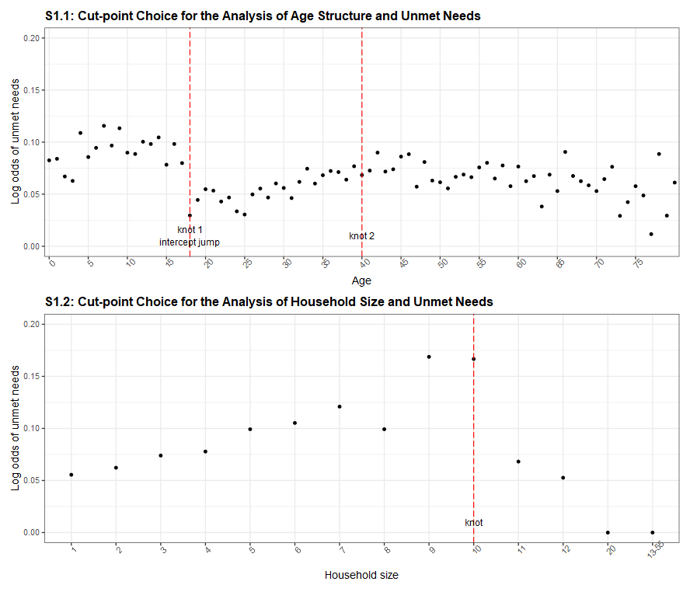

S2: Data for Figure 3 (Predicted Levels of Intergroup Disparities Intersecting Race-ethnicity with Gender and Sexual Orientation)
- Unmet Needs |  |  |  | - Hospitalized
Race-ethnicity | Gender-Sexuality | Prob  (%) | CI  (%) | Race-ethnicity | Gender-Sexuality | Prob  (%) | CI  (%)
NH White | Cismale | 1.9 | [1.6,2.2] | NH White | Cismale | 0.3 | [0.2,0.4]
NH White | Cisfemale | 1.9 | [1.6,2.3] | NH White | Cisfemale | 0.2 | [0.1,0.3]
NH White | Transgender | 2.8 | [2,4] | NH White | Transgender | 0.7 | [0.3,1.3]
NH Black | Cismale | 6.7 | [6,7.5] | NH Black | Cismale | 0.6 | [0.4,0.9]
NH Black | Cisfemale | 6.9 | [6.2,7.7] | NH Black | Cisfemale | 0.5 | [0.4,0.8]
NH Black | Transgender | 10 | [7.3,13.4] | NH Black | Transgender | 1.6 | [0.8,3.2]
Hispanic | Cismale | 5.7 | [5.2,6.3] | Hispanic | Cismale | 0.2 | [0.1,0.3]
Hispanic | Cisfemale | 5.9 | [5.3,6.5] | Hispanic | Cisfemale | 0.2 | [0.1,0.3]
Hispanic | Transgender | 8.5 | [6.2,11.5] | Hispanic | Transgender | 0.6 | [0.3,1.2]
NH Other | Cismale | 4.3 | [3.6,5.1] | NH Other | Cismale | 0.3 | [0.2,0.5]
NH Other | Cisfemale | 4.4 | [3.7,5.2] | NH Other | Cisfemale | 0.3 | [0.1,0.4]
NH Other | Transgender | 6.4 | [4.6,9] | NH Other | Transgender | 0.8 | [0.4,1.7]
NH White | Straight | 1.9 | [1.6,2.2] | NH White | Straight | 0.3 | [0.2,0.4]
NH White | Sexual minority | 2.7 | [2,3.7] | NH White | Sexual minority | 0.3 | [0.1,0.8]
NH Black | Straight | 6.7 | [6,7.5] | NH Black | Straight | 0.6 | [0.4,0.9]
NH Black | Sexual minority | 9.5 | [7.1,12.7] | NH Black | Sexual minority | 0.7 | [0.2,1.9]
Hispanic | Straight | 5.7 | [5.2,6.3] | Hispanic | Straight | 0.2 | [0.1,0.3]
Hispanic | Sexual minority | 8.1 | [6.1,10.8] | Hispanic | Sexual minority | 0.2 | [0.1,0.7]
NH Other | Straight | 4.3 | [3.6,5.1] | NH Other | Straight | 0.3 | [0.2,0.5]
NH Other | Sexual minority | 6.2 | [4.4,8.6] | NH Other | Sexual minority | 0.3 | [0.1,1]

S3: Types of Support Needed during Self-isolation
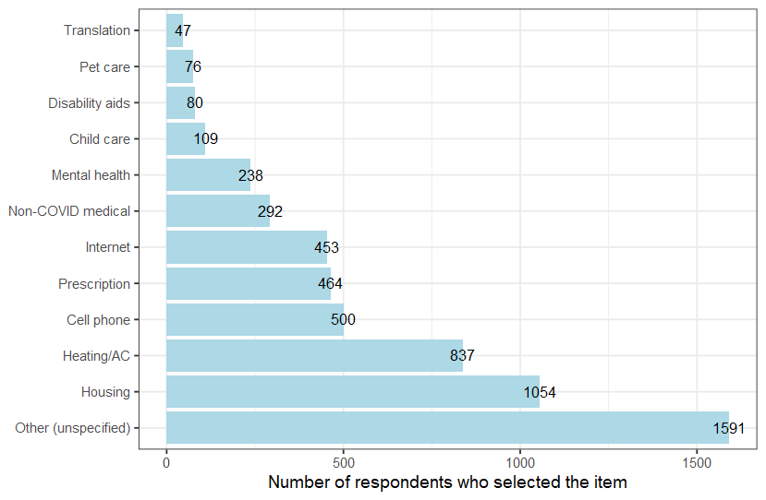
Note: Answers derived from persons who reported having at least one unmet need during self-isolation (N = 3,166 out of 50,846). Data cover COVID-positive Chicago residents who were interviewed between Sep 16, 2020, and January 13, 2022. More than one options allowed for each person.

