Supplemental data
The longitudinal measurement of demographics within the MIDRC data has changed over time (Supplemental Figures 1-5).
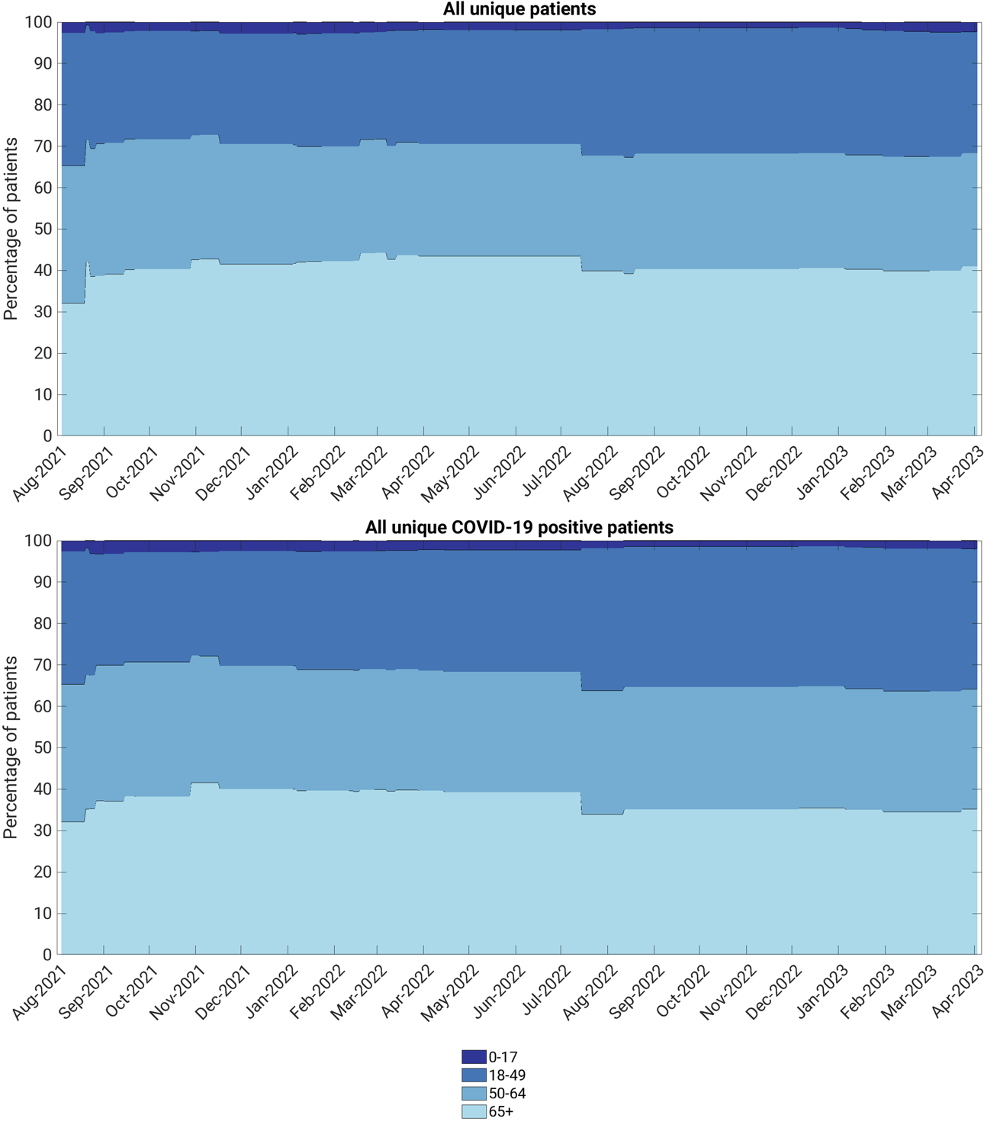
Supplemental Figure 1: Longitudinal percentage of patients in the demographic category of age (in years at index) for (top) all unique patients and (bottom) unique COVID-19 positive patients in the MIDRC data.

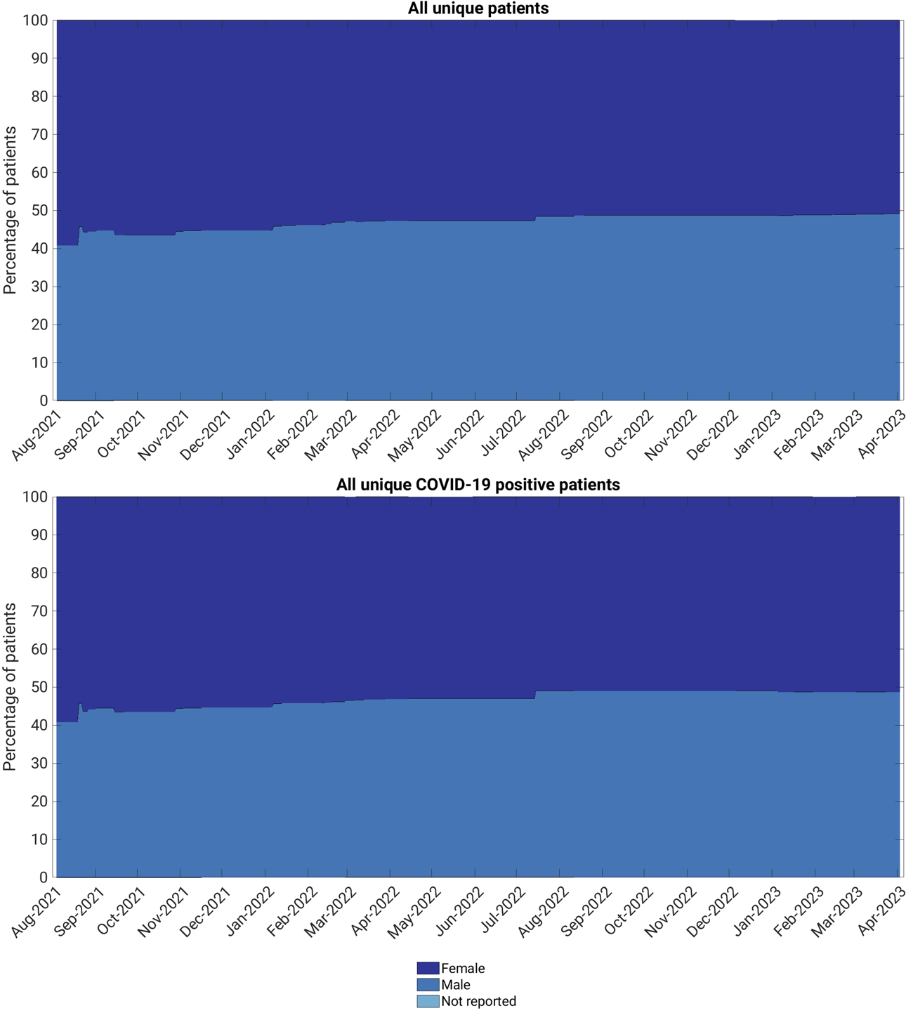
Supplemental Figure 2: Longitudinal percentage of patients in the demographic category of sex for (top) all unique patients and (bottom) unique COVID-19 positive patients in the MIDRC data.

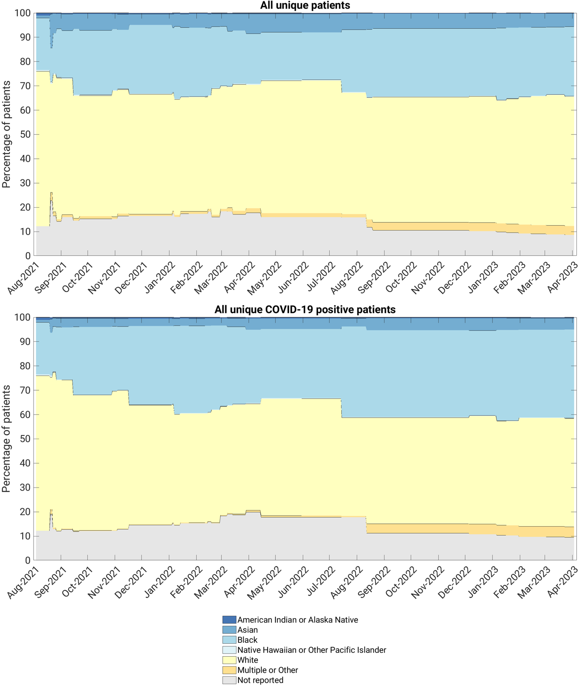
Supplemental Figure 3: Longitudinal percentage of patients in the demographic category of race for (top) all unique patients and (bottom) unique COVID-19 positive patients in the MIDRC data.

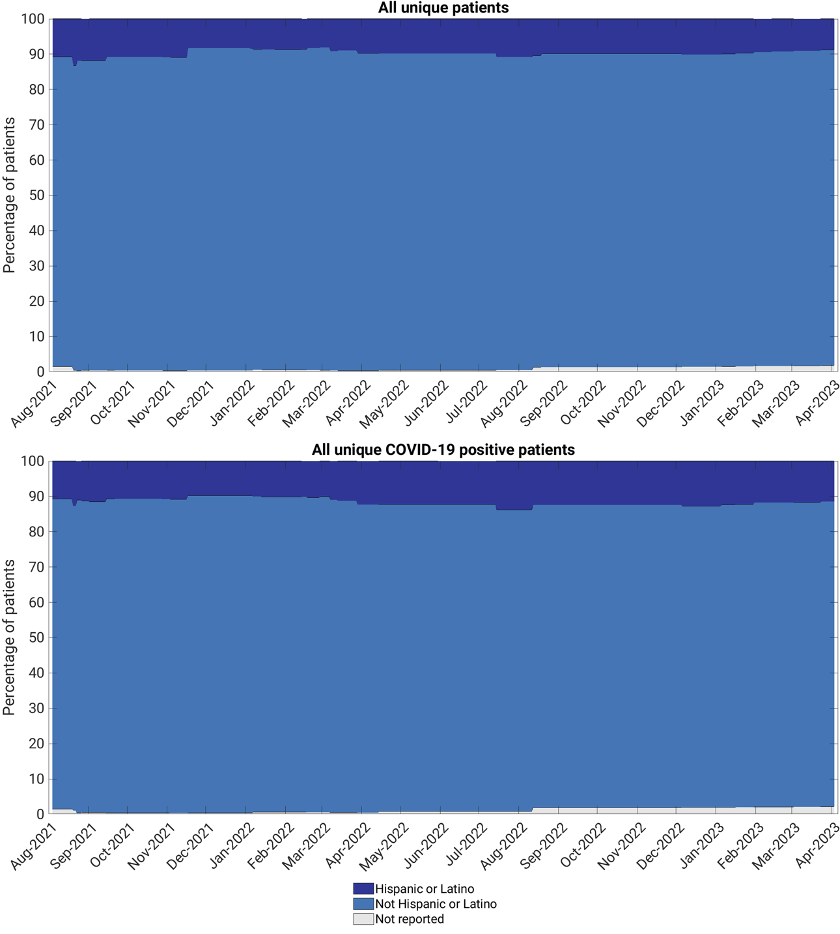
Supplemental Figure 4: Longitudinal percentage of patients in the demographic category of ethnicity for (top) all unique patients and (bottom) unique COVID-19 positive patients in the MIDRC data.

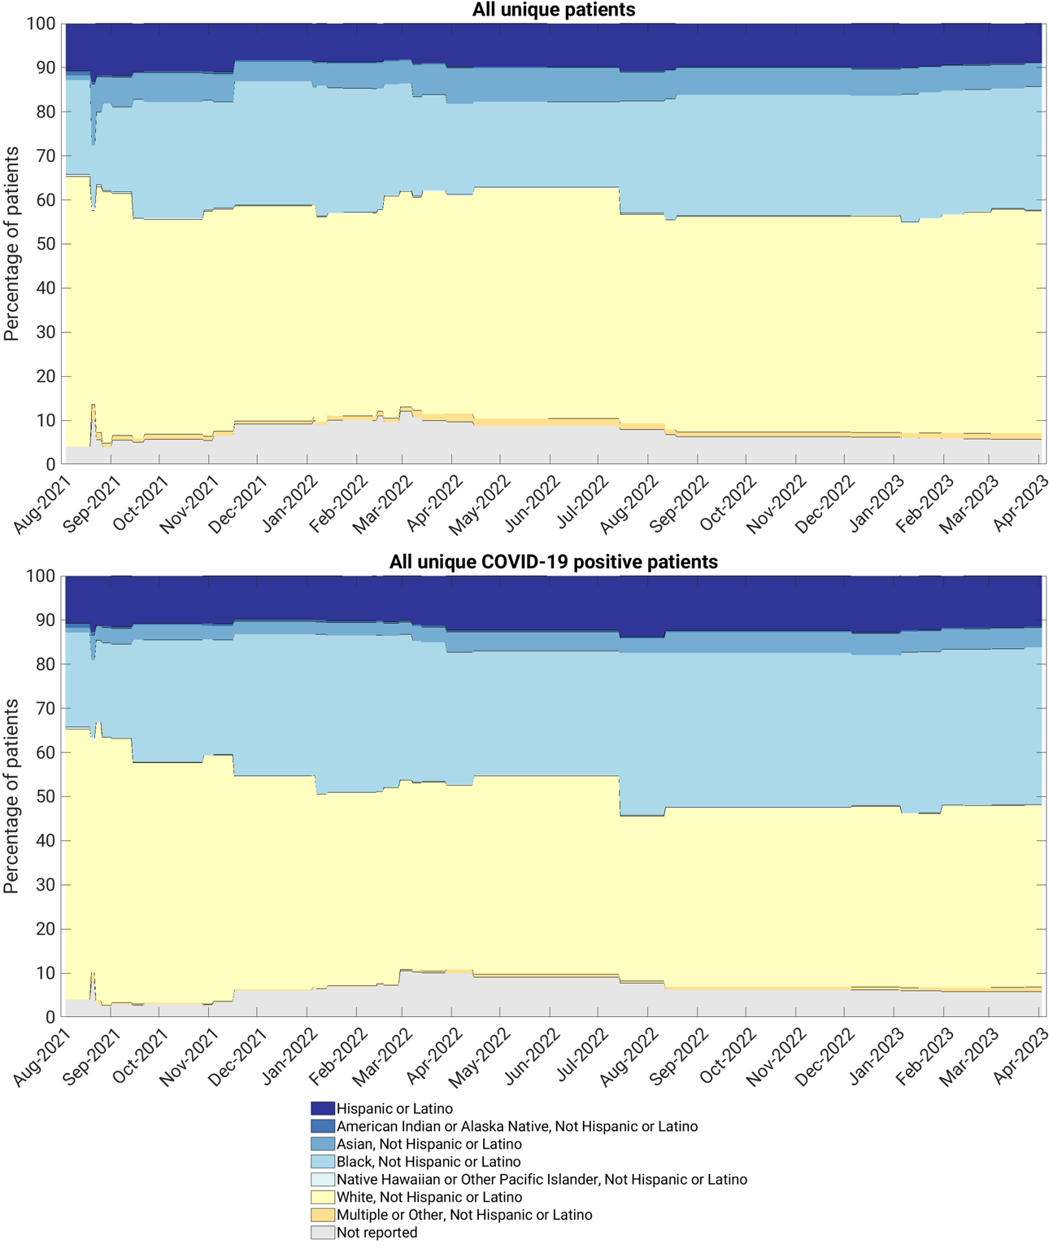
Supplemental Figure 5: Longitudinal percentage of patients in the demographic category of combination of race and ethnicity for (top) all unique patients and (bottom) unique COVID-19 positive patients in the MIDRC data.

