Supplementary File

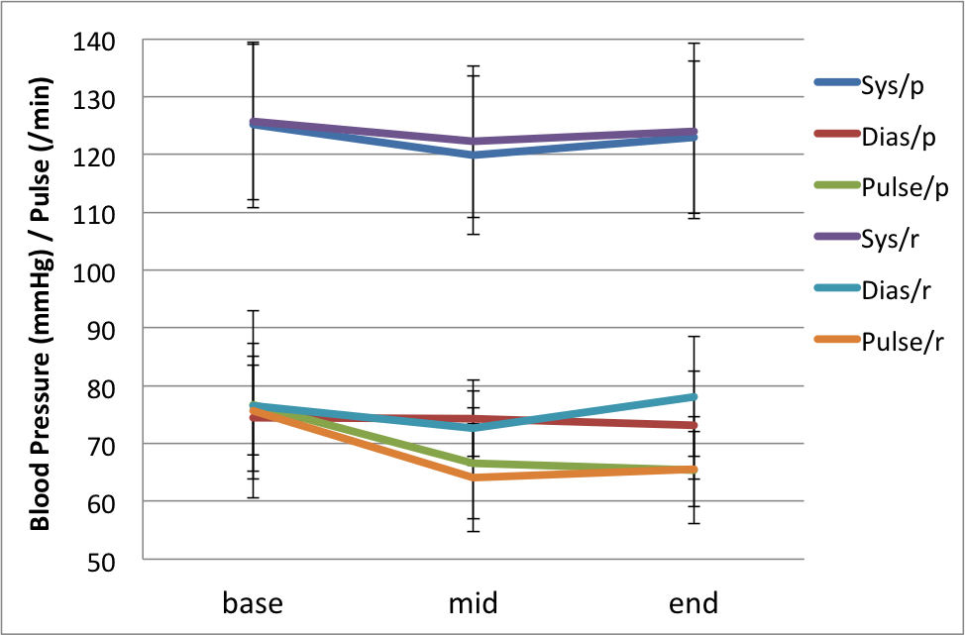

Figure 1. Cardiovascular parameters in participants during the study. Top: Pulse; Bottom: blood pressure. There were no significant treatment group by time interactions (all p>0.10). Error bars represent SEs. Abbreviations. Sys-p: systolic blood pressure with placebo, Dias-p: diastolic blood pressure with placebo, Pulse-p: pulse rate with placebo, Sys-r: systolic blood pressure with real drug, Dias-p: diastolic blood pressure with real drug, Pulse-p: pulse rate with real drug. SE: standard error of the mean.

Supplementary table (Figure 1)

 | Istradefylline (SD) |  |  | Placebo (SD)
 | Base | Mid | End | Base | Mid | End
Systolic Blood Pressure  (mmHg) | 125.7 (13.5) | 122.2 (13.1) | 124.0 (15.2) | 125.1 (14.3) | 119.9 (13.8) | 123.0 (13.1)
Diastolic Blood Pressure  (mmHg) | 76.6 (8.5) | 72.7 (6.5) | 78.2 (10.4) | 74.4 (9.2) | 74.4 (6.6) | 73.2 (9.3)
Pulse (times/min) | 75.6 (11.7) | 64.1 (9.3) | 65.6 (6.5) | 76.8 (16.1) | 66.6 (9.6) | 65.4 (9.2)

 | Base (SD) | Mid (SD) | End (SD)
Istradefylline
Systolic Blood Pressure (mmHg) | 125.7 (13.5) | 122.2 (13.1) | 124.0 (15.2)
Diastolic Blood Pressure (mmHg) | 76.6 (8.5) | 72.7 (6.5) | 78.2 (10.4)
Pulse (times/min) | 75.6 (11.7) | 64.1 (9.3) | 65.6 (6.5)
Placebo
Systolic Blood Pressure (mmHg) | 125.1 (14.3) | 119.9 (13.8) | 123.0 (13.1)
Diastolic Blood Pressure (mmHg) | 74.4 (9.2) | 74.4 (6.6) | 73.2 (9.3)
Pulse (times/min) | 76.8 (16.1) | 66.6 (9.6) | 65.4 (9.2)

Caffeine History Questionnaire (CHQ)
[Developed by Ioannidis, Hook and Chamberlain for the purposes of this study. Copyright the authors 2022. The questionnaire may be used for free for non-commercial academic research, provided the instrument is not re-printed or modified in any way, and that credit is given by citing this paper. For permission to use this instrument for commercial use (e.g. by companies), individuals are asked to contact Dr Chamberlain in advance].

Candidate ID: _______________ Date:_________________
Please take a couple of minutes to reply to the questions below:
Have you consumed any of the following products in the last week? Please circle the average e.g. two cups per day; OR if you drink them less often, circle e.g. “2 cups in a week”. Circle NONE if you haven’t consumed that product.
Percolated/brewed coffee | How many cups? | NONE
  1 | 2 | 3 | 4 | 5 | 6 | 7 | more | Day
  1 | 2 | 3 | 4 | 5 | 6 |  |  | Week
Espresso coffee | How many cups? | NONE
  1 | 2 | 3 | 4 | 5 | 6 | 7 | more | Day
  1 | 2 | 3 | 4 | 5 | 6 |  |  | Week
Decaffeinated coffee | How many cups? | NONE
  1 | 2 | 3 | 4 | 5 | 6 | 7 | more | Day
  1 | 2 | 3 | 4 | 5 | 6 |  |  | Week
Other caffeinated preparations (see below) | How many cups? | NONE
  1 | 2 | 3 | 4 | 5 | 6 | 7 | more | Day
  1 | 2 | 3 | 4 | 5 | 6 |  |  | Week
Please circle: Cappuccino | Mocha | Latte | Iced coffee | Macchiato | other

Black Tea (with or without milk) or Earl Grey | How many cups? | NONE
  1 | 2 | 3 | 4 | 5 | 6 | 7 | more | Day
  1 | 2 | 3 | 4 | 5 | 6 |  |  | Week
Green Tea | How many cups? | NONE
  1 | 2 | 3 | 4 | 5 | 6 | 7 | more | Day
  1 | 2 | 3 | 4 | 5 | 6 |  |  | Week
Herbal, peppermint, chamomile tea | How many cups? | NONE
  1 | 2 | 3 | 4 | 5 | 6 | 7 | more | Day
  1 | 2 | 3 | 4 | 5 | 6 |  |  | Week
Other Tea (see below) | How many cups? | NONE
  1 | 2 | 3 | 4 | 5 | 6 | 7 | more | Day
  1 | 2 | 3 | 4 | 5 | 6 |  |  | Week
Please circle: Nestea | Iced tea | Sweet tea | Chai Latte | other

Cola (see below) | How many? | NONE
  1 | 2 | 3 | 4 | 5 | 6 | 7 | more | Day
  1 | 2 | 3 | 4 | 5 | 6 |  |  | Week
Please circle: Coke | Diet coke or Zero | Pepsi or Diet Pepsi | Pepsi max | Dr Pepper | Jolt cola | or other

Energy drinks and shots (see below) | How many? | NONE
  1 | 2 | 3 | 4 | 5 | 6 | 7 | more | Day
  1 | 2 | 3 | 4 | 5 | 6 |  |  | Week
Please circle: Red Bull | Monster Energy | Rockstar | NOS | 5-hour Energy | Relentless | Mountain Dew | other

Coffee flavoured ice-creams or cakes | How many? | NONE
  1 | 2 | 3 | 4 | 5 | 6 | 7 | more | Day
  1 | 2 | 3 | 4 | 5 | 6 |  |  | Week
Dark chocolate bars, sweets, biscuits, cakes | How many? | NONE
  1 | 2 | 3 | 4 | 5 | 6 | 7 | more | Day
  1 | 2 | 3 | 4 | 5 | 6 |  |  | Week
Hot chocolate or cocoa | How many cups? | NONE
  1 | 2 | 3 | 4 | 5 | 6 | 7 | more | Day
  1 | 2 | 3 | 4 | 5 | 6 |  |  | Week
Other chocolate (see below) | How many? | NONE
  1 | 2 | 3 | 4 | 5 | 6 | 7 | more | Day
  1 | 2 | 3 | 4 | 5 | 6 |  |  | Week
Please circle: milk chocolate bars | sweets | biscuits | cakes

Caffeine tablets | How many? | NONE
  1 | 2 | 3 | 4 | 5 | 6 | 7 | more | Day
  1 | 2 | 3 | 4 | 5 | 6 |  |  | Week
Over the counter medications containing caffeine (see below) | How many tablets? | NONE
  1 | 2 | 3 | 4 | 5 | 6 | 7 | more | Day
  1 | 2 | 3 | 4 | 5 | 6 |  |  | Week
e.g. pain relief medications containing caffeine | migraine medication | medication for cold or cough

Caffeinated Gum (see below) | How many? | NONE
  1 | 2 | 3 | 4 | 5 | 6 | 7 | more | Day
  1 | 2 | 3 | 4 | 5 | 6 |  |  | Week
Please circle: Think Gum | Military energy | other

Guide appendix for the calculation of a gross estimate of caffeine consumption; caffeine content is provided as a mean content of a usual dosing regime for one serving e.g. one cup of coffee
Percolated/brewed coffee | 107mg | Pepsi | 38mg | Relentless | 160mg
Espresso coffee | 100mg | Diet Pepsi | 38mg | AMP | 142mg
Decaffeinated coffee | 10mg | Pepsi Max | 69mg | Other Energy | 160mg
Cappuccino | 100mg | Dr Pepper | 41mg | Coffee flavoured ice-creams or cakes | 6mg
Other caffeinated preparations | 80mg | Jolt cola | 280mg | Dark chocolate | 43mg
Black Tea | 42mg | Other cola | 35mg | Hot chocolate or Cocoa | 5mg
Green Tea | 25mg | Red Bull | 80mg | Milk chocolate | 20mg
Herbal, peppermint, chamomile tea | 0mg | Monster Energy | 160mg | Caffeine tablets | 200mg
Other Tea | 45mg | Rockstar | 160mg | Medication containing caffeine | 65mg
Coke | 34mg | NOS | 160mg | Think Gum | 10mg
Diet coke or Zero | 45mg | 5-hour Energy | 207mg | Military Gum | 100mg

