All photos are from the San Francisco Public Library and the Library of Congress historical photograph databases.

Figure A-1. Aerial photo of HPNS in the 1920s.
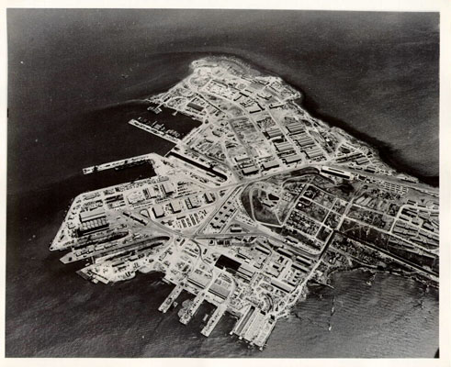

Figure A-2. Site photo (1942).
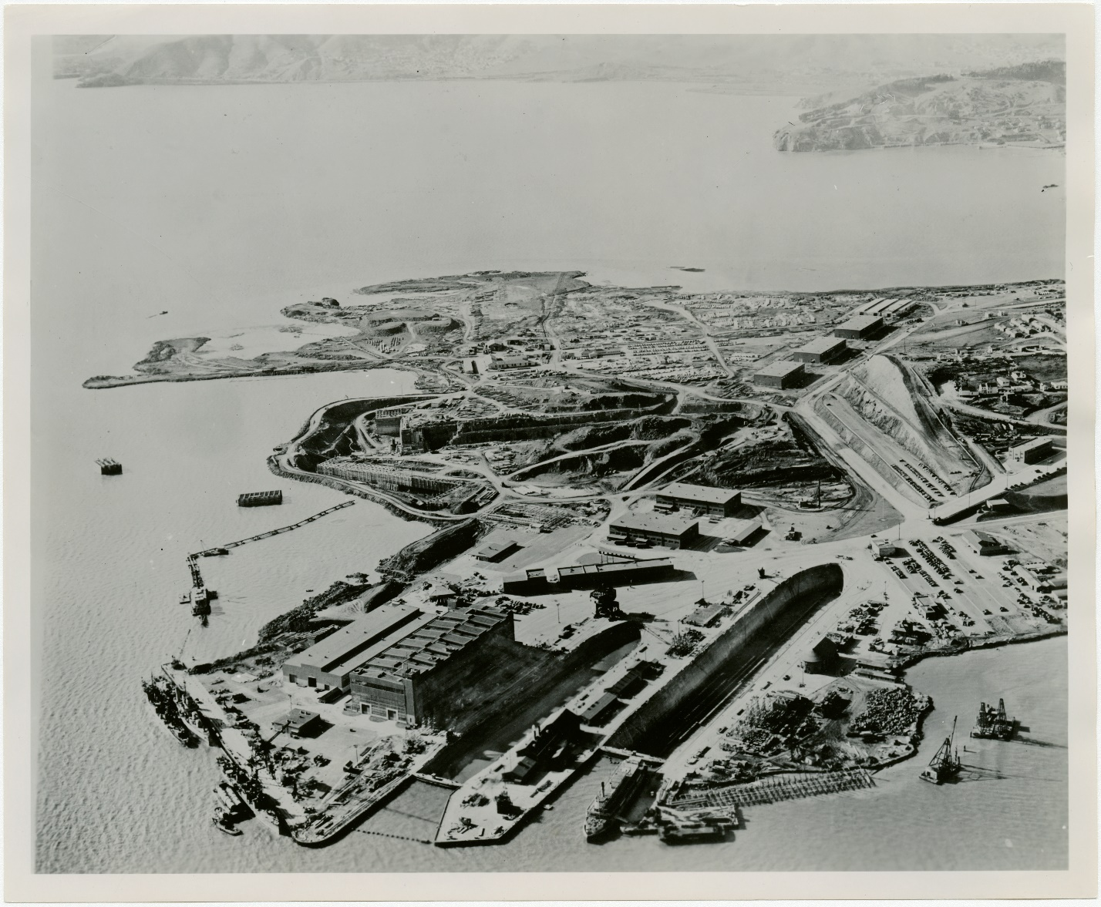

Figure A-3. Parking area and crane operations at HPNS (1943).
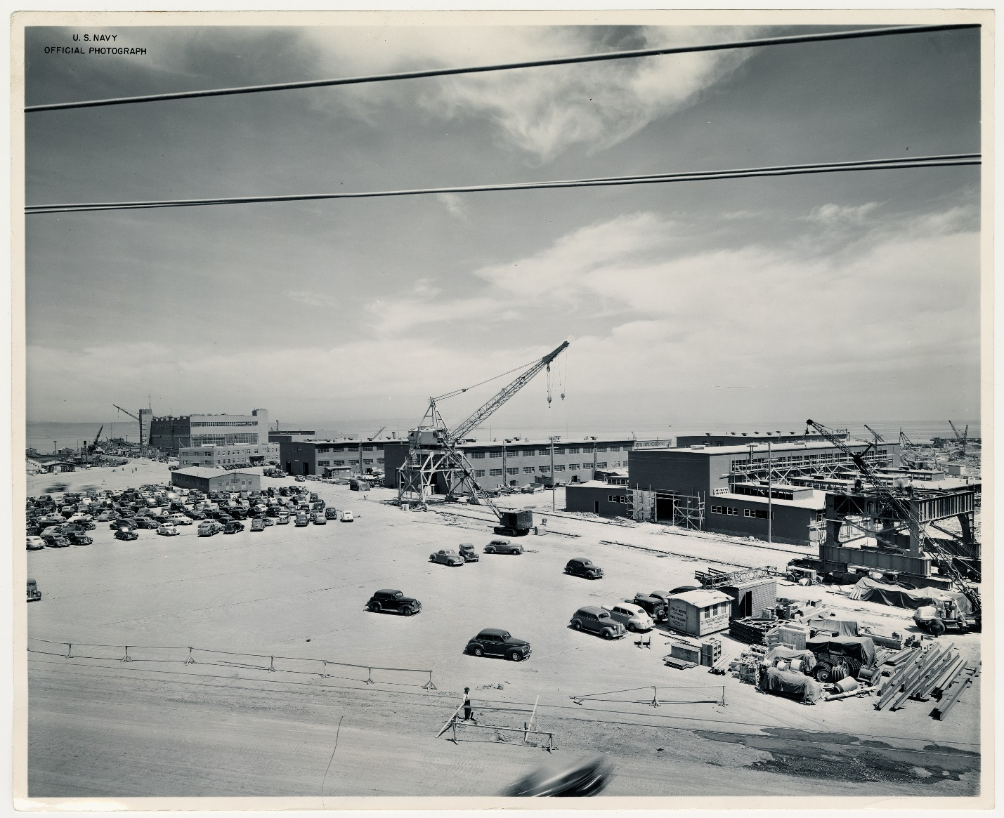

Figure A-4. Submarine Guitarro being repaired at Hunters Point Naval Shipyard (1945).
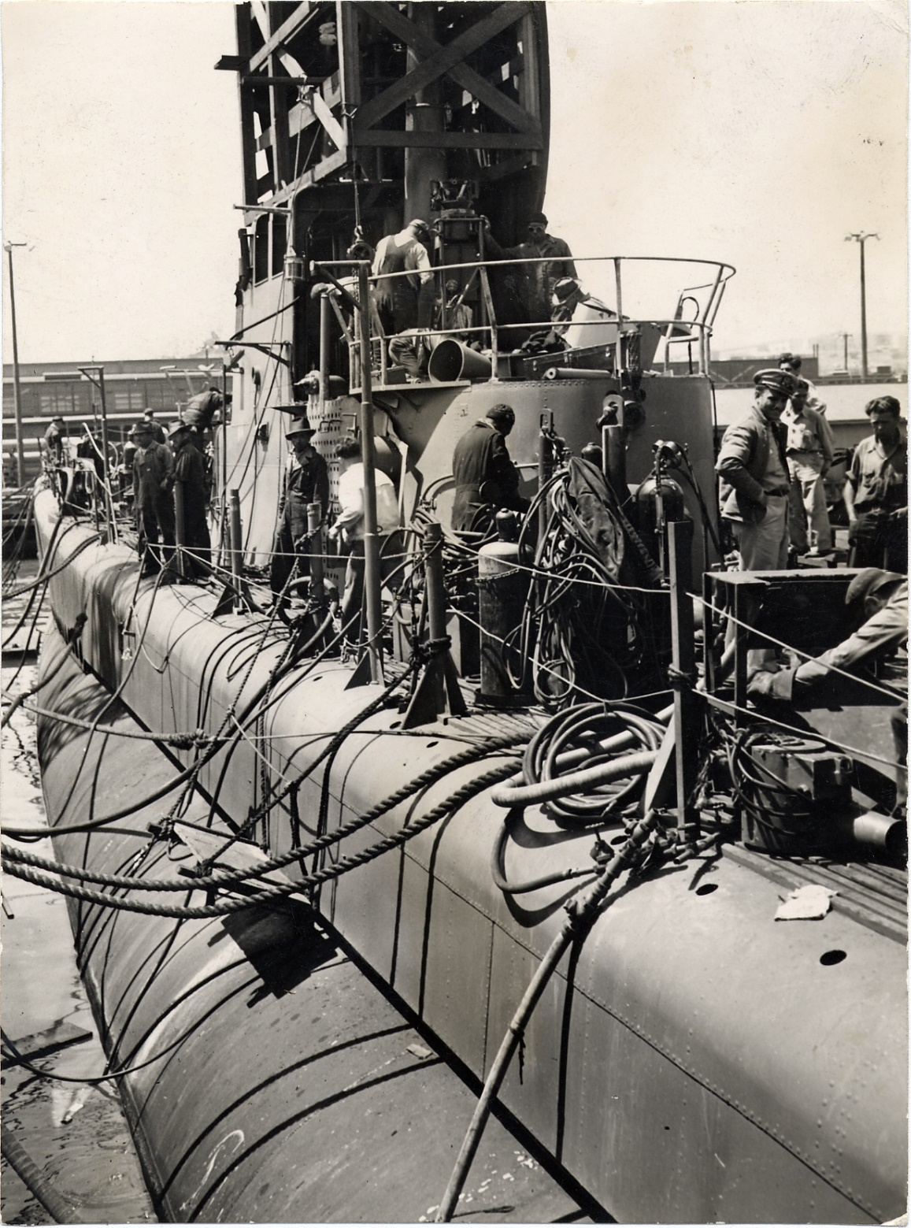

Figure A-5. Ship restoration activities at HPNS (1946).
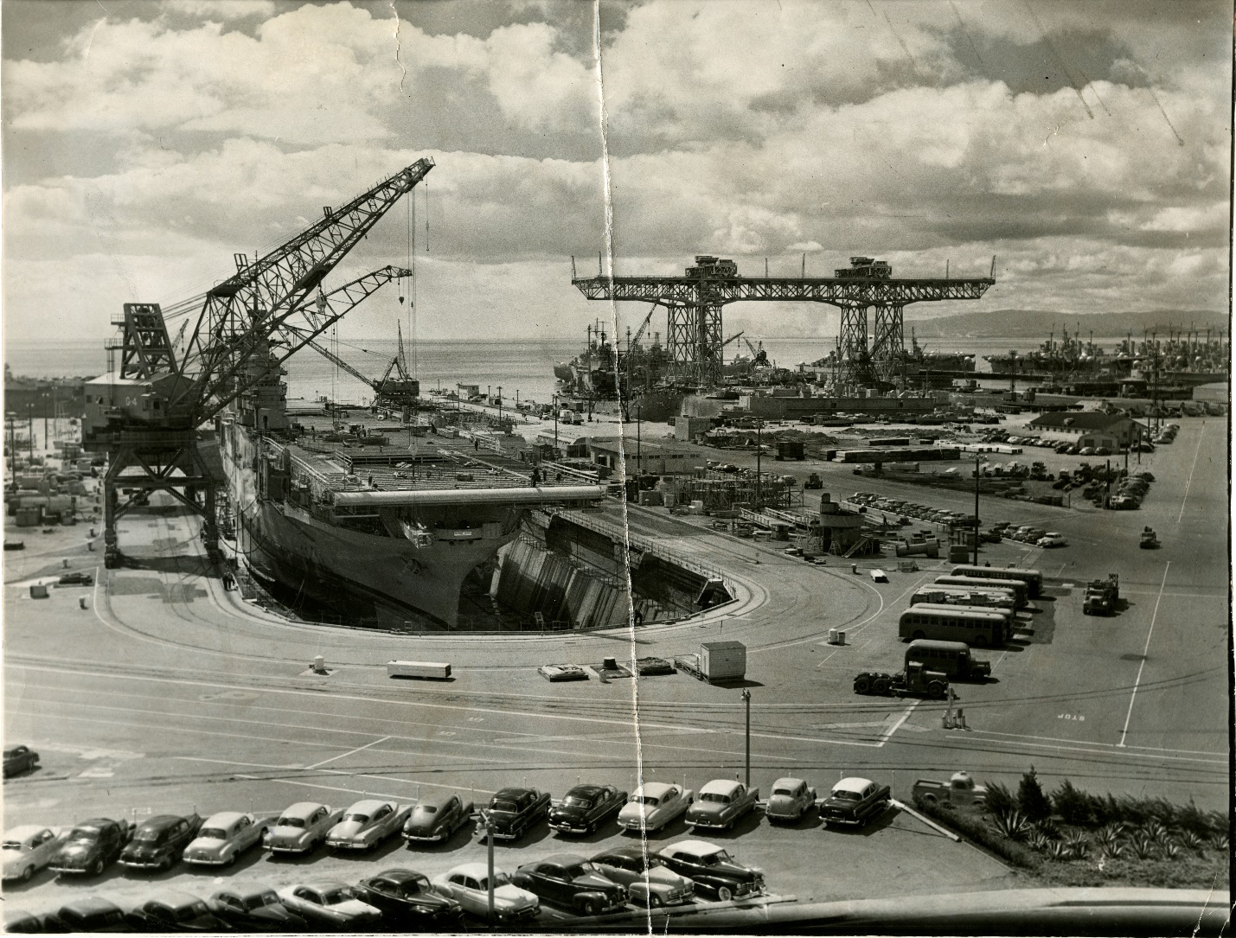

Figure A-6. One of the bays at HPNS (1946).
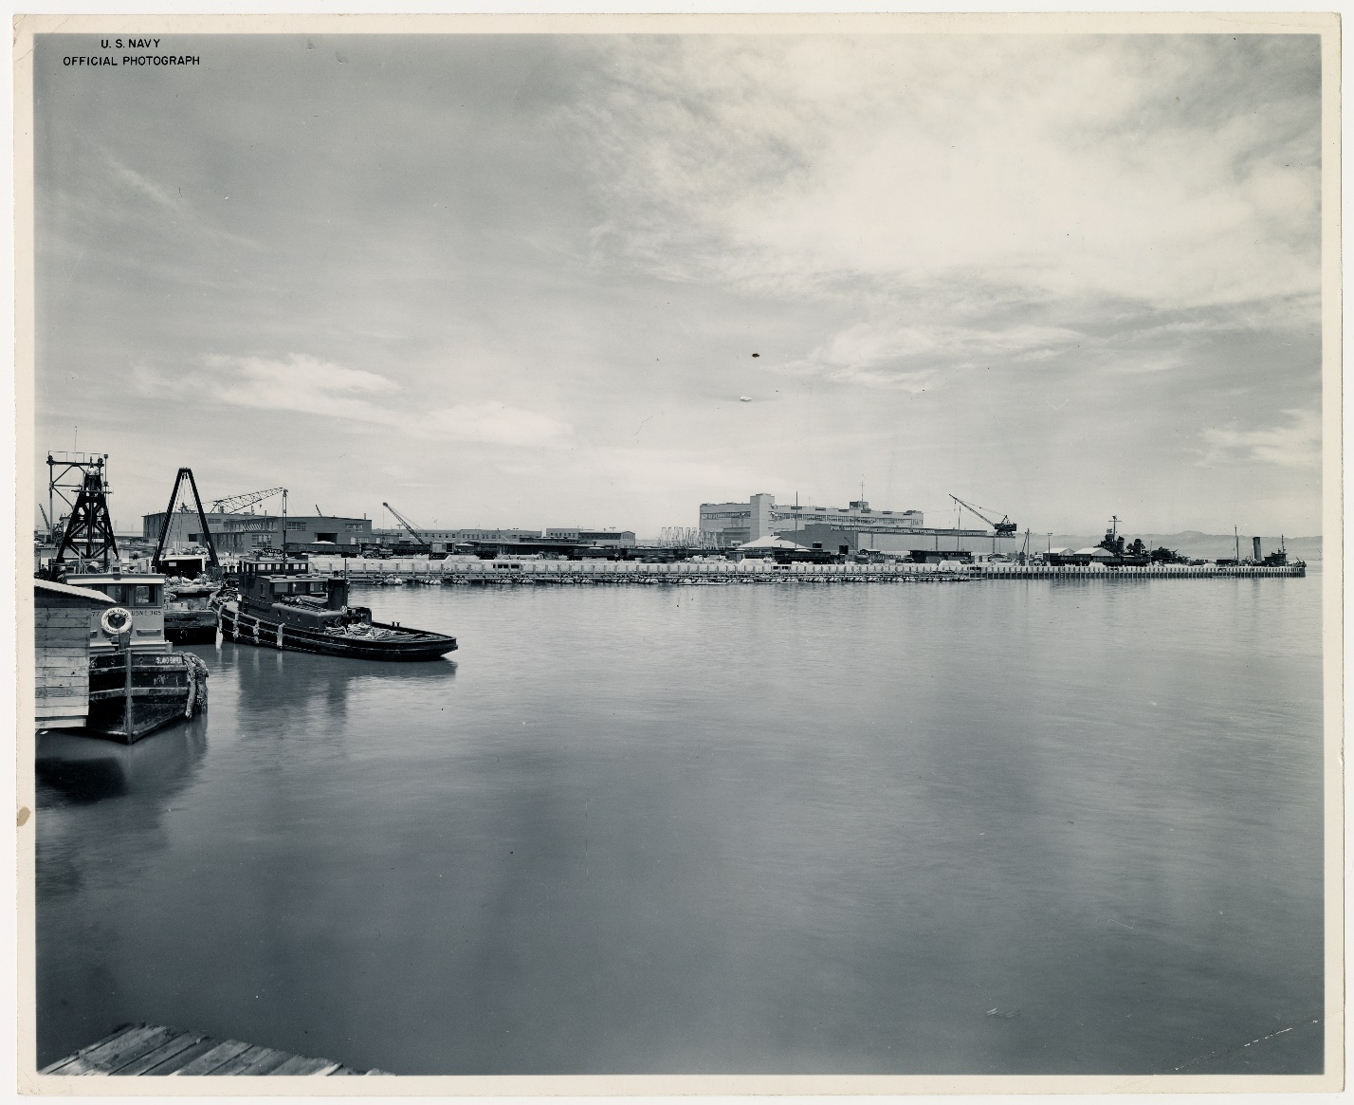

Figure A-7. Site photo (1946).
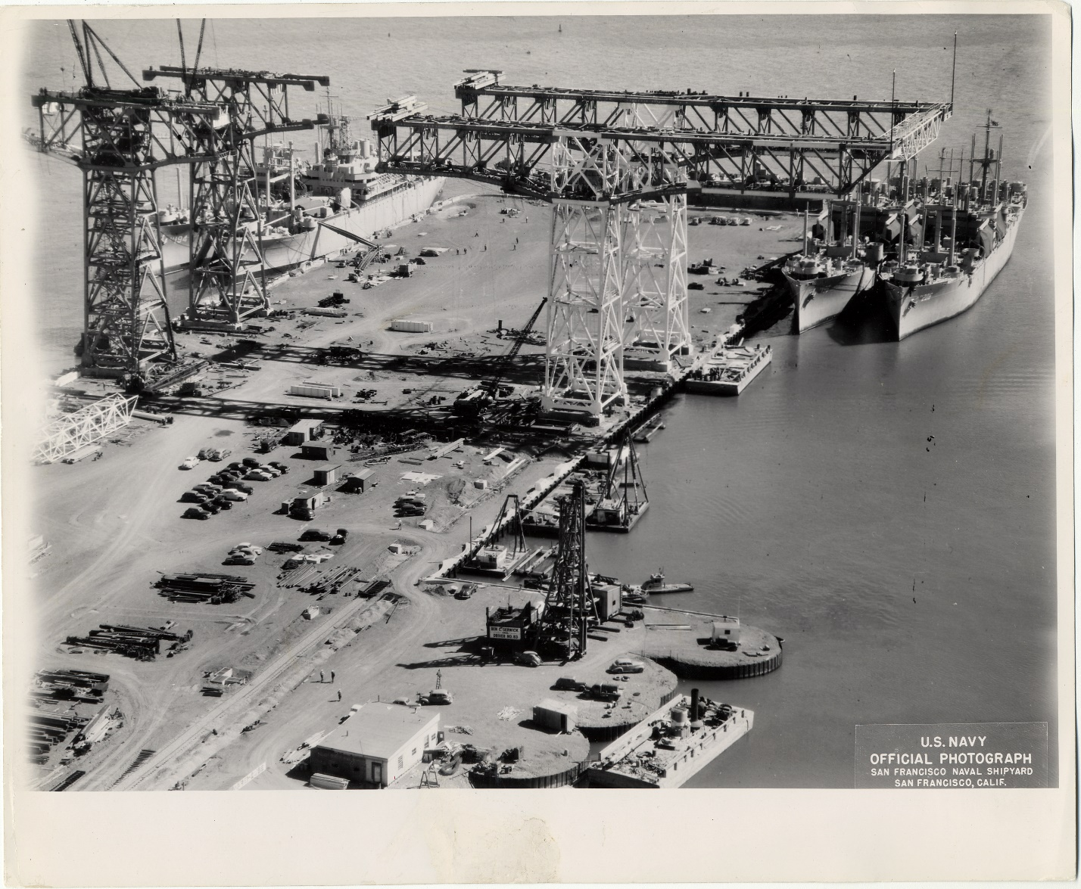

Figure A-8. Crane at Hunters Point Naval Shipyard (1947).
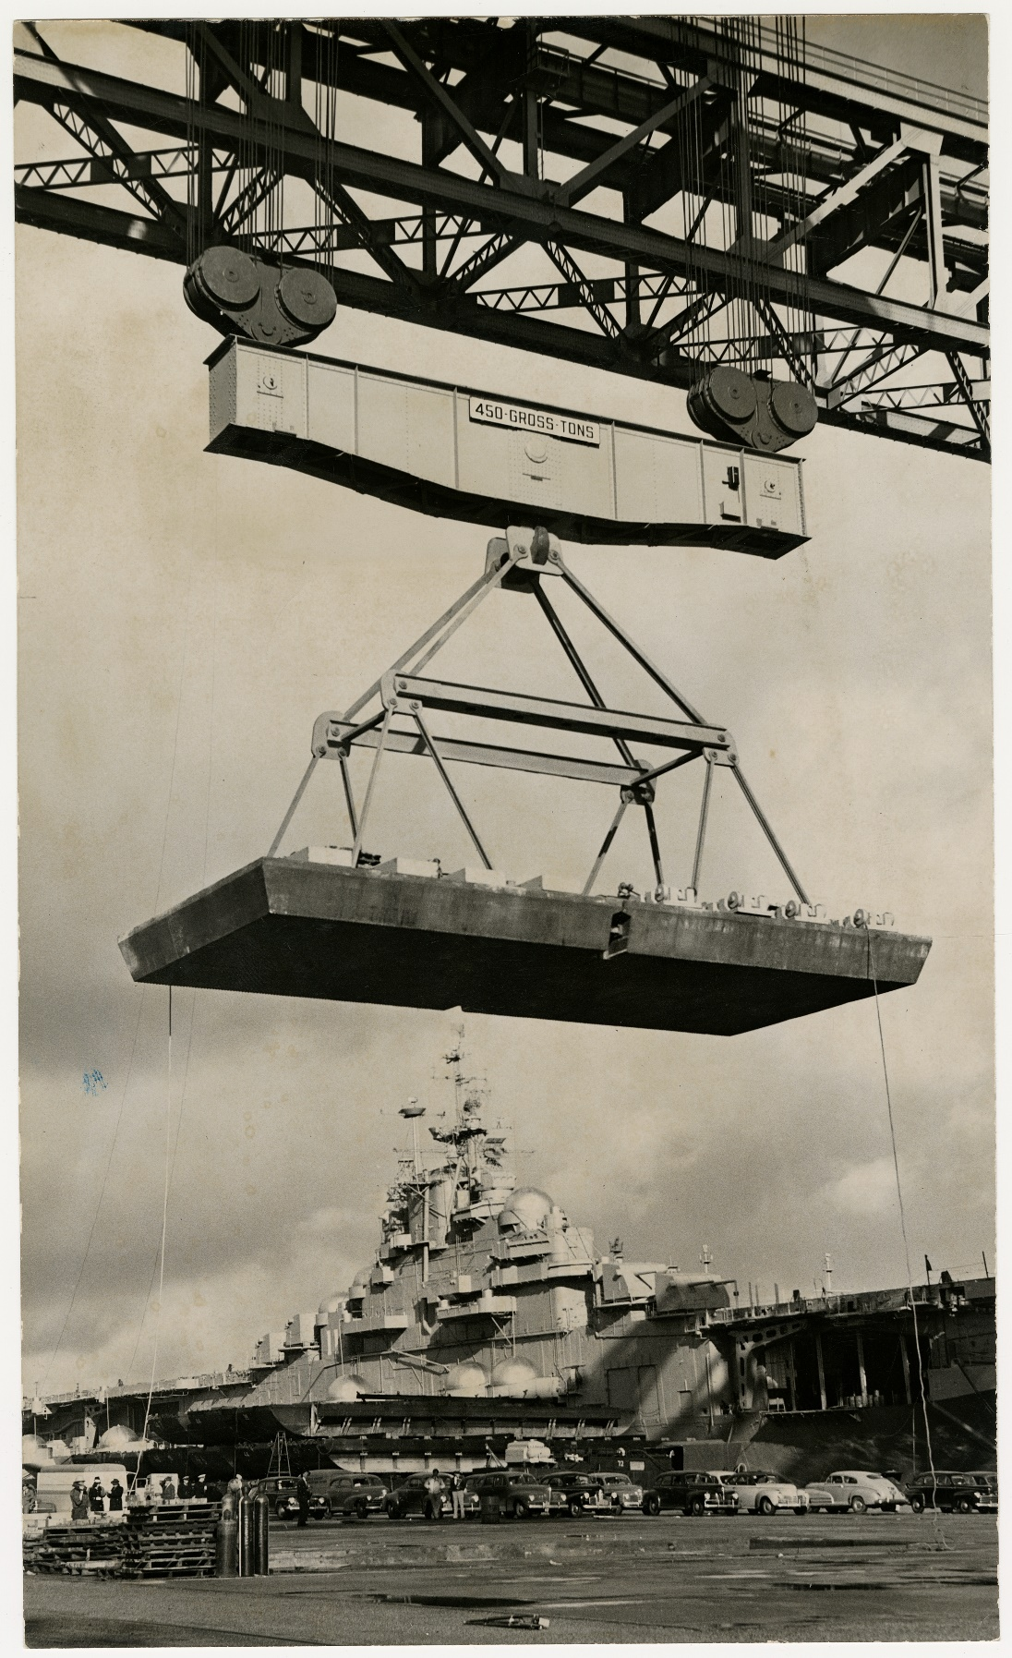

Figure A-9. Submarine drydocked at Hunters Point (1947).
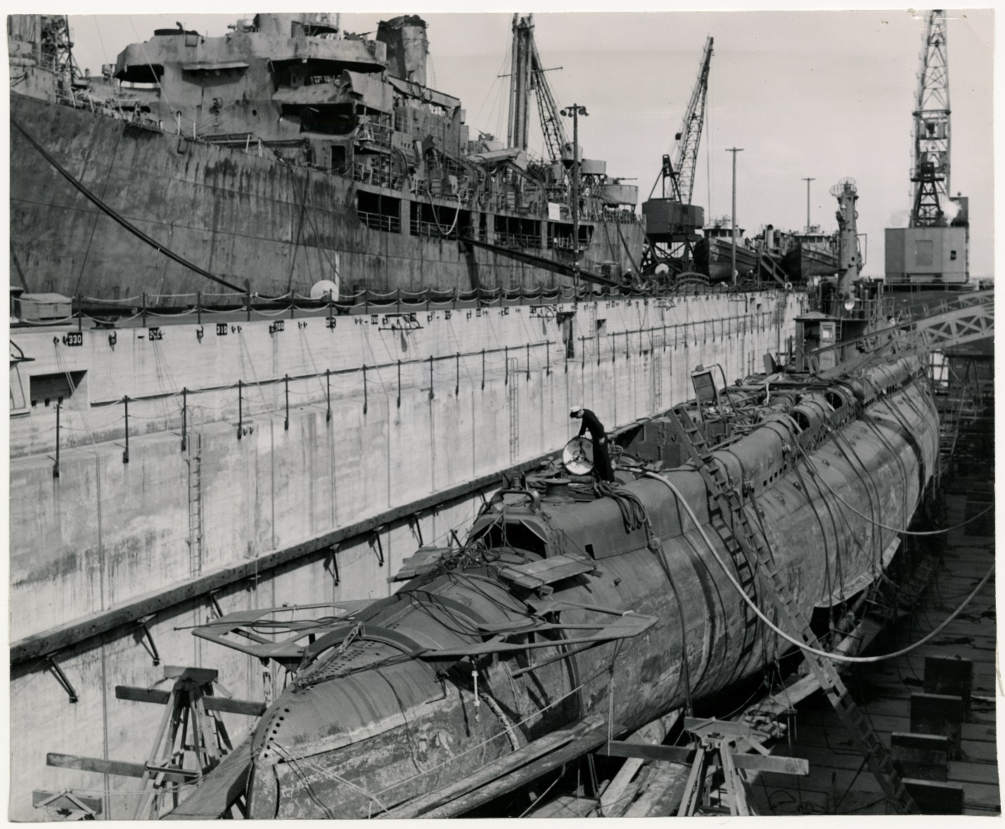

Figure A-10. Aerial photo of HPNS (1948).
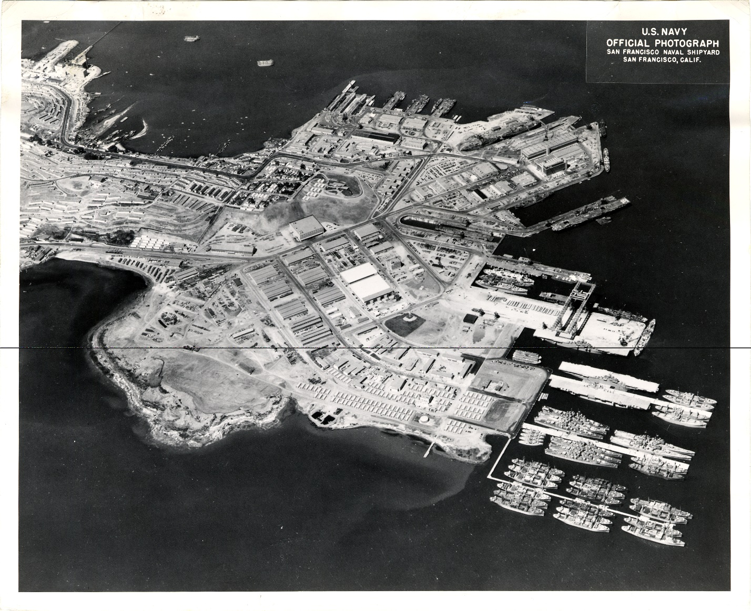

Figure A-11. Paul Bissinger, president-elect of the San Francisco Chamber of Commerce; J. Joesph Sullivan, president of the Board of Supervisors; and Francis V. Keesling Jr., city lobbyist to Washington at HPNS in order to defend against attempts to shut down the yard (1949).
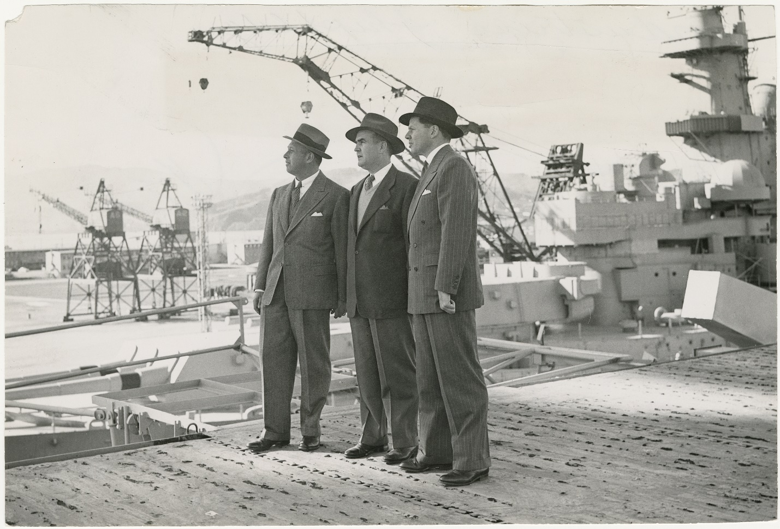

Figure A-12. Group of men accepting the award for first place in industrial safety in the marine industry (1949). Left to right, R. B. Ahern, yard safety superintendent, Rear Adm. L. D. McCormck, commandant of the 12th Naval District; William J. Bell (rear) president of the Employees Association; Congressman Franck Havenner; Rear Adm. H. E. Haven, commandant of the Mare Island naval base; Captain B. E. Manseau, commander of the Hunters Point yard, who received the award from (right) Henry E. North, a director of the National Safety Council and president of the San Francisco Chamber of Commerce.
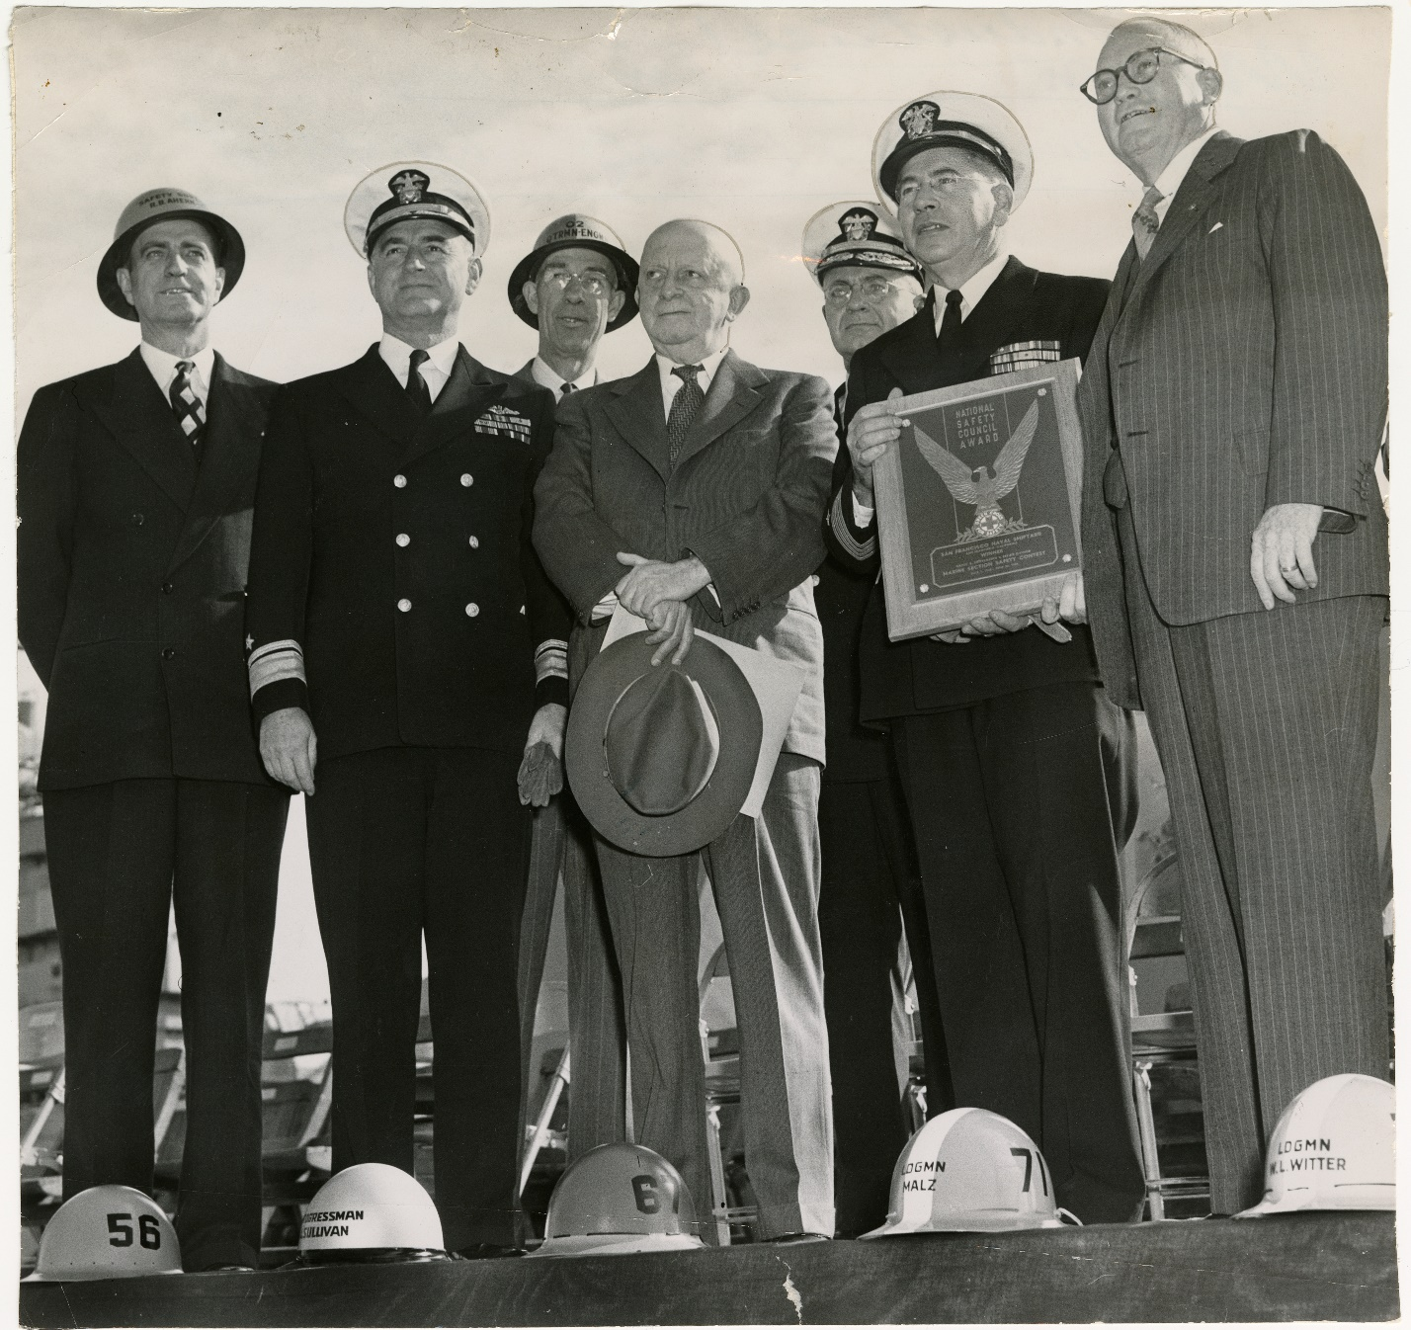

Figure A-13. Waves threatening dead ships at HPNS (1950).
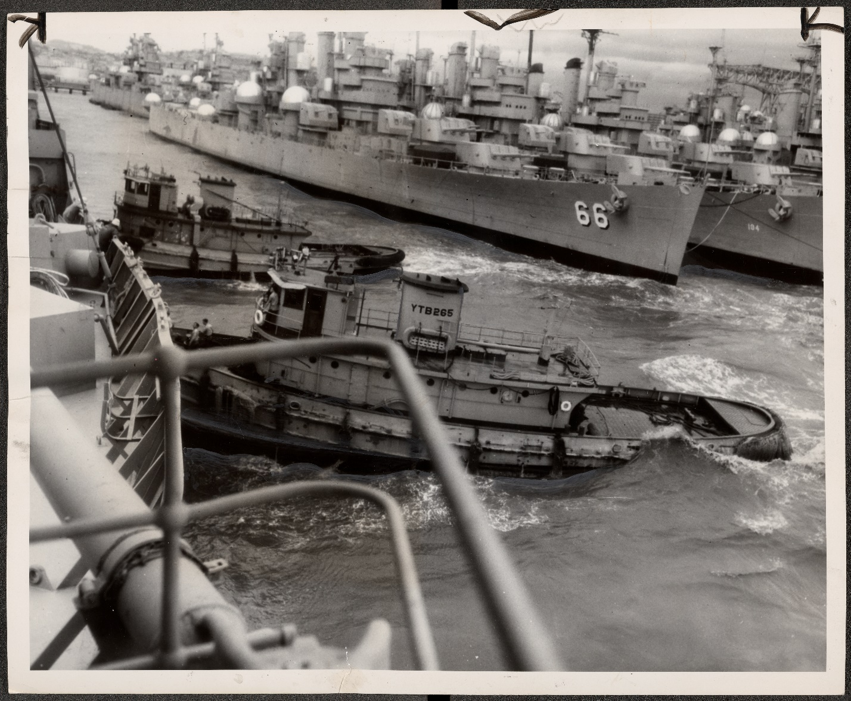

Figure A-14. Workers repairing a diesel engine on a cruiser (1953).
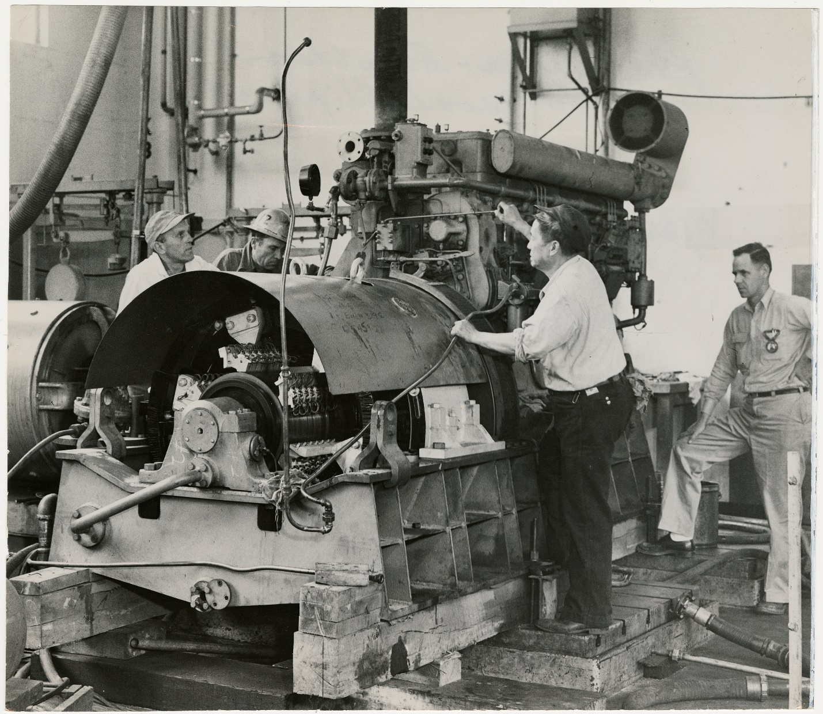
Figure A-15. Machinists balancing 20 ton propeller (1953).
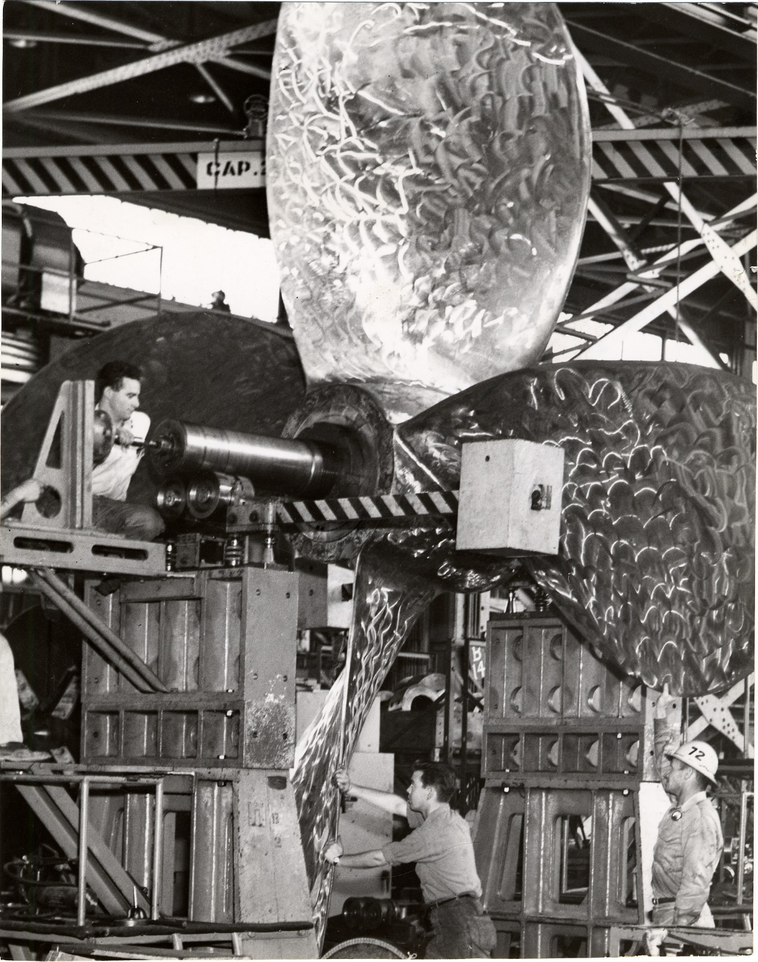

Figure A-16. Residential area of HPNS (1961).
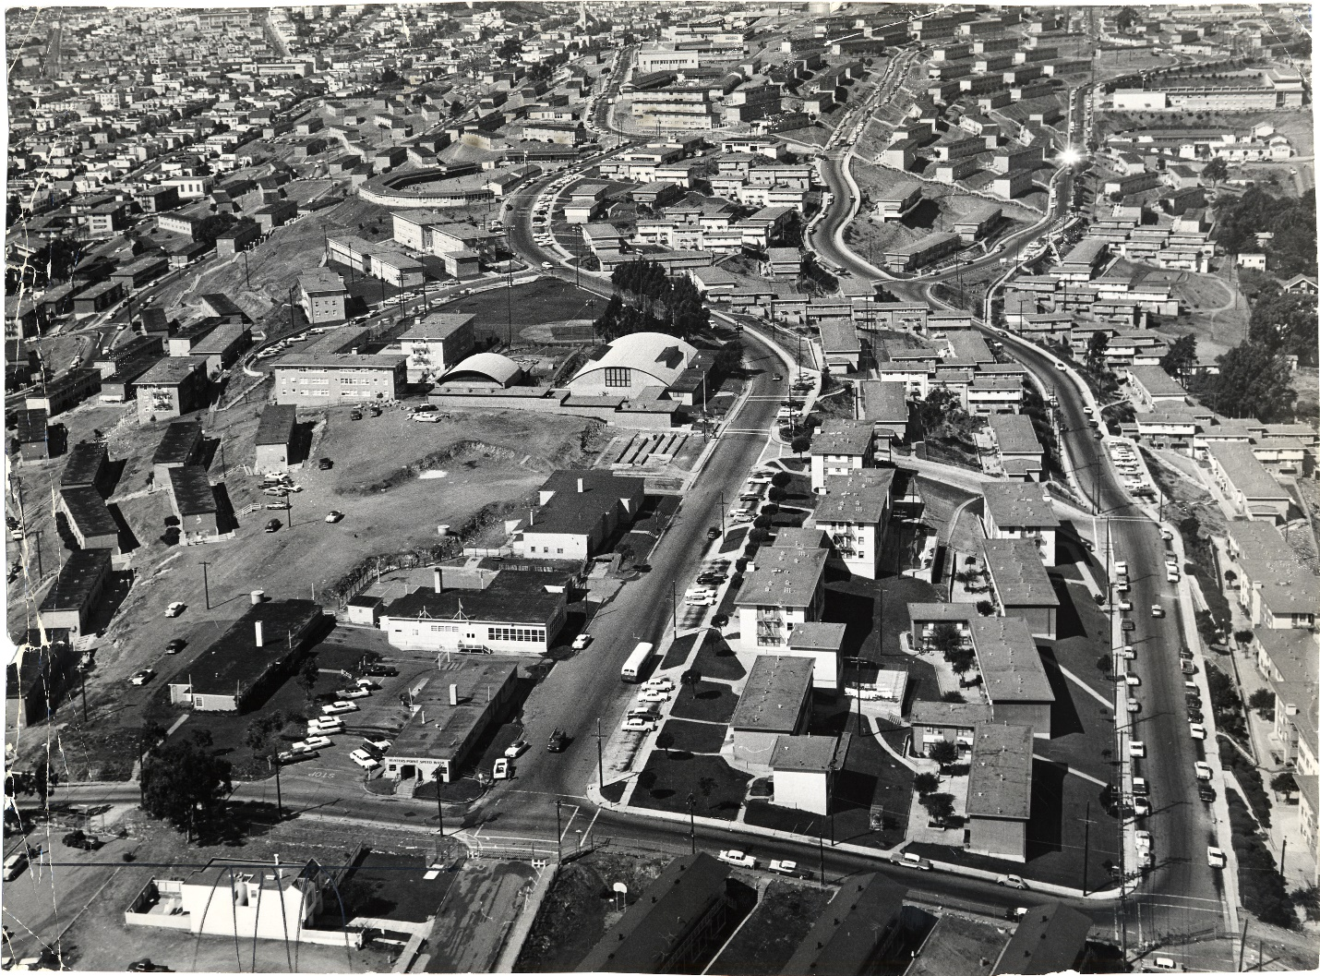
Figure A-17. Test explosion in the bay off HPNS (1963).
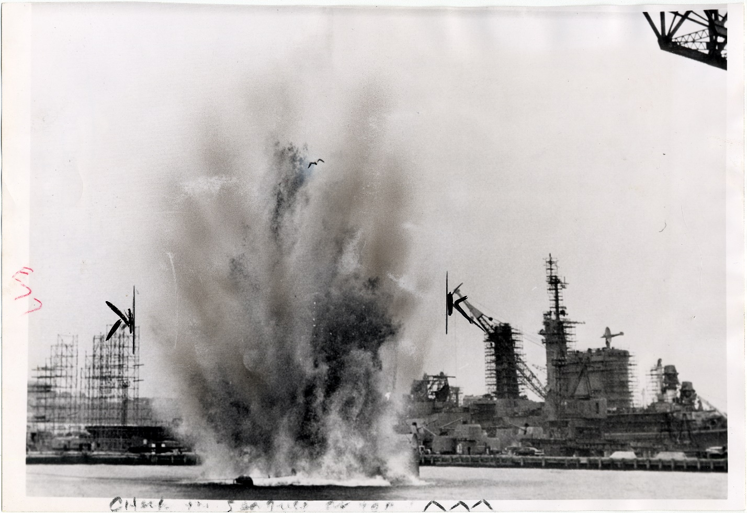

Figure A-18. Shipyard activities at HPNS (undated).
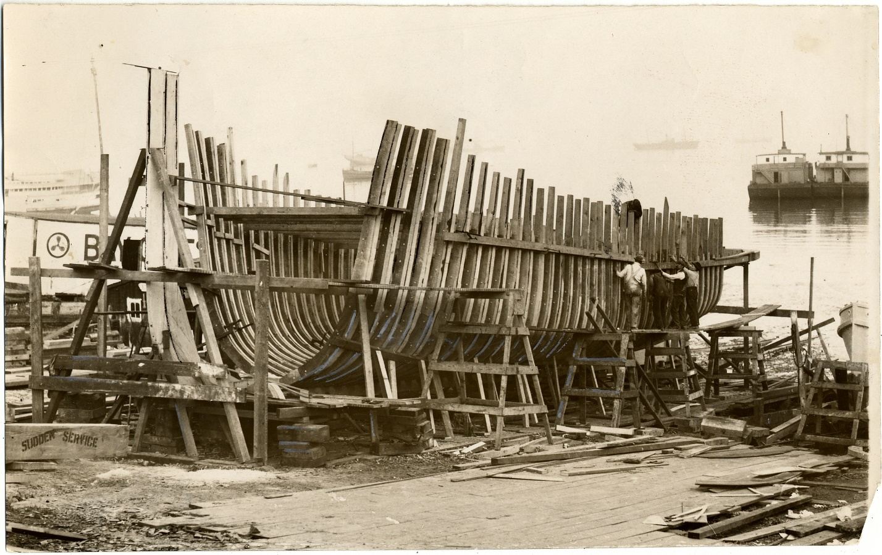

References
Library of Congress. https://www.loc.gov/resource/hhh.ca2272.photos/?sp=1&st=gallery.
San Francisco Public Library. http://sflib1.sfpl.org:82/search/?searchtype=X&searcharg=%22Hunters%22+Point+Naval+Shipyard&sortdropdown=-&SORT=D&extended=0&SUBMIT=Search&searchlimits=&searchorigarg=X%22Hunters%22+Point+Naval+Shipyard%26SORT%3DD.

