The University of Chicago

Why cannot investors hold Leveraged Exchanged Traded Funds as a long-term investment instrument given the mathematical structure of LETFs?
By
Xiaoqiao Li

A paper submitted in partial fulfillment of the requirement for the Master of Arts degree in the Master of Arts Program in Social Science

Faculty Advisor: Thomas Coleman
Preceptor: Marshall Ryan Jean

Abstract
Investments in Leveraged Exchange-Traded Funds have increased recently. Leverage is a key feature of these funds, and they're utilized mostly by short-term traders. They are also popular with individual investors who want to make leveraged or hedging investments in their portfolios. Critics, however, have charged that LETFs are unsuitable for longer-term investors, due to volatility decay. Volatility decay occurs when the returns of Leveraged Exchange Traded Funds diverge from the multiple returns of their underlying assets as the holding period lengthens. Volatility decay is demonstrated to be accelerated by increasing the leverage multiplier algebraically. In this paper, I will describe the mathematical structures of Leveraged Exchange-Traded Funds and Exchange-Traded Funds in terms of their performance in terms of arithmetic return, geometric return, rebalancing activity, and diffusion process. Using their mathematical structures, it is straightforward to demonstrate the long-term impact of volatility decay on these funds. In addition, I will use historical data to validate the influence of volatility decay, and I will examine the performance of LETFs on the assumption that the portfolio is not subject to volatility decay.

Keywords:
Leveraged Exchanged Traded Funds, arithmetic return, geometric return, re-balancing activity, volatility decay

1. Introduction
Ever since Exchanged Traded Funds (ETFs)’ introduction, the ETFs have attracted a lot of investment from market participants. According to Wagner & Farley(2012)[1], one year after SPY’s official inception, SPY traded an average of only 250,000 shares on a daily basis. Five years after its inception, at the beginning of 1998, the average daily volume of SPY had climbed by more than 12 times to more than 3 million shares. Although such a substantial gain in initial volume may seem amazing, it was simply the beginning of SPY's popularity. From 1994 to 2000, total assets in ETFs doubled every year. Since 2000, the growth has obviously slowed a bit, but combined assets are still increasing at nearly 50 percent per year.
An exchange-traded fund is a basket of stocks that trades on an exchange with the same simplicity and liquidity as an individual stock, it is a type of pooled investment security that operates much like a mutual fund. Typically, ETFs will track a particular index, sector, commodity, or another asset, but unlike mutual funds, ETFs can be purchased or sold on a stock exchange the same way that a regular stock can. An ETF can be structured to track anything from the price of an individual commodity to a large and diverse collection of securities. ETFs can even be structured to track specific investment strategies.
A leveraged exchange-traded fund is a marketable security that uses financial derivatives and debt to amplify the returns of an underlying index. A traditional LETF typically tracks the securities in its underlying index on a one-to-one basis which may aim for a 3:1 or 2:1 ratio. The extent of the gain is contingent on the amount of leveraged used in ETFs. Leveraging is an investing strategy that uses the borrowed funds to buy options and futures to increase the impact of price movement. There are two types of leveraged ETFs, bull and bear. Bullish ETFs that have a leveraged return of 2 or 3 times the underlying index's daily return. Consider the Ultra Financial ETF (UYG) from ProShares, which replicates three times as much of Dow Jones U.S. Financials as Direxion Daily Financial Bull 3X shares (FAS) from Direxion. While a leveraged bull ETF may seek to reach the return that is -2/-3 times of the daily index return, which means it will gain twice or three times the market's losses. For example,ProShares UltraShort Financial ETF (SKF) tracks the Dow Jones Financials Index at -2 times, whereas Direxion Daily Financial Bear 3X Shares (FAZ) tracks the index at -3 times.(Zhang & Avellaneda, 2010)[26].But, we will mainly focus on Bull Leveraged ETF SPXL and ETF SPY in this research while SPXL is Direxion Daily S&P 500 Bull 3X Shares and SPY is S&P 500 ETF. Thus,if SPY moves from 1000 to 1010 (a 1% rise), then a 3:1 leveraged ETF SPXL would move from 1000 to 1030 (3% rise).
There is a strong initial appeal to leveraged ETFs. In a single transaction, they allow you to boost your profits and see a bigger return on your investment. Optional futures, margins, and other forms of leverage are no longer necessary for the average investor to profit from the advantages of leveraging their investments.(Loehr&Lamb, 2013)[27]But there are issues in holding leveraged exchange-traded funds as a long-term investment instrument, due to volatility decay, even if we are with a “perfect” leveraged exchange-traded fund that incurs no transaction costs. Accounting for time volatility, a leveraged ETF’s 3 times multiplier becomes detrimental for those with money in the pool. Because of the leveraged losses, the index will have to outperform even more just for investors to gain back their losses. Thus any loss is so devastating when amplified, that the leveraged ETF can only reliably beat the index if volatility was minimal, and even when it beats the index, it is unlikely to return 3x of the index itself(Gus Zhang)[4].
A simple example can be taken into consideration if we assume that we invested the same $100 in SPXL (3x) and SPY (1x) at the same time and assume the market return is -10% one day, SPXL returned an associated -30%, then we would have $70 in SPXL and $90 in SPY after this day. In order to return SPY to its initial value of $100, the market must offer a daily return of 11.11 % on the next day while the associated return on SPXL would be 33.33 % in this case. Thus, we now have 100 dollars in SPY, but only 93.33 dollars in SPXL after obtaining an 33.33 %return. This shows that LETFs have lost 6.669 dollars in value because of the volatility decay.
In general, volatility decay is an inherent feature of the construction of standard leveraged ETFs. They are constructed so that the daily arithmetic or simple-compounded return on the leveraged fund is equal to the arithmetic return on the non-leveraged funds times the leverage ratio. Note, however, that the cumulated return of any instrument is the compounded return and not the sum of the arithmetic returns. Say that the market falls by x on day 1, then rises by x on day 2. The cumulated arithmetic return is zero, but the cumulated compounded return is (1-x)(1+x) = 1 – x². This x² term is not itself “volatility decay” but simply the difference between computing and cumulating arithmetic and compounded return. The issue of volatility decay arises, however, if the arithmetic return is leveraged, say by a factor n. The day 1 and 2 leveraged arithmetic returns will be –nx and +nx, again summing to zero. The compounded return, however, with be (1-nx)(1+nx) = 1 – n²x² = 1 – nx² – n(n-1)x². This last term, n(n-1)x², will be greater than zero for n>1, and is the “volatility decay”.
Alternatively, we could ask what additional arithmetic return ε would a leveraged portfolio require to produce a cumulative levered return. In other words, solve for ε such that (1+nx+ε)(1-nx+ε) = 1 – nx². In other words, solve for
1 + 2ε – n²x² + ε² = 1 – nx²
or
2 ε – n(n-1)x² + ε² = 0
This will have the solution
$ε=\frac{-2±\sqrt{4+4n(n-1)x^{2}}}{2}=±\sqrt{1+n(n-1)x^{2}}-1$ .
For n=3 and x=0.10, the positive solution is ε = .0296 or 3.96%.
To measure the size of the volatility effect in practical application, we can note that leveraged ETFs are generally re-balanced daily and note that the relation between the daily arithmetic (simply-compounded) and continuously-compounded returns is, approximately: $r_{A}≈r_{c}+\frac{1}{2}σ^{2}$ or $r_{c}≈r_{A}-\frac{1}{2}σ^{2}$. For an n-times leveraged fund, it will be $nr_{c}≈nr_{a}-\frac{1}{2}n^{2}σ^{2}=n\left(r_{a}-\frac{1}{2}σ^{2}\right)-\frac{1}{2}n(n-1)σ^{2}$. The term $-\frac{1}{2}n(n-1)σ^{2}$, where $σ$ is the volatility of daily returns, is the daily volatility decay due to the leveraging of arithmetic returns. For an asset with 20% annualized volatility, the daily volatility will be about 1.25% ($0.20/\sqrt{255}$). For a 3-times leveraged fund the daily volatility decay will be roughly –0.04688% (3*2*.0125²/2). Annualized volatility decay will be (roughly) –12%.
In this research, we will doing the following steps to demonstrate volatility decay using the mathematical structure of Leveraged Exchanged Traded Funds. This paper will firstly shows how geometric mean and arithmetic mean can be converted using formulas and how we can observe volatility decay using these formulas. Secondly, we will describes how rebalancing activity works in the portfolios. we'll simulate five different portfolios: $100 invested in SPY, $100 invested in SPXL,$300 in SPY, $100 of own money and $200 borrowed money in SPXL, and $100 of own money and $200 borrowed money in SPY, respectively. Then, based on the previous day's return, we'll build a framework in which investors buy or sell portions of the portfolio with borrowed money and owned money in a timely manner at the start of each day, ensuring that the leverage perfectly replicates 3x the index every day while maintaining an original or desired level of asset allocation and we are still experiencing volatility decay in leveraged ETFs in the long run despite doing rebalancing activity. Thirdly, the Black-Scholes model can also be used to demonstrate volatility decay. To test the quantitative effect of Leveraged ETFs, we will construct a trading strategy that aims to investigate the long-term investing consequence of Leveraged Exchanged Traded Funds. we are going to construct a model with the historical data of SPXL and SPY, and see what would the Leveraged Exchanged Traded Funds do if there is no volatility decay. After that, we will construct a portfolio that consists of fixed investments into LETFs which invest in one hundred dollars per month into my portfolio over the course of ten years to see what happens to my portfolio and to determine whether or not a fixed investment strategy is capable of overcoming the "force" of time decay.

2. Literature Review
Cheng&Madhaven(2009) examines several factors that explain the attraction of leveraged Exchanged Traded Funds(LETFs). First, these funds offer short-term traders and hedge funds a structured product to express their directional views regarding a wide variety of equity indexes and sectors. Second, as investors can obtain levered exposure within the product, they need not rely on increasingly scarce outside capital or the use of derivatives, swaps, options, futures, or trading on margin. Third, individual investors – attracted by the convenience and limited liability nature of these products – increasingly use them to place longer-term leveraged bets or to hedge their portfolios.
However, in general, leveraged ETFs are extremely sensitive to market volatility, and during periods of severe equities market volatility, the likelihood of leveraged ETFs failing to meet their objectives increases. Therefore, the greater market volatility, the less likely investors are to earn the desired return. The second type of risk pertains to the volatility of leveraged ETFs' market values. Given that leveraged ETF shares are traded on the secondary market, their market price will fluctuate in reaction to changes in their NAV, but will also be affected by supply and demand pressures. The final source of major risk is the so-called "counterparty risk," which arises from the use of derivatives such as swap agreements in order to achieve the desired index exposure.(Rompotis, G,2013)[24]
Furthermore, Charupat&Miu(2013) proposed a traditional speaking that Leveraged ETFs appeal primarily to short-term traders. These ETFs are, by design, not intended for long-term investors with a buy-and-hold strategy. Their goal is to provide the specified leveraged return on a daily basis. s. In addition, the embedded leverage makes these ETFs risky and speculative in nature. Consequently, they are used by short-term traders who want to express their directional views on the underlying benchmarks or to implement certain trading strategies (such as a long-short trade).(Charupat&Miu,2013)[16]
On the ability of leveraged ETFs to achieve their daily investing targets, Trainor & Baryla report that, on average, leveraged ETFs do meet their daily targets. However, by examining longer periods, they find that the long-run returns of leveraged ETFs are not comparable to two or three times the return of benchmarks due to the constant leverage trap and the lognormal nature of continuously compounded returns. The authors also point out that the effect of compounded returns becomes more intense as the holding period increases. Despite the inability of leveraged ETFs to achieve their stated multiples over longer periods, in the long run, they expose investors to volatility which equals the standard deviation of the index multiplied by the leverage ratio. (Trainor & Baryla,2008)[19]
Murphy and Wright (2010) investigate the performance of twelve commodity-based leveraged ETFs. They find that these ETFs do manage to deliver their stated multiple in the short-run. However, in the long-run, these ETFs basically fail to perform as they are expected even though they reveal evidence that some of their sample’s funds performed better than their stated multiples in the long-run. The authors conclude by recommending against using leveraged ETFs in any sort of buy-and-hold strategies.(Murphy&Wright,2010)[21]
Although Leveraged funds are not designed for a long-term buy-and-hold investment, there are also numerous studies contend that it is still beneficial for investors if they extend the time of holding Leveraged Exchanged Traded Funds. To date, however, the LETF return deviation remains largely unexplained, and there is no unified and executable framework for understanding the sources and underlying drivers of the numerous LETF return deviation components. (Tang&Xu,2013)[23]. The primary unanswered concern with these investments is how long an investor can anticipate to retain these assets without experiencing significant leverage deterioration relative to the expected return, given the daily leverage ratio. (William & Carroll,2013)[20]
Lu et al. (2012)[22] demonstrate that over holding periods not exceeding one-month investors can safely assume that the leveraged (inverse) ETFs would provide twice the return (twice the negative return) of the tracking indices. For longer periods, the performance of leveraged ETFs can differ from the return of indices multiplied by the leverage ratio. According to the authors, in the case of inverse ETFs, the deviation occurs over quarterly periods while for leveraged ETFs the deviation occurs for holding periods up to one year.
And also, Loviscek et al demonstrate that the deviation of the Leveraged Exchange Traded Product return from the leveraged product multiple times the underlying index return does not, on average, have a detrimental effect on investor returns over holding periods of one year or more. Results from robustness tests conducted on the S&P 500, S&P SmallCap 600, and NASDAQ Composite indices since their respective inceptions provide additional support for the findings. Their findings also indicate that the distribution of daily returns based on actual historical data is significantly more leptokurtic than the normal distribution. Positive excess kurtosis and a nonzero mean are advantageous to the compounding effect of daily-rebalanced Leveraged Exchanged Traded Products over extended holding periods.(Loviscek,Tang,Xu,2014)[25]
Extended holding periods can be justified depending on volatility levels and an investor's willingness to accept a certain level of decay. Based on market return and volatility averages, Trainer & Carroll are claiming that there is an inherently expected decay in leveraged ETF returns over time. Their study claims that when volatility levels are relatively low as they were in the 90's and mid 2000's, holding periods beyond a year for 2x and -1x funds can be justified. For 3x, -2x, and -3x funds, holding periods out to 6 months can be justified. When volatility levels are more "normal," holding periods of 1 to 3 months for -2x, 2x and 3x funds are justified while high volatility levels suggest holding periods of 1 month or less. (Trainer&Carroll,2013)[20]
Moreover, on the long-term performance of leveraged ETFs, Hill & Foster (2009)[18] show that the Leveraged funds have been and can be used successfully for periods longer than one day. Their study analyzed returns of hypothetical funds with a daily target of 2x and -2x S&P 500 returns over a 50-year time frame from 1959 to 2008. the S&P 500 Index has been included in their sample of every possible two-day, weekly, monthly, quarterly, and semiannual holding period. Their results shows that the impact of compounding on these funds over multiday periods for most broad indexes was virtually neutral. There is a high probability of approximating the one-day target for periods longer than a day; the shorter the period and the lower the index volatility, the higher the resulting probability of meeting the one-day target.

3. Mathematical structure of ETFs and LETFs

3.1.1 A review of arithmetic return and geometric return
The analysis of portfolio returns of ETFs and LETFs using geometric return gives a clearer result than the arithmetic return while the average return brings up some confusing issues. The relative merits of geometric and arithmetic averages of prices and quantities are frequently discussed in index number literature. A comprehensive account of this debate may be found in Crowe's book, which dates back to the mid-19th century [12](Marvin Rothstein, 1972). Suppose we have a universe of N marketable securities to consider. Let Pi(t) denote the market price of security i at time t, i=l, 2, ..., N. Assume that prices are known at the discrete times t=0, 1, 2. Define the price relative of security i at the time t as:
$$a_{i}\left(t\right)={p_{i }\left(t\right)}/{pi(t-1)}$$
Let arithmetic return as:
$r_{A}=\frac{1}{N}\sum_{k=1}^{N}{r_{i}^{(k)}}$ (1)
Where $r_{i}$ is the daily return.
Suppose the $A_{0}$ is the starting portfolio value and $A_{n}$ is the portfolio value at day n, then we will have:
$A_{n}=A_{0}\left(1+r_{1}\right)\left(1+r_{2}\right)…\left(1+r_{n}\right)$ (2)
And this gives us:
$\frac{A_{n}}{A_{0}}=\left(1+r_{1}\right)\left(1+r_{2}\right)…(1+r_{n})$ (3)
The geometric return $r_{G}$ ,sometimes referred as a compounded return, is defined as the average rate of return of a set of portfolios that connected the starting and ending portfolio values. Thus, we are going to have:
$A_{0}{(1+r_{G})}^{n}=A_{n}$ (4)
And this gives us:
$\frac{A_{n}}{A_{0}}={(1+r_{G})}^{n}$ (5)
Combing formula (3) and formula (5), we are going to have:
$\left(1+r_{1}\right)\left(1+r_{2}\right)…\left(1+r_{n}\right)={(1+r_{G})}^{n}$ (6)
Thus, we can let geometric return as:
$r_{G}={[\prod_{k=1}^{N}{(1+r^{(k)}}]}^{1/N}-1$ (7)
And, the formula for continuously-compounded rates is:
rcc=ln⁡(1+rG)
Consider the following example to illustrate why we claim that geometric return provides a more realistic explanation for the profit of our portfolio over time. If we simply assume that the annual return of ETFs for two consecutive years is 3% and -3%, respectively using arithmetic return(formula(1)) we are going to see an unchanged portfolio return but we are actually losing 0.09% in our portfolio.
Moreover, suppose we are having 100 dollars in our portfolio at day 0, the example below shows the difference between the geometric return and arithmetic in the portfolio:

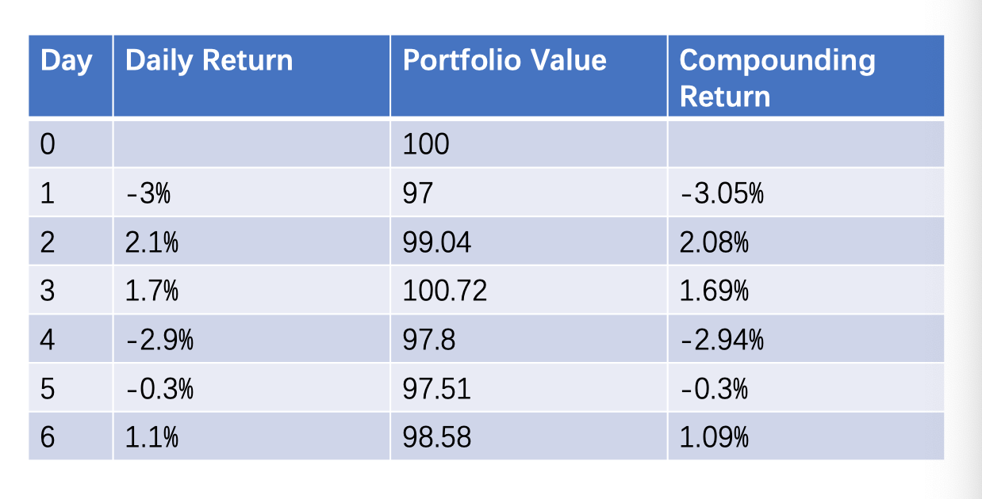
From the above example, using the formula (1), we get the arithmetic return should be -0.217%, but 100*(1-0.217%)=99.783. While using the formula (7), we can get a geometric return which is -1.29%, 100*(1-1.29%)=98.7 which is more consistent with the real portfolio value.
Thus, it is reasonable to claim that arithmetic return gives an illustration of daily leveraging and rebalancing while geometric return gives a more accurate illustration for the profit of the portfolio over a long time period. But we can use the following ways to convert $r_{A}$ to $r_{G}$:
The definition of sample variance $δ$ gives us:
$δ^{2}=\frac{1}{n}\sum_{k=1}^{n}{{(r_{k}-r_{A})}^{2}}$ (8)
According to Tylor’s expansion:
$\sum_{n=0}^{∞}{\frac{f^{\left(n\right)}(a)}{n!}{(x-a)}^{n}}$ (9)
We are going to get:
${(1+x)}^{1/n}≈1+\frac{1}{n}x+\frac{1-n}{2n^{2}}x^{2}+o(x)$ (10)
We can substitute formula (10) into (7):
$$r_{G}≈\prod_{k=1}^{N}{\left(1+\frac{1}{n}r_{k}+\frac{1-n}{2n^{2}}r_{k}^{2}\right)}-1$$
$$≈\frac{1}{n}\sum_{k=1}^{n}{r_{k}+}\frac{1}{n^{2}}\sum_{k≠l}^{n}{r_{k}r_{l}}+\frac{1-n}{2n^{2}}\sum_{k=1}^{n}{r_{k}^{2}}$$
≈rA-12δ2 (11)
Thus, one way for us the convert arithmetic return to geometric return could be :
$$r_{G}≈r_{A}-\frac{1}{2} δ^{2}$$
If the distribution of the continuous compounding is log normal. Then formula(11) is going to be exact
And also, we can simulate the relationship by the following way. The algorithm here involves first determining the mean and standard deviation of the monthly rate for continuously compounded rates, then determining the mean and standard deviation of the monthly rate for simple rates, and finally determining the implied monthly Arithmetic Mean(AM) from cc:
$$AM=e^{\left(mean of cc+\frac{{\left(s.d of cc\right)}^{2}}{2}\right)}-1$$
Where cc represents continuous compounding
And then convert from monthly to annual by multiplying by 12 and sqrt(12).
Moreover, we will converts from cc to Geometric Mean (GM) by:
$$GM=e^{mean of cc}-1$$
Finally, we can imply annualized arithmetic AM from the geometric mean GM:
$$AM=e^{\left(12*mean of cc+12*{\left(s.d of cc\right)}^{2}/2\right)}-1$$

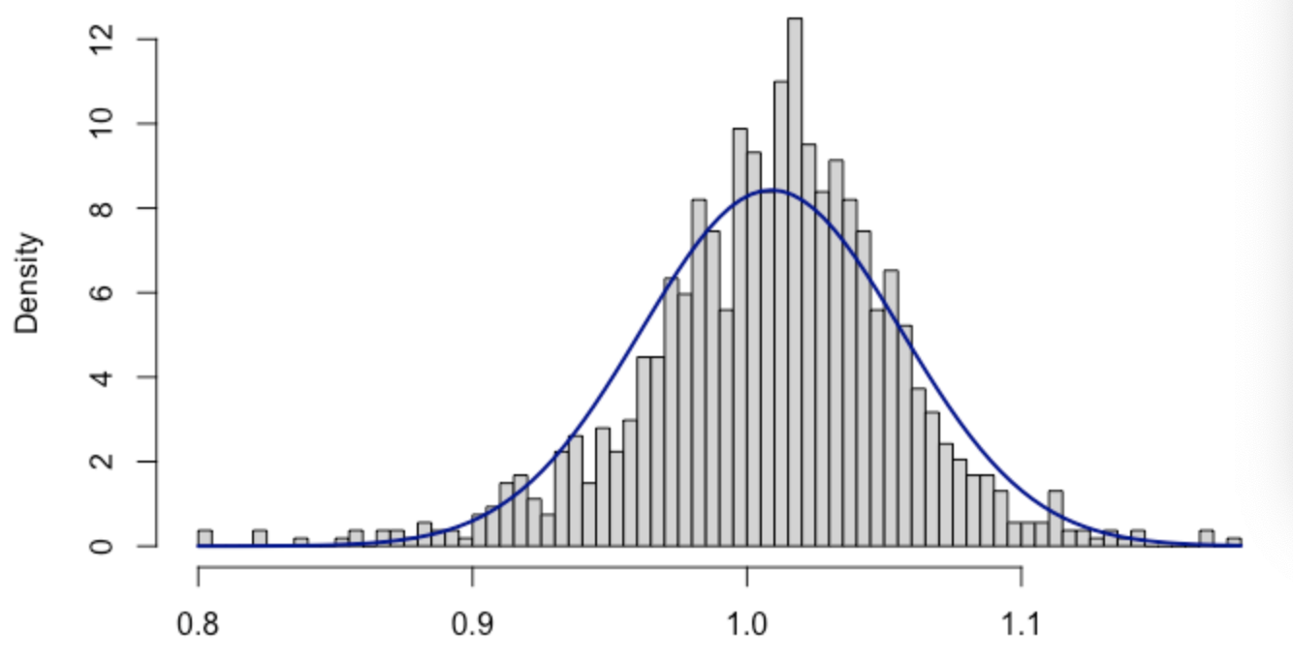
Fig1
Thus, if we use the historical data of S&P investment return from 1926 to 2016 to do simulation, the Fig 1 shows the result of the simulation and gives that the converting formula of Athematic Mean to Geometric Mean works for the historical data.
Then, we can conclude that:$$1+r_{G}=(1+r_{A})e^{-\frac{1}{2}σ^{2}}$$
And then get${ r}_{G}=r_{A}-\frac{σ^{2}}{2(1+r_{A})}$
Besides this, according to Mindlin(2011)[13], there are another 3 formulas to convert geometric return from the arithmetic return, which are:
${(1+r_{G})}^{2}≈{\left(1+r_{A}\right)}^{2}-δ^{2}$ (12)
$\ln\left(1+r_{G}\right)≈-\frac{1}{2}δ^{2}{\left(1+r_{A}\right)}^{-2}\ln\left(1+r_{A}\right)$ (13)
$1+r_{G}≈(1+r_{A})/\sqrt{(1+δ^{2}/{\left(1+r_{A}\right)}^{2})}$ (14)

3.1.2 Arithmetic Return vs. Geometric Return in ETFs and LETFs
According to the characteristics of geometric return and arithmetic return in Section 3.1.1, the arithmetic return illustrates daily leveraging and rebalancing, whereas the geometric return provides a more accurate depiction of the portfolio's long-term profit. If investors are going to leverage the ETF with X multiples one day, we are going to have a daily return $Xr_{A}$, but we will examine the long-term profit by the geometric return.
Now, we look at the return of ETFs with X multiple leverages using the geometric return, we can investigate the following relationship from formula(11) after we leverage ETFs :
$$r_{G}={Xr}_{A}-\frac{1}{2} {(Xδ)}^{2}$$
=$Xr_{A}-\frac{X^{2}}{2} δ^{2}$
$=Xr_{A}-\frac{X}{2}δ^{2}-\frac{\left(X^{2}-X\right)}{2}δ^{2}$
Thus, using the formula provided above, it is simple to see that we are losing $\frac{(X^{2}-X)}{2}δ^{2}$ money in our portfolio for Leveraged ETFs due to the volatility decay. For example, if we compare SPXL(3X) and SPY(1X) using the above approach, the geometric return for SPXL should be:
$$r_{G 3X}=3r_{A}-\frac{1}{2}{\left(3σ\right)}^{2}$$
$=3r_{A}-\frac{9}{2}σ^{2}$
From the above calculation, it is evident that even though we are having a perfect 3 times leverage ETF but we cannot have exactly 3 times geometric return for LETFs, a bigger volatility was manifested. And if the arithmetic return is zero, we are losing money in our portfolio because this gives a $-\frac{9}{2}δ^{2}$ geometric return.
Similarly, from formula (12), after leveraging the ETFs, we are going to have:
${(1+r_{G})}^{2}≈{\left(1+Xr_{A}\right)}^{2}-{(Xδ)}^{2}$ (15)
Based on the formula given above, an extra X2δ2-δ2 has been subtracted and makes the geometric return smaller than expected.(Note: what we expect here is :${(1+r_{G})}^{2}≈{\left(1+Xr_{A}\right)}^{2}-δ^{2}$)
From formula (13), we are going to have:
$$\ln\left(1+r_{G}\right)≈-\frac{1}{2}{(Xδ)}^{2}{\left(1+{Xr}_{A}\right)}^{-2}ln⁡(1+Xr_{A})$$
Then, we are going to have a formula for the geometric return of Leveraged ETFs:
rG≈1+XrA-x2δ22(1+XrA)2-1 (16)
It is reasonable to claim that:
δ2(1+rA)2<x2δ2(1+XrA)2
Since formula(16) is preceded by a “minus” sign, the powered leveraged ration X makes the geometric return smaller, the formula (16) also demonstrates how volatility becomes bigger in thegeometric return.
From formula (14), we are going to have:
$1+r_{G}≈(1+{Xr}_{A}){(1+{X^{2}δ}^{2}{(1+Xr_{A})}^{-2})}^{-\frac{1}{2}}$ (17)
And also, since X is the leveraged ratio, $X^{2}>X$, here we get a smaller geometric return than expected as well.
In conclusion, these four formulas for geometric return that we are able to depict are all lower than anticipated after leveraging since the volatility is growing larger than anticipated, which demonstrates how volatility decays manifest in this manner.
As stated in the previous section, if the market fall by x percent one day and then increase by the same x percent in the following day, the net return after two days will be (1+x) (1-x), which is equal to 1-x² and it will always be less than 1 since x is greater than zero. If we evaluate the portfolio return using Arithmetic Return(formula 1),then $r_{A}$ would be $\frac{-x+x}{2}=0$ regardless the value of x,then there will be neither a profit nor a loss. However, if we analyze the portfolio return using Geometric Return, the result will be different: If x is equal to 5%, then we earned -0.25% rather than 0.
Continuing the preceding illustration: if we simulate a portfolio (1+x+$ε$)(1-x+$ε$) and intend to acquire a value of $ε$ that will allow our portfolio return to its initial value "1", meaning that we are seeking a $ε$ that satisfies $\left(1+x+ε\right)\left(1-x+ε\right)=1$.This gives
$ε_{1x}=-1+\sqrt{1+x^{2}}$ . As for 2X Leveraged ETFs, $ε_{2x}$ need to satisfy $\left(1+2x+ε_{2x}\right)\left(1-2x+ε_{2x}\right)=1$and $ε_{3x}$ need to satisfy $\left(1+3x+ε_{3x}\right)\left(1-3x+ε_{3x}\right)=1$, while it gives a bigger $ε_{2x}=-\frac{1}{2}+\frac{\sqrt{1+4x^{2}}}{2}$ ,$ε_{3x}=-\frac{1}{3}+\sqrt{\frac{1}{9}+x^{2}}$ for 2x and 3x Leveraged Exchanged Traded Fund to bring back to the initial portfolio value “1”.
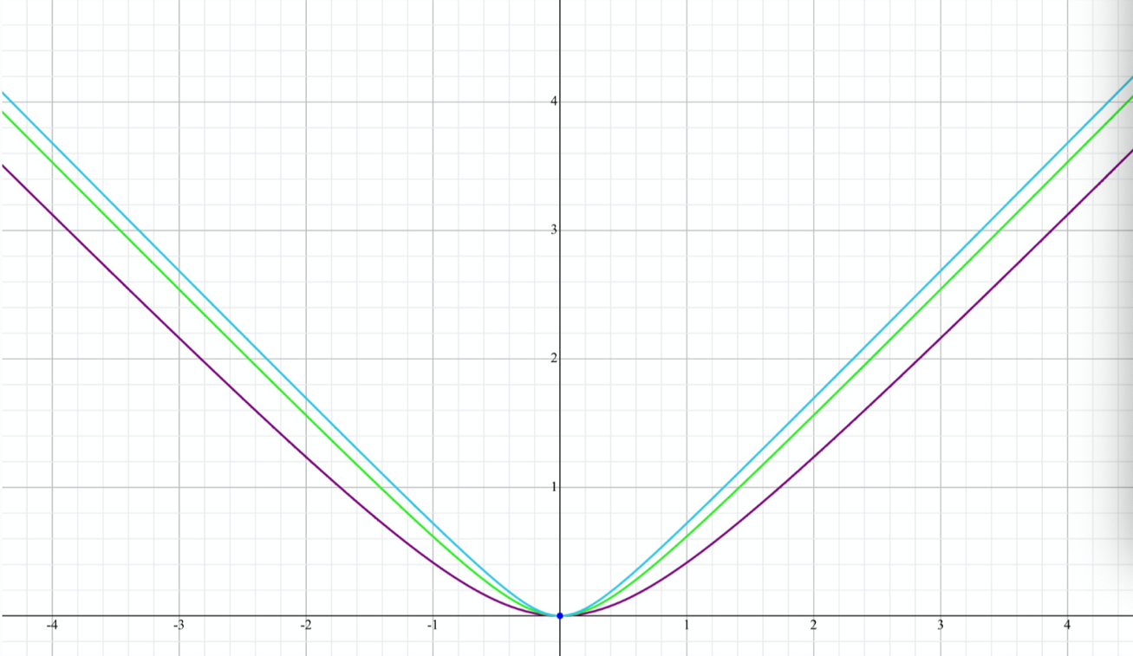

Fig2
Fig2 gives the blue line to represent $ε_{3x}$ and the green line to represent $ε_{2x}$and the purple line to show the $ε_{1x}$ .
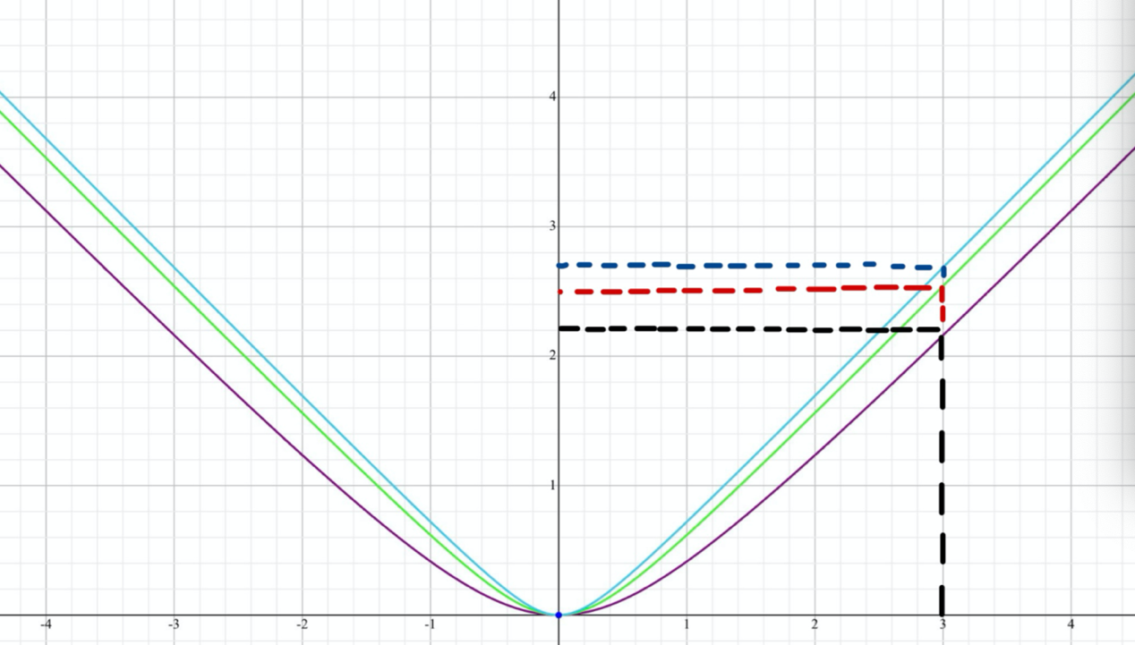
Fig 2.1
Thus, it is evident from Fig 2.1 that when x is the same, it takes a bigger $ε$ for 3x Leveraged Exchanged Traded Fund to recover the two days loss to its original portfolio value.

3.2 Simple Comparison between ETFs and LETFs
Exchange Traded Funds (ETFs) give investors with exposure to illiquid commodities, bonds, and indices. Leveraged ETFs offer a multiple of the daily return of the underlying ETFs, making them more appealing to investors seeking to multiply their returns. The daily rebalancing of exchange-traded funds (ETFs) provides a multiple of the daily return of the index being tracked, but not a multiple of the cumulative return if held for more than one day, a phenomenon known as volatility decay. （Ahmed Abdou,2017）[14]Suppose we are in an ideal market with an initial portfolio value 1 and the market fluctuates by +x on the first day and -x on the second, giving us +2x, -2x for 2x LETFs, and +3x, -3x for 3x LETFs. Consequently, the portfolio yields (1+x) (1-x), (1+2x)(1-2x), and (1+3x)(1-3x) correspondingly. Suppose we optimally put market fluctuations every two days as a combination; as time approaches infinity, we will have n such combinations, and our portfolios can be expressed independently by the formula as: ${\left(1+x\right)}^{n}{\left(1-x\right)}^{n},{\left(1+2x\right)}^{n}{(1-2x)}^{n},{(1+3x)}^{n}{(1-3x)}^{n}.$
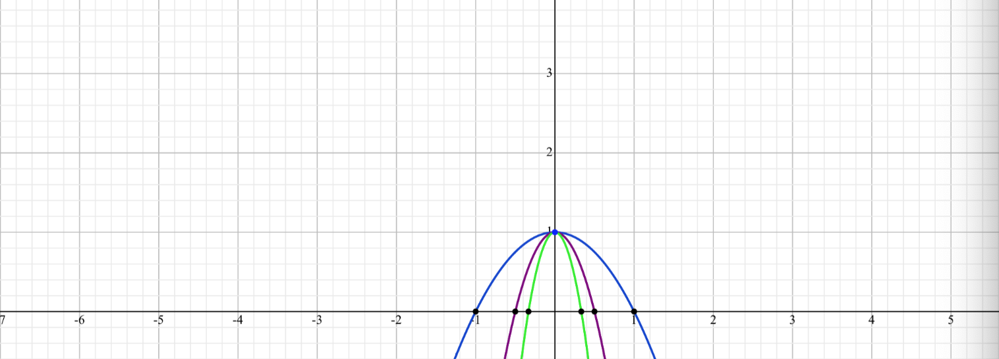
Fig3
An ETF is shown at the outermost parabola, a 2X LETF in the middle, and a 3X leveraged ETF in the innermost parabola. as can be seen from Fig3. So, it follows from the graph that in this particular case of our hypothesis, when the market has an identical “X” fluctuation, the highest value of our portfolio return y is for 1X ETFs, followed closely by 2X, and the lowest is for 3X LETFs. Obviously, this scenario does not occur in actual market fluctuations, we are merely using it to illustrate that the return on a portfolio with 3X leverage is the lowest among the three ETFs as time approaches infinity.

3.3 Diffusion process in ETFs and LETFs

In this section, we will firstly examine the historical leverage ratios.The following graphs are the 2-month return of SPY against UPRO and SPXU, in a logarithmic scale from September 29,2010 to September 30, 2012. ( Leung & Santoli,2016)[1]

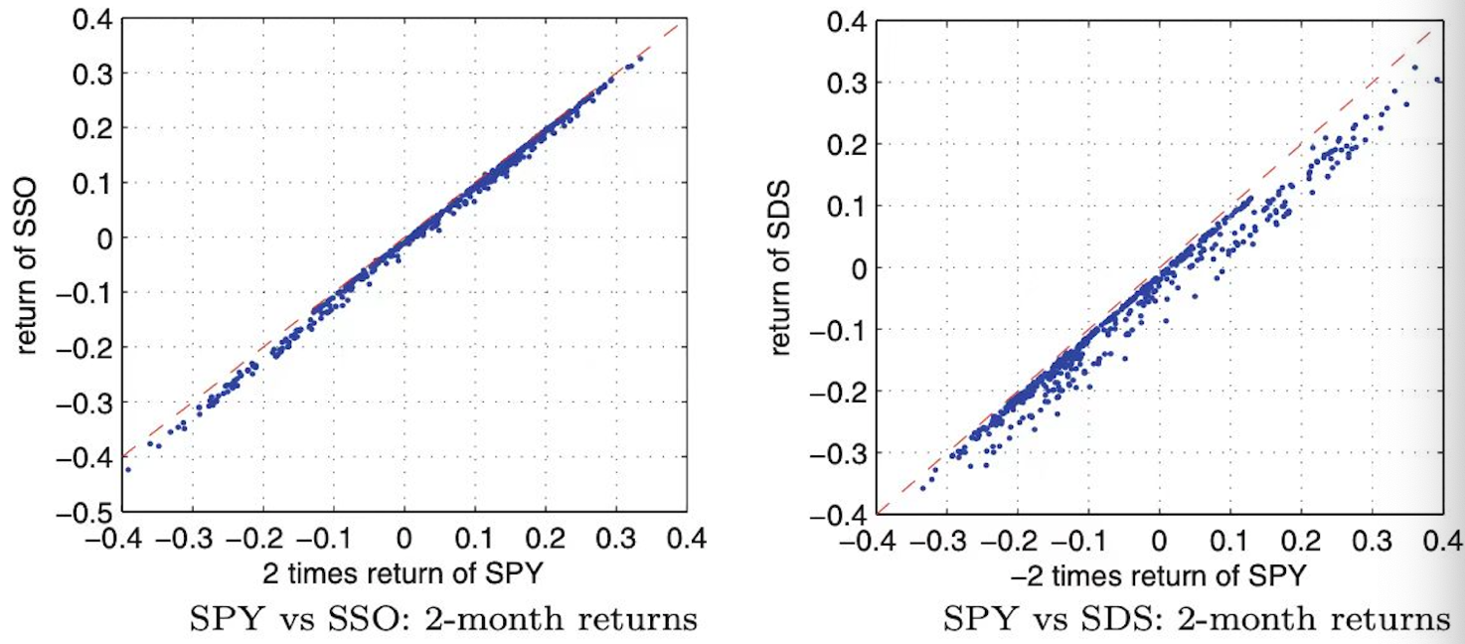
The left fig is the 2-month return of SPY against SSO and SDS, in a logarithmic scale from September 29, 2010, to September 30, 2012. ( Leung & Santoli,2016)[1]
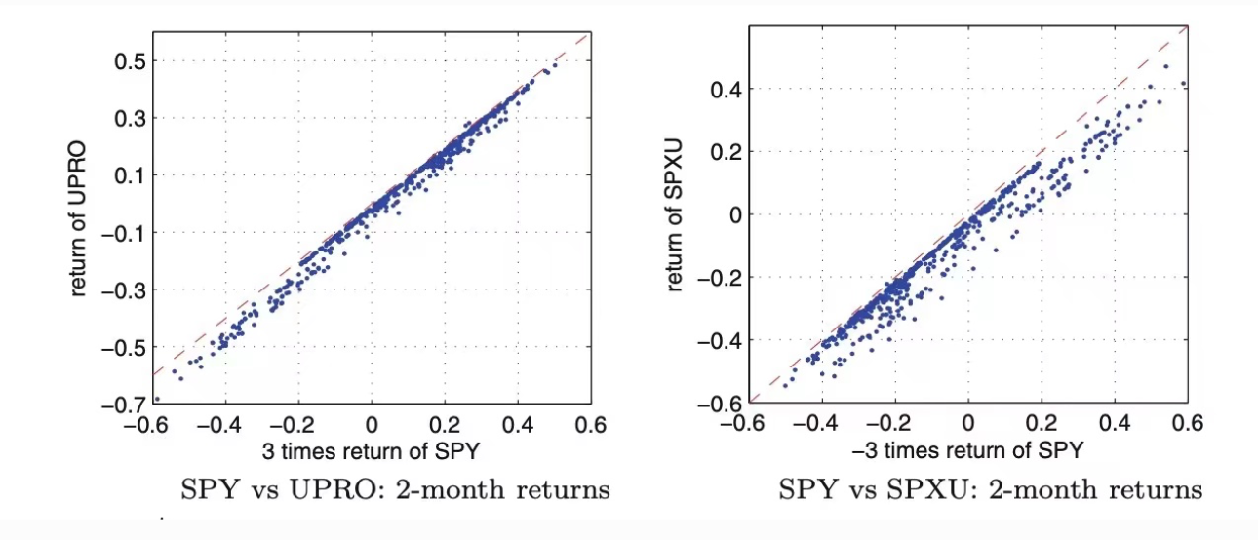
From the above graphs, we can investigate that the k ratio leveraged ETFs are not exactly k times price of ETFs.
Then, suppose ETFs follow the diffusion process, and the following relationship holds:
dSt=uStdt+σStdWt
dStSt=udt+σdWt
Where u and σ follow F-distribution and Wt follows the Brown Motion,St follows the Markov Process. The stochastic drift (μt)t≥0 represents the ex-dividend annualized growth rate process, and (σt)t≥0 is the stochastic volatility process. At this point, we do not specify a parametric stochastic volatility model, though many well-known models, such as the Heston model as well as other stochastic or local volatility models, also fit within the above framework. ( Leung & Santoli,2016)[1]
Now, we define a leveraged ratio x, the price of LETFs in time t is $L_{t}$ , and the underlying index price is $S_{t}$, the number of ETFs hold in time t is $M_{t}$ and $N_{t}$ denotes the quantity of cash held in unit t. And we are assuming that:
$$B_{t}=exp⁡\{\int_{0}^{t}{r_{s}ds\}}$$
Here, the $r_{1}$ follows F-distribution, thus we are going to have $\int_{0}^{t}{r_{s}ds<0}$ for all t.
Thus, in the time [t, t+dt] they have the following relationship:
$$dL_{t}=M_{t}dS_{t}-N_{t}dB_{t}$$
$$=M_{t }S_{t}\frac{dS_{t}}{S_{t}}-N_{t }B_{t} \frac{dB_{t}}{B_{t}}$$
=xLtdStSt-(x-1)LVtdBtBt
=Lt(xdStSt-x-1rtdt)

Thus, we have: $\frac{dL_{t}}{L_{t}}=x\frac{dS_{t}}{S_{t}}-\left(x-1\right)rdt$
Where r is the interest rate.
We can conclude that the return of x times Leveraged Exchanged Traded Funds is equal to x times the return of the corresponding ETF minus a fraction related to the interest rate.
In addition, the initial price of LETFs $L_{t }$is known, and the d$S_{t}$ satisfies $$dS_{t}=uS_{t}dt+\sqrt{v_{t}}S_{t}dW_{t}$$
We can conclude that:
dLtLtordlnLt=xdlnSt-x2-x2vtdt+1-xrdt
If we do integral of both side, then we can get:
$$\frac{L_{t}}{L_{0}}={\left(\frac{S_{t}}{S_{0}}\right)}^{m} exp⁡\{-(\frac{x^{2}-x}{2})\int_{0}^{T}{v_{u}du+\left(1-x\right)rT\}}$$

3.4.1 A review of simple re-balancing activity
Rebalancing is the process of realigning the asset portfolio's weightings and rebalancing is the periodic purchase or sale of assets in a portfolio to retain the original or planned asset allocation or degree of risk. (James Chen,2020)[15]. Rebalancing a portfolio protects the investor from taking on excessive risk in any one area. Second, rebalancing keeps the portfolio's exposures within the comfort zone of the manager. Typically, these actions are taken to reduce the level of risk to an acceptable level for the investor. As stock performance can fluctuate more than bond yields, the proportion of assets invested in stocks will vary in reaction to market conditions. By modifying the performance variable and the portfolio's overall risk, investors can tailor their portfolios to their shifting financial needs. (James Chen,2020) [15]. When an investor's objective is to get close to the daily leverage target over time, rebalancing is a useful tool. A simple method for rebalancing portfolio holdings is to compare index returns to fund returns and set a threshold percentage of variance. (Hill&Foster,2009) [18] For positions in leveraged and inverse funds, rebalancing is simple: Keep an eye on how far the fund's return deviates from the index's and rebalance when the difference reaches a predetermined threshold or at regular intervals based on the calendar. If the investor's index return is lower than their fund return, they will reduce their fund exposure, and vice versa if the index return is higher. (Hill&Foster,2009)[18]
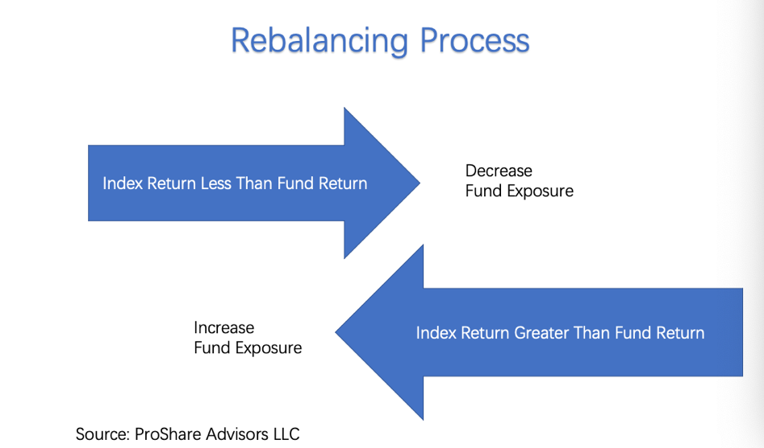

The magnitude of the rebalancing trade for any time can be estimated as the initial fund value multiplied by one hundred fifty (index return - fund return). The illustration below depicts an extreme instance of significant daily index returns and the rebalancing transactions that could be executed by an investor seeking to maintain daily leverage target compliance. Since inverse funds are designed to move in the opposite direction of their underlying indexes, they require rebalancing more frequently and/or to a larger degree than traditional funds. (Hill&Foster,2009)
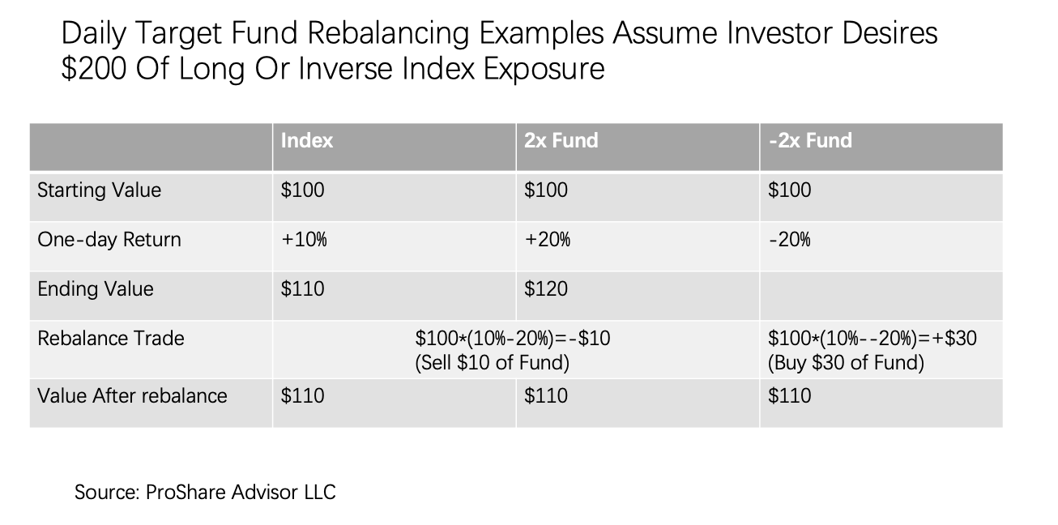
3.4.2 Re-balancing activity in ETFs & LETFs
The daily rebalancing of a leveraged exchange-traded fund(LETF) requires the fund manager to systematically modify the amount of index exposure. In particular, leveraged ETFs must rebalance their exposures daily in order to generate the promised leveraged returns. In order to achieve the investment objective of the fund, managers of LETFs use total return swaps with the appropriate leverage ratio.(Avellaneda&Dobi,2012)[29]. Contrary to intuition, regardless of whether the ETFs are leveraged, inverse, or leveraged inverse, their re-balancing activity is always in the same direction as the daily performance of the underlying index. (Cheng&Madhavan,2009) [17].
To better understand how Leveraged ETFs rebalance their daily exposure to the underlying index, we can take the following examples of 3X LETF SPXL and ETF SPY into the consideration:
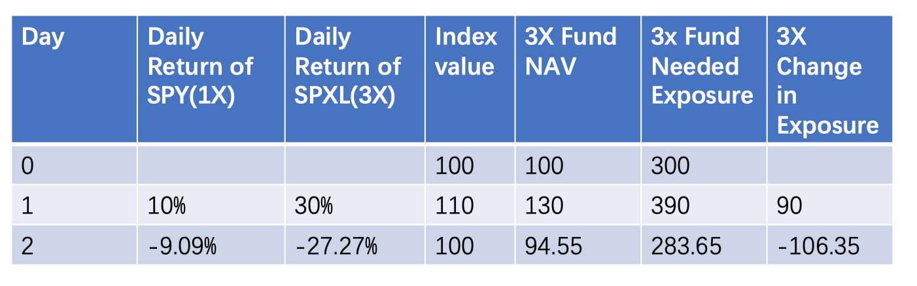
Suppose that we are having an initial portfolio value of $100. For the 3x fund, $ 300 in market exposure is needed. Assume that the underlying index grows by 10% to 110 on day 1. The 3x fund will increase by 30%. The 3x fund will require $390 in exposure to maintain its exposure at 3. Therefore, by the end of the day1, an additional $ 90 in exposure will be required. On the other hand, when the market falls from 110 to 100 on day 2, the 3x fund's exposure will need to be reduced by −$ 106.35.
Thus, this example shows an important characteristic of the rebalancing activity in Leveraged ETFs which is that they rebalance in the same direction with the underlying index.
In formulaic, Cheng and Madhavan (2009)[17] have developed a general phrase for the amount by which an ETF's counterparty is expected to rebalance. Let $A_{t_{n}}$ represent a leveraged or inverse ETF’s NAV at the close of day n or at time $t_{n}$. Corresponding to $A_{t_{n}}$ , let $L_{t_{n}}$ represent the notional amount of the total return swaps exposure that is required before the market opens on the next day to replicate the intended leveraged return of the index for the fund from time $t_{n}$to $t_{n+1}$is given by:
$$L_{t_{n}}=xA_{t_{n}}$$
The exposure of the total return swaps, denoted by Etn+1:
Etn+1=Ltn1+rtn,tn+1
=xAtn(1+rtn,tn+1)
And then the potential amount of rebalancing would be:
$$∆_{t_{n+1}}=L_{t_{n+1}}-E_{t_{n+1}}$$
$=A_{t_{n}}(x^{2}-x)r_{t_{n},t_{n+1}}$
Where
x is the exposure of the leveraged ETF to the index that it tracks, for example, x=3 for a 3X leveraged ETF
$r_{t}$is the return of the index from day(t-1)’s close to day t’s close.
According to Wagalath[28], as a function of the size of the rebalancing trade (Sk+1(δk+1 − δk )). The rebalancing impact is given by:
$$Φ(S_{k+1}\left(δ_{k+1}-δ_{k}\right))$$
Where $Φ$ is an impact function.
Then, the price dynamics of leveraged ETF is(Wagalath,2014)[28]:
$$L_{k+1}-L_{k}=δ_{k}\left(S_{k+1}-S_{k}\right)+\left(L_{k}-δ_{k}S_{k}\right)r∆t-Φ(S_{k+1}\left(δ_{k+1}-δ_{k}\right))$$
And the dynamics of the leveraged ETF can also be written as :
$$\frac{L_{k+1}-L_{k}}{L_{k}}\left(leveraged ETF return\right)=β\frac{S_{k+1}-S_{k}}{S_{k}}\left(benchmark return\right)$$
$$-c\left|β\left(β-1\right)\right|\left|\frac{S_{k+1}-S_{k}}{S_{k}}\right|+o(c)(rebalancing cost)$$
Where β is the leveraged ratio, δk shares owned at time tk and Φx=cx
To be more clear, in this section, I will construct 5 portfolios, explaining how we did re-balancing activity for Exchanged Traded Funds and Leveraged Exchanged Traded Funds and how re-balancing affects our portfolio return if we re-balance to exactly 3:1 leveraged. And shows that even if we do re-balancing activity in our portfolio, we will still have time decay for Leveraged ETFs in the long run.
Suppose that we construct 5 portfolios combinations which is
Portfolio 1: $100 in SPY
Portfolio 2: $100 in SPXL
Portfolio 3: $300 in SPY
Portfolio4: $300 in SPY ($200 borrowed money and $100 own cash in SPY)
Portfolio5: $300 in SPXL ($200 borrowed money and $100 own money)
And the daily return for the market is -10% for the first day and +11.111% for the second day thus giving SPXL(3X) -30% for the first day and +33.3333% for the second day.
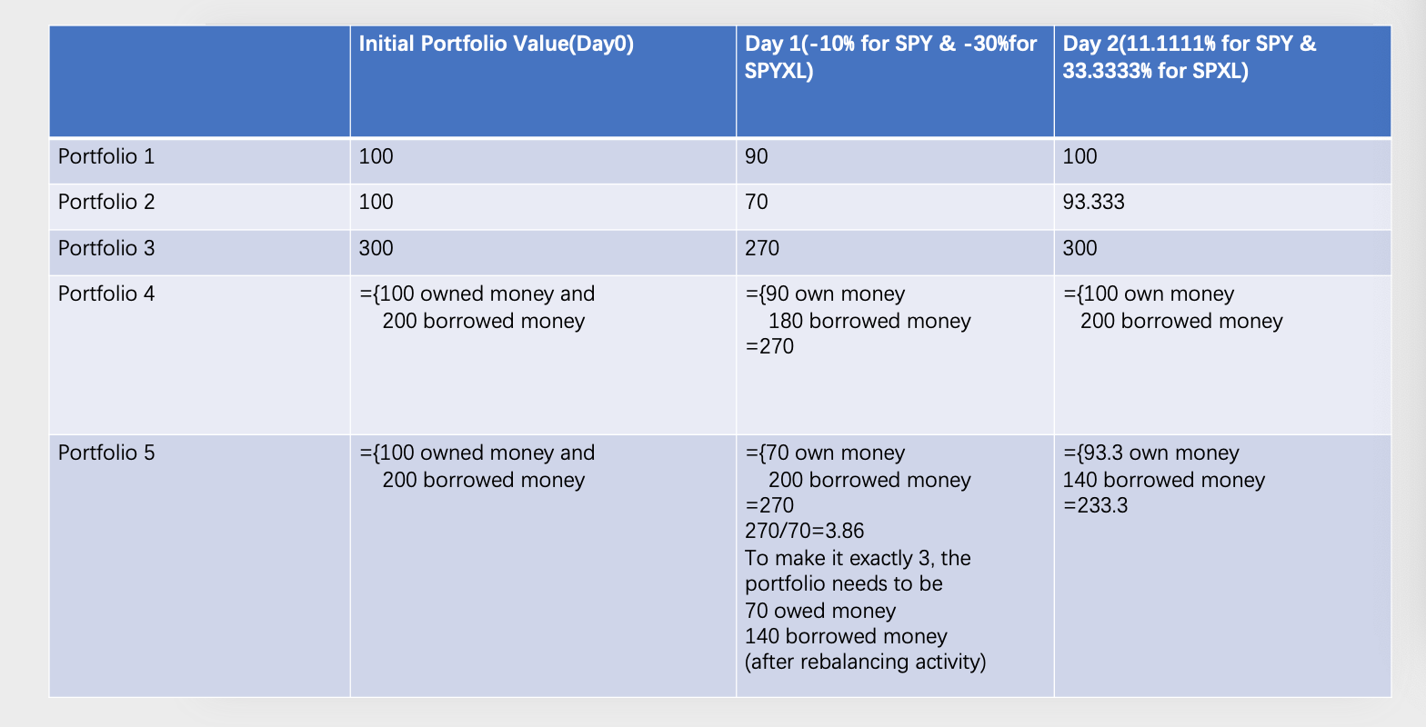
From portfolio1 and portfolio 2, suppose we expand the two-day market volatility to -10% and 11.11%, the ETF portfolio goes from 100 dollars to 90 dollars and then goes back to 100 dollars while LETFs go down to 70 dollars and go back to only 93.33 dollars, it is a clear way to show that 6.66 dollars disappear in portfolio 2 due to volatility decay.
From portfolio 5, after -10% return, our portfolio goes to combine 70 dollars own money and 200 dollars borrowed money, at this time the leveraged we are engaging here is 270/70 which is 3.86 which is bigger than 3. If we are going to rebalance the portfolio and make sure the leverage in this portfolio is exactly 3 times leveraged, we are going to adjust it to 70 dollars own money and 140 dollars bowered money making the whole portfolio is 210 dollars. And then we are going to experience an 11.11% market return which brings 210*(1+11.11%) to 233. 331. These 233.331 dollars are constituted by 93.3 dollars own money and 140 dollars own money.
Thus, it is evident that we are still losing money despite our efforts to enhance portfolio performance by rebalancing activity. Volatility decay is a long-term phenomenon, but it may also be demonstrated by a two-day spike in market volatility. In the long run, the short-term portfolio of losses is merely collecting losses. Thus, it is acceptable to assert that if we continue to leverage our portfolio or invest in Leveraged ETFs, our money in the leveraged portfolio would eventually disappear owing to time decay, even if we engage in rebalancing activities to improve portfolio performance.

4.1 Long-term consequences of holding ETFs & LETFs
In this section, we will use the historical data from 2009 to 2020 of three leveraged ETFs, we are going to use the formula:
Daily Return $D_{i}=\frac{{AP}_{i+1}}{{Ap}_{i}}-1$
Where ${AP}_{i+1}$ represent the adjusted price at time i+1
Then the monthly return should be
Monthly Return $M_{i}=\prod_{i=0}^{i=30}{(1+D_{i})}$
Thus, the average monthly return of 3x ETF(SPXL) can be shown as:
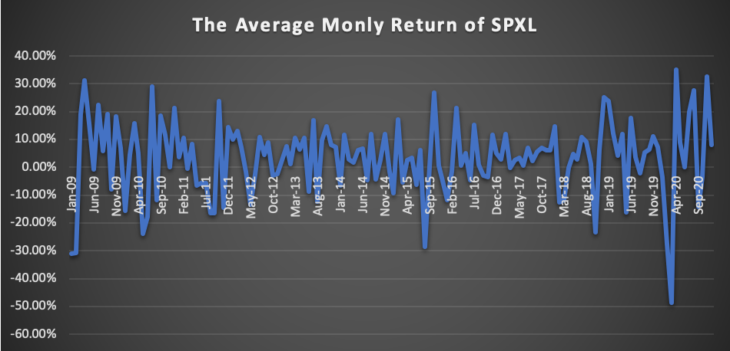
The average monthly return of ETF(SPY) can be showed as:
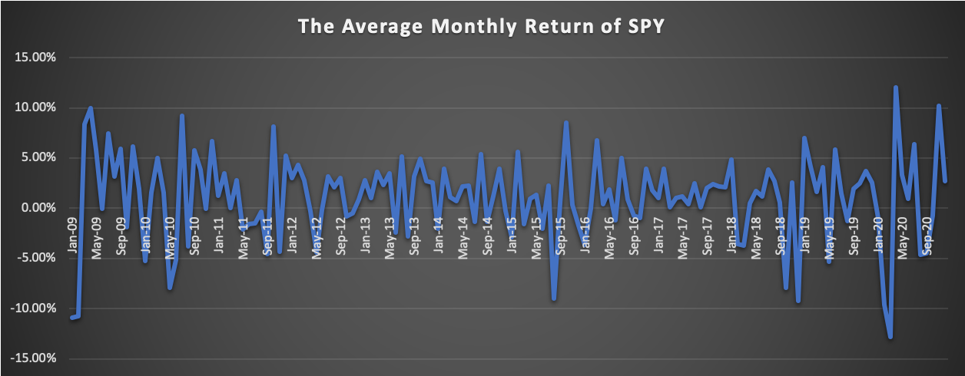
From above, we can investigate nearly the same trend of Leveraged ETF and its underlying index.
If we invest 100 dollars in SPXL and 100 dollars in SPY respectively in January 2009, the graph of the return should be:
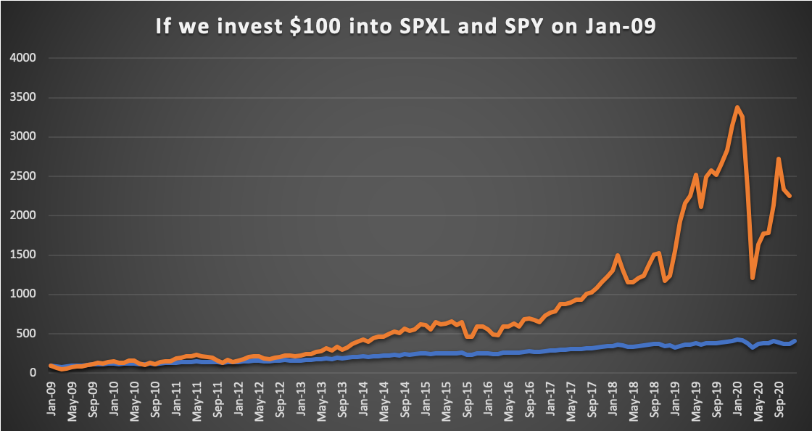
Despite the fact that we can plainly see a fairly similar pattern in the monthly return of SPXL and SPY over the previous ten years, however when we assume investing $100 each in January 2009, the difference in return after ten years is not precisely three times, but the gap is rather considerable.

4.2 What would LETFs do if no time decay?
In the previous section, we have already discussed how time decay affects Leveraged Exchanged Traded Fund in the long run, LETFs provide a multiple of the daily return of the index being tracked, but not a multiple of the cumulative return if held for more than one day. (Ahmed Abdou ,2017)[14].Volatility decay affects their performance in unexpected ways. Even for a long-term investor who is certain that “stocks only go up”, the return of Leveraged ETFs is lower than what investors expected. (Guz,Zhang)[4]. Algebraically, it is shown that volatility decay is intensified for inverse leveraged funds as the leverage multiplier increase. (Ahmed Abdou ,2017). Thus, in this section, We will use historical data to analyze what has happened to Leveraged Exchange-Traded Funds over the past decade if there is no volatility decay. Our null hypothesis is that the portfolio return of 3x Leveraged Exchanged Traded Fund will be roughly three times the portfolio returns of ETFs without time decay.
To do this, We will use the average monthly return of SPY from 2009 to 2020, calculate the continuously compounded return for the portfolio, suppose the average monthly return of the ETF is x, and use the compounding return we can get the actual return over the past ten years. then the Leveraged 3X ETFs portfolio return Y without time decay will satisfy the following relationship:
Y=e3ln1+x-11
The strategy here is we are assuming that the portfolio return of 3x Leveraged Exchanged Traded Fund without time decay would be three times the compounding return of ETFs. Then we can use the historical data of ETFs to see whether the historical data fit, it the null hypothesis is correct, we will have:
Y=e3ln1+x-1≅3x
Following a thorough investigation that included precise calculations and drawings, the blue line represents three times the portfolio return of ETFs and the orange line represents the cases where there is no time decay for 3x Leveraged ETFs in the portfolio.
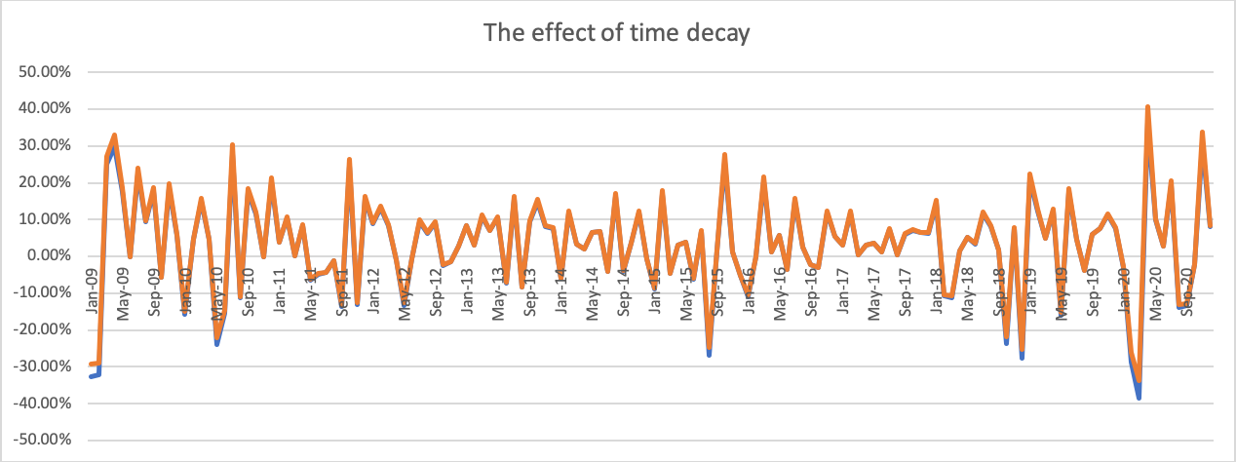
From the above, we can observe that from the past 2009 to 2020, except for January 2009, September 2015, September 2018, January 2019, and January 2020. The orange curve and the blue curve are almost coincident, which means that our null hypothesis is correct.
Moreover, if we calculate the index - start at $100.00 Jan 2009, then calculate I(t) = I(t-1)*return(t). That way we will be able to see any divergence that grows over time as follows:
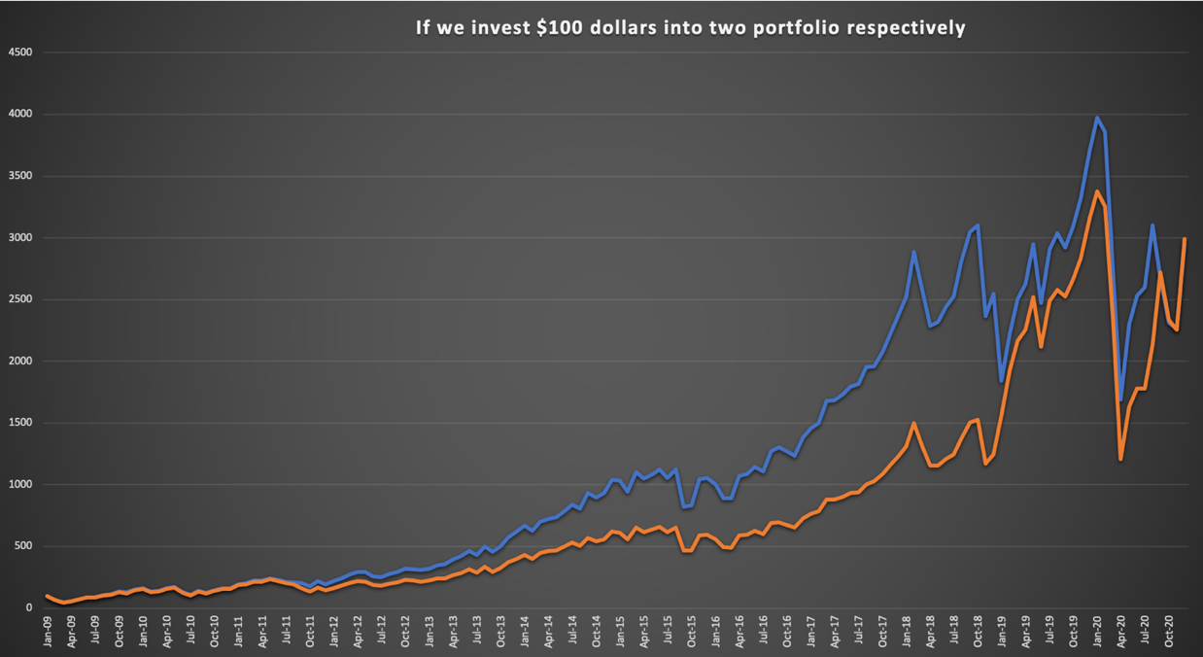

4.3 Build a Fixed investment model in LETFs
In this section, we are going to firstly use the daily return, monthly return, annualized return, standard deviation, annual volatility, sharp ratio, and max drawdown of SPXL and SPY from 2009—to 2020, and then gather the data. This is the model we use, we will stimulate, to get what happens to the portfolio value if we invest $100 each month.
If SPXL's portfolio value is precisely three times that of SPY. Thus, we might conclude that fixed investment can, to some extent, offset the impacts of volatility decay.
According to the price dynamics of LETFs and ETFs , we can use the following relationship to represent the price of LETFs if we fix invest $100 dollars into the portfolio:
$$L_{t}=\left(L_{t-1}+100\right)*(1+r_{t-1})$$
$$S_{t}=\left(S_{t-1}+100\right)*(1+r_{t-1})$$
Where represents the Leveraged ETFs price at time t and represents the Exchanged Traded Funds price at time t.
The portfolio return will be:
$\frac{S_{t}-S_{t-1}}{S_{t-1}}$ and $\frac{L_{t}-L_{t-1}}{L_{t-1}}$
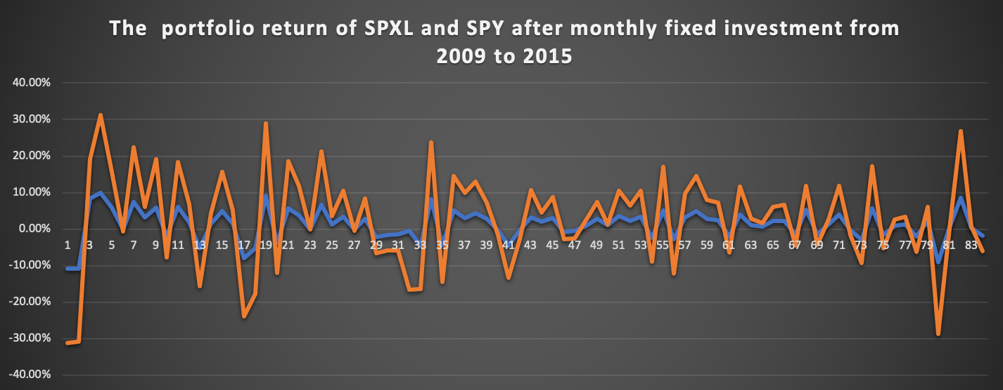
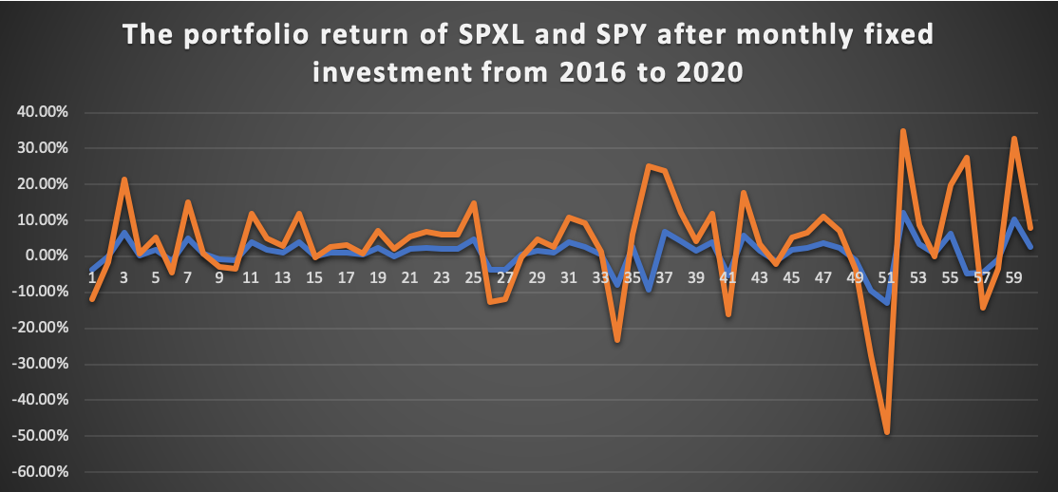
Observing that the returns of 3X LETFs are roughly triple those of ETFs after fixed invest $100 per month except a few specific points from the chart, it is evident to claim that fixed investment will mitigate the influence of volatility decay on LETFs to some extent. This assumption, however, has numerous flaws. For example, the volatility decay may be “hidden” in the $100 we invest each month, and measuring it is difficult.

5. Conclusion
Customers buying LETFs do not themselves have to borrow or dynamically rebalance to acquire the long or short leveraged exposure offered by LETFs, which makes them a unique financial instrument that is continuing to grow rapidly today. Definitely, these funds have potential, but they also have a problem with volatility decay – the fact that daily rebalancing will indeed generate arithmetic returns that average 2x or 3x the underlying return, but will then produce geometric or continuously-compounded average returns that are less than 2x or 3x. This is crucially important because it is the cumulated continuously-compounded (or geometric) return that determines the actual dollar return over a finite period. Using the mathematical relationship of arithmetic and geometric returns, it is easy to see volatility decay in the long term from the standpoint of arithmetic return, geometric return, rebalancing activity, and the diffusion process of LETFs, and to grasp the issues with leveraged exchange-traded funds. We discuss various approximations for converting from average arithmetic to geometric return, but there is always a volatility loss due to leverage, regardless of the method used to convert geometric return from arithmetic return –daily leverage and arithmetic return multiples applied to ETFs always makes the leveraged geometric return always smaller than the stated leverage ratio, and can in fact make the return negative. From the standpoint of re-balancing activity in Leveraged ETFs, this paper describes how rebalancing activity functions in the portfolio, and despite rebalancing activity works, leveraged ETFs continue to experience volatility decay. From the Black-Scholes Model, we can deduce that the timely return of x times Leveraged Exchanged Traded Funds is equivalent to x times the timely return of the corresponding ETF minus a fraction of a percentage. Moreover, using the historical data of Direxion Daily S&P500 Bull 3X Shares SPXL and SPDR S&P ETF Trust SPY, this paper demonstrates that if there is no volatility decay in the portfolio of leveraged ETFs, the portfolio return of 3x leveraged ETFs without time decay is almost three times the compound return of ETFs.

Reference
[1]Wagner, D. (2012). Trading etfs: Gaining an edge with technical analysis. Bloomberg Press/Wiley.
[2]Exchange-Traded Fund (ETF) Definition - Investopedia. https://www.investopedia.com/terms/e/etf.asp
[3]FAQ | The Bear Trader: Make Money In A Volatile Bear Market. https://beartrader.com/faq/
[4]Zhang, G. (2021, September 15).Â Volatility decay: Don't hold leveraged etfs long-term. A Frugal Doctor. Retrieved May 23, 2022, from https://www.afrugaldoctor.com/home/volatility-decay-dont-hold-leveraged-etfs-long-termÂ
[5]Cheng, M., & Madhavan, A. (2009, April 24). The dynamics of leveraged and inverse-exchange traded funds. SSRN. Retrieved May 23, 2022, from https://papers.ssrn.com/sol3/papers.cfm?abstract_id=1393995
[6]Charupat, N., & Miu, P. (2013). The pricing efficiency of leveraged exchange-traded funds: Evidence from the U.S. markets. Journal of Financial Research, 36(2), 253–278. https://doi.org/10.1111/j.1475-6803.2013.12010.x
[7]MOREIRA, A. L. A. N., & MUIR, T. Y. L. E. R. (2017). Volatility-managed portfolios. The Journal of Finance, 72(4), 1611–1644. https://doi.org/10.1111/jofi.12513
[8]Cederburg, S., O'Doherty, M. S., Wang, F., & Yan, X. S. (2019, April 18). On the performance of volatility-managed portfolios. SSRN. Retrieved November 14, 2021, from https://papers.ssrn.com/sol3/papers.cfm?abstract_id=3357038.
[9]The information in option volume for future stock prices. (n.d.). Retrieved November 14, 2021, from https://www.mit.edu/~junpan/volume.pdf.
[10]Dhankar, R. S. (2019).Â Risk-return relationship and portfolio management. Springer.
[11]Leung, T., & Santoli, M. (2016). Conclusions. SpringerBriefs in Quantitative Finance, 89–91. https://doi.org/10.1007/978-3-319-29094-2_5
[12]Rothstein, M. (1972). On Geometric and Arithmetic Portfolio Performance Indexes. The Journal of Financial and Quantitative Analysis, 7(4), 1983–1992. https://doi.org/10.2307/2329629
[13] Mindlin, D. (2011). On the relationship between arithmetic and Geometric returns. SSRN Electronic Journal. https://doi.org/10.2139/ssrn.2083915
[14] Abdou, A. (2017). Accounting for volatility decay in time series models for Leveraged Exchange Traded Funds. SSRN Electronic Journal. https://doi.org/10.2139/ssrn.2980208
[15]Chen, J. (2022, June 27). Rebalancing. Investopedia. Retrieved June 30, 2022, from https://www.investopedia.com/terms/r/rebalancing.asp#:~:text=Rebalancing%20is%20the%20process%20of,%25%20stocks%20and%2050%25%20bonds.
[16] Charupat, N., & Miu, P. (2013). The pricing efficiency of leveraged exchange-traded funds: Evidence from the U.S. markets. Journal of Financial Research, 36(2), 253–278. https://doi.org/10.1111/j.1475-6803.2013.12010.x
[17]Cheng, M., & Madhavan, A. (2009). The dynamics of leveraged and inverse exchange-traded funds. Journal of investment management, 16(4), 43.
[18] Hill, J. and Foster, G. (2009). Understanding Returns of Leveraged and Inverse Funds, Journal of Indices, 12(5), pp. 40-58.
[19] Trainor, W.J. Jr. and Baryla, E.A. Jr. (2008). Leveraged ETFs: A Risky Double that Does not Multiply by Two. Journal of Financial Planning, 21(5), pp. 48-55.
[20] Trainor, W., & Carroll, M. (2013). Forecasting holding periods for leveraged etfs using decay thresholds: Theory and applications. Journal of Financial Studies & Research, 1–13. https://doi.org/10.5171/2013.715425
[21] Murphy, R. and Wright, C. (2010). An Empirical Investigation of Commodity-Based Leveraged ETFs. Journal of Index Investing, 1(3), pp. 14-23.
[22] Lu, L., Wang, J. and Zhang, G. (2012). Long Term Performance of Leveraged ETFs, Financial Services Review, 21(1), pp. 63-80
[23] Tang, H., & Xu, X. E. (2013). Solving the return deviation conundrum of leveraged exchange-traded funds. Journal of Financial and Quantitative Analysis, 48(1), 309–342. https://doi.org/10.1017/s0022109012000622
[24]Rompotis, G. G. (2014). On leveraged and inverse leveraged exchange traded funds. AESTIMATIO, 9(2014), 150–181. https://doi.org/10.5605/ieb.9.7
[25] Loviscek, A., Tang, H., & Xu, X. E. (2014). Do leveraged exchange-traded products deliver their stated multiples? Journal of Banking & Finance, 43, 29–47. https://doi.org/10.1016/j.jbankfin.2014.02.008
[26] Zhang, J., & Avellaneda, M. (2010). Path-dependence properties of leveraged exchange-traded funds: Compounding, volatility and option pricing.
[27] Loehr, R., & Lamb, R. (2013). Long-term investing with leveraged exchange traded funds. International Journal of Arts and Commerce, 2(4), 27-34.
[28] Wagalath, L. (2014). Modelling the rebalancing slippage of leveraged exchange-traded funds. Quantitative Finance, 14(9), 1503–1511. https://doi.org/10.1080/14697688.2014.916817
[29] Avellaneda, M., & Dobi, D. (2012). Structural slippage of leveraged etfs. SSRN Electronic Journal. https://doi.org/10.2139/ssrn.2127738

The continuously compounded returns do sum to give the cumulated return, so any leveraged ETF constructed to leverage the continuously compounded unlevered return would not suffer from volatility decay.

