Methodological Details Appendix

AI-induced dehumanization

Online Appendixes | Content | Page
Online Appendix A | Pre-registrations | 2
Online Appendix B | Pretest results of Study 1 | 3
Online Appendix C | Mind perception results by dimension | 4
Online Appendix D | Study 2: dehumanization results by dimension | 5
Online Appendix E | Mediation models across studies | 6
Online Appendix F | Supplemental studies | 9
Online Appendix G | Study stimuli | 21
Online Appendix H | Supplemental study stimuli | 42

Online Appendix A: Pre-registrations

Study 1: https://aspredicted.org/W5T_BQ8
Study 2: https://aspredicted.org/N9D_T5T
Study 3: https://aspredicted.org/FYX_LRF
Study 4: https://aspredicted.org/C8J_3PB
Study 5: https://aspredicted.org/HKD_815

Online Appendix B: Pretest results of Study 1

The effect of mind perception manipulation of Atlas on mood and threat
 | High | Low
Positive Affect* | 2.79 (.71) | 2.64 (.78) | t(78) = .89, p = .38
Negative Affect* | 1.37 (.61) | 1.44 (.66) | t(78) = -.49, p = .62
Perceived threat** | 2.81 (1.57) | 2.84 (1.62) | t(78) = -.08, p = .93
*: measured by PANAS (Positive and Negative Affect Schedule; Watson, Clark, & Tellegen, 1988)
**: measured by realistic and identity threat measures in Zlotowski et al. (2017)

Pretest of negative treatment scenarios
Scenario | α* | Mean | One-tailed t-test (4)
Meal replacement Shake | .94 | 2.20 | t(79) =11.25, p < .001
Micro-capsule room | .98 | 3.45 | t(79) = 2.92, p = .002
Behavioral tracking device | .94 | 2.54 | t(79) = 15.49, p < .001
*: Mistreatment perception is measured by a composite score of four 7-point bipolar measures: negative – positive, inconsiderate – considerate, cold-hearted – warm-hearted, unkind – kind

Online Appendix C: Mind perception results by dimension

Study | Dimension | α | High | Low
Study 1 | Agency | .75 | 4.30 (1.23) | 3.73 (1.17) | t(193) = 3.34, p = .001
 | Experience | .91 | 1.76 (1.09) | 1.45 (.79) | t(193) = 2.35, p = .02
Pretest of Study 2* | Agency | .79 | 4.06 (1.31) | 3.66 (1.26) | F(1, 304) = 7.46, p = .007
 | Experience | .92 | 1.71 (1.08) | 1.43 (.86) | F(1, 304) = 6.38, p = .012
Study 4 | Agency | .81 | 4.54 (1.29) | 3.87 (1.28) | t(278) = 4.41, p < .001
 | Experience | .91 | 2.73 (1.66) | 1.56 (1.08) | t(278) = 6.98, p < .001
Study 5 | Agency | .84 | 3.91 (1.46) | 3.62 (1.42) | t(329) = 1.82, p = .07
 | Experience | .93 | 2.12 (1.41) | 1.48 (.90) | t(329) = 4.96, p < .001
Notes: Values in parentheses indicate standard deviation; *: 2×2 ANOVA revealed a significant main effect of socio-emotional capability only.

Online Appendix D: Mechanistic and animalistic dehumanization results in Study 2

 | High mind | Low mind
Mechanistic dehumanization
Moderate capability | 3.27 (1.90)ª | 2.85 (1.21)^{b}
Extreme capability | 2.78 (1.23)^{c} | 3.02 (1.23)^{b, c}
Animalistic dehumanization
Moderate capability | 3.61 (1.06)ª | 3.38 (.82)^{a, c}
Extreme capability | 3.12 (.88)^{b} | 3.56 (.88)^{c}
Notes: Values in parentheses indicate standard deviation; Values with different superscripts indicate a significant difference at p < .05.

Online Appendix E: Mediation models

[Study 1]
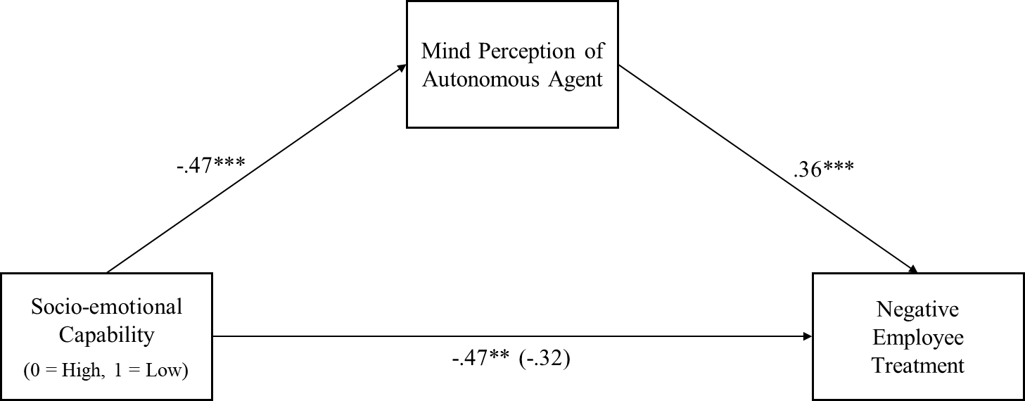
Notes: Values indicate unstandardized regression coefficients. Value in parentheses indicates results when the proposed mediator is included in the model.
*p < .05, **p < .01, ***p < .005

[Study 3]
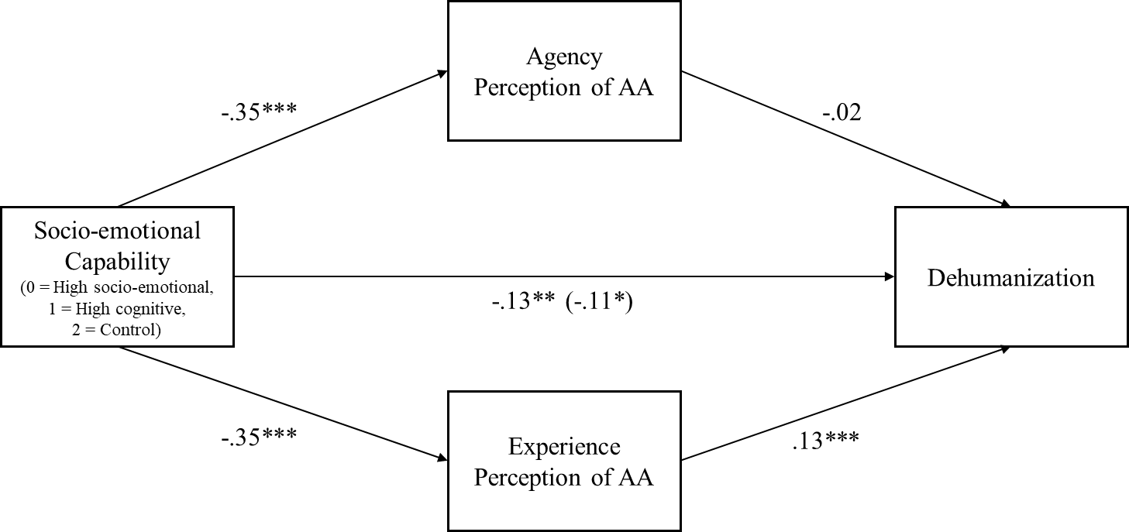
Notes: Values indicate unstandardized regression coefficients. Value in parentheses indicates results when the proposed mediators are included in the model.
*p < .05, **p < .01, ***p < .005

[Study 3] Additional results on mechanistic dehumanization
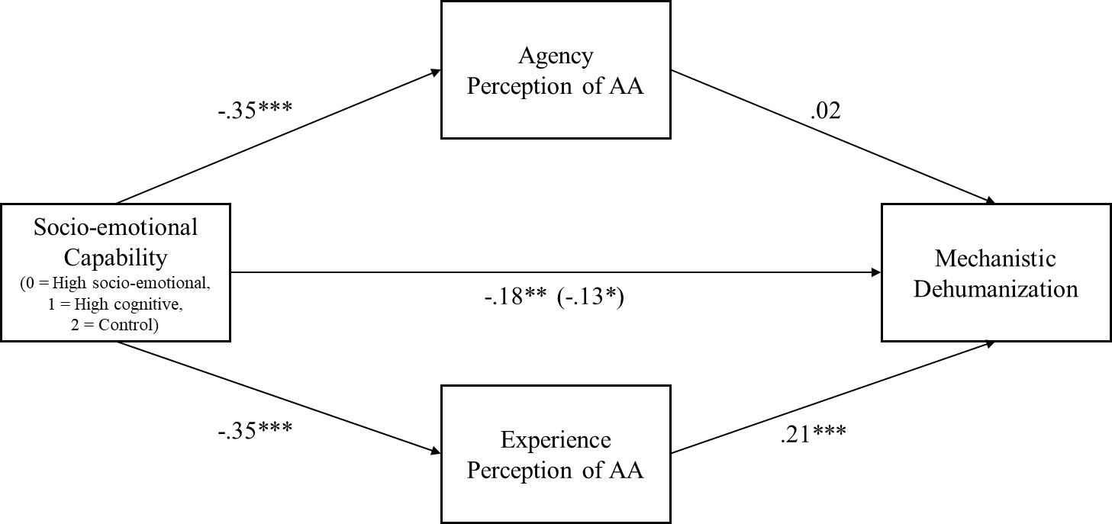
Notes: Values indicate unstandardized regression coefficients. Value in parentheses indicates results when the proposed mediators are included in the model.
*p < .05, **p < .01, ***p < .005

[Study 4]
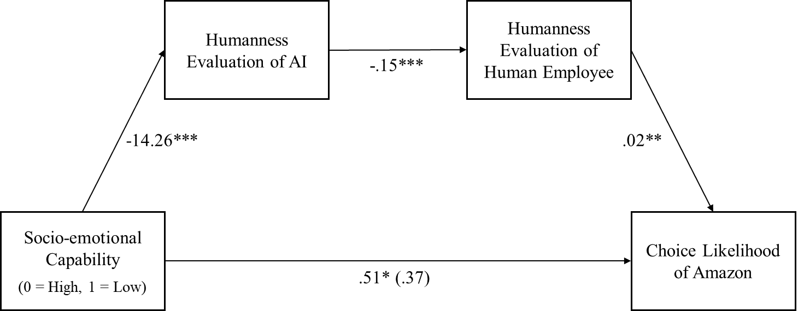
Notes: Values indicate unstandardized regression coefficients. Value in parentheses indicates results when the proposed mediator is included in the model.
*p < .05, **p < .01, ***p < .005

[Study 5]
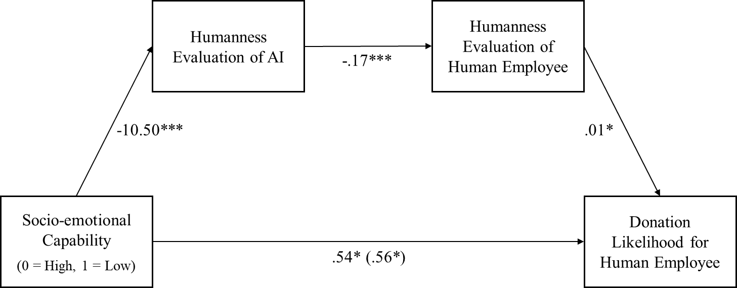
Notes: Values indicate unstandardized regression coefficients. Value in parentheses indicates results when the proposed mediator is included in the model.
*p < .05, **p < .01, ***p < .005

Online Appendix F: Supplemental studies

Study | Study characteristics | Purpose | Main findings
Study A | IV: socio-emotional features: high vs. low  DV: negative employee treatment  (same as Study 1) | To replicate the effect using a different manipulation | Greater support for poor employee treatment in the high (vs. low) socio-emotional condition
Study B | IV: 2 (socio-emotional feature: high vs. low)  DV: 1) dehumanization, 2) gift card choice | To replicate the dimension-specific assimilation effect using a different manipulation | 1) greater mechanistic dehumanization, not animalistic dehumanization in the high (vs. low) socio-emotional condition  2) greater choice likelihood for Amazon gift card in the high (vs. low) socio-emotional condition  3) significant mediation of the mechanistic dehumanization on the gift card choice
Study C | IV: 2 (anthropomorphism: high vs. low) × 2 (exemplar type: AI vs. non-AI)  DV: charity donation | 1) To investigate whether the assimilation-induced dehumanization occurs outside of high technology context (i.e., by giving humanlike superficial traits as in traditional anthropomorphism research)  2) To broaden the consequence of the dehumanization beyond employee mistreatment | Less charity donation when exposed to AI agents with high (vs. low) humanlike appearance, but no difference when exposed to non-AI agents

Supplemental studies

Supplemental Study A

Method
We collected 202 valid completed surveys from Prolific (101 male, M_{age} = 33.14; pre-registered at https://aspredicted.org/BBK_NT5). The target sample size was 200 participants, as this would detect a small-to-medium effect size between two conditions (d > .40) with 80% statistical power. In all the studies we conducted, we excluded participants who failed two or more attention check questions and didn’t follow the instructions, prior to analysis.
Participants were told that they would be participating in a consumer survey consisting of multiple sub-surveys on different topics. This study employed a between-subjects design with two conditions: high vs. low socio-emotional capability (see online appendix G for full stimuli). To manipulate the level of socio-emotional capability of an exemplar, we differed which product features were salient in a description of the same smart consumer product. In both conditions, participants first read a short description of a smart mirror for home training that provides a customized workout plan and personalized recommendations and feedback. In the high socio-emotional capability condition, social features of the product were emphasized. Participants were told that the product nudges its users to stay on track by sending personalized messages and encouraging them during workout to meet their goal. In the low socio-emotional capability condition, analytical features of the product were emphasized that the product focuses on the accurate measurements of body posture and bio feedback during workout.
After reading the description, participants answered attention check questions and filler questions about their general attitudes about the product (i.e., liking, trust, usefulness, interest in the product) and evaluated the humanness of the smart mirror using the mind perception scale of Kozak et al. (2006). This scale includes 10 items assessing how much mind is attributed to a target, related with two dimensions of mind: agency (e.g., “It is capable of doing things on purpose”) and experience (e.g., “It has complex feelings”; 1 = Strongly agree, 7 = Strongly disagree).
In the next section, the survey asked participants to read scenarios and to indicate whether they would support a change that might reduce employees’ welfare. The first scenario was about replacing regular meals for factory workers with a meal replacement shake, and participants rated the extent to which they agreed with the following statements: (1) “I like the idea of providing meal replacement shakes to workers,” (2) “I support the idea of replacing workers’ meals with meal replacement shakes,” (3) “If I am the CEO of this company, I will provide meal replacement shakes to workers,” using a seven-point scale (1 = Not at all, 7 = Very much). The second scenario was about providing workers accommodations consisting of micro-capsule rooms, which offers severely limited space. Participants answered the following questions using the same scale: (1) “I like the idea of building capsule rooms for a workers’ dormitory,” (2) “I support the idea of providing a capsule dormitory to workers,” (3) “If I am the CEO of this company, I will approve the capsule rooms as a workers’ dormitory.” The third scenario was about adopting a tracking device that monitor, time, and guide workers’ every movement at warehouse facility. Participants indicated their agreement to the following statements: (1) “I like the idea of adopting the smart tracking wristband,” (2) “I support the idea of using a behavior tracking device to increase work efficiency,” (3) “If I am the CEO of this company, I will approve the adoption of the smart wristband.” Finally, participants indicated their gender, age, education, employment status, household annual income, and political orientation for demographic information.
Results
Mind perception. We averaged the mind perception measure to create a composite score (α = .80). As we intended, participants perceived a higher level of mind from the product when its social features were made salient than when its analytical features were salient (M_{high} = 2.94, SD_{high} = .88, M_{low} = 2.21, SD_{low} = .73; t(200) = -6.41, p < .001, d = .91).
Negative treatment toward employees. We averaged the nine measures in the scenarios to create a composite score reflecting mistreatment intentions (α = .85). Participants who had been exposed to the product with its social (vs. analytical) features salient, and therefore, when they perceived greater mind from the nonhuman exemplar, showed greater support for poor treatment practices in workplace (M_{high} = 2.89, SD_{high} = 1.17, M_{low} = 2.46, SD_{low} = 1.00; t(200) = -2.77, p = .006, d = .40). The mistreating effect of mind perception remained significant after controlling the demographic variables (t(183) = -2.77, p = .006).

Supplemental Study B

Methods
We collected 127 completed surveys from MTurk participants in the United States (69 male, M_{age} = 34.61). In the first section of the survey, participants read a fictitious article about recent developments in AI and experts’ opinions about its future possibilities. We manipulated the level of socio-emotional capability participants perceive from AI by varying the last paragraph of the article. In the high socio-emotional capability condition, the article emphasized the possibility of AIs recognizing human emotions and giving emotional support to humans:
Finally, AIs can learn to recognize human emotions and respond appropriately, offering comfort where needed. For example, AIs learn to detect emotions in humans through voice, body language, facial expressions, and so on, in much the same way that we detect changes in emotional moods of our loved ones, friends, or work colleagues. In the near future, personal devices might be able to support us emotionally better than people around us.
In the low socio-emotional capability condition, on the other hand, the article went a step further and stated the limitation of AIs despite its ability to detect human emotions:
Finally, AIs can learn to recognize human emotions and respond appropriately, offering comfort where needed. However, importantly, AIs will never actually feel these emotions and really understand what people experience. For example, AIs can learn to detect and analyze superficial signals in human voice, body language, facial expressions, and so on, but such AIs cannot generate feelings and share emotions with people.
After reading the article, participants answered how much mind they perceived from AIs and robots, in general, using the same mind perception scale used in Study 1. In the next section, participants evaluated the humanness of people using the same eight-item dehumanization scale used in Study 2.
Subsequently, participants were informed that they could enter a random draw to win a $25 gift card beside their promised compensation. They were asked to choose which gift card they would like to receive, Amazon or Costco, if they won the lottery. However, before making the choice, an article was presented that described Amazon’s purportedly dehumanizing employment practices. The article was based on actual news accounts of the working conditions at Amazon warehouses (Hamilton, 2018). Our dependent measure was the share of participants who chose to receive the Amazon gift card. Our logic behind this measure was that if consumers dehumanized others and attributed less mind to actual people, they would be less bothered by the dehumanizing treatment of employees at Amazon, which would increase the choice share of the Amazon gift card. In a pretest (N = 40) where participants read the same article about Amazon’s dehumanizing practices and chose which gift card to receive for the lottery, 80% of people chose Amazon over the Costco gift card.
Results
Mind perception. The composite score of mind perception (α = .84) revealed that participants in the high socio-emotional condition attributed more mind to AIs than those in the low socio-emotional condition (M_{high} = 3.74, SD_{high} = 1.21, M_{low} = 3.17, SD_{high} = 1.05; t(125) = 2.84, p = .005, d = .51). Although mind perceptions in both dimensions were higher in the high (vs. low) socio-emotional condition, the difference was more pronounced in the experience than in the agency dimension as intended (experience: M_{high} = 2.48, SD_{high} = 1.68, M_{low} = 1.61, SD_{high} = 1.12; t(125) = 3.43, p < .001, d = .61; agency: M_{high} = 4.38, SD_{high} = 1.21, M_{low} = 3.95, SD_{high} = 1.22; t(125) = 1.97, p = .051, d = .36).
Dehumanization. A mixed ANOVA, using the level of perceived socio-emotional capability of AI as a between-subject factor and two different dimensions of dehumanization as a within-subject factor, revealed a main effect of the mind perception (M_{high} = 3.30, SD_{high} = 0.95, M_{low} = 2.84, SD_{high} = 0.80; F(1, 125) = 8.10, p = .005, η_{p}² = .06), a main effect of the dehumanization type (M_{mech} = 2.89, SD_{mech} = 1.21, M_{anim} = 3.21, SD_{anim} = .79; F(1, 125) = 11.29, p = .001, η_{p}² = .08). Importantly, and as expected, we also found a significant interaction between the mind perception and the type of dehumanization (F(1, 125) = 11.29, p = .001, η_{p}² = .08). When participants perceived higher mind from AIs with capabilities to recognize and exchange emotions as humans do, they were more likely to discount other people’s humanity in a mechanistic way (mechanistic dehumanization: α = .79; M_{high} = 3.30, SD_{high} = 1.29, M_{low} = 2.52, SD_{high} = 0.99; F(1, 125) = 14.72, p < .001, d = .68), but not necessarily in an animalistic way (animalistic dehumanization: α = .69; M_{high} = 3.29, SD_{high} = 0.97, M_{low} = 3.16, SD_{high} = 0.85; F(1, 125) = .47, p = .50, d = .14). These results suggest that the observed dehumanization effect was primarily driven by mechanistic dehumanization.
Gift card choice. When participants perceived a more humanlike mind from AIs, about 93% of participants selected the Amazon gift card instead of Costco. However, significantly fewer participants, about 74% of them, selected the Amazon gift card when they perceived AIs to be distinct from humans (χ² = 7.13, p = .008; see Figure 2).
Mediation by dehumanization. We hypothesized that when people are more likely to perceive mind from autonomous agents, they will attribute less humanness to actual people as a result of the assimilation. This dehumanized perception should, in turn, mediate the effect of mind perception from autonomous agents on participants’ gift card choice. Therefore, we ran a mediation analysis using PROCESS (Model 6; Preacher & Hayes 2004). The model used socio-emotional capability condition as the independent variable, mind perception of the AI and a composite score of the dehumanization (α = .79) as the serial mediators, and gift card choice as the dependent variable. The analysis showed a significant indirect effect of mind perception (mediator 1) and dehumanization (mediator 2) on participants’ choice of Amazon gift card (b = -.10, se = .07, 95% CI = -.2897. to -.0036). When AIs were depicted as having a high level of socio-emotional capability, participants attributed more mind to AIs, leading them to discount other people’s humanity more. As a result, they were more likely to choose the Amazon gift card despite being aware of Amazon’s dehumanizing treatment toward its employees.
Discussion
Combined with the previous findings, this study confirmed our theorizing that perceiving more humanlike mind from autonomous agents changes humanness perception of people in general, and the decreased humanity perception leads to mistreatment of employees. Further, the current study extended the previous findings on the employee mistreatment using participants’ choice with actual consequences.
The current results also suggest that the assimilation process, decreasing in humanness perception of people toward the level of humanness perception of autonomous agent, could be trait specific. When participants ascribed greater mental capacities to experience feelings and emotions to AI, their humanity perception about actual people were assimilated only in the experience dimension, showing the mechanistic dehumanization.

Supplemental Study C

Methods
We collected 844 valid complete surveys from Prolific in the United States (383 male, M_{age} = 39.24). This study employed a 2 (anthropomorphism: high vs. low) × 2 (exemplar: AI vs. non-AI) between-subjects design (online appendix G for full stimuli).
Participants were told that this is a consumer survey about a new online shopping platform before its launch. They read a description about an interior furniture shopping website. In the non-AI conditions, participants were presented with pictures describing various features of the shopping platform, such as getting style inspirations from others’ posts, one-stop shopping from tags in images, and connecting to service providers. In the AI conditions, participants read the same description, but, in addition to that, they were told that they can get a personalized design service enabled by an AI system that can learn and analyze users’ preferences, generate design suggestions, and arrange purchases. A sample interaction with the AI system was provided.
We manipulated anthropomorphism by employing humanlike appearance and conversational language style. In the high anthropomorphism condition, the shopping platform was introduced by an anthropomorphized mascot with humanlike elements (i.e., eyes and limbs), using first-person language (e.g., “Hi, I’m Mango. I’ll guide you the easiest way to design your home.”). In the low anthropomorphism condition, the same description of the platform was presented in third-person language without the mascot (e.g., “Here is Mango. The easiest way to design your home.”). Further, in the AI conditions, a sample customer interaction with the AI was presented, using either a conversational interface where people talk naturally as they do with other people (high anthropomorphism condition) or a menu-based interface where people choose from several presented options (low anthropomorphism condition) to communicate with the AI.
After reading the descriptions, participants answered attention check questions and filler questions about the website and its service (e.g., liking, trust, interest).
Then, participants were informed that this company will offer 5000 bonus points when users sign up for an interior service on this platform. They were also instructed that the website would run a campaign where participants can donate these points to a charity, Habitat for Humanity. In addition, participants were told that once the shopping platform is launched, multiple respondents of the current survey would be randomly selected and awarded 5000 points, which is worth approximately $50 either for any purchases on the platform or the charity donation. Participants indicated how many points they would like to donate, from 0 to 5000, if they are selected. Finally, participants reported their gender and age for demographic information.
Results
Pretest of mind perception. To confirm that people perceive greater mind in the AI conditions than in the non-AI conditions, we conducted an independent pretest (N = 239) on the mind perception measure used in our prior studies, using the same study design. A 2 (anthropomorphism: high vs. low) × 2 (exemplar: AI vs. non-AI) ANOVA on the mind perception (α = .86) revealed two significant main effects (anthropomorphism: M_{high} = 2.91, SD_{high} = 1.14, M_{low} = 2.50, SD_{low} = .98, F(1, 235) = 8.93, p = .003, d = .37; exemplar: M_{AI} = 2.90, SD_{AI} = 1.00, M_{non-AI} = 2.54, SD_{non-AI} = 1.16, F(1, 235) = 6.28, p = .013, d = .32). Importantly, participants attributed significantly greater mind to the anthropomorphized AI (M = 3.11, SD = 1.05) than to the non-anthropomorphized AI (M = 2.63, SD = .86; t(235) = 2.28, p = .024, d = .50). However, the mind perception from the non-AI product did not significantly differ depending on the high (M = 2.69, SD = 1.20) vs. low anthropomorphism manipulation (M = 2.38 vs. SD = 1.09; t(235) = 1.55, p = .123). Also, a higher level of mind was attributed to the anthropomorphized AI than to the anthropomorphized non-AI (t(235) = 2.51, p = .013, d = .38).
Charity donation. In the main study, we conducted a 2 (anthropomorphism: high vs. low) × 2 (exemplar: AI vs. non-AI) ANOVA on the donated points. The analysis revealed a significant interaction (F(1, 839) = 6.70, p = .010, d = .18). No other effect was significant (p’s > .52).
Replicating the results in our prior studies, in the AI condition, participants in the high (vs. low) anthropomorphism condition donated fewer points to the charity (M_{high} = 1318.32, SD_{high} = 1654.87, M_{low} =1716.46, SD_{low} = 1980.46; t(839) = -2.32, p = .020, d = .23). However, when they were exposed to non-AI products, the intended donation points did not differ depending on the level of anthropomorphism (M_{high} = 1641.13, SD_{high} = 1962.41, M_{low} = 1400.90, SD_{low} = 1750.57; t(839) = 1.34, p = .182). For completeness, we also compared intended donations across the AI and non-AI conditions. When the product was anthropomorphized explicitly with humanlike features, participants donated fewer points in the AI (vs. non-AI) condition, although this effect was marginally significant (t(839) = -1.90, p = .058). Without explicit humanlike features, however, participants in the AI (vs. non-AI) condition indicated greater donation intention, although again this effect was marginally significant (t(839) = 1.76, p = .078).
Discussion
These results suggest a boundary condition that the assimilation-induced dehumanization and its downstream consequences on social behaviors toward others are likely to occur in the high technology context, such as contexts involving AI-agents or AI-powered robots. Because when people merely notice humanlike superficial features from a generic product, the level of human mind they attribute to is relatively low, and therefore, the assimilation between the humanness perception of the nonhuman object and humanness perception of actual people is less likely to occur. The current study replicated the assimilation-induced dehumanization by showing reduced prosociality only when participants were exposed to AI agents with a high level of human mind. No such effect was observed when exposed to non-AI agents (i.e., non-tech, generic product).

Online Appendix G: Study stimuli

[Study 1]

CONSUMER PERCEPTIONS SURVEY
Now, you will see a short video of a bipetal humanoid robot, named Atlas. After seeing the video, there will be related questions to answer. Think carefully each question and give us your answers.
Please note that there are no right or wrong answers. We are just interested in your thoughts.

[High mind perception condition]

This page will auto-advance in 90 seconds. Click the video to play and enjoy the video!
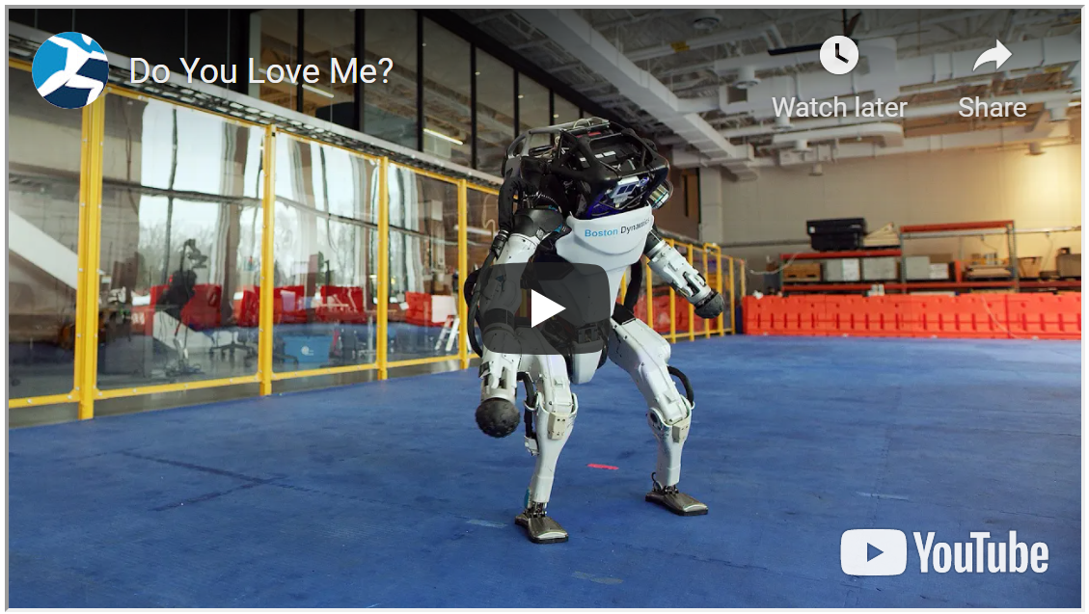

[Low mind perception condition]

This page will auto-advance in 90 seconds. Click the video to play and enjoy the video!
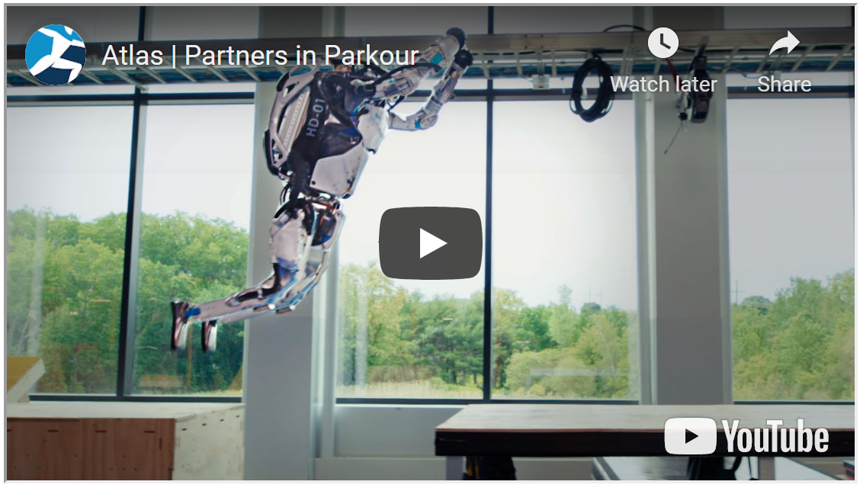

What was the video about?

- A robot moving boxes
- A robot dancing to music
- A robot doing parkour

Below is a short description of the Atlas you just saw in the video.
Please read the description and answer the following related questions.

Atlas is a humanoid robot intended to aid emergency services in search and rescue operations by searching, mapping, removing rubble, delivering supplies, providing medical treatment or evacuating casualties.
Atlas is designed to operate both outdoors and inside buildings. It is very adept at walking over a wide range of terrain, including snow or rough terrain. Atlas can perform potentially life-saving tasks in dangerous conditions: driving a utility vehicle, removing debris, climbing ladders, and shutting off valves.
Atlas uses its own sensors in its body to assess the environment and avoid obstacles. Its hands are capable of tasks using fine motor skills while using its two legs to balance. Atlas has two vision systems, a laser rangefinder, and stereo cameras, that are controlled by a computer. Based on all the sensory information and its goal, Atlas makes autonomous decisions without any real-time human intervention.
Atlas can help emergency-management workers tackle natural and man-made catastrophes by making rescues easier and less risky. In the future, Atlas can be more suited to everyday life, such as doing household chores like cleaning and sweeping floors, with the increased dexterity and fine motor skill.

Please indicate whether the statement below is true or false, according to the article that you just read.

- Atlas can help search and rescue operations in rough conditions.
- Atlas uses its own sensors to assess the environment and make decisions.
- Atlas will be able to help with household chores in the future

DECISION MAKING TASK

Please read the following situations and answer related questions.

A manufacturing company has provided its factory workers with regular meals at a cafeteria. But the dining facility is getting too old, and it needs major renovation. So, the company is considering providing its workers with a meal replacement drink, instead of regular meals, for their lunch.
Meal replacement shakes contain a complete blend of nutrients the body needs to function and thrive: carbohydrates, lipids, protein, and micronutrients. Each 400-calorie nutrition drink contains 20% of your daily vitamins and minerals. Providing meal replacement shakes could also reduce workers' lunch time, increasing the factory's productivity.
Please rate the extent to which you agree with the following statement.
(1 = Strongly disagree, 7 = Strongly agree)
- I like the idea of providing meal replacement shakes for workers.
- I support the idea of replacing workers' meals with meal replacement shakes.
- If I am the CEO of this company, I will provide meal replacement shakes to workers.

Your company is expanding its manufacturing facilities to abroad. Your company is also considering providing workers with a dormitory if they want to stay on-site. Because the dormitory will not be for a long-term residence, a capsule room could be an option.
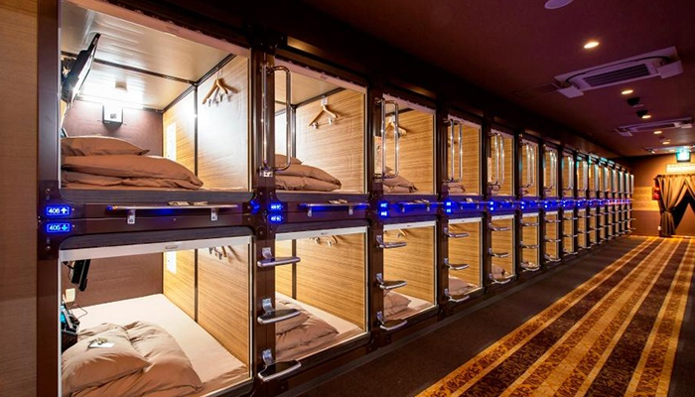
In the capsule dorm, the capsules will be stacked side-by-side, two units high, with steps or ladders providing access to the second level rooms, similar to bunk beds. Each capsule is a chamber roughly the length and width of a single bed, with sufficient height to crawl in and sit up on the bed. The capsule dormitory is a highly cost-effective way to accommodate a large number of people in a limited space.
Please rate the extent to which you agree with the following statement.
(1 = Strongly disagree, 7 = Strongly agree)
- I like the idea of building capsule rooms for a workers' dormitory.
- I support the idea of providing a capsule dormitory for workers.
- If I am the CEO of this company, I will approve capsule rooms as a workers' dormitory.

Your company is trying to "modernize" its warehouse management system. As one of the suggested improvements, your company is considering adopting a smart wristband.
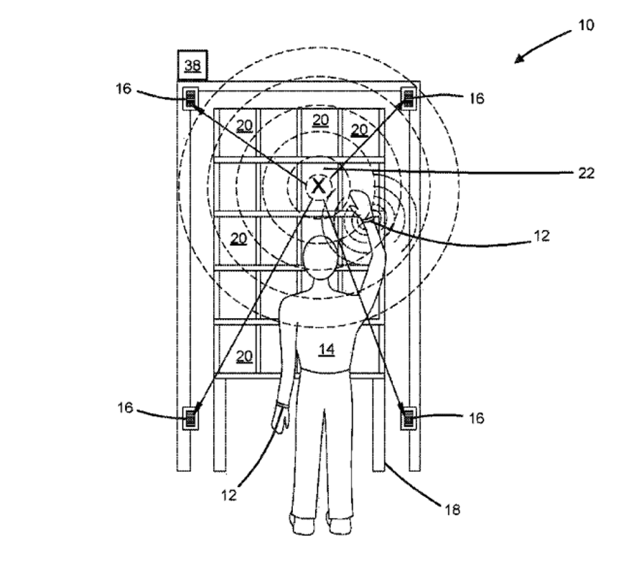
The smart wristband, as a personal digital manager of each worker at a warehouse, can monitor, time, and guide workers' every movement. The device will provide "haptic feedback" to steer the worker toward the right direction. It can also monitor a worker's location and whether the worker is "on" or "off" task, and automatically assign tasks. Your company expects that workers could fill orders much faster with the guidance from a wristband.
Please rate the extent to which you agree with the following statement.
(1 = Strongly disagree, 7 = Strongly agree)
- I like the idea of adopting a smart tracking wristband.
- I support the idea of using a behavioral tracking device to increase work efficiency.
- If I am the CEO of this company, I will approve the adoption of the smart wristband.

ROBOT PERCEPTION SURVEY
Below are questions about the robot, Atlas, that you saw in the previous section.
Please indicate your thoughts and feelings. (1 = Not at all, 7 = Very much)

- To what extent do you think it is capable of having goals?
- To what extent do you think it is capable of doing things on purpose?
- To what extent do you think it is capable of planning actions?
- To what extent do you think it is capable of having emotions?
- To what extent do you think it has complex feelings?
- To what extent do you think it is capable of experiencing pain and pleasure?
- To what extent do you think it has a good memory?
- To what extent do you think it is highly conscious?
- To what extent do you think it is capable of engaging in a great deal of thought?

Below are questions about your general thoughts.
Please indicate which describes you best. (1 = Strongly disagree, 7 = Strongly agree)

- I personally would like to have more power.
- I personally would like to have a stronger sense of control.
- I feel personally satisfied with the amount of power I have.
- I feel personally satisfied with the sense of control I have.

Please indicate your attitudes toward humans, in general.

Negative (1) – Positive (7)
Unfavorable (1) – Favorable (7)
Dislike (1) – Like (7)
Pessimistic (1) – Optimistic (7)

[Study 2]

CONSUMER PERCEPTIONS SURVEY
Now, you will see a short video of a bipetal humanoid robot, named Atlas. After seeing the video, there will be related questions to answer. Think carefully each question and give us your answers.
Please note that there are no right or wrong answers. We are just interested in your thoughts.

[High mind moderate condition] Same as High mind condition in Study 1
[Low mind moderate condition] Same as Low mind condition in Study 1
[High mind extreme condition]

This page will auto-advance in 90 seconds. Click the video to play and enjoy the video!

[Low mind extreme condition]

This page will auto-advance in 90 seconds. Click the video to play and enjoy the video!

What was the video about?

- A robot moving boxes
- A robot dancing to music
- A robot doing parkour

Below is a short description of the Atlas you just saw in the video.
Please read the description and answer the following related questions.

Atlas is a humanoid robot intended to aid emergency services in search and rescue operations by searching, mapping, removing rubble, delivering supplies, providing medical treatment or evacuating casualties.
Atlas is designed to operate both outdoors and inside buildings. It is very adept at walking over a wide range of terrain, including snow or rough terrain. Atlas can perform potentially life-saving tasks in dangerous conditions: driving a utility vehicle, removing debris, climbing ladders, and shutting off valves.
Atlas uses its own sensors in its body to assess the environment and avoid obstacles. Its hands are capable of tasks using fine motor skills while using its two legs to balance. Based on all the sensory information and its goal, Atlas makes autonomous decisions without any real-time human intervention.
What makes Atlas truly unique is its exceptional vision system far beyond human capabilities, which is particularly important for missions in the field. Beyond the spectrum of visible light waves, Atlas’ vision extends from deep infrared through extreme UV and all the way to X-ray frequencies and thermal vision. Simply put, it can “see through” thick walls to find objects or humans. If its view is obscured by environmental factors such as rain, smoke, or dirt, it can also automatically construct clear views of the “true” scene behind the distortion.
Atlas can help emergency-management workers tackle natural and man-made catastrophes by making rescues easier and less risky. In the future, Atlas can be more suited to everyday life, such as doing household chores like cleaning and sweeping floors, with the increased dexterity and fine motor skill.

Please indicate whether the statement below is true or false, according to the article that you just read.

- Atlas can help search and rescue operations in rough conditions.
- Atlas uses its own sensors to assess the environment and make decisions.
- Atlas will be able to help with household chores in the future

Please indicate whether Atlas can detect each type of wavelength, according to the description.

- Infrared light
- Visible light
- Ultraviolet light
- X-ray
- Gamma ray

ROBOT PERCEPTION SURVEY
Below are questions about the robot, Atlas, that you saw in the previous section.
Please indicate your thoughts and feelings. (1 = Not at all, 7 = Very much)

- To what extent do you think it is capable of having goals?
- To what extent do you think it is capable of doing things on purpose?
- To what extent do you think it is capable of planning actions?
- To what extent do you think it is capable of having emotions?
- To what extent do you think it has complex feelings?
- To what extent do you think it is capable of experiencing pain and pleasure?
- To what extent do you think it has a good memory?
- To what extent do you think it is highly conscious?
- How much do you think it is technologically advanced?
- How much do you think it uses sophisticated technologies?

HUMAN PERCEPTION SURVEY

In this section, you are going to answer your thoughts about "human" in general. Think about a random person you don't know personally, for example, a stranger on the street. Please indicate your thoughts and feelings to each question. (1 = Strongly disagree, 7 = Strongly agree)

- I feel like he/she would be open minded, like he/she could think clearly about things.
- I feel like he/she would be emotional, like he/she is responsive and warm.
- I feel like he/she would be superficial like he/she has no depth.
- I feel like he/she would be mechanical and cold, like a robot.
- I feel like he/she would be refined and cultured.
- I feel like he/she would be rational and logical, like he/she is intelligent.
- I feel like he/she would lack self-restraint, like an animal.
- I feel like he/she would be unsophisticated.

Finally, below are questions about Atlas that you saw in the first section of this survey. Please indicate your thoughts and feelings.
(1 = Strongly disagree, 7 = Strongly agree)

- The robot, Atlas, seems to lessen the value of human existence.
- The robot, Atlas, threatens the value of human existence.
- The robot, Atlas, blurs the line between human beings and machines.
- The robot, Atlas, makes me worry about my own job security.
- The robot, Atlas, makes me worry about my place in the world.
- The robot, Atlas, makes people like me less important.

[Study 3]

In this section, you are going to read about a new AI-powered service and answer related questions. Please read descriptions and questions carefully and answer questions.
[High socio-emotional capability condition]

Introducing EmpathicMind,
a groundbreaking AI-powered service revolutionizing psychological therapy by engaging directly with individuals. This cutting-edge tool acts as a virtual therapist, forging deep connections with patients through its exceptional emotional intelligence.
Operating within therapy sessions, EmpathicMind interacts with individuals through text or voice, creating an environment where people comfortably share their thoughts and emotions. Using advanced natural language processing, it comprehends conversational nuances, cross-referencing this information with an extensive medical database to provide insightful assessments of individuals’ current conditions and potential concerns.
By actively listening and responding with remarkable empathy, EmpathicMind fosters genuine connections and adapts interactions to resonate deeply with individuals seeking emotional support. Similar to a human therapist attuned to subtle cues, its sophisticated algorithms perceive emotions from fleeting micro-expressions, body language, tonal variations, and conversational nuances during therapy sessions.

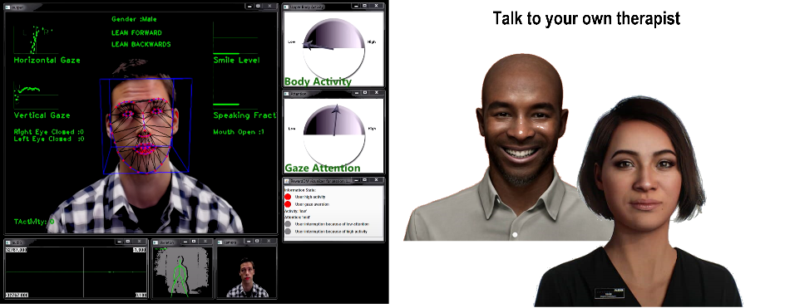
This unique fusion of cutting-edge AI capabilities and emotional intelligence allows EmpathicMind to provide compassionate, personalized, and effective therapy. This innovative tool not only expedites the diagnostic process but also cultivates a supportive environment where individuals feel understood and heard, ultimately improving the quality of mental health care and its outcomes. EmpathicMind represents a pivotal advancement in mental health care, reshaping how people access and experience therapeutic support in the digital age.

Please indicate whether the statement below is true or false, according to the article that you just read.

- EmpathicMind is a virtual therapist that interacts with people directly.
- EmpathicMind, even with recent developments, cannot understand people's subtle emotions.
- People can develop a meaningful emotional connection with EmpathicMind.

[High cognitive capability condition]

Introducing InsightMind,
a groundbreaking AI-powered service revolutionizing medical diagnosis by providing precise and holistic insights into individuals’ mental health conditions. This cutting-edge tool serves as an invaluable decision aid, monitoring individuals’ progress throughout their therapy with its exceptional cognitive intelligence.
Integrated into diagnostic procedures, InsightMind conducts intricate medical analyses of diverse visual data, such as MRI, functional MRI, EEG, and PET scans, to examine individuals' subtle anomalies and changes. In addition, it analyzes the dialogue between doctors and patients, comprehends conversational nuances, and cross-references this information with an extensive medical database to provide insightful assessments.
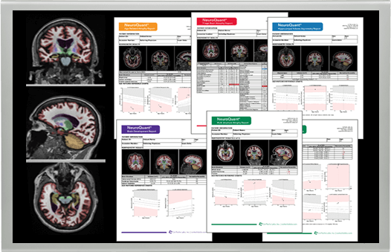
By thoroughly analyzing this integrated data, InsightMind enhances diagnostic accuracy and guides informed decision-making for treatment planning. Similar to human cognition in learning and extrapolating knowledge from limited information, its sophisticated algorithms highlight areas of concern for further examination and recommend tailored therapeutic approaches encompassing medications and behavioral interventions.
This unique fusion of cutting-edge AI capabilities and medical expertise allows InsightMind to provide accurate, personalized, and effective treatment plans. This innovative tool not only expedites the diagnostic process but also facilitates timely interventions, ultimately improving the quality of mental health care and its outcomes. InsightMind represents a pivotal advancement in mental health diagnosis, reshaping how people access and experience therapeutic support in the digital age.

Please indicate whether the statement below is true or false, according to the article that you just read.

- InsightMind can analyze visual and text data.
- InsightMind does not suggest any treatment plans due to its lack of medical knowledge.
- InsightMind can improve the accuracy and quality of mental health diagnosis.

[Control (Low socio-emotional, Low cognitive) condition]
Introducing Mind Pre-check,
an innovative AI-powered service streamlining between psychiatrists and patients by processing comprehensive pre-surveys via an online platform. This cutting-edge tool serves as an essential precursor, facilitating more effective and efficient therapy sessions between doctors and their patients.
Before their initial appointment, individuals conveniently fill out pre-surveys online, covering general information, standardized tests for depression, anxiety, or stress levels, and self-reports in a written form about personal experiences such as trauma, family background, substance use and more. Mind Pre-check, leveraging advanced AI algorithms, meticulously analyzes these survey responses and generates detailed summary statistics and reports.
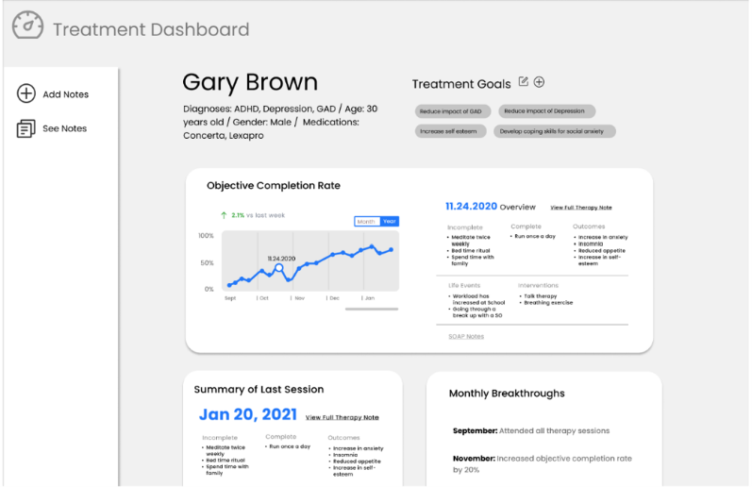
While not providing any direct diagnoses of potential mental health issues, Mind Pre-check provides doctors with essential insights extracted from these pre-assessments. Its algorithms process and summarize survey data, facilitating a smoother entry into sessions, streamlining the initial phases of therapy, and enabling a more thorough exploration of individuals' mental health concerns.
This unique fusion of cutting-edge AI capabilities and survey data processing allows Mind Pre-check to help doctors provide informed, efficient, and effective therapy. This innovative tool not only automates relatively simple, repetitive tasks but also expedites the diagnostic process, ultimately improving the quality of mental health care and its outcomes. Mind Pre-check represents a pivotal advancement in mental health diagnostics, reshaping how people access and experience therapeutic support in the digital age.

Please indicate whether the statement below is true or false, according to the article that you just read.

- Mind Pre-check generates reports from survey responses.
- Mind Pre-check analyzes people's subtle emotions from their facial expression, body language, tonal variations etc.
- Mind Pre-check automates relatively simple, repetitive tasks typically done by humans.
Below are questions about how you think about the
[EmpathicMind, an AI-powered virtual therapy program (High socio-emotional condition)];
[InsightMind, an AI-powered medical diagnosis program (High cognitive condition)];
[Mind Pre-check, an AI-powered survey analysis program (Control condition)]
described in the previous section. There is no right answer. Please indicate your thoughts and feelings to each question.

Same mind perception measure used in Studies 1 and 2

In this section, you are going to answer about your thoughts about "human", in general. Think about a random person you don't know personally, for example, a stranger on the street. Please indicate your thoughts and feelings to each question.
Same dehumanization measure used in Study 2

[Study 4]

SECTION 1

Now, you will read a short article about recent developments of Artificial Intelligence (AI) and experts' opinions about AIs and robots. After reading the article, there will be a couple of questions to answer. Read carefully the article and give us your answers.

[High Socio-emotional capability condition]

The Evolving AI: Advancements in Cognitive Fluency and Emotional Intelligence

Advancements in AI and robotics have transformed various industries, revolutionizing how tasks are performed and reshaping the way we interact with technology. These advancements have significantly impacted sectors such as healthcare, manufacturing, and even daily life. With AI's ability to process vast amounts of data at incredible speeds, coupled with robotics' physical capabilities, we're witnessing a new era of innovation that's enhancing efficiency, productivity, and personal well-being across multiple domains.

One fascinating development showcasing AI's resemblance to human cognitive abilities is in the realm of medical diagnostics. AI models, specifically in healthcare, demonstrate a capacity similar to human learning from limited data. For instance, with only a handful of labeled medical images or patient records, these AI systems can identify diseases or anomalies in medical scans, such as X-rays or MRIs, akin to how a medical student learns to diagnose conditions from observing a few cases. This ability to draw insights from sparse data signifies a resemblance to human cognitive processes of learning and generalizing knowledge, contributing significantly to improved healthcare diagnostics and patient care.

Further, emotional and social capabilities of AIs have become astonishing. AI systems now possess an exceptional capacity to accurately understand and respond to human emotions. Much like the way people understand others’ emotions, AIs with emotional intelligence can “feel” emotions from fleeting micro-expressions, subtle tonal variations, and conversational nuances. This heightened emotional intelligence empowers AI to respond with remarkable empathy and adapt its interactions accordingly, forging deeper and more meaningful connections with individuals. For instance, social robots like Peppers are utilized for providing emotional support, assisting autistic children in learning social cues, or even serving as companions for the elderly.

Please indicate whether the statement below is true or false, according to the article that you just read.

- Recent AIs can learn and generalize knowledge from a limited data set.
- AIs, even with recent developments, cannot understand subtle emotions.
- Social robots can provide emotional support and serve as true companions of people.

[Low socio-emotional capability condition]

The Evolving AI: Advancements in Cognitive Fluency amid Emotional Constraints

Advancements in AI and robotics have transformed various industries, revolutionizing how tasks are performed and reshaping the way we interact with technology. These advancements have significantly impacted sectors such as healthcare, manufacturing, and even daily life. With AI's ability to process vast amounts of data at incredible speeds, coupled with robotics' physical capabilities, we're witnessing a new era of innovation that's enhancing efficiency, productivity, and personal well-being across multiple domains.

One fascinating development showcasing AI's resemblance to human cognitive abilities is in the realm of medical diagnostics. AI models, specifically in healthcare, demonstrate a capacity similar to human learning from limited data. For instance, with only a handful of labeled medical images or patient records, these AI systems can identify diseases or anomalies in medical scans, such as X-rays or MRIs, akin to how a medical student learns to diagnose conditions from observing a few cases. This ability to draw insights from sparse data signifies a resemblance to human cognitive processes of learning and generalizing knowledge, contributing significantly to improved healthcare diagnostics and patient care.

On the other hand, emotional and social capabilities of AIs are still tethered to limitations in accurately understanding and responding to human emotions. Despite advancements in recognizing faces and processing natural language, AI systems frequently exhibit errors in comprehending the complexity and contextual nature inherent in human emotions. Additionally, while AI can simulate empathy, its responses are algorithmically generated and lack genuine emotional understanding – it can’t really “feel” emotions like people do. This limitation impedes AIs and AI-powered social robots from being true companions capable of providing holistic emotional support, as they lack the intrinsic human empathy and intuition crucial in deeply understanding and connecting with individuals on an emotional level.

Please indicate whether the statement below is true or false, according to the article that you just read.

- Recent AIs can learn and generalize knowledge from a limited data set.
- AIs, even with recent developments, cannot understand subtle emotions.
- Social robots can provide emotional support and serve as true companions of people.

SECTION 2

Below are questions about how you think about AIs and AI-powered robots, in general. There is no right answer. Please indicate your thoughts and feelings to each question.

Same mind perception measure used in Studies 1 and 2

Please take a moment and think about machines and humans.
Using the scale below, indicate where you would position recent AI-powered agents.

(Left: pure object with no intelligence at all;
Right: fully developed, mentally and emotionally mature human)

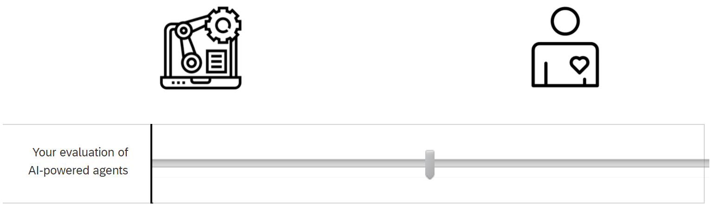

Now, using the same scale below, indicate where you would position people, in general. Think about a random person you don't know personally, for example, a stranger on the street.
(Left: pure object with no intelligence at all;
Right: fully developed, mentally and emotionally mature human)
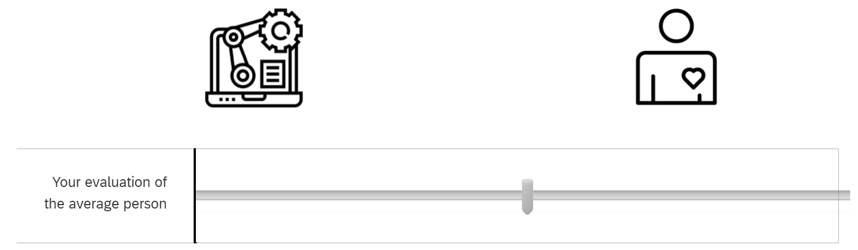

Thank you for your participation.
Once data collection is completed, we are going to randomly select participants of this survey and send them a $25 gift card of their choice, either Amazon or Costco.
Before choosing which gift card you would prefer, please read the recent news article below.
Amazon’s Global Work Conditions Under Fire: Reports Highlight Dehumanizing Practices
Amid mounting concerns over Amazon's treatment of its workforce, a recent fine of $60,269 has been levied against the tech giant, further fueling the discourse surrounding its dehumanizing work conditions. The fine, issued as a penalty for safety violations in certain warehouses, underscores the persistent challenges faced by employees within Amazon's facilities.
In 2022, UNI Global Union surveyed 2,000 Amazon workers from eight different countries. Their survey found that the unsafe and dehumanizing conditions detailed in the Department of Labor’s latest meager fine of Amazon is not relegated to a few warehouses in the United States, but standard operating procedure across Amazon warehouses, delivery networks and even at office buildings, around the world.
The results showed that a “majority of workers surveyed expressed their belief that Amazon’s monitoring of their work performance is excessive and opaque, that its expectations are unrealistic, and that striving to meet these unrealistic expectations has negative effects on their physical health and, even more acutely, their mental health.”
In the survey, workers described how Amazon treats its employees like robots –never stopping, never letting our minds wander off task.
“Technology has enabled employers to enforce a work pace with no room for inefficiency, squeezing every ounce of downtime out of workers’ days. The scan gun I used to do my job was also my own personal digital manager. Every single thing I did was monitored and timed. After I completed a task, the scan gun not only immediately gave me a new one but also started counting down the seconds I had left to do it.”
If you want to read the full report, click the link: “Life in the Amazon Panopticon: An international survey of Amazon Workers.”

Please indicate which gift card you would like to choose. (gift cards can be used both online and offline)
- Amazone
- Costco (no membership needed)

[Study 5]

In this section, you are going to read about a new AI-powered service and answer related questions. Please read descriptions and questions carefully and answer questions.

[High socio-emotional condition]
Introducing our groundbreaking emotional intelligence-powered voicebot service, elevating customer interactions to a new level of convenience and understanding. You can talk naturally, without the need to listen to menus or press number on a keypad, just as if you were speaking to a human operator. Powered by natural language processing and machine learning technology, our voicebots continually learn how to understand human intentions expressed through speech and upgrade their responses based on the behavior and history of a customer.
Say goodbye to robotic, impersonal interactions. Our voicebot goes beyond understanding human language. It analyzes tonal variations and subtle nuances in conversation, extracts emotions, and responds with a natural-sounding voice that adapts its tone – cheerful, empathetic, neutral, or uncertain – to suit each situation and meet your emotional needs. This dynamic interaction ensures that every customer feels heard and understood. With our voicebot’s emotional intelligence, your interaction will become empathetic, supportive, and personalized.
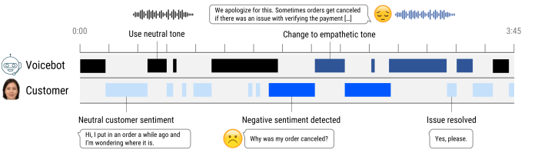

Please indicate whether the statement below is true or false, according to the article that you just read.

- The voicebot recognizes and understands human emotions.
- The voicebot, even with recent developments cannot understand tonal variations or subtle nuances in language
- The voicebot changes its tone depending on the situation and emotions of the interaction partner.

[Low socio-emotional condition]
Introducing our groundbreaking artificial intelligence-powered voicebot service, elevating customer interactions to a new level of convenience and understanding. You can talk naturally, without the need to listen to menus or press number on a keypad, just as if you were speaking to a human operator. Powered by natural language processing and machine learning technology, our voicebots continually learn how to understand human intentions expressed through speech and upgrade their responses based on the behavior and history of a customer.
Say goodbye to repetitive conversations. When a complex issue arises, our voicebot seamlessly connects you with the most suitable human operator. It generates a summary report that includes your issue, goals or priorities, and essential details such as order numbers, sparing you the frustration of repeating the same basic information. This proactive approach not only saves you time but also ensures a smooth transition between AI and human support. With our voicebot’s enhanced intelligence, your interaction will become effortless, efficient, and personalized.
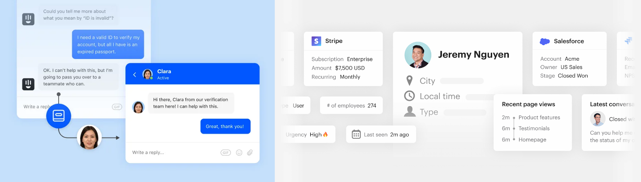

Please indicate whether the statement below is true or false, according to the article that you just read.

- The voicebot generates a summary report based on the interaction.
- The voicebot analyzes people's subtle emotions from their facial expression, body language, tonal variations etc.
- Using this voicebot, customers do not have to provide the same detailed information to human operators.

Below are questions about how you think about the voicebot, an emotional intelligence-powered customer service program [High socio-emotional] / voicebot, an artificial intelligence-powered customer service program [Low socio-emotional] described in the previous page. There is no right answer. Please indicate your thoughts and feelings to each question.
Same mind perception measure used in Studies 1 and 2

Please take a moment and think about AI-powered autonomous agents and humans. Using the scale below, indicate where you would position the voicebot, an emotional intelligence-powered customer service program [High socio-emotional] / voicebot, an artificial intelligence-powered customer service program [Low socio-emotional].

(Left: pure object with no intelligence at all;
Right: fully developed, mentally and emotionally mature human)

Now, using the same scale below, indicate where you would position customer service agents. Consider a human operator whom you randomly connect with when calling a customer service center.
(Left: pure object with no intelligence at all;
Right: fully developed, mentally and emotionally mature human)
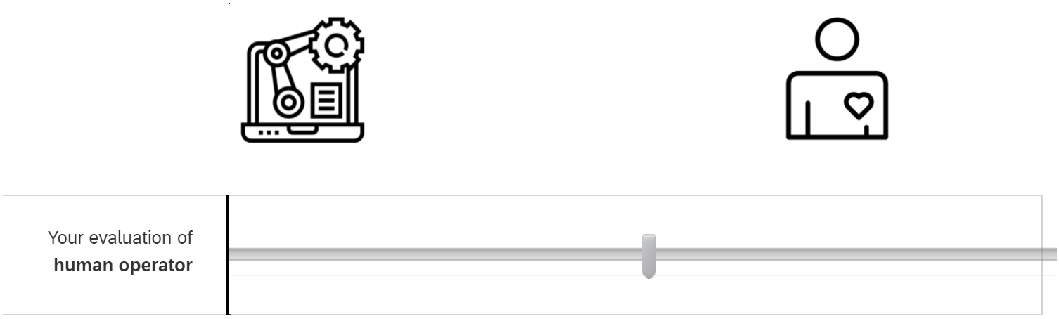

Thanks for your participation!
The company behind the voicebot, the AI-based customer service program, is planning a fundraising campaign for customer service personnel.
It has been known that customer service agents, including call center employees, have a higher risk of emotional stress and mental health issues compared to employees in other industries.
The funds raised will be directed towards the well-being of customer service staff at partner companies that have adopted the voicebot. This fund will specifically support programs designed to improve the mental health of these employees, including access to psychological therapy.
Once we finish data collection of this research, you are going to receive a bonus payment of $0.25. Would you support and donate the bonus to this campaign for customer service agents?
- Yes
- No

Online Appendix H: Supplemental study stimuli

[Supplemental Study A]

CONSUMER PRODUCT SURVEY
Now, you will see a description of a consumer product. After reading the description, there will be a couple of questions to answer. Think carefully each question and give us your answers.
Please note that there are no right or wrong answers. We are just interested in your opinions.
[High socio-emotional condition]

Meet Mirror, a smart mirror for your home training!
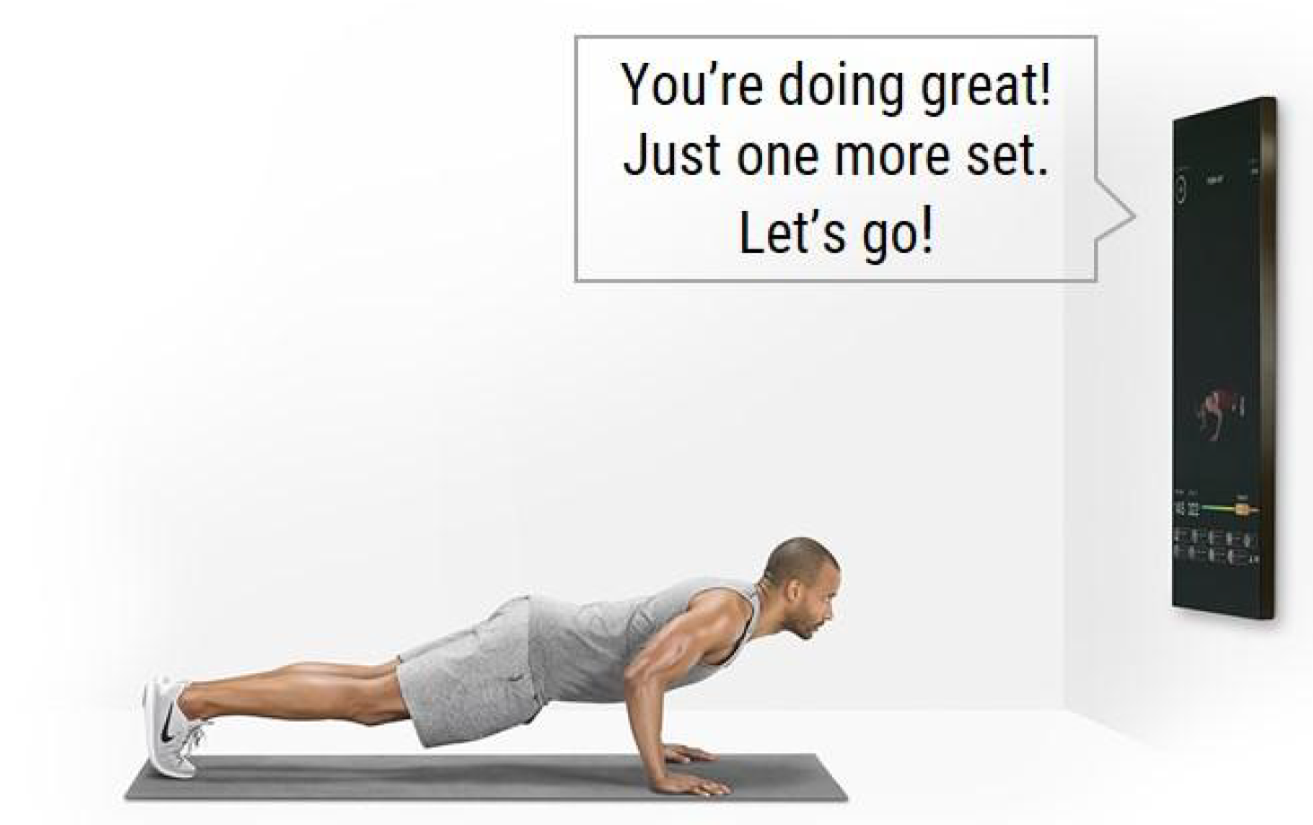
Of course, Mirror isn't an ordinary mirror. It looks just like one when it's turned off, measuring 22 inches wide, 52 inches high and a little over an inch deep. But embedded inside its large frame is actually a virtual personal trainer, who comes to life when it's switched on.
Mirror provides you with a customized workout plan. Just tell Mirror that you have a bad knee, for instance, so instead of doing the jumps on screen, you're offered an alternate workout, such as squats. If you tell Mirror that you recently had back surgery, Mirror will recommend the right classes for you to take — Mirror offers cardio, strength, yoga, Pilates, barre, boxing, and stretch, with levels ranging from beginner to expert.
It’s all about encouragement!
The most important thing in home training is to stay motivated and make yourself DO workout. Oftentimes you set your exercising goal and start ambitiously only to quit after a month. Mirror helps to make sure you maintain your motivation. As an interactive virtual trainer that gets to know you, Mirror tracks your progress and workout routine and “nudge” you to stay on track -- it might send you a friendly reminder when you skip workout for days!
You can also tell Mirror your goals, preferences and share biometrics. Then, Mirror will encourage you to workout harder if you’re below your target heart rate zone. During workout, Mirror can also understand your facial expressions, and it gives personal shout-outs and cheers you on the whole way!

Please indicate whether the statement below is true or false, according to the description that you read.

- Mirror can provide a customized workout plan for each user.
- Mirror tracks your progress and may send personal messages to keep you motivated.
- Mirror can understand your facial expressions and cheers you during workout.

[Low socio-emotional condition]

Meet Mirror, a smart mirror for your home training!
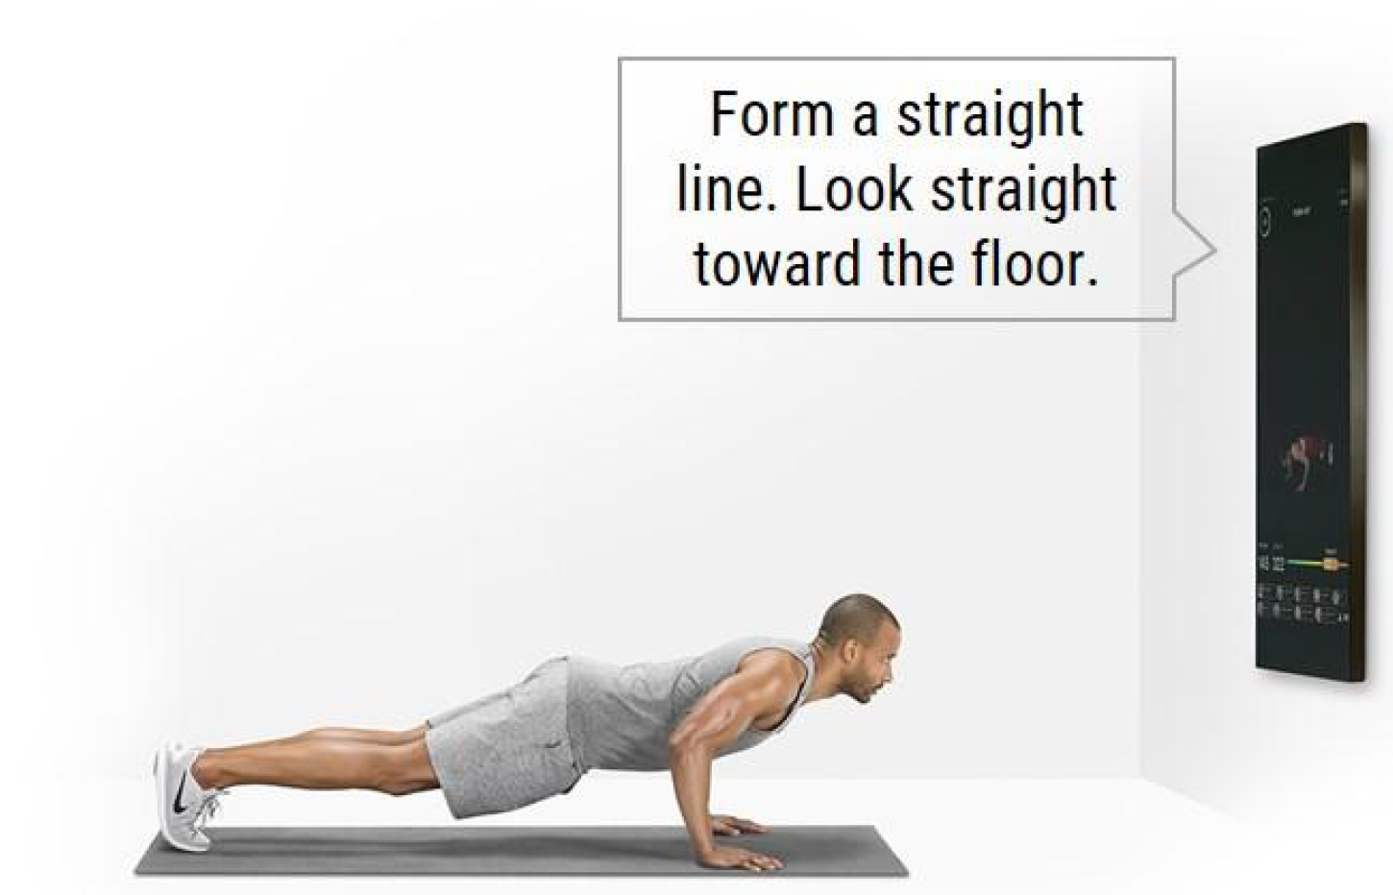
Of course, Mirror isn't an ordinary mirror. It looks just like one when it's turned off, measuring 22 inches wide, 52 inches high and a little over an inch deep. But embedded inside its large frame is actually a virtual personal trainer, who comes to life when it's switched on.
Mirror provides you with a customized workout plan. Just tell Mirror that you have a bad knee, for instance, so instead of doing the jumps on screen, you're offered an alternate workout, such as squats. If you tell Mirror that you recently had back surgery, Mirror will recommend the right classes for you to take — Mirror offers cardio, strength, yoga, Pilates, barre, boxing, and stretch, with levels ranging from beginner to expert.
It’s all about measurement and accuracy!
The most important thing in home training is to make sure you are doing the workout in the RIGHT way. Oftentimes you don't know your shoulders are hunched until somebody says it. Mirror helps to make sure you have the right posture and form. Powered by advanced camera technology and machine learning, Mirror instantly calculates the angle of your body parts and gives real-time feedback to correct your posture and get the most out of the workout.
You can also tell Mirror your goals, preferences, and share biometrics. Then, Mirror will track your ability and automatically adjust the workout program to reach your target heart rate zone. During workout, Mirror provides bio feedback and stats – your heart rate, exertion level, calories burnt are displayed real-time.

Please indicate whether the statement below is true or false, according to the description that you read.

- Mirror can provide a customized workout plan for each user.
- Mirror provides real-time feedback about your posture during workout.
- Mirror can understand your facial expressions and cheers you during workout.

- How much do you like the concept of this smart mirror?
- How much do you think you can trust the quality of this smart mirror?
- How much do you think you can get useful help from this smart mirror?
- How much are you interested in using this smart mirror?

Below are questions about the Mirror that you read in the previous page.
Please indicate your thoughts and feelings. (1 = Not at all, 7 = Very much)

Same mind perception measure used in Studies 1 and 2

DECISION MAKING TASK
Please read the following situations and answer related questions.
Same negative treatment questions used in Study 1

[Supplemental study B]

SECTION 1

Now, you will read a short article about recent developments of Artificial Intelligence (AI) and experts' opinions about AIs and robots. After reading the article, there will be a couple of questions to answer. Read carefully the article and give us your answers.

[High socio-emotional condition]
The Next Technological Revolution

Households are about to be upended, for the better, one more time courtesy of the technology industry. Artificial Intelligence (AI), which is already in many homes in the form of digital assistants such as Amazon’s Alexa and other smart devices, promises to get better and do more very quickly.
Experts have noted that these devices, although very simple now, will soon be able to engage in natural language conversation. That ability can be used to do chores for households such as calling a restaurant and speaking to the hosts/hostesses, who may not be at all aware that they are speaking to an AI. These devices with AI can schedule a car tune-up or a furnace repair. That ability will also ease much of the loneliness people living alone commonly feel as speaking to them will be familiar, interesting, and comfortable.

Further, AIs can learn so that their reactions are not just pre-programmed responses but are instead constructed for the situation. Each AI will learn and change in its own way, becoming a distinct entity.
Finally, AIs can learn to recognize human emotions and respond appropriately, offering comfort where needed. For example, AIs learn to detect emotions in humans through voice, body language, facial expressions, and so on, in much the same way that we detect changes in emotional moods of our loved ones, friends, or work colleagues. In the near future, personal devices might be able to support us emotionally better than people around us.

Please indicate whether the statement below is true or false, according to the article that you just read.

- AIs will use text, not voices, to make a restaurant reservation.
- AIs and robots are flexible, not just following pre-programmed commands.
- AIs and robots will be able to feel emotions as people do.

[Low socio-emotional condition]
The Next Technological Revolution

Households are about to be upended, for the better, one more time courtesy of the technology industry. Artificial Intelligence (AI), which is already in many homes in the form of digital assistants such as Amazon’s Alexa and other smart devices, promises to get better and do more very quickly.
Experts have noted that these devices, although very simple now, will soon be able to engage in natural language conversation. That ability can be used to do chores for households such as calling a restaurant and speaking to the hosts/hostesses, who may not be at all aware that they are speaking to an AI. These devices with AI can schedule a car tune-up or a furnace repair. That ability will also ease much of the loneliness people living alone commonly feel as speaking to them will be familiar, interesting, and comfortable.

Further, AIs can learn so that their reactions are not just pre-programmed responses but are instead constructed for the situation. Each AI will learn and change in its own way, becoming a distinct entity.
Finally, AIs can learn to recognize human emotions and respond appropriately, offering comfort where needed. However, importantly, AIs will never actually feel these emotions and really understand what people experience. For example, AIs can learn to detect and analyze superficial signals in human voice, body language, facial expressions, and so on, but such AIs cannot generate feelings and share emotions with people.

Please indicate whether the statement below is true or false, according to the article that you just read.

- AIs will use text, not voices, to make a restaurant reservation.
- AIs and robots are flexible, not just following pre-programmed commands.
- AIs and robots will be able to feel emotions as people do.

Below are questions about how you think about Artificial Intelligence (AI) and robots, in general.
There is no right answer. Please indicate your thoughts and feelings to each question.
(1 = Not at all, 7 = Very much)

Same mind perception measure used in Studies 1 and 2
SECTION 2

Below are questions about "human" in general. For example, a random person whom you might bump into on streets, but you don't know personally. Please indicate your thoughts and feelings to each question.

Same dehumanization measure used in Studies 2 and 3

Thank you for your participation.
In addition to your compensation, you can enter a drawing to win a $25 gift card. Before choosing which gift card you would prefer, please read the recent article below.
Amazon's employment practices have been labeled "deadly and dehumanizing" in a report by a New York labor union.
A New York labor union has published a scathing report on Amazon, just as the company prepares to move into New York City under its new second-headquarters plan. The report from the Retail, Wholesale and Department Store Union (RWDSU) cited grueling, dangerous conditions at Amazon warehouses. It has been alleged that the daily work targets at the company were so strict, the employees were forced to urinate in bottles as leaving the workplace even for a moment was a sure way to miss them. Others claimed that the company “arranged to have paramedics parked in ambulances outside” some of its warehouses in the summertime instead of installing proper air conditioning.
Amazon has faced numerous allegations of maintaining an awful working atmosphere at their facilities. Back in 2017, a journalist James Bloodworth went undercover at one of the company’s warehouses, claiming that workers were treated like “robots” or “slaves,” being forced to work long shifts until they literally collapsed.
The company, however, has repeatedly denied the accusations, claiming that their warehouses were perfectly safe places to work, and they respect the rights of their employees.

Please indicate which gift card you would like to receive if you win a lottery.
- Amazon
- Costco (no membership needed)

[Supplemental study C]

Thank you for participating in this survey!
You are going to participate in a consumer survey about a new online shopping platform before its launch. Please read descriptions and questions carefully and answer questions.

[High Anthropomorphism AI condition]
Below is the description of an interior furniture shopping platform, called Mango.
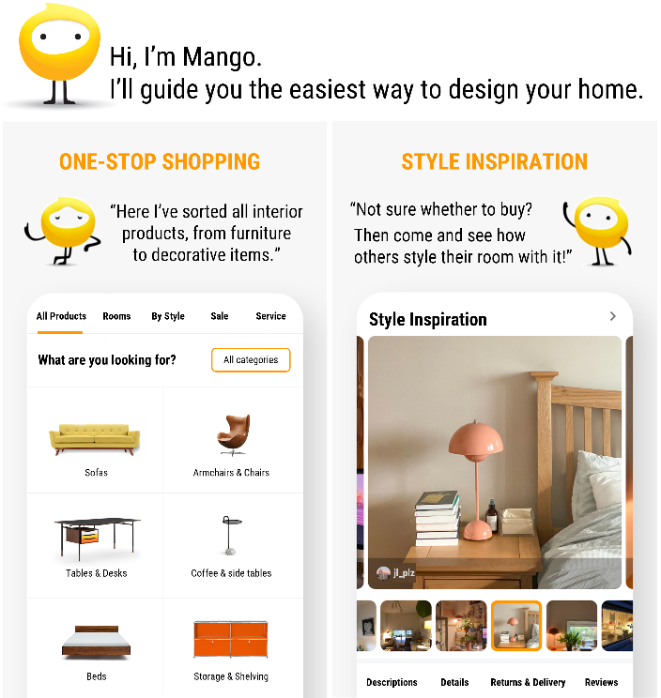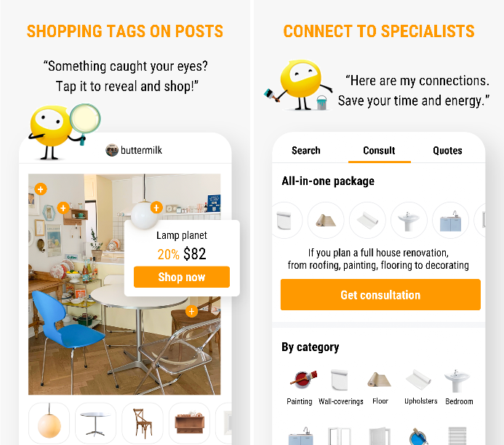

Mango also provides a personalized design service enabled by an Artificial Intelligence (AI) that does the job of an interior designer.
Below is the description about how Mango the Designer service works.
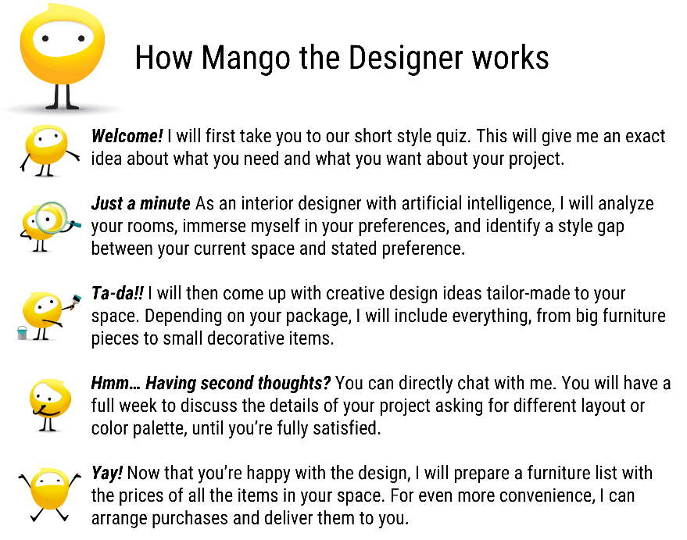
Below is a sample customer interaction with the AI. Customers can talk naturally with the AI as they do with other people. Customers can use either text or even voice to discuss their design details with their AI designer.
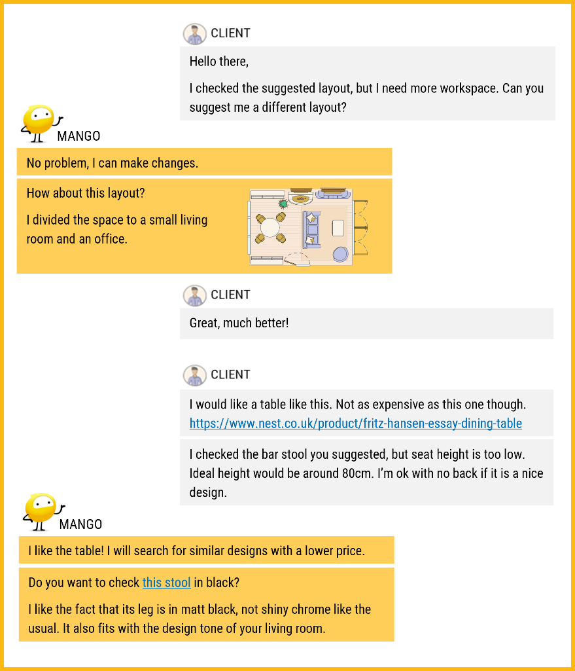

Please indicate whether the statement below is true or false, according to the description that you just read.
- The interior service is provided by an algorithm, not by a human designer.
- Mango will provide design ideas based on your preferences.
- Users can interact with Mango naturally, using their voice.

[Low Anthropomorphism AI condition]
Below is the description of an interior furniture shopping platform, called Mango.
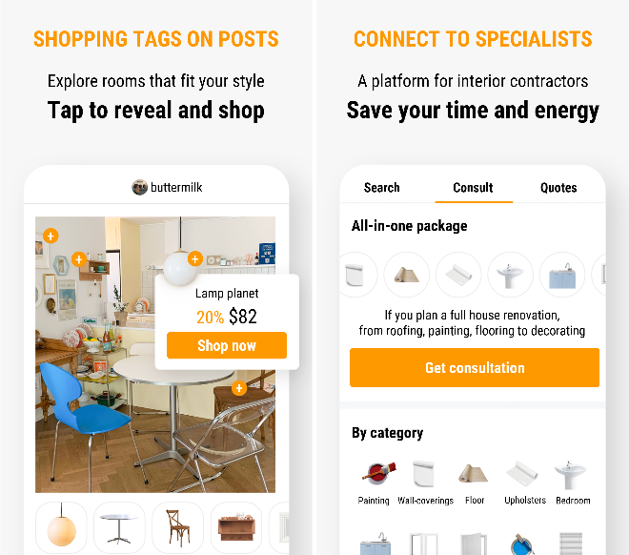

Mango also provides a personalized design service enabled by an Artificial Intelligence (AI) system.
Below is the description of how the Mango Plus service works.

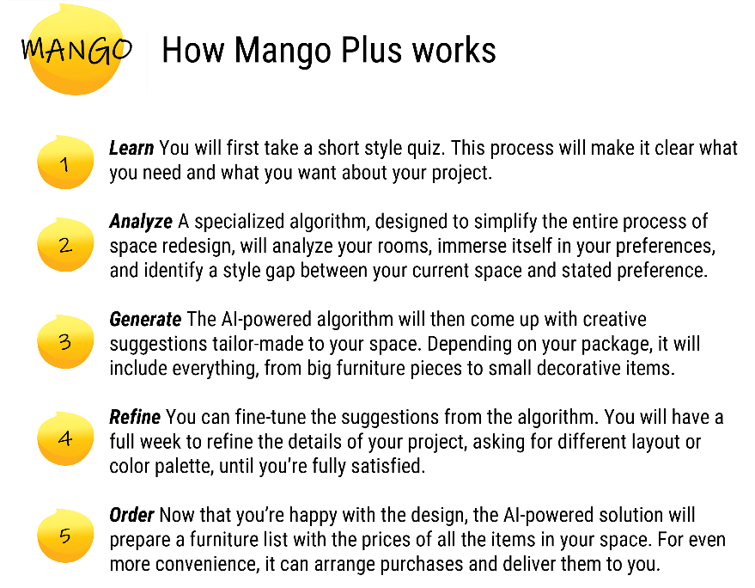
Below is a sample customer interaction with the AI. Currently, customers cannot "talk" naturally with the AI as they do with other people. The AI offers users the chance to choose from several options, and users communicate with the AI by clicking one of the options provided. If an issue is too complex, the AI relays it to a human designer.
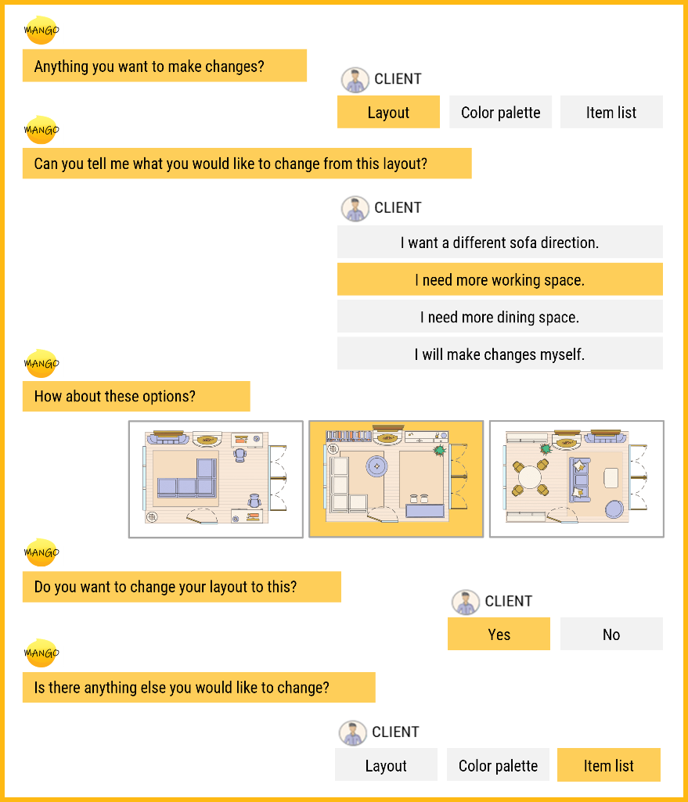

Please indicate whether the statement below is true or false, according to the description that you just read.
- The interior service is provided by an algorithm, not by a human designer.
- Mango will provide design ideas based on your preferences.
- Users can interact with Mango naturally, using their voice.

[High Anthropomorphism non-AI condition]
Below is the description of an interior furniture shopping platform, called Mango.

Please indicate whether the statement below is true or false, according to the description that you just read.
- Users can get home décor ideas from other users’ posts.
- Users can directly purchase tagged items on photos.
- Users cannot get information about interior contractors on this platform.

[Low Anthropomorphism non-AI condition]
Below is the description of an interior furniture shopping platform, called Mango.

Please indicate whether the statement below is true or false, according to the description that you just read.
- Users can get home décor ideas from other users’ posts.
- Users can directly purchase tagged items on photos.
- Users cannot get information about interior contractors on this platform.

- How much do you like the concept of this service?
- How much do you think you can trust the quality of this service?
- How much do you think you can get helpful suggestions from this service?
- How much are you interested in using this service?

Please keep reading the following and answer related questions:

When you sign up for an interior design service from Mango, it will offer 5,000 welcome bonus points, which is worth approximately $50. You can use the points when you purchase any additional services from Mango or when you order furniture and other decorative items for your interior project.
The company is also considering running a campaign where users can donate their points to a charity as below.


Please indicate how many points you would like to donate to the charity if you are awarded 5,000 points. (Please use numbers only between 1 to 5000) If you don’t want to donate your points, please write down 0 in the text box below.

Once the shopping platform is launched, we are going to randomly select participants of this survey and give 5,000 points to use on the platform without any restrictions.



A pretest (N = 80) verified that people evaluate each action of a company in the scenarios as negative (a composite score of four 7-point bipolar measures: negative – positive, inconsiderate – considerate, cold-hearted – warm-hearted, unkind – kind). A meal replacement shake (α = .94; M = 2.20, t(79) = 11.25, p < .001), a micro-capsule room (α = .98; M = 3.45, t(79) = 2.92, p = .002), and a behavioral tracking device for workers (α = .94; M = 2.54, t(79) = 15.49, p < .001) were rated significantly below the midpoint (4).

