Supplementary Figures (Link: https://docs.google.com/document/d/1NVLGW-pG1Fsr1TauMTcmOc74gLs7ZeE7o6sZSUPONJY/edit?usp=sharing)

Supplementary Tables (Link: https://docs.google.com/spreadsheets/d/1a2gTlOSlzP7FOiiZExeEi8QOPvRaqjkf/edit?usp=sharing&ouid=117559917419234773214&rtpof=true&sd=true)
Table S1: Shannon Alpha Diversity Index and Observed ASV Richness calculated for each temperature-nutrient treatment combination and for sampling populations (Cherry Point or Turn Rock) before experiment (T_{o}) and at the end of the experiment (T_{f}). Results are shown in Figure 4.

Table S2: Analysis of Variance (ANOVA) of Shannon Alpha Diversity Index and Observed ASV Richness with regards to temperature, DIN availability, and site effects. Significance values are *** for p < 0.001, ** for p < 0.01, * for p < 0.05, and for p < 0.01. Significant p values are bolded. Results are shown in Figure 4.

Table S3: Tukey HSD post-hoc results for T_{f} ANOVA of Observed ASV Bacterial Richness. Only factors that were found to be significant in the ANOVA are shown here. Significant p_{adj} are in bold. Results are shown in Figure 4.

Table S4: Bray-Curtis Permutational Analysis of Variance (PERMANOVA) of kelp blade microbiomes before and after experimental incubation with regards to temperature, DIN availability, and collection site of the kelp blade. PERMANOVAs were conducted for all kelp blade microbiomes at T_{o}, all kelp blade microbiomes at T_{f}, and kelp blade microbiomes split into site groupings at T_{f}. Significance values are *** for p < 0.001, ** for p < 0.01, * for p < 0.05, and for p > 0.05 and >0.10. Results are shown in Figures 1 and 2.

Table S5: Similarity Percentage (SIMPER) analysis of 3 temperature treatments. All taxa present in this table were significantly enriched in abundance when comparing T_{o} to T_{f} at a p<0.05 significance level. Results are shown in Figure 3.

Table S6: Beta Dispersion using the Bray-Curtis dissimilarity metric analysis of 3 temperature treatments and 2 nitrogen treatments before and after experiment. Significance is found at the p <0.05 level.

APPENDIX

Figure S1: Principal Coordinates Analysis (PCoA) of kelp blade microbial communities from Turn Rock and Cherry Point and seawater microbiomes from incoming seawater to the experimental mesocosms

after the experimental manipulation of temperature and nutrients. Each point on the PCoA represents the microbiome of a specific kelp blade. PCoA of kelp blade microbiomes

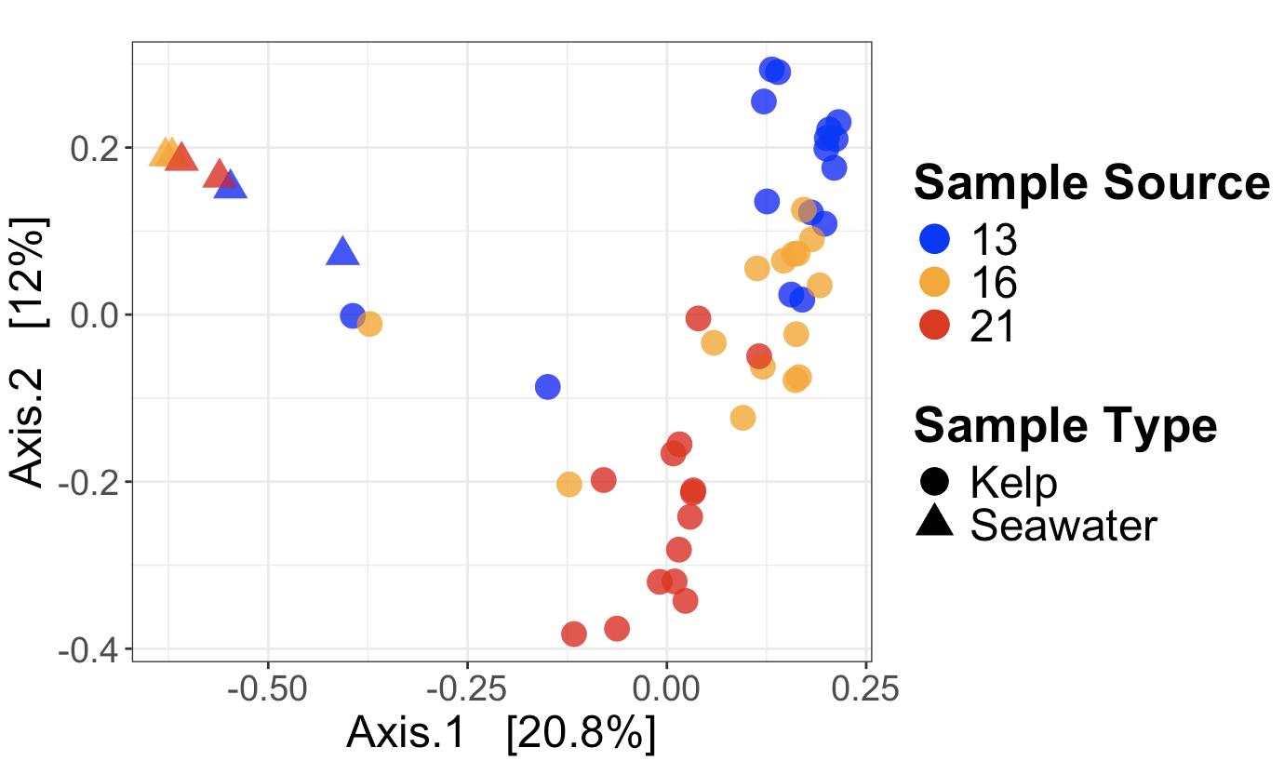

Figure S2: The relative decrease or increase in abundance of microbial taxa. The taxa that changed significantly are shown with a Log2FoldChange metric based on the number of reads for specific ASVs from the beginning to the end of the experiment, for (A) the 13°C treatment, (B) the 16°C treatment, and (C) the 21°C treatment. ASVs are grouped at the Family level. Taxa that changed more than +/- 20 fold were considered those that went from absent to present and vice versa.

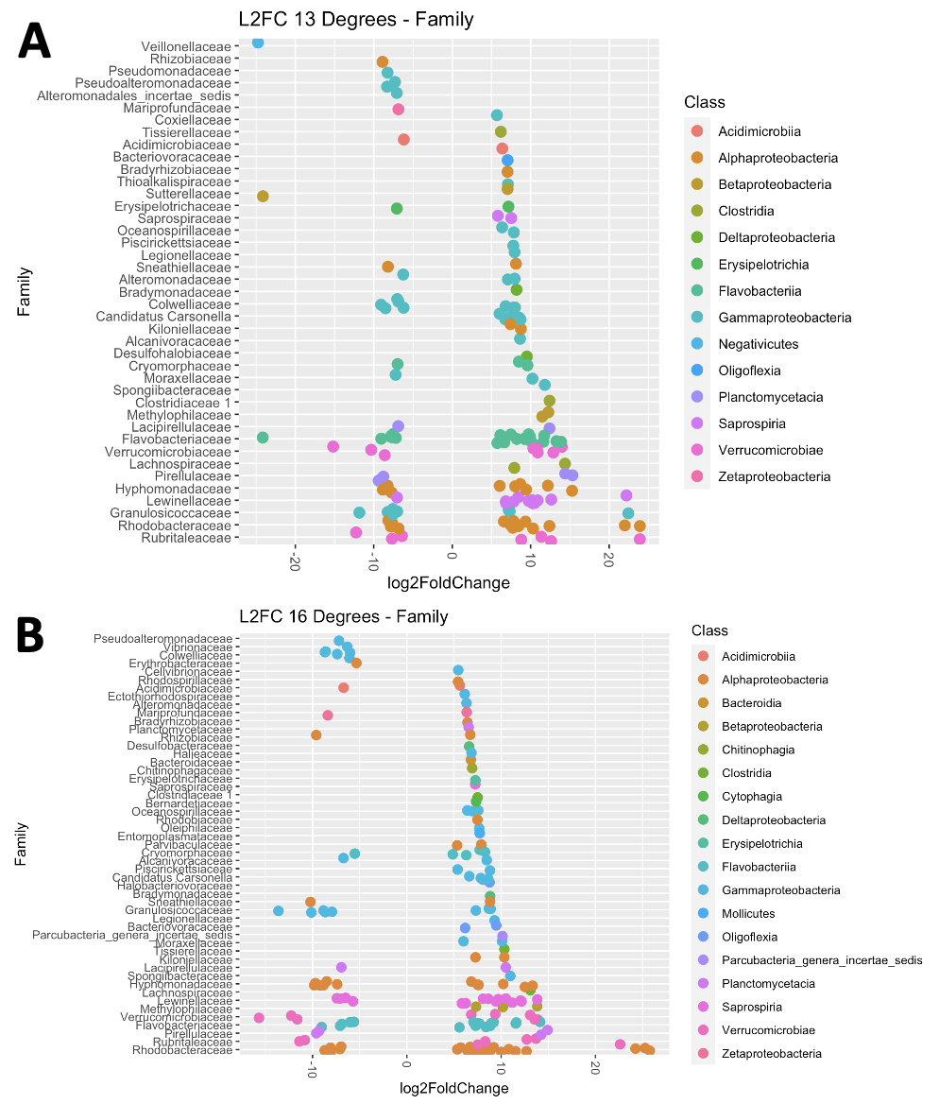
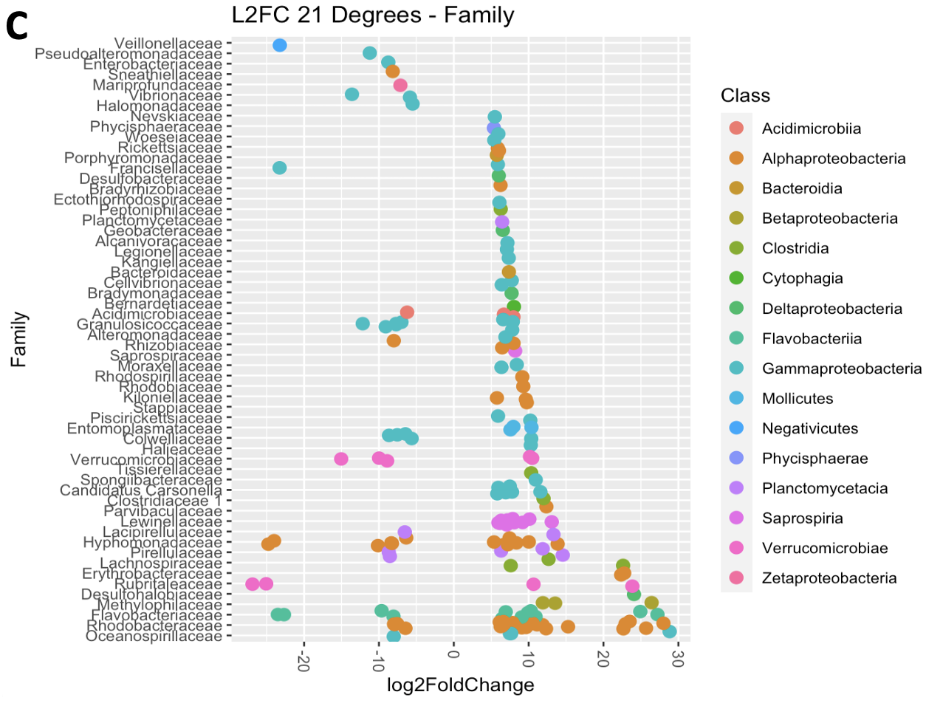

Figure S3. Venn Diagram of the overlap of ASVs between Cherry Point and Turn Rock at T0.
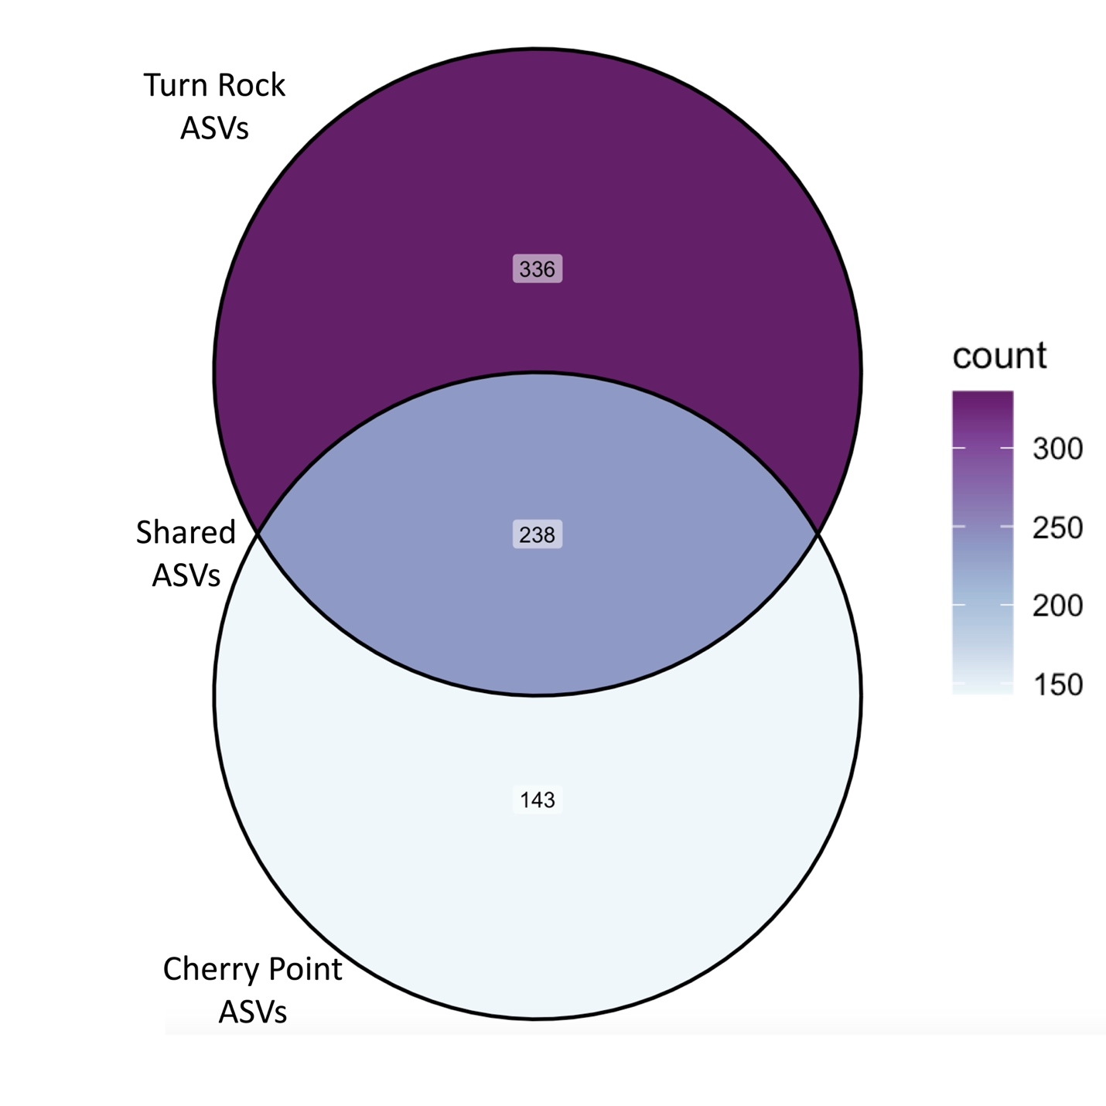
Table S1: Shannon Alpha Diversity Index and observed ASV Richness calculated for each temperature-nutrient treatment combination and for sampling populations (Cherry Point or Turn Rock) before the experiment (T₀) and at the end of the experiment (T_{f}). Results are shown in Figure 4.

Sample Name | Shannon Diversity | Observed ASV Richness
T0 Cherry Point | 2.17 | 382
T0 Turn Rock | 2.83 | 576
T0 13 | 2.10 | 282
T0 13 + N | 2.42 | 213
T0 13 - N | 1.84 | 200
T0 16 | 2.28 | 398
T0 16 + N | 2.01 | 219
T0 16 - N | 2.38 | 318
T0 21 | 2.52 | 478
T0 21 + N | 2.23 | 229
T0 21 - N | 2.56 | 390
TF Cherry Point | 3.87 | 870
TF Turn Rock | 3.76 | 964
TF 13 | 3.39 | 497
TF 13 + N | 3.08 | 359
TF 13 - N | 3.50 | 322
TF 16 | 3.65 | 629
TF 16 + N | 3.59 | 449
TF 16 - N | 3.45 | 370
TF 21 | 3.79 | 777
TF 21 + N | 3.29 | 489
TF 21 - N | 3.73 | 535

Time & Diversity Metric | Variable | Df | Sum.Sq | Mean.Sq | F.value | Pr(>F) | Significance
T0 Shannon | temperature | 2 | 0.4372 | 0.2186 | 0.463 | 0.63621
T0 Shannon | DIN | 1 | 0.5245 | 0.5245 | 1.111 | 0.30504
T0 Shannon | samplesite | 1 | 1.9928 | 1.9928 | 4.222 | 0.05391 | .
T0 Shannon | temperature:DIN | 2 | 2.0048 | 1.0024 | 2.124 | 0.14709
T0 Shannon | temperature:samplesite | 2 | 0.4372 | 0.2186 | 0.463 | 0.63624
T0 Shannon | DIN:samplesite | 1 | 0.8608 | 0.8608 | 1.824 | 0.19273
T0 Shannon | temperature:DIN:samplesite | 2 | 0.7225 | 0.3612 | 0.765 | 0.47899
T0 Shannon | Residuals | 19 | 8.9680 | 0.4720 | NA | NA
TF Shannon | temperature | 2 | 0.1729 | 0.0865 | 1.250 | 0.29983
TF Shannon | DIN | 1 | 0.1561 | 0.1561 | 2.256 | 0.14263
TF Shannon | samplesite | 1 | 1.5561 | 1.5561 | 22.486 | 0.00004 | ***
TF Shannon | temperature:DIN | 2 | 2.0256 | 1.0128 | 14.636 | 0.00003 | ***
TF Shannon | temperature:samplesite | 2 | 0.9029 | 0.4515 | 6.524 | 0.00410 | **
TF Shannon | DIN:samplesite | 1 | 0.0437 | 0.0437 | 0.631 | 0.43263
TF Shannon | temperature:DIN:samplesite | 2 | 0.5803 | 0.2902 | 4.193 | 0.02384 | *
TF Shannon | Residuals | 33 | 2.2837 | 0.0692 | NA | NA
T0 Observed | temperature | 2 | 388 | 194 | 0.081 | 0.92208
T0 Observed | DIN | 1 | 0 | 0 | 0.000 | 0.99061
T0 Observed | samplesite | 1 | 30 | 30 | 0.013 | 0.91140
T0 Observed | temperature:DIN | 2 | 926 | 463 | 0.194 | 0.82500
T0 Observed | temperature:samplesite | 2 | 2707 | 1354 | 0.568 | 0.57608
T0 Observed | DIN:samplesite | 1 | 3236 | 3236 | 1.358 | 0.25838
T0 Observed | temperature:DIN:samplesite | 2 | 180 | 90 | 0.038 | 0.96309
T0 Observed | Residuals | 19 | 45293 | 2384 | NA | NA
TF Observed | temperature | 2 | 24326 | 12163 | 6.159 | 0.00533 | **
TF Observed | DIN | 1 | 5903 | 5903 | 2.989 | 0.09318 | .
TF Observed | samplesite | 1 | 1805 | 1805 | 0.914 | 0.34596
TF Observed | temperature:DIN | 2 | 6720 | 3360 | 1.701 | 0.19804
TF Observed | temperature:samplesite | 2 | 10926 | 5463 | 2.766 | 0.07749 | .
TF Observed | DIN:samplesite | 1 | 1081 | 1081 | 0.548 | 0.46453
TF Observed | temperature:DIN:samplesite | 2 | 9263 | 4631 | 2.345 | 0.11159
TF Observed | Residuals | 33 | 65168 | 1975 | NA | NA
TF CP vs TR Shannon | samplesite | 1 | 1.634 | 1.634 | 11.5461 | 0.0015 | **
TF CP vs TR Shannon | Residuals | 43 | 6.087 | 0.142 | NA | NA
TF TR Shannon | temperature | 2 | 0.4184 | 0.2092 | 1.8347 | 0.1917
TF TR Shannon | DIN | 1 | 0.0147 | 0.0147 | 0.1285 | 0.7246
TF TR Shannon | temperature:DIN | 2 | 2.4454 | 1.2227 | 10.7229 | 0.0011 | **
TF TR Shannon | Residuals | 16 | 1.8245 | 0.1140 | NA | NA
TF TR Observed | temperature | 2 | 23875 | 11938 | 4.2785 | 0.0325 | *
TF TR Observed | DIN | 1 | 5641 | 5641 | 2.0219 | 0.1742
TF TR Observed | temperature:DIN | 2 | 16578 | 8289 | 2.9709 | 0.0799 | .
TF TR Observed | Residuals | 16 | 44642 | 2790 | NA | NA
TF CP Shannon | temperature | 2 | 0.4016 | 0.2008 | 7.4338 | 0.0048 | **
TF CP Shannon | DIN | 1 | 0.1196 | 0.1196 | 4.4267 | 0.0506 | .
TF CP Shannon | temperature:DIN | 2 | 0.4035 | 0.2018 | 7.4695 | 0.0047 | **
TF CP Shannon | Residuals | 17 | 0.4592 | 0.0270 | NA | NA
TF CP Observed | temperature | 2 | 9956 | 4978 | 4.1228 | 0.0347 | *
TF CP Observed | DIN | 1 | 1181 | 1181 | 0.9780 | 0.3366
TF CP Observed | temperature:DIN | 2 | 1390 | 695 | 0.5758 | 0.5728
TF CP Observed | Residuals | 17 | 20526 | 1207 | NA | NA

Table S2: Analysis of Variance (ANOVA) of Shannon Alpha Diversity Index and Observed ASV Richness with regards to temperature, DIN availability, and site effects. Significance values are *** for p < 0.001, ** for p < 0.01, * for p < 0.05, and . for p < 0.01. Significant values are bolded. Results are shown in Figure 4.

Effect | Difference | Lower | Upper | P-adj
16 Deg vs 13 Deg | 29.813 | -9.377 | 69.002 | 0.164
21 Deg vs 13 Deg | 56.955 | 17.050 | 96.861 | 0.004*
21 Deg vs 16 Deg | 27.143 | -13.379 | 67.664 | 0.242
Plus N-Minus N | 22.900 | -4.062 | 49.862 | 0.093
TR-CP | -12.635 | -39.597 | 14.327 | 0.347
16:CP-12:CP | 48.57 | -18.61 | 115.75 | 0.271
20:CP-12:CP | 38.82 | -30.72 | 108.35 | 0.549
12:TR-12:CP | -10.34 | -77.53 | 56.84 | 0.997
16:TR-12:CP | -2.71 | -72.25 | 66.83 | 1.000
20:TR-12:CP | 64.75 | -4.79 | 134.29 | 0.080
20:CP-16:CP | -9.76 | -79.3 | 59.78 | 0.998
12:TR-16:CP | -58.92 | -126.1 | 8.26 | 0.113
16:TR-16:CP | -51.29 | -120.82 | 18.25 | 0.252
20:TR-16:CP | 16.18 | -53.36 | 85.72 | 0.980
12:TR-20:CP | -49.16 | -118.7 | 20.38 | 0.294
16:TR-20:CP | -41.53 | -113.35 | 30.29 | 0.511
20:TR-20:CP | 25.94 | -45.88 | 97.75 | 0.881
16:TR-12:TR | 7.63 | -61.91 | 77.17 | 0.999
20:TR-12:TR | 75.1 | 5.56 | 144.63 | 0.028
20:TR-16:TR | 67.46 | -4.36 | 139.28 | 0.076

Table S3: Tukey HSD post-hoc results for TF ANOVA of Observed ASV Bacterial Richness. Only factors that were found to be significant in the ANOVA are shown here. Significant p-adjusted values are in bold. Results are shown in Figure 4.

Timepoint & Population | Effect | Df | SumOfSqs | R2 | F | Pr(>F) | Significance
T0 | samplesite | 1 | 1.367 | 0.146 | 5.289 | 0.001 | ***
T0 | temperature | 2 | 0.931 | 0.100 | 1.801 | 0.059 | .
T0 | DIN | 1 | 0.297 | 0.032 | 1.149 | 0.335
T0 | samplesite:temperature | 2 | 0.505 | 0.054 | 0.976 | 0.416
T0 | samplesite:DIN | 1 | 0.410 | 0.044 | 1.586 | 0.117
T0 | temperature:DIN | 2 | 0.516 | 0.055 | 0.998 | 0.425
T0 | samplesite:temperature:DIN | 2 | 0.395 | 0.042 | 0.764 | 0.649
T0 | Residual | 19 | 4.911 | 0.526 | NA | NA
T0 | Total | 30 | 9.331 | 1.000 | NA | NA
TF | samplesite | 1 | 0.786 | 0.076 | 6.283 | 0.001 | ***
TF | temperature | 2 | 2.415 | 0.232 | 9.646 | 0.001 | ***
TF | DIN | 1 | 0.715 | 0.069 | 5.714 | 0.001 | ***
TF | samplesite:temperature | 2 | 0.530 | 0.051 | 2.116 | 0.002 | **
TF | samplesite:DIN | 1 | 0.180 | 0.017 | 1.441 | 0.124
TF | temperature:DIN | 2 | 1.375 | 0.132 | 5.492 | 0.001 | ***
TF | samplesite:temperature:DIN | 2 | 0.273 | 0.026 | 1.090 | 0.355
TF | Residual | 33 | 4.130 | 0.397 | NA | NA
TF | Total | 44 | 10.404 | 1.000 | NA | NA
Turn Rock TF | temperature | 2 | 1.504 | 0.264 | 4.422 | 0.001 | ***
Turn Rock TF | DIN | 1 | 0.532 | 0.093 | 3.125 | 0.004 | **
Turn Rock TF | temperature:DIN | 2 | 0.949 | 0.166 | 2.789 | 0.001 | ***
Turn Rock TF | Residual | 16 | 2.722 | 0.477 | NA | NA
Turn Rock TF | Total | 21 | 5.706 | 1.000 | NA | NA
Cherry Point TF | group | 2 | 1.453 | 0.372 | 8.769 | 0.001 | ***
Cherry Point TF | treatment | 1 | 0.351 | 0.090 | 4.230 | 0.002 | ***
Cherry Point TF | group:treatment | 2 | 0.699 | 0.179 | 4.216 | 0.001 | ***
Cherry Point TF | Residual | 17 | 1.409 | 0.360 | NA | NA
Cherry Point TF | Total | 22 | 3.911 | 1.000 | NA | NA

Table S4: Bray-Curtis Permutational Analysis of Variance (PERMANOVA) of kelp blade microbiomes before and after experimental incubation with regards to temperature, DIN availability, and collection site of the kelp blade. PERMANOVAs were conducted for all kelp blade microbiomes at T0, all kelp blade microbiomes at TF, and kelp blade microbiomes split into site groupings at TF. Significance values are *** for p < 0.001, ** for p < 0.01, * for p < 0.05, and . for p > 0.05 and >0.10. Results are shown in Figures 1 and 2.

21°C | Avg | SD | T0 Abd. | TF Abd. | Cumsum | p-val | Class | Genus
ASV00513 | 0.0872 | 0.1026 | 0.0 | 4870.5 | 0.2366 | 0.002 | Alphaproteobacteria | Octadecabacter
ASV00277 | 0.0730 | 0.0461 | 0.0 | 3592.4 | 0.3099 | 0.001 | Planctomycetacia | Mariniblastus
ASV00590 | 0.0378 | 0.0254 | 0.0 | 2164.4 | 0.3963 | 0.001 | Betaproteobacteria | Methylotenera
ASV00394 | 0.0376 | 0.0298 | 0.0 | 2225.5 | 0.4340 | 0.001 | Alphaproteobacteria | Litorimonas
ASV00882 | 0.0319 | 0.0565 | 0.0 | 1659.0 | 0.4661 | 0.002 | Planctomycetacia | Lacipirellula
ASV01250 | 0.0259 | 0.0322 | 0.0 | 1421.5 | 0.4921 | 0.002 | Gammaproteobacteria | Pontibacterium
ASV00722 | 0.0240 | 0.0188 | 0.0 | 1351.1 | 0.5405 | 0.001 | Saprospiria | Portibacter
ASV00527 | 0.0200 | 0.0177 | 0.3 | 1235.1 | 0.5826 | 0.001 | Clostridia | Coprococcus
ASV01592 | 0.0170 | 0.0171 | 0.0 | 906.9 | 0.5997 | 0.001 | Alphaproteobacteria | Tepidicaulis
ASV01391 | 0.0151 | 0.0278 | 0.0 | 919.9 | 0.6149 | 0.007 | Alphaproteobacteria | Sulfitobacter
ASV00145 | 0.0132 | 0.0333 | 0.0 | 810.4 | 0.6281 | 0.001 | Verrucomicrobiae | Luteolibacter
ASV01757 | 0.0127 | 0.0192 | 0.0 | 700.6 | 0.6409 | 0.002 | Alphaproteobacteria | Jannaschia
ASV00482 | 0.0115 | 0.0131 | 0.0 | 553.2 | 0.6524 | 0.001 | Gammaproteobacteria | Granulosicoccus
ASV01817 | 0.0100 | 0.0082 | 0.0 | 587.1 | 0.6625 | 0.001 | Alphaproteobacteria | Pelagimonas
ASV01477 | 0.0100 | 0.0093 | 0.0 | 558.1 | 0.6725 | 0.001 | Betaproteobacteria | Methylophilus
ASV00463 | 0.0099 | 0.0119 | 0.0 | 469.4 | 0.6923 | 0.001 | Planctomycetacia | Mariniblastus
ASV00715 | 0.0068 | 0.0137 | 0.0 | 373.4 | 0.7160 | 0.006 | Flavobacteriia | Dokdonia
ASV02194 | 0.0066 | 0.0070 | 0.0 | 345.6 | 0.7294 | 0.001 | Alphaproteobacteria | Sulfitobacter
ASV02423 | 0.0066 | 0.0091 | 0.0 | 365.3 | 0.7360 | 0.002 | Betaproteobacteria | Methylophilus
ASV01878 | 0.0064 | 0.0095 | 0.0 | 393.9 | 0.7424 | 0.001 | Flavobacteriia | Dokdonia
16 °C | Avg | SD | T0 Abd. | TF Abd. | Cumsum | p-val | Class | Genus
ASV00166 | 0.1982 | 0.1705 | 14882.7 | 0.0 | 0.1984 | 0.002 | Verrucomicrobiae | Luteolibacter
ASV00277 | 0.0733 | 0.0471 | 0.0 | 4779.0 | 0.2717 | 0.002 | Planctomycetacia | Mariniblastus
ASV00576 | 0.0525 | 0.0528 | 3951.9 | 0.0 | 0.3243 | 0.004 | Gammaproteobacteria | Granulosicoccus
ASV00590 | 0.0330 | 0.0250 | 0.0 | 1964.3 | 0.4364 | 0.001 | Betaproteobacteria | Methylotenera
ASV00815 | 0.0321 | 0.0248 | 0.0 | 2029.4 | 0.5014 | 0.007 | Verrucomicrobiae | Rubritalea
ASV00717 | 0.0229 | 0.0180 | 0.0 | 1514.7 | 0.5834 | 0.004 | Verrucomicrobiae | Persicirhabdus
ASV00527 | 0.0201 | 0.0200 | 0.0 | 1200.1 | 0.6241 | 0.001 | Clostridia | Coprococcus
ASV00394 | 0.0195 | 0.0183 | 0.0 | 1183.7 | 0.6437 | 0.001 | Alphaproteobacteria | Litorimonas
ASV00513 | 0.0147 | 0.0135 | 0.0 | 895.9 | 0.6759 | 0.009 | Alphaproteobacteria | Octadecabacter
ASV01035 | 0.0130 | 0.0088 | 0.0 | 884.3 | 0.7165 | 0.005 | Alphaproteobacteria | Litorimonas
ASV02371 | 0.0095 | 0.0249 | 263.6 | 0.0 | 0.7582 | 0.004 | Gammaproteobacteria | Granulosicoccus
ASV00879 | 0.0077 | 0.0051 | 0.0 | 508.1 | 0.7659 | 0.001 | Flavobacteriia | Nonlabens
ASV00955 | 0.0074 | 0.0057 | 0.0 | 495.9 | 0.7734 | 0.006 | Flavobacteriia | Nonlabens
ASV01856 | 0.0049 | 0.0049 | 318.4 | 0.0 | 0.7956 | 0.001 | Alphaproteobacteria | Hellea
ASV03930 | 0.0034 | 0.0086 | 102.9 | 0.0 | 0.8410 | 0.001 | Gammaproteobacteria | Colwellia
ASV02303 | 0.0033 | 0.0035 | 221.7 | 0.0 | 0.8443 | 0.002 | Planctomycetacia | Mariniblastus
ASV02778 | 0.0030 | 0.0064 | 106.3 | 0.0 | 0.8504 | 0.001 | Gammaproteobacteria | Colwellia
ASV02357 | 0.0030 | 0.0022 | 0.0 | 173.1 | 0.8534 | 0.001 | Clostridia | Schnuerera
ASV02581 | 0.0029 | 0.0028 | 211.4 | 0.0 | 0.8563 | 0.004 | Alphaproteobacteria | Litorimonas
ASV01477 | 0.0027 | 0.0020 | 0.0 | 169.9 | 0.8645 | 0.004 | Betaproteobacteria | Methylophilus
13 °C | Avg | SD | T0 Abd. | TF Abd. | Cumsum | p-val | Class | Genus
ASV00166 | 0.1970 | 0.2008 | 12582.7 | 0.0 | 0.1977 | 0.001 | Verrucomicrobiae | Luteolibacter
ASV00277 | 0.0931 | 0.0607 | 0.0 | 4760.4 | 0.2912 | 0.001 | Planctomycetacia | Mariniblastus
ASV00394 | 0.0924 | 0.0698 | 0.0 | 4743.7 | 0.3840 | 0.006 | Alphaproteobacteria | Litorimonas
ASV00527 | 0.0512 | 0.0318 | 0.0 | 2558.0 | 0.4354 | 0.001 | Clostridia | Coprococcus
ASV00463 | 0.0430 | 0.0290 | 0.0 | 2106.5 | 0.4785 | 0.001 | Planctomycetacia | Mariniblastus
ASV01000 | 0.0236 | 0.0278 | 1521.1 | 0.0 | 0.5918 | 0.008 | Verrucomicrobiae | Rubritalea
ASV00576 | 0.0192 | 0.0213 | 1172.1 | 0.0 | 0.6111 | 0.005 | Gammaproteobacteria | Granulosicoccus
ASV01050 | 0.0080 | 0.0077 | 483.7 | 0.0 | 0.7441 | 0.003 | Verrucomicrobiae | Persicirhabdus
ASV00899 | 0.0053 | 0.0039 | 0.0 | 263.8 | 0.7799 | 0.003 | Verrucomicrobiae | Rubritalea
ASV02307 | 0.0029 | 0.0045 | 185.7 | 0.0 | 0.8239 | 0.01 | Alphaproteobacteria | Neopararhizobium
ASV01856 | 0.0026 | 0.0029 | 154.0 | 0.0 | 0.8349 | 0.001 | Alphaproteobacteria | Hellea
ASV02579 | 0.0019 | 0.0020 | 102.4 | 0.0 | 0.8550 | 0.007 | Alphaproteobacteria | Litorimonas
ASV02581 | 0.0018 | 0.0021 | 99.1 | 0.0 | 0.8625 | 0.006 | Alphaproteobacteria | Litorimonas
ASV02205 | 0.0018 | 0.0025 | 111.9 | 0.0 | 0.8661 | 0.01 | Alphaproteobacteria | Taonella
ASV03981 | 0.0017 | 0.0025 | 59.6 | 0.0 | 0.8746 | 0.01 | Flavobacteriia | Gaetbulibacter
ASV02989 | 0.0014 | 0.0014 | 73.9 | 0.0 | 0.8910 | 0.005 | Alphaproteobacteria | Litorimonas
ASV01483 | 0.0013 | 0.0015 | 78.0 | 0.0 | 0.8991 | 0.006 | Verrucomicrobiae | Rubritalea
ASV03296 | 0.0012 | 0.0011 | 71.0 | 0.0 | 0.9015 | 0.001 | Alphaproteobacteria | Loktanella
ASV05890 | 0.0011 | 0.0016 | 43.3 | 0.0 | 0.9039 | 0.006 | Flavobacteriia | Crocinitomix
ASV02978 | 0.0010 | 0.0012 | 64.3 | 0.0 | 0.9092 | 0.008 | Gammaproteobacteria | Granulosicoccus

Table S5: Similarity Percentage (SIMPER) analysis of 3 temperature treatments. All taxa present below were significantly enriched in abundance when comparing T0 to TF at a 0.05 significance level. Results are shown in Figure 3.

Effect | T0 Dispersion | TF Dispersion | F-Value | P-Value
13°C | 0.4693 | 0.3789 | 0.8094 | 0.377
13°C Cherry Point | 0.3871 | 0.2780 | 1.1176 | 0.334
13°C Turn Rock | 0.5099 | 0.4055 | 0.4337 | 0.494
16°C | 0.4284 | 0.3696 | 0.6196 | 0.455
16°C Cherry Point | 0.2901 | 0.3354 | 0.4870 | 0.519
16°C Turn Rock | 0.5467 | 0.4165 | 1.6011 | 0.264
21°C | 0.4467 | 0.42 | 0.3068 | 0.593
21°C Cherry Point | 0.3710 | 0.3559 | 0.0286 | 0.910
21°C Turn Rock | 0.4110 | 0.3780 | 0.0429 | 0.854
High DIN | 0.4321 | 0.431 | 0.0003 | 0.991
Low DIN | 0.4947 | 0.4599 | 0.4288 | 0.512
Cherry Point | 0.3821 | 0.4084 | 0.3574 | 0.564
Turn Rock | 0.5821 | 0.495 | 5.6771 | 0.019 *

Table S6: Beta Dispersion using the Bray-Curtis dissimilarity metric analysis of 3 temperature treatments and 2 nitrogen treatments before and after experiment. Significance values are *** for p < 0.001, ** for p < 0.01, * for p < 0.05, and . for p > 0.05 and >0.10.

