Supplementary Information for

Neighborhoods and COVID-19 Fatalities: Evidence from a full population study in Sweden

Sofia Wixe¹, José Lobo², Charlotta Mellander³* Luís M.A. Bettencourt^{4,5}
*Corresponding author. Email: charlotta.mellander@ju.se

This file includes:

The Supplementary Material Figures S1-S7 present descriptive statistics for all neighborhood variables. Tables S1-S3 present descriptive statistics for the individual level descriptive statistics variables. Table S4 illustrates what countries are included in each region of origin.

Other Supplementary Materials for this manuscript include the following:

Data Figures S1-S7, Tables S1-S4

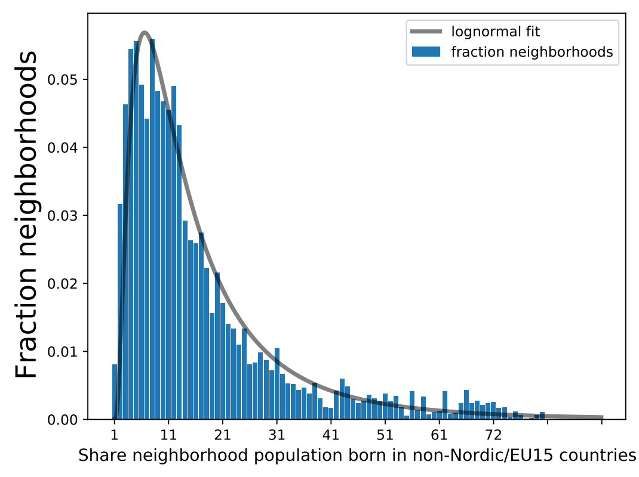
Figure S1. Distribution of individuals across different neighborhoods, according to share of population born in non-Nordic/EU15 countries (Ethnic segregation).

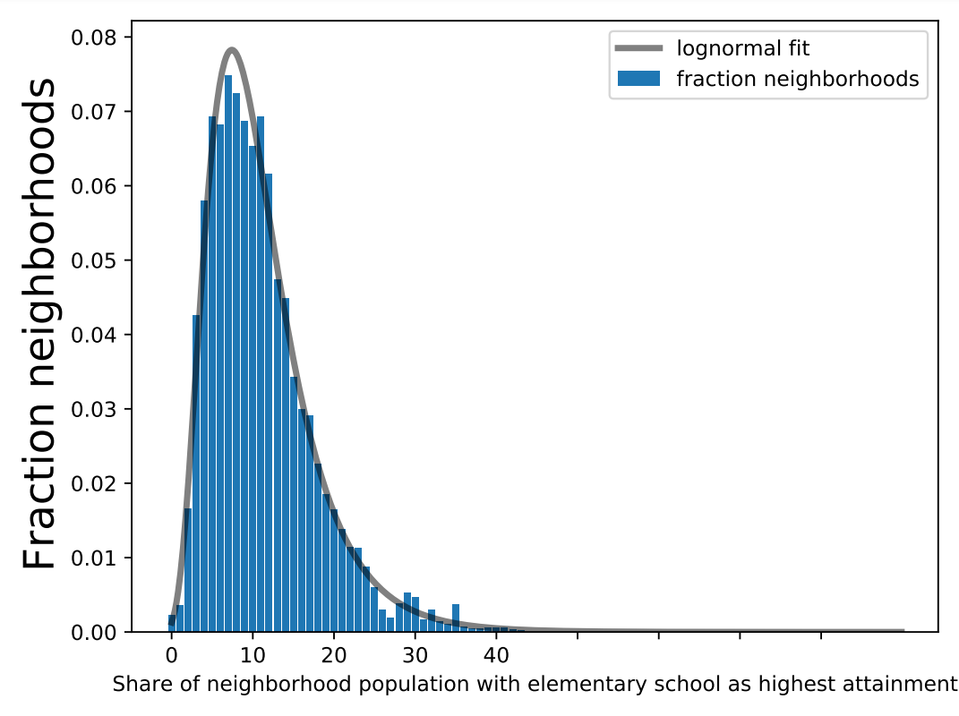

Figure S2. Distribution of individuals across different neighborhoods, according to share of population (aged 20-64) with elementary school as highest educational attainment (Socioeconomic segregation – Low education).

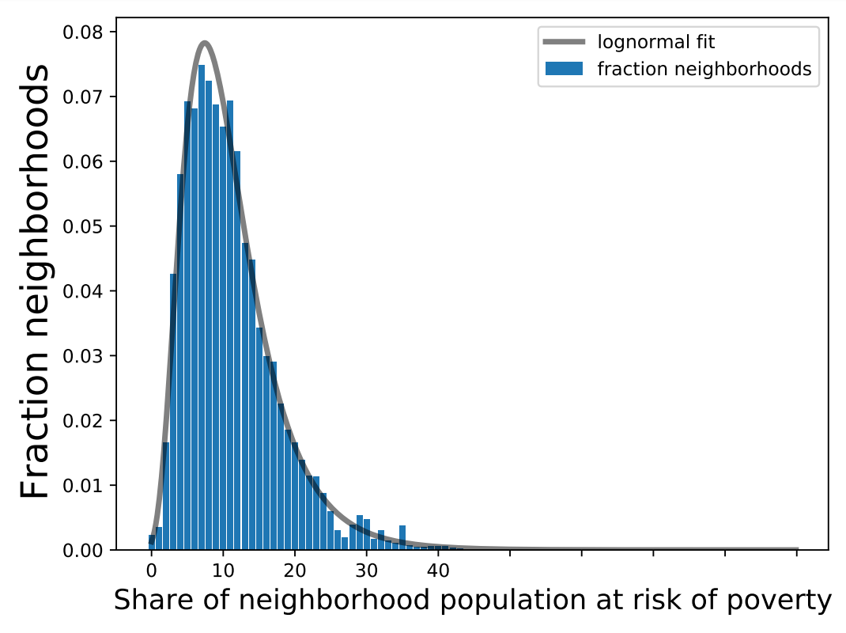

Figure S3. Distribution of individuals across different neighborhoods, according to share of population (aged 20+) in risk of poverty (Socioeconomic segregation – Poverty).

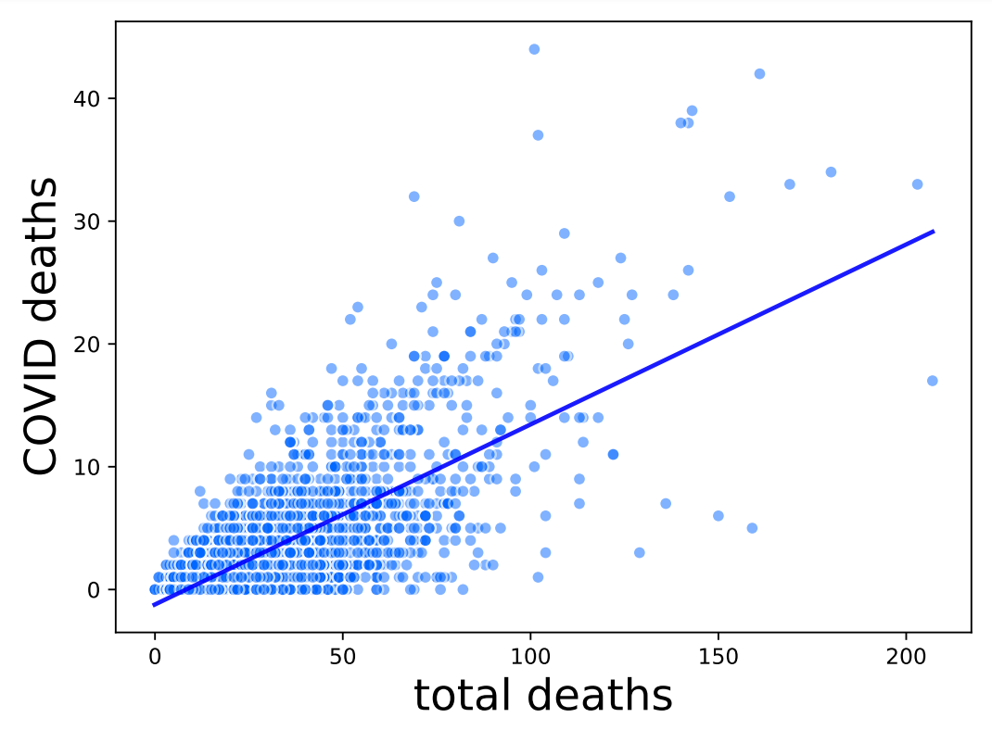Figure S4. Total COVID-19 deaths vs all deaths per neighborhood.

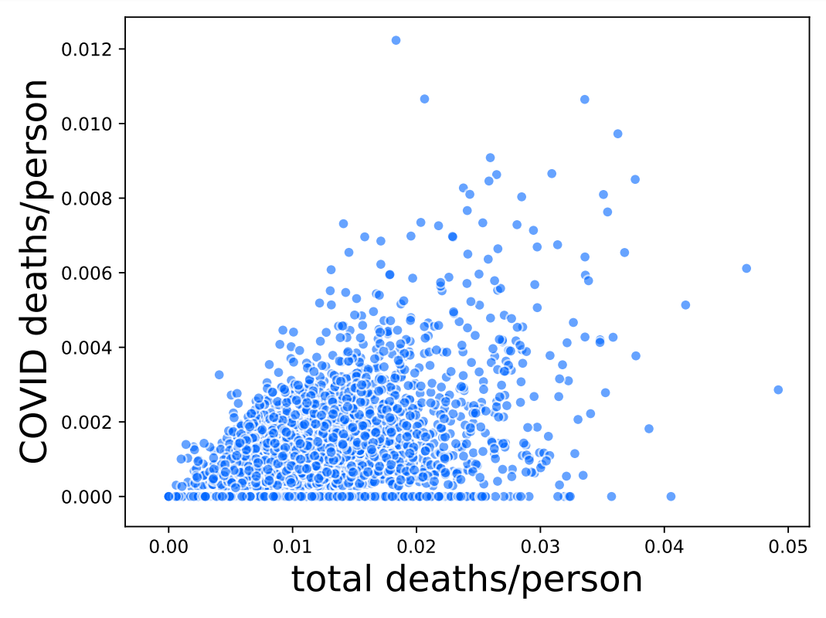

Figure S5. Total COVID-19 deaths vs all deaths per neighborhood, both weighted by neighborhood population.

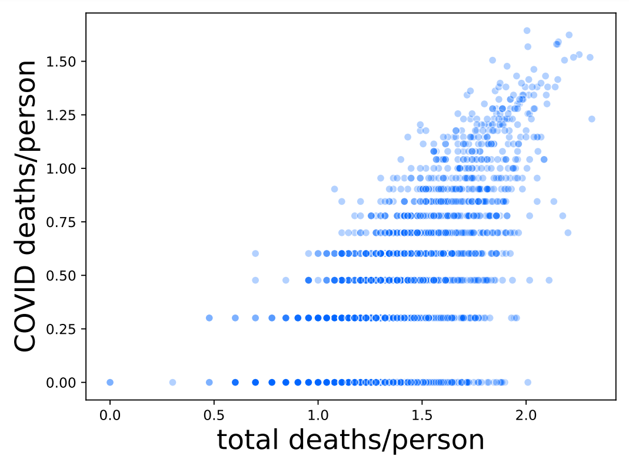

Figure S6. Total COVID-19 deaths vs all deaths per neighborhood, both log transformed. Neighborhoods with zero COVID-19 deaths are excluded.

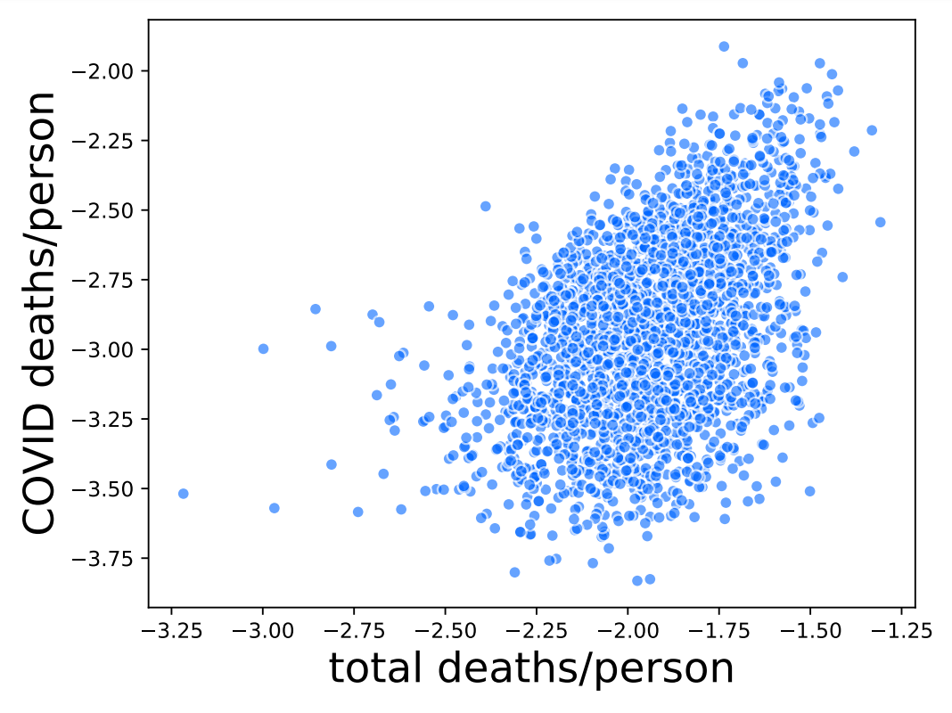

Figure S7. Total COVID-19 deaths vs all deaths per neighborhood, both weighted by neighborhood population, both log transformed. Neighborhoods with zero COVID-19 deaths are excluded.

Table S1. Variables Description.

Variable | Equation | Description
Dead | Selection (S) | Binary variable equal to one if individual i died in year 2020, zero otherwise. Dependent variable in the selection equation.
COVID-19 | Outcome (O) | Binary variable equal to one if individual i died with COVID-19 in year 2020, zero if the individual died by any other cause/s. Dependent variable in the outcome equation.  In Sweden, the definition of a COVID-19 related death includes both (1) a person reported dead by a medical doctor via SmiNet (the database system used to report by law notifiable infectious diseases) or by the health care sector via the regional infectious restraints, and (2) a person who has died within 30 days after a confirmed COVID-19 test has been taken.
Neighborhood characteristics
Ethnic | S + O | Categorical variable showing share of neighborhood population born in non-Nordic/EU15 countries.
Ethnic | S + O | - 0 – 7% (base)  - >7 – 15%  - >15 – 25%  - >25 – 35%  - >35 – 45% |  | - >45 – 55%  - >55 – 65%  - >65 – 75%  - >75%
Low education | S + O | Categorical variable showing share of population aged 20-64 with elementary school as highest educational attainment.
Low education | S + O | - 0 – 7% (base)  - >7 – 10%  - >10 – 15%  - >15 – 20% |  |  |  | - >20 – 25%  - >25 – 30%  - >30 – 35%  - >35%
Poverty | S + O | Categorical variable showing share of population aged 20 and above in risk of poverty, defined as having an equivalized disposable income below 60 percent of the corresponding national median (69).
Poverty | S + O | - 0 – 10% (base)  - >10 – 17.5%  - >17.5 – 25%  - >25 – 32.5% |  |  |  |  | - >32.5 – 40%  - >40 – 47.5%  - >47.5 – 55%  - >55%
No-go-zone | S + O | Binary variable equal to one if residing in a post code area classified as especially distressed by the Swedish police.
Regional characteristics
Population density | S + O | Natural logarithm of population per square kilometer per municipality.
Regional type | S | Categorical variable.  - Rural municipalities (base)  - Urban municipalities  - Metropolitan municipalities
Stockholm | O | Dummy equal to one if residing in Stockholm county (26 municipalities).
Virus exposure | O | Access to total number of confirmed COVID-19 cases in the municipality and county one week before death (spatially weighted total number of cases in the county, accounting for travel time between municipalities). Given that Sweden had no strict lockdown and individuals could move freely, one might have been exposed to the virus also outside of the own neighborhood.
Individual characteristics
Ethnic background | S + O | Categorical variable (see Table S5 for included countries in each category).
Ethnic background | S + O | - Sweden (base)  - Nordic  - EU15  - West Balkan  - East Europe  - Middle East | - East Africa  - North-South-West Africa  - South-Central Asia  - Southeast-East Asia  - South-Central America  - North America-Oceania
Education | S + O | Categorical variable showing highest formal schooling attainment.  - Elementary school (base)  - High school  - Shorter higher education (< 3 years)  - Longer higher education (> 3 years)
Income | S + O | The natural logarithm of disposable income, inferred from the whole family’s disposable income (disposable income per consumption weight).
Age | S + O | Categorical variable of age groups.
Age | S + O | - 15 – 29 (base)  - 30 – 39  - 40 – 49  - 50 – 59 |  |  | - 60 – 69  - 70 – 79  - 80 – 89  - 90 +
Female | S + O | Binary variable equal to one if female.
Civil status | S + O | Categorical variable.  - Single with no children (base)  - Single with at least one child below 18  - Married/co-habitant with no children  - Married/co-habitant with at least one child below 18
Frontline worker | S + O | Binary variable equal to one if having an occupation classified as frontline, including health and welfare workers, police, cashiers, taxi- and public transport drivers.
Elderly home | S + O | Binary variable equal to one if residing in an elderly home.
House type | S + O | Categorical variable.  - Rental apartment (base)  - Tenant-owned apartment  - Owner-occupied house
Inter-generational household | O | Binary variable equal to one if residing in a household with at least one member aged below 18 and at least one member aged 70 or above.
Crowded household | O | Binary variable equal to one is residing in a household classified as crowded, excluding single households without children in one-room apartments.
Multiple causes | O | Categorical variable showing the number of unique causes of death.  - One cause of death (base)  - Two causes of death  - Three causes of death  - Four causes of death  - Five or more causes of death
Diabetes | O | Binary variable equal to one if diagnosed with diabetes. Only available for individuals who have died.

Table S2. Descriptive statistics for categorical and binary variables at individual level. Share (%) belonging to each group/category.
 | All | Dead | Dead in COVID-19
Observations | 8,477,638 | 97,197 | 10,154
Ethnic background
Sweden | 78.3 | 86.2 | 79.6
Nordic | 2.62 | 5.56 | 6.85
EU15 | 1.78 | 1.76 | 2.09
West Balkan | 1.75 | 1.38 | 1.71
East Europe | 3.06 | 1.78 | 2.15
Middle East | 4.70 | 1.49 | 4.00
East Africa | 1.61 | 0.31 | 0.99
North-South-West Africa | 0.79 | 0.17 | 0.31
South-Central Asia | 2.47 | 0.54 | 1.06
Southeast-East Asia | 1.57 | 0.27 | 0.39
South-Central America | 1.01 | 0.37 | 0.68
North America-Oceania | 0.34 | 0.16 | 0.15
Education
Elementary school | 19.1 | 42.8 | 42.3
High school | 41.4 | 37.8 | 36.8
Shorter higher education | 13.8 | 7.63 | 7.62
Longer higher education | 21.8 | 9.77 | 9.73
Unknown | 3.96 | 2.07 | 3.57
Age
15-29 | 22.3 | 0.74 | 0.14
30-39 | 16.1 | 0.77 | 0.27
40-49 | 15.3 | 1.43 | 0.69
50-59 | 15.3 | 3.96 | 2.39
60-69 | 13.1 | 9.87 | 6.40
70-79 | 11.7 | 24.4 | 22.1
80-89 | 5.15 | 35.9 | 42.7
90+ | 1.17 | 22.9 | 25.4
Female | 50.0 | 49.7 | 46.7
Civil status
Single | 40.6 | 67.3 | 69.4
Single with child | 5.21 | 0.32 | 0.10
Married | 28.1 | 31.1 | 29.5
Married with child | 26.1 | 1.23 | 0.97
Frontline worker | 10.1 | 1.68 | 1.08
Elderly home | 1.00 | 18.1 | 24.0
House type
Rental (apartment) | 30.2 | 44.0 | 49.3
Tenant-owned (apartment) | 20.4 | 18.8 | 20.9
Owner-occupied (house) | 47.2 | 31.8 | 22.4
Unknown | 2.18 | 5.40 | 7.37
Inter-generational household | 0.86 | 1.19 | 1.57
Crowded household | 9.24 | 2.31 | 2.96
Multiple causes of death
One cause | - | 27.2 | 4.77
Two causes | - | 27.3 | 19.2
Three causes | - | 22.2 | 28.5
Four causes | - | 13.3 | 25.0
Five or more causes | - | 9.96 | 22.5
Diabetes | - | 12.2 | 18.4

Table S3. Descriptive statistics for continuous variables.
Variable | Population | Observations | Mean | Std. Dev. | Min | Max
Age | All | 8,477,503 | 48.10 | 19.93 | 15 | 111
Age | Dead | 97,197 | 79.86 | 12.90 | 16 | 111
Age | Dead in COVID-19 | 10,154 | 82.45 | 10.38 | 18 | 107
Income (ln) | All | 8,477,638 | 7.707 | 1.127 | 0 | 17.59
Income (ln) | Dead | 97,197 | 7.563 | 0.7073 | 0 | 13.46
Income (ln) | Dead in COVID-19 | 10,154 | 7.587 | 0.6374 | 0 | 12.31
Virus exposure (ln) | Dead | 97,197 | 4.752 | 3.0205 | 0 | 10.65
Virus exposure (ln) | Dead in COVID-19 | 10,154 | 6.521 | 1.942 | 0 | 10.65
Population density (ln) | All | 8,477,638 | 4.950 | 1.997 | -1.609 | 8.705
Population density (ln) | Dead | 97,197 | 4.624 | 1.992 | -1.609 | 8.705
Population density (ln) | Dead in COVID-19 | 10,154 | 5.361 | 2.107 | -1.204 | 8.705

Table S4. Descriptive statistics for neighborhood variables.
 | Ethnic | Low education | Poverty
Observations | 8,477,638 | 8,477,638 | 8,477,638
Mean | 0.1729 | 0.1155 | 0.1632
Standard deviation | 0.1540 | 0.0645 | 0.0940
Minimum | 0.0112 | 0.0010 | 0.0148
Maximum | 0.8166 | 0.4624 | 0.6944
Percentiles
1% | 0.0211 | 0.0243 | 0.0430
5% | 0.0322 | 0.0371 | 0.0599
10% | 0.0428 | 0.0467 | 0.0717
25% | 0.0713 | 0.0690 | 0.1003
50% (median) | 0.1235 | 0.1032 | 0.1402
75% | 0.2120 | 0.1466 | 0.1992
90% | 0.3833 | 0.2008 | 0.2805
95% | 0.5346 | 0.2387 | 0.3527
99% | 0.7202 | 0.3310 | 0.5135

Table S5. Countries included in each region of origin.
Region of origin | Countries
Sweden | Sweden
Nordic | Denmark, Finland, Norway, Iceland
EU15 | Austria, Belgium, France, Germany, Greece, Ireland, Italy, Luxembourg, Netherlands, Portugal, Spain, United Kingdom
West Balkan | Albania, Bosnia-Hercegovina, Kosovo, Macedonia, Montenegro, Yugoslavia
East Europe | Andorra, Bulgaria, Croatia, Cyprus, Czech Republic, Estonia, Hungary, Latvia, Liechtenstein, Lithuania, Malta, Moldavia, Monaco, Poland, Romania, Russia, San Marino, Serbia, Slovakia, Slovenia, Switzerland, Vatican City State
Middle East | Armenia, Azerbaijan, Bahrain, Georgia, ‎Iraq, Israel, Jordan, Kuwait, Lebanon,‎ Oman, Palestine, Qatar‎, Saudi Arabia, Syria, Turkey, United Arab Emirates, Yemen
East Africa | Burundi, Comoros, Djibouti, Eritrea, Ethiopia, Kenya, Madagascar, Malawi, Mauritius, Mozambique, Rwanda, Seychelles, Somalia, Tanzania, Uganda, Zambia, Zanzibar, Zimbabwe
North-South-West Africa | All other countries in Africa
South-Central Asia | Afghanistan, Bangladesh, Bhutan, India, Iran, Kazakhstan, Kyrgyzstan, Maldives, Nepal, Pakistan, Sikkim, Sri Lanka, Tajikistan, Turkmenistan, Uzbekistan
Southeast-East Asia | Brunei, Burma (Myanmar), Cambodia, China, Hong Kong, Indonesia, Japan, Laos, Malaysia, Mongolia, North Korea, the Philippines, Singapore, South Korea, Taiwan, Thailand, Timor-Leste, Vietnam
South-Central America | All countries in South and Central America
North America-Oceania | All countries in North America and Oceania

Table S6. Marginal effects for the probability of dying with COVID-19 at the individual level, probit estimations without selection bias correction.
 | (1b’) |  | (2b’) |  | (3b’)
Neighborhood characteristics | i) Ethnic |  | ii) Low education |  | iii) Poverty
 | >7-15%  >15-25%  >25-35%  >35-45%  >45-55%  >55-65%  >65-75%  >75% | .0075*  .0147*  .0134*  .0310*  .0265*  .0359 *  .0530*  .0933* | >7-10%  >10-15%  >15-20%  >20-25%  >25-30%  >30-35%  >35% | -.0013  -.0018  .0036  .0129*  .0338*  .0347*  .0708* | >10-17.5%  >17.5-25%  >25-32.5%  >32.5-40%  >40-47.5%  >47.5-55%  >55% | .0008  -.0005  .0101*  .0266*  .0454*  .0158  .0799*
No-go-zone | -.0043 |  | -.0011 |  | .0022
Regional characteristics
Virus exposure | .0215* |  | .0216* |  | .0216*
Population density | -.0078* |  | -.0065* |  | -.0071*
Stockholm | .0619* |  | .0634* |  | .0654*
Individual characteristics
Ethnic background  Nordic  EU15  West Balkan  East Europe  Middle East  East Africa  North-South-West Africa  South-Central Asia  Southeast-East Asia  South-Central America  North America-Oceania | .0128*  .0058  .0230*  .0096  .1121*  .2216*  .0487  .0797*  .0586*  .0532*  -.0127 |  | .0134*  .0064  .0261*  .0111  .1204*  .2206*  .0510  .0856*  .0615*  .0561*  -.0118 |  | .0136*  .0064  .0250*  .0108  .1184*  .2247*  .0524  .0847*  .0621*  .0565*  -.0126
Education  High school  Shorter higher education  Longer higher education | .0011  .0001  -.0066 |  | .0012  -.0000  -.0072 |  | .0010  -.0004  -.0074
Income | .0036 |  | 0.0036 |  | 0.0037
Age  30 – 39  40 – 49  50 – 59  60 – 69  70 – 79  80 – 89  90 + | .0186  .0344*  .0453*  .0516*  .0745*  .0951*  .0922* |  | .0188  .0342*  .0451*  .0515*  .0744*  .0951*  .0917* |  | .0189  .0340*  .0453*  .0516*  .0746*  .0952*  .0920*
Female | -.0165* |  | -.0165* |  | -.0164*
Civil status  Single with child  Married  Married with child | -.0317  .0013  .0277 |  | -.0307  .0013  .0265 |  | -.0319  .0014  .0272
Frontline worker | .0089 |  | .0099 |  | .0099*
Elderly home | .0300* |  | .0296* |  | .0295*
House type  Tenant-owned (apartment)  Owner-occupied (house) | .0024  -.0031 |  | .0027  -.0057 |  | .0024  -.0059
Inter-generational household | .0091 |  | .0092 |  | .0091
Crowded household | .0002 |  | .0000 |  | -.0002
Multiple causes of death  Two causes  Three causes  Four causes  Five or more causes | .0567*  .1109*  .1676*  .2057* |  | .0568*  .1109*  .1680*  .2060* |  | .0568*  .1110*  .1679*  .2060*
Diabetes | -.0149* |  | -.0150* |  | -.0149*
Observations | 97,192 |  | 97,192 |  | 97,192
Pseudo R2 | .1912 |  | .1909 |  | .1909
Wald Chi2 | 9,818* |  | 9,836* |  | 9,817*
Notes: * denote significance at 1% level. Robust standard errors in parenthesis.

We have also tested two weeks before, with robust results.
This variable is not available at the neighborhood level.
North America and Oceania are grouped together due to the relatively low number of foreign-born individuals with origin in these regions, as well as the sharing of similar cultural backgrounds.
In Sweden, households are classified as crowded if there are less rooms than household members, with the exception that married/co-habiting adults are assumed to share a bedroom. The number of rooms do not include a kitchen and a living room. Hence, single individuals living in one-room apartments are classified as crowded according to Swedish standards.

