Supplementary Figure 1: Example of the Children’s Early Warning Tool (CEWT) observation and escalation chart. Observations are recorded for each component in a longitudinal format from left to right. Colors indicate scores associated with each observation, and the total CEWT score is to be indicated at the bottom. Actions, such as observational frequency, urgent review, or placing an emergency call, are listed on the bottom right. Scoring sheets exist for <1 year, 1-4 years, 5-11 years (shown above), and > 12 years.

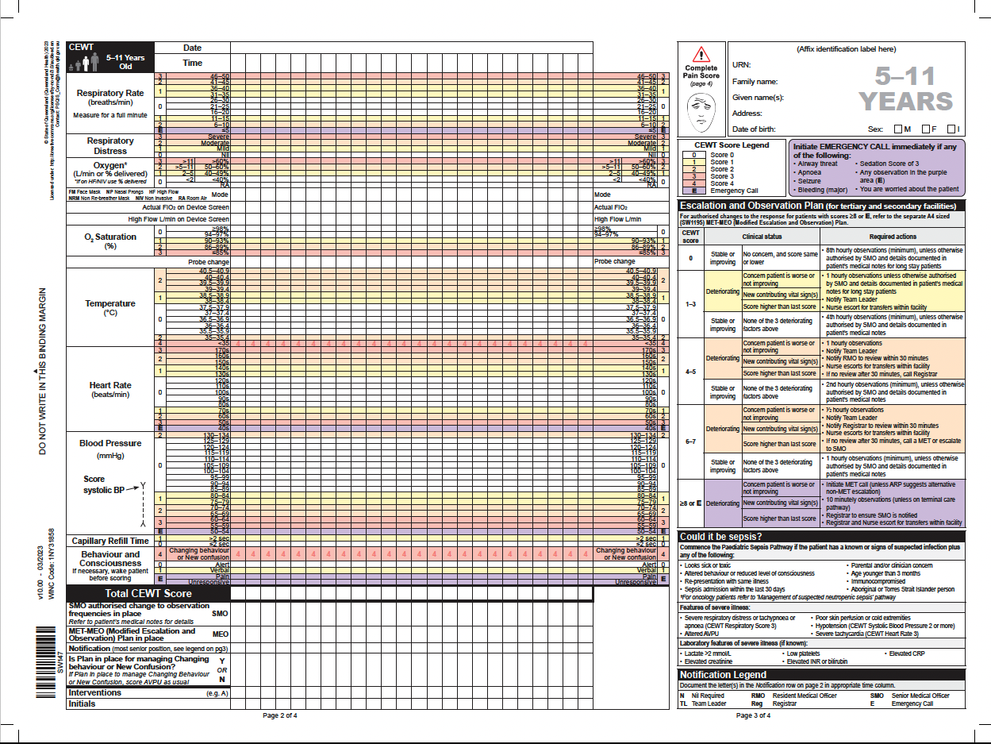

Supplementary Figure 2: Performance of Bedside PEWS, BTF, and CEWT for predicting ICU transfer events across years 2009-2017 for Cohort 1. Brighton PEWS was implemented in our hospital in 2013 (indicated by a dashed line).

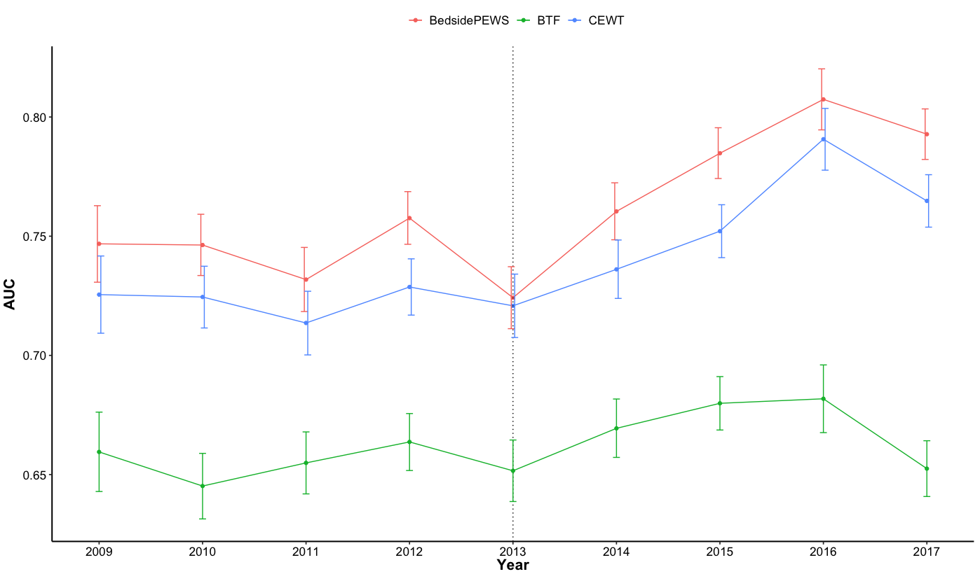

Supplementary Table 1: List of vital signs included and excluded in the modified versions of EW tools compared in this study.

 | CEWT* | Bedside PEWS* | BTF* | pCART
Included list of vital signs in the EW tools used in this study | RR, SpO2, O2 therapy, temp, HR, SBP, AVPU | RR, SpO2, O2 therapy, temp, HR, SBP | RR, SpO2, temp, HR, SBP, AVPU | RR, SpO2, O2 therapy, temp, HR, SBP, DBP, AVPU
Excluded list of vital signs from the original EW definition | Capillary refill, respiratory effort/distress | Capillary refill, respiratory effort/distress | Capillary refill, respiratory effort/distress, pain score | nil
Expanded/Non-vital sign inclusions | nil | nil | nil | Age**, Laboratory values***
Abbreviations: RR= respiratory rate, SpO2 = oxygen saturation, O2 therapy can be recorded as either Fraction of inspired oxygen (FiO2, where available) or L/min, temp = temperature, HR = heart rate, SBP = systolic blood pressure, AVPU = alert-verbal-pain-unresponsive (AVPU) scale, DBP = diastolic blood pressure.

* Modified from the original score
** Age was included as a variable for pCART, but the other tools have thresholds specific to 4-6 age categories.
*** pCART lab values = albumin, alkaline phosphatase, anion gap, aspartate transaminase, bands percentage, bilirubin, bicarbonate, blood urea nitrogen, calcium, creatinine, glucose, hemoglobin, lactate, mean corpuscular volume, neutrophil percentage, phosphate, and platelets.

Supplementary Table 2: Distribution and missingness of variables in the cohort.

Variable | Median (IQR) | % of patient admissions with missing values
Heart Rate | 108 (88, 129) | 0
Respiratory Rate | 23 (19, 30) | 0
Systolic Blood Pressure | 105 (95, 116) | 0
Diastolic Blood Pressure | 62 (53, 72) | 0
O2 Saturation | 98 (97, 100) | 0
Temperature | 36.6 (36.3, 37) | 0
Fraction of Inspired Oxygen | 21 (21, 21) | 2
AVPU | 0 (0, 0) | 49
Albumin | 3.7 (3.2, 4.1) | 67
Alkaline Phosphate | 155 (103, 234) | 67
Anion Gap | 13 (11, 15) | 64
SGOT | 31 (21, 48) | 67
Bands | 4 (2, 10) | 84
Bilirubin | 0.2 (0.1, 0.5) | 67
Blood Urea Nitrogen | 10 (6, 14) | 45
Calcium | 9.1 (8.6, 9.5) | 45
Creatinine | 0.4 (0.3, 0.5) | 45
Glucose | 99 (88, 116) | 45
Bicarbonate | 23 (21, 25) | 45
Hemoglobin | 10.5 (9, 11.9) | 45
Lactate | 1.1 (0.8, 1.7) | 91
MCV | 82.9 (78.5, 87.5) | 45
Neutrophil | 57 (39, 72) | 63
Phosphate | 4.3 (3.5, 5) | 72
Platelet | 266 (171, 364) | 45
Potassium | 4.1 (3.7, 4.5) | 45
Total protein | 6.4 (5.7, 7) | 67
Sodium | 139 (137, 141) | 45
WBC | 8.7 (5.6, 12.5) | 45
Age | 5 (1,12) | 0

Supplementary Table 3: Comparison of clinical characteristics and outcomes among patients who were transferred to the ICU and those who remained on the ward

Feature | Patient admissions with ICU transfer  (n=1,874) | Patient admissions without ICU transfer  (n=48,941) | P-value
Age years, median, (IQR) | 3 (0, 10) | 5 (1, 12) | <0.001
Female, n (%) | 835 (45) | 22072 (45) | 0.881
Race, n (%)
Black | 1150 (61) | 29253 (60) | 0.061
White | 469 (25) | 13480 (28) | 0.061
Other | 255 (14) | 5758 (12) | 0.061
Hispanic, n (%) | 239 (13) | 5868 (12) | 0.551
Mortality, n (%) | 42 (2) | 21 (0) | <0.001
Hospital length of stay days, median (IQR) | 8 (5,17) | 2 (1, 4) | <0.001
Initial Hospital Location,
n (%)
Ward | 608 (32) | 13401 (27) | <0.001
ED | 949 (51) | 25412 (52) | <0.001
ICU | 180 (10) | 3585 (7) | <0.001
Other | 137 (7) | 6093 (14) | <0.001

