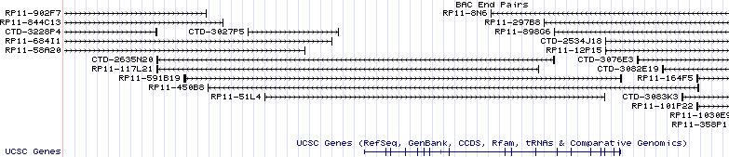
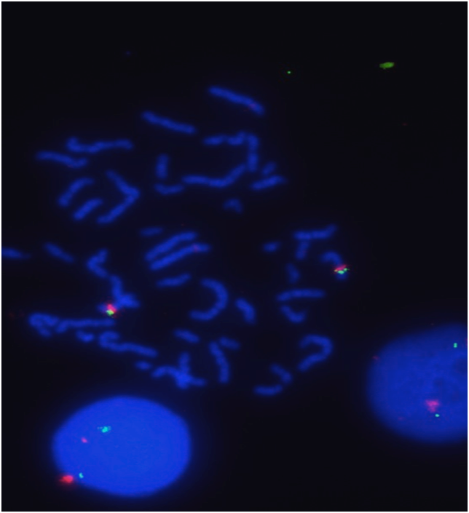
A
http:/genome.ucsc.edu/cgi-bin/
BAC RP11-450B8 size ≈ 200kb
9p13.2
MELK gene size ≈ 105kb
B Normal Lymphoblastoid cell line
MELK CEP9
Chromosome 9

S1 Fig. MELK selected clone, probe validation and FISH assay. (A) BAC clone RP11-450B8 (http:// genome.ucsc.edu/cgi-bin) contains the full-length of 105 kb MELK DNA with the optimal probe size of 200 kb. (B) An image of MELK:CEP9 FISH in control normal human lymphoblastoid cell line in metaphase and interphase is presented. The MELK gene is localized by green fluorescent signal, CEP9 is localized by red fluorescent signal. The MELK probe gave adequate bright signals. The normal pattern of two signals per cell for MELK and CEP9 probes can be detected on chromosome 9 (see also Table 1). The cells were counterstained with DAPI (blue). Original magnification x630.

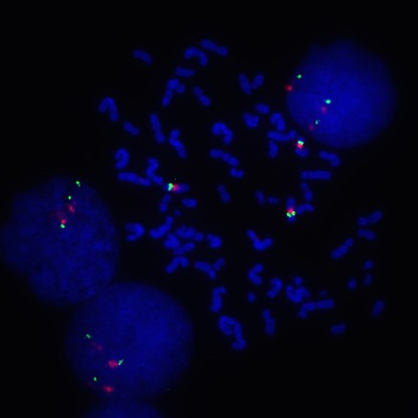
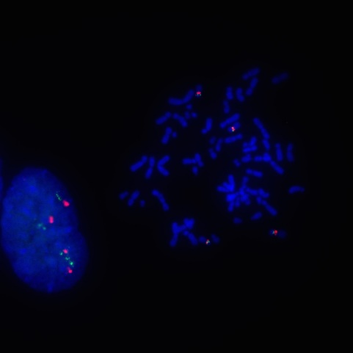
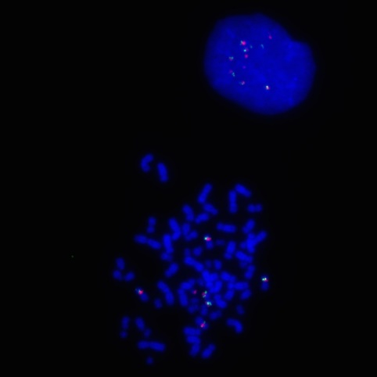

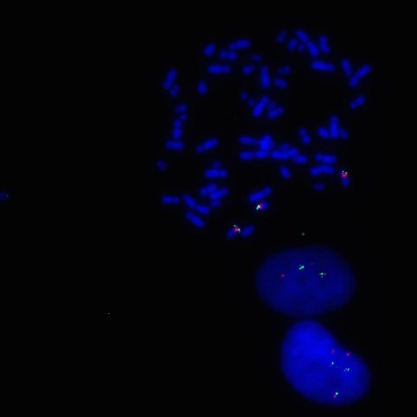
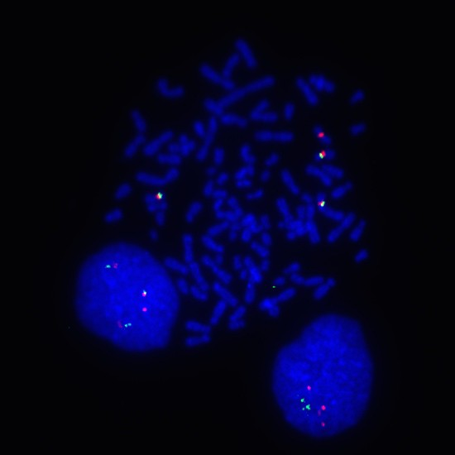

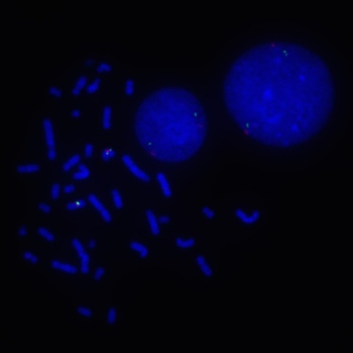
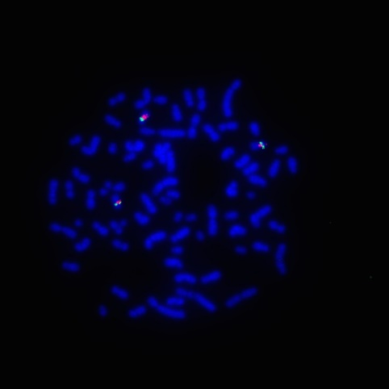
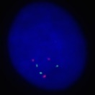
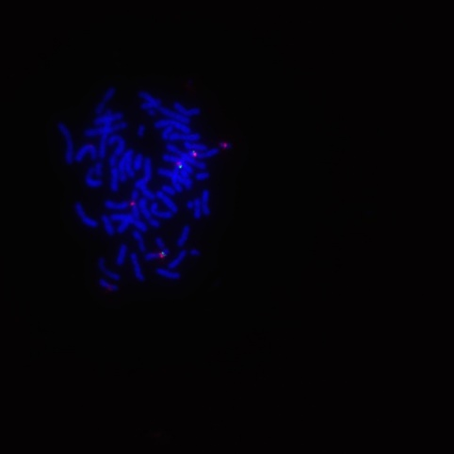
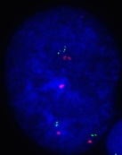


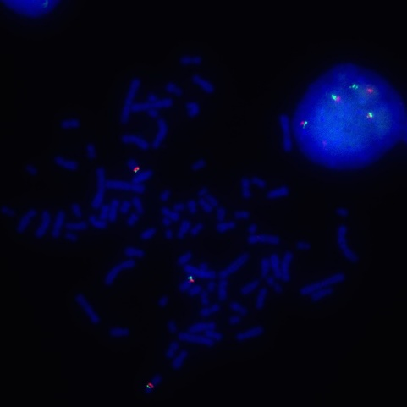
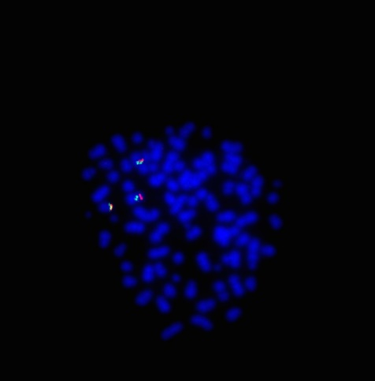
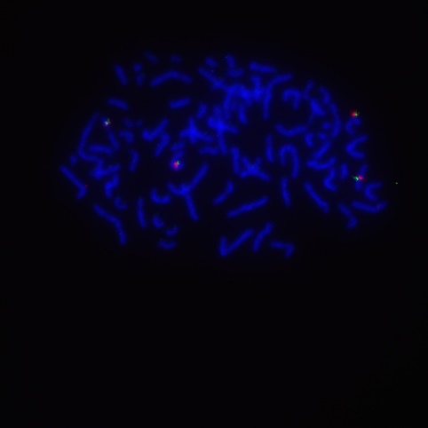
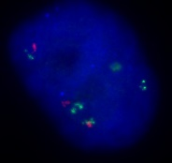
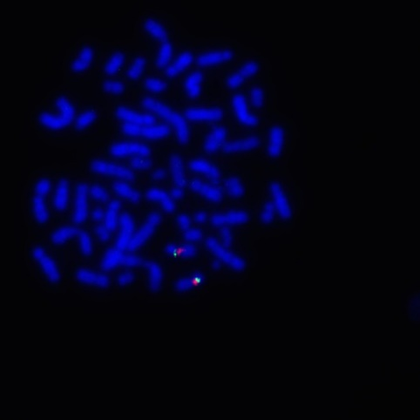
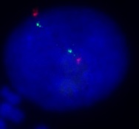
BT549
TNBC UACC3199
TNBC HCC1187
TNBC
MELK CEP9
MELK CEP9
MELK CEP9
MDAMB231
TNBC
MELK CEP9
HCC1954
TNBC
MELK CEP9
HCC1500
TNBC
MELK CEP9
HCC202
HER2+ SKBR3
HER2+
MELK CEP9
MELK CEP9
HCC1428
LumA
MELK CEP9
MCF7
LumA
MELK CEP9
KLE
Endometrial HEC1B
Endometrial
MELK CEP9
MELK CEP9

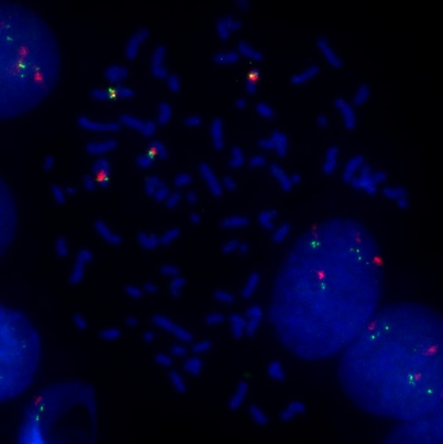
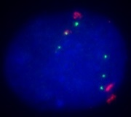

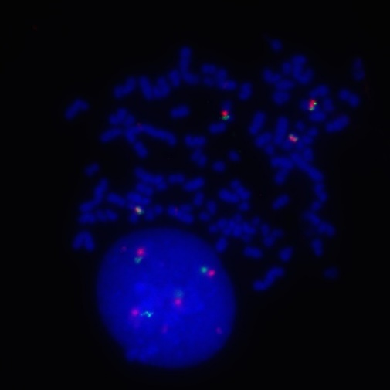
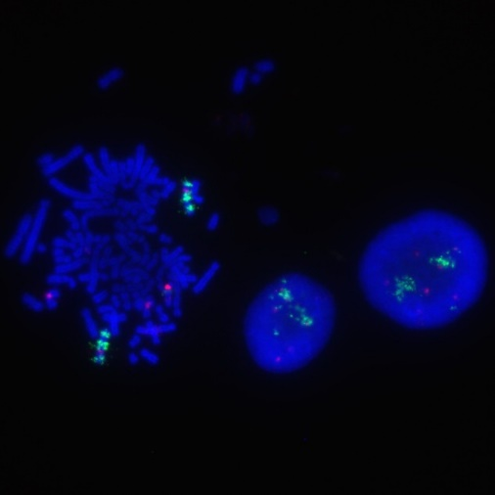


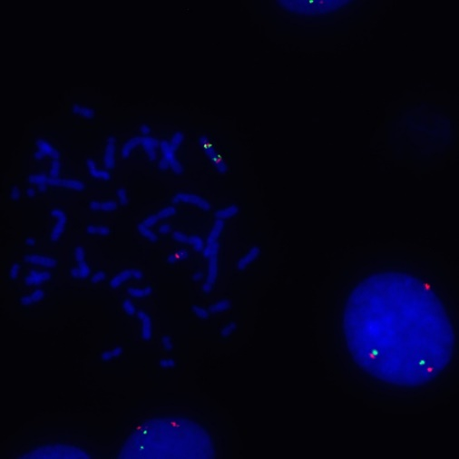

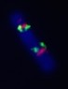

SKOV3 (Ovary)
MELK CEP9
HCC1937 (TNBC)
MELK CEP9
HCC2185 (HER2+)
MELK CEP9
BT20 (TNBC)
MELK CEP9

S2 Fig. Representative FISH images of MELK alterations in cancer cell lines. The MELK gene is localized by the green fluorescent signal; chromosome 9 centromere enumeration probe (CEP9) is localized by the red fluorescent signal. The cells were counterstained with DAPI (blue). Original magnification x630. In UACC3199, HCC1428 and HEC1B the presence of two extra copies of both signals defined high balanced and unbalanced tetrasomy. BT549 cells show high unbalanced polysomy with >6 copies of each signal.
HCC1187, MDAMB231, HCC1954, SKBR3, HCC202 and MCF7 cells carried one extra copy of MELK and 1-3 extra copies of chromosome 9, and were classified as having balanced and unbalanced low polysomy. HCC1500 and KLE cells showed two copies of each signal (balanced disomy). HCC2185 cells showed high amplification. Multiple copies of MELK (13–50/nucleus) are located within intrachromosomal amplicons on two chromosomes 9; three extra copies of the red signal show high polysomy for a derivative of chromosome 9. BT20 cells carry dicentric chromosome 9 with duplicated MELK and one extra copy of chromosome 9 derivative (unbalanced low polysomy). HCC1937 cells show trisomy for chromosome 9 with concordant gain of MELK (balanced polysomy). SKOV3 ovarian cancer cells were polysomic by carrying three copies of chromosome 9 with intact MELK and one chromosome 9 derivative with duplicated MELK. Arrow indicated gene amplification and arrowhead indicated structural alteration.

S3 Fig. MELK DNA copy numbers were analyzed by FISH and compared between basal-like (n=9) and luminal subtypes (n=4) in thirteen breast cancer cell lines. FISH images were shown in Figure 4B and supplementary Figure S2.

Positive Control Negative Control

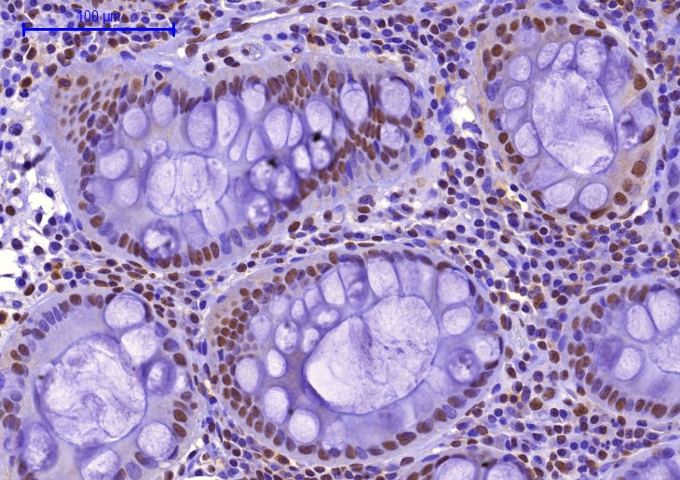
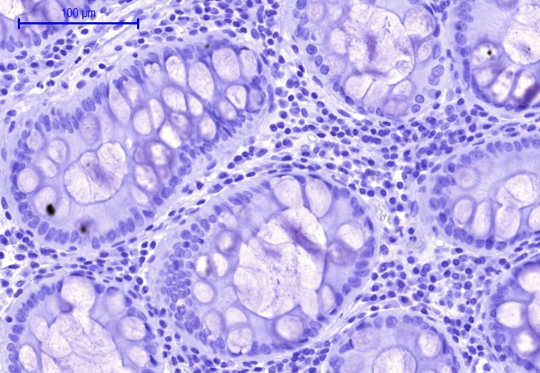
A
B

S4 Fig. Photomicrographs of positive (A) and negative (B) IHC staining with anti-MELK antibody in benign colon tissues as controls for the IHC detection of corresponding biomarker in breast cancer. (A) Antibody against MELK protein showed moderate nuclear staining in > 80% of benign colon crypts epithelium and lymphocytes. (B) For the negative control, isotype staining with corresponding immunoglobulin instead of antibody was used on adjacent slide. Original magnification x200.

S1 Table. Patient and tumor characteristics in association with MELK IHC expression
Characteristic | Total,  n=46  n (%) | MELK nuclear expression |  |  |  | MELK cytoplasmic expression
Characteristic | Total,  n=46  n (%) | Positive,  n = 39  n (%) | Negative,  n = 7  n (%) | P-value² |  | Positive,  n = 19  n (%) | Negative,  n = 27  n (%) | P-value²
Age at Diagnosis
Median age (range), years | 54.5 (21-90)
≤ 50 years old | 17 (37) | 15 (38.5) | 2 (28.6) | 1.000 |  | 6 (31.6) | 11 (40.7) | 0.555
> 50 years old | 29 (63) | 24 (61.5) | 5 (71.4) |  |  | 13(68.4) | 16 (59.3)
Race
Black | 38 (82.6) | 32 (82.1) | 6 (85.7) | 1.000 |  | 15 (78.9) | 23 (85.2) | 0.839
White | 6 (13) | 5 (12.8) | 1 (14.3) |  |  | 3 (15.8) | 3 (11.1)
Other | 2 (4.3) | 2 (5.1) | 0 (0.0) |  |  | 1 (5.3) | 1 (3.7)
Histologic Grade
Low | 4 (8.7) | 4 (10.3) | 0 (0) |  |  | 0 (0.0) | 4 (14.8)
Intermediate | 17 (37.0) | 15 (38.5) | 2 (28.6) | 0.828 |  | 7 (36.8) | 10 (37.0) | 0.316
High | 22 (47.8) | 18 (46.2) | 4 (57.1) |  |  | 10 (52.7) | 12 (44.5)
Unknown | 3 (6.5) | 2 (5.0) | 1 (14.3) |  |  | 2 (10.5) | 1 (3.7)
Lymph nodes
Positive | 15 (32.6) | 12 (30.8) | 3 (42.9) |  |  | 6 (31.6) | 9 (33.3)
Negative | 31 (67.4) | 27 (69.2) | 4 (57.1) | 0.667 |  | 13 (68.4) | 18 (66.7) | 1.000
Tumor size (cm) mean ± SD | 2.7± 1.9
≤ 2.0 cm | 20 (43.5) | 17 (43.6) | 3 (42.9) |  |  | 8 (42.1) | 12 (44.5)
> 2.0 cm | 25 (54.3) | 21 (53.8) | 4 (57.1) | 1.000 |  | 11 (57.9) | 14 (51.8) | 1.000
Unknown | 1 (2.2) | 1 (2.6) |  |  |  | 0 (0.0) | 1 (3.7)
Pathologic stage
0 | 3 (6.5) | 3 (7.7) | 0 (0.0) |  |  | 2 (10.5) | 1 (3.7)
I | 15 (32.5) | 13 (33.3) | 2 (28.6) | 0.912 |  | 5 (26.3) | 10 (37.0) | 0.750
II | 17 (37.0) | 15 (38.5) | 2 (28.6) |  |  | 8 (42.1) | 9 (33.4)
III | 10 (21.8) | 8 (20.5) | 2 (28.6) |  |  | 4 (21.1) | 6 (22.2)
Unknown | 1 (2.2) | 0 (0.0) | 1 (14.2) |  |  | 0 (0.0) | 1 (3.7)
Estrogen Receptor (ER) Status
Positive | 26 (56.5) | 23 (59) | 3 (42.9) |  |  | 13 (68.4) | 13 (48.1)
Negative | 17 (37) | 14 (35.9) | 3 (42.9) | 0.667 |  | 5 (26.3) | 12 (44.5) | 0.219
Unknown | 3 (6.5) | 2 (5.1) | 1 (14.3) |  |  | 1 (5.3) | 2 (7.4)
Progesterone Receptor (PR)
Positive | 24 (52.2) | 21 (53.8) | 3 (42.9) |  |  | 12 (63.1) | 12 (44.5)
Negative | 19 (41.3) | 16 (41.0) | 3 (42.9) | 1.000 |  | 6 (31.6) | 13 (48.1) | 0.351
Unknown | 3 (6.5) | 2 (5.1) | 1 (14.3) |  |  | 1 (5.3) | 2 (7.4)
HER2 Status
Positive | 3 (6.5) | 1 (2.6) | 2 (28.6) |  |  | 1 (5.3) | 2 (7.4)
Negative | 40 (87) | 36 (92.3) | 4 (57.1) | 0.047 |  | 17 (89.4) | 23 (85.2) | 1.000
Unknown | 3 (6.5) | 2 (5.2) | 1 (14.3) |  |  | 1 (5.3) | 2 (7.4)
Tumor subtype¹
Luminal A | 24 (52.2) | 22 (56.4) | 2 (28.6) |  |  | 12 (63.1) | 12 (44.5)
Luminal B | 2 (4.3) | 1 (2.6) | 1 (14.3) | 0.064 |  | 1 (5.3) | 1 (3.7) | 0.616
HER2-positive | 1 (2.2) | 0 (0.0) | 1 (14.3) |  |  | 0 (0.0) | 1 (3.7)
Triple-negative (TNBC) | 16 (34.8) | 14 (35.9) | 2 (28.6) |  |  | 5 (26.3) | 11 (40.7)
Unknown | 3 (6.5) | 2 (5.1) | 1 (14.3) |  |  | 1 (5.3) | 2 (7.4)
¹Defined by 3-marker (ER/PR/HER2) IHC classifier
²P-values are from Fisher’s exact test, excluding missing values

