SUPPORTING INFORMATION FOR
Sulfated GAG Mimetic Peptide Nanofibers Enhance Chondrogenic Differentiation of Mesenchymal Stem Cells in Three-Dimensional In Vitro Models

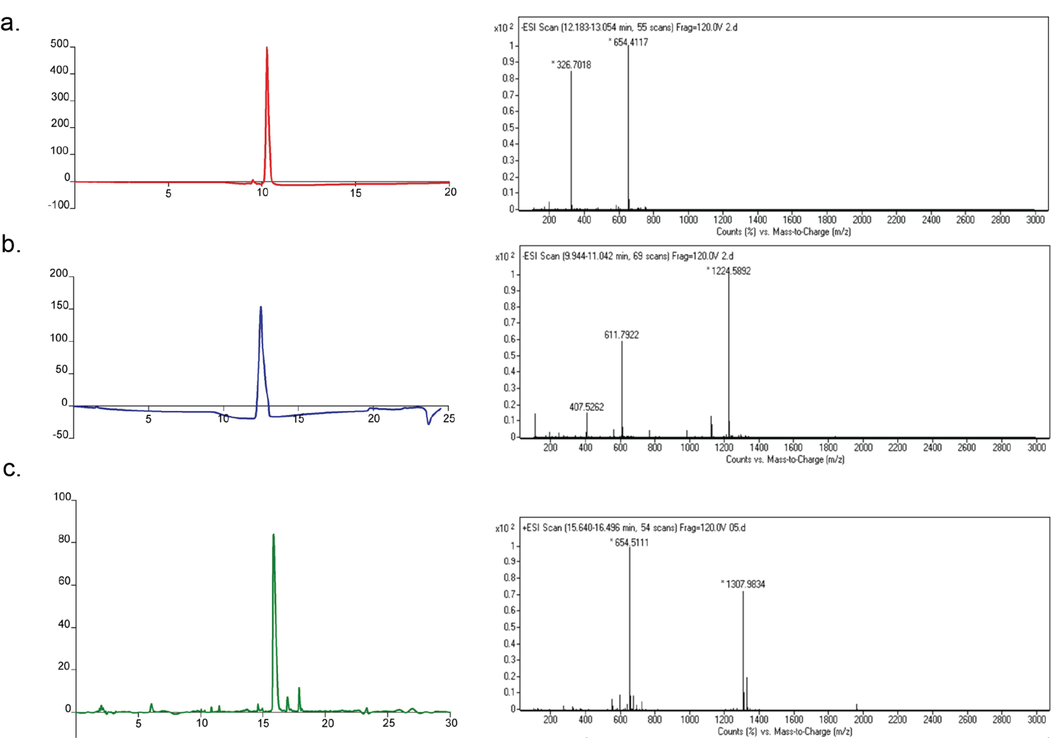
FIGURE S 1. Reverse-HPLC chromatogram and Liquid chromatography-mass spectrometry (LC-MS) analyses of E-PA (a), SO₃-PA (b) and K-PA(c).

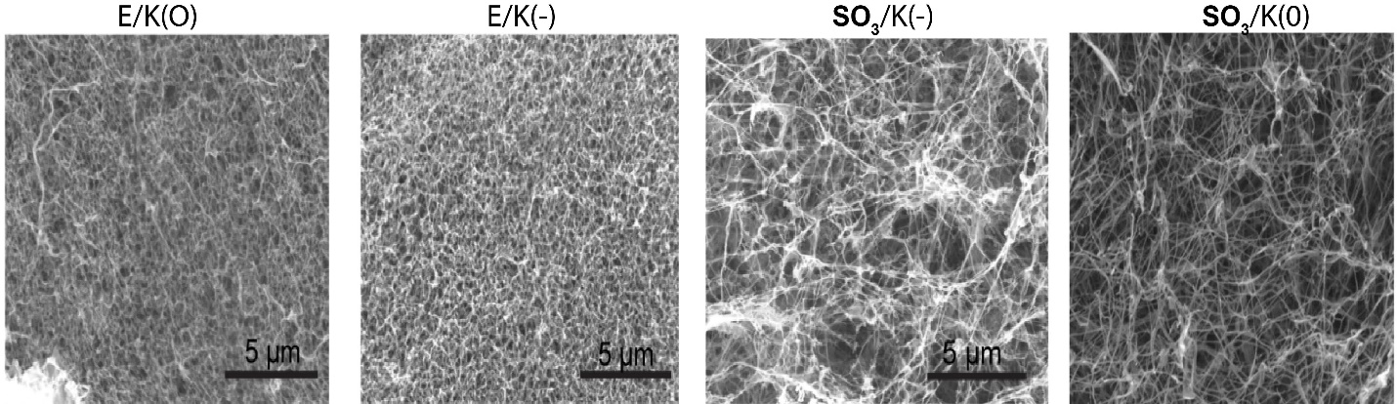

FIGURE S 2 Scanning electron microscope micrograph of indicated nanofibers.

Table S 1 Sequences, molecular weights and net charges and HPLC Analysis of the peptide amphiphile molecules at pH 7

PA  molecule | PA sequence | Molecular weight  (g/mol) | Net Charge (pH7) | Retention Time (min) | Purity (area %)
SO₃-PA | C12-VVAGEGD(K-pbs)S | 1226 | -3 | 10.8 | 97.1
E-PA | C12-VVAGE | 655,82 | -2 | 12.7 | 96.4
K-PA | C12-VVAGK | 654 | +1 | 15.4 | 96.8

Table S 2 Composition and net loads of the nanofiber scaffolds
PA combination | Volume ratio | Net Charge (pH7)
SO₃/K(0); SO₃-PA/K-PA | 1:3 | Neutral
SO₃/K(-); SO₃-PA/K-PA | 1:2 | Negative
E/K(0); E-PA/K-PA | 1:1 | Neutral
E/K(-); E-PA/K-PA | 2:1 | Negative

Table S 3 Different media and their contents when culturing msenchymal stem cells on peptide nanofibers

Maintenance medium | 10% FBS + DMEM
Basal medium | 10⁻⁷M Dexamethazone, 1 µM, Transferrin, 6 μg/mL insulin, 3x10⁻⁵ M Sodium Selenite, 0.5mg/mL BSA+ DMEM
Chondrogenic medium 1 | 10⁻⁷M Dexamethazone, 1 µM, Transferin, 6 μg/mL insulin, 3x10⁻⁵ M Sodium Selenite, 0.5 mg/mL BSA+ DMEM + 2 ng/mL TGF beta-1
Chondrogenic medium 2 | 10⁻⁷M Deksamethazone, 1 µM, Transferin, 6 μg/mL Insulin, 3x10⁻⁵ M Sodium Selenite, 0.5 mg/mL BSA+ DMEM + 10 ng/mL TGF beta-1

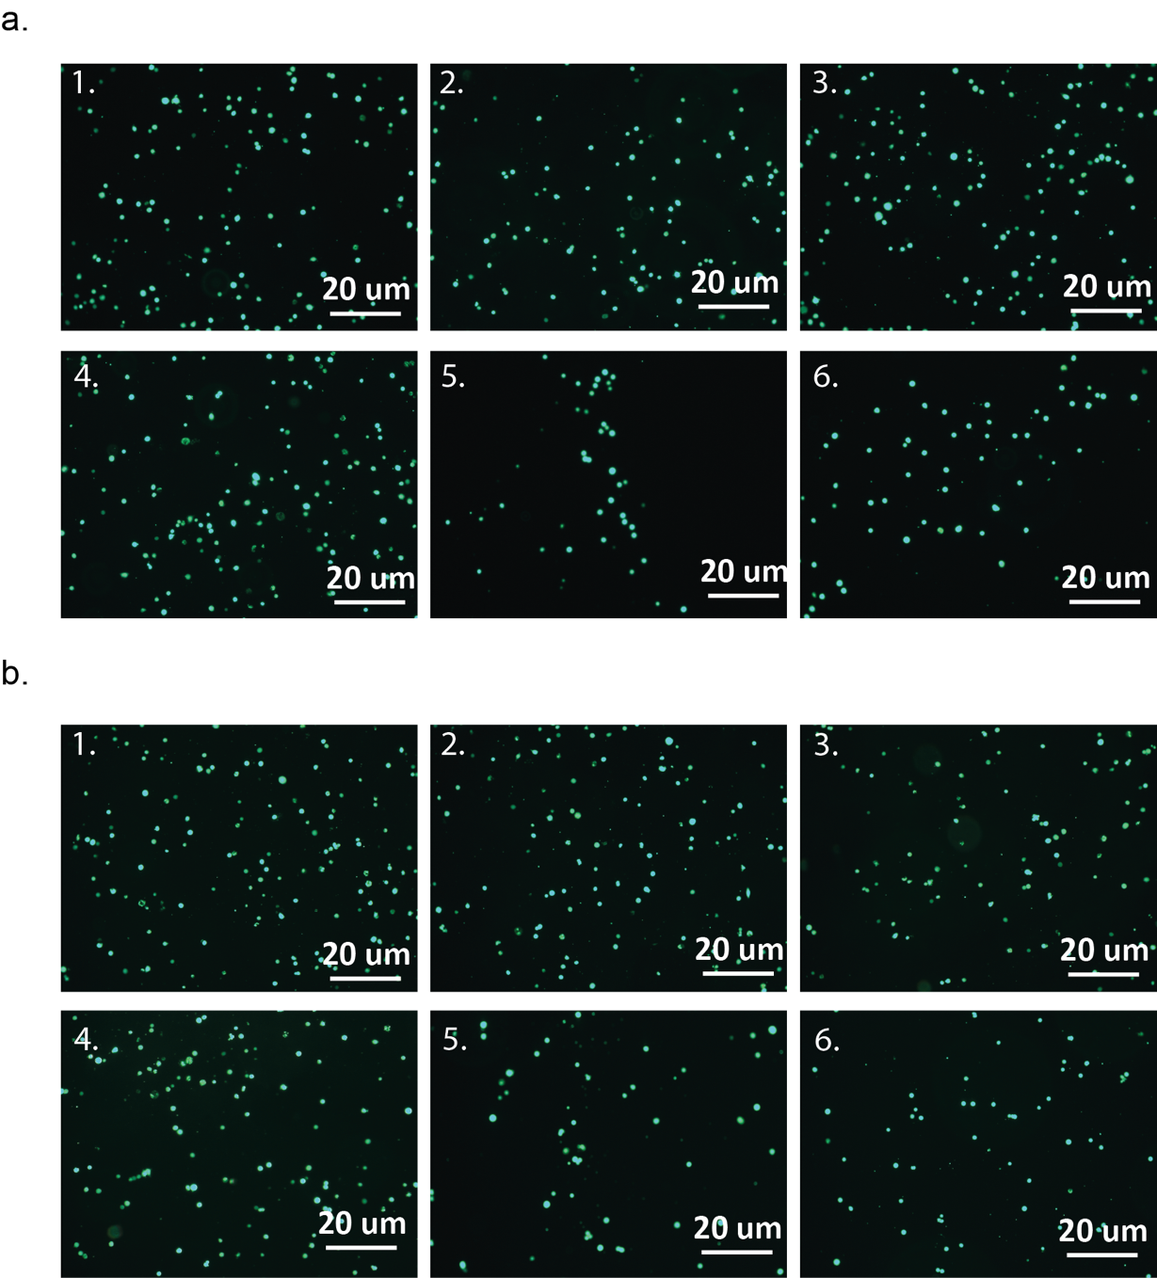

FIGURE S 3 Representative images of adhered live mouse mesenchmal stem cells at (a) 1 h and (b) 3 h of culture on various coatings (1; E/K (0), 2;E/K (-), 3;SO₃/K (0), 4;SO₃/K (-), 5;TCP and 6; Collagen I. Live cells stained with Calcein AM (green).

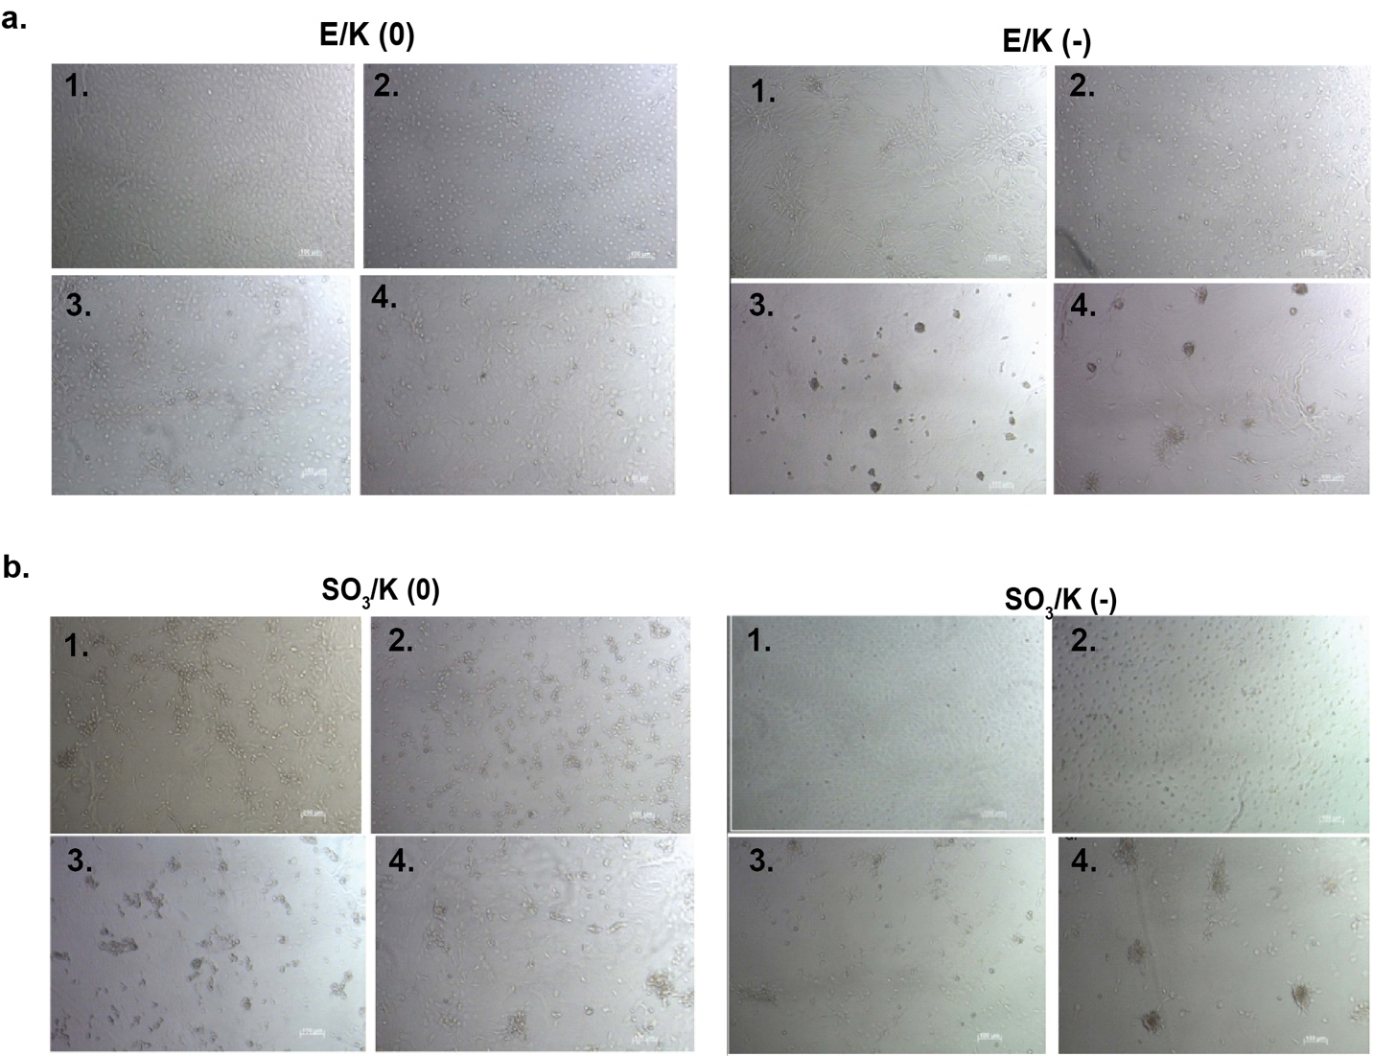

FIGURE S 4 Light microscope images of mouse mesenchymal stem cells cultured on (a) E/K (0), E/K (-) and (b) SO₃/K(0), SO₃/K(-) coatings in 1; maintenance medium, 2; basal medium, 3; chondrogenic medium 1 and 4; chondrogenic medium at day 7.

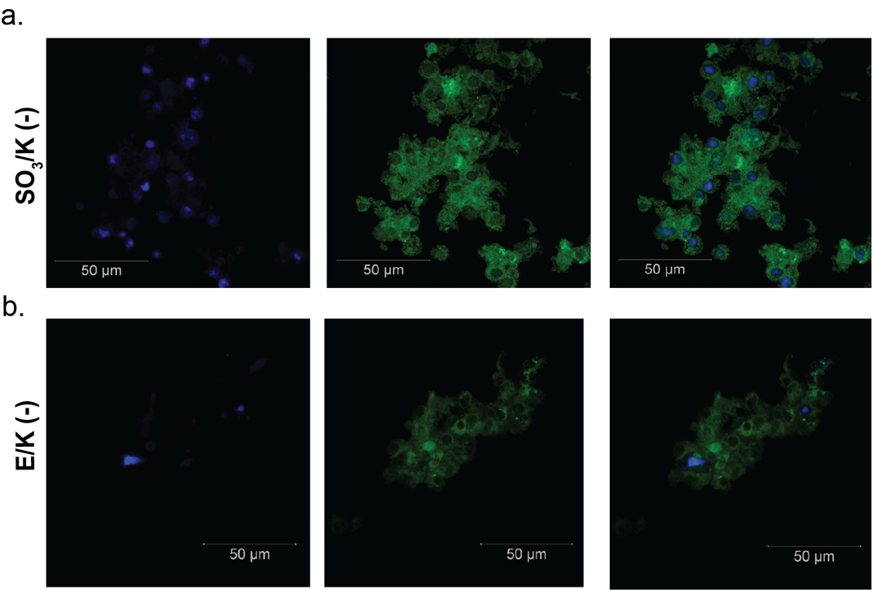

FIGURE S 5 Mouse mesenchymal stem cells cultured on E/K (-) and SO₃/K (-) coatings express cartilage specific Aggrecan proteins on day 7. Collagen II were labeled with Cy3 secondary antibody (green) and cell nuclei were labeled with DAPI®-3 (blue).

FIGURE S 6 (a, c) Collagen II (b, d) Aggrecan expression of mouse mesenchymal stem cells on indicated coatings (a, b) on day 7 and (c, d) on day 14 in maintenance, basal, chondrogenic medium 1 and 2. The expression level of each gene was normalized against uncoated tissue culture plate samples (TCP) and GAPDH was used as the internal control. Values represent mean ± SEM, n = 3 (***p < 0.0001, **p < 0.01, *p < 0.05).

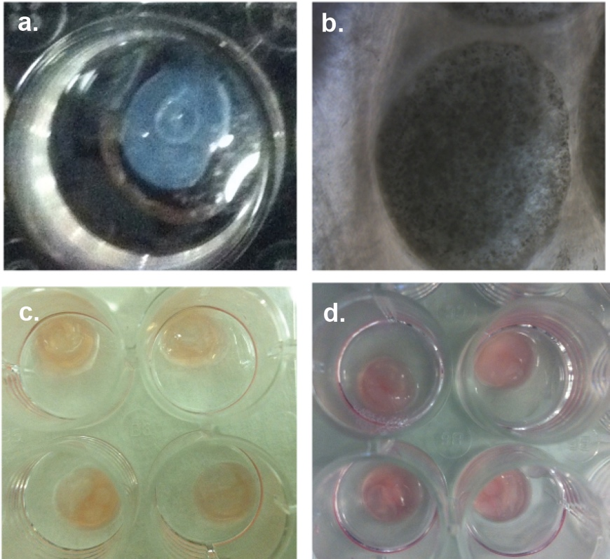
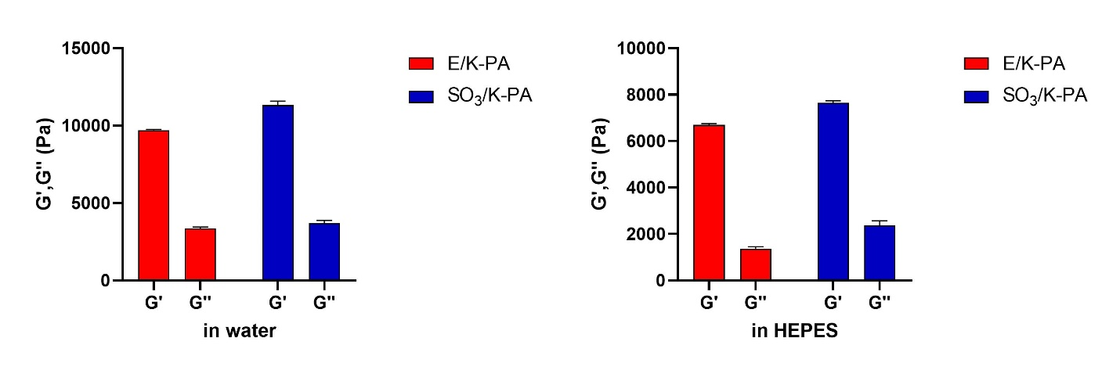
e.
f.

FIGURE S 7 (a) 3D culture formation by mixing peptide amphiphiles in a well of 24-well plate. (b) Light microscope images of seeded mouse mesenchymal stem cells in 3-dimensional hydrogels. Images of 3-dimensional hydrogel on day 3 (c) and on day 7 (d) Storage and loss modulus of E/K(-) and SO₃(-) hydrogels in water (e) and HEPES buffer (f) at pH 7.

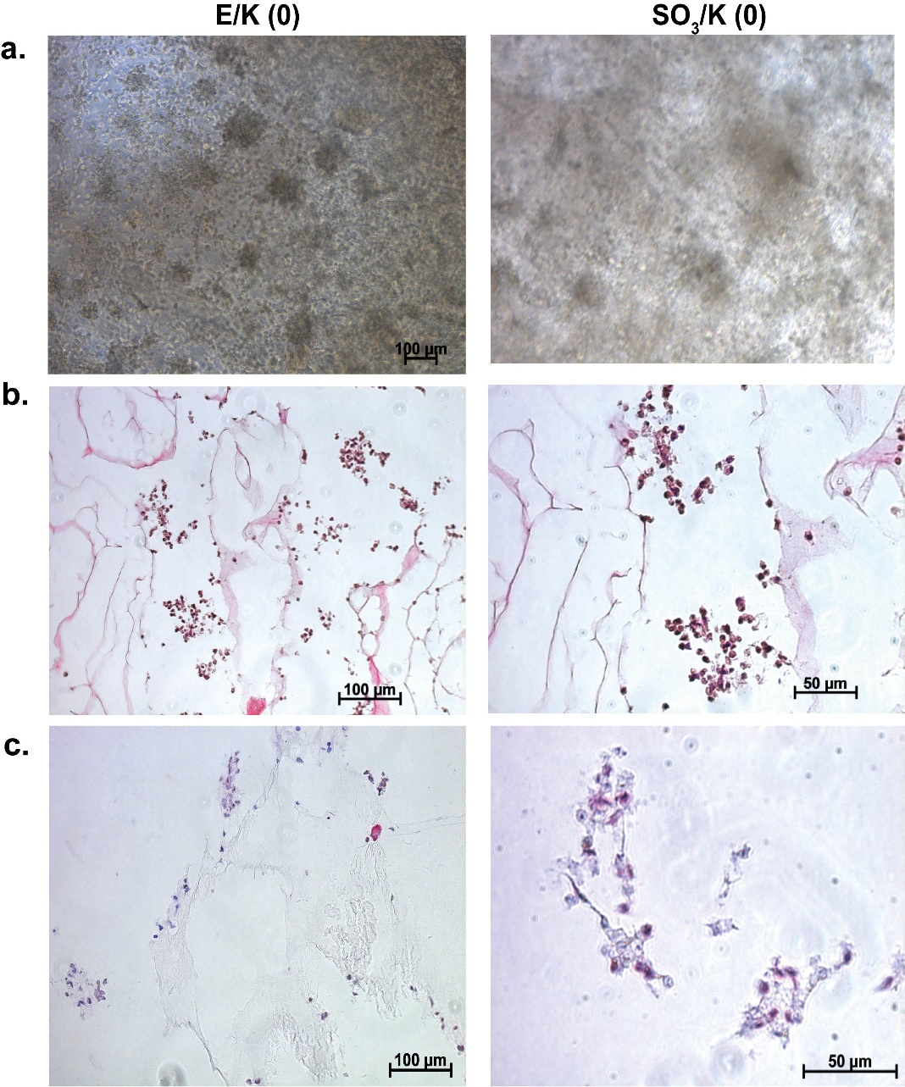

FIGURE S 8 (a) Light microscope images of mMSCs cultured in E/K(0) and SO₃(0) hydrogels on day 14. (b) Hematoxylin and eosin stainings showing aggregate formation by mMSCs cultured in 3D E/K(0) and SO₃(0) hydrogels on day 14. (c) Safranin-O stainings showing glycosaminoglycan depositions by mMSCs cultured in E/K(0) and SO₃(0) hydrogels on day 14.

FIGURE S 9 Immunofluorescence collagen II staining on sections of mMSC cultured in 3D E/K(0) and SO₃(0) hydrogels on day 14. Collagen II were labeled with Cy3 secondary antibody (green) and cell nuclei were labeled with DAPI®-3 (blue).

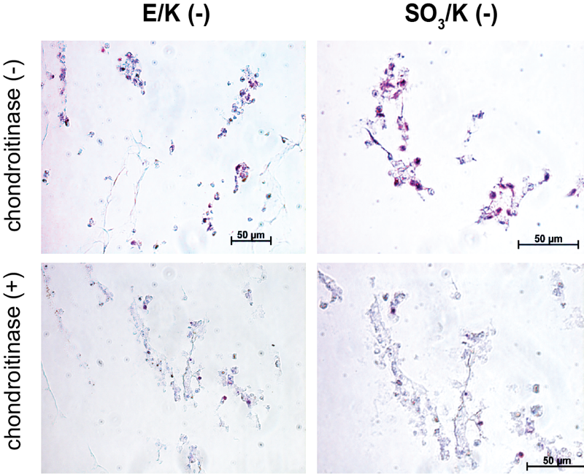

FIGURE S 10 Safranin-O stainings of mouse mesenchymal stem cells cultured in 3-dimensional E/K(-) and SO₃(-) hydrogels on day 14 incubated with and without chondroitinase before Safranin-O staining.

