Supplemental Materials
Summary of Test Responses and Participant Attrition Across Studies
Study 1a. In total, 478 individuals started the survey. We removed 72 from analysis: 14 because they were test responses (e.g., by experimenters and research assistants), 18 because they did not complete the survey, and 40 because they did not report having a relationship in their assigned relationship condition.
Study 1b. In total, 169 individuals started the survey. We removed 69 from analysis: 60 who were test responses (e.g., by experimenters and research assistants) and 9 individuals who did not complete the survey.
Study 1c. In total, 418 individuals started the survey. We removed from analysis 15 who did not complete the full survey.
Study 2a. In total, 214 individuals started the survey. We removed from the analysis 8 participants who did not complete the survey.
Study 2b. In total, 410 individuals started the survey. We removed from analysis 4 individuals who were test responses (e.g., by experimenters and research assistants) and 5 individuals who did not complete the survey.
Study 3. In total, 265 individuals started the survey. We removed from analysis 65 who did not complete the survey. Of the 65, 20 did not write a statement for the movie plot (the first writing task of the study), 22 wrote a movie plot but did not list four relationship partners, 14 wrote a movie plot and listed four partners but did not complete any of the survey questions about the partners, and the final 9 wrote a plot, listed four partners, and completed some but not all of the survey questions. None of the 65 completed the demographic questions.
Study 4 writers. In total, 107 individuals started the survey, 90 of whom completed the survey and 69 of whom passed our preregistered criteria to be in the study (see main text footnote 12 for details).
Study 4 evaluators. In total, 265 individuals started the survey. We removed from analysis 5 test responses (e.g., by experimenters and research assistants) and 9 individuals who did not complete the survey.
Study 1a Additional Analyses
Table S1
Output of Regression Models Examining the Effects of Subjective Knowledge on Relationship Satisfaction in Study 1a (N = 405)
 | Model 1 |  |  |  |  |  |  | Model 2
Variable | Unstandardized  Coefficients |  | Standardized  Coefficients | t | p |  | Standardized  Coefficients |  | t | p
Variable | B | SE | β | t | p |  | β |  | t
Constant | 2.358 | .176 |  | 13.39 | <.001
Feeling known | .554 | .050 | .590 | 11.12 | <.001 |  | .785 |  | 11.54 | <.001
Felt knowing | .173 | .051 | .180 | 3.38 | .001 |  | .170 |  | 2.43 | .016
Known × Knowing |  |  |  |  |  |  | -.108 |  | -3.04 | .003
Note. All models include dummy-coded variables controlling for relationship type (mother, father, brother, sister). R² for Model 1 is 0.54 and for Model 2 is 0.55. To improve interpretability, we only report the standardized coefficients in Model 2.

Figure S1
The Effect of High (+1 SD) and Low (-1 SD) Feeling Known and Felt Knowing on Relationship Satisfaction in Study 1a

Note: This figure was generated using the template available at www.jeremydawson.co.uk/slopes.htm.

To examine whether our predicted effect interacted meaningfully with family member condition, we conducted an ANOVA analysis with family member condition entered as a fixed effect and our two measures of relationship knowledge (feeling known and felt knowing) entered as covariates predicting relationship satisfaction. We tested for all possible interaction effects in the model. There was an effect of feeling known, F(1, 390) = 61.63, p < .001, η_{p}² = 0.136, a smaller effect of felt knowing, F(1, 390) = 15.89, p < .001, η_{p}² = 0.039, a marginal effect of partner-condition, F(3, 390) = 2.33, p = .074, η_{p}² = 0.018, and an interaction between the two types of relationship knowledge, F(1, 390) = 9.68, p = .002, η_{p}² = 0.024. There was only one marginally significant interaction with family member condition (between knowing and condition, F(3, 390) = 2.26, p = .081, η_{p}² = 0.017); other interactions with family member condition were non-significant, Fs < 1.16.
We further examined the effects of feeling known and felt knowing for each family member. Specifically, we separated the data by family member to examine the effects of feeling known and felt knowing on relationship satisfaction in regression models. Considering just the effect of feeling known on satisfaction, there was a significant association that emerged for all relationship types (mother: β = .55, p < .001; father: β = .55, p < .001; brother: β = .62, p < .001; and sister: β = .65, p < .001). Next considering just the effect of felt knowing on satisfaction, the association was weaker or non-significant in each relationship type (mother: β = .25, p = .023; father: β = .24, p = .030; brother: β = .15, p = .144; sister: β = .07, p = .482). Tests between the regression coefficients showed that feeling known was a significantly stronger predictor of satisfaction than knowing for mother (z = 2.03, p = .043), brother (z = 3.22, p = .001), and sister (z = 3.68, p < .001), but only marginally for father (z = 1.90, p = .058).
Study 1b Additional Analyses
Participants reported that it was more important for their relationship satisfaction for them to know their partner (M = 5.87, SD = 0.84) than for their partner to know them (M = 5.68, SD = 0.89), paired t(99) = 3.12, p = .002, d = 0.22. This result may suggest that participants are not aware of, or would not like to admit, what will make them happy in relationships. Indeed, to social desirability concerns may have led participants to overemphasize the importance of knowing. We consider this result further in the General Discussion.

Table S2
Output of Regression Models Examining the Effects of Subjective Knowledge on Relationship Satisfaction in Study 1b (N = 99)
 | Model 1 |  |  |  |  |  |  | Model 2
Variable | Unstandardized  Coefficients |  | Standardized  Coefficients | t | p |  | Standardized  Coefficients |  | t | p
Variable | B | SE | β | t | p |  | β |  | t
Constant | 1.946 | .578 |  | 3.37 | .001
Feeling known | .711 | .118 | .640 | 6.04 | <.001 |  | .641 |  | 5.58 | <.001
Felt knowing | .040 | .134 | .032 | .303 | .763 |  | .001 |  | 0.01 | .992
Known × Knowing |  |  |  |  |  |  | -.234 |  | -3.51 | <.001
Note. R² for Model 1 is 0.44 and for Model 2 is 0.50. To improve interpretability, we only report the standardized coefficients in Model 2.

Figure S2
The Effect of High (+1 SD) and Low (-1 SD) Feeling Known and Felt Knowing on Relationship Satisfaction in Study 1b

Note: This figure was generated using the template available at www.jeremydawson.co.uk/slopes.htm.

Study 1c Additional Analysis
We gave participants the opportunity to categorize their friendship in more depth: 18% reported their friend was also a coworker, 8% reported the friend was a roommate, 7% reported the friend was a neighbor, 6% reported the friend was some sort of family member (e.g., parent, child, sibling), 6% reported the friend was a romantic partner, and 60% did not categorize the friend further (note that participants could select multiple categories). None of the categorizations varied significantly by experimental condition, ps > .250.
Table S3
Output of Regression Models Examining the Effects of Subjective Knowledge on Relationship Satisfaction in Study 1c (N = 402)
 | Model 1 |  |  |  |  |  |  | Model 2
Variable | Unstandardized  Coefficients |  | Standardized  Coefficients | t | p |  | Standardized  Coefficients |  | t | p
Variable | B | SE | Β | t | p |  | β |  | t
Constant | 2.649 | .186 |  | 14.22 | <.001
Feeling known | .345 | .038 | .412 | 9.12 | <.001 |  | .485 |  | 9.05 | <.001
Felt knowing | .256 | .043 | .270 | 5.97 | <.001 |  | .323 |  | 6.05 | <.001
Known × Knowing |  |  |  |  |  |  | .125 |  | 3.11 | .002
Note. R² for Model 1 is 0.34 and for Model 2 is 0.36. To improve interpretability, we only report the standardized coefficients in Model 2.

Figure S3
The Effect of High (+1 SD) and Low (-1 SD) Feeling Known and Felt Knowing on Relationship Satisfaction in Study 1c

Note: This figure was generated using the template available at www.jeremydawson.co.uk/slopes.htm.

Study 2a Scenarios
Scenario introduction. Imagine that you run into an acquaintance who you have met many times in the past. You very often run into him or her at social events. During the last party when you saw this person, you chatted for about an hour. You feel like you know this person relatively deeply: You know their hopes, desires, and dreams. You also feel like this person knows you deeply: This person knows your hopes, desires, and dreams. You would consider this person a "friend."
Name scenarios.
Feeling-unknown. When you see your friend again, you greet them warmly and they do the same to you. You start to tell them about the latest things happening in your life. At some point, someone interrupts the conversation and asks your friend to introduce you. Your friend looks embarrassed, turns to you, and says: "I'm so sorry, but I've forgotten your name." Your "friend" doesn't remember your name. You realize that your friend doesn't know you as well as you thought they did.
Felt-not-knowing. When you see your friend again, you greet them warmly and they do the same to you. You start to tell them about the latest things happening in your life. At some point, someone interrupts the conversation and asks you to introduce your friend. You feel embarrassed, turn to your friend, and say: "I'm so sorry, but I've forgotten your name." You don't remember your "friend's" name. You realize that you don't know your friend as well as you thought you did.
Childhood scenarios.
Feeling-unknown. When you see your friend again, you greet them warmly and they do the same to you. You start to tell them about the latest things happening in your life. At some point, your friend asks you a question about your childhood. You say: "I'd prefer not to talk about that." You realize you have never told your friend about your childhood. Your "friend" doesn't know anything about your childhood or your past. You realize that your friend doesn't know you as well as you thought they did.
Felt-not-knowing. When you see your friend again, you greet them warmly and they do the same to you. You start to tell them about the latest things happening in your life. At some point, you ask your friend a question about their childhood. Your friend says: "I'd prefer not to talk about that." You realize that your friend has never told you about their childhood. You do not know anything about your "friend's" childhood or their past. You realize that you don't know your friend as well as you thought you did.
Study 2a Additional Analyses
Manipulation checks. We conducted a 2 (relationship knowledge condition: feeling unknown vs. felt not-knowing) × 2 (scenario condition: name vs. childhood) × 2 (relationship knowledge ratings for self vs. other) mixed-model ANOVA on perceived knowledge. Supporting our manipulation, there was an interaction between knowledge condition and ratings, F(1, 202) = 46.60, p < .001, η_{p}² = 0.19, such that the effect of condition was larger for the self-ratings, whereby participants felt less known in the feeling unknown condition (M = 3.46, SD = 1.46) than in the felt not-knowing condition (M = 4.72, SD = 1.19), t(204) = -6.80, p < .001, d = -0.95. The effect was relatively smaller for other-ratings, whereby participants did not feel they knew the other person any less well in the feeling unknown condition (M = 4.41, SD = 1.09) than in the felt not-knowing condition (M = 4.46, SD = 1.38), t(204) = 0.31, p = .754, d = 0.04. The ANOVA also showed three main effects: participants reported less overall knowledge in the feeling unknown (vs. felt not-knowing) condition, F(1, 202) = 11.47, p < .001, η_{p}² = 0.05; participants reported less knowledge in the name (vs. childhood) scenario, F(1, 202) = 15.74, p < .001, η_{p}² = 0.07; and participants reported lower knowledge when rating themselves (vs. others), F(1, 202) = 12.45, p = .001, η_{p}² = 0.06.
Study 2b Scenarios
Family scenario. Imagine that you run into an acquaintance who you have met one time in the past. You do not know this person very well, but you happened to run into him at a social event recently. During the last party when you saw this person, you chatted for only a few minutes, but you had a conversation about each other's family and in particular talked about your relationship with your siblings. Imagine you mentioned that you have a sister, and your acquaintance said he has a sister too.
Further imagine that you are at an event when you run into this person again.
Feeling-unknown. You start exchanging pleasantries. Early in the conversation, the topic turns to family experiences. The other person starts to ask you about your family, but then says, "I'm sorry, I've forgotten whether or not you have a sister, can you remind me?" You realize that the other person forgot your siblings.
Feeling-known. You start exchanging pleasantries. Early in the conversation, the topic turns to family experiences. The other person starts to ask you about your family, and then says, "I remember that you have a sister." You realize that the other person remembers your siblings.
Felt-not-knowing. You start exchanging pleasantries. Early in the conversation, the topic turns to family experiences. You start to start to ask him about his family, but then say, "I'm sorry, I've forgotten whether or not you have a sister, can you remind me?" He realizes that you forgot his siblings.
Felt-knowing. You start exchanging pleasantries. Early in the conversation, the topic turns to family experiences. You start to ask him about his family, and then say, "I remember that you have a sister." He realizes that you remember his siblings.
Name scenario. Imagine that you run into an acquaintance who you have met one time in the past. You do not know this person very well, but you happened to run into him at a social event recently. During the last party when you saw this person, you chatted for only a few minutes.
Further imagine that you are at an event when you run into this person again.
Feeling-unknown. You start exchanging pleasantries. Early in the conversation, he starts to introduce you to one of his colleagues, but then says to you, "I'm sorry, I've forgotten your name. Can you remind me?" You realize that he forgot your name.
Feeling-known. You start exchanging pleasantries. Early in the conversation, he introduces you to one of his colleagues and mentions your name. You realize that he remembered your name.
Felt-not-knowing. You start exchanging pleasantries. Early in the conversation, you start to introduce him to one of your colleagues, but then say to him, "I'm sorry, I've forgotten your name. Can you remind me?" He realizes that you have forgotten his name.
Felt-knowing. You start exchanging pleasantries. Early in the conversation, you introduce him to one of your colleagues and mention his name. He realizes that you remembered his name.
Study 2b Additional Analyses
Manipulation checks. We conducted two subsequent 2 (target: knowledge related to self vs. knowledge related to partner) × 2 (amount: high vs. low) × 2 (scenario: name vs. family) ANOVAs on participants’ ratings of feeling known and felt knowing. The two-way interaction between target and amount emerged for feeling known, F(1, 393) = 12.70, p < .001, η_{p}² = 0.031, such that there was a larger effect of knowledge amount on feeling known in the self-relevant knowledge conditions (i.e., feeling known vs. feeling unknown) than in the partner-relevant knowledge conditions (i.e., felt knowing vs. felt not-knowing). Main effects of target, amount, and scenario type also emerged on felt knowing, Fs > 6.49, ps < .011, η_{p}²s > 0.016, but no other interactions reached statistical significance, ps > .573. In contrast, for felt knowing, the two-way interaction between target and amount was statistically non-significant, F(1, 393) = 1.40, p = .237, η_{p}² = 0.004. For felt knowing, there were also main effects of target, amount, and scenario type, Fs > 9.04, ps < .003, η_{p}²s > 0.022, but no statistically significant interactions, ps > .537.
Study 3 Additional Materials
Manipulation checks. As manipulation checks, we measured the extent to which participants expected to receive support in the relationship (α = .74): 1) To what extent is your relationship with [name] characterized by them giving you emotional support? 2) How much do you expect emotional support from [name]? and expected to provide support in the relationship (α = .73): 1) To what extent is your relationship with [name] characterized by you giving them giving emotional support? 2) How much does [name] expect to get emotional support from you? (1 = not at all, 10 = very much).

Study 3 Additional Analyses
Table S4
Frequency of Relationship Type in Each Experimental Condition in Study 3
 | High Receive Support/High  Provide Support |  | Low Receive Support/Low  Provide Support |  | Low Receive Support/High  Provide Support |  | High Receive Support/Low Provide Support
 | Frequency | Percent | Frequency | Percent | Frequency | Percent | Frequency | Percent
Friend | 65 | 32.5% | 75 | 37.5% | 87 | 43.5% | 70 | 35.0%
Romantic Partner | 81 | 40.5% | 7 | 3.5% | 11 | 5.5% | 12 | 6.0%
Parent | 18 | 9.0% | 26 | 13.0% | 13 | 6.5% | 72 | 36.0%
Child | 7 | 3.5% | 3 | 1.5% | 14 | 7.0% | 3 | 1.5%
Sibling | 16 | 8.0% | 20 | 10.0% | 34 | 17.0% | 12 | 6.0%
Grandparent | 1 | 0.5% | 3 | 1.5% | 1 | 0.5% | 2 | 1.0%
Colleague | 3 | 1.5% | 22 | 11.0% | 7 | 3.5% | 4 | 2.0%
Boss | 0 | 0.0% | 6 | 3.0% | 4 | 2.0% | 6 | 3.0%
Subordinate | 0 | 0.0% | 1 | 0.5% | 2 | 1.0% | 1 | 0.5%
Neighbor | 2 | 1.0% | 7 | 3.5% | 4 | 2.0% | 3 | 1.5%
Acquaintance | 2 | 1.0% | 10 | 5.0% | 5 | 2.5% | 3 | 1.5%
Note: The two most frequently nominated relationship categories for each experimental condition other than “friend” (which was almost always the most common category selected) are shown in bold font. Participants who categorized the relationship as “other” are excluded in this table.

Analysis of manipulation checks. Supporting the manipulation, across each of the four relationship types, participants in the high-receive condition reported that they expected to receive more support (M = 7.08, SD = 2.35) than participants in the low-receive condition (M = 3.39, SD = 2.23), t(798) = 22.79, p < .001, d = 1.61, and participants in the high-provide condition expected to provide more support (M = 7.06, SD = 2.25) than participants in the low-provide condition (M = 4.22, SD = 2.54), t(798) = 16.77, p < .001, d = 1.19. The relationship categories that participants selected for each condition, shown in Supplemental Table S4, further indicates the validity of the manipulation. Other than “friend” which was almost always selected most often, participants in the high receive support/ high provide support condition were most likely to select their romantic partner (40.5% of participants) or parent (9.0% of participants), participants in the low receive support/ low provide support condition were most likely to select their parent (13.0%) or colleague (11.0%), participants in the low receive support/ high provide support condition were most likely to select their sibling (17.0%) or child (7.0%), and participants in the high receive support/ low provide support condition were most likely to select their parent (36.0%).
Robustness analyses. To be thorough, we examined the effects of felt knowing and feeling known on relationship satisfaction for each of the four types of relationships separately. For high receive support/ high provide support relationships, feeling known was a similarly strong predictor of satisfaction, β = .27, p = .013, as felt knowing, β = .33, p = .003. For low receive support/ low provide support relationships, feeling known was a stronger predictor of satisfaction, β = .62, p < .001, than felt knowing, β = -.01, p = .894. For high receive support/ low provide support relationships, feeling known was a stronger predictor of satisfaction, β = .56, p < .001, than felt knowing, β = .19, p = .026. Last, for low receive support/ high provide support relationships, feeling known was also a similarly strong predictor of satisfaction, β = .25, p = .005, as felt knowing, β = .17, p = .063. Thus, for all relationship types, feeling known had as stronger or a stronger effect on relationship satisfaction compared to felt knowing.
As noted in Footnote 7, some participants listed dubious relationships or even reported lying about the relationship they listed. We asked two research assistants to read all of the relationship descriptions and flag doubtful relationships or reported lies. A third research assistant reconciled differences and the lead co-author made final exclusion decisions. In total, we excluded four participants: one who reported lying (“Every relationship except Damian was honest”); one who wrote that they could not think of a relationship in two of the conditions (“I give no one outside my immediate family any substantive emotional support” and “Again, I do not provide emotional support to anyone outside my immediate family”); one who wrote a suspicious description of their relationship partner (“my husband touchy hes my stepson"); and one who reported writing about their cat ("Well misty is my cat I don't really have 4 people I talk to but I am very close to my cat and we do talk and are very emotional towards each other"). After removing those cases, we found results that were not statistically significantly different from those reported in the main text.

Table S5
Correlational Matrix of Key Variables in Study 3 (N = 800 Relationships)
Measure | 1 | 2 | 3 | 4 | 5 | 6 | 7
1. Relationship Satisfaction | —
2. Receive Condition (1/0) | .507 | —
3. Provide Condition (1/0) | .264 | — | —
4. Receive Support (Measured) | .616 | .628 | .158 | —
5. Provide Support (Measured) | .460 | .219 | .510 | .593 | —
6. Feeling Known (Measured) | .694 | .503 | .252 | .684 | .521 | —
7. Felt Knowing (Measured) | .631 | .388 | .341 | .595 | .628 | .834 | —
Note. All correlations are statistically significant at the p<.001 level (two-tailed). We conducted this analysis at the relationship level (which ignores the nonindependence due to each participant making multiple ratings).

Table S6
Output of Regression Models Examining the Effects of Subjective Knowledge and Experimental Condition on Relationship Satisfaction in Study 3 (N = 800 Relationships)
 | Model 1 |  |  |  |  |  |  | Model 2 |  |  | Model 3
Variable | Unstandardized  Coefficients |  | Standardized  Coefficients | t | p |  | Standardized  Coefficients |  | t | p |  |  | Standardized  Coefficients | t | p
Variable | B | SE | β | t | p |  | β |  | t |  |  |  | β | t | p
Constant | 2.839 | .107 |  | 26.48 | <.001
Feeling Known | .355 | .039 | .425 | 9.09 | <.001
Felt Knowing | .133 | .040 | .149 | 3.30 | <.001
Receive Support Condition | .673 | .081 | .236 | 8.34 | <.001 |  | 1.398 |  | 15.72 | <.001
Provide Support Condition | .304 | .074 | .106 | 4.10 | <.001 |  |  |  |  |  |  |  | .829 | 8.66 | <.001
Difference in Known vs. Knowing |  |  |  |  |  |  | .074 |  | 1.33 | .185 |  |  | .333 | 4.78 | <.001
Receiver Condition X Difference in Knowledge |  |  |  |  |  |  | .049 |  | 0.52 | .603
Provide Condition X Difference in Knowledge |  |  |  |  |  |  |  |  |  |  |  |  | -.033 | -0.34 | .733
Note. R² for Model 1 is 0.54, for Model 2 is 0.26, and for Model 3 is 0.12. We conducted this analysis at the relationship level (which ignores the nonindependence due to each participant making multiple ratings). To improve interpretability, we only report the standardized coefficients for the models with interaction terms.
Study 4 Additional Materials
Table S7
Example Dating Profiles in Study 4

Condition | Profile
Wanting to be known | Introduction: Hiiii I'm just a girl living under a million layers in the Northeast, wishing I was in Hawaii.  I am excited for you to get to know me because... We can laugh together and figure out this crazy world hand in hand.  For you to get to know me, I will... share my random thoughts and feelings with you with honesty.
Wanting to be known | Introduction: Hi, I'm a female currently living in the US.  I am excited for you to get to know me because... I am super compassionate and looking for someone that is interested in traveling and shares similar values to me.  For you to get to know me, I will... tell you all about my hobbies and how I nearly got kicked out of Costco.
Wanting to be known | Introduction: Hello, I am a man living in Beachwood, NJ.  I am excited for you to get to know me because... I am eccentric and you may never meet anyone like me again! Eccentric in what I think is a good way in that I am trying to do good things and good things only.  For you to get to know me, I will... tell you some things about me. My love of truth and justice (no I am not Superman lol). My hobbies and my favorite TV shows.
Wanting to know | Introduction: Hi, I'm a woman currently living in Florida.  I am excited to get to know you because... I'm looking forward to finding someone to create memories with.  To get to know you, I will... spend time doing your favorite things with you.
Wanting to know | Introduction: Hey there, I’m a young man working his way up in the south. Recently just moved down here.  I am excited to get to know you because... I’m looking forward to meeting you, in hope that can spark genuine conversations and share experiences.  To get to know you... we can have dinner and share what we’ve done so far in life.
Wanting to know | Introduction: Hello! I'm a woman artist working from Oklahoma.  I am excited to get to know you because... I'd like to know more about your beliefs and thoughts.  To get to know you, I will... always be an ear for you to talk to about your worries or goals.
Uninstructed | Introduction: Hello, I'm a male currently living in a suburban area located near the Pacific Ocean.  Dating Profile: I'm not much of a people person. I prefer staying in to going out and my hobbies are things like reading and sleeping.
Uninstructed | Introduction: Hello, I’m a man living in metro Detroit.  Dating Profile: I have all the necessities in life - car, house, dog. Looking to find someone to enjoy life with!
Uninstructed | Introduction: Hello! I am a guy who lives in San Francisco.  Dating Profile: I enjoy several different things in my spare time. Such as rock climbing, mountain biking, running, and 3d printing!

Study 4 Additional Analyses
Manipulation check. After writing a profile, participants completed a manipulation check: “Which of the following do you think your Dating Profile expresses more clearly?” (How much I want my future partner to get to know me; How much I want to get to know my future partner). Supporting our manipulation, the majority of writers in the want-to-know condition reported that their Dating Profile expressed how much they wanted to know their future partner (20/23, 87.0%) whereas the majority of writers in the want-to-be-known condition reported that their Dating profile instead expressed how much they wanted their future partner to know them (17/21, 81.0%), η² = 20.42, p < .001. Most of the writers in the uninstructed condition also reported that their profile focused on how much they wanted to be known (22/25, 88.0%) instead of how much they wanted to know their partner (3/25, 12.0%), similar to the ratings of the writers in the want-to-be-known condition, η² = 0.44, p < .507, but significantly different from the ratings in the want-to-known condition, η² = 26.97, p < .001. In other words, the uninstructed Dating Profiles were more like the want-to-be-known Dating Profiles than the want-to-know Dating Profiles.
Writer predictions. Writers also predicted: “After reading your Dating Profile, how much would a potential partner: 1) Find you appealing and 2) Want to contact you” (1 = not at all, 7 = extremely), which we combined to assess predictions of how appealing was their profile (r = .89). There was a marginal difference in writers’ predictions about how appealing their profiles would be across conditions, F(2, 66) = 2.40, p = .099; writers in the want-to-know condition believed their profiles would be most appealing (M = 4.39, SD = 1.16), more than writers in the uninstructed condition (M = 3.68, SD = 1.22), t(46) = 2.06, p = .045, d = 0.61, and directionally more than writers in the want-to-be-known condition (M = 3.88, SD = 1.05), t(42) = 1.53, p = .134, d = 0.47 (with no difference between predictions in the uninstructed and want-to-be-known conditions, t(44) = 0.59, p = .557).

Supplemental Studies

Table S8
Summary of Supplemental Studies

Study Number | Relationship Type | Main Findings
Study S1 | Relationships with romantic partners | Feeling known and supported by a romantic partner more strongly predicted relationship satisfaction than felt knowing and support of one’s partner—but people predict the opposite result. Conceptually replicates Study 1b.
Study S2 | Relationships with friends | Feeling known more strongly predicted relationship satisfaction with a friend than felt knowing, conceptually replicating Study 1c.
Study S3 | 11 types of relationships with one’s: acquaintance, child, colleague, employee, employer, friend, neighbor, parent, partner, roommate, and spouse | Moderation by relationship: The more people wanted to provide support, the more that feeling known (vs. felt knowing) was a stronger predictor of relationship satisfaction. Consistent with Study 3.
Study S4 | Relationships with intended romantic partners | People were more interested in potential partners who wanted to know/support them than potential partners who wanted to be known/supported. Conceptually replicates Study 4.

Study S1: Romantic Relationships
Study S1 conceptually replicates the effects of Study 1b, but measures both perceived knowledge and support. Thus, it tests whether feeling known and supported is more important for relationship satisfaction than felt knowing and felt providing of support. We excluded it from the main text because the measures confound knowledge and support.
Method
Participants. We predetermined that we would collect 100 individuals in romantic relationships for our study. We recruited these individuals at a popular outdoor spot on a college campus. In total, 108 individuals who reported having a current romantic relationship participated (M_{age} = 26.94, SD = 14.70; 55.6% female; average relationship duration = 275.09 weeks, SD = 568.20).
Study design. Participants reported how much knowledge they had for two types of relationship knowledge: feeling known/supported by their romantic partner and felt knowing/support of their romantic partner (within-subjects).
Procedure. To measure how much participants felt known and supported by their partner, they rated how “true are each of the following about your current romantic relationship” (7 items, α = .88): “Your partner is sensitive to your needs”; “Your partner listens to you”; “Your partner anticipates your desires”; “Your partner remembers details about you, such as your favorite food”; “Your partner supports your decisions”; “Your partner gives you romantic surprises”; “Your partner cheers you up when you are upset or tired.” To measure how much participants felt like they knew and supported their partner, they rated how “true are each of the following about your current romantic relationship” (7 items, α = .82): “You are sensitive to your partner’s needs”; “You listen to your partner”; “You anticipate your partner’s desires”; “You remember details about your partner, such as his/her favorite food”; “You support your partner’s decisions”; “You give your partner romantic surprises”; “You cheer up your partner when your partner is upset or tired.” (For all items, 1 = not at all; 7 = very much). The order of the items within each scale was randomized.
To examine participants’ expectations about how feeling known/supported and felt knowing/support influence their own relationship satisfaction, participants then predicted “how important is each of the following for you to feel happy and satisfied in your current romantic relationship” on the same seven items measuring feeling known and supported (α = .82) and felt knowing and support (α = .81; 1 = not at all important; 7 = extremely important).
To measure relationship satisfaction, participants reported how happy (1 = not very happy; 7 = very happy) and satisfied (1 = not very satisfied; 7 = very satisfied) they feel in their current romantic relationship (r = .85, p < .001).
At the end of the survey, participants reported their own age, gender, nationality, and education level as well as their partner’s age, gender, nationality, and education level. They also reported their relationship duration in years, months, and weeks, which we converted into weeks (assuming 52 weeks in a year and 4.5 weeks in a month).
Results
Consistent with the results reported in Study 1b, when we regressed relationship satisfaction on feeling known/supported and felt knowing/support, we found that feeling known/supported predicted relationship satisfaction (β = .65, p < .001), while felt knowing/support did not (β = -.05, p = .689). See Figure S4. Further controlling for participants’ age, gender (0=male; 1=female), and time in relationship in weeks did not change these results.
Interestingly, though, participants did not expect this result: They believed it was more important for their relationship satisfaction for them to know and support their partner (M = 5.73, SD = 0.94) than for them to be known and supported by their partner (M = 5.40, SD = 1.01), paired t(107) = 5.59, p < .001, d = 0.34, suggesting that participants may have the wrong intuition about what will make them happy in relationships.
Tests for multicollinearity. How much participants knew/supported their partner correlated with how much their partner knew/supported them (r = .76, p < .001), and both correlated with relationship satisfaction (feeling known/supported: r = .62, p < .001; felt knowing/support: r = .45, p < .001). Collinearity statistics indicated that there was not problematic multicollinearity in these models (VIF = 2.35, tolerance = 0.43). In an alternative regression model that eliminated the possibility of multicollinearity, the difference score between feeling known/supported and felt knowing/support (M = -0.15, SD = 0.73; 13.9% of respondents had a difference score of 0) positively predicted relationship satisfaction (β = .43, p < .001).
Figure S4
Partial Regression Plot of the Effects of Feeling Known/Supported (Standardized Residuals Controlling for Felt Knowing/Support) and Felt Knowing/Support (Standardized Residuals Controlling for Feeling Known/Supported) on Standardized Residual of Relationship Satisfaction with Romantic Partner in Study S1
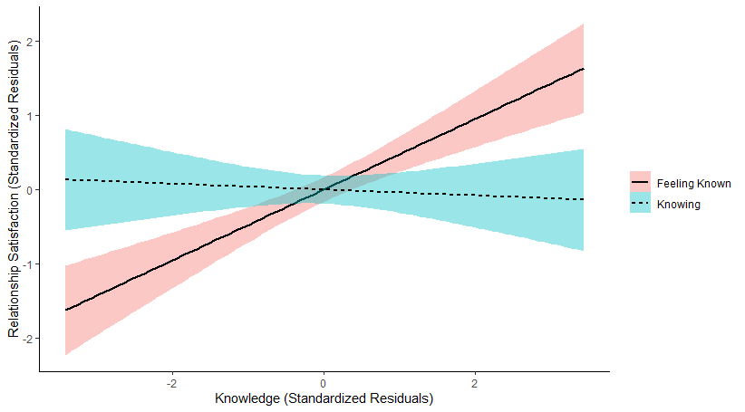
Note. Colored regions depict the 95% confidence intervals.

Study S2: Relationships with Friends
This study conceptually replicates the findings from Study 1c, using an entirely correlational design. We decided not to include it in the main text as Study 1c provides the same result but with an additional experimental manipulation, making it a stronger study.
Method
Participants. We a priori decided to collect data from all of the students taking part in a leadership class in a college campus via an intake survey that the students were required to complete for the class. In total, 163 students completed the survey (M_{age} = 21.60, SD = 4.05, 86 females, 77 males).
Study design. The study contained two conditions (within-participants) measuring the type of relationship knowledge: feeling known by one’s friend versus felt knowing of one’s friend.
Procedure. The survey asked participants to “think of a friend you’ve made recently. This does not have to be someone you know particularly well. It must be a person you met within the last two years.” We instructed participants to “write the person's initials in the box below.” We measured feeling known (α = .94), felt knowing (α = .93), and relationship satisfaction (α = .80) using the same measures described in Study 1a.
Results
When we regressed relationship satisfaction on feeling known and felt knowing, we found that feeling known predicted relationship satisfaction (β = .73, p < .001) while felt knowing did not (β = -.07, p = .576). In support of the hypothesis, the beta coefficient in the model for feeling known was statistically larger than the coefficient for felt knowing, z = 4.45, p < .001 (see Figure S5). Controlling for other characteristics of participants (specifically, their age, gender, and GPA) did not meaningfully change results. See Table S9 for the regression output.
We additionally found support for the illusion of asymmetric insight: Participants believed that they knew their friend (M = 4.26, SD = 1.44) more than their friend knew them (M = 4.10, SD = 1.50), paired t(162) = 2.77, p = .006, d = 0.11.
Tests for multicollinearity. Feeling known and felt knowing were highly correlated with each other, r = .88, p < .001, and each positively correlated with relationship satisfaction (feeling known: r = .67, p < .001; felt knowing: r = .58, p < .001). Examining the multicollinearity coefficients in our models revealed a VIF of 4.55 and tolerance statistic of 0.22. An alternative analysis that eliminates the possibility of multicollinearity examined whether the difference score between feeling known and felt knowing (M = -0.15, SD = 0.71; 16.6% of respondents had a difference score of 0) predicted relationship satisfaction. Consistent with the primary analysis, the difference between feeling known and felt knowing positively predicted relationship satisfaction (β = .24, p = .002). Controlling for participants’ age, gender, and GPA did not change results.

Figure S5
Partial Regression Plot of the Effects of Feeling Known (Standardized Residuals Controlling for Felt Knowing) and Felt Knowing (Standardized Residuals Controlling for Feeling Known) on Standardized Residual of Relationship Satisfaction with Friends in Study S2
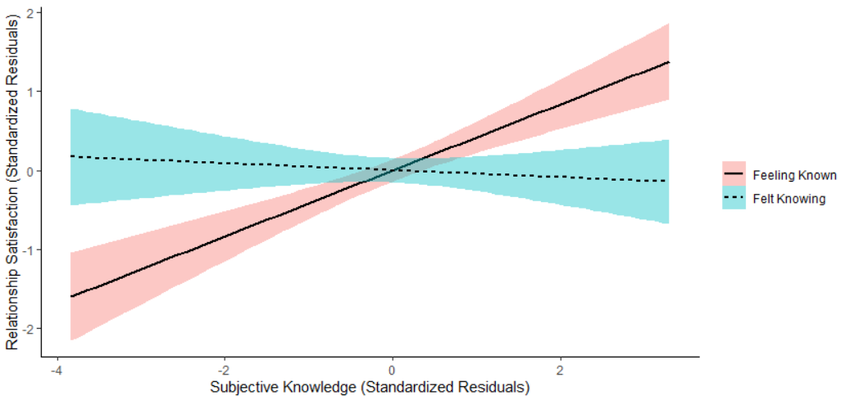
Table S9
Output of Regression Model Examining the Effects of Subjective Knowledge on Relationship Satisfaction in Study S2 (N = 162)
Variable | Unstandardized  Coefficients |  | Standardized  Coefficients | t | p
Variable | B | SE | β | t | p
Constant | 4.134 | .163 |  | 25.39 | .001
Feeling known | .432 | .074 | .731 | 5.84 | .001
Felt knowing | -.043 | .077 | -.070 | -.561 | .576
Note. The R² is 0.44.

Study S3: Moderation by Support
We proposed that feeling known predicts relationship satisfaction more than felt knowing because the feeling of receiving good support, more than the feeling of providing good support, is what drives relationship satisfaction. This suggests that when a relationship is more about providing support than receiving support (like parents’ relationships with their children), felt knowing could be just as important (or more important) for relationship satisfaction than feeling known. Accordingly, Study S3 examined whether the extent to which a partner expects to provide support moderates the effect of subjective knowledge type on relationship satisfaction. We hypothesized that the more participants perceive that providing support (and less that receiving support) is important in their relationship, the more that felt knowing (relative to feeling known) would matter for relationship satisfaction.
This study was excluded from the main text because our measure of support only examined providing support, not receiving support. Hence, providing and receiving support may be confounded in this study. Study 3 in the main text provides a better test of our theory.
Method
We preregistered our hypotheses and analysis plan at https://aspredicted.org/blind.php?x=gy2xt2.
Participants. We planned to collect 600 participants to aim for 100 people responding about each relationship partner. In total, 604 adults from MTurk (M_{age} = 36.99, SD = 10.99, 326 males, 277 females, 1 nonbinary) participated in exchange for $1.50 each.
Study design. Participants selected into up to 11 different relationships (with their: adult child, married spouse, unmarried romantic partner, parent, employer, employee, friend, acquaintance, colleague, roommate, and neighbor). For each relationship that they had, they reported how much they feel known by the relationship-partner and feel like they know the relationship-partner (within-subjects).
Procedure. Participants selected up to 11 relationship partners they had (e.g. relationship with their parents, neighbors, and friends). For each relationship the participants selected, we then piped in the text of that partner’s name to ask questions about that partner. Participants rated how much they feel known (α = .97), how much they know their partner (α = .97), and their relationship satisfaction (α = .92) using the same scales described in Study 1a. We additionally measured the degree to which providing support was important in the relationship (α = .91) using three items: 1) To what extent is it your job to support [name] (for instance, helping [name] to achieve his or her goals? 2) How meaningful is it to you to support [name]? and 3) How much do you value and enjoy supporting [name]? (1 = not at all, 7 = extremely). As potential control variables, participants rated: “How long have you known [name]?” and “How often do you have substantive conversations with [name]?” (free-response). Participants continued answering these questions for each relationship partner until they had completed as many partners as they reported they had.
Results
On average, participants reported having 5.48 relationships (SD = 2.38); the descriptive statistics for all 11 relationship partners on the primary measures of feeling known, knowing, relationship satisfaction, and expectation of support are reported in Supplemental Table S10. In total, we collected ratings of 3,309 relationships.
Table S10
Measures Aggregated by Relationship Partner Type in Study S3
Relationship Partner | # Participants who have Relationship | Feeling Known | Knowing | Relationship Satisfaction | Importance of Providing Support
Acquaintance | 397 | 3.13 (1.59) | 3.33 (1.59) | 4.68 (1.12) | 3.69 (1.67)
Child | 151 | 5.38 (1.47) | 5.67 (1.33) | 6.40 (1.02) | 6.36 (1.18)
Colleague | 370 | 3.95 (1.50) | 4.14 (1.43) | 5.17 (1.12) | 4.56 (1.49)
Employee | 140 | 4.07 (1.67) | 4.23 (1.59) | 5.07 (1.16) | 4.71 (1.47)
Employer | 342 | 3.44 (1.57) | 3.67 (1.51) | 4.74 (1.16) | 4.33 (1.64)
Friend | 536 | 5.08 (1.26) | 5.20 (1.20) | 6.02 (0.93) | 5.47 (1.30)
Neighbor | 357 | 2.77 (1.72) | 2.91 (1.70) | 4.56 (1.16) | 3.32 (1.71)
Parent | 465 | 5.09 (1.52) | 5.44 (1.31) | 6.01 (1.35) | 5.67 (1.52)
Partner | 207 | 5.70 (1.33) | 5.80 (1.27) | 6.23 (1.12) | 6.10 (1.24)
Roommate | 95 | 4.84 (1.67) | 5.02 (1.56) | 5.48 (1.41) | 5.11 (1.84)
Spouse | 249 | 6.08 (1.13) | 6.26 (1.02) | 6.46 (1.04) | 6.40 (1.15)
Note. Mean (Standard Deviation) of how much participants believed that each relationship partner knew them (feeling known), how much participants believed they knew each relationship partner (knowing), relationship satisfaction, and the importance of providing support for the 11 different relationships tested in Study S3.

For our primary preregistered analysis, we conducted a general linear model predicting relationship satisfaction that controlled for the participant number (random effect) and relationship type (fixed effect) and included the knowledge difference score (between feeling known and knowing), support, and the interaction between the difference score and providing support as fixed effects in the model. Supporting our hypothesis, an interaction emerged between the knowledge difference score and providing support, t(3,190.51) = -2.33, p = .020, d = -0.08, showing that support moderated the effect of knowledge type on relationship satisfaction. There was also a main effect of the knowledge difference score, t(3,229.07) = 4.40, p < .001, d = 0.15, indicating that feeling known was more strongly associated with relationship satisfaction than felt knowing, and a main effect of support, t(3,281.74) = 54.15, p < .001, d = 1.89, suggesting that relationships in which providing support was more important were associated with greater relationship satisfaction.
We used a median split of support (median = 5.33) to decompose the pattern of results for the interaction effect. For relationships characterized by less importance of providing support, feeling known was more strongly associated with relationship satisfaction (β = .29, p < .001) than knowing (β = -.06, p = .202). But for relationships characterized by more importance of providing support, feeling known was actually less strongly associated with relationship satisfaction (β = .16, p = .03) than knowing (β = .23, p < .001). See Figure S6 to visualize these results.

Figure S6
Partial Regression Plot of the Effects of Feeling Known (Standardized Residuals Controlling for Knowing) and Knowing (Standardized Residuals Controlling for Feeling Known) on Standardized Residual of Relationship Satisfaction for Relationships Characterized by Higher Importance for Providing Support (Top Panel) and Lower Importance for Providing Support (Bottom Panel) in Study S3
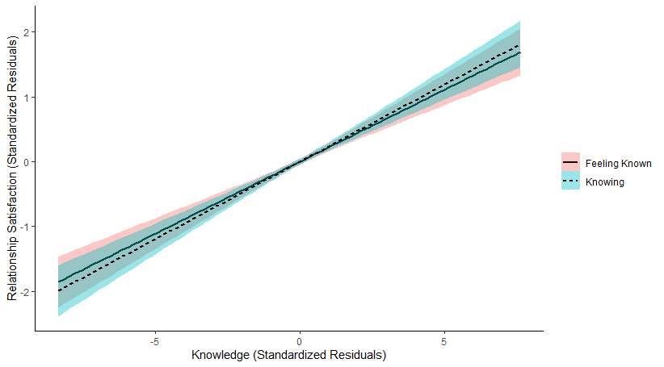
Relationships Characterized by Higher Importance of Providing Support

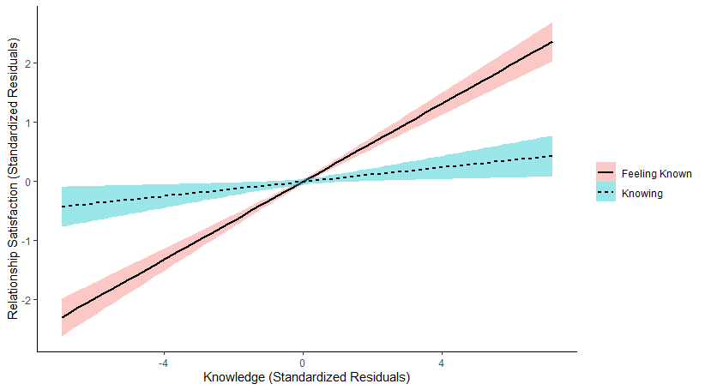
Relationships Characterized by Lower Importance of Providing Support

Note. Colored regions depict the 95% confidence intervals.

Supplemental Study S4: Dating Profiles
The purpose of Study S4 was to test whether the same dating profile would seem more appealing when it sought to get to know a potential partner or be known by a potential partner. We excluded this study from the main text because the different dating profile conditions manipulated but knowledge as well as support, and thus contained a confound in the experimental design.
Method
We preregistered our hypotheses and analysis plan at https://aspredicted.org/blind.php?x=js64rs.
Participants. We planned to collect 720 participants. In total, 732 adults on MTurk (M_{age} = 38.07, SD = 11.58, 369 males, 361 females) participated in exchange for $0.15.
Study design. We created 12 dating profiles based on real profiles we observed on websites like match.com, and for each profile created two versions: want-to-be-known or want-to-know. See all profiles in Table S11. We then randomly assigned participants to view the want-to-be-known or want-to-know version of one of 12 profiles. For example, a want-to-be-known profile read: “Hi, I would like to meet my true love. I want someone who will understand me and always stand by my side.” And the analogous want-to-know profile read: “Hi, I would like to meet my true love. I want to understand you and always stand by your side.”
Procedure. Participants read that they would “view a dating profile and share your opinions about it.” They then read their randomly assigned profile, rated how appealing it was on six items (α = .97). Specifically, they answered: “After reading the Dating Profile, how much do you think that a potential partner would: Want to get to know this person; Want to contact this person; Find this person appealing; Find this person interesting; Find this person attractive” (1 = not at all, 7 = extremely). They also answered: “Overall, how compelling do you think the dating profile is for attracting a potential partner?” (1 = not at all, 7 = extremely). We preregistered combining these items into a single index. Finally, participants answered the same questions about their own dating life as the writers in Study 4 had completed.
Table S11
Profiles in Study S4
Profile Number | Want-to-be-known | Want-to-know
1 | Hi. I'm an outgoing person and can't wait to meet my soulmate. I am looking for a soulmate who will listen to me and support me. | Hi. I'm an outgoing person and can't wait to meet my soulmate. I am looking to listen to my soulmate and support him.
2 | Hi, I would like to meet my true love. I want someone who will understand me and always stand by my side. | Hi, I would like to meet my true love. I want to understand you and always stand by your side.
3 | Hey! I’m a fun-guy who is a lil’ quirky and looking for love. I’m looking for someone who is genuine, supportive, and will make me smile. | Hey! I’m a fun-guy who is a lil’ quirky and looking to love. I will be genuine, supportive, and make you smile.
4 | I’m a happy dog mom born and raised in the area. I’m looking for someone to take me on an adventure! | I’m a happy dog mom born and raised in the area. I’m looking to take someone on an adventure!
5 | I like brunches, camping, and going on adventures! I’d love to meet someone who takes the time to get to know me and all of my quirks. | I like brunches, camping, and going on adventures! I’d love to take the time to get to know you and all of your quirks.
6 | I am easy going, a little sarcastic, and a sweetheart! I’m looking for someone who shows care and concern for me. | I am easy going, a little sarcastic, and a sweetheart! I will show care and concern for you.
7 | I am a teacher passionate about work, and I don’t take myself too seriously. I want someone who can take me to travel and explore new places! | I am a teacher passionate about work, and I don’t take myself too seriously. I want someone who I can take to travel and explore new places!
8 | I enjoy hanging out with friends, watching movies, and playing with my cat! I want someone special who makes fun plans for me! | I enjoy hanging out with friends, watching movies, and playing with my cat! I want to make fun plans for someone special!
9 | Hey there, I am an undergraduate student studying philosophy looking for self-fulfillment. I’d love for you to read philosophy books to me and console me when I’m upset. | Hey there, I am an undergraduate student studying philosophy looking for self-fulfillment. I’d love to read philosophy books to you and console you when you’re upset.
10 | Hi, I love nature and love to hike. I hope you can take hikes with me and make me happy! | Hi, I love nature and love to hike. I hope I can take hikes with you and make you happy!
11 | I’m looking for a serious relationship. I am hoping to find someone who will be loyal to me, kind to me, and treat me with respect. | I’m looking for a serious relationship. I will be loyal to you, kind to you, and treat you with respect.
12 | I am an introvert who enjoys a quiet night at home as much as a night out. I’m hoping to find a person who will always greet me with a smile, hold my hand, and give my hobbies a try! | I am an introvert who enjoys a quiet night at home as much as a night out. I will always greet you with a smile, hold your hand, and give your hobbies a try!

Results
In a mixed model GLM that included profile number as a random factor and experimental condition (want-to-be-known vs. want-to-know) as the fixed factor on ratings of how appealing the profile is, the profiles that wanted to know the other person were perceived as more appealing (M = 4.25, SD = 1.42) than profiles that wanted to be known (M = 3.99, SD = 1.64), t(719.04) = 2.27, p = .024.

The reported scale reliabilities are aggregated across all four relationships.
This preregistration referred to relationships that are higher in wanting to provide support as “other-focused relationships” (and those that are lower in wanting to provide support as “self-focused relationships”). We changed the language when we wrote the paper.
Notably, this measure of support confounds both expectations of receiving and providing support in the relationship. We theorize that expectations of receiving good support is more associated with relationship satisfaction, which we show in Study 3 in the paper.
When we wrote the paper, we re-labeled the conditions as “wanting-to-be-known” instead of “self-focused” and “wanting-to-know” instead of “other-focused.”

