The role of heparanase during ischemia/ reperfusion injury in the lungs of male mice
Noda K et al, University of Pittsburgh

Table for context
Page | Context
2 | Figures S1 Supplemental data for figure 1H, western blotting for I-κBα.
3 | Figure S2. The effect of HPSE gene deletion on the expression of other glycocalyx-regulating enzymes.
3 | Figure S3. Strategy employed for the flow cytometry analysis.
4 | Figure S4. Supplemental data for flow cytometry data

Supplemental Figures

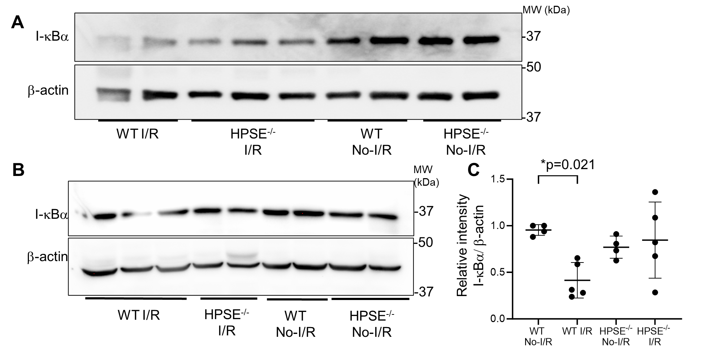
Figure S1. Supplemental data for figure 1H, western blotting for I-κBα. (A,B) The representative images of western blotting for inhibitor of nuclear factor κB α (Ι−κBα) and β-actin expression. (C) Quantitative data of relative intensity of each band of Ι−κBα to β-actin. *p<0.05.
Figure S2. The effect of HPSE gene deletion on the expression of other glycocalyx-regulating enzymes.
Real-time RT PCR was performed to quantify the mRNA expression of (A) Serpin-1, (B) TIMP-1, (C) TIMP-2, (D) TIMP3, and (E) TIMP-4 in WT and HPSE^{-/-} lungs. White bars, WT; gray bars, HPSE^{-/-}. TIMP, tissue inhibitor of matrix metalloproteinase.
Figure S3. Strategy employed for the flow cytometry analysis.
Representative flow-cytometric plots of flow cytometry data of single-cell suspensions from mouse lungs and the gating strategy used to identify endothelial cells, neutrophils, alveolar/M1/M2 macrophages. FSC, forward scatter; SSC, side scatter.

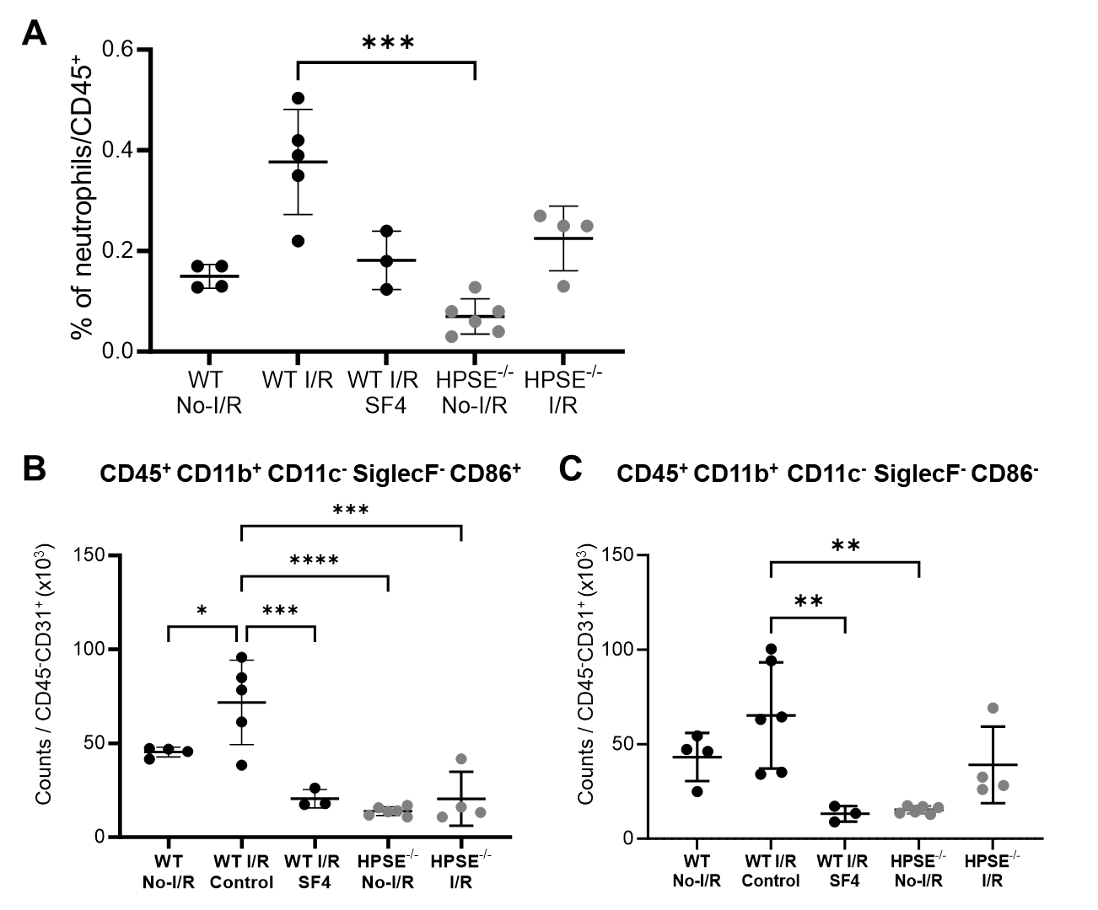
Figure S4. Supplemental data for flow cytometry data. (A) the percentage of neutrophils in the CD45⁺ population. (B, C) The cellular count for CD45⁺ CD11b⁺ CD11c⁻ SiglecF⁻ CD86⁺ population and CD45⁺ CD11b⁺ CD11c⁻ SiglecF⁻ CD86⁻ population in single cell suspension of lungs after I/R injury were normalized by endothelial cells x 10³ (CD45⁻ CD31⁺). ***p<0.001, **p<0.01, *p<0.05.

