SUPPLEMENTARY MATERIALS for Zhang K, Imas A, & Clark L, ‘A clean slate: adapting the realization effect to online gambling and its effectiveness in people with gambling problems’

Supplementary Table 1. Demographics information on the three gambling groups in the cash-out and feedback conditions.

 |  |  | Cash-out (n = 356)
 |  | Non-problem group | At-risk group | Gambling problems group
 |  | n = 116 | n = 123 | n = 117
Gender
 | Female | 60 | 65 | 30
 | Male | 56 | 58 | 87
PGSI score | M (SD) | 0 (0) | 2.88 (1.91) | 13.05 (4.98)
Age | M (SD) | 33.33 (8.14) | 30.03 (7.43) | 31.40 (6.42)
Employment status | Employed | 85 | 74 | 90
 | Self-employed | 13 | 18 | 9
 | Temporarily unemployed | 11 | 23 | 13
 | Permanently unemployed | 1 | 2 | 2
 | Other | 6 | 6 | 3
Income | Less than $15,000 | 11 | 10 | 8
 | $15,000 - $24,999 | 7 | 8 | 8
 | $25,000 - $34,999 | 8 | 8 | 16
 | $35,000 - $49,999 | 9 | 15 | 17
 | $50,000 - $74,999 | 29 | 29 | 23
 | $75,000 - $99,999 | 10 | 12 | 11
 | $100,000 - $149,999 | 17 | 8 | 11
 | $150,000 - $199,999 | 3 | 1 | 2
 | Above $200,000 | 4 | 1 | 3
 | No report | 18 | 31 | 18
Relationship status | Single | 45 | 61 | 59
 | Partnered | 16 | 26 | 22
 | Married | 51 | 30 | 31
 | Divorced or Separated | 4 | 5 | 5
 | Other | 0 | 1 | 0
 |  |  | Feedback (n = 333)
 |  | Non-problem group | At-risk group | Gambling problems group
 |  | n = 111 | n = 116 | n = 106
Gender
 | Female | 58 | 58 | 25
 | Male | 53 | 58 | 81
PGSI score | M (SD) | 0 (0) | 3.16 (1.83) | 11.37 (4.01)
Age | M (SD) | 33.50 (8.33) | 31.16 (8.15) | 30.91 (6.32)
Employment status | Employed | 84 | 83 | 70
 | Self-employed | 7 | 10 | 17
 | Temporarily unemployed | 11 | 12 | 10
 | Permanently unemployed | 2 | 2 | 4
 | Other | 7 | 9 | 5
Income | Less than $15,000 | 9 | 14 | 2
 | $15,000 - $24,999 | 8 | 5 | 14
 | $25,000 - $34,999 | 8 | 17 | 17
 | $35,000 - $49,999 | 16 | 17 | 11
 | $50,000 - $74,999 | 19 | 11 | 17
 | $75,000 - $99,999 | 16 | 15 | 16
 | $100,000 - $149,999 | 12 | 10 | 7
 | $150,000 - $199,999 | 1 | 2 | 3
 | Above $200,000 | 2 | 2 | 0
 | No report | 20 | 23 | 19
Relationship status | Single | 45 | 46 | 43
 | Partnered | 22 | 33 | 26
 | Married | 39 | 34 | 29
 | Divorced or Separated | 4 | 3 | 8
 | Other | 1 | 0 | 0

Supplementary Results on the Bet Change measures in the manipulation checks
Bet change (i.e. from the 6th to 7th bet, in the cash-out condition only) by responses on the willingness to switch item
With median bet changes of -5 (SD = 34.18) for “Strongly wanted to stay”; -10 (SD = 33.97) for “Wanted to stay”; 0 (SD = 26.27) for “Neutral”; 0 (SD = 33.81) for “Wanted to switch”; 0 (SD = 27.12) for “Strongly wanted to switch”.

Bet change (i.e. from the 6th to 7th bet, in the cash-out condition only) by the degree of reference point updating
On average, the fully updated participants reduced their bet amount by 3.16 (SD = 29.81), the partially updated participants reduced their bet amount by 4.35 (SD = 27.74), while the over-updated participants increased their bet amounts by 5.55 (SD = 24.35).

Pilot Experiments 1 – 3 Summary
Results from three pilot experiments informed some key design decisions in the main study, namely:
- The addition of the manipulation checks: the pilot experiments showed inconsistent realization effects, and in realizing that the cashing out procedure alone might not be strong enough to elicit ‘realization’, we incorporated several manipulation checks into the main experiment.
- Refining the cashing out procedure itself: In the pilot experiments, feedback was only presented after the bets on which the cash-out or feedback manipulation occurred. The pilot experiments also included a non-feedback condition, to compare loss-chasing between the non-feedback and feedback conditions. The pilot experiments and prior literature indicated that bet-by-bet feedback may lead to greater loss-chasing than only showing feedback on a blocked basis. Given that the sensitivity of any realization procedure relies upon loss chasing being elicited in the comparator condition, we added bet-by-bet feedback to the main study’s procedure.
- The recruitment approach: the pilot experiments recruited participants using both the Amazon Mechanical Turk and Prolific crowdsourcing platforms. These experiences indicated higher quality data from Prolific, which we therefore decided to use for the main experiment. Subsequent work has confirmed the superiority of Prolific as a data source (Rigotti et al., 2023).

There were two further differences between the pilot experiments and the main study, meaning that the data cannot be readily compared across the 4 experiments:
- The pilot experiments used a gamble prospect with a win of three times the bet amount with a 2/3 chance, or a loss of the bet with a 1/3 chance. The main study offered a gamble prospect with a lower probability of winning - a win of 2.5 times of the bet amount with a 1/3 chance, or the loss of the bet with a 2/3 chance.
- In the pilot experiments, participants cashed out from one lottery game and re-deposited their funds in a second lottery game. The main study offered a more ecologically-valid design with cashing out and moving funds between two gambling websites.

Pilot Experiment 1
We recruited participants on Amazon Mechanical Turk (MTurk) from 2019 Feb 16 – May 28. The analytical sample contained 308 participants in the groups with non-problem gambling (n = 118), at-risk gambling (n = 144), and gambling problems (n = 46).
Participants completed a gambling task with 9 bets, which was bracketed into two blocks of three bets and six bets (Supplementary Figure 1). The order of the blocks of 3 bets and 6 bets was counterbalanced, and participants were informed of the block length at the start of the block. The blocks were framed as participating in two different lotteries (Lottery ‘CAERUS’ and ‘PLUTUS’). At the end of the first block (i.e., either after the 3rd or 6th bet), all participants cashed out from one lottery and switched to another lottery for the following block. In the second block, participants were randomly assigned to the feedback (N = 138) and no-feedback (N = 170) conditions.
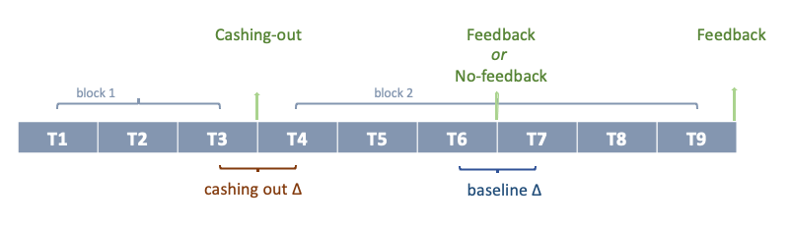
Supplementary Figure 1. Pilot Experiment 1 task design. The order of blocks of 3 bets and 6 bets was counterbalanced, some participants cashed out after three bets, and some cashed out after six bets.

Compared bet changes between the feedback and the no-feedback conditions (Supplementary Table 2), the feedback did not change bet amounts significantly compared to the no-feedback. There was also no Gambling Group * Condition interaction (Supplementary Figure 2). Compared bet changes between the feedback and the cash-out conditions, gamblers on average bet significantly more after cashing out than after the feedback, but this effect depended on gambling groups: significant Gambling Group * Condition interaction effects suggested that the group with non-problem gambling and the group with at-risk gambling bet less after cashing out than after feedback, whereas gamblers with gambling problems bet more after cashing out than after feedback (Supplementary Figure 3).

Pilot Experiment 2
The data were collected from Prolific Academia (Prolific) in 2020 January 10 – March 16. Ultimately, with the onset of the COVID-19 pandemic in North America in March 2020, we decided to exclude participants who completed our survey after 11 March 2020, when the WHO announced the COVID-19 pandemic. The analytical sample of 398 in the groups with non-problem gambling (n = 138), at-risk gambling (n = 153), and gambling problems (n = 107). Pilot Experiment 2 used the same nine-bet lottery task as Pilot Experiment 1.
Compared to bet changes between the feedback and the no-feedback conditions (Supplementary Table 2; Supplementary Figure 2), participants bet significantly less after the no-feedback condition compared to the feedback condition, and there was no significant Gambling Group * Condition interaction. Compared bet changes between the feedback and the cash-out conditions (Supplementary Table 3; Supplementary Figure 3). The cash-out condition did not have significantly different bet changes compared to the feedback condition, and the Gambling Group * Condition interaction was not significant.

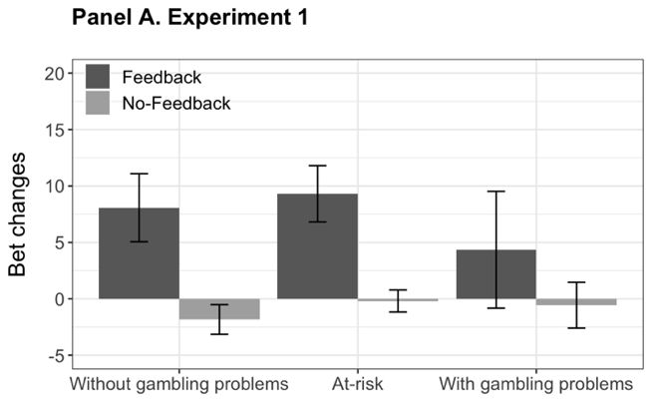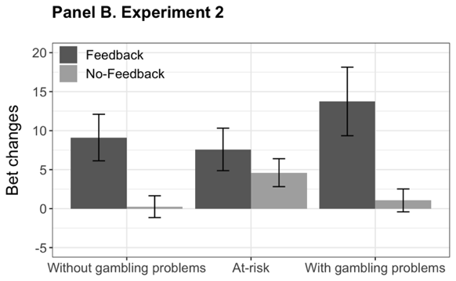
Supplementary Figure 2. Average bet amounts in the feedback vs. no-feedback conditions in pilot experiment 1 and 2

Panel A. Pilot Experiment 1
 | Beta | Std. Error | t | p-value
Cashout | 14.20 | 7.15 | 1.99 | .048
Non-problem group | 2.98 | 5.68 | 0.52 | .601
At-risk group | 4.02 | 5.53 | 0.73 | .468
Counterbalance | 7.60 | 3.87 | 1.96 | .051
Average bet | -0.09 | 0.07 | -1.37 | .172
Cashout * Non-problem group | -17.62 | 7.98 | -2.21 | .028
Cashout* At-risk group | -17.74 | 7.80 | -2.27 | .024
Cashout * Counterbalance | -3.88 | 5.45 | -0.71 | .478
Constant | 5.38 | 6.01 | 0.90 | .372

Panel B. Pilot Experiment 2
 | Beta | Std. Error | t | p-value
No-Feedback | -10.66 | 4.54 | -2.35 | .019
Non-problem group | -3.70 | 3.85 | -0.96 | .336
At-risk group | -5.84 | 3.67 | -1.59 | .011
Counterbalance | 4.54 | 2.95 | 1.54 | .124
Average bet | 0.09 | 0.05 | 1.77 | .077
No-Feedback * Non-problem group | 3.49 | 5.21 | 0.67 | .504
No-Feedback * At-risk group | 9.91 | 5.09 | 1.95 | .052
No-feedback * Counterbalance | -3.15 | 4.08 | -0.77 | .441
Constant | 7.04 | 4.04 | 1.74 | .082

Supplementary Table 2. Regressions of bet amount changes in the feedback vs. no-feedback conditions.

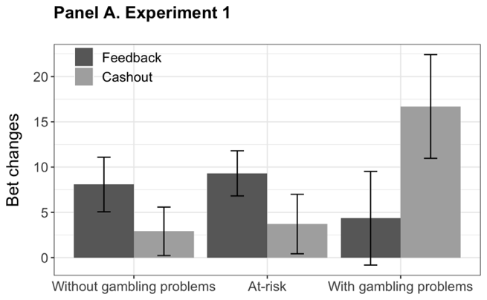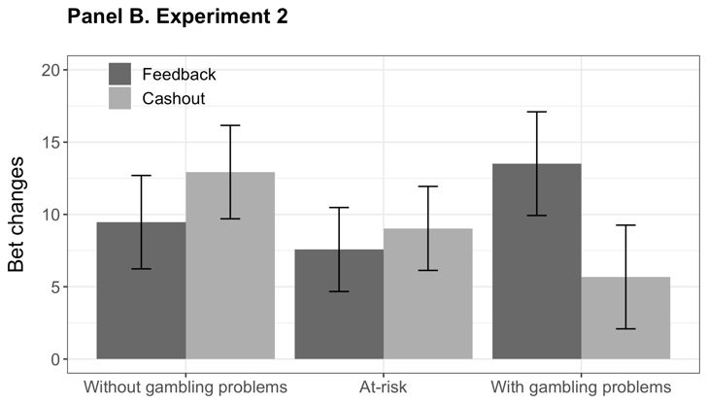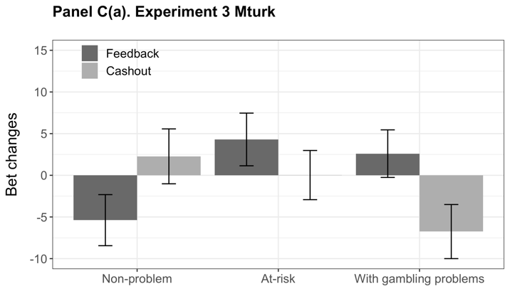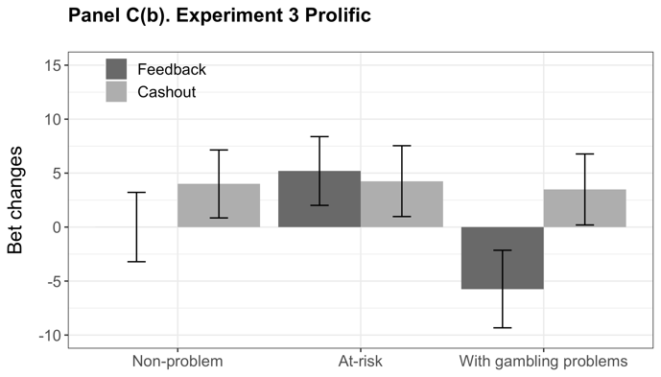
Supplementary Figure 3. The average bet amount in the feedback vs. cash-out conditions in pilot experiments 1 and 2.

Panel A. Pilot Experiment 1
 | Beta | Std. Error | t | p-value
Cashout | 14.20 | 7.15 | 1.99 | .048
Non-problem group | 2.98 | 5.68 | 0.52 | .601
At-risk group | 4.02 | 5.53 | 0.73 | .468
Counterbalance | 7.60 | 3.87 | 1.96 | .051
Average bet | -0.09 | 0.07 | -1.37 | .172
Cashout * Non-problem group | -17.62 | 7.98 | -2.21 | .028
Cashout* At-risk group | -17.74 | 7.80 | -2.27 | .024
Cashout * Counterbalance | -3.88 | 5.45 | -0.71 | .478
Constant | 5.38 | 6.01 | 0.90 | .372

Panel B. Pilot Experiment 2
 | Beta | Std. Error | t | p-value
Cashout | -3.05 | 5.8 | -0.53 | .599
Non-problem group | -4.05 | 4.84 | -0.84 | .403
At-risk group | -5.94 | 4.61 | -1.29 | .199
Counterbalance | 4.57 | 3.71 | 1.32 | .219
Average bet | 0.02 | 0.07 | 0.33 | .744
Cashout * Non-problem group | 11.3 | 6.83 | 1.66 | .099
Cashout* At-risk group | 9.3 | 6.52 | 1.43 | .155
Cashout * Counterbalance | -9.57 | 5.24 | -1.83 | .069
Constant | 10.3 | 5.06 | 2.04 | .042

Panel C(a). Pilot Experiment 3 Mturk
 | Beta | Std. Error | t | p-value
Cashout | -9.35 | 4.32 | -2.16 | .031
Non-problem group | -7.98 | 4.19 | -1.91 | .057
At-risk group | 1.70 | 4.26 | 0.40 | .689
Average bet | 0.09 | 0.06 | 1.45 | .147
Cashout * Non-problem group | 17.01 | 6.24 | 2.73 | .007
Cashout* At-risk group | 5.07 | 6.11 | 0.83 | .407
Constant | -1.35 | 4.00 | -0.34 | .735

Panel C(b). Pilot Experiment 3 Prolific
 | Beta | Std. Error | t | p-value
Cashout | 9.23 | 4.86 | 1.9 | .059
Non-problem group | 5.74 | 4.83 | 1.19 | .235
At-risk group | 10.94 | 4.8 | 2.28 | .023
Average bet | 0.05 | 0.07 | 0.72 | .473
Cashout * Non-problem group | -5.23 | 6.62 | -0.79 | .430
Cashout* At-risk group | -10.17 | 6.67 | -1.52 | .128
Constant | -7.9 | 4.78 | -1.65 | .099
Supplementary Table 3. Regression results of the bet amount in the feedback vs. cash-out conditions in pilot experiments 1, 2, and 3.
Pilot Experiment 3
The data were collected from Mturk and Prolific simultaneously from October 2020 – February 2021. We obtained an analytical Mturk sample of 473, comprising groups with non-problem gambling (n = 149), at-risk gambling (n = 161), and gambling problems (n = 163). For Prolific, the sample of 477 comprised groups with non-problem gambling (n = 169), at-risk gambling (n = 163), and gambling problems (n = 145). For the gambling task in Pilot Experiment 3, we 1) removed the no-feedback baseline condition, shifting to a between-subject design with participants randomized to cash-out vs. feedback after the 6th bet, and 2) the instructions and screen displays were redesigned so that participants cashed out and moved funds between two gambling websites, rather than a lottery game.
The effect of cash-out on bet amount changes differed between Mturk and Prolific samples (Supplementary Figure 4). The Mturk sample showed a significant cash-out effect, such that participants bet significantly less after cashing out than after the feedback. There was a significant Gambling Group * Condition interaction effect observed, in which the group with non-problem gambling bet significantly more after cashing out than after the feedback, whereas the group with gambling problems bet significantly less after cashing out. However, the Prolific sample neither showed a significant cash-out effect nor a Gambling Group * Condition interaction effect.

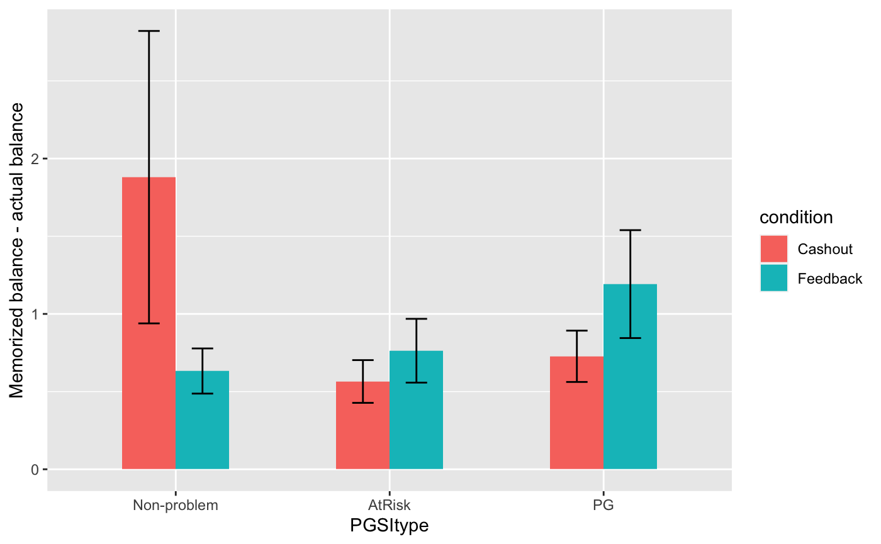
(a). Mturk
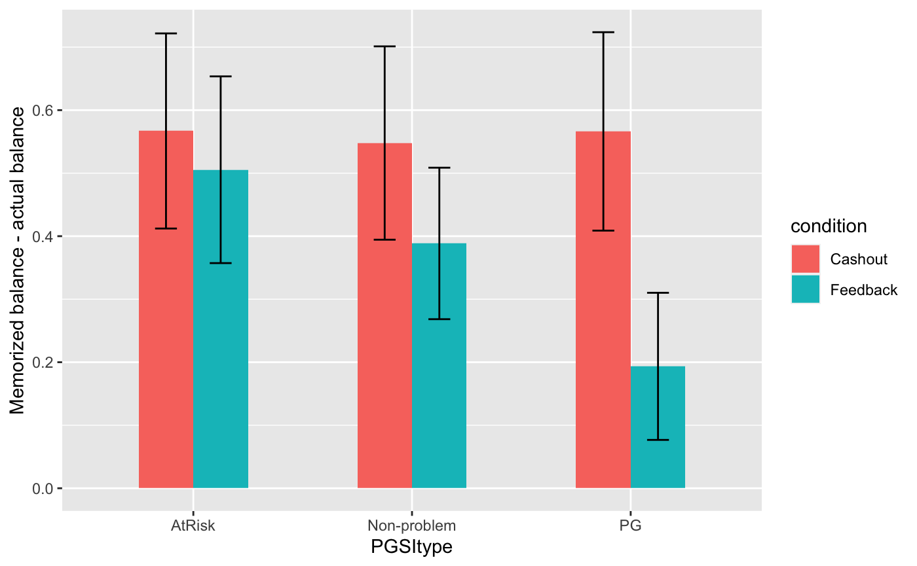
(b). Prolific
Supplementary Figure 4. The average bet amount in the feedback vs. cash-out conditions.

