Diverse climate actors show limited coordination in a large-scale text analysis of strategy documents
Supplementary Information
Angel Hsu^{1,2} and Ross Rauber³
¹Yale-NUS College, 16 College Ave W, Singapore, 138609, ²University of North Carolina-Chapel Hill, Department of Public Policy, Abernethy Hall, Chapel Hill, NC 27514, ³University of Chicago, Department of Computer Science, 5730 S. Ellis Ave, Chicago, IL
60637

Supplementary Table 1. Data sources used in this analysis. *data sources marked with an asterisk were included in the final corpus.
Climate Action Platform | Data Source
C40 Cities for Climate Leadership* | C40 Cities for Climate Leadership. (2019). 2018 Cities Emissions Reduction Targets; 2018_Cities Community-wide Emissions Map. Accessed May 2019 from www.data.cdp.net.
ICLEI Local Governments for Sustainability carbonn Climate Registry* | ICLEI - carbonn center. (2018). individual targets, action plans, and progress data collected for all reporting members. Accessed April 2018 from www.carbonn.org.
CDP Cities* | CDP. (2019). 2018-2019 City-wide Emission Reduction Activities. Accessed November 2019 from: www.data.cdp.net.
CDP 2012-2017 Disclosure Survey* | CDP (2012-2017). Climate action data for companies based on the 2012-2017 disclosure responses.
Climatewatch - Transcription of Nationally Determined Contributions* | Climate Watch. 2018. Washington, DC: World Resources Institute. Available online at: https://www.climatewatchdata.org.
Compact of States and Regions* | Compact of States and Regions. (2018). 2017 States and Regions Climate Actions. Accessed July 2018 from www.data.cdp.net.
EU Covenant of Mayors* | EU Covenant of Mayors. (2019). individual targets, action plans, and progress data collected for all reporting members. Accessed April 2019 from https://www.covenantofmayors.eu/.
Under2 Coalition | Under 2 Coalition. (2019). Membership and action data collected from annual reports. Accessed August 2019 from www.under2mou.org.
Global Covenant of Mayors for Climate and Energy | www.globalcovenantofmayors.org and limited baseline and target data provided directly from Global Covenant of Mayors, May 2018.
US Climate Alliance | U.S. Climate Alliance. Accessed July 2019 from: https://www.usclimatealliance.org/state-climate-energy-policies.  Information from this source was supplemented through desk research of participants’ climate action targets or plans.
US Climate Mayors | US Climate Mayors. Accessed July 2019 from: www.climatemayors.org and http://climatemayors.org/actions/climate-action-compendium/.  Information from this source was supplemented through desk research of participants’ climate action targets or plans.

Supplementary Table 2. Custom stopwords removed from document corpus.

'energy', 'emissions', 'emission', 'reduction', 'reductions', 'reduce', 'will', 'can', 'year', 'europe', 'canada', 'mexico', 'zealand', 'new', 'india', 'london', 'nsw', '£m', 'scottish', 'south', 'africa', 'duke', 'argentina', 'hk', 'vienna', 'denver', 'boulder', 'chennai', 'indonesia', 'british', 'france', 'jordan', 'queensland', 'ukraine', 'nigeria', 'switzerland', 'ii', 'iii', 'iv', 'russian', 'singapore', 'yorkshire', 'use', 'city', 'cities', 'pittsburgh', 'italy', 'germany', 'turkey', 'also','uk', 'us', 'australia', 'são', 'paulo', 'minnesota', 'wales', 'portugal', 'california', 'fy', 'well', 'use', 'sector', 'york', 'portland', 'uae'

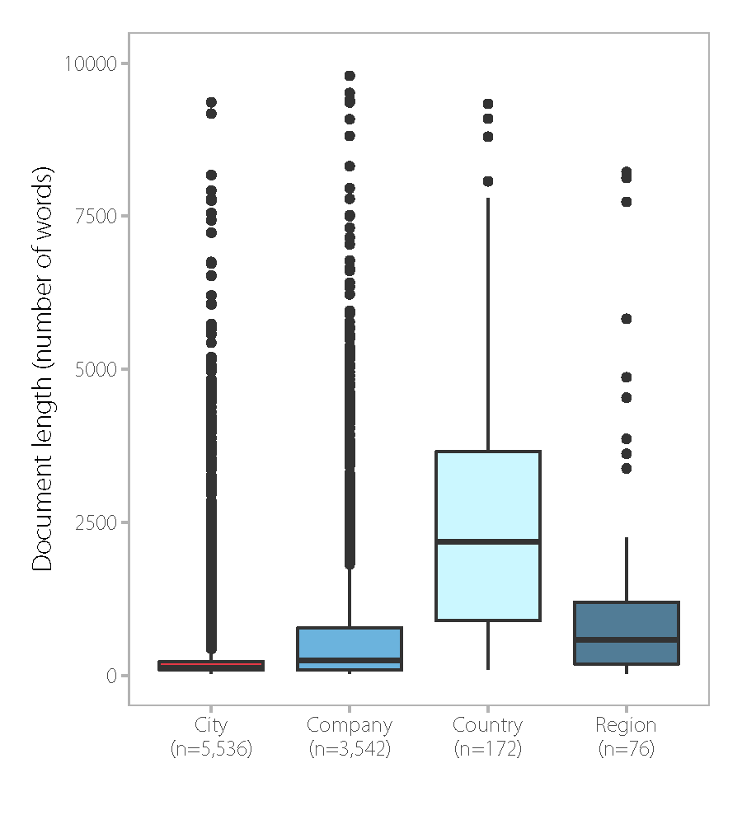
Supplementary Figure 1. Comparison of document lengths between different actors in the text corpus. *Note: documents with lengths >10,000 words are not included in this plot.

Supplementary Table 3

 | Topic (Prevalence) | Word cloud | Top term probabilities | Representative text
1 | Consumption (0.0254) | 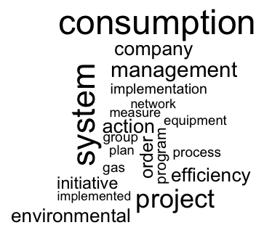 | 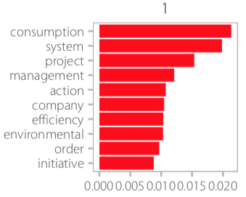 | Collection and disposal of material of recycling; the sustainability committee is considering implementing some initiative...in order to save and/or preserve natural resource generating benefit to the company, focused on' an ‘integral project energy saving’ that applies to the facilities of Televisa San Angel-collection center and Santa Fe, which aim to enable energy saving in an approximate or close to 1 % in consumption, as well as to improve and optimize the operation and/or use of the various equipment found in the facility.” Grupo Televisa S.A., Mexico, CDP
2 | Projects and programs for energy savings (0.0187) | 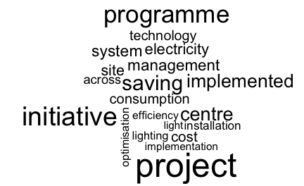 | 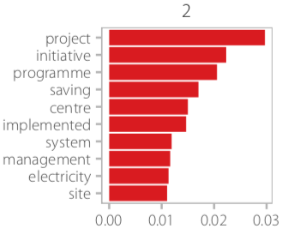 | “Energy efficiency: building service LED lighting retrofit; the examples in this table relate to our electronic system business 2015 programme of energy saving project. All businesses across the group will have a similar programme in place to realise energy saving opportunities across their estate.” BAE Systems, United Kingdom, CDP
3 | Waste and public transport (0.0250) | 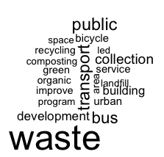 | 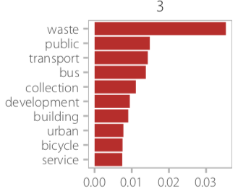 | “Infrastructure for non-motorized transport, green space and/or biodiversity preservation and expansion; 100 % of the street lightning are now LED; the bus rapid transport is under construction; ground reforestation, creation of green park and pocket park; 100 % of the street lightning are now LED; waste separation workshops are being held in schools and companies to promote waste separation; in the municipal nursery we have the christmas pine collection program, in which we generate compost from them; the bus rapid transport is under construction .” Torreón, Mexico, CDP Cities, ICLEI.
4 | Employee travel + office operations (0.0295) |  | 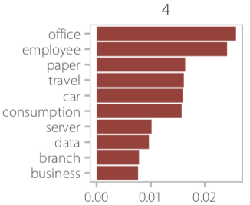 | Reduce GHG emissions due to travelling; desktop hibernate policy, printer usage policy, video conferencing, eco-friendly e-waste disposal, employee awareness - climate change & ghg emission.Installation of thin client at the branch... [which] consumes [less] electricity compared to desktop, result[ing] in saving 125 watt per hour.Started using recycled office paper in some of our regional offices,reducing scope 3 emissions;we've initiated digital storing of important business documents into document management solution for future reference and various approval, [which] has also helped in the reduction of paper consumption. By the installation of video conferencing facilities [at] all our major locations of operation, the number of employee travel (flight roundtrips) have reduced and this accounts for the reduction in our scope 3 ghg emission; solar power ups were installed at various remote branches, which decreased scope 3 emissions.” Mahindra & Mahindra Financial Services, India, CDP.
5 | Residential building efficiency (0.0416) | 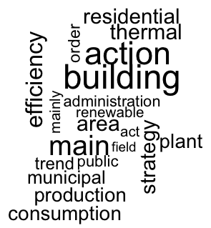 | 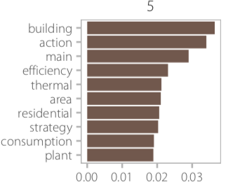 | “Final energy consumption are related mainly to the residential sector, which commits around 67 % of the [baseline emissions inventory] . Key action on the demand side in this field concern the retrofitting of existing buildings and refurbishment of thermal plants so as to reduce fossil fuel consumption for heating. For new buildings, high energy performance is foreseen, based on requirement of the new building regulation energy annex. with reference to renewable energy production (offer side), the strategy focuses on integrated pv-system diffusion and solar thermal plant for hot water production, both on existing and new buildings. Moreover, it promotes wooden biomass exploitation in small and medium plant for thermal heating. Efficiency increase actions involving municipal facilities are part of [this] strategy too, enabling energy retrofitting of envelops and refurbishment of plant and equipment.” Crespellano, Italy, EU Covenant of Mayors
6 | Sustainable transportation (0.0578) |  | 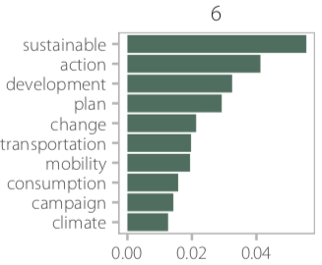 | “The ...priorities for action, given the volume of emissions, have been both road traffic and power consumption in the residential sector, trade and service, and industry. To this end, policy to promote sustainable mobility, or the commitment to a more efficient alternative transportation (pedestrian mobility, bicycle, etc .), the spread of energy from renewable sources, along with awareness raising and public awareness as a fundamental pillar in achieving the objective, form the core of this document.” Cúllar Vega, Spain, EU Covenant of Mayors.
7 | Lighting in schools + municipal buildings  (0.0516) | 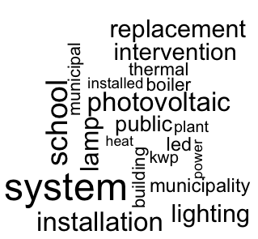 | 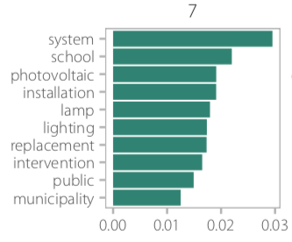 | “According to the analysis of the energy situation of the municipality, the main area where emphasis will be placed to achieve the emission reduction target will be : reduction of energy consumption, road management and mobility, improvement of outdoor public lighting of several streets of the municipality including: 1. renovation of command center ; 2. replacement of mercury lamp (given the low efficiency and toxicity of their component) with other high-pressure sodium vapor; 3. elimination of excess power in luminaires by replacing the existing ballast with an electronic and adjustable type (more efficient); and 4. incorporation of a point-to-point remote management and control system that allows the regulation and control of the replaced installation as well as the incorporation of future renovation or new installation into said system.” Villaluenga del Rosario, Spain, EU Covenant of Mayors.
8 | Green building standards (0.0195) |  | 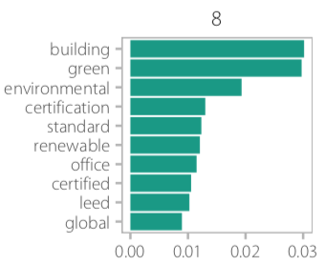 | “Energy efficient building: we are integrating energy efficiency and other environmental considerations into our property acquisition and capital expenditure process so that where possible any property we lease, purchase, fit out or renovate meets advanced energy and environmental standards, such a leadership in energy and environmental design (LEED) and environment assessment methods (BREEAM). 16 % of our total floor space is currently certified to such standards, up from 13 % in 2014. Space over 50,000 square feet must be certified to advanced sustainability standards, such as LEED and BREEAMAs part of our capital expenditure approval process, we also have our own impact assessment tool which is used to understand the energy and carbon impact of a particular investment decision. In 2013, we commissioned an independent energy survey at 15 of our largest locations where we have long-term leases.” WPP, United Kingdom, CDP.
9 | Buildings (0.0392) | 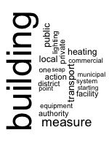 | 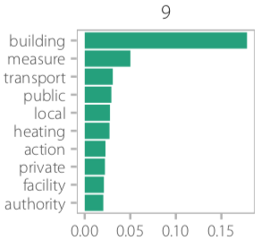 | “The local authority focus the co2 reduction action on: 1) new regulation for buildings that lead to high quality new buildings and a series of incentives to refurbish the old ones; 2) increasing the use of renewable energy with woody biomass in district heating and cogeneration system and using hydroelectric power 3) the mobility actions are focused on the optimization of the actual system and the improving of public transport that include the construction of another tramway. ” Piazzatorre, Italy, EU Covenant of Mayors
10 | LED lighting (0.0377) | 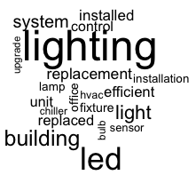 | 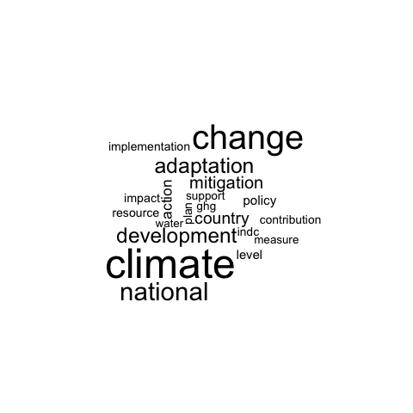 | “Replaced 175 watt metal halide on the loading dock of east and west deck with energy efficient t5 high output fixture. Replaced all of the incandescent Christmas lights in 60 plus trees around the park with energy efficient LEDs. Implemented custom energy saving programming in the building automation system to reduce HVAC pump and fan run time. Replaced metal halide fixture in the private parking area with energy efficient t5ho fixtures. Replaced all elevator light bulbs with energy efficient LEDs. Implemented critical zone reset on the hvac system. This reduces fan speed on the main HVAC unit on each floor to help save energy. Replaced all first floor lobby light bulbs with energy efficient LEDs.” Lincoln Harris, USA, CDP
11 | Climate change adaptation (0.0247) |  | 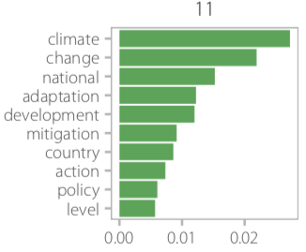 | “Adaptation to climate change across major vulnerable sectors, including water , agriculture, and coastal areas represents the central focus of this document, which also requires international collaboration including financial support, and capacity building to assist in addressing climate induced vulnerability to build resilience. Nevertheless, the INDC document provides a vision of collaboration with the international community, including potential conditional and unconditional mitigation trajectories to reduce ghg emission relative to business- as- usual (bau) scenario contingent on international support.” Yemen, INDC.
12 | Municipal climate actions (0.0349) | 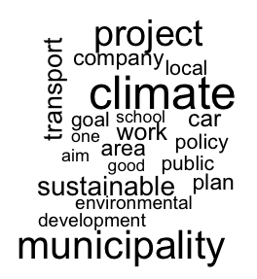 | 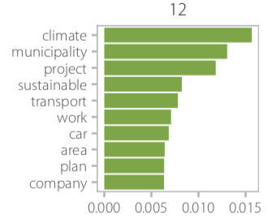 | “Achieving objectives is done using short- and long-term goals. Trias energetica is applied: energy demand is reduced, renewable energy is used and clean energy is used efficiently. Climate change policy is part of sustainable development and is integrated into all policy areas. The municipality sets a good example in several different ways regarding climate change and energy. Public support is important: several initiatives will be designed to involve everyone in the implementation of climate change policy monitoring and staying informed about new technologies.” Zutendaal, Belgium, Global Covenant of Mayors.
13 | Target-setting (0.0214) | 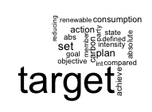 | 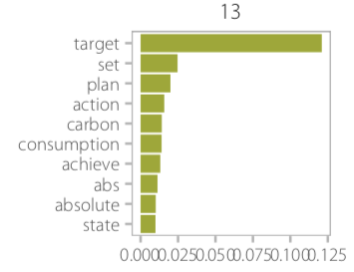 | “Install solar power (e.g. pv, csp); provide loan guarantee for energy efficiency; install energy storage system; adopt feed-in tariff for renewables; install geothermal power; install wind power (e.g. onshore, offshore); measure energy productivity (e.g. gdp per unit of energy); increase awareness/engage public on financing mechanism and incentives for energy efficiency; clean energy investment in clean tech r & d; establish waste reduction/recycling plan; install combined heat and power; establish guidelines for siting renewable power; promote conservation efforts for natural areas.” - Connecticut, USA, Compact of States and Regions
14 | Citizen municipal actions (0.0315) | 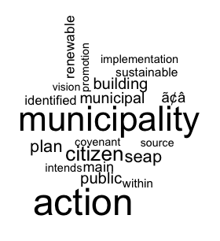 | 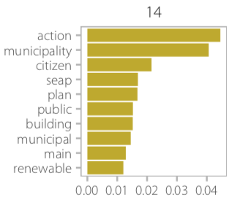 | “ the municipality intends to intervene in all major sector in an effort to promote energy conservation and efficiency a well a the use of renewable energy.priority will be given to activity and initiative with the greatest potential for reducing co2 emission into the atmosphere and minimizing energy expenditure and cost . specifically , the municipality intends to adopt policy in support of sustainable mobility / transportation in collaboration with other local municipality and the province of sassari itself . another key target is energy efficiency in public building and in construction of private residence . to this end , the municipality intends to adopt new building regulation in support of this goal . additional notable objective include the implementation of more efficient public lighting system and the increased involvement of key player and all citizen in these effort .” - Alghero, Italy (EU Covenant of Mayors)
15 | Administrative goals and objectives (0.0315) | 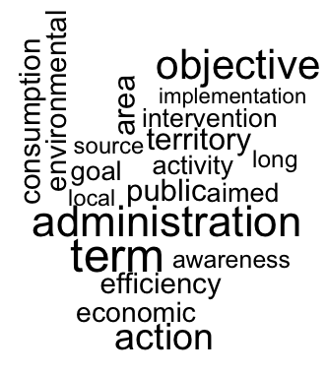 | 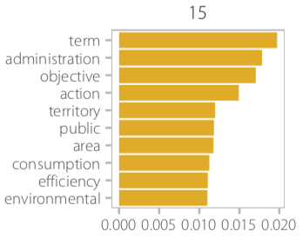 | “By joining the Covenant of mayors the Suardi aims, by 2020, a goal of reducing CO2 emissions compared to 2005, exceeding 20%. Within this general objective, the different activities give rise to specific objectives, functional to the first, and that will contribute to the achievement of this important milestone. Objectives are identified in the short term and medium-long term. In the short (1-3) are expected, through access to public funding made available to you by your State or community organisation, implementation and the implementation of interventions aimed at energy efficiency and the reduction of impacts to areas designated as most critics focusing on the real estate sector, public, private residential and local production of energy from renewable sources. Through the system's efficiency will also implement a cost cutting municipal energy supply, aimed at the establishment of the Revolving Fund.” - Suardi, Italy, EU Covenant of Mayors
16 | Cost and monetary savings (0.0332) | 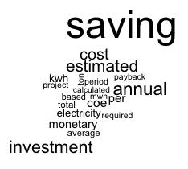 | 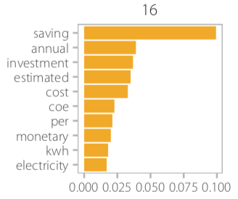 | “Investment shown is for incentives in each location to reduce commuting, including annual bike giveaway, commuting reduction incentives (no cost saving for employer but represents cost saving for associates estimated at about $ 435,000 in total)...Investment requirement represents recycling cost minus revenue...Technology investments were made and paid back several years ago. This year, we realized greater energy saving from shifting more production to this equipment.” - American Licorice, USA, CDP
17 | Fuel (0.0195) | 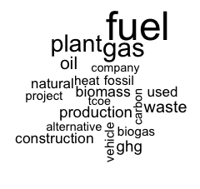 | 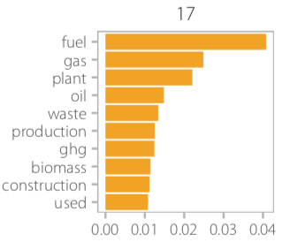 | “Construction of methane capture plant in Berkat Sawit Sejati palm oil mill (Sumatra Selatan, Indonesia) to capture the biogas generated from the palm oil mill effluent and utilise it in biogas engines for power generation. The methane contained within the biogas is combusted and converted into carbon dioxide which reduces the impact on the environment.” - PT Musim Mas, Indonesia, CDP
18 | Municipal and public actions (0.0248) | 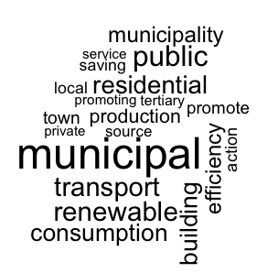 | 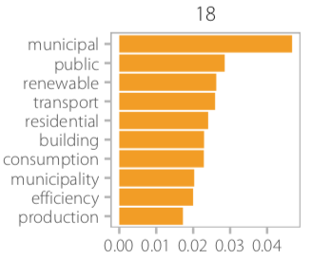 | “The municipality aims to harness the potential of structural funding opportunities for RUE and RES, both with public and private investment, being a reference to the local community, establishing best practices in RUE and RES, boosting production and export of high value-added solutions which reduce the dependence from fossil fuels and the emissions of CO₂. The key concept is: support public and private initiative, mobilization towards improving energy sustainability, particularly as it relates to enhancing competitiveness and innovation in energy services markets and increasing population and social agents participation in meeting targets for reducing municipal energy and carbon intensity.” - Braga, Portugal (CDP Cities)
19 | Air and HVAC systems (0.0247) | 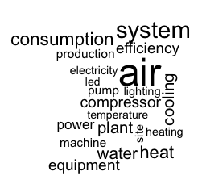 | 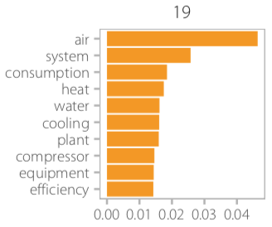 | “Air conditioning efficiency degradation was improved by introducing water spray cooling equipment to the outdoor unit when the outside temperature is more than 30 degrees. Power consumption was reduced by replacing a plastic curtain with an air curtain installed at the door opening in order to prevent the outflow of air conditioner cold air. Power consumption of air conditioning was reduced by reviewing the layout and downsizing the production area. Power consumption was reduced by installing a new design chiller unit. Power consumption was reduced by stopping the chiller unit for the air conditioning up to 30 minute before the end of production so far as it that does not effect the air conditioning temperature. Power consumption was reduced by exchanging to energy efficient air conditioning at the processing area” - Brother Industries, Japan, CDP
20 | Government promotion of waste, transport efficiency (0.0113) | 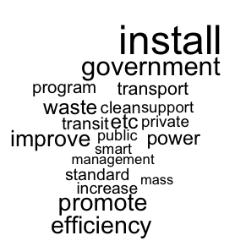 | 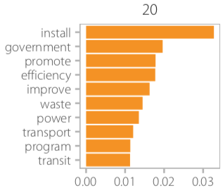 | “Install wind power ( e.g . onshore , offshore ); install combined heat and power or trigen; install solar electricity install solar power (e.g. pv, csp). Switch freight from truck to rail private transport: increase awareness/engage public on private transport measure private transport: install electric vehicle charging infrastructure (i.e. home, work, highway, etc.) Set/strengthen fuel economy standard for cars/trucks. Promote building energy performance rating/certification/benchmarking. Improve transmission to integrate renewables. Install natural gas power. Install biomass power. Improve fuel efficiency of trains (e.g . efficient engines, regenerative braking, energy storage, etc.). Improve heating and cooling efficiency (e.g . audit, insulation, white roof, etc.)” - Attica, Greece, Compact of States and Regions
21 | Public and community water management (0.0315) | 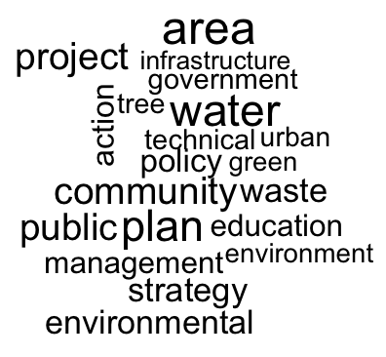 | 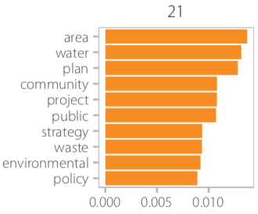 | “Dar es Salaam City planned to have flood resilience as [part of its] adaptation strategy to climate change. The project includes a number of activities such as flood modeling, construction of storm water drains, river embarkments, and greening the catchment area. Mangrove afforestation along beaches in areas of Ununio, Mbewni, Kunduchi and Mbewni. These include several number of activities such as seedling, planting and capacity building. A pilot project has been carried out at Tandale and Hekima primary school within Dar es Salaam. The project aims at increasing efficient energy use, readily availability of water and provision and of food supplement.” - Dar es Salaam, Tanzania, carbonn Climate Registry
22 | Project-level efficiency and system upgrades (0.0328) | 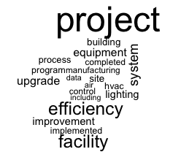 | 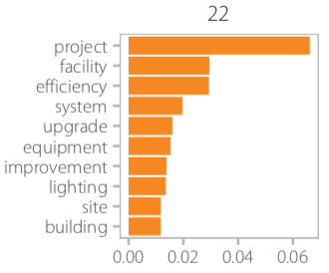 | “Data center energy efficiency: 1. best practice implementation (air flow balancing and temperature adjustment). 2. virtualization and consolidation of server and storage assets. The data center energy efficiency initiative will continue to deliver energy and CO₂ saving for many years following the completion of the project. Heating ventilation and air conditioning and lighting system: 1. equipment upgrade: control system and more efficient equipment. 2. refine alignment of system operation time with building occupancy time. The IBM team is also implementing innovative, leading-edge technology that enables real-time management of energy use. IBM is deploying its smarter building technology (for example, IBM Tririga Real Estate Environmental Sustainability Manager) to increase the energy efficiency of its own facility.” - IBM, USA, CDP.
23 | Offsetting carbon from business and employee travel (0.0207) | 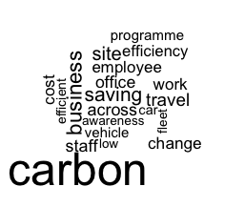 | 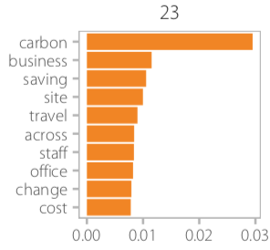 | “Emissions associated with the company car fleet are monitored on a quarterly basis with a dedicated report sent to each business to highlight their performance and how it compares with the rest of the UK business. This is supported by the company car policy to encourage employees to select low emitting vehicles. Vehicles above 225g/CO₂/km are not available whilst employees choosing a vehicle below 150g/CO₂/km receive a financial incentive. Videocon, telecon and webinar technology is being continued to be spread out across the business to reduce the need for travel. These are supported by podcasts on how to get the most from the technology.” - Atkins, United Kingdom, CDP
24 | Natural gas (0.0131) | 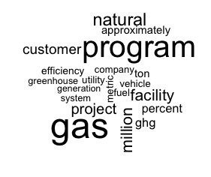 | 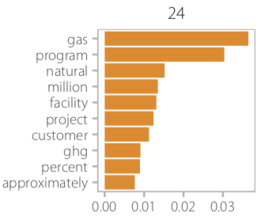 | “Our business unit SoCalGas has been a member of the U.S. EPA natural gas star program since 1994. Each year since that time, SoCalGas has networked with other program members to identify partner-reported opportunities which have become best management practices. SoCalGas annually has reported a reduction in fugitive emission (scope 1) by such practices as reclaiming rather than blowing to atmosphere the natural gas remaining in a pipeline preceding pipeline maintenance operation. In 2015, SoCalGas reported a reduction of more than 39,000 metric tons CO₂e in potential fugitive and vented emissions through activity including maintenance to minimize leaks, pressure adjustment, and altered emergency shutdown practices. SoCalGas recently signed on to the U.S. EPA's methane challenge program.” - Sempra Energy, USA, CDP
25 | Packaging, waste and recycling (0.0225) | 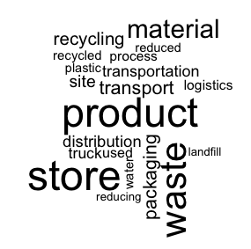 | 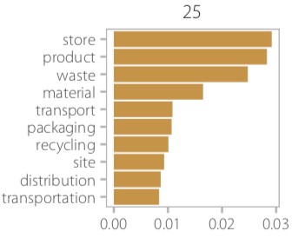 | “Certain retail products are now packed on a new line that allows for a cardboard base and shrink wrap. Customers also have the option of packing product in a pouch instead of plastic or glass bottle. Pouch packaging are a more environmentally friendly choice and lighter than glass, allowing for less weight and more product per truck for distribution. PET plastic is used as much as possible when plastic is used as it is recyclable. Product throughput has been increased on each production line thereby saving on energy and reducing ghg emissions per unit. We are also engaged in water conservation plans and have invested significantly in treatment methods of wastewater for reuse purposes.” - Whytes Food Corporation Inc., Canada, CDP .
26 | Boilers and furnace efficiency (0.0335) | 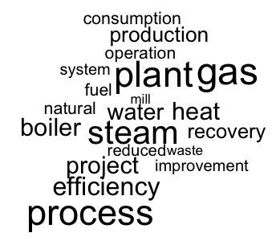 | 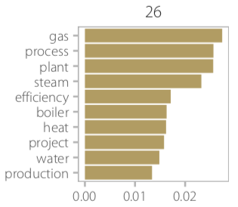 | “In 2015 we invested more than r $60,000.00 (BRL) for replacement the washer gas system by cyclone in boiler to generate steam. This new process has made the system more efficient, and significantly reduces the water consumption and increases efficiency.” - SRM - MAET, Brazil, CDP
27 | Fuel efficiency in vehicle fleets (0.0223) | 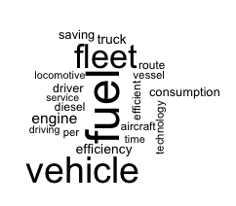 | 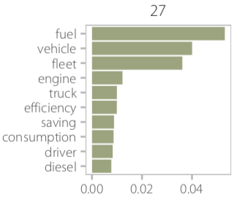 | “Improved mpg performance from vehicles using driver training, telematics and vehicle design. Reduction of transport fleet by 4.9 % running 3,549,711 fewer km compared with the previous year. Continuing cpc driver training which includes fuel efficiency. Continued use of telematics to monitor and manage driving style with particular focus on excess engine idling and vehicle speed. We continue to monitor these initiatives and add further such a forward facing camera to improve driver behaviour and fuel consumption. Maintaining the remould tyre policy for our lgv fleet using bandvulc tyre kilometre driven reduced to 76,732,358 ( -1.72 % ) total carbon ( kilogrammes ) per kilometre.” - Bibby Distribution, United Kingdom, CDP
28 | Voluntary emissions reductions (0.0195) | 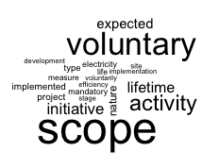 | 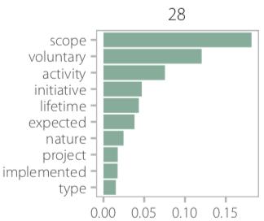 | “Nature of activity: reducing energy consumption from lighting, replacing 470 existing metal halide light fixtures with high bay fluorescent fixtures. Install motion sensors in the main office area. Replacing four hot water heaters for restroom use with tank-less heaters. Scope type: the project impacts on Bic 's scope 1 & 2 emissions. Engagement type: the project is a voluntary initiative. Expected lifetime: over 3 year on business sites involved. Nature of activity: energy savings (electricity and fuel for 2010).” - Bic, France, CDP
29 | Community building programs (0.0158) | 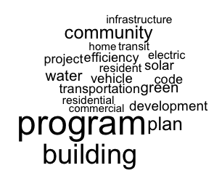 | 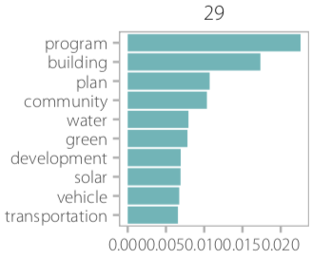 | “In December 2016, Orlando passed Bewes Ordinance - the first city in Florida to do so. The ordinance aims to drive energy and water efficiency in large buildings in Orlando. Since March 2016 , with unanimous approval from the Orlando City Council, the city has enabled more than $ 500 million for PACE, an energy financing program to support community-oriented energy efficiency upgrades and solar installation. PACE helps remove the barrier of high upfront costs and offer low-interest financing to help Orlando residents and business owners modernize, mitigate weather-related damage, and improve energy and water efficiency on their property. Since 2015, the city has been partnering with the non-profit solar and energy loan fund (SELF) and the orlando utility commission (OUC) to expand the home energy improvement program, providing Orlando residents, especially in low-income communities, with tools and resources to reduce their energy bill.” - Orlando, Florida, USA, CDP
30 | Renewable energy - solar and wind (0.0248) | 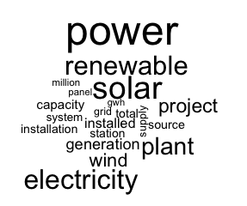 | 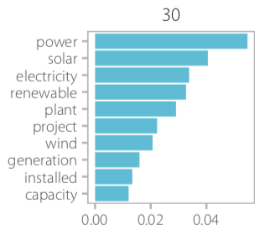 | “A 600 KW roof top mounted solar power plant has been installed and the energy generated is being used to run the detergent plant.” - Naga Dets Ltd, India, CDP .

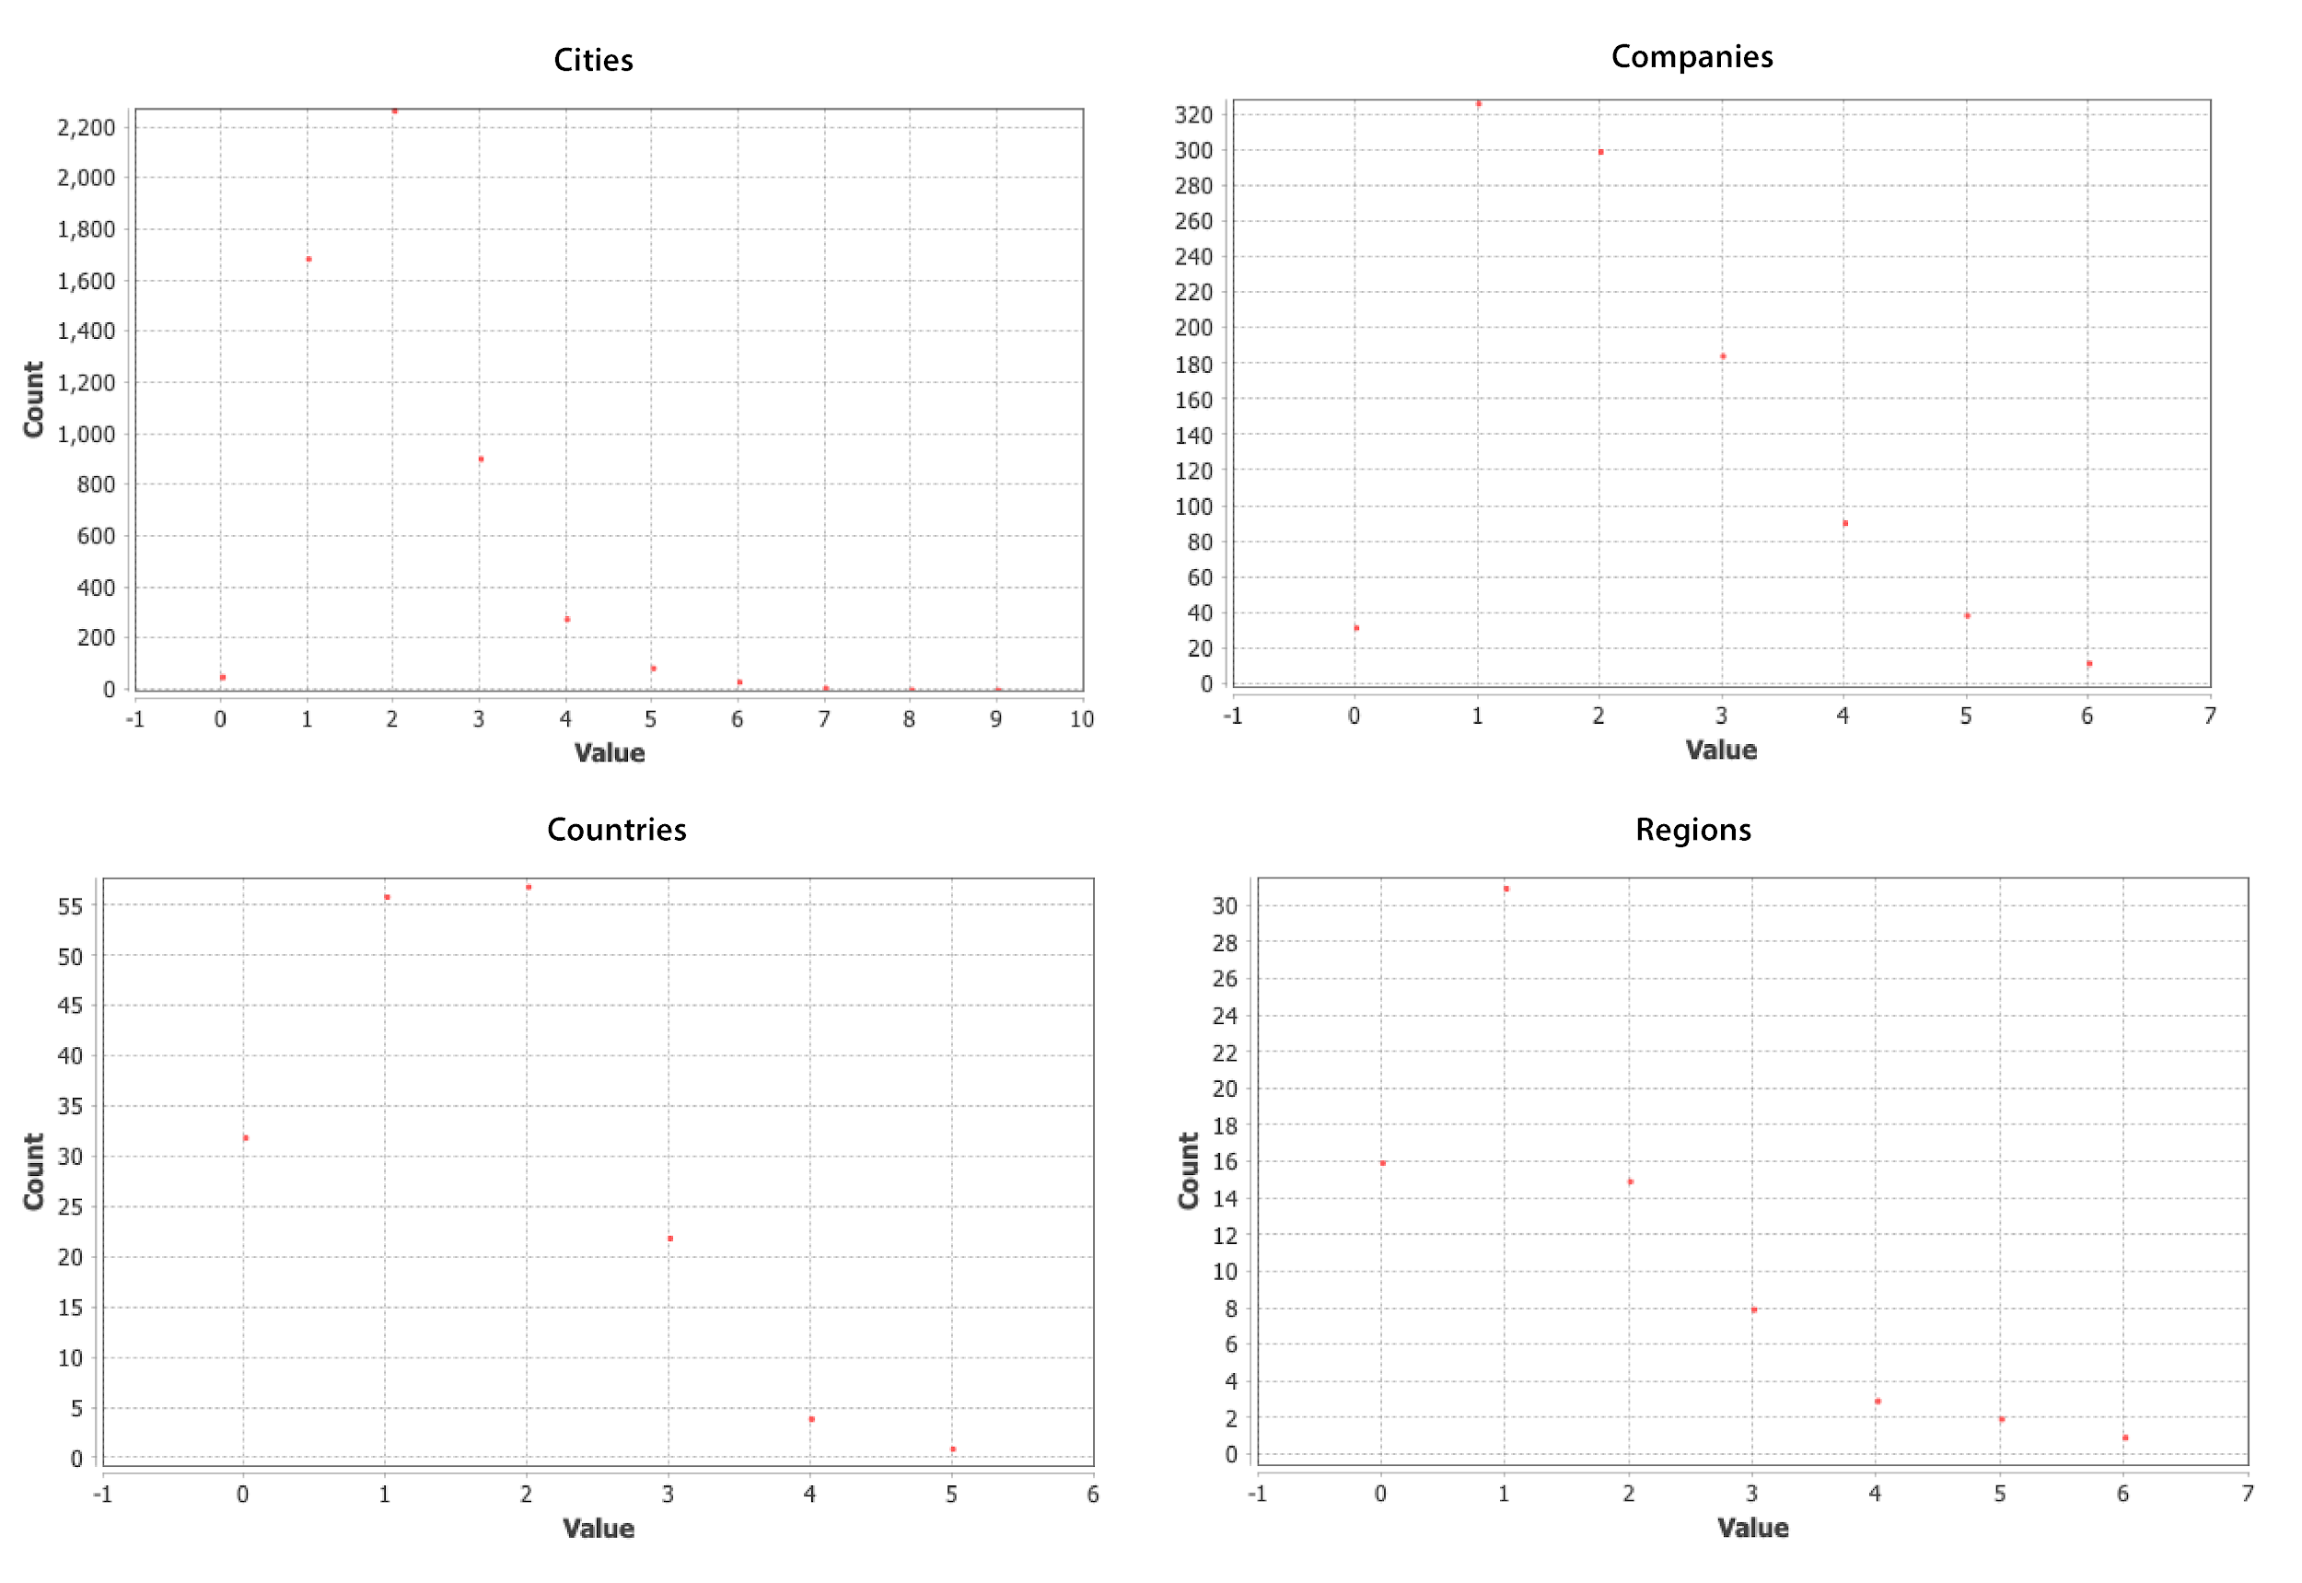
Supplementary Figure 2. Eccentricity plots for actor groups show the longest shortest path between an actor node and all other nodes.
Supplementary Table 4. Climate actors by region and percentage of total. 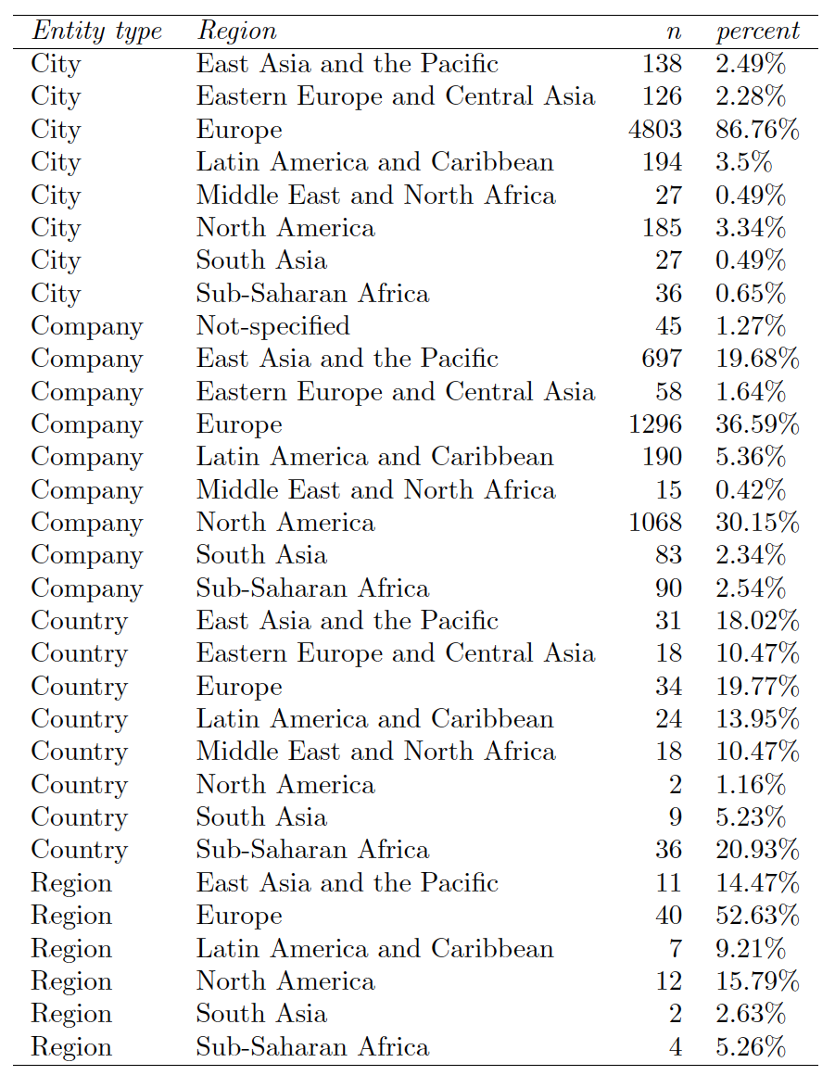
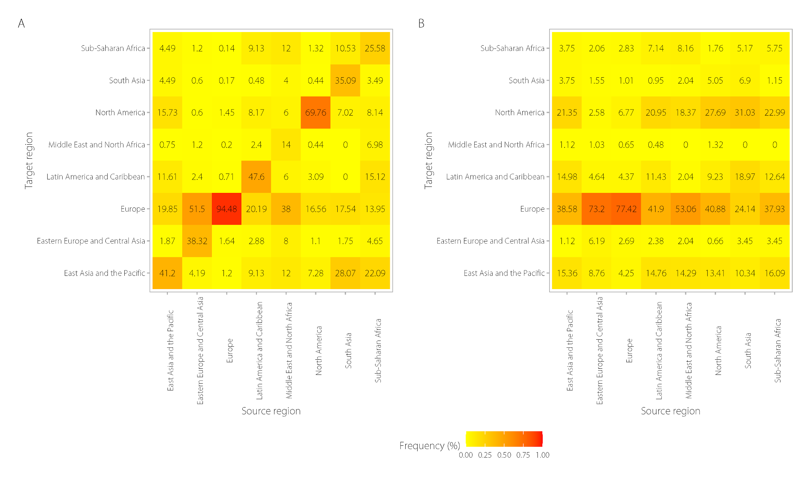
Supplementary Figure 3. Heat map of the frequency of connected edges by region of all actors in the text corpus based on euclidean distance (A) and cosine similarity (B).

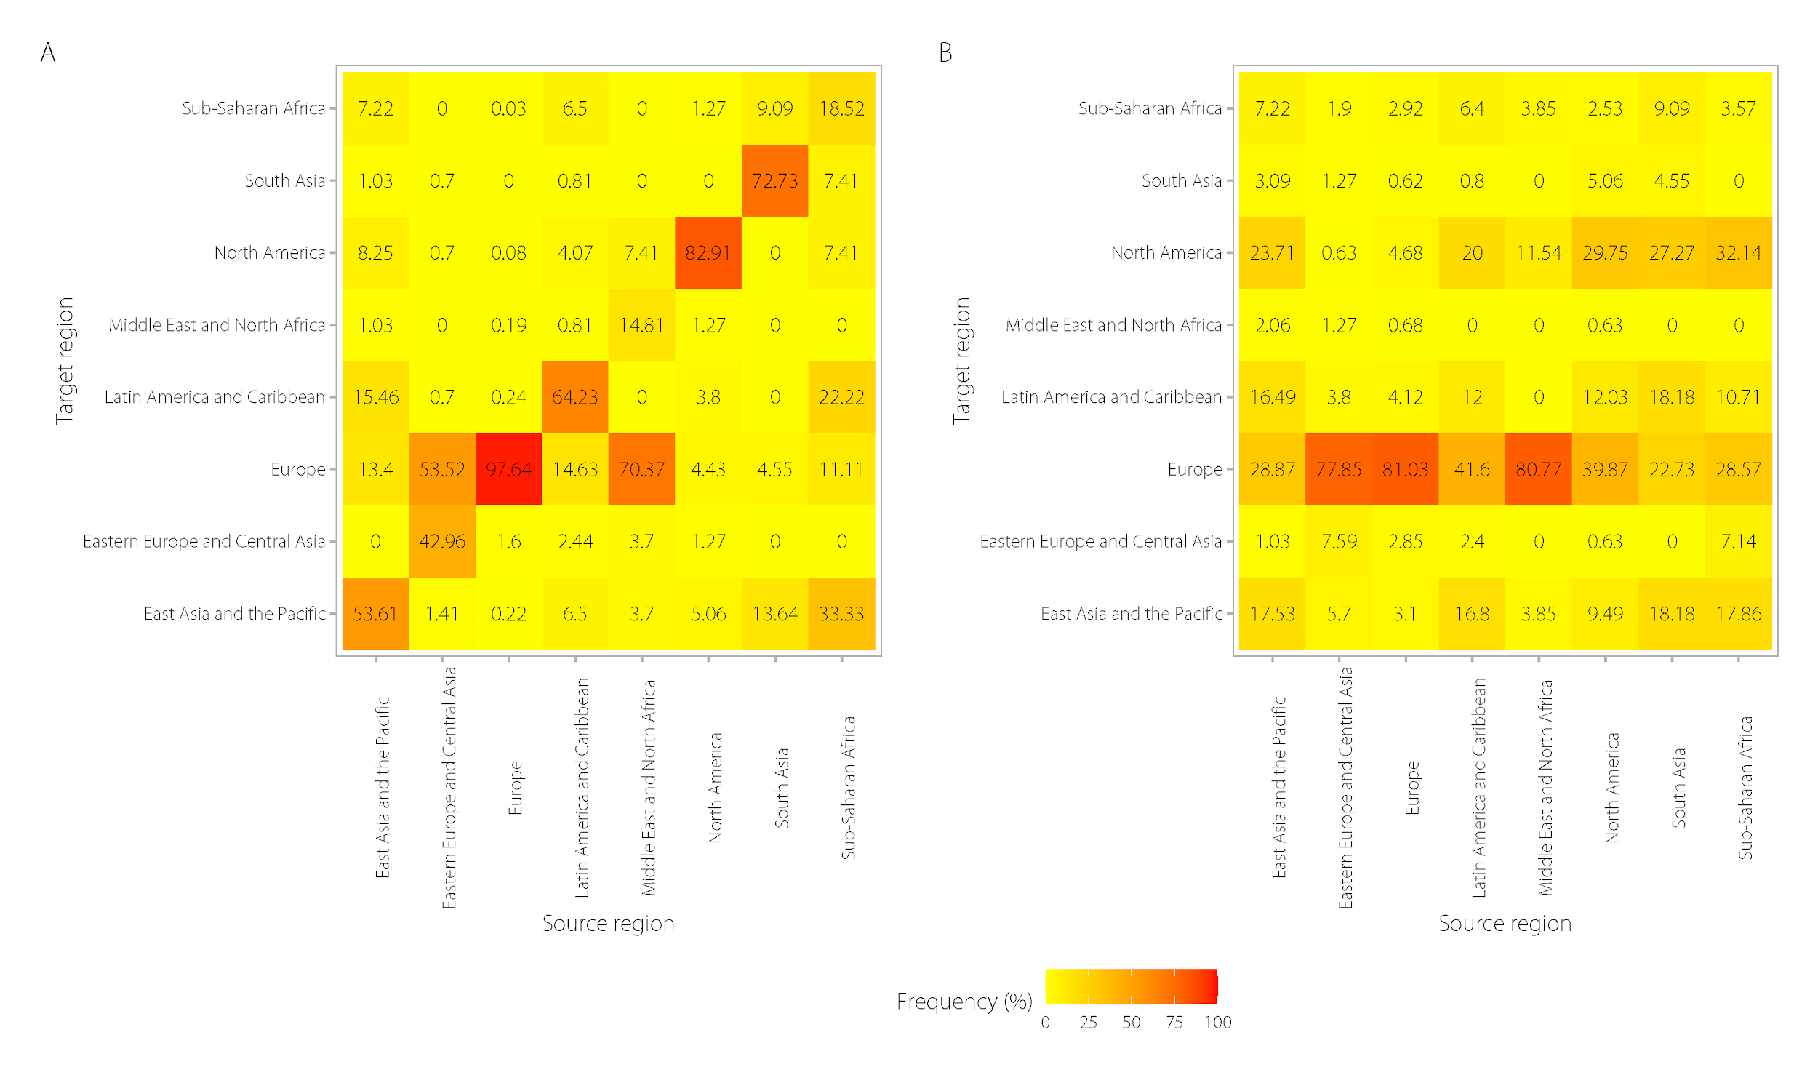
Supplementary Figure 4. Heat map of the frequency of connected edges by region of city actors in the text corpus based on euclidean distance (A) and cosine similarity (B).
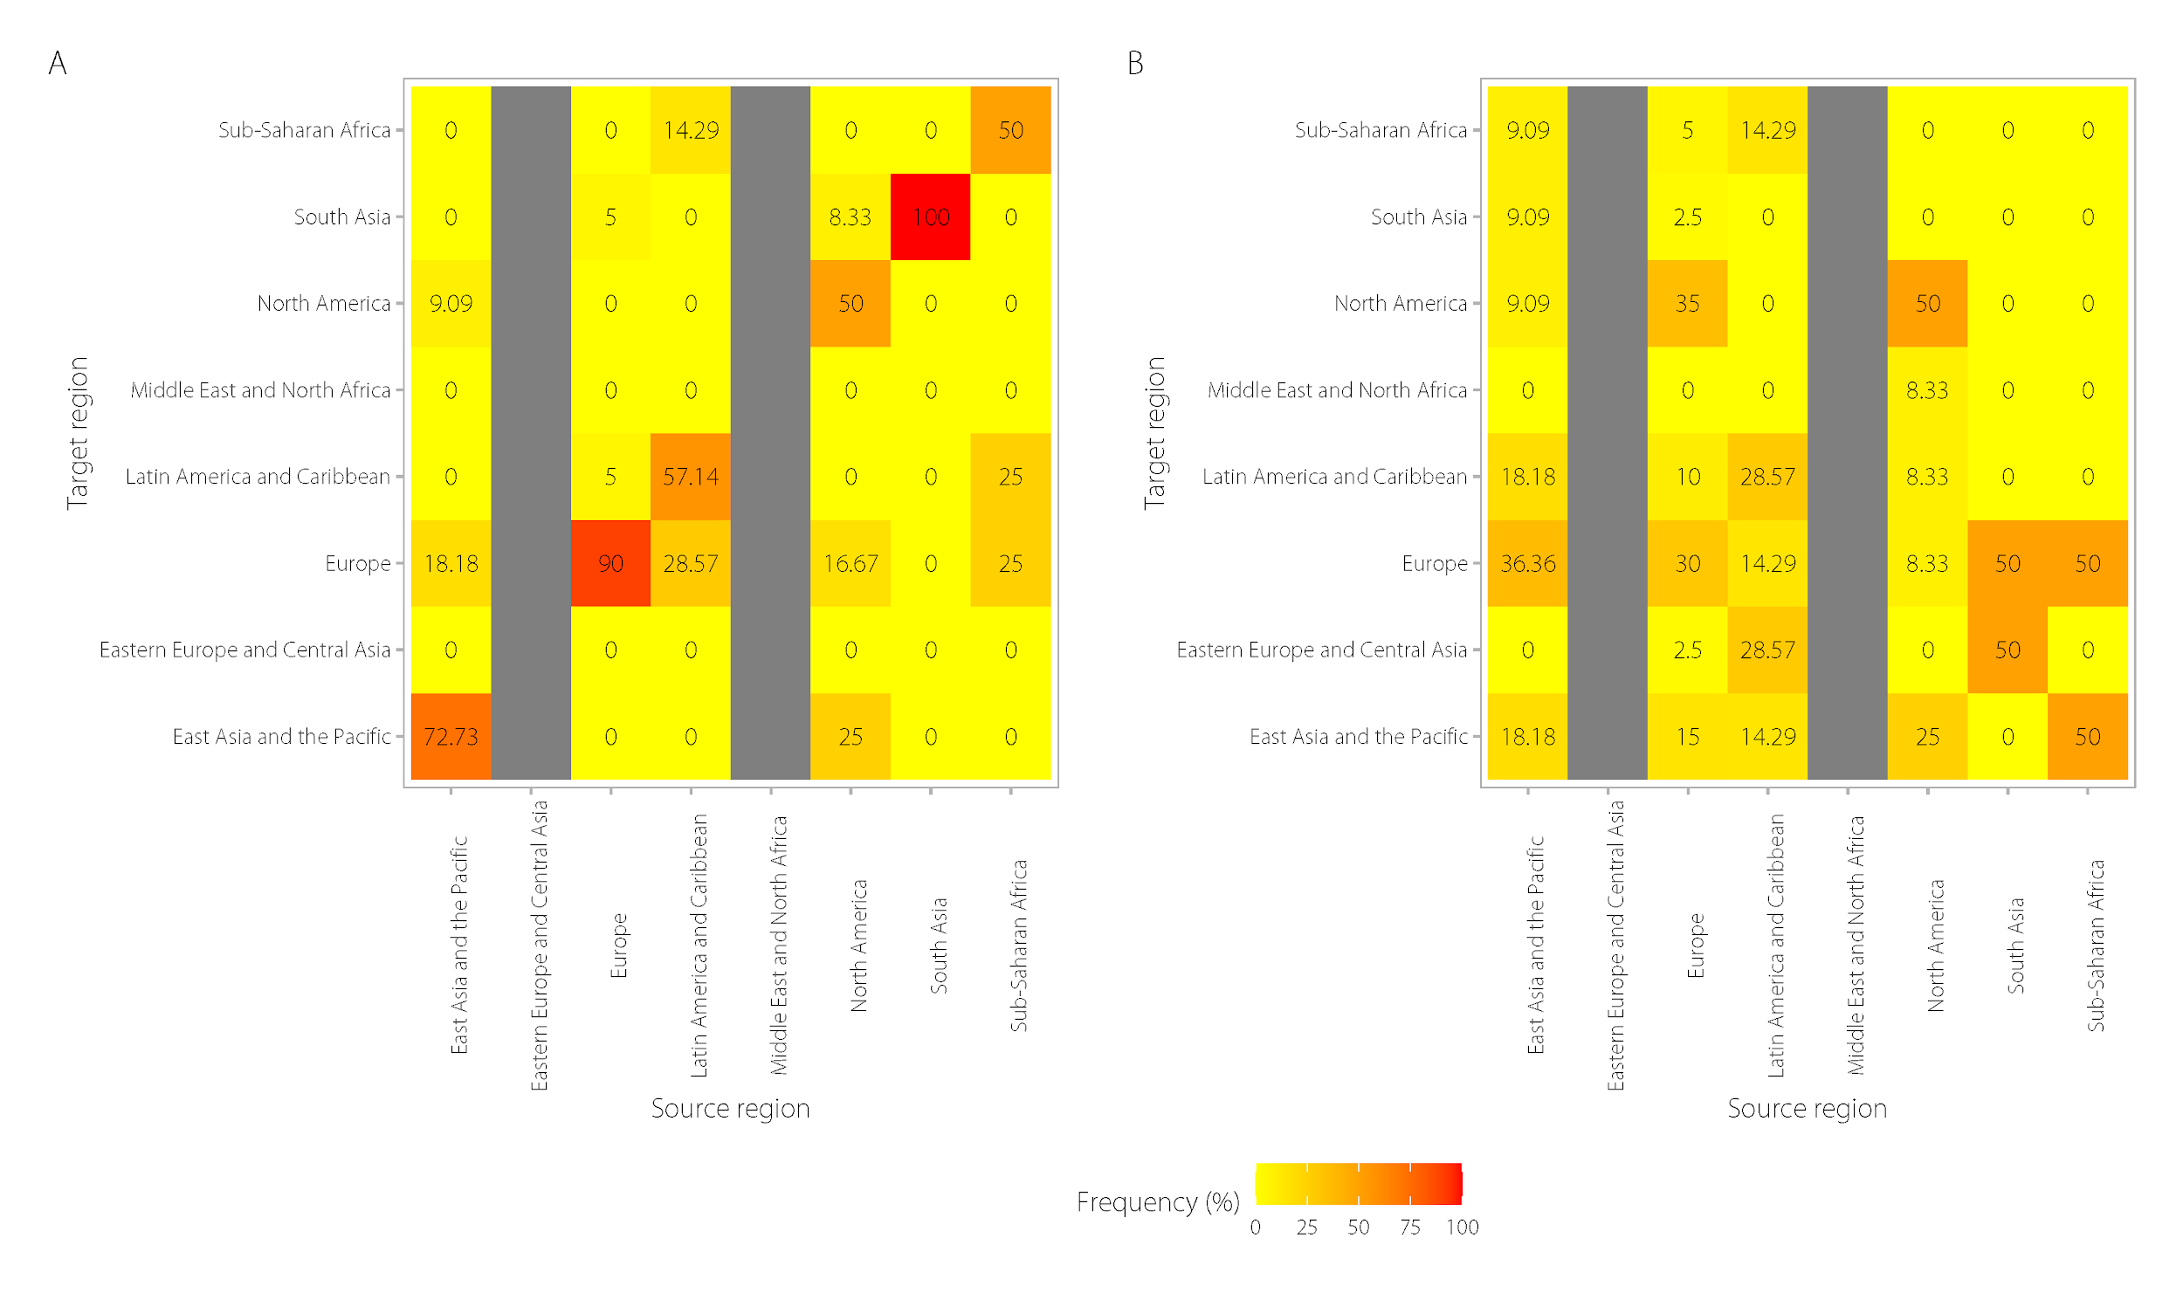
Supplementary Figure 5. Heat map of the frequency of connected edges by region of region actors in the text corpu based on euclidean distance (A) and cosine similarity (B).

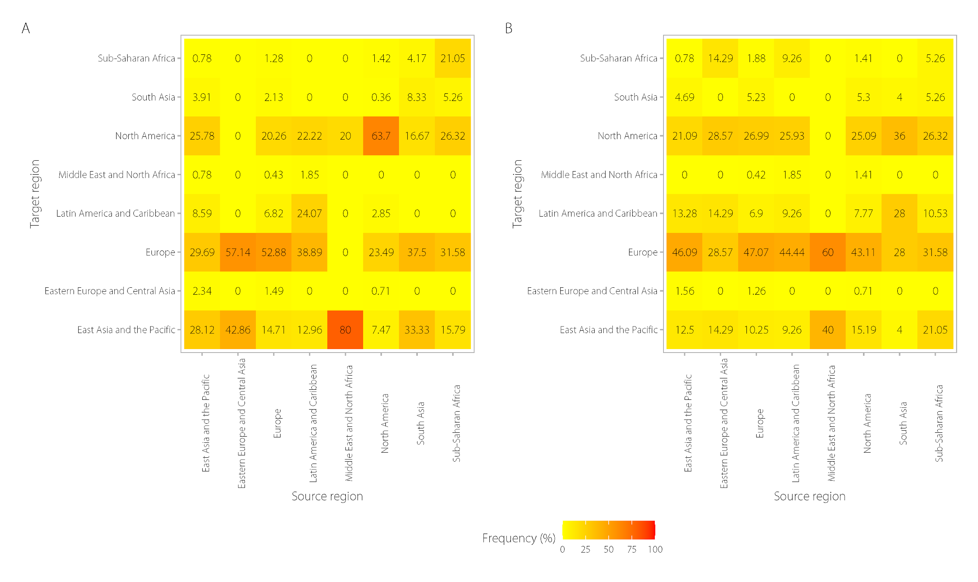
Supplementary Figure 6. Heat map of the frequency of connected edges by region of company actors in the text corpus based on euclidean distance (A) and cosine similarity (B).

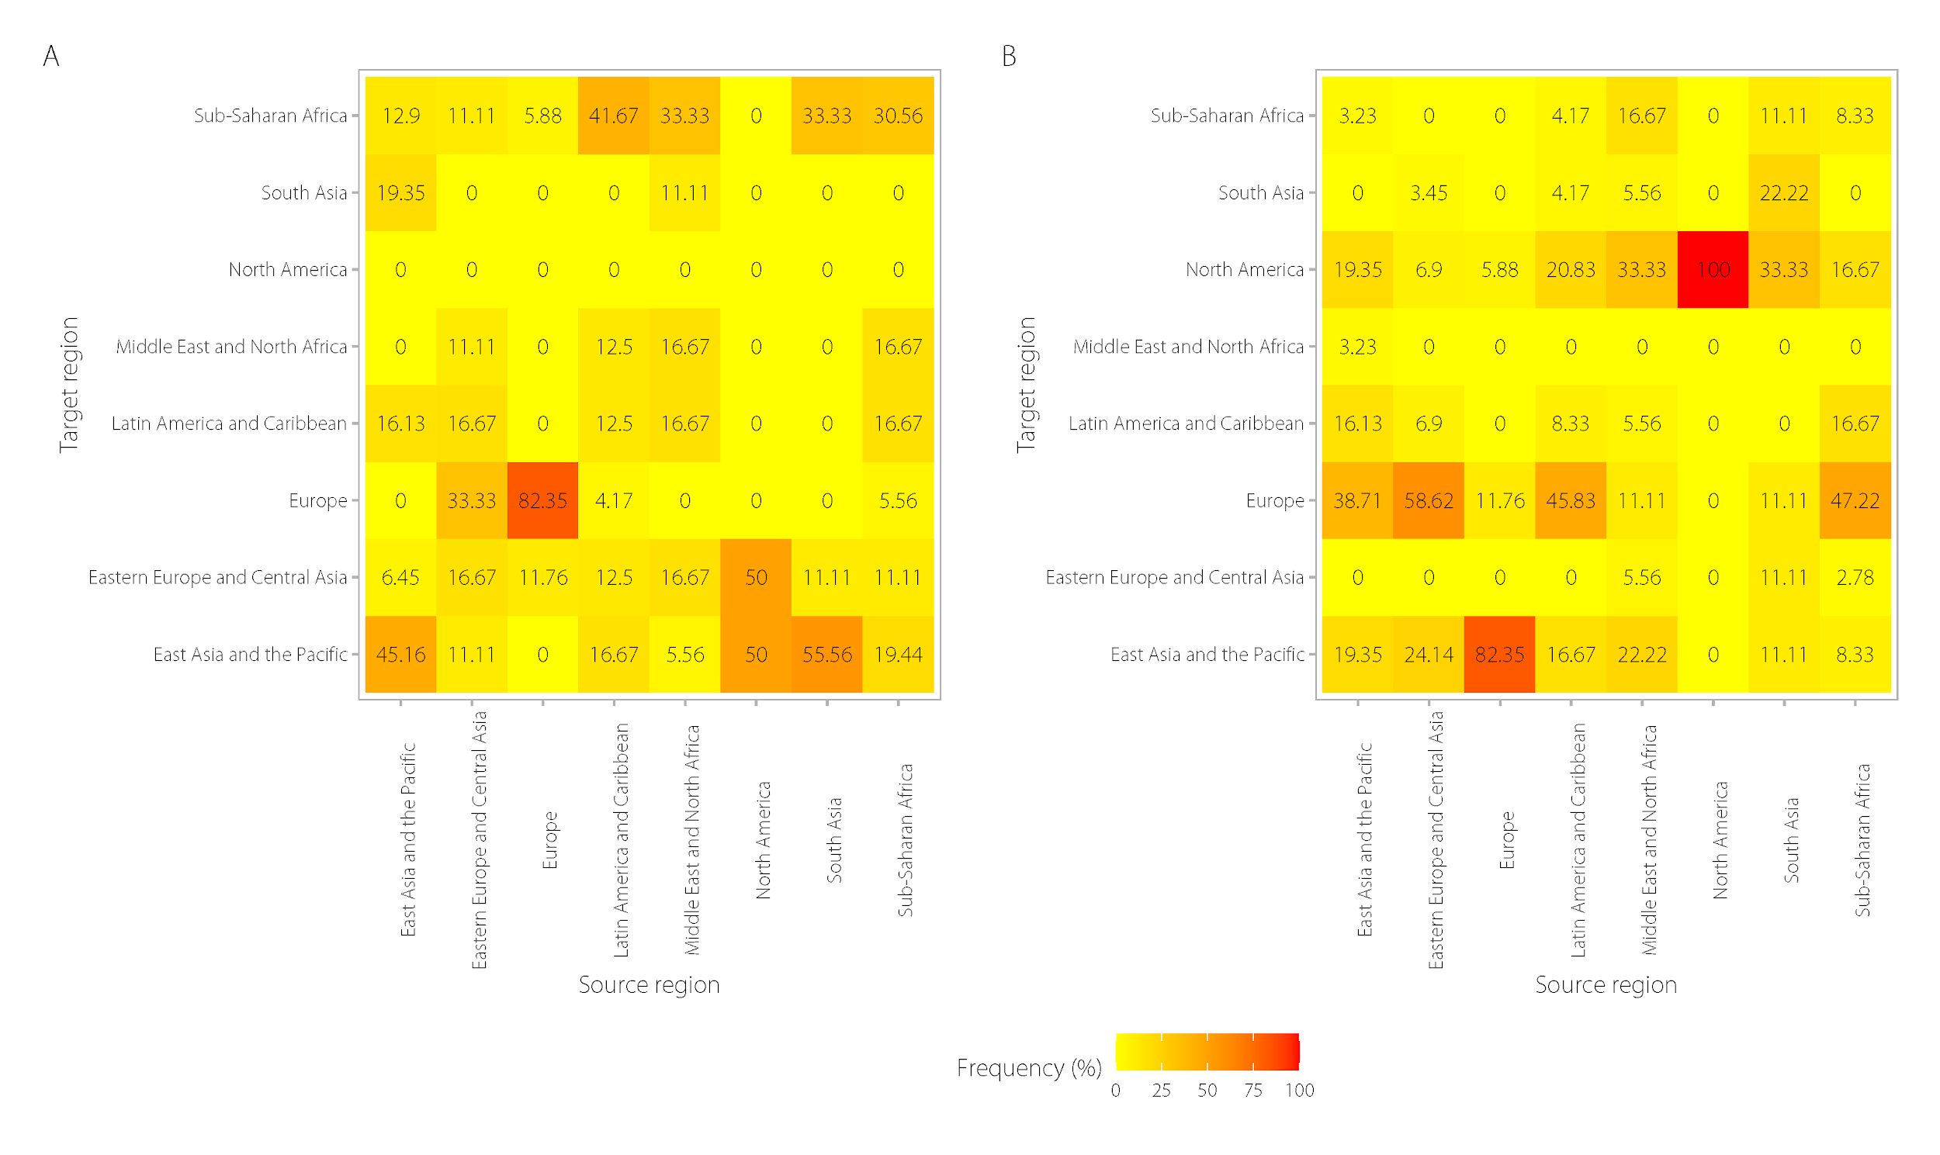
Supplementary Figure 7. Heat map of the frequency of connected edges by region of country actors in the text corpus based on euclidean distance (A) and cosine similarity (B).

Robustness Checks and Sensitivity analysis

We conducted several robustness checks to evaluate our topic model. We first conducted a sensitivity analysis to evaluate the robustness of our topic model in relation to the length and number of actors included in our text corpus, given the variation in the number of actors and the length of their climate actions in our database (Table 1). First, we assessed whether the dominance of one data source for cities affected the topic model by randomly selecting 400 texts from the CDP (n=535) and EU Covenant of Mayors (n=4,699), which represented the largest sources of data. Second, we randomly selected a number of actors’ texts to achieve a balanced corpus length for each actor group, since previous studies (Chakrabarti and Frye, 2017) have found that relatively shorter (between 300-600 words) documents improve the accuracy and consistency of the STM approach. The results of the sensitivity analysis is in Supplementary Table 5. Through visual inspection, we determined that the 30-topic model developed from our corpus that includes all actors’ text is not affected by variable lengths in actors’ documents or dominance of one data source.

We also conducted a robustness check to examine whether the writing or reporting style with which climate actors communicate climate actions may impact the topic model and the prevalence of certain topics represented in text over others (Column 4, Supplementary Table 5). To conduct this check, we normalized texts by only considering the nouns in each actor’s text documents using a process called lemmatization (May et al., 2019). This process reduces the influence of potential idiosyncrasies in actors’ writing styles by removing punctuation, capitalization, and only considering the nouns within each document.

Supplementary Table 5. Comparison of four 30-topic STM models to test the sensitivity of the final selected topic model. Topic Model 2 balanced the number of cities’ documents by data source; Topic Model 3 balanced the corpus according to roughly equal numbers of actors and length of document text; Topic Model 4 is based on the lemmatized text considering only nouns . The topic numbers do not correspond to each other - topic 1 in models 1, 2, 3 and 4 do not reflect the same topic and are arbitrarily labeled as topic 1 by the model algorithm.

- Final Topic Model - with all texts | - Topic Model - Balanced Data Source | - Topic Model - Balanced Actor Type | - Topic Model - Lemmatized Text (Nouns Only)
Topic 1 Top Words: | Topic 1 Top Words: | Topic 1 Top Words: | Topic 1 Top Words:
Highest Prob: consumption, system, project, management, action, company, efficiency | Highest Prob: waste, public, municipal, program, transport, project, consumption | Highest Prob: led, lighting, lights, replacement, street, efficient, lamps | Highest Prob: climate, development, change, strategy, policy, carbon, greenhouse
Topic 2 Top Words: | Topic 2 Top Words: | Topic 2 Top Words: | Topic 2 Top Words:
Highest Prob: project, initiative, programme, saving, centre, implemented, system | Highest Prob: lighting, public, vehicles, consumption, system, led, transport | Highest Prob: climate, change, development, national, adaptation, mitigation, water | Highest Prob: environment, mobility, district, bicycle, traffic, space, education
Topic 3 Top Words: | Topic 3 Top Words: | Topic 3 Top Words: | Topic 3 Top Words:
Highest Prob: waste, public, transport, bus, collection, development, building | Highest Prob: consumption, group, initiatives, scope, employees, electricity, voluntary | Highest Prob: vehicles, fuel, electric, power, system, fossil, fleet | Highest Prob: adaptation, mitigation, country, level, impact, indc, action
Topic 4 Top Words: | Topic 4 Top Words: | Topic 4 Top Words: | Topic 4 Top Words:
Highest Prob: office, employee, paper, travel, car, consumption, server | Highest Prob: water, resources, country, development, climate, state, growth | Highest Prob: project, plans, technicalinfrastructure, investment, raising, policystrategiesaction, educationawareness | Highest Prob: waste, plan, transport, municipality, management, food, school
Topic 5 Top Words: | Topic 5 Top Words: | Topic 5 Top Words: | Topic 5 Top Words:
Highest Prob: building, action, main, efficiency, thermal, area, residential | Highest Prob: green, facilities, public, system, power, carbon, saving | Highest Prob: program, waste, residents, action, programs, recycling, efficiency | Highest Prob: period, usage, effort, time, saving, team, change
Topic 6 Top Words: | Topic 6 Top Words: | Topic 6 Top Words: | Topic 6 Top Words:
Highest Prob: sustainable, action, development, plan, change, transportation, mobility | Highest Prob: solar, water, project, waste, system, power, corporation | Highest Prob: efficiency, renewable, facilities, lighting, offices, projects, scope | Highest Prob: nature, monetary, station, base, stage, investment, implementation
Topic 7 Top Words: | Topic 7 Top Words: | Topic 7 Top Words: | Topic 7 Top Words:
Highest Prob: system, school, photovoltaic, installation, lamp, lighting, replacement | Highest Prob: projects, lighting, savings, building, office, data, scope | Highest Prob: packaging, green, council, system, waste, management, design | Highest Prob: plant, water, power, promotion, efficiency, lamp, consumption
Topic 8 Top Words: | Topic 8 Top Words: | Topic 8 Top Words: | Topic 8 Top Words:
Highest Prob: building, green, environmental, certification, standard, renewable, office | Highest Prob: waste, policystrategiesaction, technicalinfrastructure, municipality, plans, project, investment | Highest Prob: lighting, system, building, scope, air, office, fixtures | Highest Prob: vehicle, fleet, technology, time, customer, amount, service
Topic 9 Top Words: | Topic 9 Top Words: | Topic 9 Top Words: | Topic 9 Top Words:
Highest Prob: building, measure, transport, public, local, heating, action | Highest Prob: action, municipality, buildings, public, actions, municipal, renewable | Highest Prob: water, waste, solar, installation, total, per, electricity | Highest Prob: efficiency, investment, product, material, carbon, train, technology
Topic 10 Top Words: | Topic 10 Top Words: | Topic 10 Top Words: | Topic 10 Top Words:
Highest Prob: lighting, led, building, light, system, replacement, installed | Highest Prob: indc, states, parties, member, indcs, communicate, objective | Highest Prob: voluntary, initiative, scope, years, efficiency, project, investment | Highest Prob: consumption, electricity, student, annum, property, coe, efficiency
Topic 11 Top Words: | Topic 11 Top Words: | Topic 11 Top Words: | Topic 11 Top Words:
Highest Prob: climate, change, national, adaptation, development, mitigation, country | Highest Prob: waste, buildings, transport, efficiency, improve, building, development | Highest Prob: waste, landfill, public, recycling, green, food, bus | Highest Prob: company, measure, goal, equipment, report, spain, category
Topic 12 Top Words: | Topic 12 Top Words: | Topic 12 Top Words: | Topic 12 Top Words:
Highest Prob: climate, municipality, project, sustainable, transport, work, car | Highest Prob: green, council, waste, project, public, building, system | Highest Prob: plant, gas, power, efficiency, production, heat, carbon | Highest Prob: office, employee, business, travel, carbon, purchase, campaign
Topic 13 Top Words: | Topic 13 Top Words: | Topic 13 Top Words: | Topic 13 Top Words:
Highest Prob: target, set, plan, action, carbon, consumption, achieve | Highest Prob: climate, change, adaptation, national, development, impacts, electricity | Highest Prob: air, system, cooling, electricity, lighting, equipment, consumption | Highest Prob: activity, lifetime, target, type, voluntary, mandatory, decrease
Topic 14 Top Words: | Topic 14 Top Words: | Topic 14 Top Words: | Topic 14 Top Words:
Highest Prob: action, municipality, citizen, seap, plan, public, building | Highest Prob: plant, gas, power, savings, efficiency, heat, electricity | Highest Prob: stage, programme, facilities, initiative, waste, consumption, management | Highest Prob: lighting, facility, shop, foot, efficiency, technology, equipment
Topic 15 Top Words: | Topic 15 Top Words: | Topic 15 Top Words: | Topic 15 Top Words:
Highest Prob: term, administration, objective, action, territory, public, area | Highest Prob: fuel, program, fleet, vehicles, customers, savings, transport | Highest Prob: buildings, public, renewable, plan, sustainable, consumption, climate | Highest Prob:truck, diesel, supply, transportation, result, equipment, maintenance
Topic 16 Top Words: | Topic 16 Top Words: | Topic 16 Top Words: | Topic 16 Top Words:
Highest Prob: saving, annual, investment, estimated, cost, coe, per | Highest Prob: scope, voluntary, initiative, expected, activity, efficiency, lifetime | Highest Prob: projects, fuel, savings, project, voluntary, scope, vehicles | Highest Prob: centre, network, footprint, server, space, site, solution
Topic 17 Top Words: | Topic 17 Top Words: | Topic 17 Top Words: | Topic 17 Top Words:
Highest Prob: fuel, gas, plant, oil, waste, production, ghg | Highest Prob: air, project, system, lighting, scope, led, voluntary | Highest Prob: electricity, consumption, savings, data, supply, employees, renewable | Highest Prob: process, site, improvement, production, steam, boiler, optimization
Topic 18 Top Words: | Topic 18 Top Words: | Topic 18 Top Words: | Topic 18 Top Words:
Highest Prob: municipal, public, renewable, transport, residential, building, consumption | Highest Prob: program, community, plan, water, green, residents, waste | Highest Prob: public, waste, buildings, consumption, transport, municipal, water | Highest Prob: initiative, cost, programme, payback, asset, bottle, investment
Topic 19 Top Words: | Topic 19 Top Words: | Topic 19 Top Words: | Topic 19 Top Words:
Highest Prob: air, system, consumption, heat, water, cooling, plant | Highest Prob: climate, change, national, measures, greenhouse, gas, global | Highest Prob: government, gas, projects, program, renewable, electricity, support | Highest Prob:data, center, paper, location, hour, branch, bank
Topic 20 Top Words: | Topic 20 Top Words: | Topic 20 Top Words: | Topic 20 Top Words:
Highest Prob: install, government, promote, efficiency, improve, waste, etc | Highest Prob: environmental, urban, public, program, areas, management, sustainable | Highest Prob: scope, activity, savings, voluntary, data, lifetime, initiative | Highest Prob: community, program, water, transportation, infrastructure, street, service
Topic 21 Top Words: | Topic 21 Top Words: | Topic 21 Top Words: | Topic 21 Top Words:
Highest Prob: area, water, plan, community, project, public, strategy | Highest Prob: paris, climate, plan, public, local, development, urban | Highest Prob: green, waste, development, project, system, carbon, public | Highest Prob: fuel, operation, vessel, meeting, speed, cell, test
Topic 22 Top Words: | Topic 22 Top Words: | Topic 22 Top Words: | Topic 22 Top Words:
Highest Prob: project, facility, efficiency, system, upgrade, equipment, improvement | Highest Prob: install, promote, etc, power, waste, improve, transport | Highest Prob: building, program, buildings, green, plan, community, infrastructure | Highest Prob: coe, tonne, generation, wind, source, investment, power
Topic 23 Top Words: | Topic 23 Top Words: | Topic 23 Top Words: | Topic 23 Top Words:
Highest Prob: carbon, business, saving, site, travel, across, staff | Highest Prob: climate, municipality, sustainable, project, transport, environmental, work | Highest Prob: carbon, savings, fleet, power, solar, company, green | Highest Prob: unit, machine, factory, time, metal, panel, insulation
Topic 24 Top Words: | Topic 24 Top Words: | Topic 24 Top Words: | Topic 24 Top Words:
Highest Prob: gas, program, natural, million, facility, project, customer | Highest Prob: program, building, solar, water, buildings, code, plan | Highest Prob: transport, plan, climate, action, heating, public, waste | Highest Prob: installation, heat, heating, pump, ship, paint, workshop
Topic 25 Top Words: | Topic 25 Top Words: | Topic 25 Top Words: | Topic 25 Top Words:
Highest Prob: store, product, waste, material, transport, packaging, recycling | Highest Prob: savings, carbon, renewable, efficiency, green, estimated, coe | Highest Prob: customers, waste, transport, tonnes, program, reducing, service | Highest Prob: light, control, replacement, equipment, lighting, upgrade, lamp
Topic 26 Top Words: | Topic 26 Top Words: | Topic 26 Top Words: | Topic 26 Top Words:
Highest Prob: gas, process, plant, steam, efficiency, boiler, heat | Highest Prob: transport, project, town, programme, development, plan, waste | Highest Prob: climate, change, national, measures, area, implementation, intensity | Highest Prob: increase, power, transport, standard, efficiency, waste, transit
Topic 27 Top Words: | Topic 27 Top Words: | Topic 27 Top Words: | Topic 27 Top Words:
Highest Prob: fuel, vehicle, fleet, engine, truck, efficiency, saving | Highest Prob: heating, heat, buildings, building, public, project, measures | Highest Prob: paris, climate, areas, public, urban, environmental, development | Highest Prob: sustainability, impact, construction, performance, design, level, awareness
Topic 28 Top Words: | Topic 28 Top Words: | Topic 28 Top Words: | Topic 28 Top Words:
Highest Prob: scope, voluntary, activity, initiative, lifetime, expected, nature | Highest Prob: gas, program, renewable, electricity, projects, government, carbon | Highest Prob: municipality, project, waste, environmental, work, community, environment | Highest Prob: scope, voluntary, life, store, technology, retrofit, refrigeration
Topic 29 Top Words: | Topic 29 Top Words: | Topic 29 Top Words: | Topic 29 Top Words:
Highest Prob: program, building, plan, community, water, green, development | Highest Prob: national, climate, adaptation, change, mitigation, indc, development | Highest Prob: install, promote, etc, power, improve, transport, efficiency | Highest Prob: building, action, intervention, waste, service, efficiency, food
Topic 30 Top Words: | Topic 30 Top Words: | Topic 30 Top Words: | Topic 30 Top Words:
Highest Prob: power, solar, electricity, renewable, plant, project, wind | Highest Prob: climate, change, development, national, adaptation, mitigation, actions | Highest Prob: program, gas, climate, natural, transit, plan, programs | Highest Prob: program, management, implementation, cogeneration, technology, efficiency, carbon

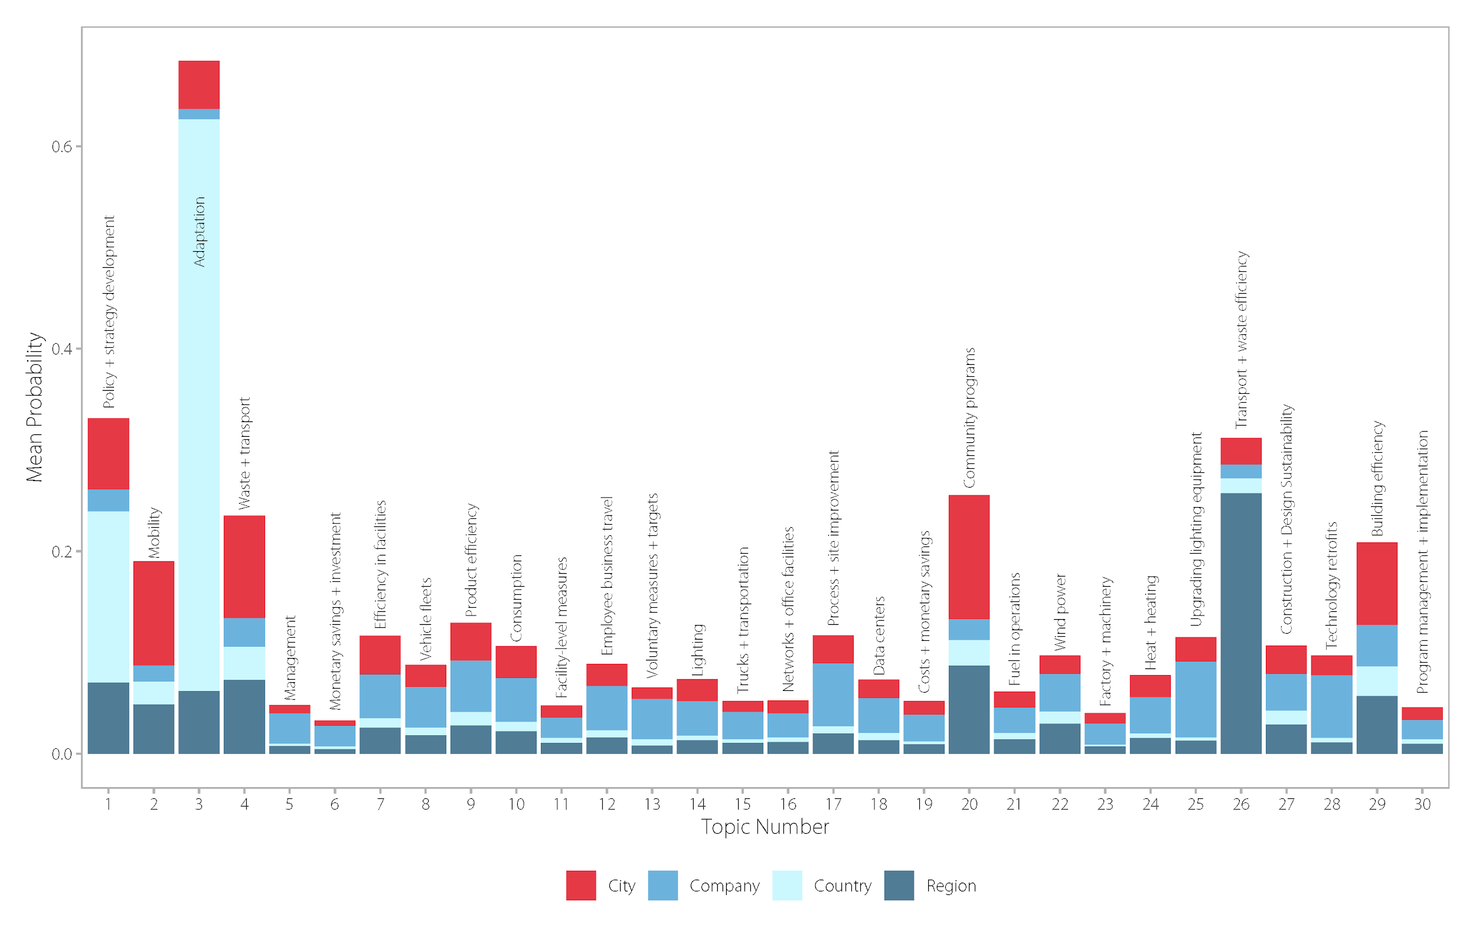
Supplementary Figure 8. Per-document-per-topic probabilities for four groups of climate actors show the estimated proportion of words from a corpus of actors’ noun-only, lemmatized documents that are generated from one of 30 topics in the topic model.
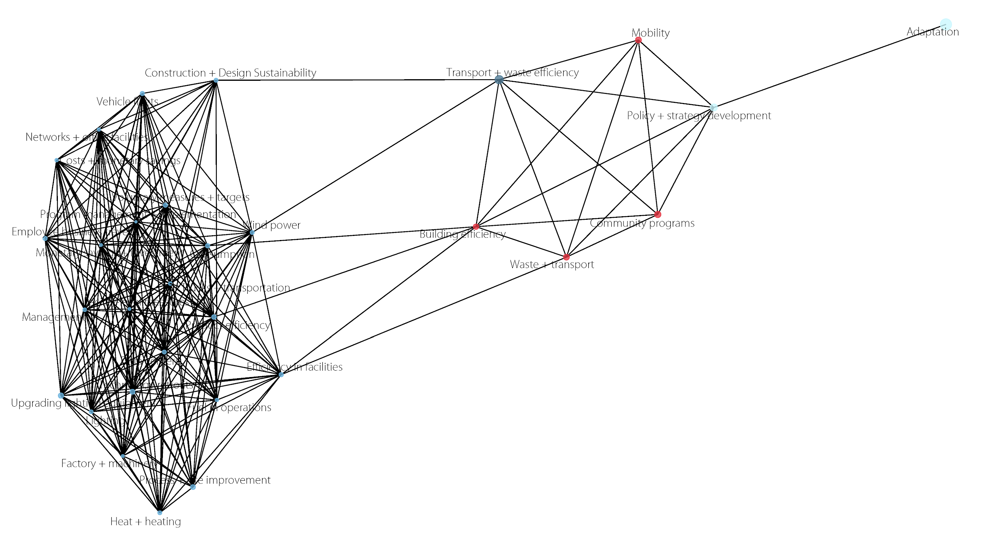
Supplementary Figure 9. Per-document-per-topic probabilities for four groups of climate actors show the estimated proportion of words from a corpus of actors’ noun-only, lemmatized documents that are generated from one of 30 topics in the topic model.

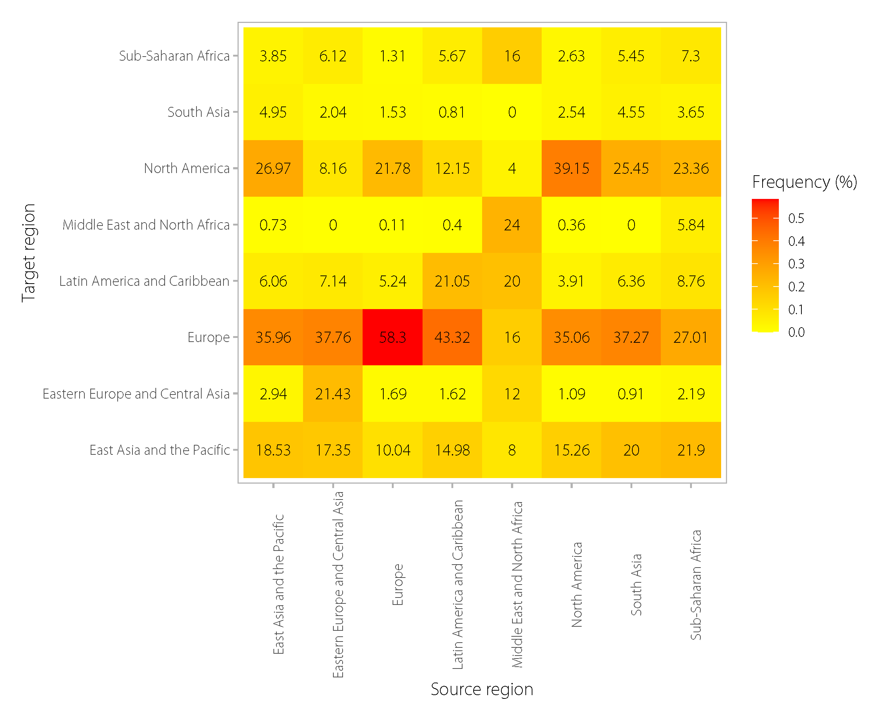
Supplementary Figure 10. Heat map of the frequency of connected edges by region of all actors in the noun-only, lemmatized text corpus.

Supplementary References
May, C., Cotterell, R., & Van Durme, B. (2016). An Analysis of Lemmatization on Topic Models of Morphologically Rich Language. arXiv preprint arXiv:1608.03995.

