What Makes a Role Model Motivating for Young Girls?
The Effects of the Role Model’s Growth versus Fixed Mindsets about Ability and Interest

Supplementary Online Materials

Table of Contents

Supp. Text 1: The Description of Urban Ecology 2
Supp. Text 2: Introduction to the Role Model 4
Supp. Text 3: The Role Model’s Perceived Race/Ethnicity 5
Supp. Text 4: Exploratory Items 6
Supp. Figure 1: Fixed Mindsets about Ability 7
Supp. Figure 2: Growth Mindsets about Ability 8
Supp. Figure 3: Fixed Mindsets about Interest 9
Supp. Figure 4: Growth Mindsets about Interest 10
Supp. Figure 5: The Effects of the Interest Mindset Manipulation 11

Supp. Text 1: The Description of Urban Ecology

Now we're going to talk about jobs.
It's good for kids to learn about all the different kinds of jobs there are in the world, so they can start thinking about what kind of job they're going to do when they grow up.

Today, I'll tell you about a kind of job that you might not know about.
Make sure to listen carefully, because I'll ask you some questions about this job as we go.

The job I'll tell you about is called
urban ecology.
And people who do urban ecology for a job are called urban ecologists.


First, let's talk about ecology. So, what does an ecologist do?
Well, an ecologist uses science to learn about how living things like humans, animals, plants, and trees all live together in the same place. They learn about how living things eat, drink, and grow all around each other.


Okay, so you remember how we said that the job we'll talk about is called an urban ecologist?
We've talked about what ecologists do, but what does an urban ecologist do?
Urban means like in a city, where there are a lot of buildings and people all living near each other. So, urban ecologists are scientists that use science to learn about living things in cities and places where there are lots of people.


Supp. Text 2: Introduction to the Role Model

Now that you’ve learned all about urban ecology, let’s meet some of the people who do urban ecology for their job.
Now you’ll hear some questions and answers with a real urban ecologist named Elizabeth P.

Here's a picture of Elizabeth P. at work.



Supp. Text 3: The Role Model’s Perceived Race/Ethnicity

A sample of 25 adult participants (20 women, 3 men, 2 non-binary; M_{age} = 25.3 years) were shown the picture of the role model that we used to introduce her to children (see Supplementary Text 2) and were then asked, “This is Elizabeth P. What race/ethnicity do you think Elizabeth P. is? Please select all that apply.” Six racial/ethnic categories were displayed in random order: American Indian or Alaska Native, Asian, Black or African American, Hispanic or Latina, Native Hawaiian or Pacific Islander, and White. Participants were then asked to indicate their confidence in their judgment on a scale from 0 = not at all confident to 100 = extremely confident. This study was programmed in Qualtrics and conducted online.

A distribution of the perceived race/ethnicity judgments is shown in the figure below. Because participants could assign more than one race/ethnicity to the role model, the percentages add up to more than 100%.

The role model was overwhelmingly identified as a woman of color. However, multiple racial/ethnic minority identities were judged to be plausible, with the most commonly selected identity being Hispanic or Latina (72%). Participants selected 1.92 identities on average (SD = 1.29), reflecting some degree of uncertainty. Consistent with this behavioral uncertainty, participants’ average rated certainty was 40.8 (SD = 20.9), which was significantly below the midpoint of 50, t(24) = 2.21, p = .037. Overall, these results suggest that the role model was identified as a woman of color of relatively ambiguous race/ethnicity.

Supp. Text 4: Exploratory Items

At the end of the sessions, we administered three items to explore girls’ perceptions of the role model and two items to explore girls’ perceptions of urban ecology. All exploratory items are listed in the table below. The items were presented to children in the order in which they are listed below. A correlation matrix and other analyses of these items—specifically, regression models with the same predictors as in the main text—can be found in the “Additional Results” folder on OSF.

Exploratory Item | Response Scale
Perceptions of the Role Model
1. How much do you like Elizabeth P.? | 1 = don’t like her at all  4 = really like her
2. How much do you want to be like Elizabeth P. when you grow up? | 1 = don’t want to at all  4 = really want to
3. How smart do you think Elizabeth P. is? | 1 = not smart at all  4 = really smart
Perceptions of the Field
4. Do you think women would do better as an urban ecologist? Men would do better? Or women and men would do the same as an urban ecologist? | −1 = men would do better  0 = the same  1 = women would do better
5. Do you think there are more urban ecologists who are women? Who are men? Or are there an equal number of women and men urban ecologists? | −1 = more men  0 = equal number  1 = more women

Supp. Figure 1: Fixed Mindsets about Ability



“You know, this kind of work has always been pretty easy for me. In fact, I always got good grades in math and science, so I realized that I didn’t need to try hard if I wanted to succeed. After realizing this and not trying very hard, I still did well and earned all A’s in my math and science classes. My ability in math and science has really helped me to do well as an urban ecologist.”

Note. Children did not see the text printed below the image. Instead, this text was recorded by a female researcher and played for children on headphones to ensure uniformity of delivery and minimize experimenter bias. The audio recording was accompanied by the visuals at the top of the figure, which appeared one at a time, from left to right, and were synchronized with the spoken script. The bolded portions of the text convey the key mindset message.

Supp. Figure 2: Growth Mindsets about Ability



“You know, this kind of work hasn’t always been easy for me. In fact, I never got good grades in math and science, so I realized that I should try harder if I wanted to do well. After realizing this and trying harder, I did well and started earning all A’s in my math and science classes. My hard work in math and science has really helped me to do well as an urban ecologist.”

Note. Children did not see the text printed below the image. Instead, this text was recorded by a female researcher and played for children on headphones to ensure uniformity of delivery and minimize experimenter bias. The audio recording was accompanied by the visuals at the top of the figure, which appeared one at a time, from left to right, and were synchronized with the spoken script. The bolded portions of the text convey the key mindset message.

Supp. Figure 3: Fixed Mindsets about Interest
“When I was a child, I was really interested in the wild animals and plants that lived near us. I always knew I wanted to do something with animals and plants when I grew up. Because I was always interested in urban ecology, I took lots of urban ecology classes in school and loved it! So, once I finished school, I got a job at the Urban Ecology Center.”

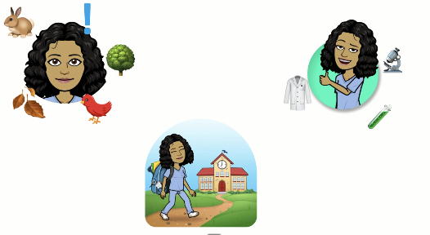

Note. Children did not see the text printed below the image. Instead, this text was recorded by a female researcher and played for children on headphones to ensure uniformity of delivery and minimize experimenter bias. The audio recording was accompanied by the visuals at the top of the figure, which appeared one at a time, from left to right, and were synchronized with the spoken script. The bolded portions of the text convey the key mindset message.

Supp. Figure 4: Growth Mindsets about Interest
“When I was a child, I wasn’t really interested in the wild animals and plants that lived near us. I wasn’t really sure what I wanted to be when I grew up. Because I wasn’t sure what I liked, I took lots of different classes. One of the classes was urban ecology and I loved it! So, once I finished school, I got a job at the Urban Ecology Center.”

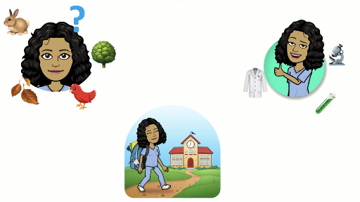

Note. Children did not see the text printed below the image. Instead, this text was recorded by a female researcher and played for children on headphones to ensure uniformity of delivery and minimize experimenter bias. The audio recording was accompanied by the visuals at the top of the figure, which appeared one at a time, from left to right, and were synchronized with the spoken script. The bolded portions of the text convey the key mindset message.

Supp. Figure 5: The Effects of the Interest Mindset Manipulation

Note. The means depicted are marginal (or adjusted) means computed from the regression models in Table 1 in the main text. Error bars = ± 1 SE. No growth versus fixed mindset differences were significant.

