Appendix 1. Association between the sum of all 11 ACE Items with Depressive Symptoms and Anxiety

 | Unadjusted Results |  | Adjusted Results*
 | Depressive Symptoms (scores: 0 – 24) | Anxiety (scores: 0 – 21) | Depressive Symptoms (scores: 0 – 24) | Anxiety (scores: 0 – 21)
 | Beta coefficient (95% CI) |  | Beta coefficient (95% CI)
ACE (scores: 0-11) | 0.356 (0.103, 0.610) | 0.435 (0.150, 0.719) | 0.353 (0.082, 0.625) | 0.435 (0.128, 0.742)
 | Probable Depression vs No depression:  Risk ratio | Anxiety vs No anxiety:  Risk ratio | Probable Depression vs No depression:  Risk ratio | Anxiety vs No anxiety:  Risk ratio
ACE (scores: 0-11) | 1.060 (0.991, 1.245) | 1.057 (0.946, 1.177) | 1.064 (0.982, 1.252) | 1.063 (0.942, 1.198)
*adjusted for all sociodemographics listed in Table 3 (age, sexual orientation, gender identity, income, education, employment, and housing instability).

Appendix 2. Infit and Outfit Statistics of Individual response
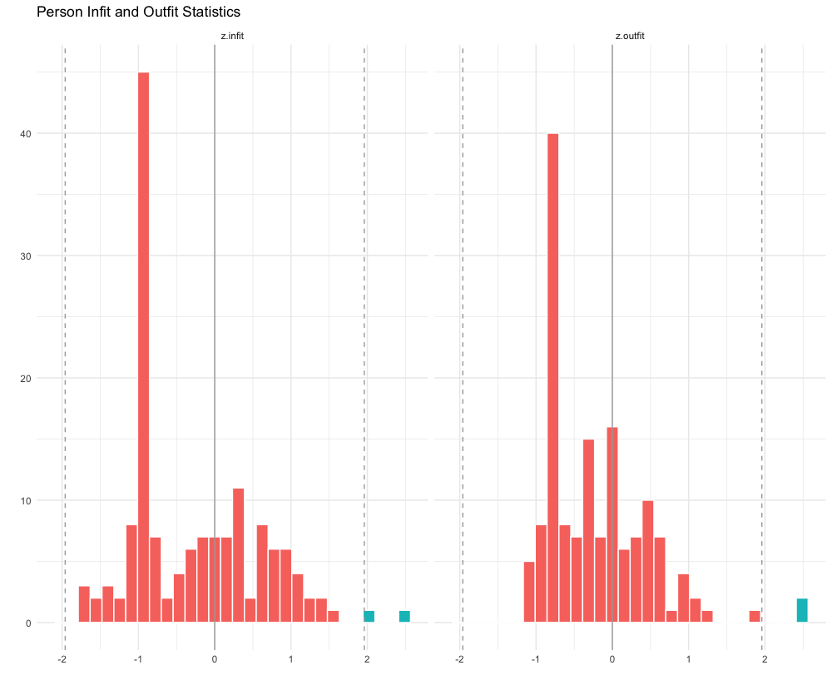
Appendix 3. Confirmatory Factor Analysis and Item Response Theory Results when Participants with Parents who were never married were removed (n = 97)
3a. Confirmatory Factor Analysis results:

 | Unidimensional 1 factor structure result | 3 factor structure results (with loadings as specified in Table 1)
RMSEA | 0.144 (0.103, 0.187) | 0.075 (0.034, 0.110)
CFI | 0.795 | 0.949
TLI | 0.713 | 0.931

Fit statistics does not fit the model as well possibly due to reduced sample size

3b. Item Response Theory Results:

Domain |  | Discrimination (Slope Parameters) | Severity | Outfit | Infit
1 | Household Mental Illness | 2.931 | 1.034 | 0.369 | 0.861
2 | Household Substance Abuse | 1.750 | 0.661 | 0.706 | 0.930
3 | Incarcerated Family Member | 1.353 | 0.530 | 0.809 | 0.935
4 | Divorced Family | 0.620 | 0.184 | 0.955 | 0.964
5 | Intimate Partner Violence | 2.400 | 0.451 | 0.559 | 0.869
6 | Physical Abuse | 3.160 | 0.678 | 0.383 | 0.803
7 | Emotional Abuse | 2.602 | 0.096 | 0.518 | 0.790
8 | Sexual Abuse | 1.715 | 0.791 | 0.712 | 0.938

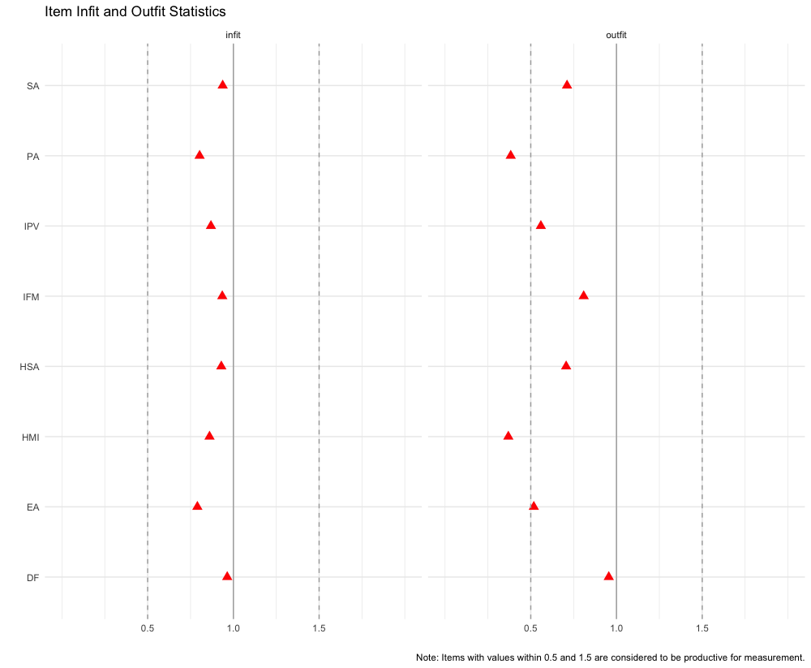

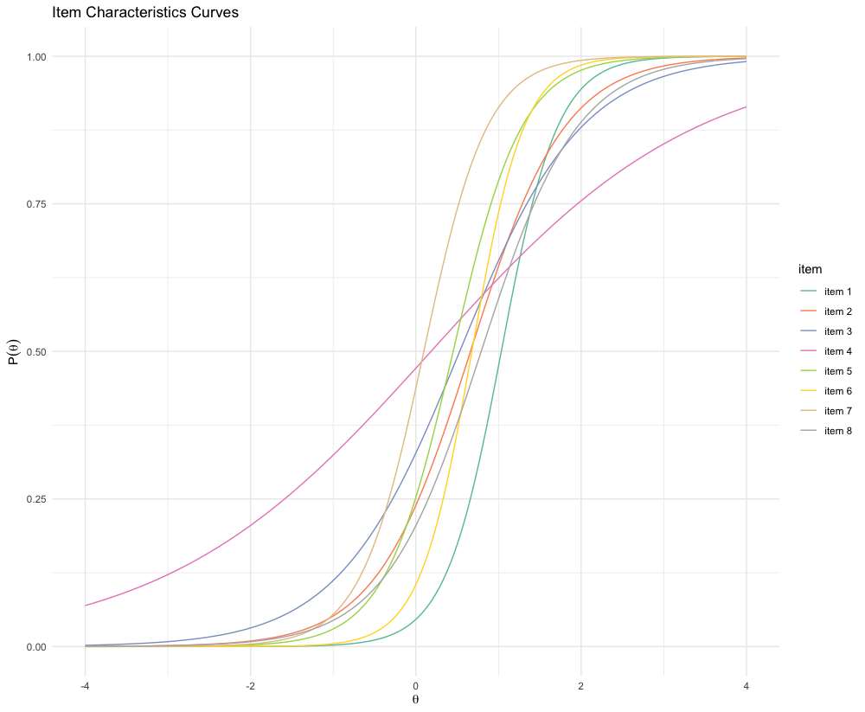
Domain / Item
1 | Household Mental Illness
2 | Household Substance Abuse
3 | Incarcerated Family Member
4 | Divorced Family
5 | Intimate Partner Violence
6 | Physical Abuse
7 | Emotional Abuse
8 | Sexual Abuse

