Table S1. Descriptive statistics of average PM_{2.5} concentrations (in µg/m³) over different exposure durations
Exposure duration (in month) | Min | Q1 | Median | Mean | Q3 | Max
1 | 6.00 | 7.50 | 9.00 | 8.96 | 10.00 | 15.60
2 | 5.90 | 7.85 | 8.90 | 9.04 | 10.05 | 13.35
3 | 6.90 | 8.30 | 8.97 | 9.09 | 9.67 | 12.67
4 | 6.83 | 8.55 | 9.00 | 9.10 | 9.50 | 11.95
5 | 7.30 | 8.68 | 9.02 | 9.06 | 9.56 | 12.16
6 | 7.65 | 8.67 | 8.97 | 9.02 | 9.45 | 11.70
7 | 7.71 | 8.56 | 8.89 | 8.99 | 9.33 | 12.34
8 | 7.78 | 8.58 | 8.83 | 9.00 | 9.41 | 11.85
9 | 7.96 | 8.54 | 8.87 | 9.03 | 9.44 | 12.19
10 | 8.12 | 8.60 | 8.88 | 9.05 | 9.40 | 11.80
11 | 8.12 | 8.65 | 8.89 | 9.03 | 9.34 | 11.85
12 | 8.17 | 8.62 | 8.89 | 9.01 | 9.30 | 11.67
13 | 8.12 | 8.62 | 8.85 | 8.99 | 9.32 | 11.66
14 | 8.14 | 8.59 | 8.86 | 8.98 | 9.30 | 11.85
15 | 8.21 | 8.59 | 8.83 | 8.97 | 9.22 | 11.85
16 | 8.13 | 8.61 | 8.89 | 8.98 | 9.19 | 11.81
17 | 8.21 | 8.62 | 8.86 | 8.98 | 9.21 | 11.79
18 | 8.28 | 8.65 | 8.89 | 8.98 | 9.21 | 11.72
19 | 8.17 | 8.65 | 8.91 | 8.98 | 9.13 | 11.66
20 | 8.18 | 8.62 | 8.90 | 8.99 | 9.14 | 11.50
21 | 8.23 | 8.61 | 8.94 | 9.00 | 9.17 | 11.45
22 | 8.22 | 8.62 | 8.95 | 9.01 | 9.18 | 11.69
23 | 8.19 | 8.64 | 8.92 | 9.01 | 9.16 | 11.58
24 | 8.12 | 8.68 | 8.92 | 9.01 | 9.13 | 11.62
25 | 8.15 | 8.76 | 8.90 | 9.03 | 9.12 | 11.52
26 | 8.19 | 8.74 | 8.91 | 9.06 | 9.14 | 11.61
27 | 8.29 | 8.77 | 8.91 | 9.08 | 9.21 | 11.60
28 | 8.31 | 8.80 | 8.95 | 9.11 | 9.26 | 11.58
29 | 8.31 | 8.82 | 8.95 | 9.13 | 9.29 | 11.57
30 | 8.29 | 8.82 | 9.00 | 9.14 | 9.33 | 11.54
31 | 8.33 | 8.82 | 9.00 | 9.16 | 9.34 | 11.63
32 | 8.35 | 8.83 | 9.03 | 9.19 | 9.38 | 11.72
33 | 8.33 | 8.83 | 9.05 | 9.21 | 9.42 | 11.75
34 | 8.35 | 8.84 | 9.05 | 9.23 | 9.46 | 11.76
35 | 8.30 | 8.85 | 9.07 | 9.26 | 9.52 | 11.75
36 | 8.31 | 8.86 | 9.10 | 9.27 | 9.50 | 11.80

Table S2. Associations of average PM_{2.5} concentrations over different exposure durations with ghrelin, resistin, leptin, and C-peptide in linear regression.
Exposure duration  (in month) | β (95% CI)ª
Exposure duration  (in month) | Ghrelin | Resistin | Leptin | C-peptide
1 | -0.03 (-0.06, 0.01) | 0.05 (0.00, 0.09) | 0.01 (-0.03, 0.05) | 0.00 (-0.10, 0.10)
2 | -0.06 (-0.11, -0.02) | 0.07 (0.01, 0.12) | 0.04 (-0.01, 0.09) | 0.02 (-0.10, 0.15)
3 | -0.13 (-0.19, -0.07) | 0.11 (0.04, 0.18) | 0.08 (0.01, 0.14) | 0.06 (-0.10, 0.22)
4 | -0.21 (-0.28, -0.15) | 0.16 (0.07, 0.25) | 0.12 (0.04, 0.19) | 0.09 (-0.10, 0.28)
5 | -0.25 (-0.33, -0.17) | 0.18 (0.08, 0.28) | 0.15 (0.06, 0.24) | 0.12 (-0.10, 0.35)
6 | -0.29 (-0.38, -0.19) | 0.21 (0.09, 0.33) | 0.18 (0.07, 0.28) | 0.18 (-0.08, 0.45)
7 | -0.31 (-0.40, -0.21) | 0.18 (0.05, 0.30) | 0.17 (0.06, 0.28) | 0.17 (-0.10, 0.44)
8 | -0.32 (-0.41, -0.23) | 0.18 (0.05, 0.30) | 0.18 (0.07, 0.28) | 0.16 (-0.11, 0.43)
9 | -0.33 (-0.43, -0.24) | 0.20 (0.08, 0.33) | 0.22 (0.11, 0.32) | 0.18 (-0.09, 0.45)
10 | -0.36 (-0.46, -0.26) | 0.23 (0.10, 0.35) | 0.23 (0.12, 0.34) | 0.19 (-0.09, 0.47)
11 | -0.40 (-0.50, -0.30) | 0.25 (0.12, 0.39) | 0.25 (0.13, 0.36) | 0.21 (-0.09, 0.50)
12 | -0.41 (-0.52, -0.31) | 0.27 (0.13, 0.41) | 0.25 (0.13, 0.38) | 0.22 (-0.08, 0.53)
13 | -0.40 (-0.50, -0.29) | 0.27 (0.14, 0.41) | 0.24 (0.12, 0.36) | 0.23 (-0.07, 0.53)
14 | -0.39 (-0.49, -0.29) | 0.25 (0.11, 0.38) | 0.23 (0.11, 0.35) | 0.27 (-0.03, 0.56)
15 | -0.41 (-0.52, -0.31) | 0.25 (0.12, 0.39) | 0.25 (0.13, 0.37) | 0.30 (0.00, 0.60)
16 | -0.45 (-0.55, -0.34) | 0.23 (0.09, 0.37) | 0.25 (0.13, 0.37) | 0.27 (-0.03, 0.58)
17 | -0.46 (-0.56, -0.35) | 0.21 (0.07, 0.35) | 0.24 (0.11, 0.36) | 0.22 (-0.09, 0.54)
18 | -0.45 (-0.56, -0.34) | 0.19 (0.05, 0.33) | 0.22 (0.10, 0.34) | 0.19 (-0.12, 0.50)
19 | -0.46 (-0.57, -0.35) | 0.18 (0.04, 0.32) | 0.21 (0.09, 0.34) | 0.17 (-0.14, 0.48)
20 | -0.45 (-0.56, -0.35) | 0.18 (0.04, 0.33) | 0.21 (0.09, 0.34) | 0.19 (-0.12, 0.50)
21 | -0.45 (-0.56, -0.35) | 0.17 (0.03, 0.31) | 0.22 (0.09, 0.34) | 0.25 (-0.06, 0.56)
22 | -0.44 (-0.55, -0.33) | 0.16 (0.02, 0.30) | 0.21 (0.09, 0.34) | 0.28 (-0.03, 0.60)
23 | -0.43 (-0.54, -0.32) | 0.14 (0.00, 0.29) | 0.20 (0.08, 0.33) | 0.28 (-0.03, 0.60)
24 | -0.43 (-0.55, -0.32) | 0.12 (-0.03, 0.26) | 0.20 (0.07, 0.33) | 0.30 (-0.03, 0.62)
25 | -0.41 (-0.52, -0.30) | 0.11 (-0.04, 0.25) | 0.19 (0.06, 0.32) | 0.31 (0.00, 0.63)
26 | -0.39 (-0.50, -0.28) | 0.08 (-0.06, 0.23) | 0.17 (0.04, 0.29) | 0.31 (-0.01, 0.62)
27 | -0.39 (-0.50, -0.28) | 0.08 (-0.06, 0.23) | 0.16 (0.04, 0.29) | 0.31 (0.00, 0.62)
28 | -0.39 (-0.50, -0.28) | 0.07 (-0.07, 0.22) | 0.16 (0.03, 0.28) | 0.29 (-0.02, 0.60)
29 | -0.38 (-0.49, -0.27) | 0.06 (-0.08, 0.21) | 0.15 (0.02, 0.27) | 0.25 (-0.06, 0.56)
30 | -0.36 (-0.47, -0.25) | 0.05 (-0.09, 0.20) | 0.14 (0.01, 0.27) | 0.24 (-0.08, 0.55)
31 | -0.34 (-0.44, -0.23) | 0.04 (-0.11, 0.18) | 0.12 (-0.01, 0.24) | 0.24 (-0.07, 0.55)
32 | -0.31 (-0.42, -0.21) | 0.03 (-0.11, 0.17) | 0.10 (-0.02, 0.22) | 0.24 (-0.07, 0.54)
33 | -0.30 (-0.41, -0.20) | 0.02 (-0.12, 0.15) | 0.09 (-0.03, 0.21) | 0.21 (-0.08, 0.51)
34 | -0.29 (-0.39, -0.19) | 0.00 (-0.13, 0.14) | 0.08 (-0.04, 0.20) | 0.20 (-0.10, 0.49)
35 | -0.28 (-0.39, -0.18) | -0.01 (-0.15, 0.12) | 0.07 (-0.05, 0.19) | 0.17 (-0.12, 0.47)
36 | -0.27 (-0.38, -0.17) | -0.02 (-0.16, 0.11) | 0.07 (-0.05, 0.19) | 0.17 (-0.12, 0.47)
ª Adjusted for age (35-39, 40-44, 45-49, 50-64, 65+), race/ethnicity (non-Hispanic White, non-Hispanic Black, Hispanic, other), gender (male, female), education (less than high school, high school, some college, college or more), household income (< $15,000, $15,000 - $24,999, $25,000 - $34,999 and >$34,999), body mass index (BMI; <25, 25-29.9, 30-39.9, >39.9), type 2 diabetes (yes, no), and heart attack history (yes, no), and neighborhood area deprivation index (ADI, in quartiles).

Table S3. Associations of average PM_{2.5} concentrations over different exposure durations with CK-MB and MCP-1 in linear regression.
Exposure duration  (in month) | β (95% CI)ª
Exposure duration  (in month) | CK-MB | MCP-1
1 | -0.04 (-0.07, -0.02) | 0.13 (0.01, 0.25)
2 | -0.05 (-0.09, -0.01) | 0.23 (0.08, 0.37)
3 | -0.03 (-0.08, 0.02) | 0.36 (0.16, 0.55)
4 | -0.02 (-0.08, 0.03) | 0.50 (0.27, 0.73)
5 | -0.01 (-0.08, 0.05) | 0.68 (0.42, 0.95)
6 | 0.00 (-0.08, 0.08) | 0.85 (0.54, 1.16)
7 | -0.04 (-0.11, 0.04) | 0.87 (0.55, 1.19)
8 | -0.05 (-0.13, 0.03) | 0.89 (0.57, 1.21)
9 | -0.04 (-0.12, 0.04) | 0.89 (0.57, 1.21)
10 | -0.02 (-0.11, 0.06) | 0.84 (0.52, 1.17)
11 | 0.00 (-0.09, 0.09) | 0.95 (0.60, 1.30)
12 | 0.02 (-0.07, 0.11) | 1.05 (0.69, 1.41)
13 | 0.03 (-0.05, 0.12) | 1.01 (0.65, 1.37)
14 | 0.03 (-0.05, 0.12) | 1.01 (0.66, 1.35)
15 | 0.04 (-0.04, 0.13) | 1.02 (0.66, 1.38)
16 | 0.04 (-0.05, 0.13) | 0.96 (0.60, 1.32)
17 | 0.05 (-0.04, 0.15) | 0.93 (0.56, 1.30)
18 | 0.05 (-0.04, 0.15) | 0.84 (0.47, 1.21)
19 | 0.06 (-0.03, 0.15) | 0.82 (0.45, 1.19)
20 | 0.08 (-0.02, 0.17) | 0.78 (0.40, 1.15)
21 | 0.10 (0.01, 0.19) | 0.74 (0.37, 1.11)
22 | 0.12 (0.03, 0.21) | 0.69 (0.32, 1.07)
23 | 0.14 (0.04, 0.23) | 0.66 (0.28, 1.03)
24 | 0.13 (0.04, 0.23) | 0.64 (0.26, 1.03)
25 | 0.13 (0.03, 0.22) | 0.61 (0.22, 1.00)
26 | 0.11 (0.01, 0.20) | 0.51 (0.13, 0.89)
27 | 0.11 (0.02, 0.20) | 0.45 (0.08, 0.83)
28 | 0.12 (0.03, 0.21) | 0.42 (0.04, 0.80)
29 | 0.13 (0.04, 0.22) | 0.39 (0.01, 0.77)
30 | 0.13 (0.04, 0.22) | 0.35 (-0.03, 0.73)
31 | 0.12 (0.03, 0.21) | 0.30 (-0.07, 0.68)
32 | 0.13 (0.04, 0.21) | 0.24 (-0.13, 0.60)
33 | 0.13 (0.04, 0.21) | 0.16 (-0.20, 0.51)
34 | 0.13 (0.04, 0.21) | 0.12 (-0.24, 0.48)
35 | 0.13 (0.04, 0.21) | 0.08 (-0.28, 0.43)
36 | 0.12 (0.04, 0.21) | 0.05 (-0.31, 0.41)
ª Adjusted for age (35-39, 40-44, 45-49, 50-64, 65+), race/ethnicity (non-Hispanic White, non-Hispanic Black, Hispanic, other), gender (male, female), education (less than high school, high school, some college, college or more), household income (< $15,000, $15,000 - $24,999, $25,000 - $34,999 and >$34,999), body mass index (BMI; <25, 25-29.9, 30-39.9, >39.9), type 2 diabetes (yes, no), and heart attack history (yes, no), and neighborhood area deprivation index (ADI, in quartiles).

Table S4. Associations of average PM2.5 concentrations over different exposure durations with TNF-alpha, NT-proBNP, troponin, and IL-6 in logistic regression
Exposure duration  (in month) | OR (95% CI)ª
Exposure duration  (in month) | TNF-alpha | NT-proBNP | Troponin | IL-6
1 | 1.35 (1.14, 1.59) | 1.73 (1.19, 2.51) | 1.29 (1.09, 1.54) | 1.27 (1.07, 1.51)
2 | 1.47 (1.19, 1.81) | 1.73 (1.09, 2.73) | 1.34 (1.07, 1.66) | 1.26 (1.01, 1.57)
3 | 1.51 (1.16, 1.97) | 1.62 (0.88, 3.00) | 1.38 (1.04, 1.82) | 1.29 (0.97, 1.70)
4 | 1.95 (1.42, 2.68) | 1.43 (0.67, 3.07) | 1.73 (1.24, 2.42) | 1.57 (1.13, 2.18)
5 | 2.35 (1.62, 3.40) | 1.10 (0.42, 2.86) | 2.04 (1.39, 3.01) | 1.55 (1.06, 2.27)
6 | 2.56 (1.69, 3.87) | 0.84 (0.26, 2.68) | 2.21 (1.43, 3.42) | 1.41 (0.91, 2.17)
7 | 2.22 (1.48, 3.31) | 1.15 (0.36, 3.71) | 1.88 (1.23, 2.89) | 1.33 (0.86, 2.05)
8 | 2.16 (1.45, 3.21) | 1.69 (0.59, 4.87) | 1.73 (1.13, 2.65) | 1.40 (0.91, 2.15)
9 | 2.07 (1.41, 3.04) | 1.59 (0.56, 4.51) | 1.76 (1.16, 2.66) | 1.34 (0.88, 2.04)
10 | 2.19 (1.50, 3.21) | 1.33 (0.42, 4.19) | 1.87 (1.24, 2.82) | 1.40 (0.91, 2.14)
11 | 2.41 (1.60, 3.63) | 1.30 (0.35, 4.80) | 2.06 (1.33, 3.19) | 1.37 (0.87, 2.16)
12 | 2.70 (1.77, 4.11) | 1.65 (0.47, 5.76) | 2.33 (1.49, 3.65) | 1.49 (0.94, 2.36)
13 | 2.50 (1.67, 3.73) | 1.99 (0.67, 5.92) | 2.20 (1.43, 3.40) | 1.51 (0.97, 2.35)
14 | 2.37 (1.61, 3.50) | 1.96 (0.69, 5.53) | 2.06 (1.35, 3.14) | 1.45 (0.94, 2.24)
15 | 2.36 (1.59, 3.52) | 1.82 (0.60, 5.53) | 1.97 (1.27, 3.04) | 1.38 (0.88, 2.16)
16 | 2.41 (1.61, 3.59) | 1.68 (0.51, 5.51) | 1.97 (1.28, 3.04) | 1.33 (0.84, 2.09)
17 | 2.48 (1.65, 3.72) | 1.58 (0.44, 5.63) | 2.02 (1.30, 3.13) | 1.35 (0.85, 2.15)
18 | 2.34 (1.56, 3.50) | 1.77 (0.52, 6.01) | 1.92 (1.24, 2.97) | 1.26 (0.79, 2.01)
19 | 2.23 (1.49, 3.34) | 1.88 (0.58, 6.03) | 1.82 (1.17, 2.83) | 1.26 (0.79, 2.01)
20 | 2.22 (1.48, 3.34) | 2.10 (0.69, 6.44) | 1.84 (1.18, 2.87) | 1.29 (0.81, 2.05)
21 | 2.18 (1.44, 3.29) | 1.90 (0.58, 6.16) | 1.82 (1.16, 2.86) | 1.25 (0.78, 2.02)
22 | 2.23 (1.48, 3.37) | 1.66 (0.46, 5.96) | 1.90 (1.22, 2.98) | 1.30 (0.81, 2.08)
23 | 2.20 (1.45, 3.33) | 1.56 (0.40, 6.08) | 1.89 (1.20, 2.96) | 1.25 (0.77, 2.02)
24 | 2.15 (1.41, 3.29) | 1.65 (0.42, 6.57) | 1.85 (1.17, 2.93) | 1.20 (0.73, 1.95)
25 | 2.07 (1.36, 3.14) | 1.77 (0.48, 6.52) | 1.79 (1.14, 2.83) | 1.17 (0.72, 1.91)
26 | 2.00 (1.33, 3.02) | 1.95 (0.59, 6.47) | 1.70 (1.08, 2.67) | 1.15 (0.71, 1.86)
27 | 1.94 (1.28, 2.94) | 1.86 (0.55, 6.34) | 1.64 (1.04, 2.59) | 1.12 (0.69, 1.82)
28 | 1.95 (1.28, 2.96) | 1.84 (0.52, 6.45) | 1.65 (1.04, 2.61) | 1.15 (0.71, 1.87)
29 | 1.94 (1.27, 2.95) | 1.77 (0.49, 6.44) | 1.65 (1.04, 2.62) | 1.19 (0.73, 1.92)
30 | 1.90 (1.24, 2.91) | 2.04 (0.59, 7.09) | 1.61 (1.01, 2.57) | 1.14 (0.70, 1.85)
31 | 1.82 (1.20, 2.78) | 2.22 (0.68, 7.22) | 1.55 (0.98, 2.46) | 1.10 (0.68, 1.79)
32 | 1.75 (1.15, 2.65) | 2.18 (0.70, 6.76) | 1.48 (0.93, 2.34) | 1.08 (0.67, 1.74)
33 | 1.64 (1.08, 2.48) | 2.09 (0.68, 6.43) | 1.39 (0.88, 2.20) | 1.03 (0.64, 1.66)
34 | 1.61 (1.06, 2.44) | 2.00 (0.63, 6.32) | 1.36 (0.86, 2.15) | 1.03 (0.64, 1.66)
35 | 1.56 (1.02, 2.37) | 1.88 (0.56, 6.33) | 1.33 (0.84, 2.11) | 1.00 (0.62, 1.62)
36 | 1.57 (1.03, 2.40) | 2.08 (0.63, 6.88) | 1.35 (0.85, 2.15) | 1.02 (0.63, 1.64)
ª Adjusted for age (35-39, 40-44, 45-49, 50-64, 65+), race/ethnicity (non-Hispanic White, non-Hispanic Black, Hispanic, other), gender (male, female), education (less than high school, high school, some college, college or more), household income (< $15,000, $15,000 - $24,999, $25,000 - $34,999 and >$34,999), body mass index (BMI; <25, 25-29.9, 30-39.9, >39.9), type 2 diabetes (yes, no), and heart attack history (yes, no), and neighborhood area deprivation index (ADI, in quartiles).

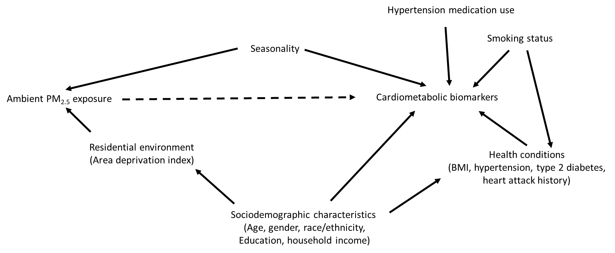
Figure S1. Causal directed acyclic graph between ambient PM_{2.5} exposure and cardiometabolic biomarkers in the study. The dashed line represents the causal effect of interest.

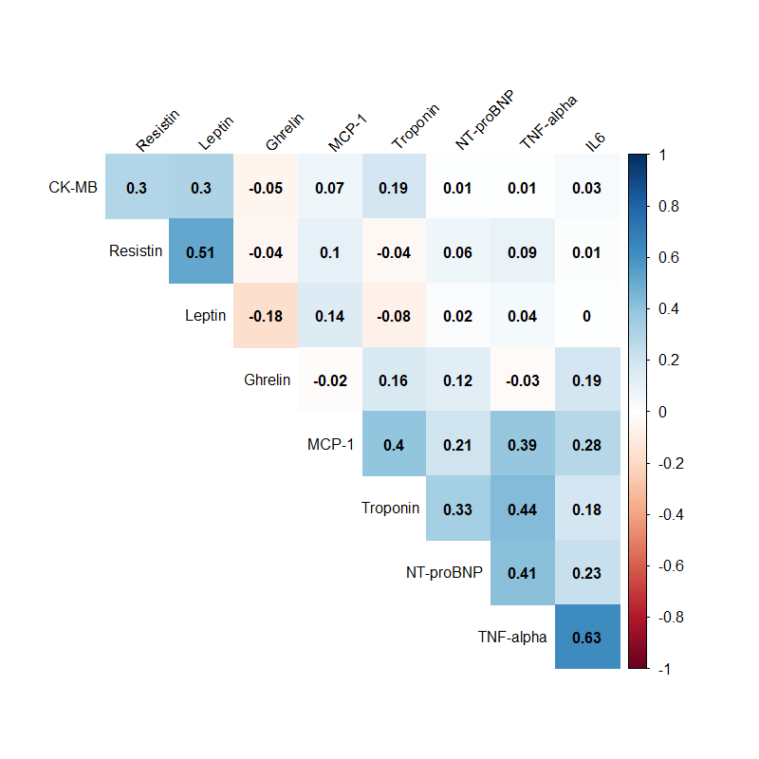
Figure S2. Pearson correlations between cardiometabolic biomarkers analyzed in this study

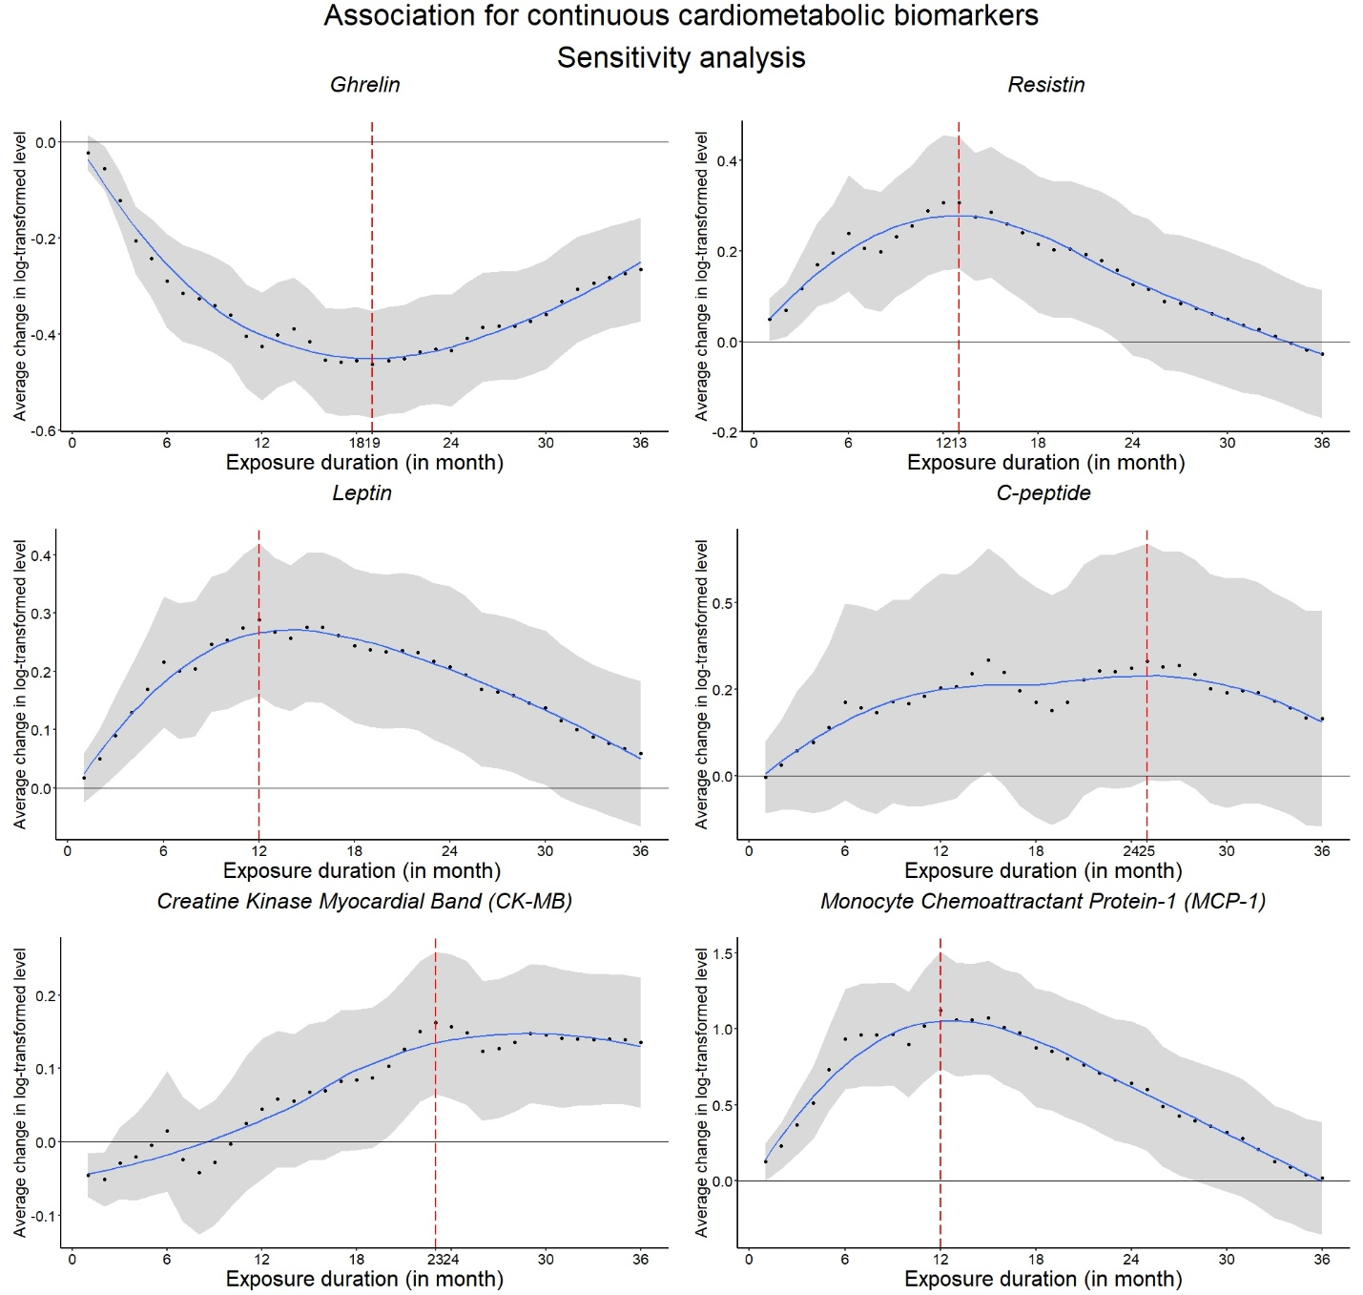
Figure S3. Associations of average PM2.5 concentrations over different exposure durations with continuous cardiometabolic biomarkers in linear regression in the sensitivity analysis restricting to non-Hispanic Black people and additionally adjusted for hypertension medication intake.

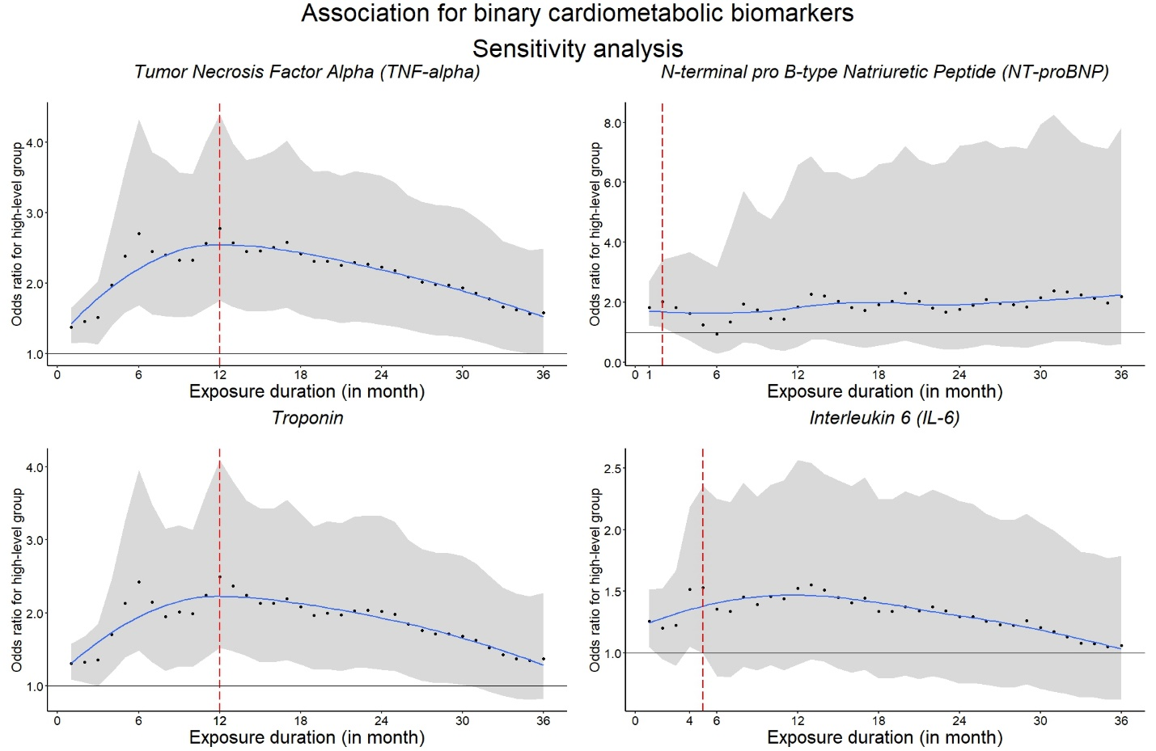
Figure S4. Associations of average PM2.5 concentrations over different exposure durations with binary cardiometabolic biomarkers in logistic regression in the sensitivity analysis restricting to non-Hispanic Black people and additionally adjusted for hypertension medication intake.

